NexusMeals Performance Report

By Plamen Peev

Contents

Introduction 2

Test Scenarios 2

Detailed Analysis 3

Data Transmission 3

Dropped Iterations 3

HTTP Request Duration 4

Iteration Duration 4

Iterations and HTTP Requests 4

Conclusion 5

Datadog Monitoring 5

# Introduction

This report compares the load test results from two different environments:

* Local (My machine, Docker, no scalability i.e. one instance per service)
* Qualification (NetLab, Kubernetes cluster with 3 worker nodes, Horizontal Pod Autoscaling enabled)

The goal is to evaluate how the Qualification setup improves the performance metrics.

# Test Scenarios

The test focused on the inventory/product/create scenario, designed to assess the system under varying load conditions. The load test gradually increases the number of requests for creating a product. The most intensive period occurs when the system attempts to handle 100 requests per second for a duration of 5 minutes, after which the load gradually decreases.

# Detailed Analysis

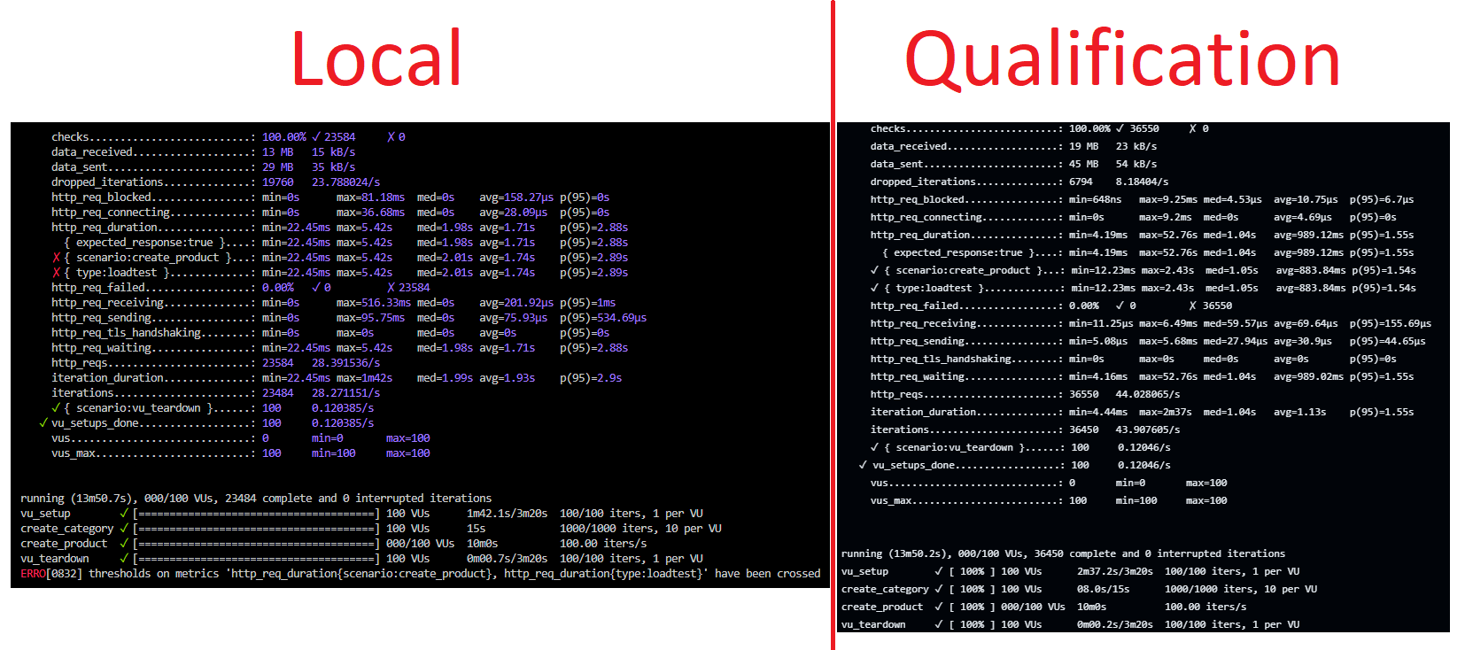Here is a summary of the key performance metrics from both environments:

## Data Transmission

* **Data Received:** The Qualification environment received 6 MB more data.
* **Data Sent:** The Qualification environment sent 16 MB more data.

## Dropped Iterations

* **Local:** 19768
* **Qualification:** 6794
* The Qualification environment significantly reduced the number of dropped iterations, indicating better handling of load.

## HTTP Request Duration

* **Local:**
  + Avg: 1.74s
  + p(95): 2.89s
* **Qualification:**
  + Avg: 883.84ms
  + p(95): 1.54s
* The average and 95th percentile request durations in the Qualification environment are substantially lower, demonstrating improved performance.

## Iteration Duration

* **Local:**
  + Avg: 1.93s
  + p(95): 2.9s
* **Qualification:**
  + Avg: 1.13s
  + p(95): 1.55s
* The Qualification environment again shows a lower average and 95th percentile for iteration duration, highlighting more efficient request processing.

## Iterations and HTTP Requests

* **Iterations Completed:**
  + Local: 23484
  + Qualification: 36450
* **HTTP Requests:**
  + Local: 23584
  + Qualification: 36550
* The Qualification environment handled significantly more iterations and HTTP requests, showing improved scalability.

# Conclusion

The Qualification environment (NetLab, Kubernetes, horizontal scaling) demonstrated significant improvements over the Local environment (Docker) across all key performance metrics. The most notable improvements were in reduced HTTP request and iteration durations, fewer dropped iterations, and increased capacity to handle more iterations and HTTP requests. These improvements are attributed to the Kubernetes setup with auto-scaling and multiple worker nodes, allowing for better load distribution and resource management.

# Datadog Monitoring

Below are some statistics on resource utilization from DataDog at the time of performing the qualification load test:

