**Student housing project analysis**

**Group** №07

Plamen Peev – Student number : 4179080

Tomislav Tonchev – Student number : 4181476

Jean-Marc Dañe – Student number : 4339169

Introduction

We are a freshly-gathered team which is tasked to develop a software solutions for the Student Housing Agency BV. We are the perfect team for this task , because we are ambitious students who knows what is it to share accommodation with other people. Therefore we know what obstacles may occur and how we can approach them.

Main objective

For a student housing agency , the priority is the well-being of the tenants. If lack of organization occurs because of unjustified work , consequently the residents would have some inconveniences and quarrels.

Our main purpose is to analyze the omissions and develop a solution which helps the Housing Agency BV’s tenants organize and divide workloads evenly between each other without having the Student Housing agency involved in personal matters. Reducing the interaction needed between employees and tenants should also be considered. Especially in these times with the Covid-19.

Solution

In order to achieve our goal , we will implement this in a software manner. An application that helps our tenants schedule and see all their daily tasks and responsibilities , mark a certain task as done , see the rules of our policy and write an anonymous complaint. This will benefit the agency and the students respectively. Students would definitely improve their cooperative skills and home establishment. In conjunction, the agency will be able to receive a feedback form them and furthermore decide how to tackle it.

End-users and contribution

The software users are the students and the employees of the agency as well. When the application is started , a form with username and password will pop up. There are two account types. If a student logged in , he won’t have certain permissions , for instance , to change the rules of the agency , or see the complains that had been made , whereas an admin(employee) has permission to perform these actions. On the other hand , the admin wouldn’t be able to see the Agreements environment or change it , because this would mean interfering with the tenants’ personal life.

CRUD Methodology

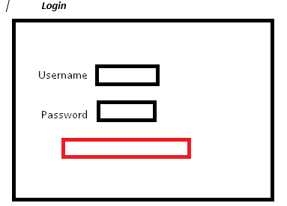

When the student logged in , he will have three options on the tab menu.

For the Tasks , he will be able to create a task , and as well mark certain task as done/not done. For the complains, the student can write an anonymous complain , and mark if it is for a student or for the housing agency , and then send it.

For the last page , the student is able only to read the rules , defined from an admin. (Instead of Help , there will be logout option which redirects to the login form)

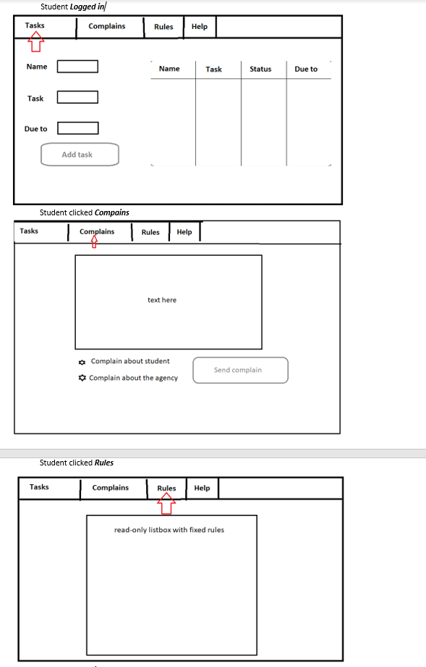

When an admin logs in , he will have 2 options – see the complains(without changing them) and edit the rules.

(Instead of Help , there will be logout option which redirects to the login form)

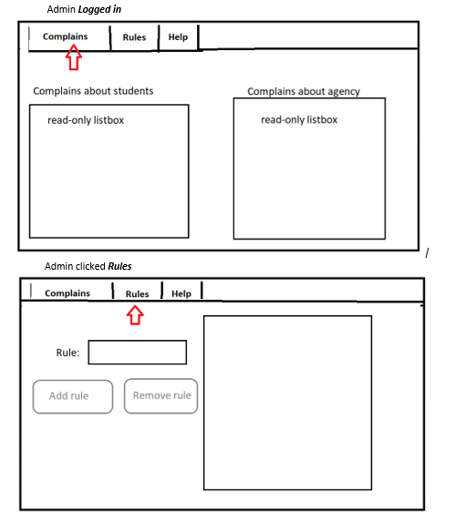

Risks of the project

Due to the pandemic obstacles it isn’t appropriate to make physical team meetings , therefore our simultaneous contribution to the project and discussions have to be online. Thus , communication may be less convenient and beneficial.

Another problem may be the scheduling of the meetings , as everyone has personal matters to accomplish at different time of the day.

Implementing material that hasn’t been presented to us at university may be needed in order to fully establish the program.

Way of working

|  |  |  |  |  |  |  |
| --- | --- | --- | --- | --- | --- | --- |
| **Weeks** | **13** | **14** | **15** | **16** | **17** | **18** |
| **Official plan** | Deliver project analysis document | Start coding | Deliver and present first version | Continue coding | Finish final version and report | Present and evaluate |
| **Our plan** | Deliver project analysis document & start coding | Deliver and present first version & continue coding | Deliver and present completed  version | Improve completed version if needed | Finish the improving of the completed version | Present and evaluate |

Positions of the team members

|  |  |  |
| --- | --- | --- |
| **Name** | **Position** | **Objectives** |
| Jean-Mark | Senior developer &  front-end developer | Approve the algorithms , eventually improve it and work on the design |
| Plamen Peev | Junior back-end developer | Work on the algorithms of the program |
| Tomislav Tonchev | Junior back-end developer | Work on the algorithms of the program |