**Student housing project analysis**

**Group** №07

Plamen Peev – Student number : 4179080

Tomislav Tonchev – Student number : 4181476

Jean-Marc Dañe – Student number : 4339169

**Introduction**

We are a freshly-gathered team which is tasked to develop a software solution for the Student Housing Agency BV. We are the perfect team for this task , because we are ambitious students who knows what it is to share accommodation with other people. Therefore we know what obstacles may occur and how we can approach them.

**Background**

Student Housing BV offers accommodation for students who can stay there during their education in the Netherlands. The tenants have their private rooms but they are also sharing facilities such as toilets, bathroom, kitchen and etc.  
They are receiving complains from time to time and they think this happens when one of the students overdoes with its behavior. Unannounced parties, forgotten garbage – not done on time, etc.

BV Housing is searching for an application where the rules can be shown, tasks can be arranged between the tenants, anonymous complains sent and everything else which can contribute for better and more useful app.

**Problem statement**

For a student housing agency , the priority is the well-being of the tenants. If lack of organization occurs because of unjustified work , consequently the residents would have some inconveniences and quarrels.

Our main purpose is to analyze the omissions and develop a solution which helps the Housing Agency BV’s tenants organize and divide workloads evenly between each other without having the Student Housing agency involved in personal matters. Reducing the interaction needed between employees and tenants should also be considered. Especially in these times with the Covid-19.

**Process & Result**

In order to achieve our goal , we will implement this in a software manner. An application that helps our tenants schedule and see all their daily tasks and responsibilities , mark a certain task as done , see the rules of our policy and write an anonymous complaint. This will benefit the agency and the students respectively. Students would definitely improve their cooperative skills and home establishment. In conjunction, the agency will be able to receive a feedback form them and furthermore decide how to tackle it.

**First version of the application :**

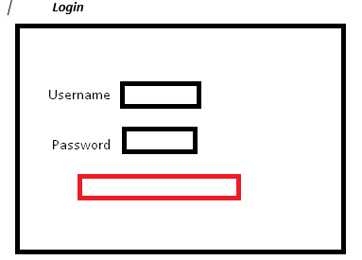

When the student logged in , he will have three options on the tab menu.

For the Tasks , he will be able to create a task , and as well mark certain task as done/not done. For the complains, the student can write an anonymous complain , and mark if it is for a student or for the housing agency , and then send it. For the last page , the student is able only to read the rules , defined from an admin. (Instead of Help , there will be logout option which redirects to the login form) 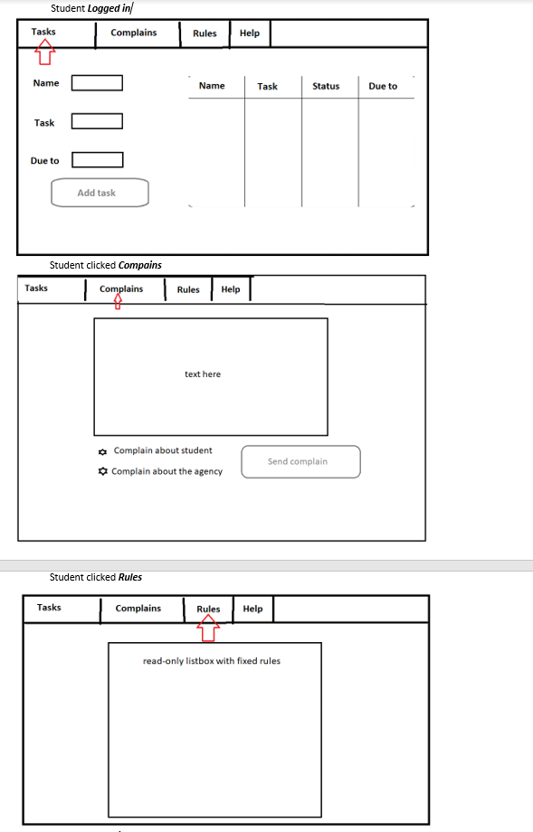

When an admin logs in , he will have 2 options – see the complains(without changing them) and edit the rules.

(Instead of Help , there will be logout option which redirects to the login form)

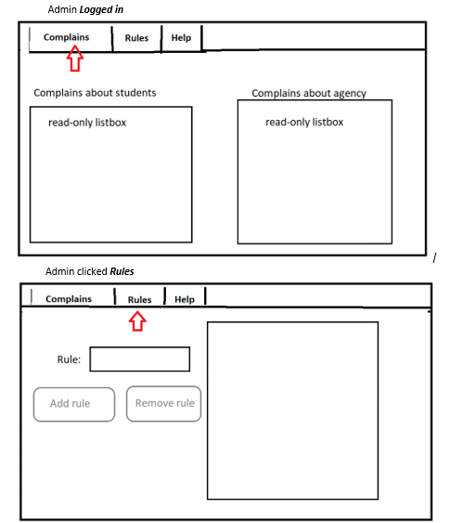

We think that there will be many pros taken out of the app because it will discipline the “naughty” tenants. Moreover the work for agency to collect data, set rules and etc. is going to be easier because of the flexible way we structured the application.

**Final version of the application , pictures taken from app running:**

CRUD STUDENT

A student has the whole CRUD methodology for his own tasks , and for the general tasks he can only see them as information.

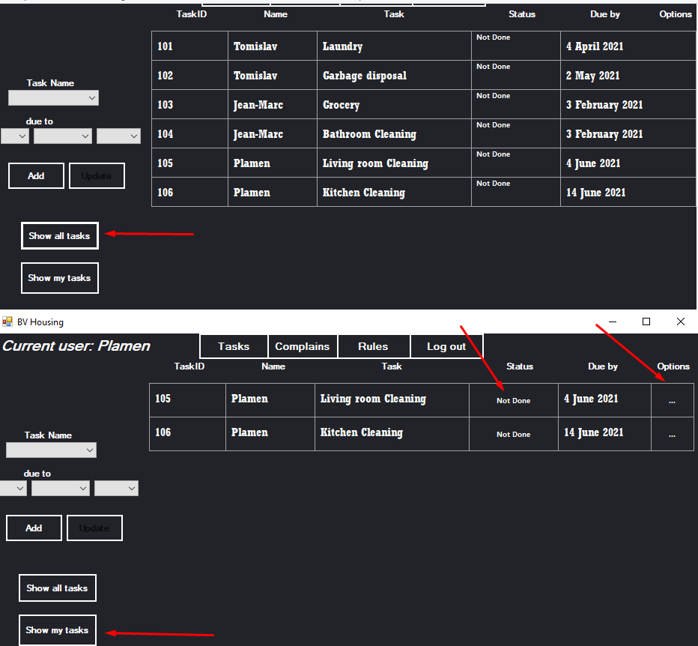

Here at the second picture The Status is now clickable , and the Options button “…” opens the following choices :

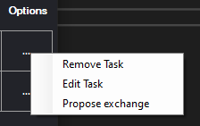

For the complains , the student can only create one anonymously and send it to the admins. He should choose who is the complain about

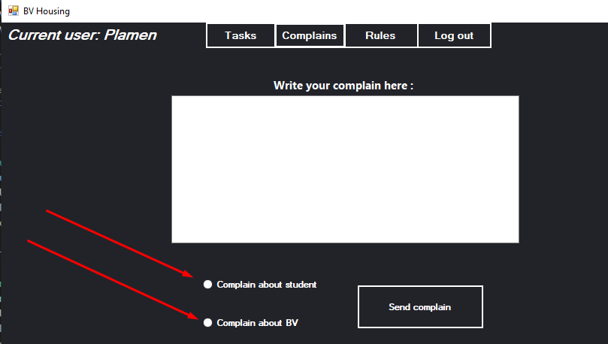

The student can only read the defined rules from the admins. 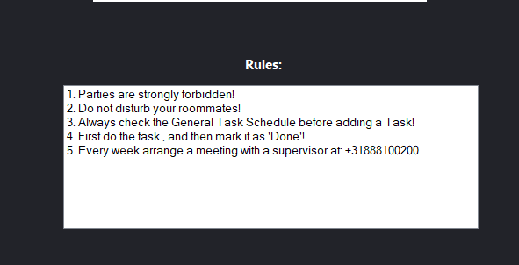

CRUD ADMIN

Admins can only read the complains from the students , as shown in this window.

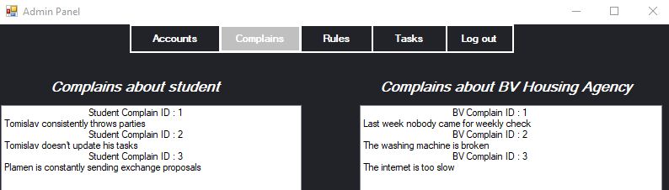

For the Accounts(students only) , Rules and Task names they have the complete CRUD methodology.

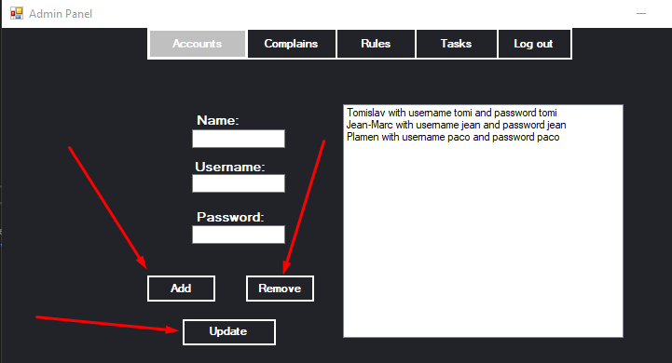

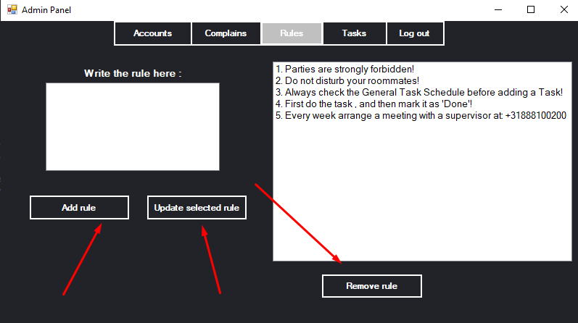

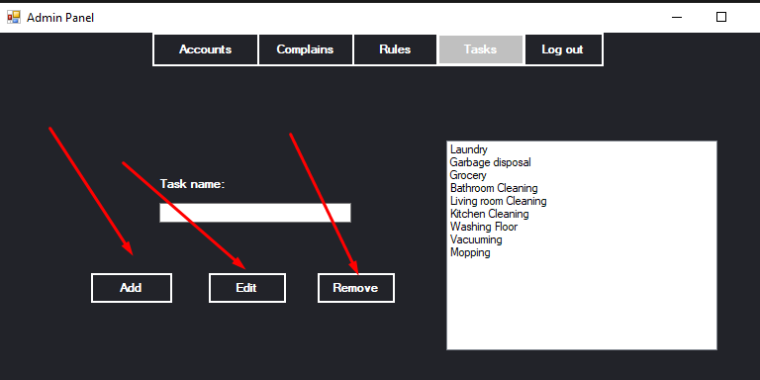By Task names , we mean the possible choices for the students to assign themselves a task.

UML Diagram and Classes’ functionality

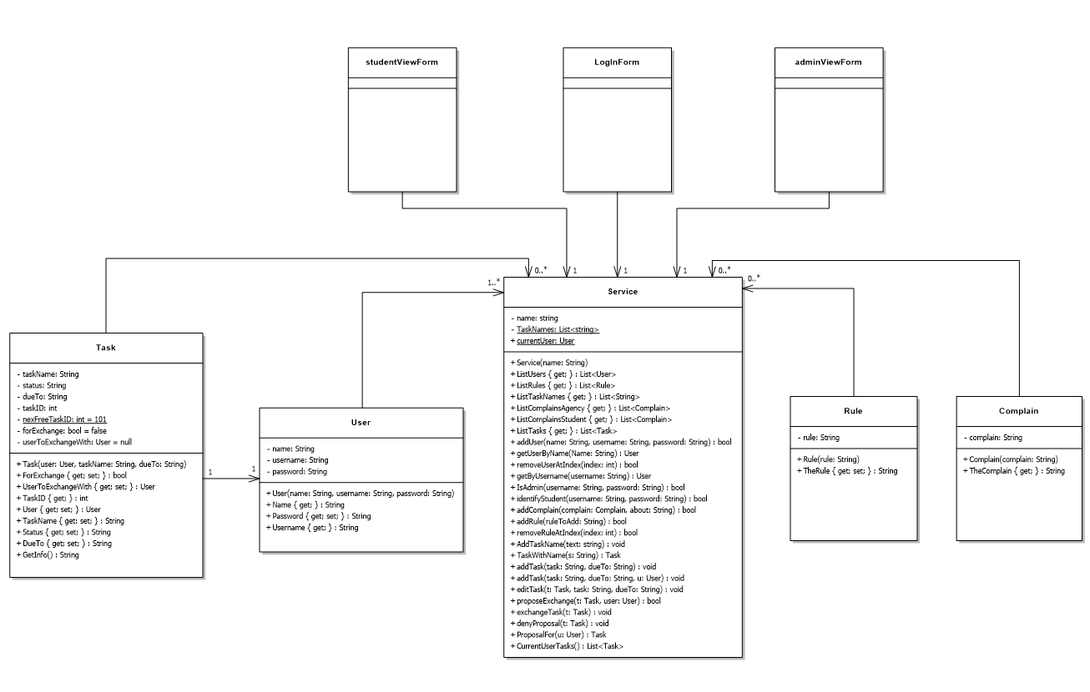

We use 4 classes to store the objects we work with : Task , User , Rule , Complain. Their main functionality is to store and retrieve the instances in the object. The class Service is the key to the whole functionality of the application. There we store Lists of all the other types of classes , and consequently methods that are used for the CRUD methodology in the forms.

We have three forms : Login , Student Form and Admin Form. The Login form creates the object “BV Service” , and when a user logs in , the corresponding form is created , given the parameter BV Service , and then showed.

**Conclusion & Recommendation**

When we started working on the project , the implementation and the improvements were going so rapidly that far exceeded our predictions. Therefore we decided to extend our limits , and consequently learned how to simultaneously work in a dynamic atmosphere with efficient results. Some decisions we made for the functionality of the application led us to the point where we had to comprehend material which far surpassed the material we have learned in the first semester. Of course , we could’ve done the project simpler and easier , but we wanted to push ourselves further.

As a result of our impatience for knowledge and progress , we had both advantages and disadvantages from the process of doing the project.

The disadvantages were that we implemented most of the base algorithm for the application only after one lecture for classes and objects. We thought that we are ready to implement everything we came up to this point , simply because we thought we knew how to do it. Then , we thought that the only important thing is the user interaction and the code doesn’t matter that much if it works properly. After the third week of the Advanced Phase , we realized that almost everything we did for the code , wasn’t in the right direction. After we heard about Refactoring , we tried our best to rearrange the whole system for the application , but the deadline was approaching and we didn’t have enough time to refactor everything the way it should be.

The advantages we earned were produced from the disadvantages. The fact that we tried to rush everything led us to many mistakes which we didn’t have time to overcome. These obstacles gave us an important lesson that we might not have learned another way. Exactly because our intentions at the beginning weren’t convenient enough , we now know that everything should be well-considered before implementing , we should always consider another possibilities and be more cautious.

**Evaluation**

**Personal reflection Plamen:** As a conclusion from this project , I am satisfied with the work I’ve done , as well as the final result which everyone contributed to.

I exceeded my expectations for my own capabilities , because the experience I have with programming is only form Fontys. For the previous 4 and a half months I’ve been putting all my efforts , I’ve struggled a lot , had a lot of obstacles and now when I see the application we’ve done I am proud of myself that I was able to contribute to it. I think this project was crucial for my further development in the IT sphere , because from all the downsides of our working process I was able to understand my mistakes and therefore now I know how to prevent them in future projects.

**Personal reflection Tomislav:** For me, this project was like an adventure. Our team rushed into it struggled and everyone contributed to the final product. We had obstacles as every team and polished current skills of working as one. I had some past experience with programming but didn’t practise enough, and I am happy that here I had the time and the opportunity to improve myself. I liked the attitude of the teachers, I think they helped us with advice and suggestions when it comes to the project. As a conclusion the project and the team were really great, we did and got the best we could despite the difficulties we had.

**Personal reflection Jean-Marc:** This project was a good experience for me, I do have past experiences with programming. But doing this project allowed me to learn things I have missed before and methods and ways to work in a team on a project.

The parts I contributed were somewhat challenging but I enjoyed learning new things and implementing things in a group for a final product.

Due to circumstances, we did not have in school classes or meetings, but it was enough setup how we wanted to do the project.

At this current point in time I believe our product is good, but as we keep learning I can see it being possible to remake and improve over and over again.

**P.S.**

We are very thankful to Ms. Zhao who was always available and moreover when we were out of ideas she was there to suggest something and also to Mr. Bert who checked the mess behind the app not once and gave us advice how to improve our coding for the future!

Thank you!