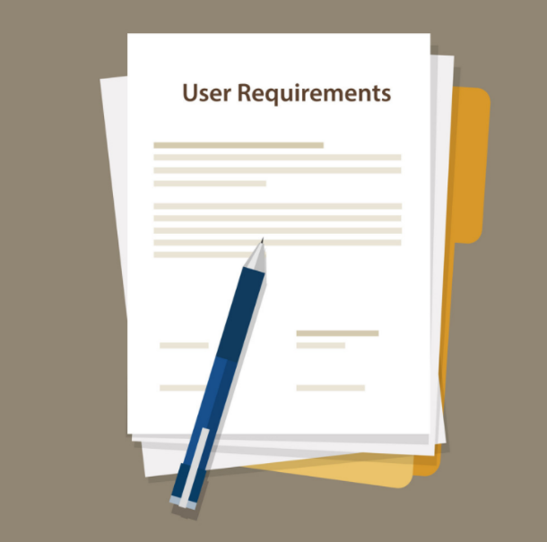

Software Solution for

Media Bazar,

-User Requirements Specifications-

-Semester two-

Team Oxya

***By: Ioan Popa, Matei Mitran, Plamen Peev, Alexander Bogdanov and Aleksej Borisov***

***Tutor: Qin Zhao***

# Agreements with Client

***Agreements with client:***

We have agreed to deliver to the client the following products:  
* Windows application for managing the store stock, employee schedules, setting prices for the products, ect.

* A website for customers to view available products in stock, store working hours, pictures and descriptions of products, purchase products, etc.

* Databases for the software products to store information  
* Wireframes of the software products  
* UML diagrams of the software products

* We have agreed to make decisions about the design of the software products ourselves and seek approval from the client
* We have agreed to keep the client updated with the progress of the software products
* We have agreed to add / remove / change features of the software products upon request from the client

# Functional Requirements

**1.Mid-management Form**

Main Window:

FR-MM-MW-01: Manager should have access to employees’ information

FR-MM-MW-02: Manager should be able to hire/promote/dismiss workers

Reports Window:

FR-MM-RW-01: Manager should be able to approve/deny day-off requests

FR-MM-RW-02: Manager should be able to view and confirm/deny ‘sick reports’

Schedule Window:

FR-MM-SW-01: Manager should be able to see shift preferences

FR-MM-SW-02: System should be able to auto-generate the schedule

3 main shifts: Morning(08:00-12:30),Midday(12:30-17:00),Evening(17:00-21:30)

2 double shifts: Morning + Midday OR Midday + Evening – 45 min break between

The schedule is for the upcoming 2 weeks

Based mainly on the needed amount of positions per working day

Based partly on the employees’ preferences

Employees can’t have the same shifts consistently

FR-MM-SW-03: Manager should be able to change the schedule, based on the constrains of FR-MM-SW-02

**2.Regular Employees Form**

Main Window:

FR-RE-MW-01: Employee should be able to view announcements, rules and upcoming events.

Personal Information Window:

FR-RE-PI-01:Employee should be able to change his address , telephone number, email and password.

Schedule Window:

FR-RE-SW-01: Employee should be able to view personal schedule

FR-RE-SW-02: Employee should be able to view general schedule

FR-RE-SW-03: Employee can give preferences for the next schedule

3 main shifts: Morning(08:00-12:30),Midday(12:30-17:00),Evening(17:00-21:30)

2 double shifts: Morning + Midday OR Midday + Evening – 45 min break between

The employee can’t give the same shift consistently

Report Window:

FR-RE-RW-01: Employee should be able to ask for a day(s)-off

Day(s)-off should be minimum 4 weeks ahead.

The employee should select/type the reason for his absence.

FR-RE-RW-02: Employee should be able to fill-in a sick report

The employee should provide roughly estimated absence period.

The employee should give a description of his situation/condition.

# Use casses

* Use case: Manipulate information of an employee:

Actor: HR mid-manager

Pre-conditions:

* An HR manager is logged in the system with its account
* The manager must have opened the ‘Employees’ tab.
* The manager must have selected an employee from the drop-down list.
* The manager must have pressed the ‘Show info’ button
* The chosen employee’s information has been displayed in two categories

Main Success Scenario:

1.The actor aknowledged the possibilities that are presented and takes action according to its intent .

2.The data of the employee is updated and displayed.

Extensions:

1-A). Promote

.a) The actor selects a position to promote the employee to.

.b) The action is contested:

* The actor confirms the promotion.
* Return to MSS step 2.
* The actor denies the promotion.
* Return to MSS step 1.

1-B). Demote

.a) The actor selects a position to demote the employee to.

.b) The action is contested.

* The actor confirms the demoting.
* Return to MSS step 2.
* The actor denies the demotion.
* Return to MSS step 1.
* Use case: Conclude employee “day-off” requests: -ACCEPTING REQUEST

Actor: HR Mid-manager

Pre-conditions:

* An HR manager is logged in the system with its account
* The manager must have opened the ‘Requests’ tab.
* The application displays the employees’ requests.

Main Success Scenario:

1.The actor selects a day-off request.

2.The selected request details are displayed.

3. The actor inputs a change

4. The changes are saved

5.The list with the requests and the schedules are updated

Extensions:

3). Accept ‘day-off’ request

a) The acceptance is contested

* The actor confirms the acceptance.
* Return to MSS step 4.

OR

* The actor denies the acceptance.
* Return to MSS step 3.
* Use case: Conclude employee “day-off” requests: - DENNY REQUEST

Actor: HR Mid-manager

Pre-conditions:

* An HR manager is logged in the system with its account
* The manager must have opened the ‘Requests’ tab.
* The application displays the employees’ requests.

Main Success Scenario:

1.The actor selects a day-off request.

2.The selected request details are displayed.

3. The actor inputs a change

4. The changes are saved

5.The list with the requests and the schedules are updated

Extensions:

3). Deny ‘day-off’ request

a) The denial is contested

* The actor confirms the denial.
* Return to MSS step 4.

OR

* The actor denies the denial.
* Return to MSS step 3.
* Use case: Conclude employee sick reports: - ACCEPT REQUEST

Actor: HR Mid-manager

Pre-conditions:

* An HR manager is logged in the system with its account
* The manager must have opened the ‘Sick Reports’ tab.
* The application displays the employees’ Sick reports.

Main Success Scenario:

1.The actor selects a sick report.

2.The selected sick report details are displayed.

3. The actor performs an action

4. The changes are saved

5.The list with the sick reports and the schedules are updated

Extensions:

3). Accept sick report

a) The acceptance is contested

* The actor confirms the acceptance.
* Return to MSS step 4.

OR

* The actor denies the acceptance.
* Return to MSS step 3.
* Use case: Conclude employee sick reports: - DENNY REQUEST

Actor: HR Mid-manager

Pre-conditions:

* An HR manager is logged in the system with its account
* The manager must have opened the ‘Sick Reports’ tab.
* The application displays the employees’ Sick reports.

Main Success Scenario:

1.The actor selects a sick report.

2.The selected sick report details are displayed.

3. The actor performs an action

4. The changes are saved

5.The list with the sick reports and the schedules are updated

Extensions:

3). Deny sick report

a) The denial is contested

* The actor confirms the denial.
* Return to MSS step 4.

OR

* The actor denies the denial.
* Return to MSS step 3.

* Use case: Manipulate the employees’ schedule: - ACCEPT CHANGES

Actor: HR Mid-manager

Pre-conditions:

* An HR manager is logged in the system with its account
* The manager must have opened the ‘Schedule’ tab.

Main Success Scenario:

1. An empty table is created for 2 weeks ahead.
2. The schedule table is updated.
3. The actor makes changes on the schedule.
4. The actor saves the changes.
5. The schedule is updated and displayed.

Extensions:

1-A): The actor pressed ‘Generate Schedule’

a) Shifts are assigned to the employees.

b) Return to MSS step 2

1-B): The actor hasn’t pressed ‘Generate Schedule’

a) Go to MSS step 3

4): The shifts are assigned according to the rules.

a) The changes are contested

* The actor confirms the changes.
* Return to MSS step 5.

OR

* The actor denies the changes.
* Return to MSS step 3.
* Use case: Manipulate the employees’ schedule: - DENNY CHANGES

Actor: HR Mid-manager

Pre-conditions:

* An HR manager is logged in the system with its account
* The manager must have opened the ‘Schedule’ tab.

Main Success Scenario:

1. An empty table is created for 2 weeks ahead.
2. The schedule table is updated.
3. The actor makes changes on the schedule.
4. The actor saves the changes.
5. The schedule is updated and displayed.

Extensions:

1-A): The actor pressed ‘Generate Schedule’

a) Shifts are assigned to the employees.

b) Return to MSS step 2

1-B): The actor hasn’t pressed ‘Generate Schedule’

a) Go to MSS step 3

4): The shifts are not assigned according to the rules.

1. The actor is informed about the mistake
2. Return to MSS step 3.

# GUI

