**TASK OVERVIEW**

  

**Visualizing Data via google data studio**

**Data cleaning via pandas library**

**Importing data files from google sheets**

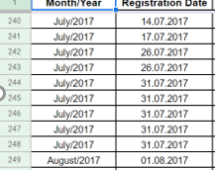 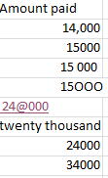 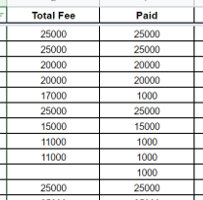 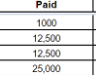

Removing negative symbol.

Function to replace all the garbage values to the right values.

Transitioning Month/Year and Reg column to Date-time format.

Month/Year & Reg column transformed to date time format.

7transformed to Datetime format

Replaced null and garbage values with zero and type casted to int.

Successfully removed negative values.

Successfully removed commas in numerical columns.

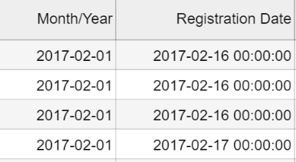 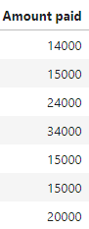 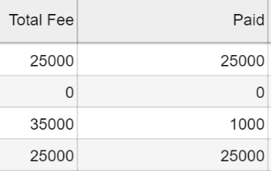 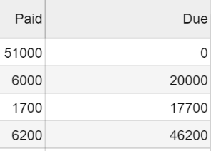

Removing commas in numerical data values.