**Bidding Site Demo**

1. Home page

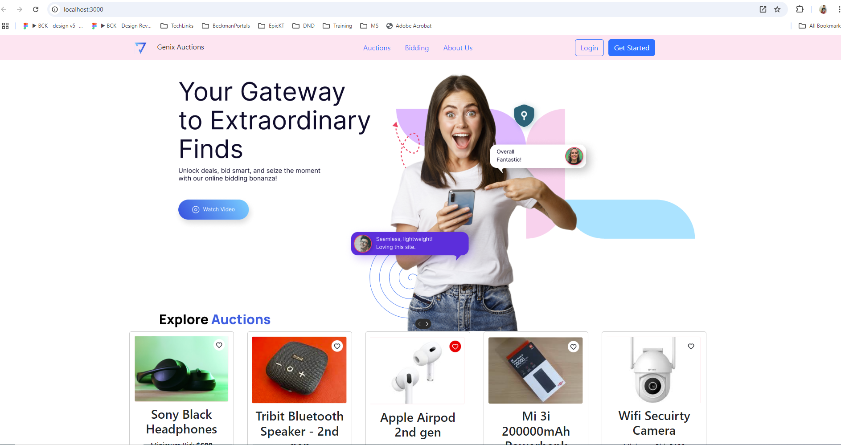

1. User registration page

1. Login user page

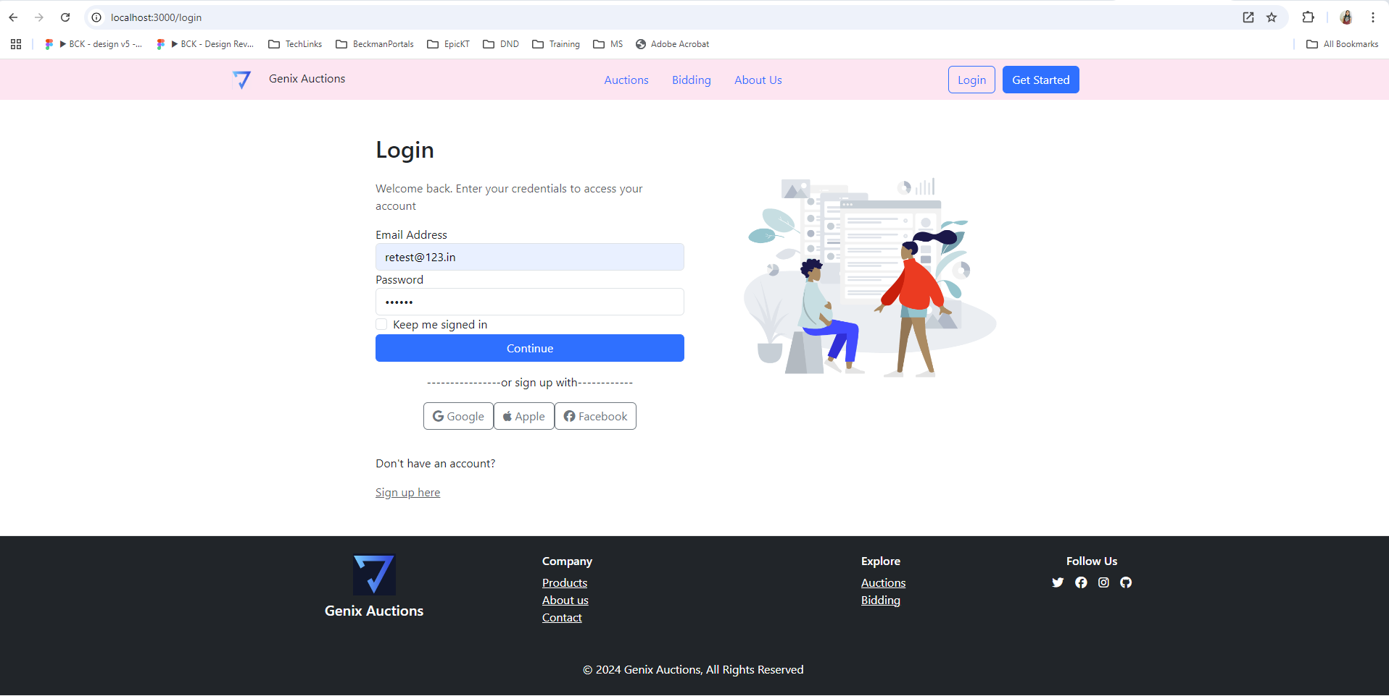

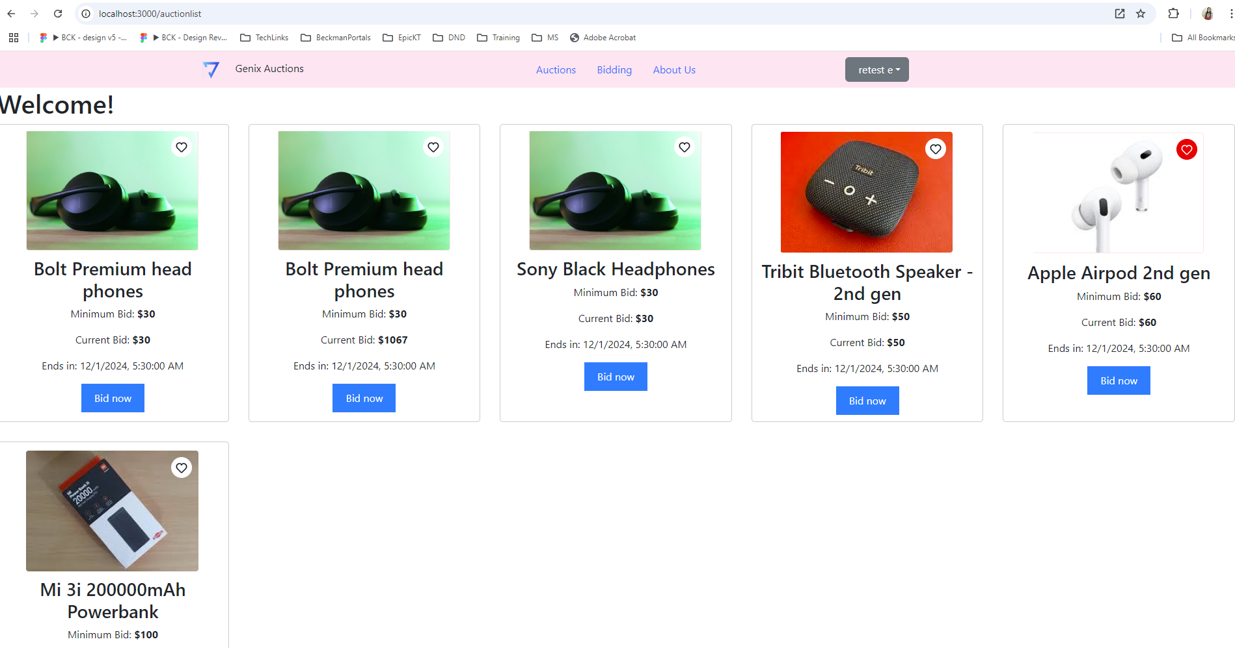

1. Auction list Page

1. Bidding Description page

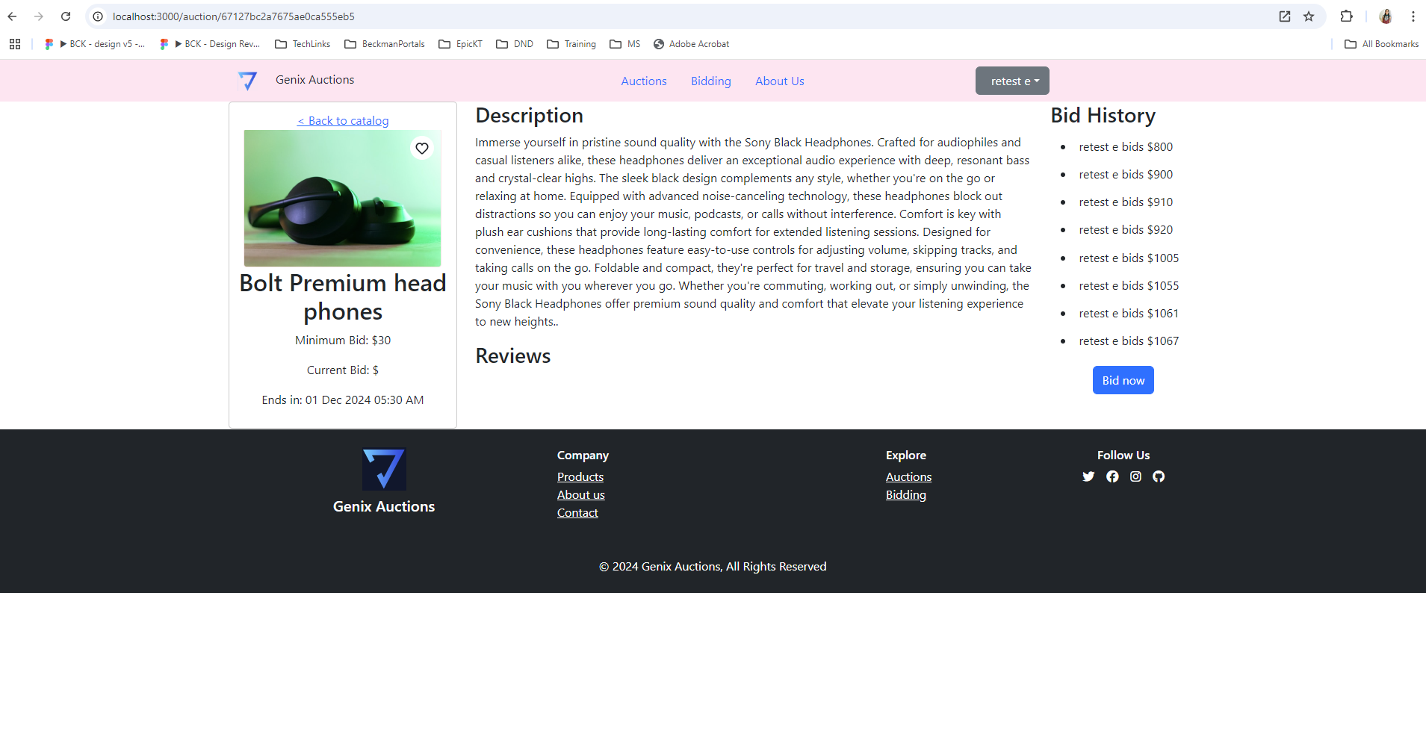

1. Bid auction page

