Introduction 1
Determining the Files That Have Changed During a Release 1
What Now? 5

Introduction
This document explains how to get RTC to generate a change log containing the name of files that have been touched during a specific product release development cycle.

Determining the Files That Have Changed During a Release
When RTC is used for source control, it is not a simple task to determine which files have been added/changed/deleted during the release cycle. For instance, the timestamps of local files can no longer be used to determine if changed after a particular starting date. There is no straightforward way to generate a list of files modified since a particular date.

The following process is based on the exploratory work of Darren Dunne using TBSM’s RTC. You’ll need to adjust the TBSM specific items to match your RTC release ☺
- Login to your RTC client
- Activate the Team Artifacts tab
- Expand/open the BSM node [this will be your product’s Rational Jazz Team Server]
- Open the Builds node
- Double-click the tbsm_dev Production Build node to populate the Builds view. [this will be your release’s production build]
This may take a while since there may have been 100’s and 100’s of builds during this release. You may even receive a popup message indicating that the retrieval failed (QueryExpiredException). If this occurs, try again using the Refresh toolbar button.
Tips from the Trench: Experience from the TBSM Chief Programmer
You can dramatically reduce the volume of builds displayed by deleting Completed Build Results (you'll need appropriate authorization to do this). I've done this for TBSM so we're down to only a couple 100 builds now (from 700+)
It's also useful to tag the "first" build for a release (to make it easier to find in the future), and disallow it from being deleted. This will then be shown in the Tags column of the Builds view.
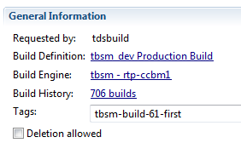

- In the Builds list, select the following two builds (using Ctrl+Click)
  - most current successful build
  - first build of this release [this will be your release’s first production build]
- Right click and select Compare Builds
- The Change Explorer view is populated.
Optional, but not required for change log generation: By default, it shows Change Sets. Click the Show files toolbar button to switch the view to file mode. This lets you see the damage from the UI…
- Click on the View Menu drop-down (at far right of toolbar) and select Save Change Log...
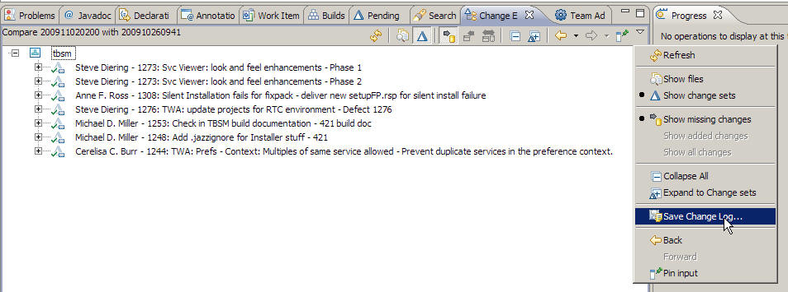
- Fill in these options and click OK
What Now?
The COD rtc-changes ANT task can now be used to process the saved change log. Please refer to the task’s documentation for complete details including a brief discussion of the change log’s format/content.

Tips from the Trench: Experience from the TBSM Chief Programmer
The change log includes an entry for every file touched during this release. This includes the following activities:
- additions
- modifications
- deletions
Unfortunately, there is no indication in the log that defines which of these activity(s) apply…
How addressed by rtc-changes ANT task
Deletions are detected by verifying each file’s continued existent in the current RTC source tree.

