MINI PROJECT PORTFOLIO

2D GRAPHICS EDITOR USING C

Submitted By
Name: Poonam kumari
School: School of Computer Science and Engineering
SRN: R25Ej100

ABSTRACT
The 2D Graphics Editor is a menu-driven application developed using the C programming language. The project provides a text-based graphical environment where users can create and manipulate basic geometric shapes such as rectangles, lines, triangles, and circles on a 20×40 canvas. The editor supports object creation, deletion, modification, display, and canvas reset operations.

OBJECTIVES
1. Create a 2D drawing canvas using a character array.
2. Implement drawing of geometric shapes.
3. Support deletion and modification of objects.
4. Display graphical output in the console.
5. Apply modular programming concepts in C.

PROBLEM STATEMENT
Design and implement a menu-driven 2D Graphics Editor using the C programming language.

SYSTEM REQUIREMENTS
Hardware: Intel Core i3+, 4 GB RAM.
Software: Windows 10/11, C, Code::Blocks, GitHub.

SYSTEM DESIGN
Canvas Size: 20 rows × 40 columns. Coordinate range x:0-39, y:0-19. Top-left corner is (0,0).

DATA STRUCTURES USED
Object Types: Rectangle, Line, Triangle, Circle.
Canvas: 20×40 character array.
Object Storage: Array of objects.

FEATURES IMPLEMENTED
Canvas Initialization, Display Canvas, Draw Rectangle, Draw Line, Draw Triangle, Draw Circle, Delete Object, Modify Object, Reset Canvas, Exit Application.

ALGORITHM
Initialize canvas, display menu, accept user choice, perform operation, render objects, display canvas, repeat until exit.

IMPLEMENTATION DETAILS
Rectangle, Line, Triangle, and Circle drawing implemented using coordinates and dimensions. Circle uses (x-cx)^2 + (y-cy)^2 <= r^2.

TEST CASES
Rectangle(5,5,10,5), Line(2,2,8), Triangle(20,10,6), Circle(30,10,4), Delete Object, Modify Object.

OUTPUT SCREENSHOTS
Insert screenshots of menu, rectangle, line, triangle, circle, delete, modify, and reset operations.
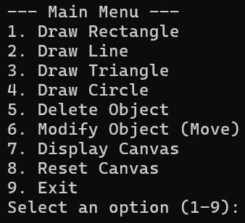

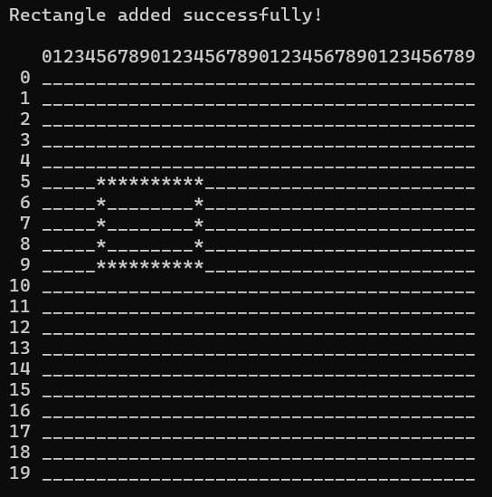

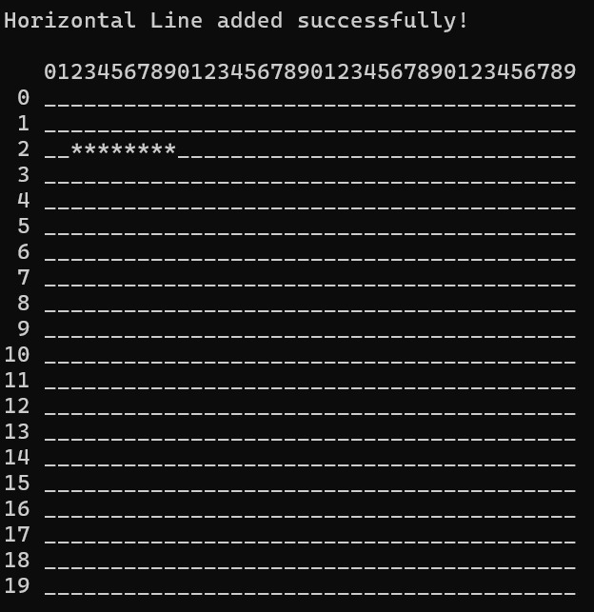

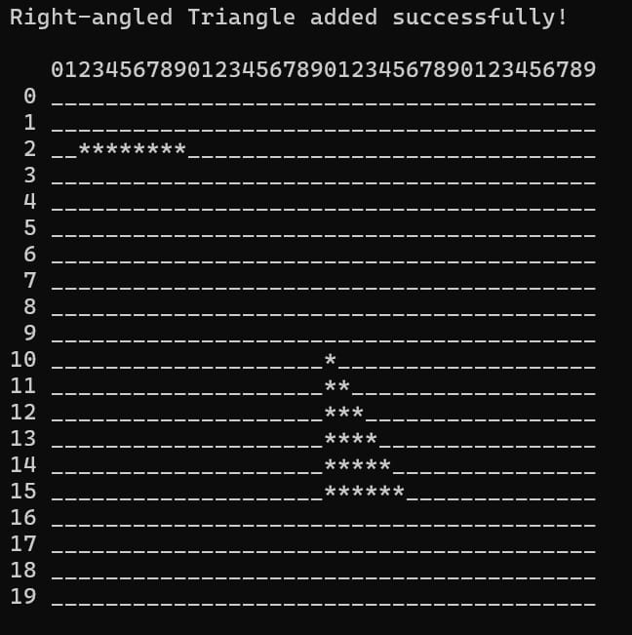

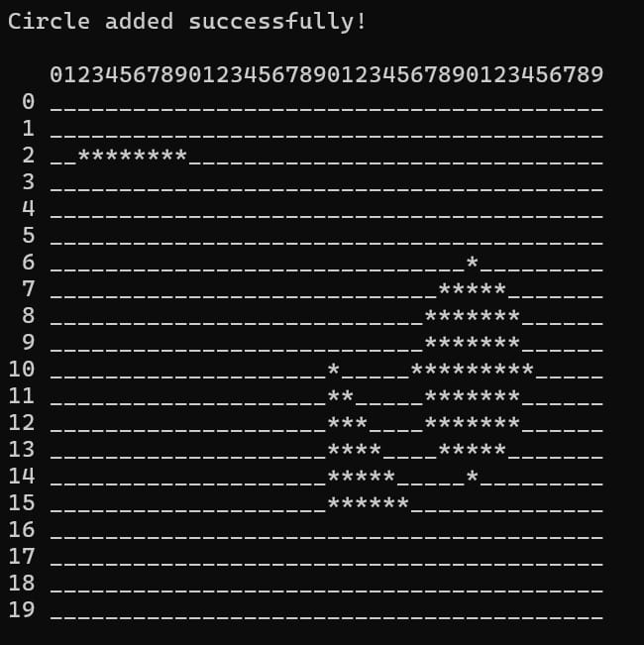

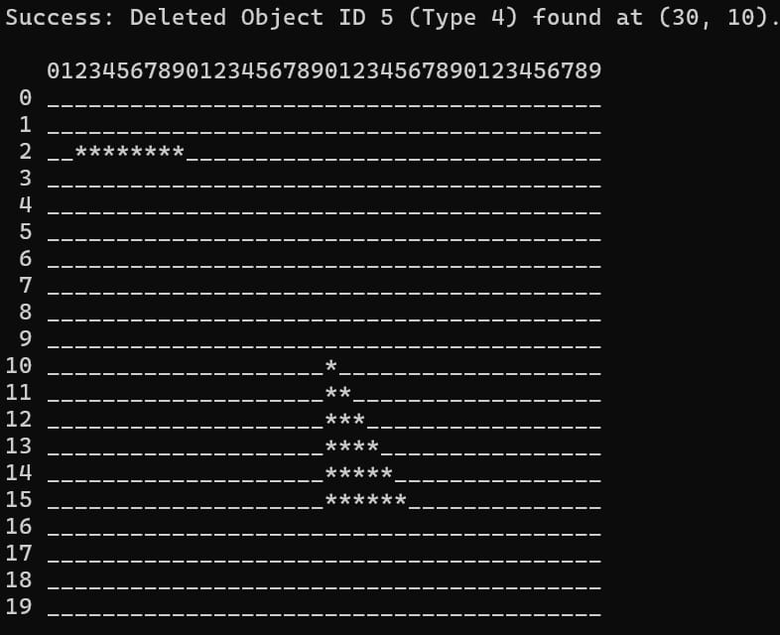

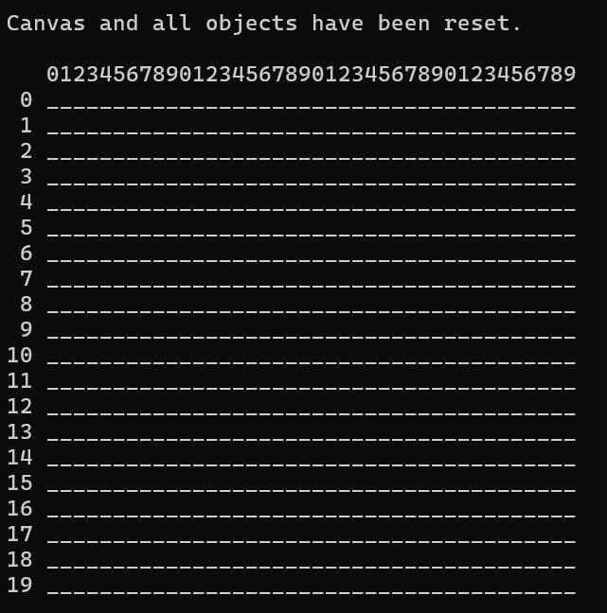

ADVANTAGES
Simple interface, demonstrates C concepts, modular design, supports multiple objects.

FUTURE ENHANCEMENTS
Colored objects, filled shapes, save/load drawings, GUI implementation.

CONCLUSION
The project successfully implements a 2D Graphics Editor using C with object creation, modification, deletion, and display capabilities.

REFERENCES
Kernighan & Ritchie - The C Programming Language;
Code::Blocks Documentation;
GCC Documentation;
GitHub Documentation.

