<https://get.jenkins.io/war-stable/>

[2.303.2/](https://get.jenkins.io/war-stable/2.303.2/) 2021-10-06 15:47

With that set up, the Jenkins package can be run with: java -jar jenkins.war

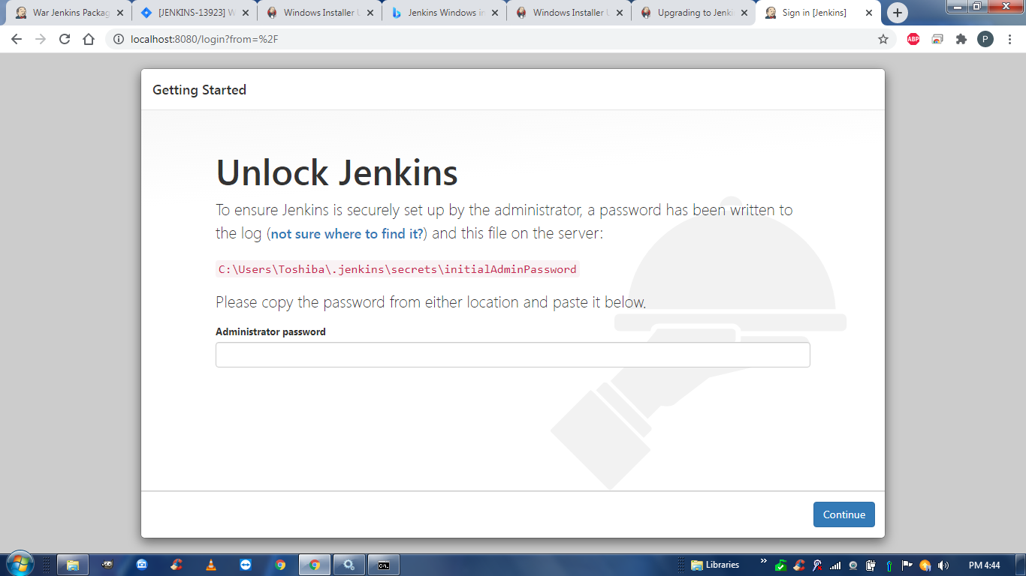

18397d242a45412c893b548541958a1b

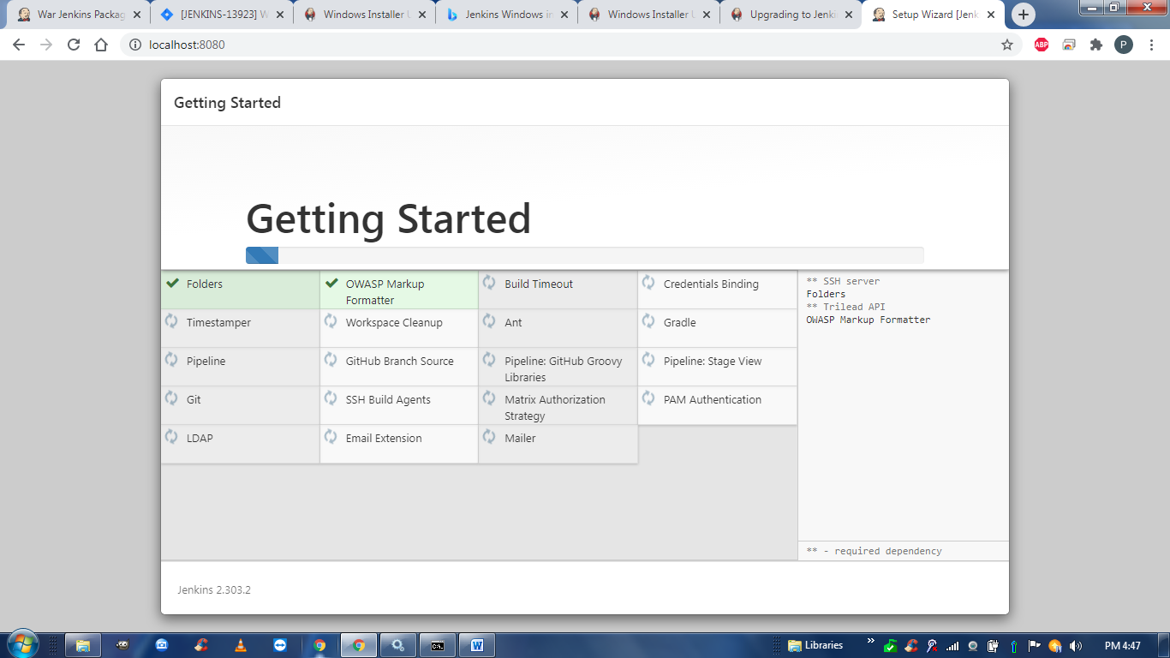

User id , password, name = > **admin**

And email id is **poonam22091983@gmail.com**

