1. Open Windows Task Scheduler.

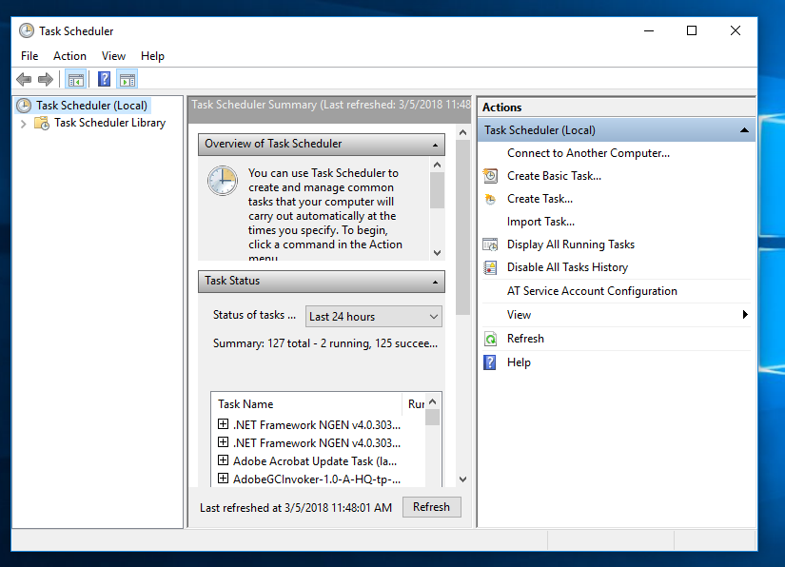

1. Click on Create task.

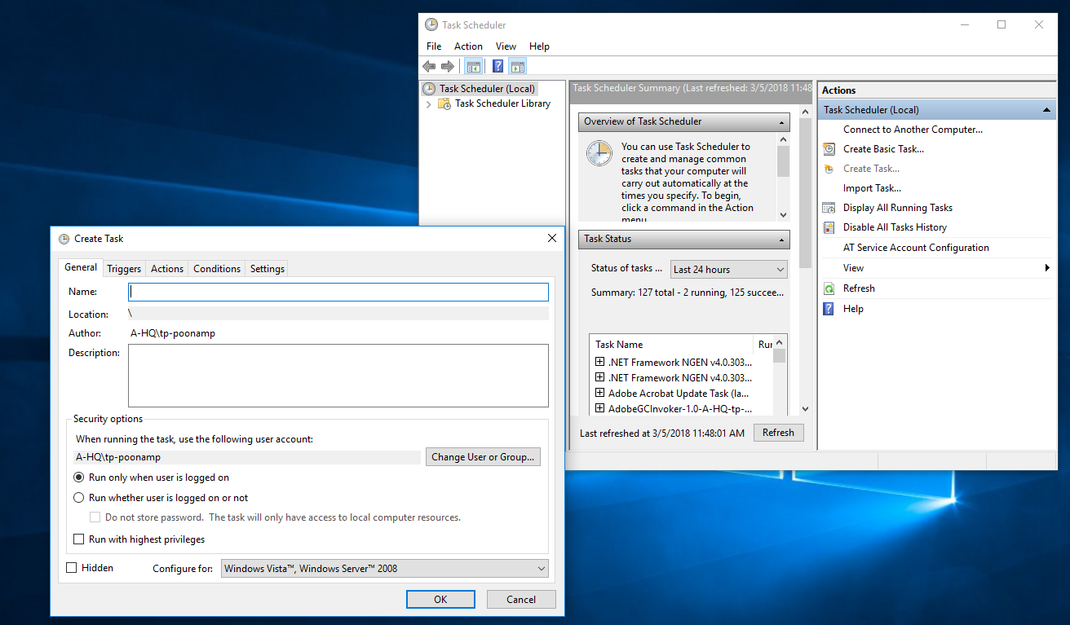

1. In General Tab provide following details.
2. batch Name ActiveDirectoryUsersBatch .
3. Also provide Description.
4. Provide the user or group under which batch job will be running on production.
5. Select “Run whether user is logged on or not”
6. Click OK

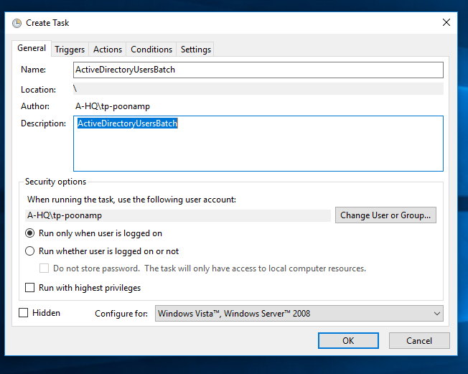

1. In Triggers tab, click on New trigger and provide below details as per below screenshot.
2. For Begin the task, select On a schedule
3. For Settings – Select Daily and provide start date and time as per production port date and time as decided by team.
4. Click OK

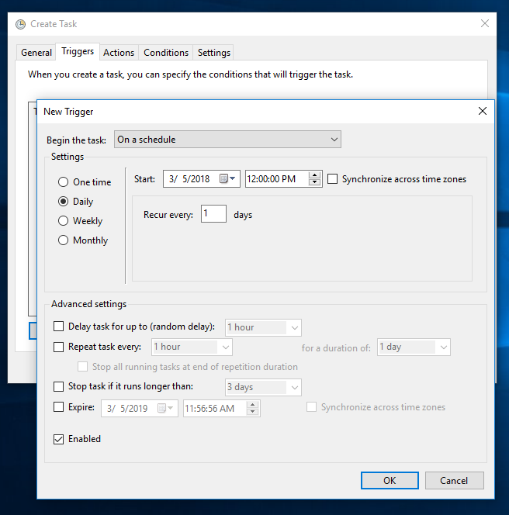

1. In Action Tab, provide below details.
2. Click on New Action.
3. In Action window, Select Start a program for Action.
4. For Settings, Select path of ActiveDirectoryUsersBatch.exe on production by clicking browse button.
5. Click OK

