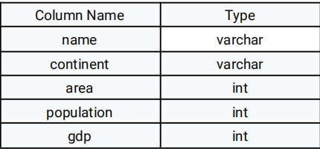

**51.)** name is the primary key column for this table.

Each row of this table gives information about the name of a country, the continent to which it

belongs, its area, the population, and its GDP value.

A country is big if:

● it has an area of at least three million (i.e., 3000000 km2), or

● it has a population of at least twenty-five million (i.e., 25000000).

Write an SQL query to report the name, population, and area of the big countries.

Return the result table in any order.

The query result format is in the following example.

Input:

World table:

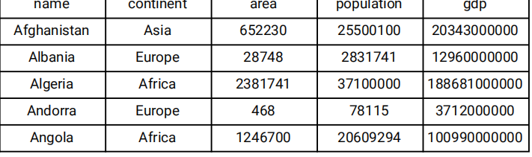

**QUERY:-**

select name,population,area from World where area >=3000000 or population >= 25000000;

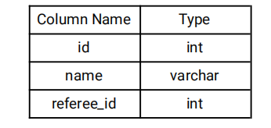

**52.)** id is the primary key column for this table.

Each row of this table indicates the id of a customer, their name, and the id of the customer who

referred them.

Write an SQL query to report the names of the customer that are not referred by the customer with id = 2.

Return the result table in any order.

The query result format is in the following example.

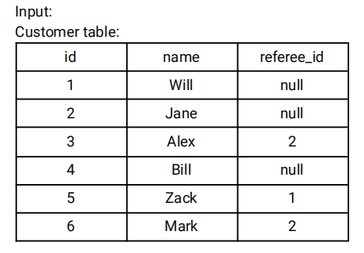

**QUERY:-**

select name from Customer where id<>2 OR id IS NULL;

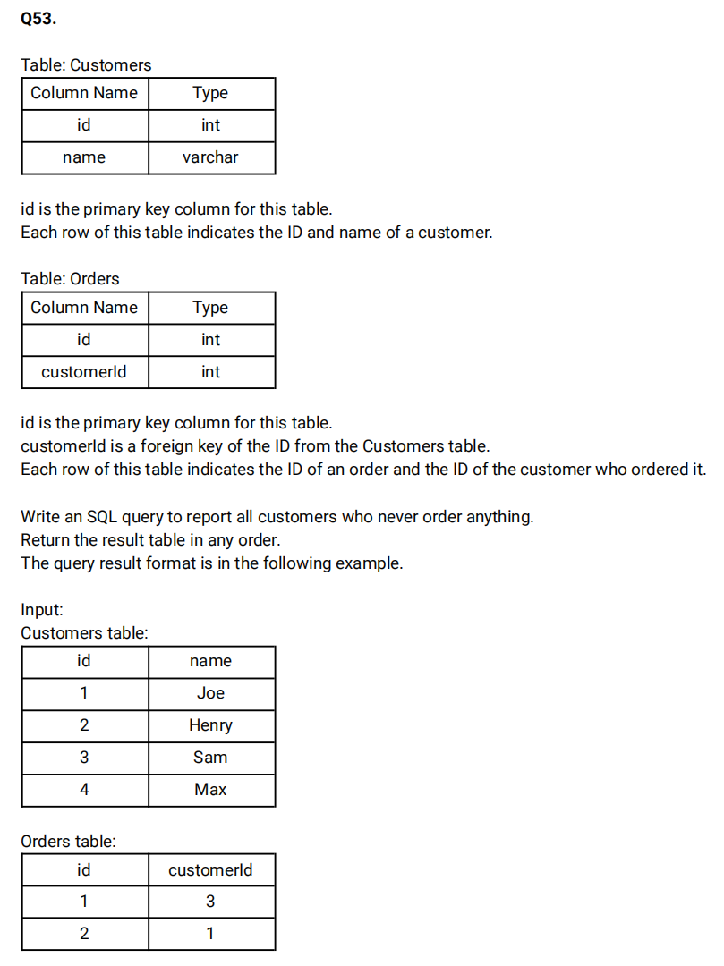

**QUERY:-**

select distinct name from Customers C join orders o where C.id NOT IN(Select customer_id from orders) ;

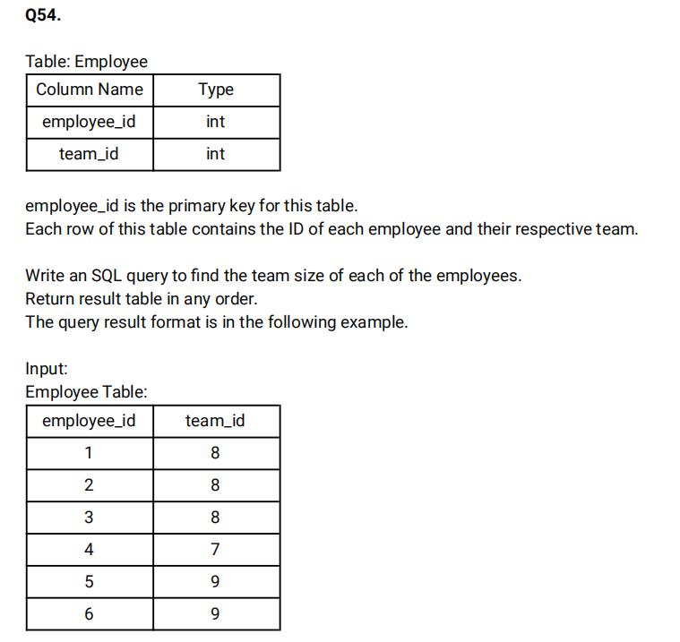

**QUERY:-**

select employee_id, COUNT(team_id) OVER(PARTITION BY team_id) as team_size from employee order by employee_id;

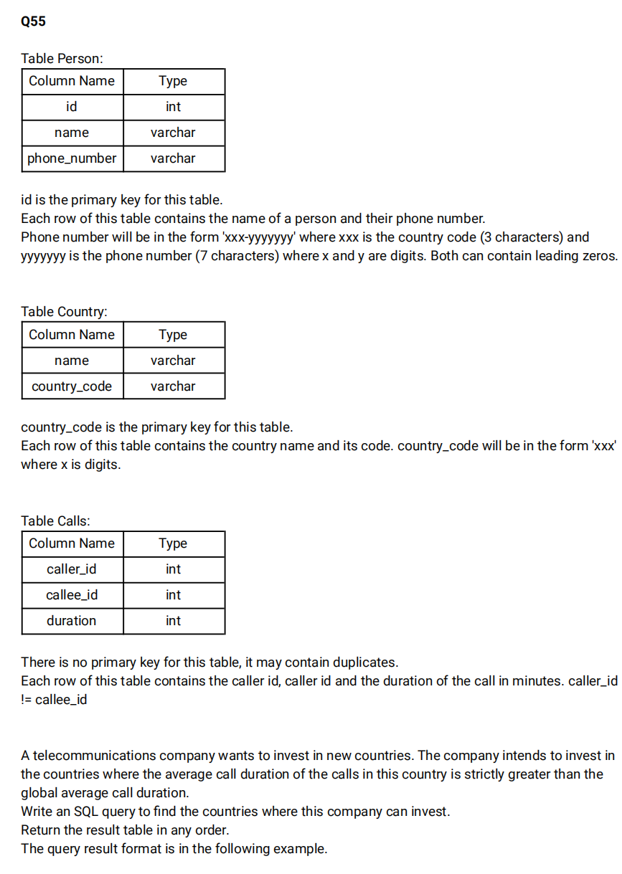

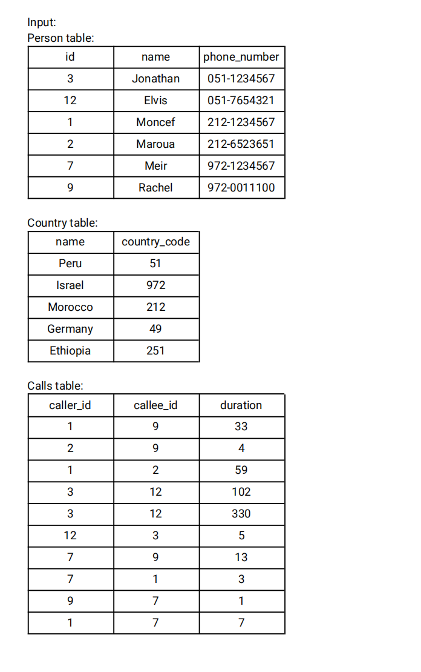

**QUERY:-**

 select c.name as country from person p join country c on SUBSTRING(phone_number,1,3)=c.country_code join calls ca on p.id IN (ca.caller_id,ca.callee_id) group by c.name HAVING AVG(duration)>(select AVG(duration) from calls);

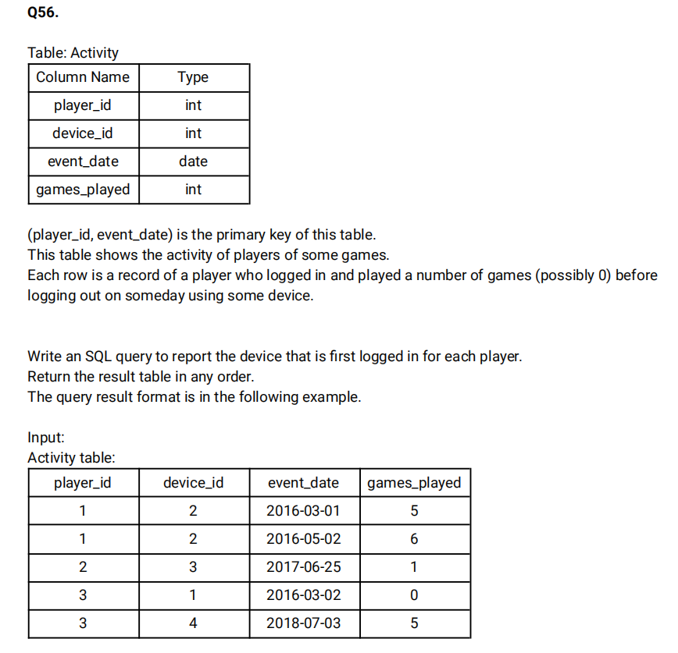

**QUERY:-**

select player_id,device_id FROM (select player_id,device_id, DENSE_RANK() OVER (partition by player_id order by event_date ASC) as cnt from Activity)temp WHERE cnt=1;

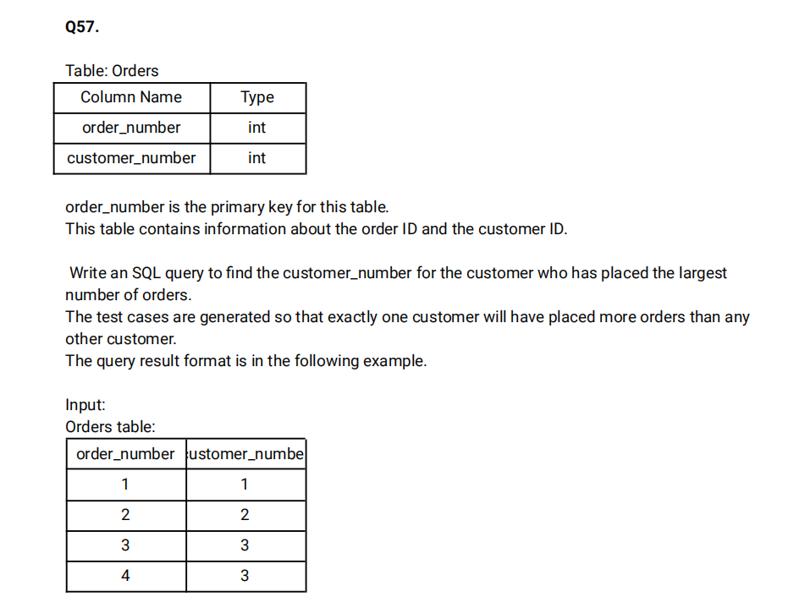

**QUERY:-**

 select customer_number from (select customer_number,count(order_number) as cnt from Orders group by customer_number order by cnt desc limit 1)t;

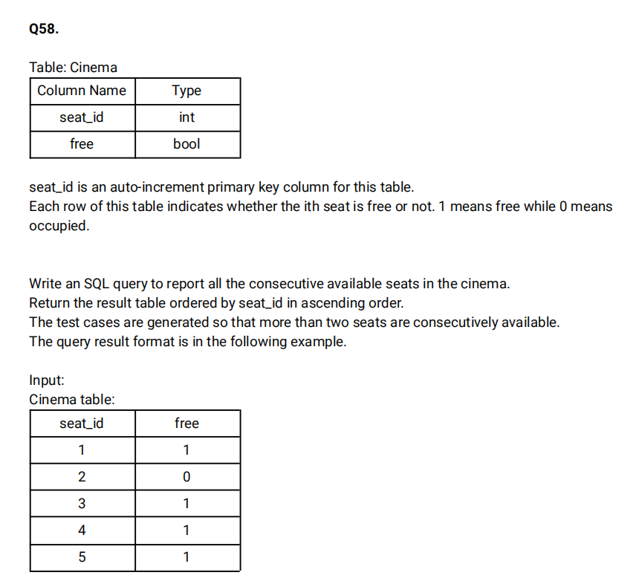

**QUERY:-**

select  s1.seat_id from cinema s1 join cinema s2 on s1.seat_id=s2.seat_id+1 and s1.free <> 0;

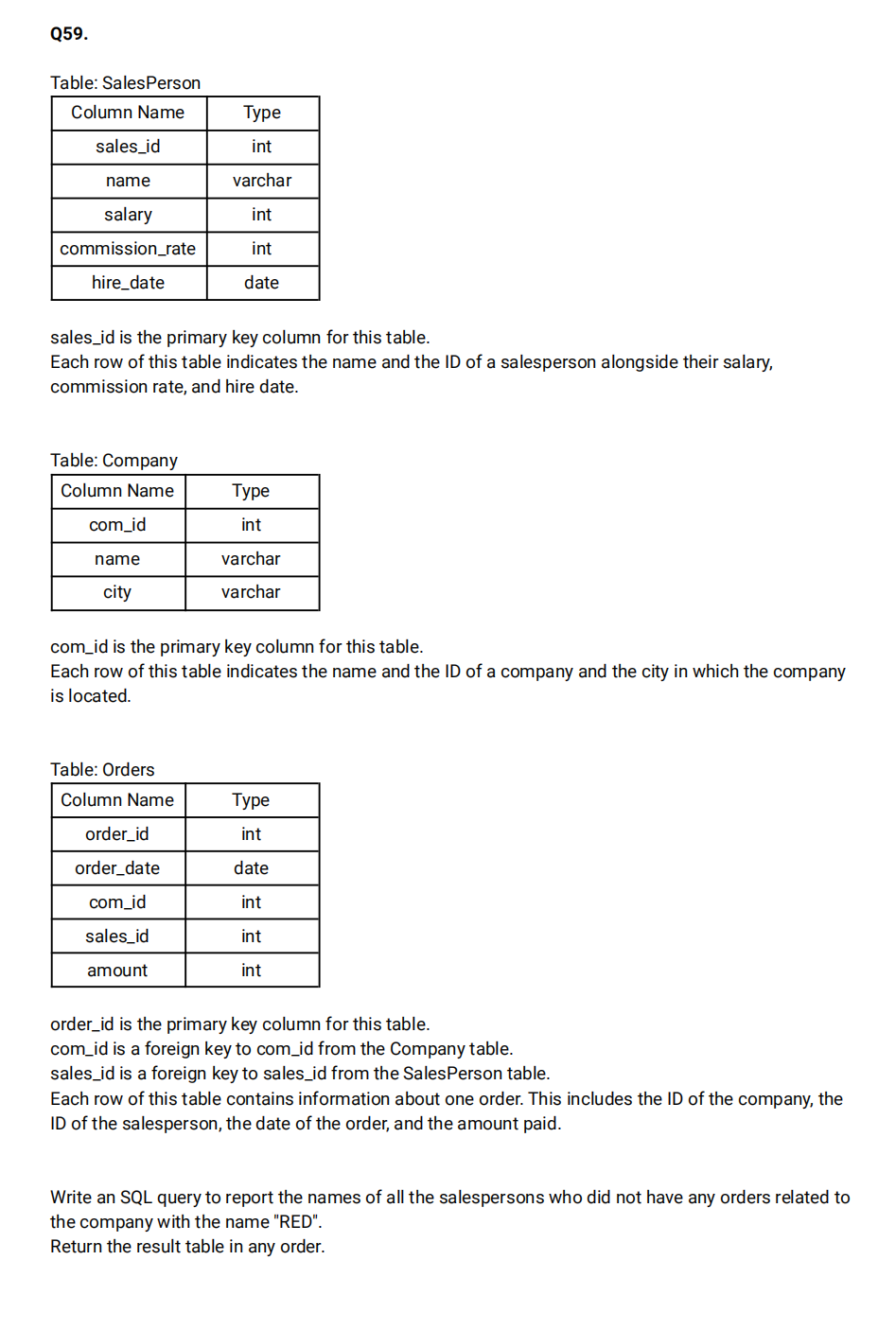

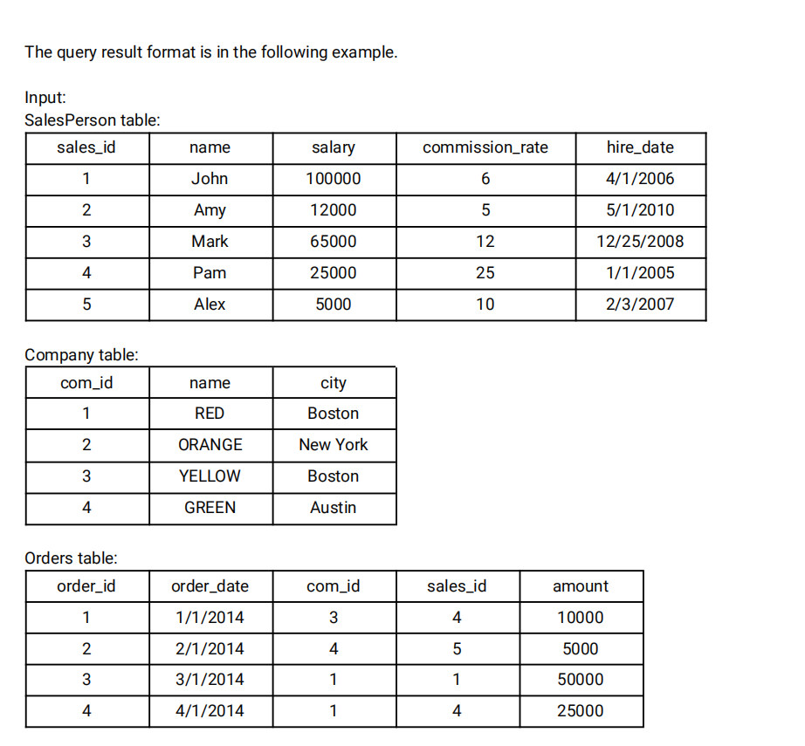

**QUERY:-**

 select s.name from salesperson s where s.sales_id NOT IN (select o.sales_id from Orders o join company c on o.com_id=c.com_id where c.name='Red');

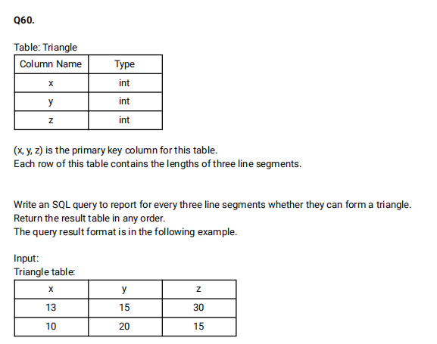

**QUERY:-**

 SELECT x,y,z,CASE

 when (x+y>z AND x+z>y AND y+z>x) then 'Yes'

 else 'No'

 end as triangle FROM Triangle;

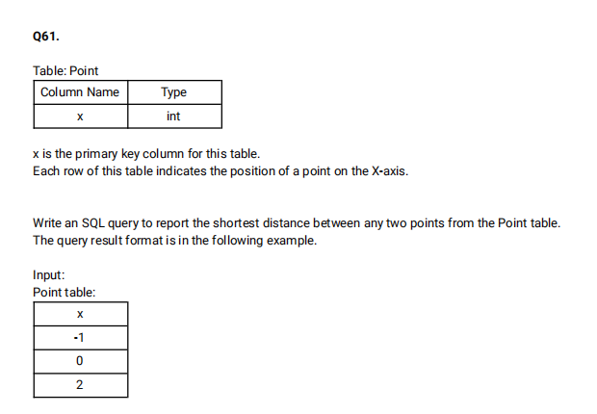

**QUERY:-**

select MIN(shortest) as shortest from (select  LEAD(a.x) OVER(order by a.x) -b.x as shortest from point a join point b on a.x=b.x)c;

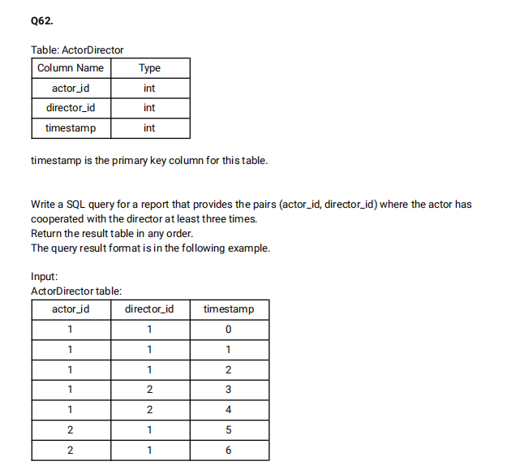

**QUERY:-**

select actor_id,director_id from (select actor_id,director_id,COUNT(timestamp) as cnt from Actordirector group by actor_id,director_id) a where cnt >=3;

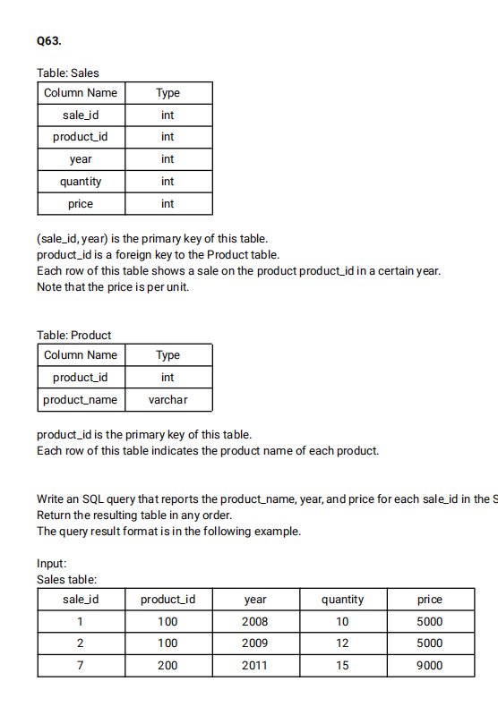

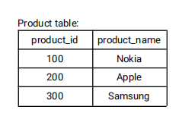

**QUERY:-**

select product_name,year,price from Sales s join product p on s.product_id=p.product_id;

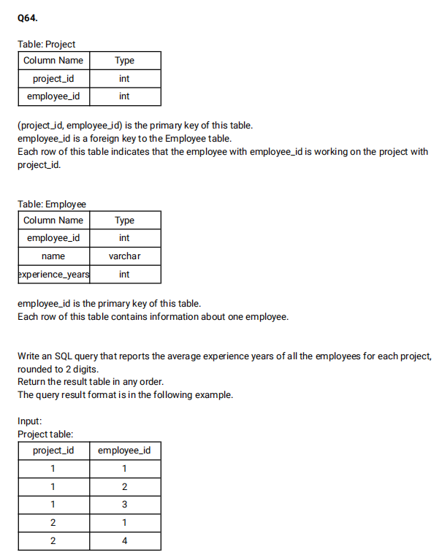

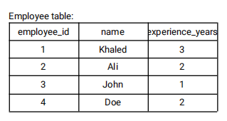

**QUERY:-**

select project_id,Round(AVG(experience_years),2) as average_years from Employee e join project p on e.employee_id=p.employee_id group by project_id;

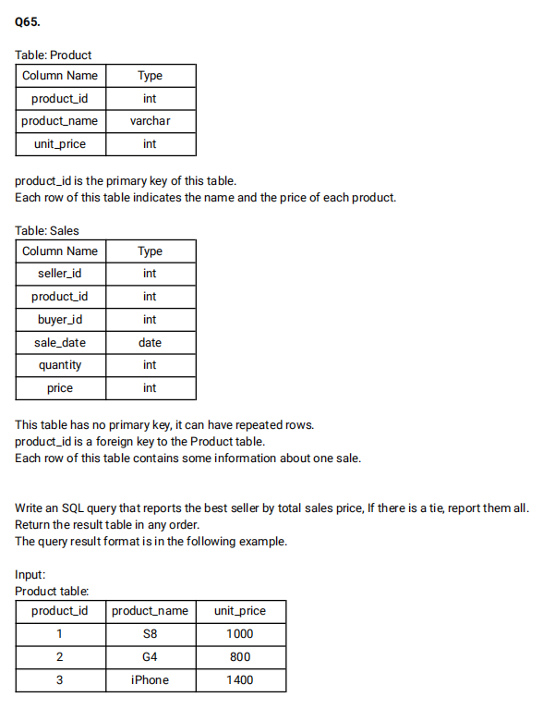

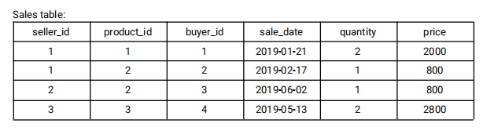

**QUERY:-**

select seller_id from (select seller_id,sum,RANK() over( order by sum desc) as rnk from (select seller_id, SUM(price) as sum from sales s join product p on s.product_id=p.product_id group by seller_id)a)b where rnk=1 ;

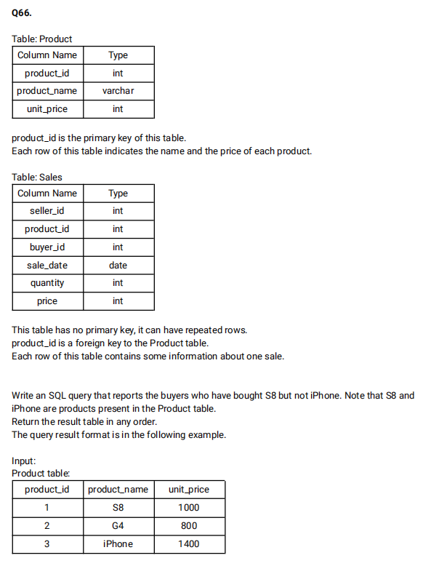

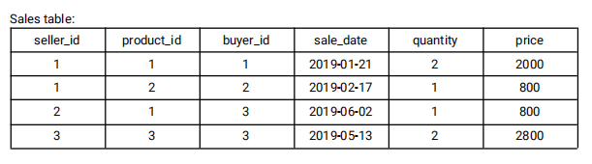

**QUERY:-**

select buyer_id from sales s join product p on s.product_id=p.product_id where p.product_name ='S8' AND p.product_name <> 'iphone';

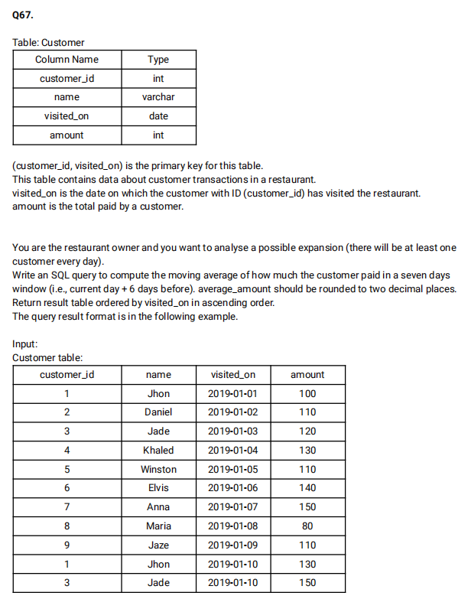

**QUERY:-**

select c1.visited_on, SUM(c1.amount) as amount, round(AVG(c2.amount),2) as average_amount from (select visited_on,sum(amount) as amount from customer group by visited_on)c1 join (select visited_on,sum(amount) as amount from customer group by visited_on)c2 on DATEDIFF(c1.visited_on,c2.visited_on) between 0 and 6 group by c1.visited_on having count(c2.amount)=7 order by c1.visited_on;

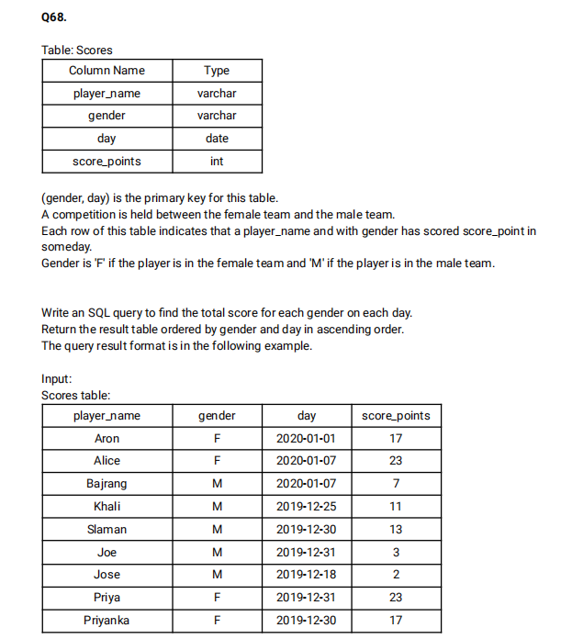

**QUERY:-**

select gender,day,SUM(score_points) over(partition by gender order by gender,day) as total from Scores;

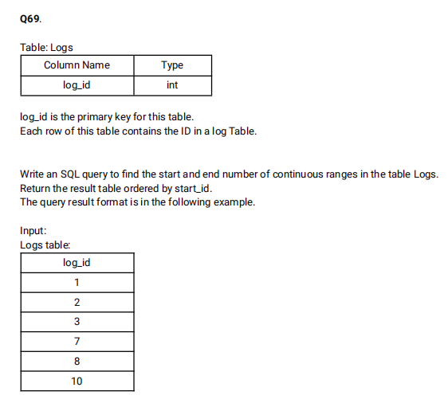

**QUERY:-**

select min(log_id) as start_id,max(log_id) as end_id from (select log_id,rn,log_id-rn as diff from (select log_id, ROW_NUMBER() OVER() as rn from Logs)l1)l2 GROUP BY diff;

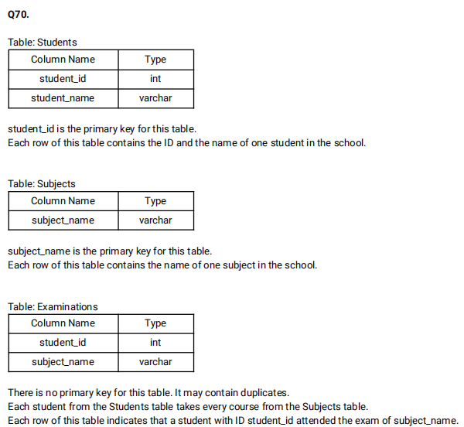

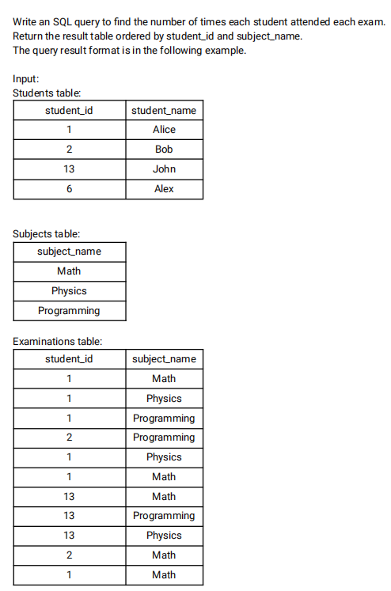

**QUERY:-**

select s.student_id,student_name,s1.subject_name,count(e.student_id) as attended_exams from students s join subjects s1 left join examinations e on e.student_id=s.student_id and s1.subject_name=e.subject_name GROUP BY s.student_id,student_name,subject_name order by s.student_id,subject_name;

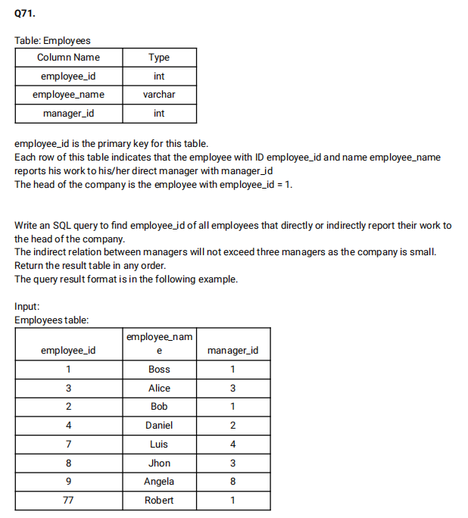

**QUERY:-**

select e4.emp_id  FROM

((select e2.employee_id as e_id,e1.manager_id as m_id from Employees e1 join Employees e2 where e2.manager_id=e1.employee_id and e2.employee_id <>1)e3

  RIGHT join

(select e2.employee_id as emp_id,e1.manager_id as mng_id from Employees e1 join Employees e2 where e2.manager_id=e1.employee_id and e2.employee_id <>1)e4

 ON e4.mng_id=e3.e_id) where m_id is null or m_id=1;

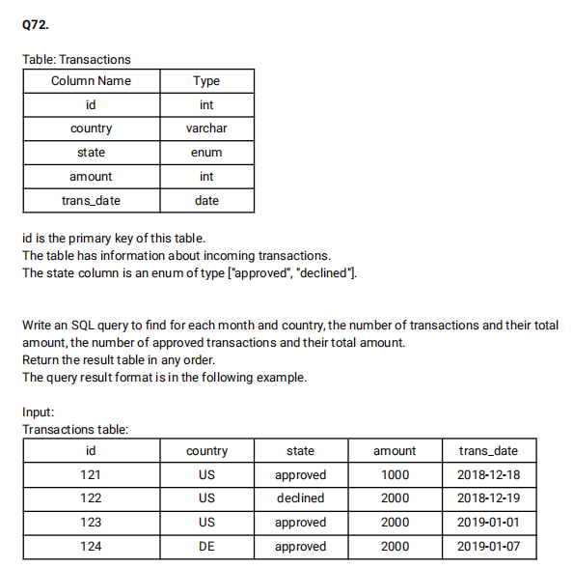

**QUERY:-**

select EXTRACT(YEAR_MONTH from trans_date) as month,country,count(amount) as trans_count,sum(case when state='approved' then 1 else 0 end) as approved_count,sum(amount) as trans_total_amount, sum(case when state='approved' then amount else 0 end)as approved_amount from Transactions GROUP BY month,country

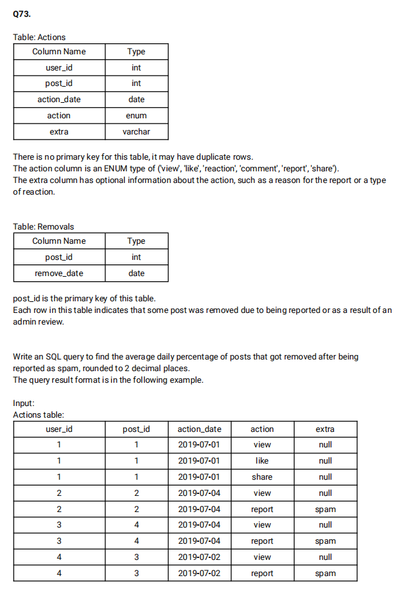

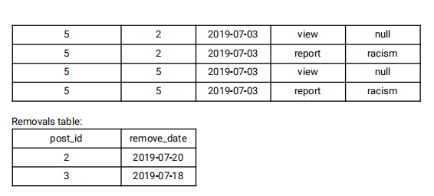

**QUERY:-**

select ROUND(AVG(cnt1),2) as avg_daily_percent from (select (count(b.post_id)*100)/(count(a.post_id)) as cnt1 from Actions a left join removals b on a.post_id=b.post_id where extra='spam' group by action_date)c;

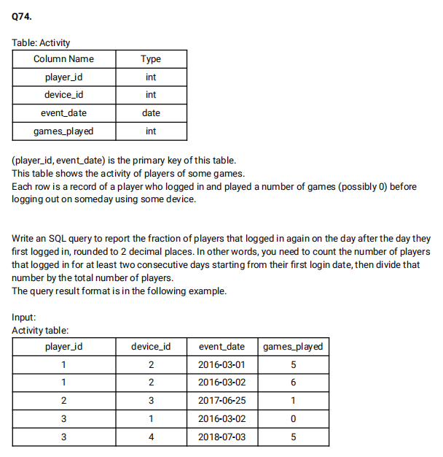

**QUERY:-**

select ROUND(count(distinct b.player_id)/count(distinct a.player_id),2) as fraction from Activity a left join Activity b on b.player_id=a.player_id and a.device_id=b.device_id and DATEDIFF(a.event_date,b.event_date)<>0

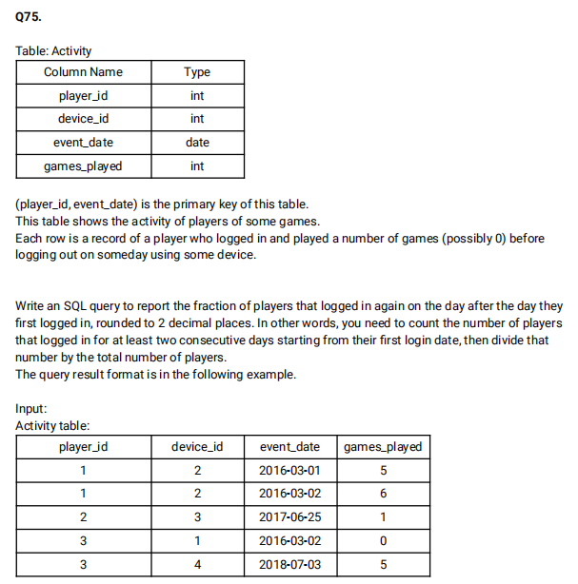

**QUERY:-**

select ROUND(count(distinct b.player_id)/count(distinct a.player_id),2) as fraction from Activity a left join Activity b on b.player_id=a.player_id and a.device_id=b.device_id and DATEDIFF(a.event_date,b.event_date)<>0;

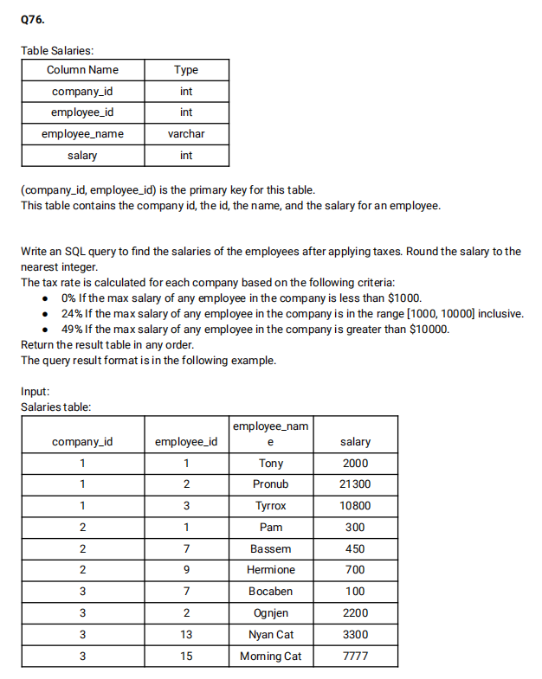

**QUERY:-**

select s1.company_id,s1.employee_id,s1.employee_name, ROUND(CASE when s2.max_salary BETWEEN 1000 AND 10000 then 0.76*salary when s2.max_salary>10000 then 0.51*salary

else salary end) as salary from salaries s1 join (select company_id,MAX(salary) as max_salary from salaries s2 group by company_id)s2 on s1.company_id=s2.company_id order by company_id;

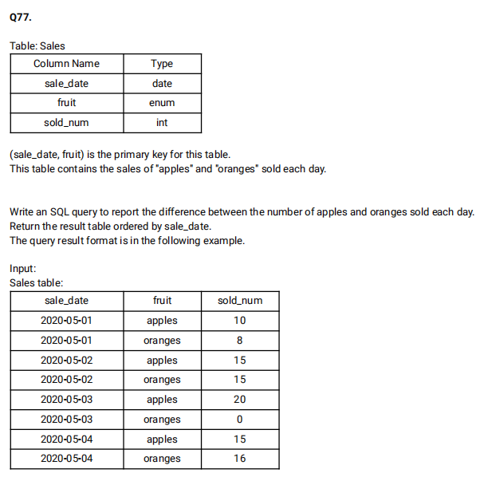

**QUERY:-**

select sale_date ,(sum(case when fruit='apples' then sold_num else 0 end) - sum(case when fruit='oranges' then sold_num else 0 end)) as diff from Sales GROUP BY sale_date;

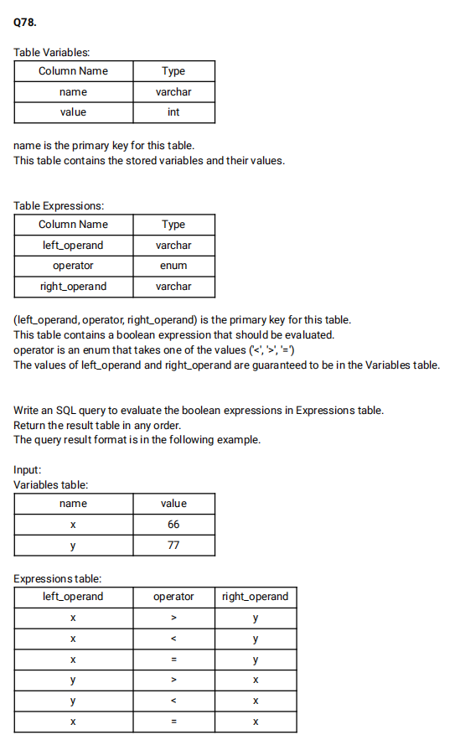

**QUERY:-**

select left_operand,operator,right_operand,

(case when operator='<' then if(v1.value<v2.value,'true','false')

when operator='>' then if(v1.value>v2.value,'true','false')

else if(v1.value=v2.value,'true','false') end) as value from Expressions e left join Variables v1 on e.left_operand=v1.name

left join Variables v2 on e.right_operand=v2.name;

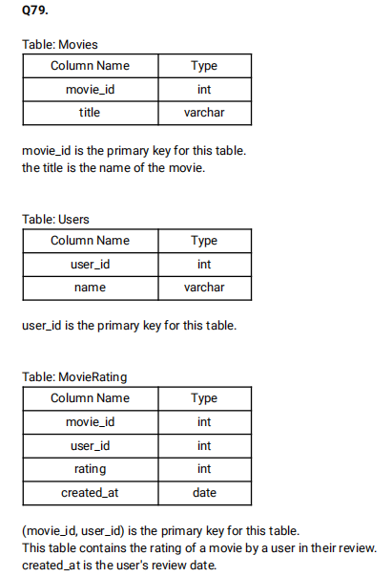

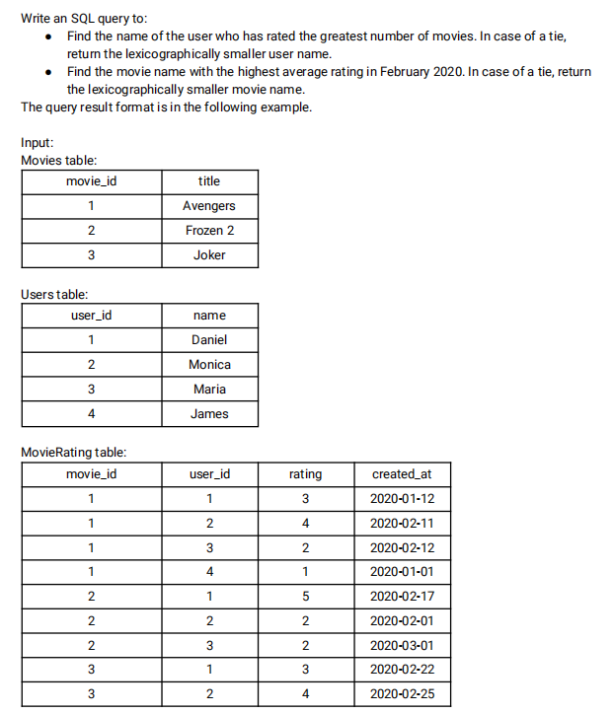

**QUERY:-**

select a.name as results from (select u.name,count(mr.rating) as cnt from Users u join movierating mr on mr.user_id=u.user_id group by u.name order by cnt desc,u.name limit 1)a

union ALL

select b.title as results from (select title,AVG(mr.rating) as avg from movies m join movierating mr on mr.movie_id=m.movie_id where Extract(YEAR_MONTH from created_at)='202002' group by title order by avg desc,title limit 1)b;

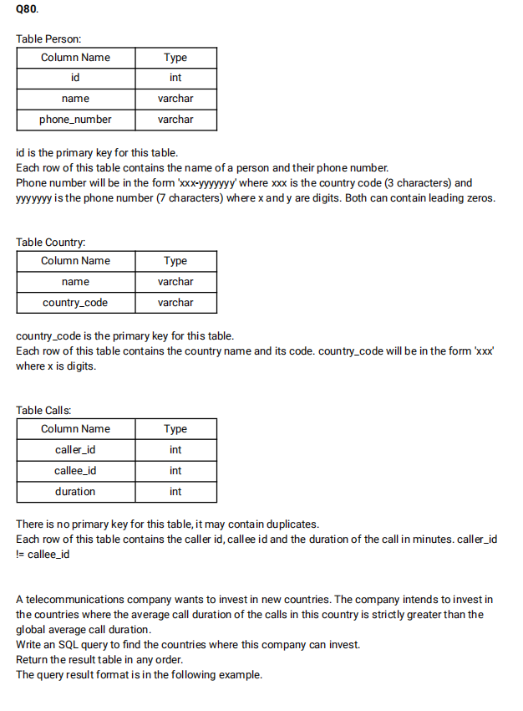

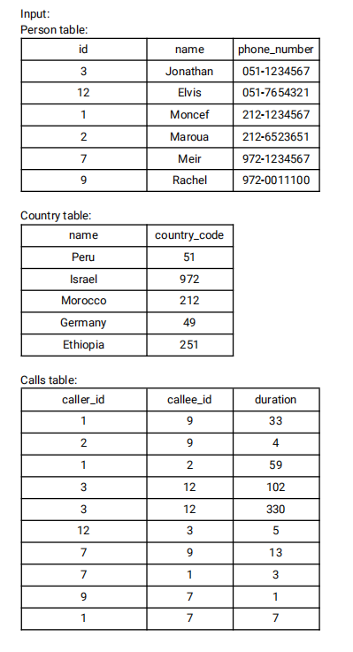

**QUERY:-**

 select c.name as country from person p join country c on SUBSTRING(phone_number,1,3)=c.country_code join calls ca on p.id IN (ca.caller_id,ca.callee_id) group by c.name HAVING AVG(duration)>(select AVG(duration) from calls);

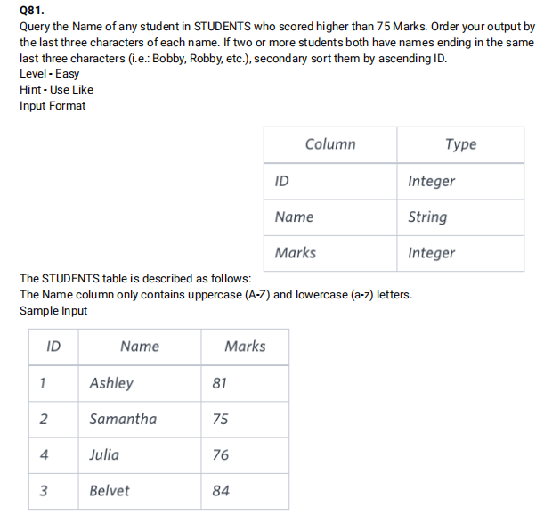

**QUERY:-**

select name from Students where marks>75 order by right(name,3),id;

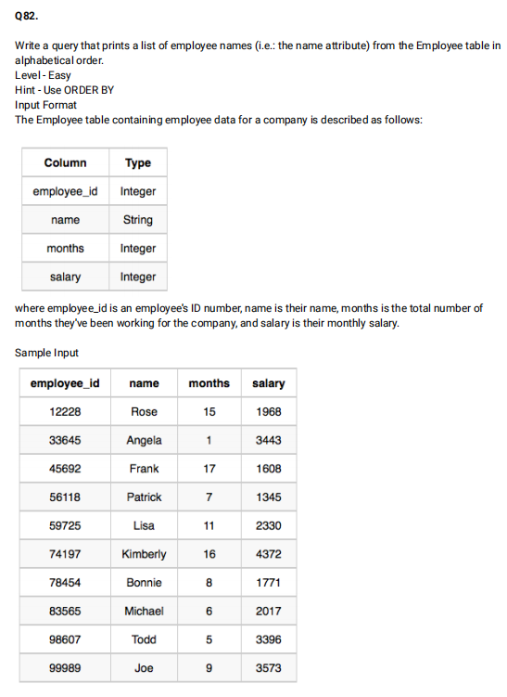

**QUERY:-**

select name from Employees order by name;

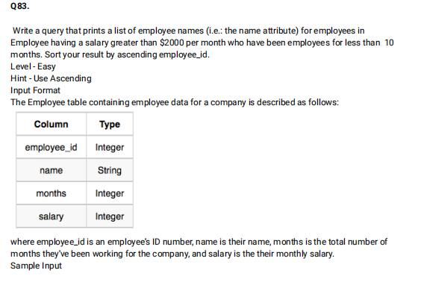

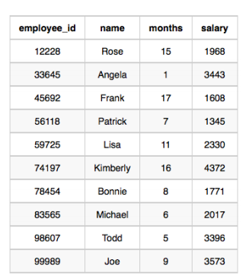

**QUERY:-**

select name from Employees where months<10 and salary >2000;



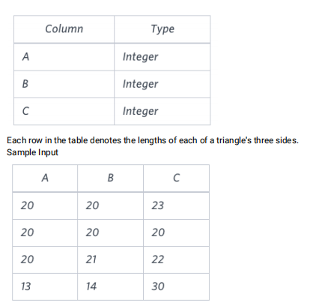

**QUERY:-**

select IF((A+B<C or B+C<A or A+C<B),'Not a Triangle',(case when A=B=C then 'Equilateral' when A<>B and B<>C then 'Scalene' else 'Isoceles' end)) as Type from Triangle;

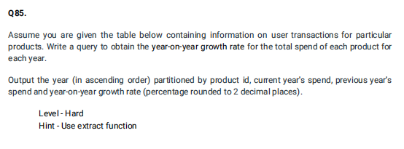

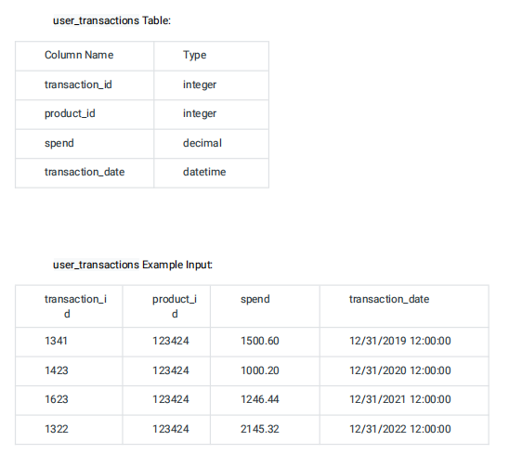

**QUERY:-**

select year,curr_year_spend,prev_year_spend,ROUND((((curr_year_spend-prev_year_spend)*100)/prev_year_spend),2) as yoy_rate from (select Extract(year from transaction_date) as year,spend as curr_year_spend,lag(spend) over(order by EXTRACT(year from transaction_date)) as prev_year_spend from user_transactions order by year)a;

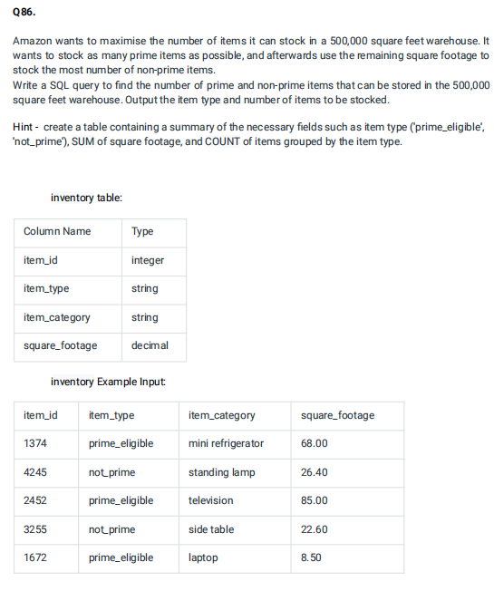

**QUERY:-**

select item_type,count(item_id) as item_count from Inventory where square_footage<500000 GROUP BY item_type;

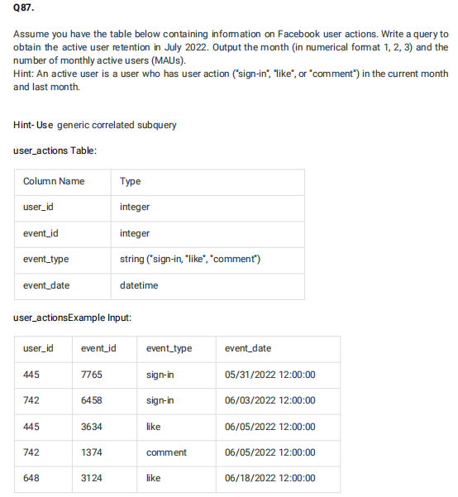

**QUERY:-**

select EXTRACT(MONTH from event_date) as month,sum(case when event_type='like' or event_type='comment' or event_type='sign-in' then 1 else 0 end) as monthly_active_users from user_actions group by month;

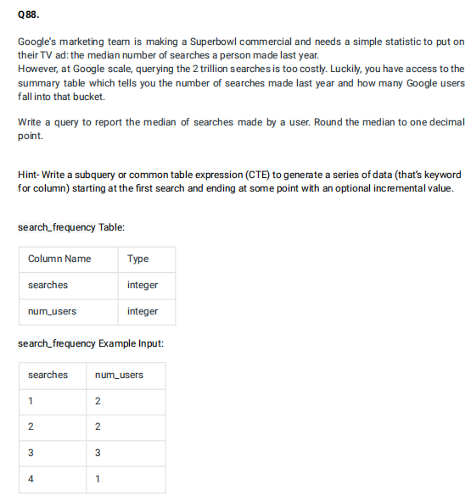

**QUERY:-**

select AVG(searches) from (select searches, ROW_NUMBER() OVER(order by searches) as rn_asc,ROW_NUMBER() OVER(order by searches desc) rn_desc from search_frequency order by searches)a where ABS(rn_asc-rn_desc)<=1;

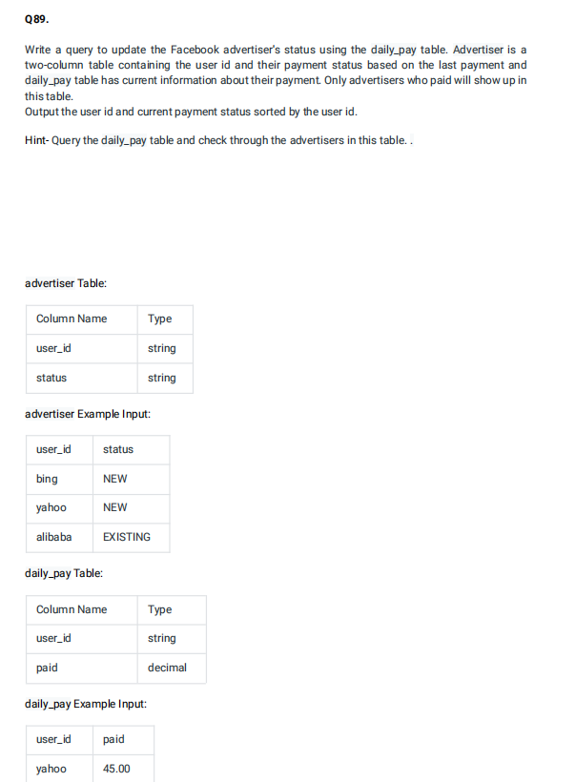

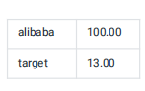

**QUERY:-**

WITH pay_status as

 ((select a.user_id, a.status ,paid from advertiser a left join daily_pay d on d.user_id=a.user_id)

UNION

(select d.user_id,a.status,paid from daily_pay d left join advertiser a on d.user_id=a.user_id))

select user_id, (case when paid is NULL then 'Churn'

when STATUS ='Churn' and paid is not NULL then 'Resurrect'

when STATUS <> 'Churn' and paid is NOT NULL then 'Existing'

when STATUS is NULL then 'NEW' end) as new_status

FROM pay_status;

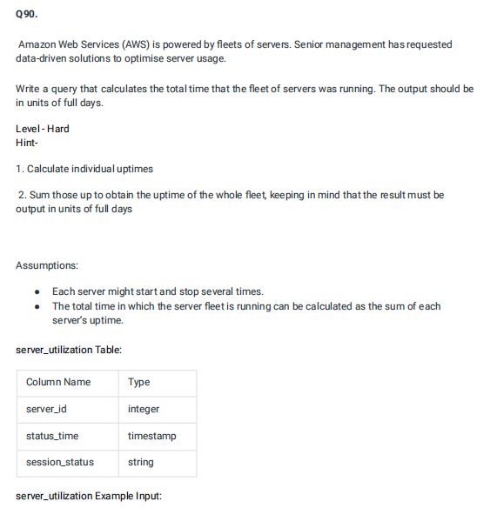

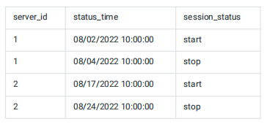

**QUERY:-**

select sum(diff) as total_uptime_days from (select  s2.server_id,DATEDIFF(s2.status_time,s1.status_time) as diff from server_utilization s1 join server_utilization s2 on s2.server_id=s1.server_id where s2.session_status='stop')a;

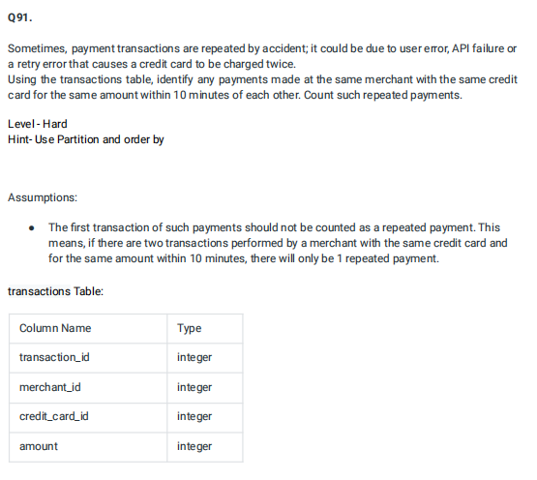

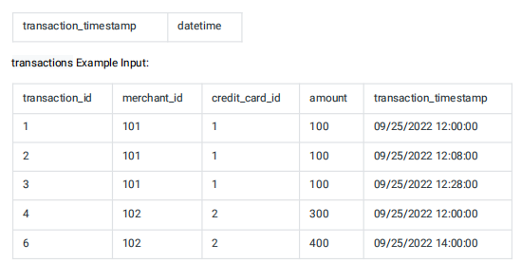

**QUERY:-**

select count(distinct amount) as payment_count from (select  t2.transaction_id,t2.amount,TIMESTAMPDIFF(MINUTE,t2.transaction_timestamp,t1.transaction_timestamp) as t from transactions t1 join transactions t2 WHERE t1.transaction_id <> t2.transaction_id AND t1.merchant_id=t2.merchant_id AND t1.credit_card_id=t2.credit_card_id AND t1.amount=t2.amount)a where abs(t)<=10;

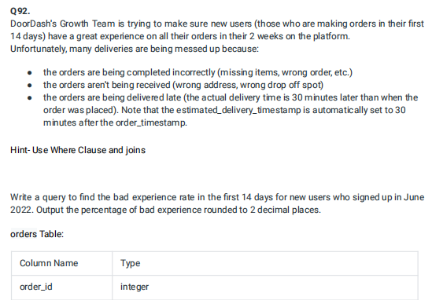

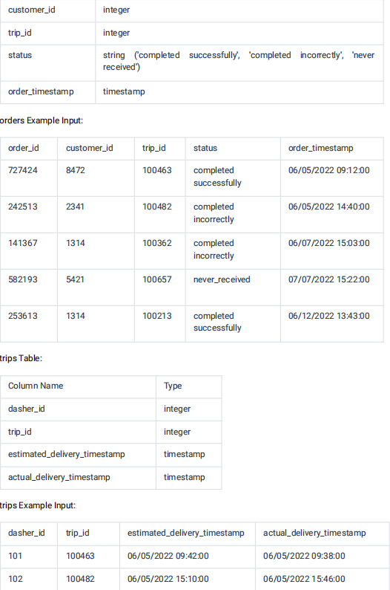

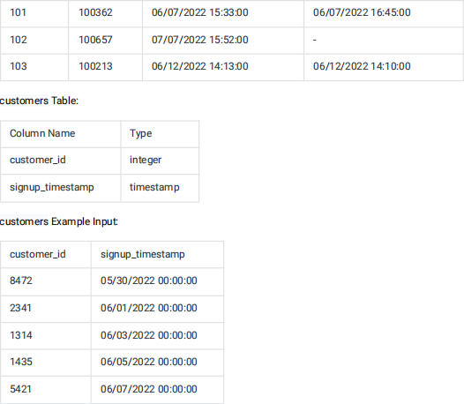

**QUERY:-**

select (((cnt-good_delivery)*100)/cnt) as bad_pct from (select COUNT(a.trip_id) as cnt,sum(case when a.status='completed successfully' AND TIMESTAMPDIFF(MINUTE,estimated_delivery_timestamp,actual_delivery_timestamp)>=0 then 1 else 0 end) as good_delivery from orders a left join trips b on b.trip_id=a.trip_id)a;

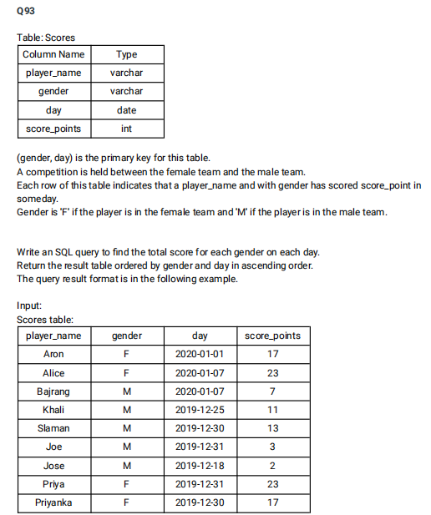

**QUERY:-**

 select gender,day,SUM(score_points) over(partition by gender order by gender,day) as total from Scores;

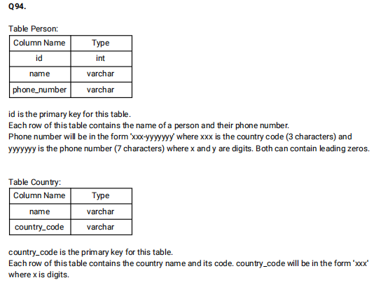

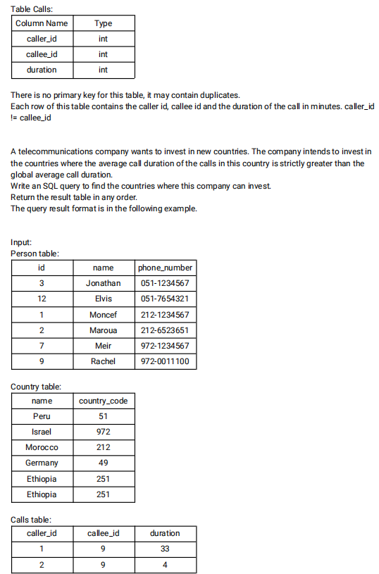

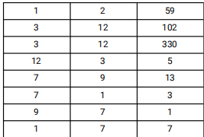

**QUERY:-**

 select c.name as country from person p join country c on SUBSTRING(phone_number,1,3)=c.country_code join calls ca on p.id IN (ca.caller_id,ca.callee_id) group by c.name HAVING AVG(duration)>(select AVG(duration) from calls)

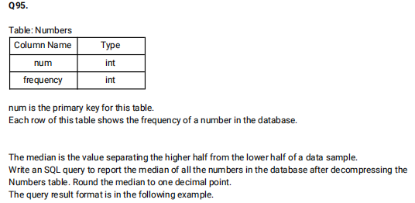

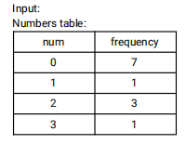

**QUERY:-**

with cte as(

  select * from numbers

  union all

  select num, freq - 1

  from cte where freq > 1

), cte2 as(

  select *, rn = row_number() over(order by num), cn = count(1) over()

  from cte

)

select avg(num) from cte2

where rn between cn*1.0/2 and cn*1.0/2 + 1

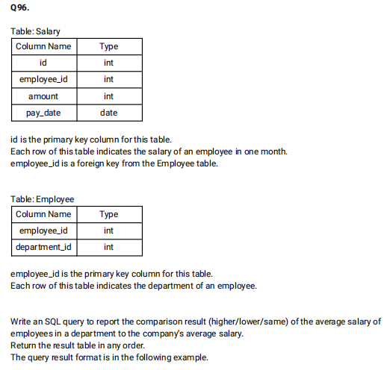

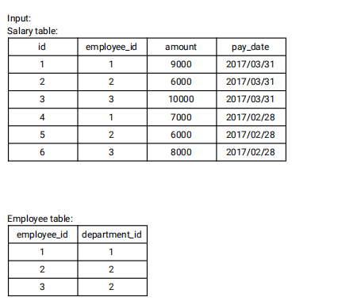

**QUERY:-**

select dept_salary.pay_month,dept_salary.department_id,(case when dept_avg>comp_avg then 'Higher' when dept_avg<comp_avg then 'Lower' else 'Same' end) as comparison  from ((select e.department_id,EXTRACT(YEAR_MONTH from pay_date) as pay_month,AVG(amount) as dept_avg from Salary s join Employee e on e.employee_id=s.employee_id group by e.department_id,pay_month) as dept_salary join

(select AVG(amount) as comp_avg,EXTRACT(year_month from pay_date) as pay_month from Salary GROUP BY pay_month) as comp_salary on dept_salary.pay_month=comp_salary.pay_month) order by dept_salary.department_id;

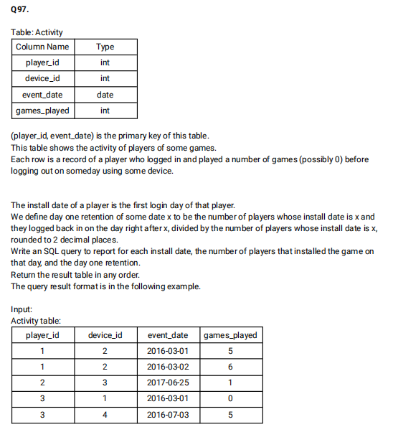

**QUERY:-**

select a.install_date,count(a.install_date) as installs,ROUND(count(b.event_date)/count(*),2) from (select player_id,min(event_date) as install_date from Activity GROUP BY player_id)a left join Activity b on DATE_ADD(a.install_date, INTERVAL 1 DAY)=b.event_date AND a.player_id=b.player_id group by a.install_date order by a.install_date;

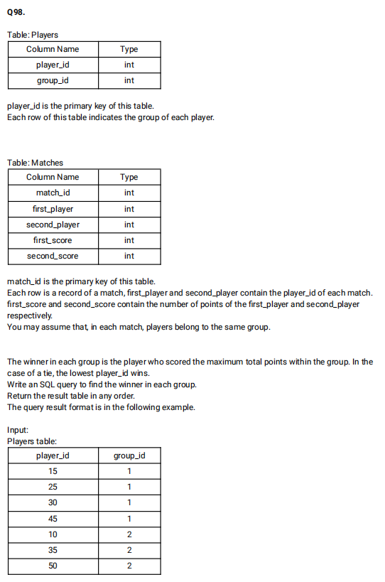

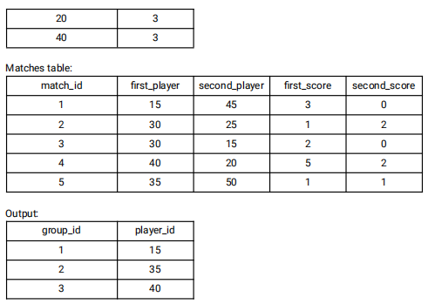

**QUERY:-**

SELECT group_id,player_id

FROM   (SELECT p.group_id,ps.player_id,  Sum(ps.score) AS score   FROM players p INNER JOIN (SELECT first_player AS player_id,  first_score  AS score  FROM   matches

  UNION ALL

SELECT second_player AS player_id, second_score  AS score FROM   matches) ps  ON  p.player_id = ps.player_id   GROUP  BY ps.player_id  ORDER  BY group_id, score DESC, player_id) top_scores

GROUP  BY group_id;

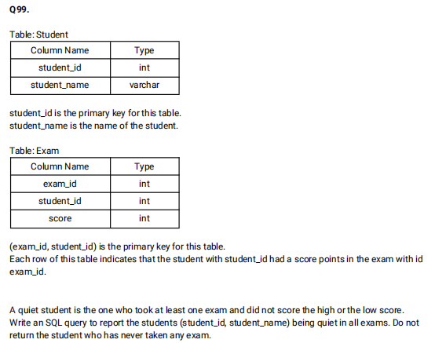

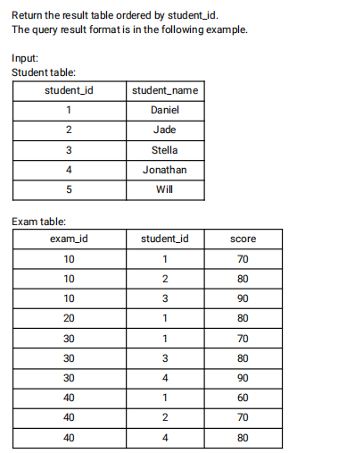

**QUERY:-**

select distinct s.student_id,s.student_name

from Student s inner join Exam e

on s.student_id = e.student_id

where s.student_id not in (select e1.student_id from Exam as e1 inner join (select exam_id, min(score) as min_score, max(score) as max_score from Exam group by exam_id) as e2 on e1.exam_id = e2.exam_id where e1.score = e2.min_score or e1.score = e2.max_score) order by student_id

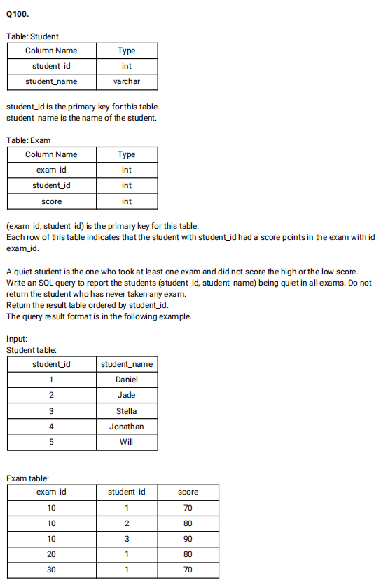

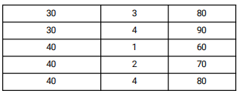

**QUERY:-**

select distinct s.student_id,s.student_name

from Student s inner join Exam e

on s.student_id = e.student_id

where s.student_id not in (select e1.student_id from Exam as e1 inner join (select exam_id, min(score) as min_score, max(score) as max_score from Exam group by exam_id) as e2 on e1.exam_id = e2.exam_id where e1.score = e2.min_score or e1.score = e2.max_score) order by student_id;