1. SELECT TOPIC

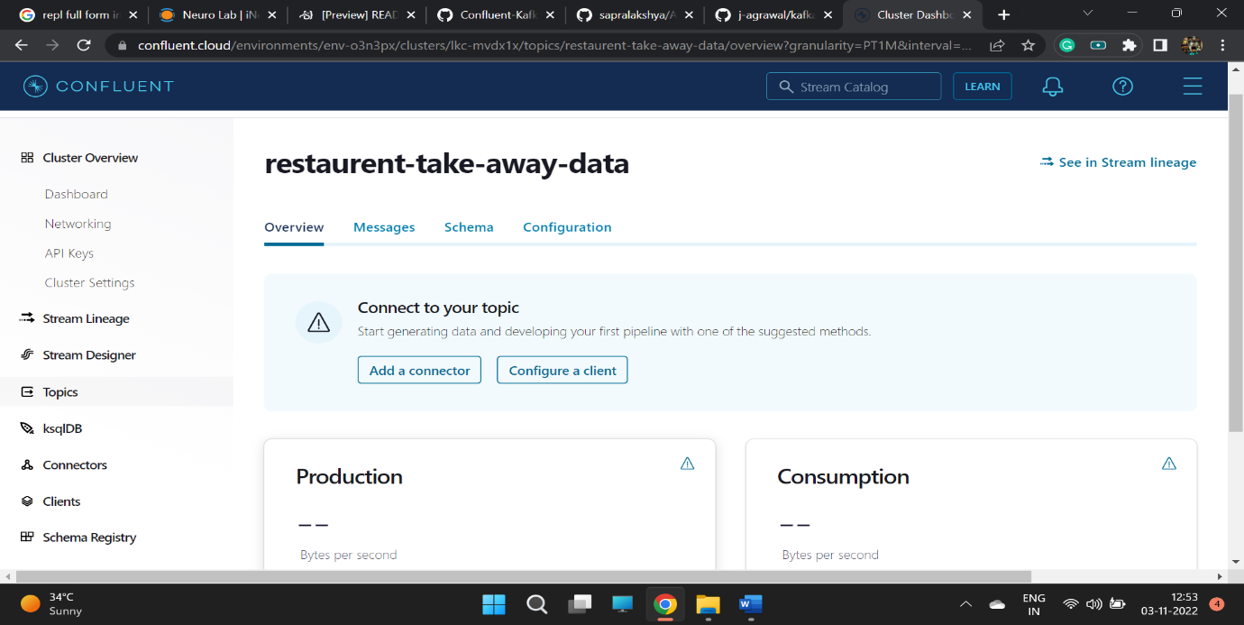

1. Click on Schema

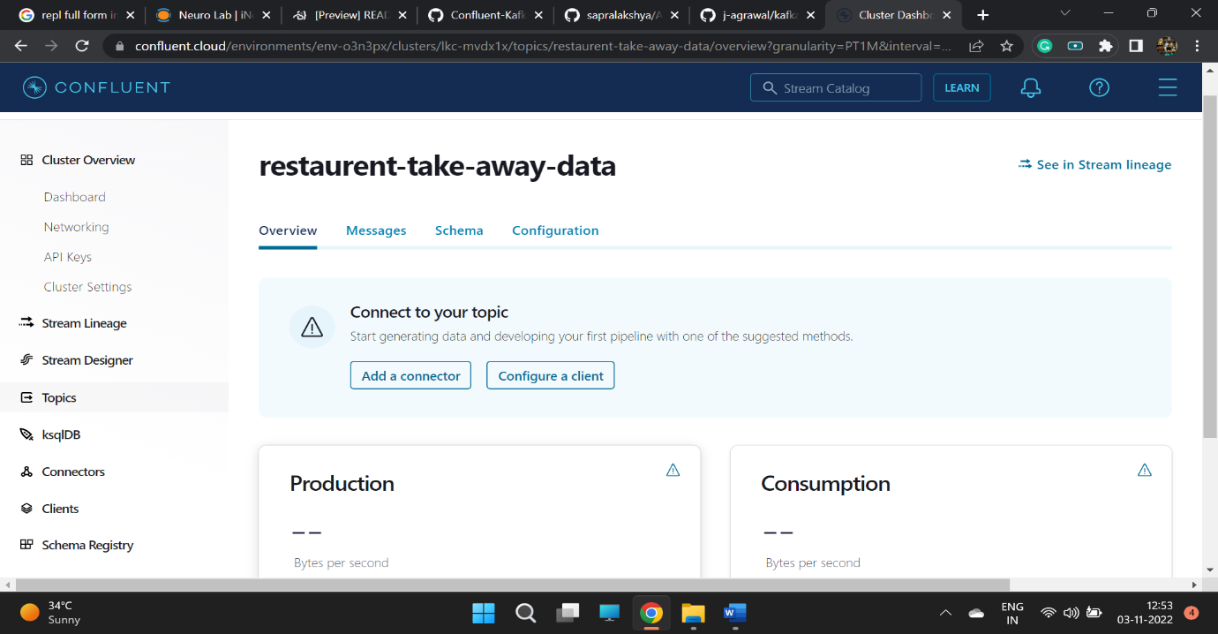

1. Store schema for Value

Select Value

Click Set a Schema

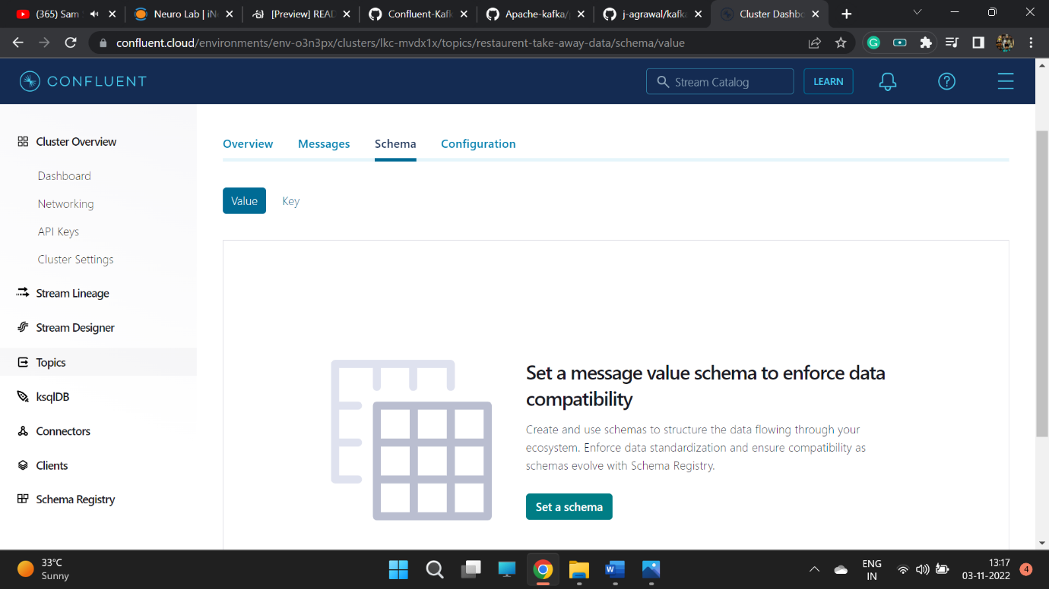

1. Select Json Schema

Insert the json schema code

Click validate

Click Create

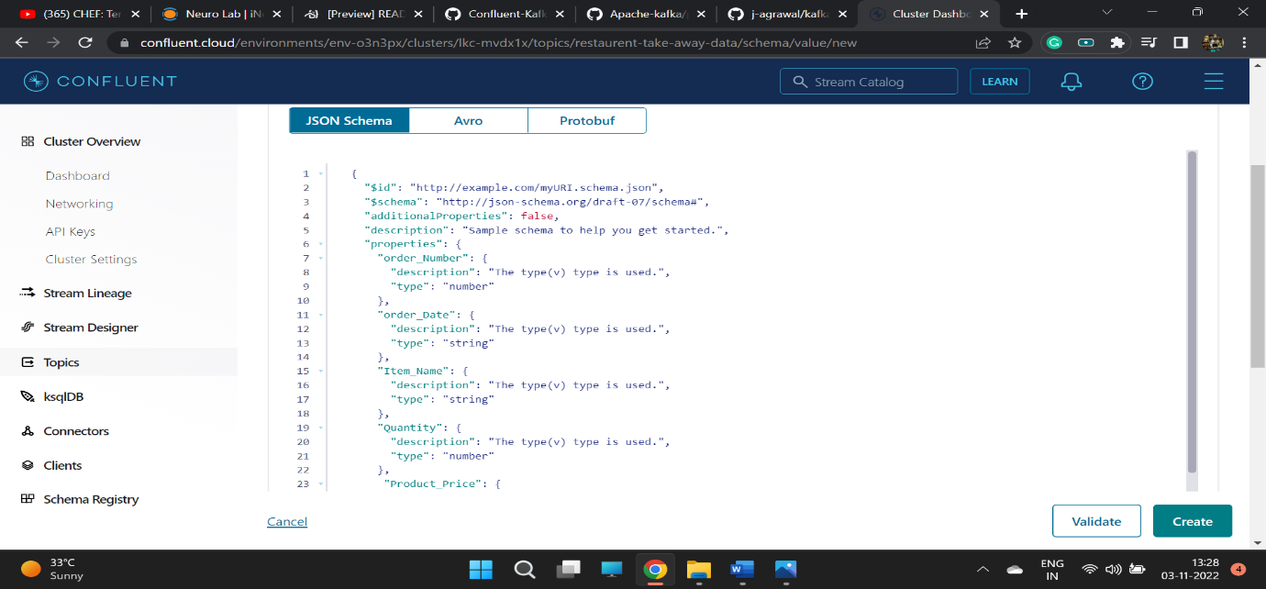

1. Schema for Value is created now

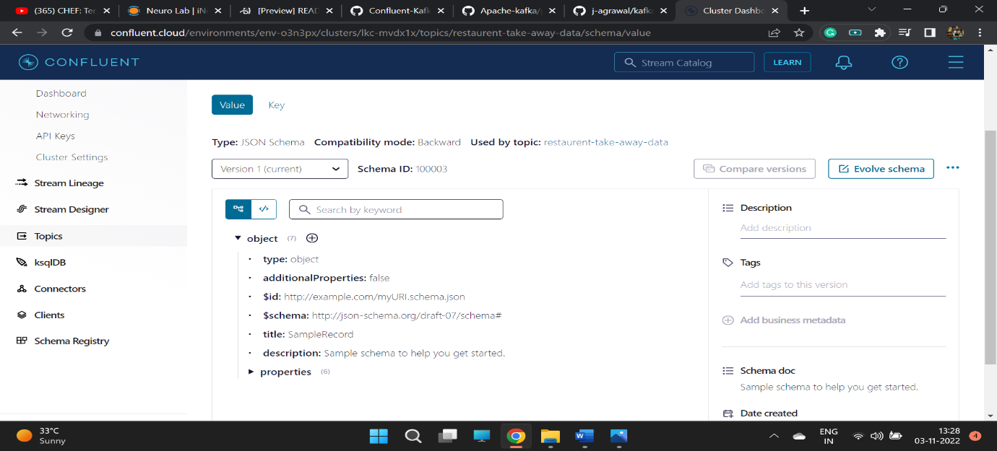

1. Store schema for key

Select key

Click Set a Schema

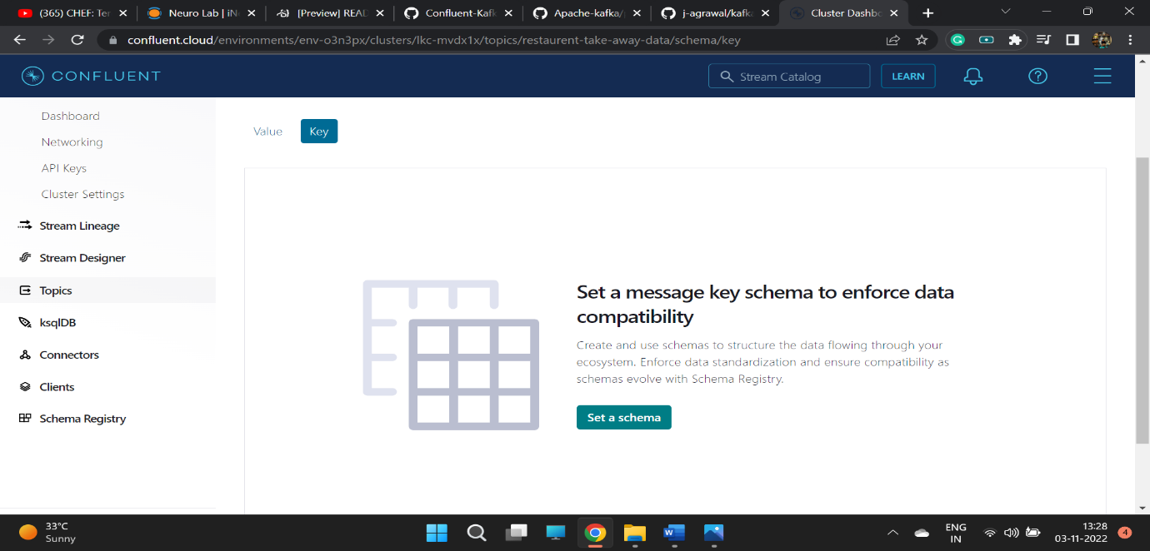

1. Select Json Schema

Insert the json schema code

Click validate

Click Create

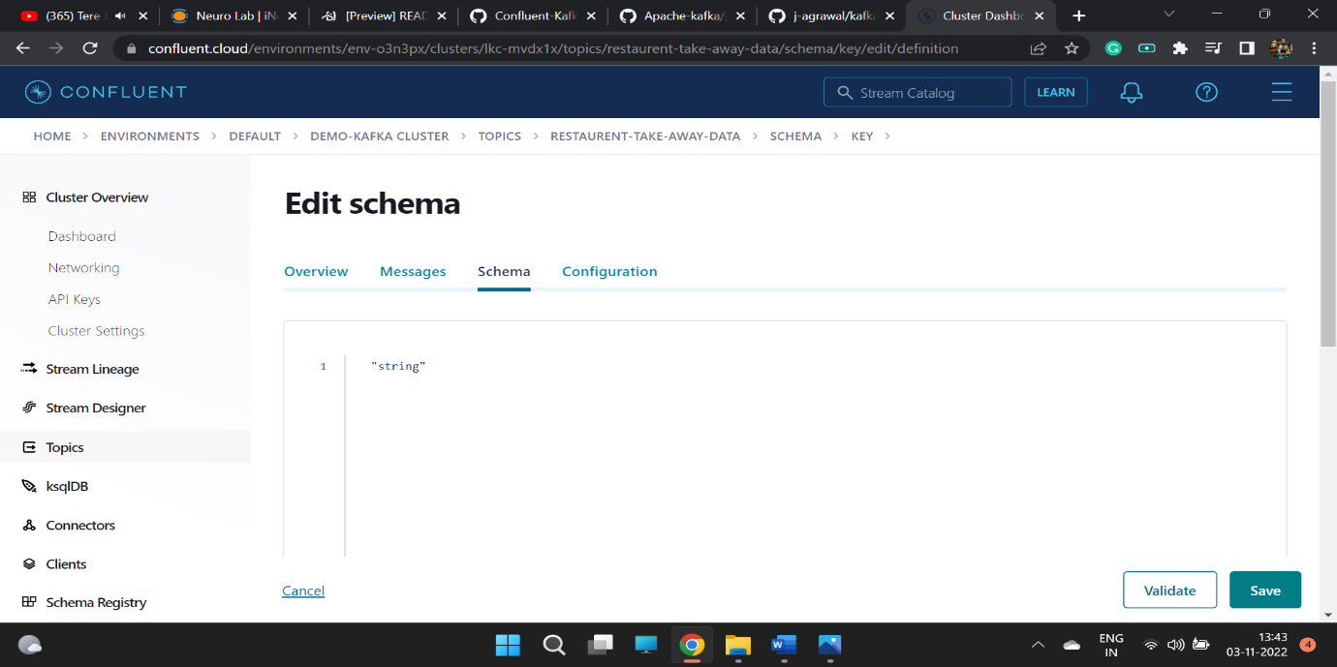

1. Schema for key is created now

