**kafka-Create Account**

**Create Account**

1. open signup page of confluent Kafka [Confluent Kafka](https://www.confluent.io/get-started/) [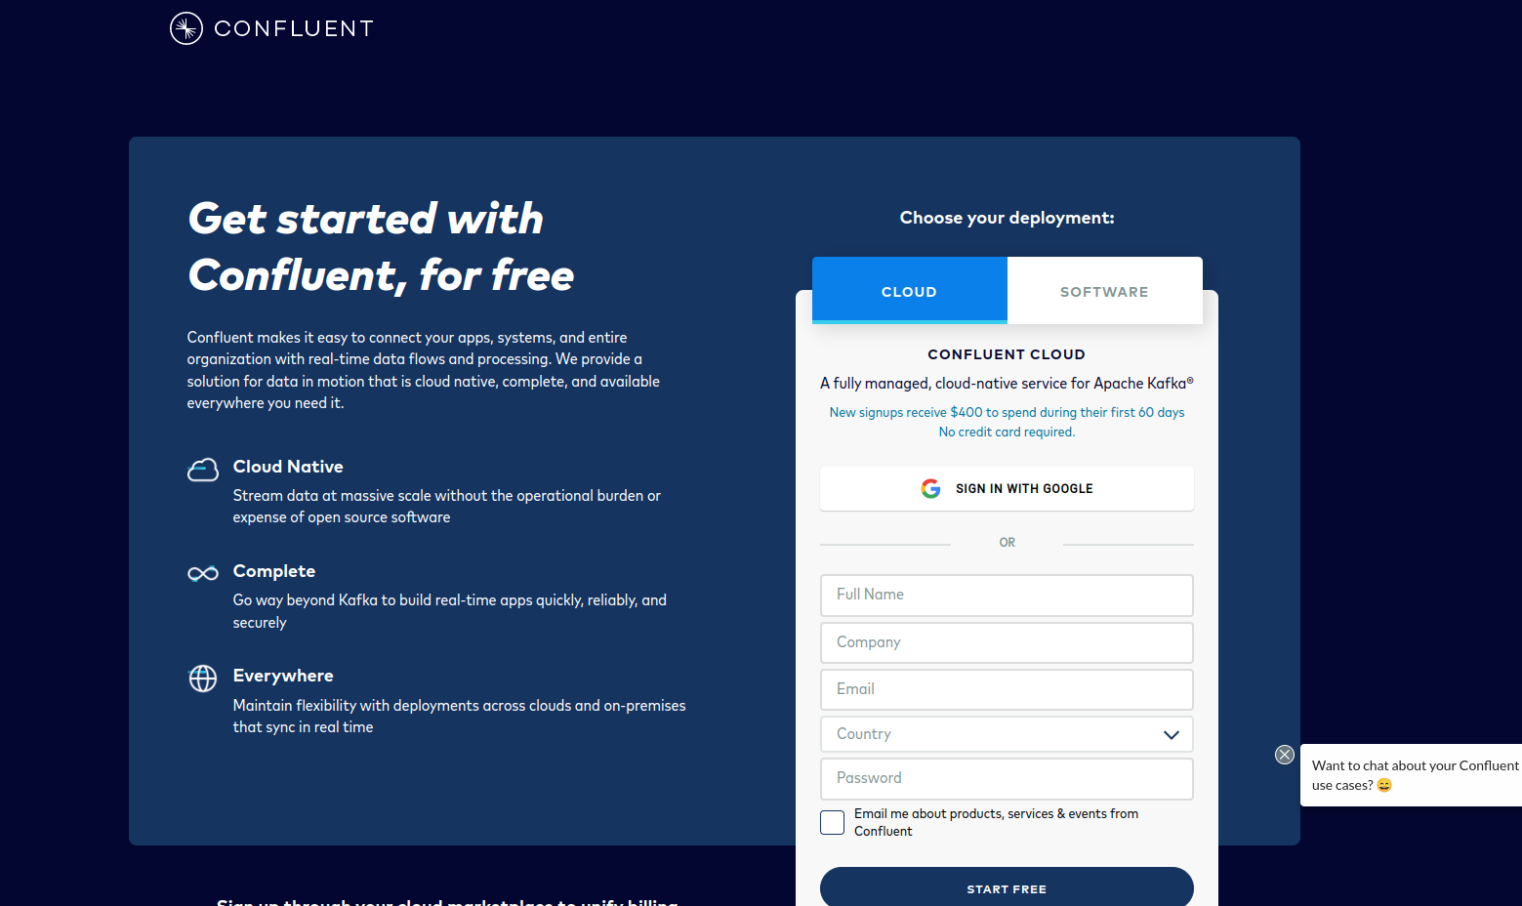](https://user-images.githubusercontent.com/34875169/169843335-edbf331f-96a2-499f-81a0-892dfeed9d78.png)
2. Go to Confluent [Login page](https://confluent.cloud/signup/idp/google-oauth2?signup_source=iosocial&iov_id=49a3b680-a2a1-4f52-8c1d-888fae73120e&_ga=2.145483828.1681359053.1653306300-338132655.1653306300)

[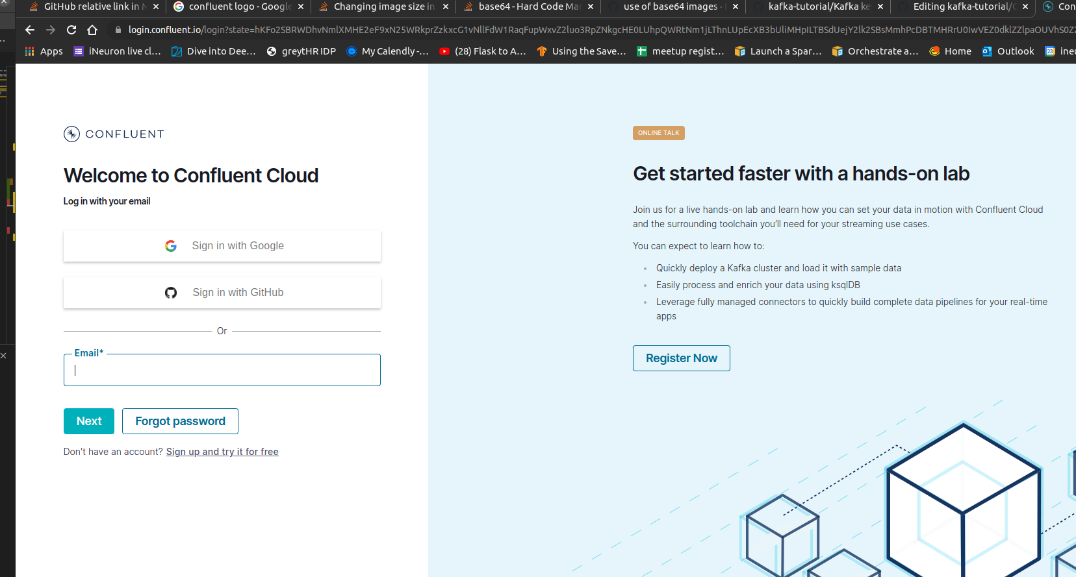](https://user-images.githubusercontent.com/34875169/169844230-41d01336-f22d-4037-99e4-ac5e458e0c24.png)