Project Report

Design and simulate a 100W Flyback converter for EV battery Charging.

**Poonam Chand (231040409)**



DEPARTMENT OF ELECTRICAL ENGINEERING INDIAN INSTITUTE OF TECHNOLOGY, KANPUR

August 2024 – September 2024

**Design and simulate a 100W Flyback converter for EV battery Charging.**

**Input: 48V output 5V**

Choose the appropriate transform/inductor turn ratio, magnetizing inductance, switching frequency, etc. Topology: Conventional flyback Design a single loop control with appropriate SSE, Settling time, and PM.

Show a step response in simulation and verify the setting time. From the digiky.in or mouser.in find the appropriate switching devices (Ex. MOSFET and Diode)

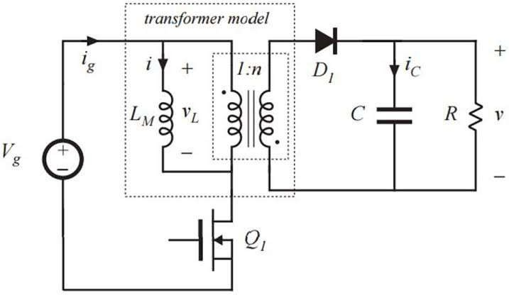

Fig. Circuit design for forward converter

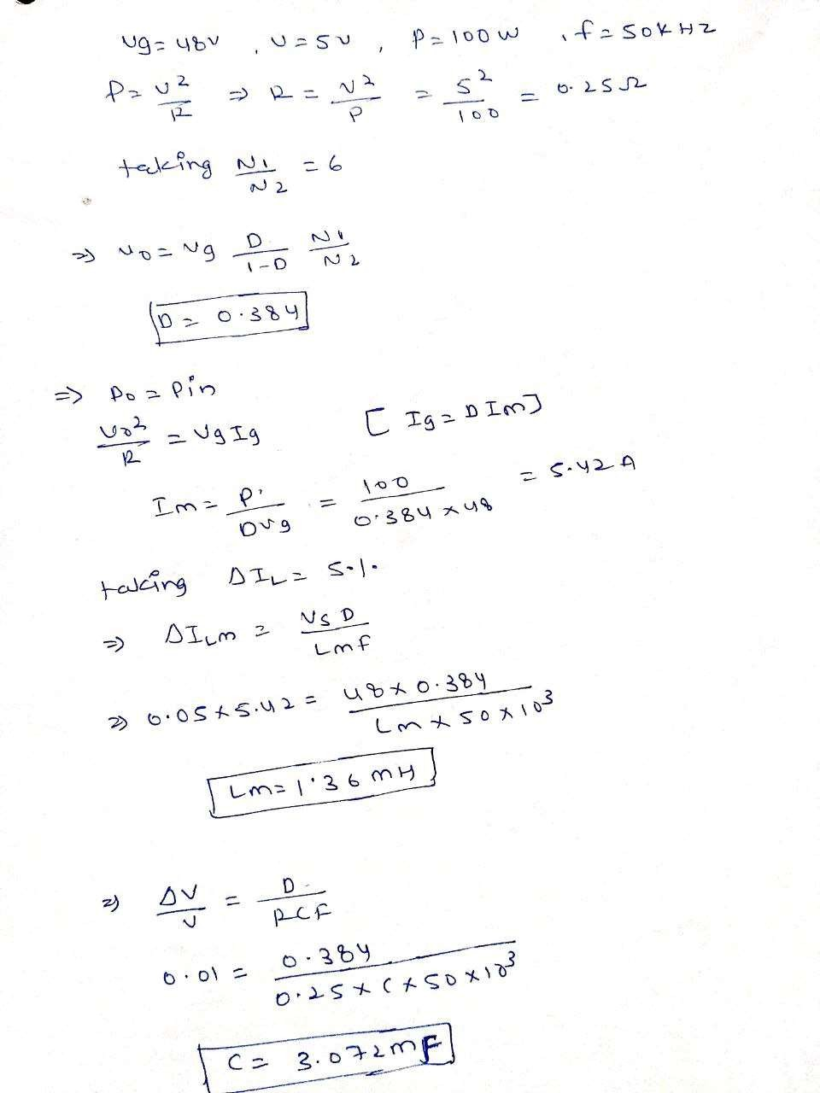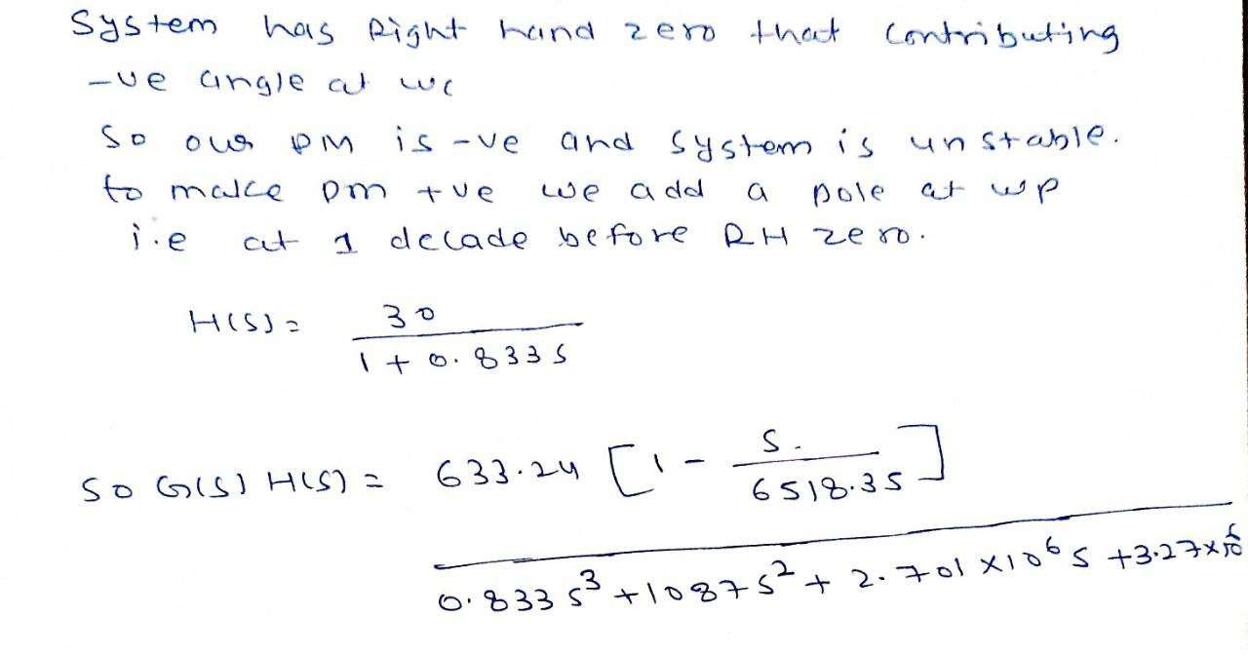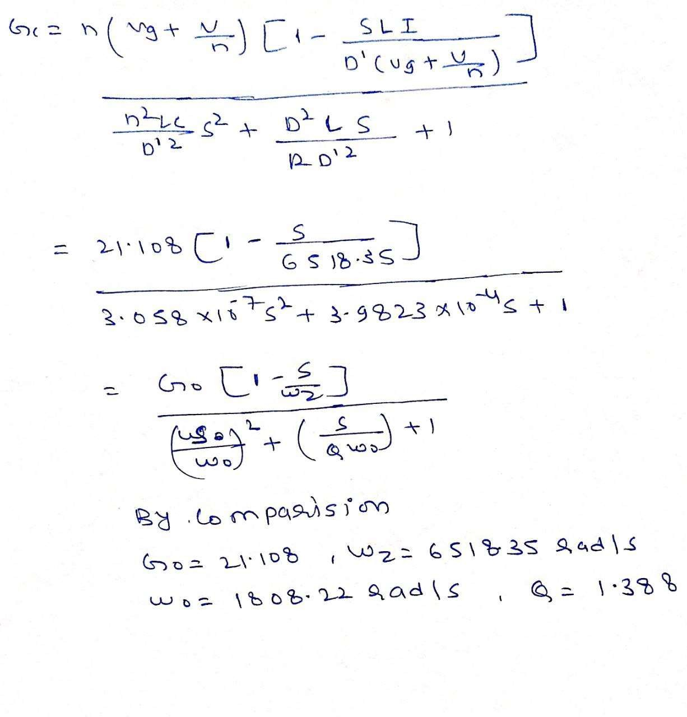

* **Bode plot of uncompensated system**

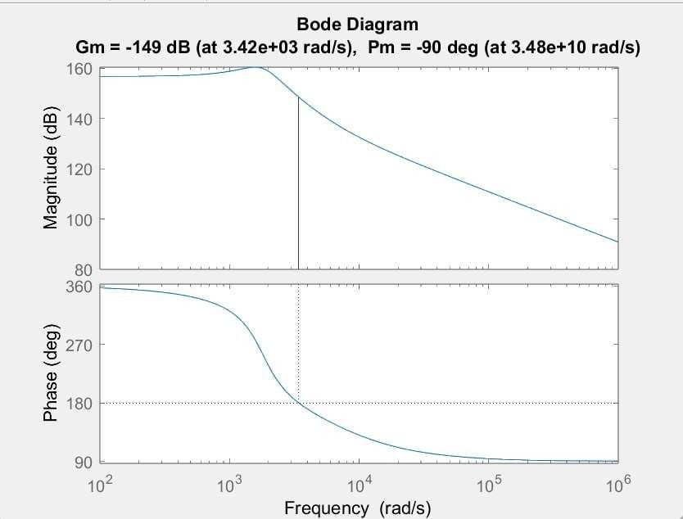

* + **Bode plot of compensated system**

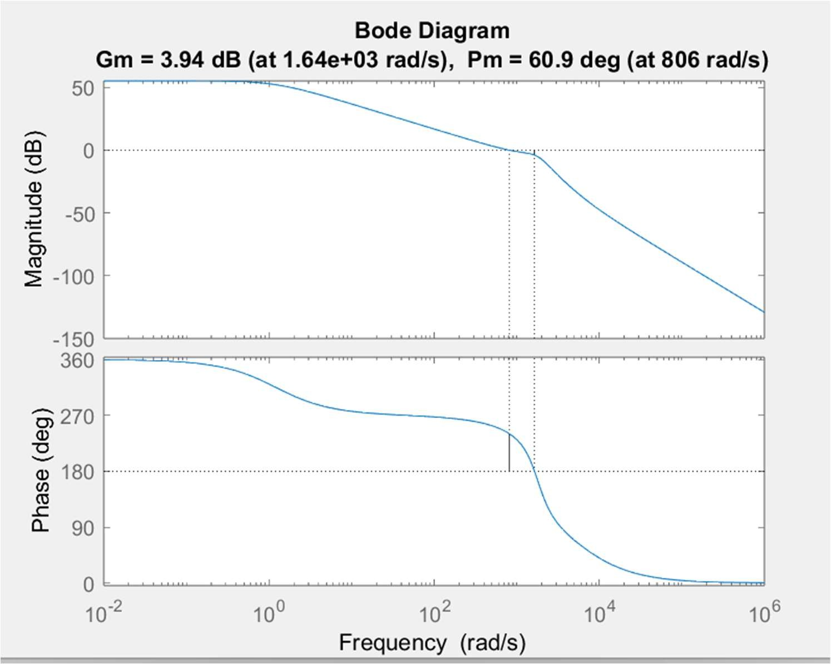

* **Uncompensated circuit**

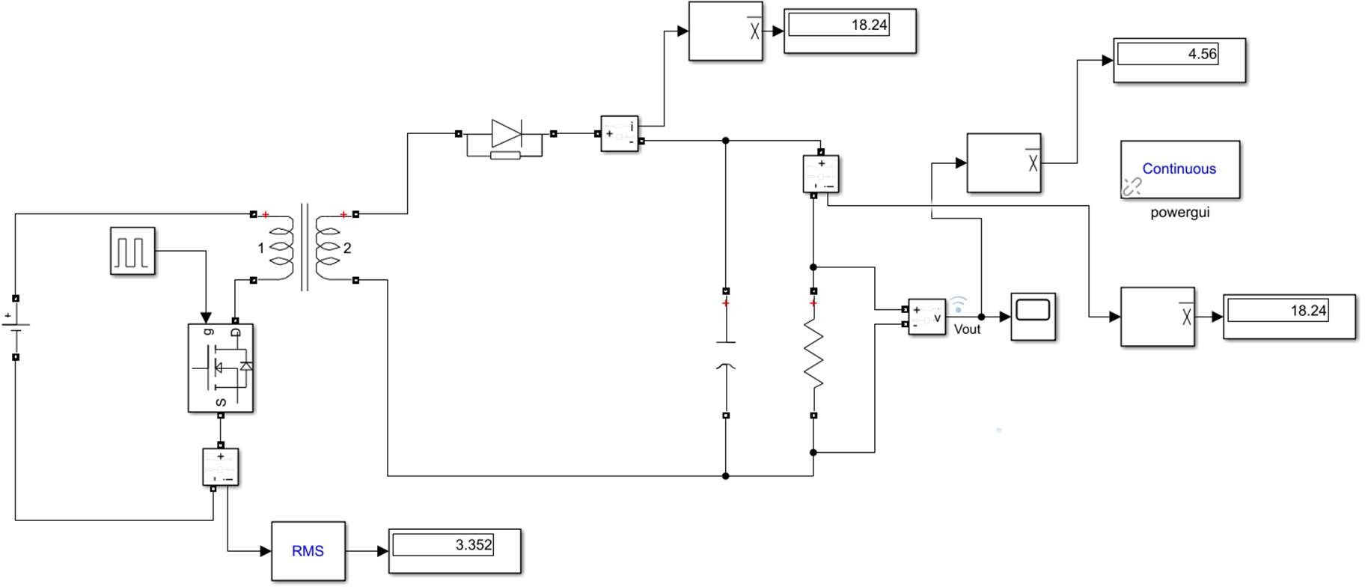

* **Compensated circuit**

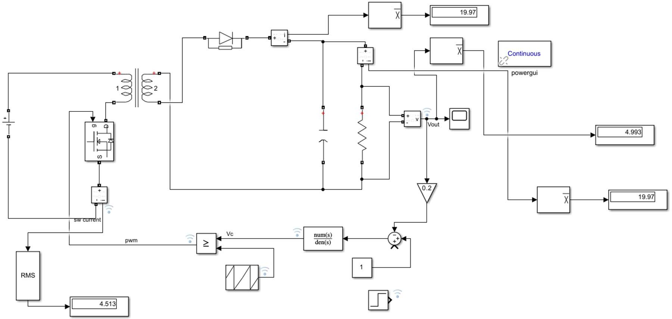

* **Output voltage waveform**

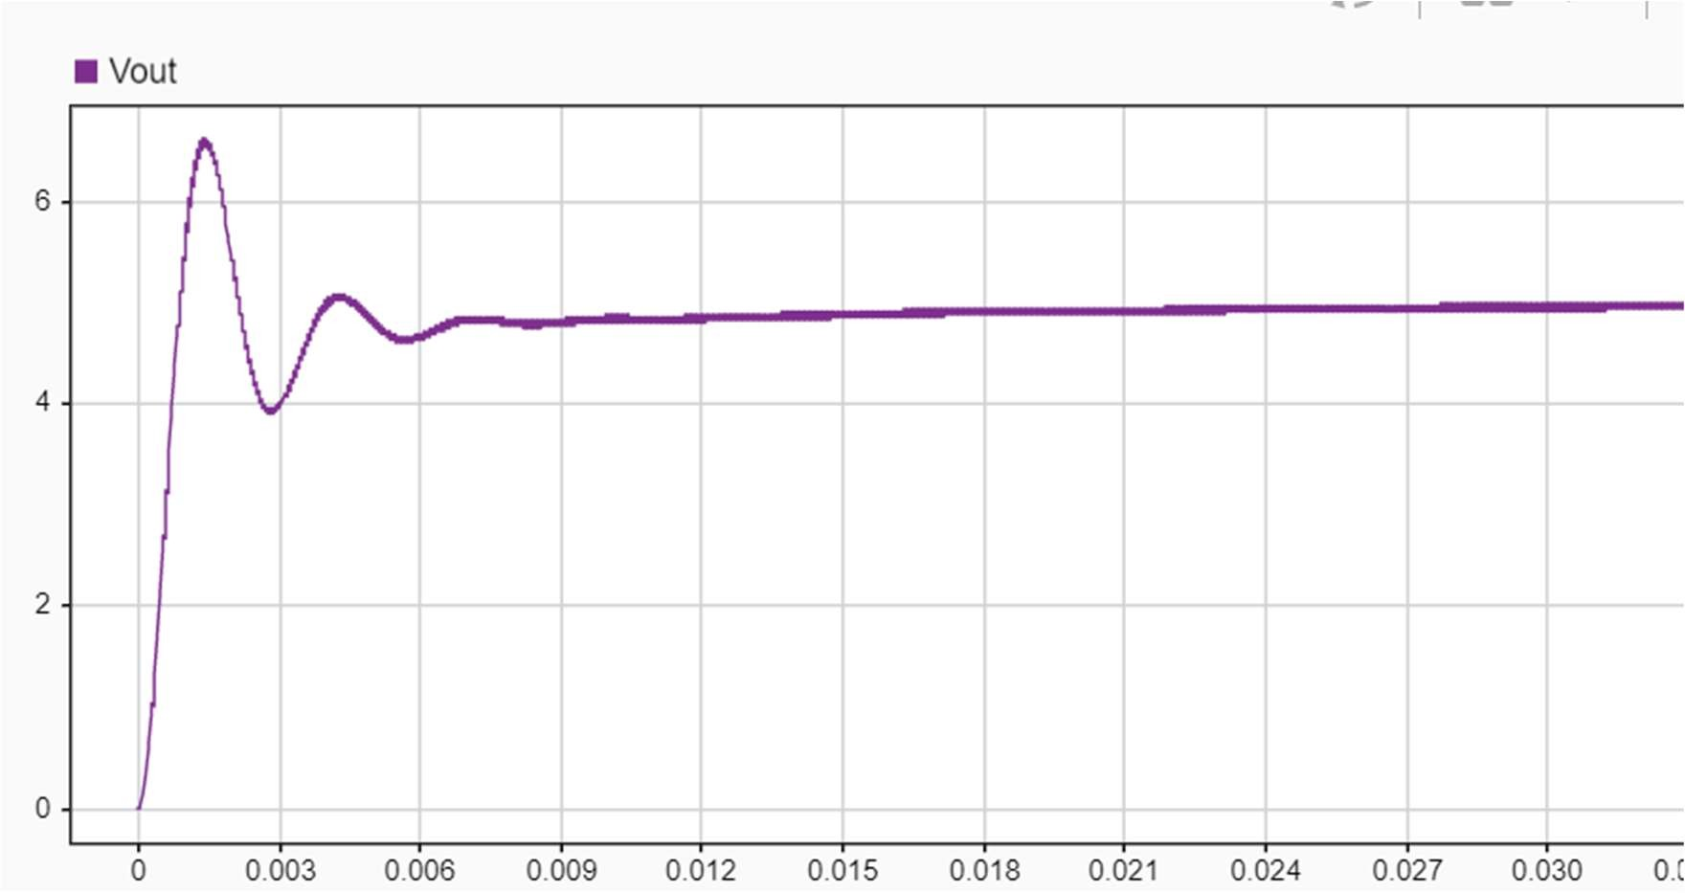

* **Settling time**

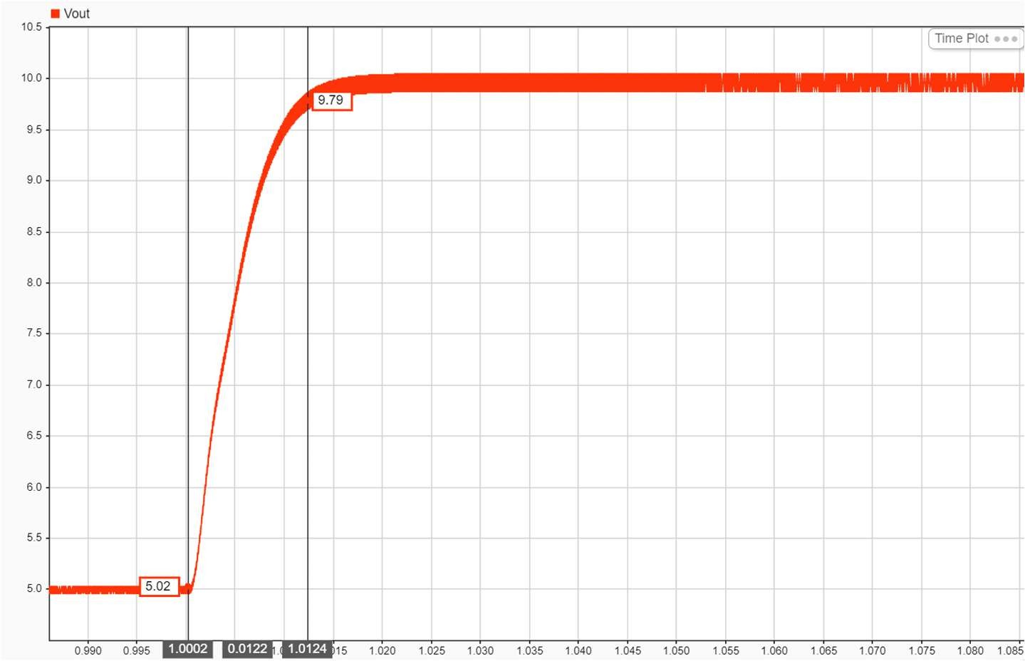

Ts= 12 msec (approx.)

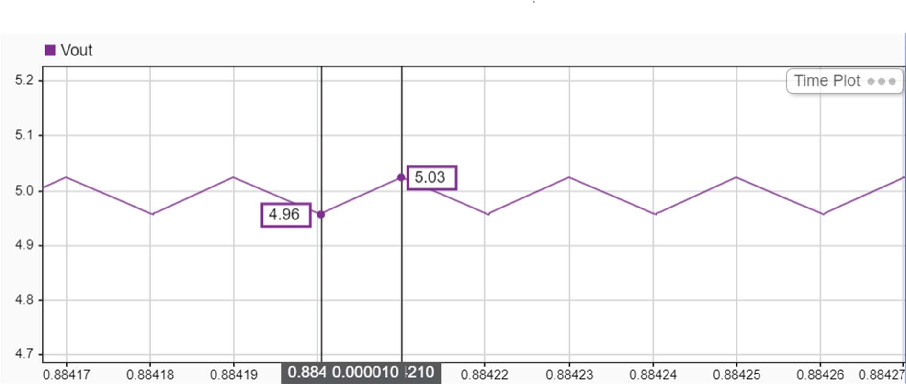

* **Steady state error**

Ess=0.07 V i.e 1.4 %

* **SWITCH SELECTION**

1. **MOSFET SELECTION**

Vds=[vg+(V0+vd)*(Np/Ns)]*2 Safety factor =2

Vds= 165 V

Irms= 5*2=10 A

For the flyback converter presented, the required minimum voltage rating of the MOSFET calculates to be 160V. An IXFH150N17T2 N-channel power MOSFET is chosen.

1. **Diode selection**

Vd= (Vo+Vg*(Np/Ns))*2=26 V Id= 20*2=40 A

Schottky for a specific application depends mainly on the working peak reverse voltage rating, the average forward current rating of the device. An VS-42CTQ030-M3 Schottky diode is chosen

* **Results**

1. **Uncompensated system Vo=4.56 V**

Wgc=3.48e10 rad/sec PM= -90 deg

GM= -149 db

unstable system

1. **Compensated system Vo=4.996 V**

Wgc=806 rad/sec

Ts= 5 msec (theoretical) Ts= 12 sec (simulation) PM= 60.9 deg

Gm 3.94 db Stable system