GitOps Deployment using ArgoCD on Amazon EKS
This project demonstrates an end-to-end GitOps deployment pipeline using GitHub Actions, Amazon EKS, Amazon ECR, Kubernetes, ArgoCD, and AWS Load Balancer Controller. Code changes are automatically built into Docker images, pushed to Amazon ECR, and deployed to the EKS cluster through ArgoCD synchronization.

Project Summary
• Source code stored in GitHub
• GitHub Actions builds Docker images and pushes them to Amazon ECR
• Workflow updates Kubernetes deployment manifest with the latest image tag
• ArgoCD monitors the Git repository and automatically syncs changes to Amazon EKS
• Application is exposed using Kubernetes Ingress and AWS Application Load Balancer
• Deployment status, health, and sync are managed through the ArgoCD UI

Architecture Flow
Developer → GitHub → GitHub Actions → Amazon ECR → Update deployment.yaml → ArgoCD → Amazon EKS → Service → Ingress (AWS ALB) → End Users

Screenshots
1. ArgoCD Dashboard showing Healthy and Synced application.
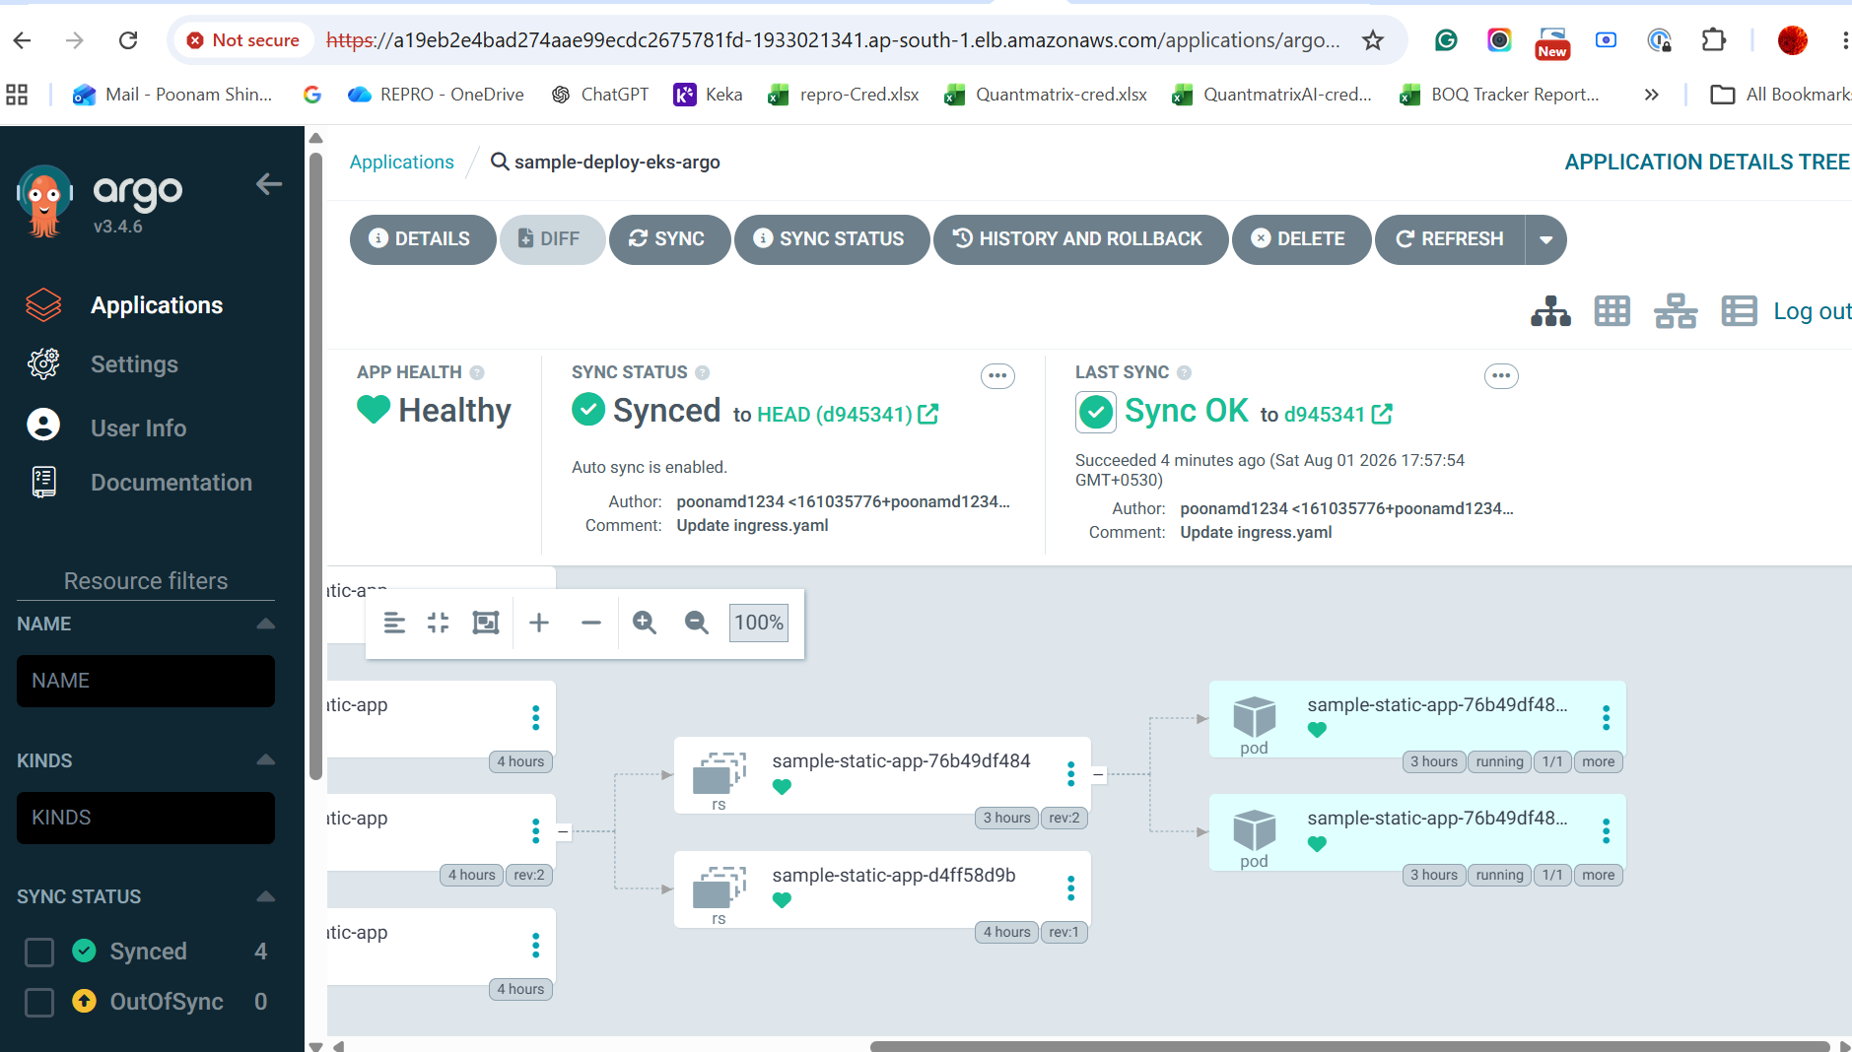
Figure 1: ArgoCD successfully synchronized the application with the Kubernetes cluster.
2. Application accessible through AWS Application Load Balancer.
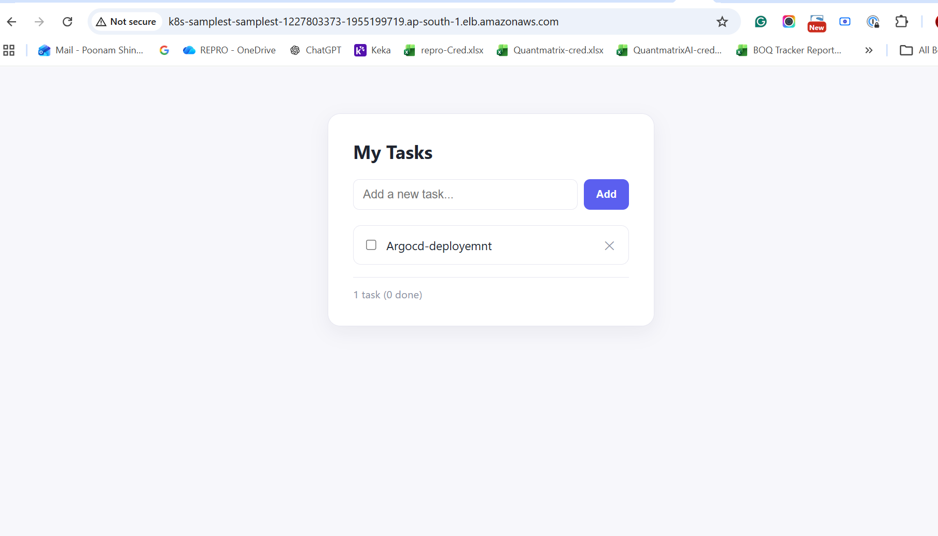
Figure 2: Sample application deployed on Amazon EKS and accessed through AWS ALB Ingress.

Key Technologies
AWS, Amazon EKS, Docker, Amazon ECR, Kubernetes, GitHub Actions, ArgoCD, AWS Load Balancer Controller, ALB Ingress

Interview Highlights
• Implemented GitOps using ArgoCD.
• Automated Docker image build and deployment using GitHub Actions.
• Configured Amazon ECR as the container registry.
• Installed and configured AWS Load Balancer Controller.
• Exposed the application using ALB Ingress.
• Achieved automatic synchronization between GitHub and Amazon EKS.

