Statistical Analysis and Hypothesis Testing
Week 4 Internship Project Report
Dataset: Students Performance | Tools: Python, Pandas, SciPy, Statsmodels, Matplotlib, Seaborn

1. Executive Summary
This project analyzes 1000 records and 8 columns from the Students Performance dataset. Three inferential methods were applied: Welch's independent t-test, one-way ANOVA, and Pearson correlation. A 5% significance level was used. The analysis examines mathematics score differences by test-preparation status and parental education, and the relationship between reading and writing scores.
The dataset contains 0 missing values across the fields required for these analyses. Statistical significance indicates that the observed result is unlikely under the corresponding null hypothesis; it does not establish causation.

2. Objectives
- Formulate null and alternative hypotheses for each statistical test.
- Compare mathematics scores by test-preparation status.
- Test for differences among parental education groups.
- Measure the linear association between reading and writing scores.
- Report p-values, confidence intervals, effect sizes and limitations.

3. Dataset and Preparation
The dataset includes student background variables, test-preparation status and mathematics, reading and writing scores. The score columns were converted to numeric values for analysis. Each test uses complete observations for the variables relevant to that test.
Dataset dimensions: 1000 rows and 8 columns. Missing values in analysis fields: 0.

4. Statistical Methodology
The significance threshold was alpha = 0.05. When p < 0.05, the null hypothesis was rejected. Otherwise, the analysis would fail to reject the null hypothesis. P-values are interpreted together with effect sizes and confidence intervals rather than as measures of practical importance.

4.1 Welch Independent t-test
This test compares the mean mathematics scores of two independent groups without assuming equal population variances. H0: the two population means are equal. H1: the population means differ. The 95% confidence interval estimates the mean difference (completed minus none). Cohen's d summarizes the standardized difference.

4.2 One-way ANOVA
One-way ANOVA tests H0: all parental education groups have equal mean mathematics scores. H1: at least one group mean differs. Eta squared estimates the proportion of observed score variation associated with between-group differences. Tukey HSD post-hoc comparisons are included to explore which pairs differ while controlling family-wise error.

4.3 Pearson Correlation
Pearson's correlation coefficient measures the direction and strength of a linear relationship. H0: the population correlation is zero. H1: the population correlation is non-zero. A Fisher-transformation 95% confidence interval is reported. Correlation does not prove causation.

5. Results
Test | Statistic | P-value | Effect size | Conclusion
Welch independent t-test | 5.7870 | 1.043e-08 | 0.3763 | Significant difference in group means
One-way ANOVA | 6.5216 | 5.592e-06 | 0.0318 | At least one group mean differs
Pearson correlation | 0.9546 | 0 | 0.9546 | Significant linear association

5.1 Welch t-test: Detailed Findings
The completed preparation group had a mean mathematics score of 69.70 (n = 358), compared with 64.08 (n = 642) for the group with no preparation. The mean difference was 5.62 points, with a 95% confidence interval from 3.71 to 7.52. The test statistic was t = 5.7870, p = 1.043e-08, and Cohen's d = 0.376. The difference was statistically significant at the 5% level.
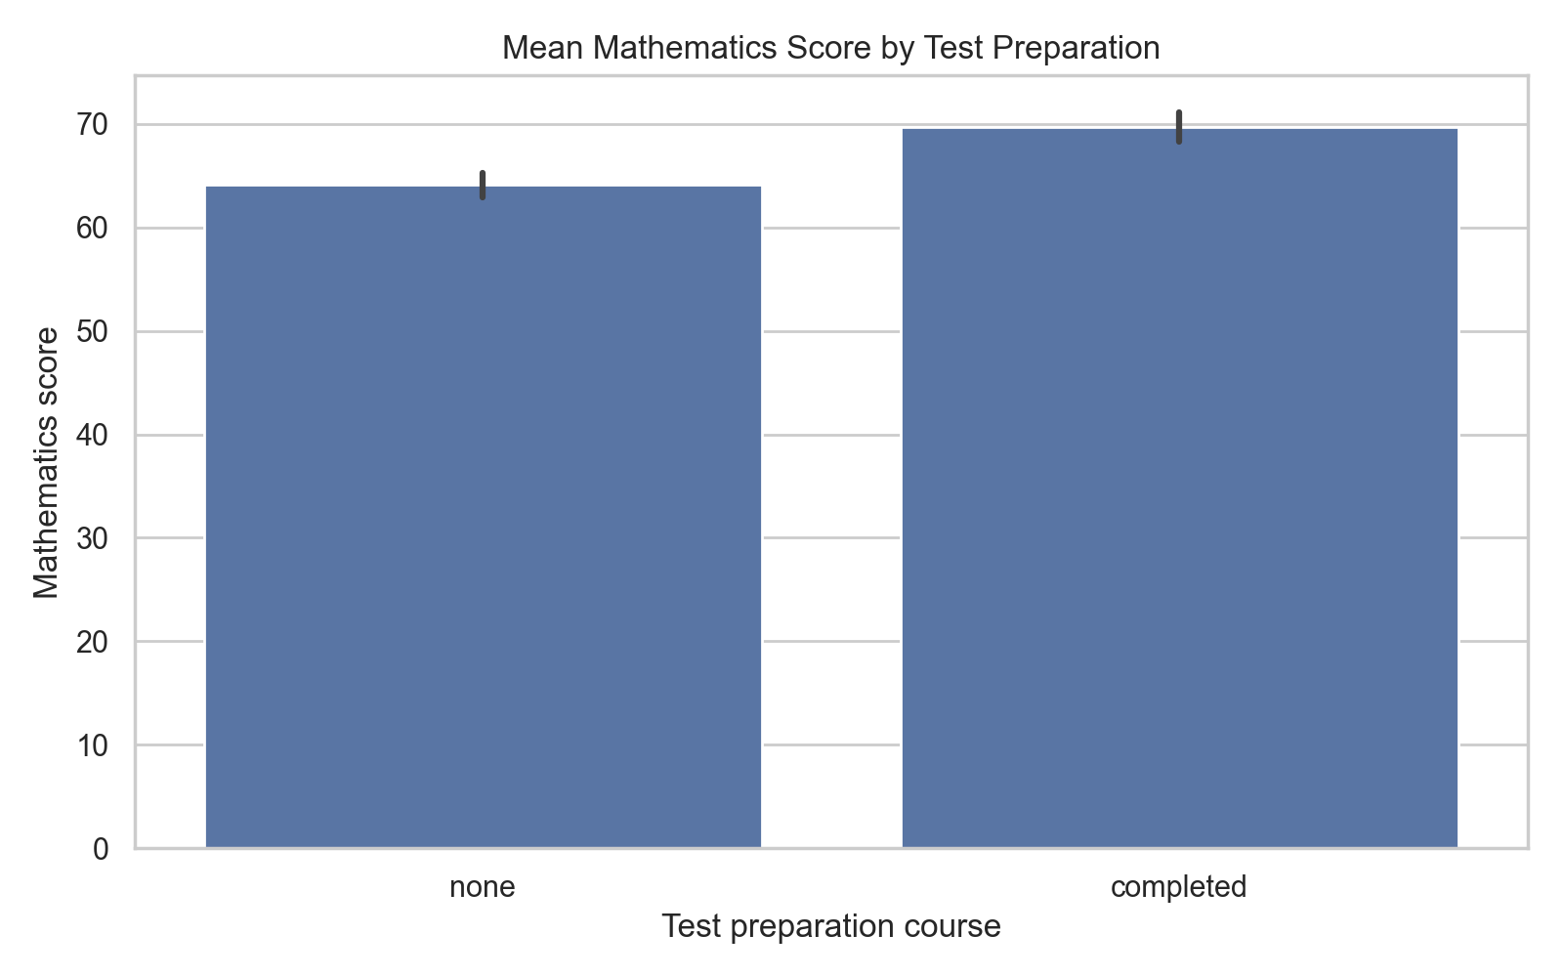
Figure 1. Mathematics score means by test-preparation status. Error bars represent 95% confidence intervals around the group means.

5.2 ANOVA: Detailed Findings
The one-way ANOVA produced F = 6.5216 and p = 5.592e-06. Eta squared was 0.0318. The null hypothesis of equal group means was rejected; at least one parental education group differs.
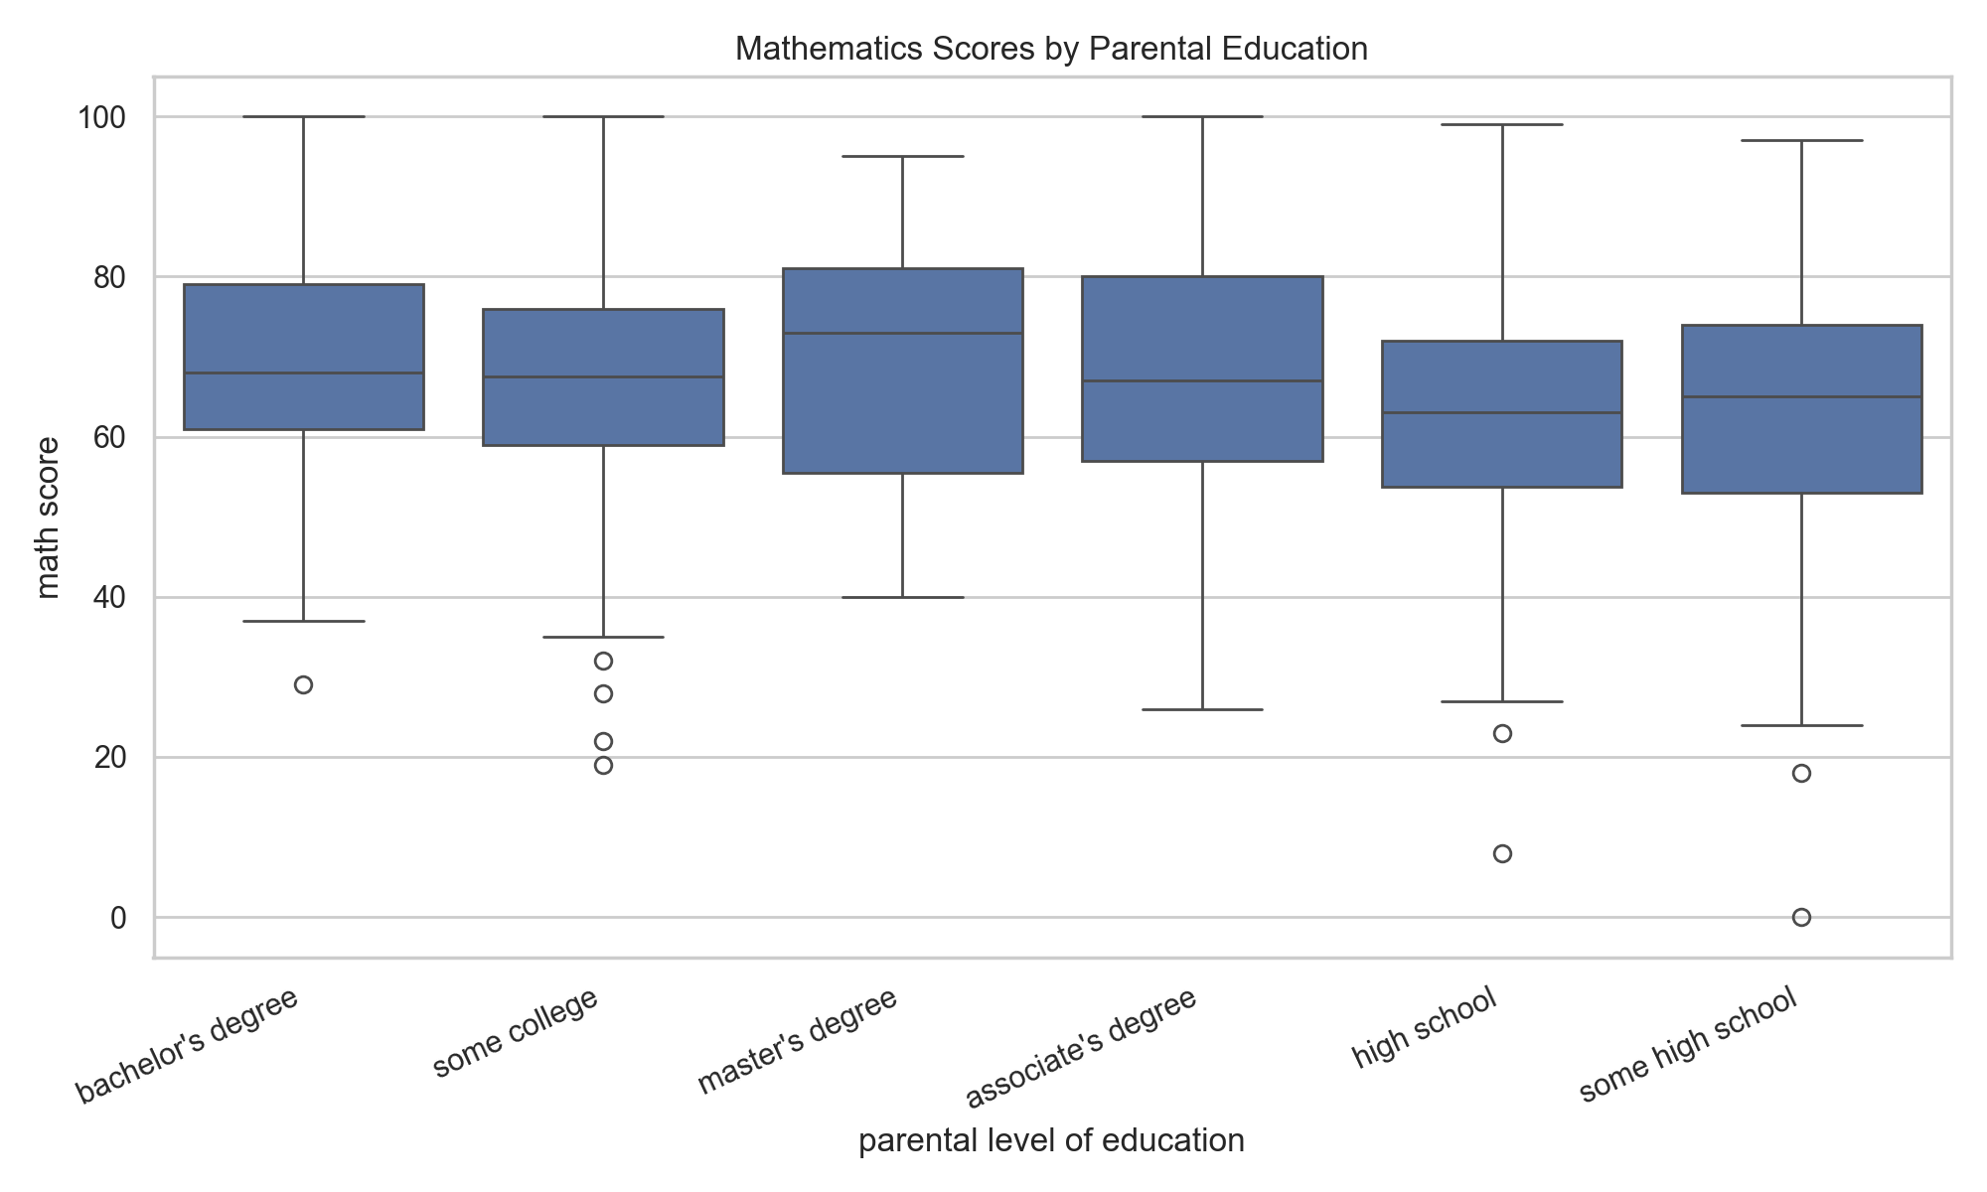
Figure 2. Distribution of mathematics scores across parental education groups.

Tukey HSD Post-hoc Comparisons
The table below reports pairwise comparisons after ANOVA. A significant pairwise result indicates evidence of a difference between that pair of groups; it does not imply that every group differs from every other.
group1 | group2 | meandiff | p-adj | lower | upper | reject
associate's degree | bachelor's degree | 1.5069 | 0.9503 | -3.3587 | 6.3726 | False
associate's degree | high school | -5.7451 | 0.0013 | -9.9311 | -1.5591 | True
associate's degree | master's degree | 1.8629 | 0.9578 | -4.3927 | 8.1185 | False
associate's degree | some college | -0.7546 | 0.9948 | -4.7903 | 3.2812 | False
associate's degree | some high school | -4.3857 | 0.0418 | -8.676 | -0.0954 | True
bachelor's degree | high school | -7.2521 | 0.0005 | -12.2284 | -2.2757 | True
bachelor's degree | master's degree | 0.3559 | 1.0 | -6.4539 | 7.1658 | False
bachelor's degree | some college | -2.2615 | 0.7676 | -7.1122 | 2.5892 | False
bachelor's degree | some high school | -5.8926 | 0.0119 | -10.957 | -0.8282 | True
high school | master's degree | 7.608 | 0.0084 | 1.2659 | 13.9501 | True
high school | some college | 4.9906 | 0.0086 | 0.822 | 9.1592 | True
high school | some high school | 1.3595 | 0.9515 | -3.056 | 5.7749 | False
master's degree | some college | -2.6174 | 0.8384 | -8.8614 | 3.6265 | False
master's degree | some high school | -6.2486 | 0.0611 | -12.66 | 0.1628 | False
some college | some high school | -3.6311 | 0.1482 | -7.9044 | 0.6422 | False

5.3 Pearson Correlation: Detailed Findings
The correlation between reading and writing scores was r = 0.9546, p = 0. Its 95% confidence interval was (0.9488, 0.9598). The result indicates a statistically significant linear association.
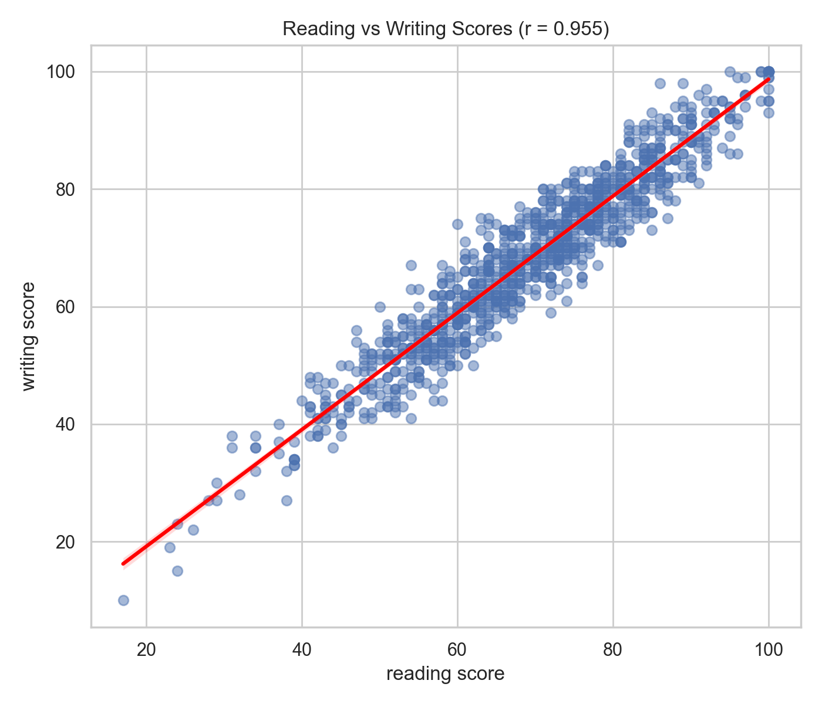
Figure 3. Reading and writing scores with a fitted linear regression line.

6. Overall Discussion
The analysis found evidence of a mathematics-score difference between students who completed test preparation and those who did not. ANOVA also found evidence that mathematics means are not all equal across parental education categories. Reading and writing scores showed a strong positive linear relationship. These results are descriptive of this dataset and do not demonstrate that test preparation or parental education caused the observed scores.

7. Limitations
- The dataset is observational, so causal conclusions are not justified.
- Statistical tests depend on assumptions about observations and distributions.
- ANOVA identifies an overall difference but needs post-hoc comparisons to locate it.
- The dataset may not represent all student populations.
- Effect sizes and confidence intervals should be considered alongside p-values.

8. Conclusion
This project demonstrates how inferential statistics can test group differences and relationships in educational data. Welch's t-test, one-way ANOVA, Tukey HSD and Pearson correlation provide complementary evidence. The results, confidence intervals, effect sizes, tables and figures make the analysis more transparent and reproducible.

9. Tools and References
Python; Pandas; SciPy; Statsmodels; Matplotlib; Seaborn; python-docx.
Documentation: SciPy statistical functions (scipy.org), Statsmodels documentation (www.statsmodels.org), and Pandas documentation (pandas.pydata.org).

