Week 3: Data Visualization and Reporting
Yuva Internship – Virtual Data Analysis Apprentice
Project: Students' Academic Performance Analysis

1. Introduction
This project explores students' academic performance using data visualization techniques in Python. The objective is to present important patterns, compare average subject scores, examine score distributions, and study relationships between subjects.

2. Objectives
- Compare average scores in mathematics, reading, and writing.
- Visualize the distribution of students' scores.
- Examine the relationship between mathematics and reading scores.
- Measure correlations between the three subject scores.
- Communicate findings using charts and descriptive statistics.

3. Dataset Description
The StudentsPerformance.csv dataset contains 1000 records and 8 columns. It includes demographic and educational information, along with mathematics, reading, and writing scores.
Measure | Value
Number of records | 1000
Number of columns | 8
Average mathematics score | 66.09
Average reading score | 69.17
Average writing score | 68.05

4. Tools and Methodology
Python was used with Pandas for data handling, Matplotlib for chart creation, and Seaborn for statistical visualizations. The dataset was loaded into a DataFrame, the subject score columns were selected, and averages and Pearson correlation coefficients were calculated.

5. Visualizations and Findings

Figure 1: Average Scores by Subject
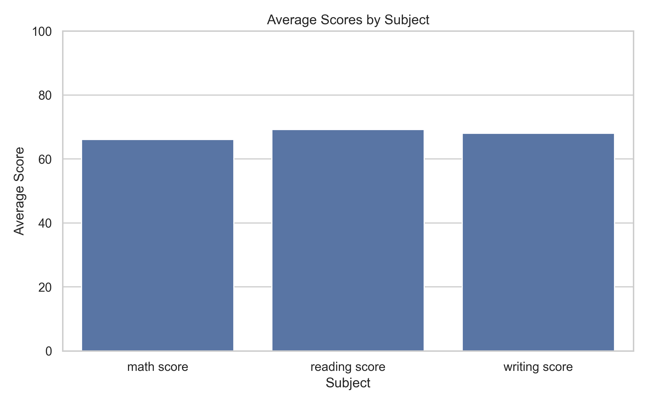
Reading has the highest average score (69.17), followed by writing (68.05). Mathematics has the lowest average (66.09). These averages describe the dataset overall and do not explain the reasons behind the differences.

Figure 2: Distribution of Student Scores
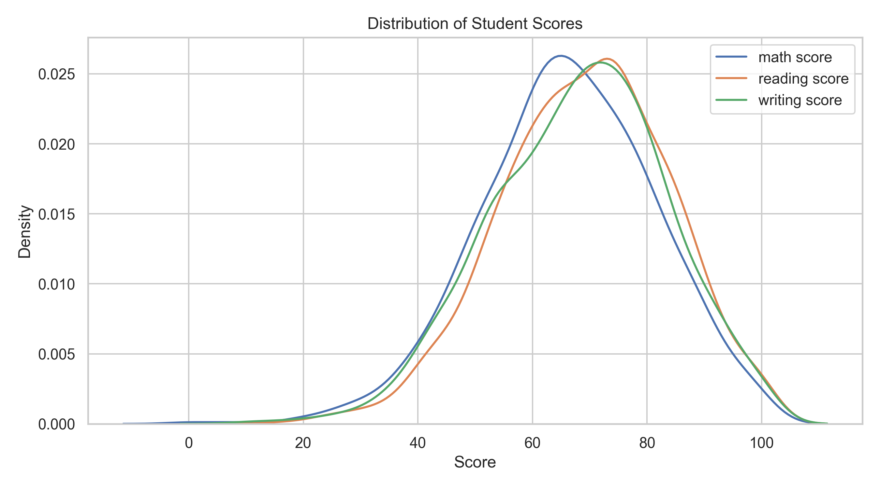
This density plot compares the distributions of mathematics, reading, and writing scores. It helps show where scores are concentrated and how their spreads differ.

Figure 3: Mathematics vs Reading Scores
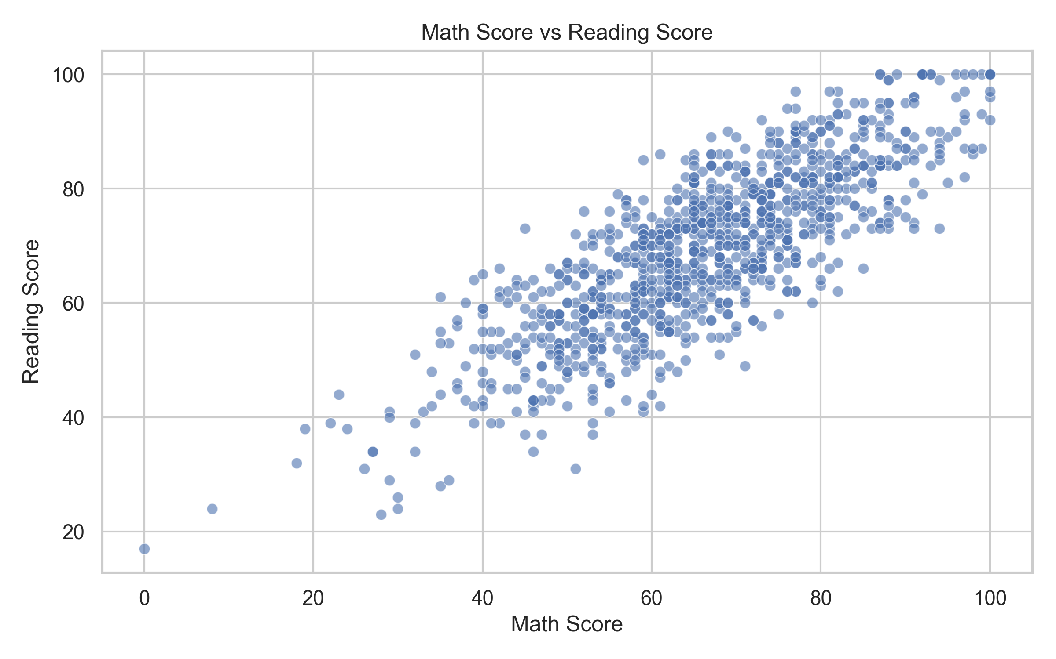
The Pearson correlation between mathematics and reading scores is 0.82. The scatter plot helps visualize their positive association and the variation between individual student records.

Figure 4: Correlation Between Subject Scores
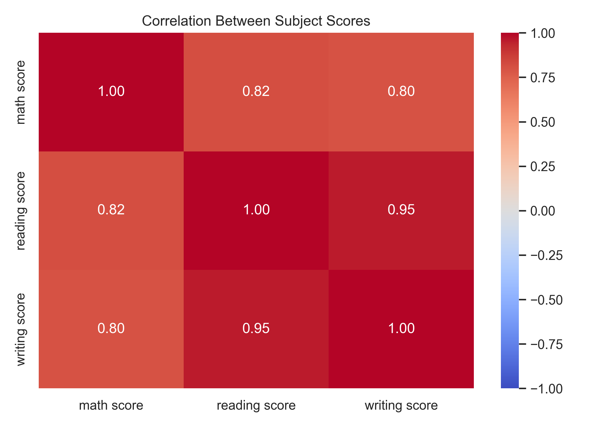
Reading and writing have the strongest positive correlation (0.95). Mathematics and writing have a correlation of 0.80. Correlation indicates association, not causation.

Figure 5: Subject Scores Across Dataset Records
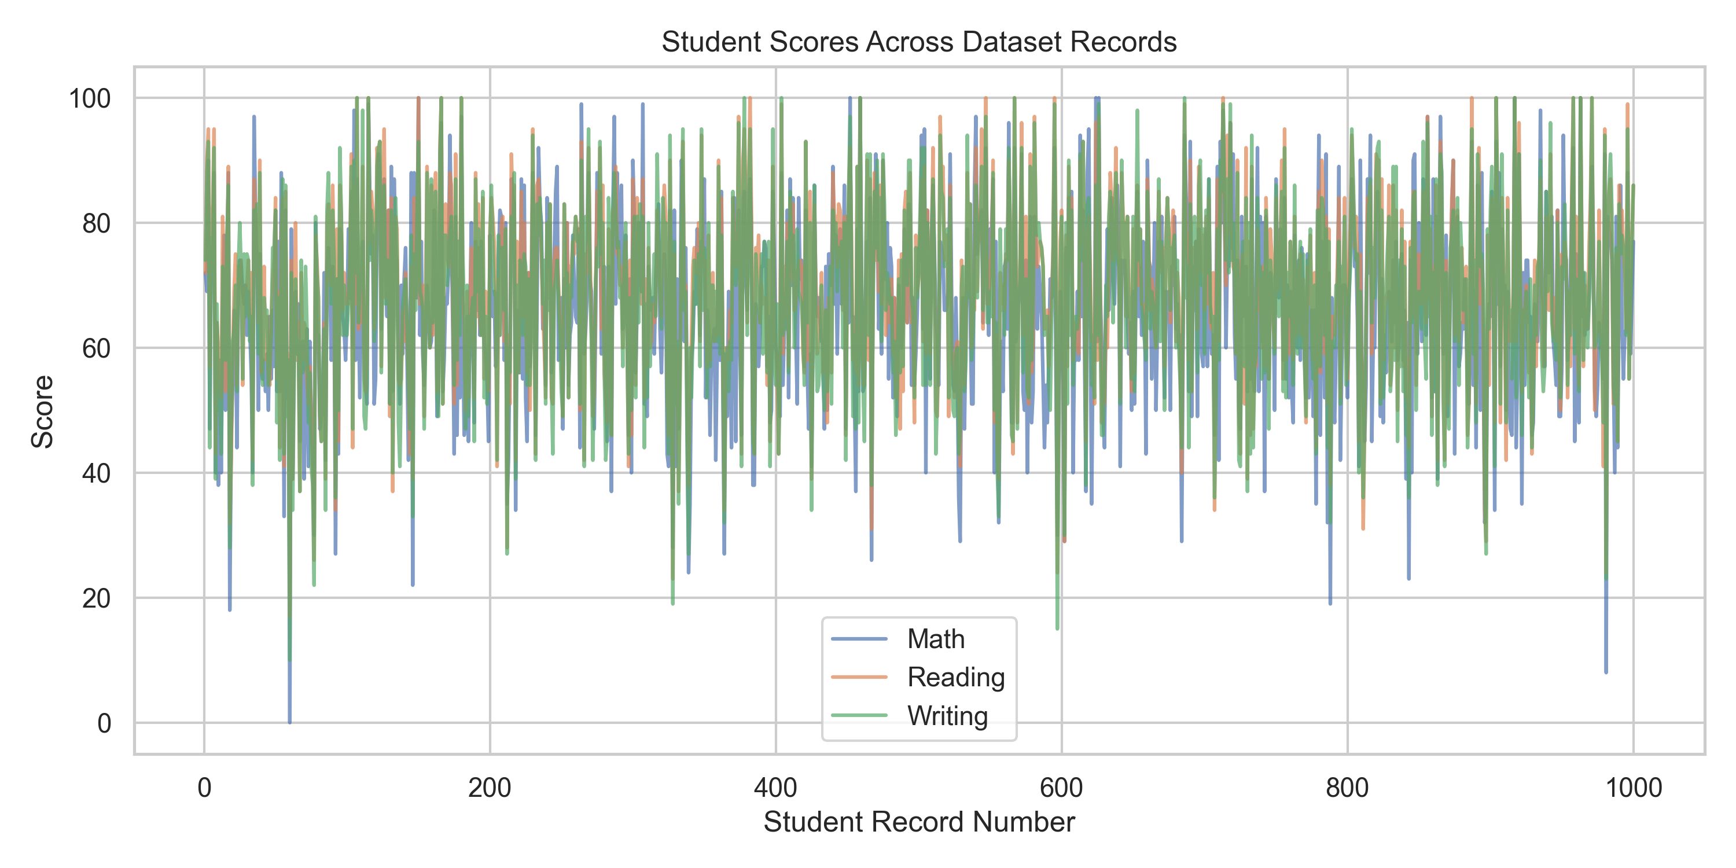
The line chart displays the three subject scores across dataset record numbers. Since the records are not time-series observations, the lines should be interpreted as record-wise patterns rather than changes over time.

6. Correlation Results
Subject | Math | Reading | Writing
Math | 1.00 | 0.82 | 0.80
Reading | 0.82 | 1.00 | 0.95
Writing | 0.80 | 0.95 | 1.00

7. Conclusion
The visual analysis shows that reading has the highest average score among the three subjects, while mathematics has the lowest. Reading and writing scores show a strong positive relationship in this dataset. The visualizations demonstrate how charts and correlation analysis can summarize academic data and support clearer interpretation. These results describe associations in the dataset and should not be treated as proof of cause-and-effect relationships.

8. Limitations
This analysis focuses on descriptive statistics and visual patterns. It does not establish why score differences occur, and the dataset's record order does not represent time. Further analysis would be needed to investigate the effects of demographic and educational factors.

