YUVA INTERN
FINAL CAPSTONE PROJECT REPORT
End-to-End Student Performance Data Analysis
Weeks 1–5 Consolidated Work | Week 6 Final Submission

Project Information | Details
Internship Organization | Yuva Intern
Internship Track | Virtual Data Analysis Apprentice
Project Dataset | Students Performance in Exams
Dataset Size | 1,000 student records × 8 original columns
Tools & Technologies | Python, Pandas, NumPy, Matplotlib, Seaborn, SciPy, Statsmodels, Scikit-learn
Final Project Focus | Exploration, cleaning, visualization, statistical analysis and predictive modelling

Prepared as a consolidated record of the practical work completed during the internship.

Executive Summary
This capstone project consolidates a complete data analytics workflow using the Students Performance in Exams dataset. The dataset contains 1,000 records and eight variables describing student demographics, family and school-related context, test preparation status, and scores in mathematics, reading, and writing.
The work progressed from initial data exploration to preprocessing, visualization, inferential statistics, and supervised machine learning. The original dataset contained no missing values and no duplicate rows. Preprocessing expanded the dataset from 8 to 15 columns by adding derived, encoded, and scaled features. Exploratory analysis showed that students who completed test preparation had higher average scores in all three subjects. Reading had the highest overall mean score (69.17), followed by writing (68.05) and mathematics (66.09).
Statistical testing found a significant difference in mathematics scores by test-preparation status, a significant difference among parental-education groups, and a very strong positive relationship between reading and writing scores. Two regression models were evaluated for predicting mathematics scores. Linear Regression achieved an R² of 0.8804 and outperformed Random Forest on the recorded test split.

Project Objectives
- Understand the structure, variables, quality, and patterns in the student performance dataset.
- Clean and transform data while preserving the original dataset.
- Create visual summaries to communicate score distributions and relationships.
- Use statistical tests to evaluate selected differences and associations.
- Train and compare regression models for mathematics-score prediction.
- Document findings, limitations, and practical recommendations in one coherent report.

1. Dataset and Problem Definition
The project uses the Students Performance in Exams dataset (commonly distributed through Kaggle). It includes 1,000 student records and eight original columns.
Variable | Description | Type
gender | Student gender | Categorical
race/ethnicity | Race/ethnicity group | Categorical
parental level of education | Parent/guardian education category | Categorical
lunch | Lunch programme category | Categorical
test preparation course | Whether the test-preparation course was completed | Categorical
math score | Mathematics examination score | Numeric
reading score | Reading examination score | Numeric
writing score | Writing examination score | Numeric

Problem definition: explore which recorded student and context variables are associated with academic scores, summarize the patterns, test selected statistical relationships, and assess whether the available features can predict mathematics scores.

2. Week 1 – Data Exploration and Problem Definition
The initial Python analysis used Pandas, NumPy, Matplotlib, and Seaborn. The script loaded the CSV file, displayed sample records, checked dataset dimensions and column names, inspected data types and descriptive statistics, counted missing and duplicate records, and examined categorical value counts.
Verified dataset dimensions: 1000 rows and 8 columns. Missing values: 0. Duplicate rows: 0.
Subject | Mean score
Math Score | 66.09
Reading Score | 69.17
Writing Score | 68.05

Exploratory comparisons

Test Preparation Course
Test Preparation Course | Math | Reading | Writing
completed | 69.70 | 73.89 | 74.42
none | 64.08 | 66.53 | 64.50

Gender
Gender | Math | Reading | Writing
female | 63.63 | 72.61 | 72.47
male | 68.73 | 65.47 | 63.31

Lunch
Lunch | Math | Reading | Writing
free/reduced | 58.92 | 64.65 | 63.02
standard | 70.03 | 71.65 | 70.82

Initial observations: the completed test-preparation group had higher mean scores in all three subjects. Female students had higher mean reading and writing scores, while male students had a higher mean mathematics score in this dataset. Students in the standard-lunch group had higher average scores than those in the free/reduced-lunch group. These are descriptive associations and should not be interpreted as proof of causation.

3. Week 2 – Data Cleaning and Preprocessing
The preprocessing script created a copy of the original data, standardized categorical text by trimming extra spaces and converting text to lowercase, and engineered additional features. It added average_score and total_score, binary-encoded gender and test-preparation status, and created min–max scaled versions of the three subject scores.
Preprocessing check | Recorded result
Original rows | 1,000
Processed rows | 1,000
Original columns | 8
Processed columns | 15
Missing values after processing | 0
Duplicate rows after processing | 0
New columns added | 7

The seven added columns were average_score, total_score, gender_encoded, test_prep_encoded, math score_scaled, reading score_scaled, and writing score_scaled. Validation included checking encoded values, scaled ranges, reloading the saved CSV, and comparing original and processed dimensions.
The original dataset was preserved and the processed data was saved separately as StudentsPerformance_Cleaned.csv.

4. Week 3 – Data Visualization and Reporting
The visualization workflow used Matplotlib and Seaborn to create a set of charts and a numerical score summary. The supplied outputs include an average-score bar chart, score-distribution plot, mathematics-versus-reading scatter plot, subject-correlation heatmap, and student-score trend plot.
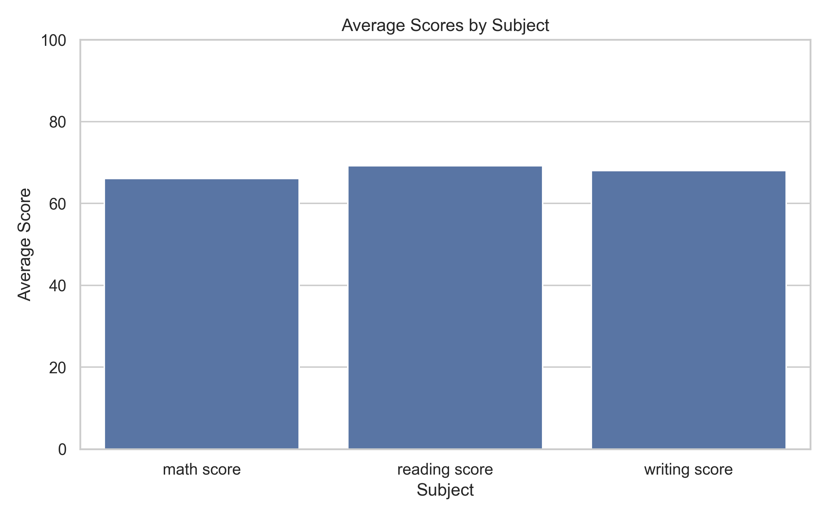
Figure 1. Average scores by subject.
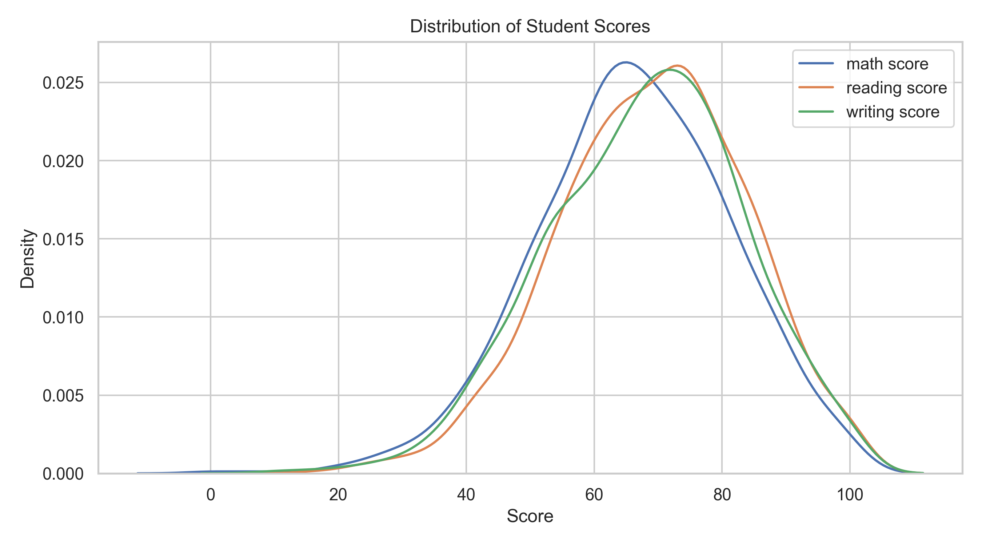
Figure 2. Distribution of mathematics, reading, and writing scores.
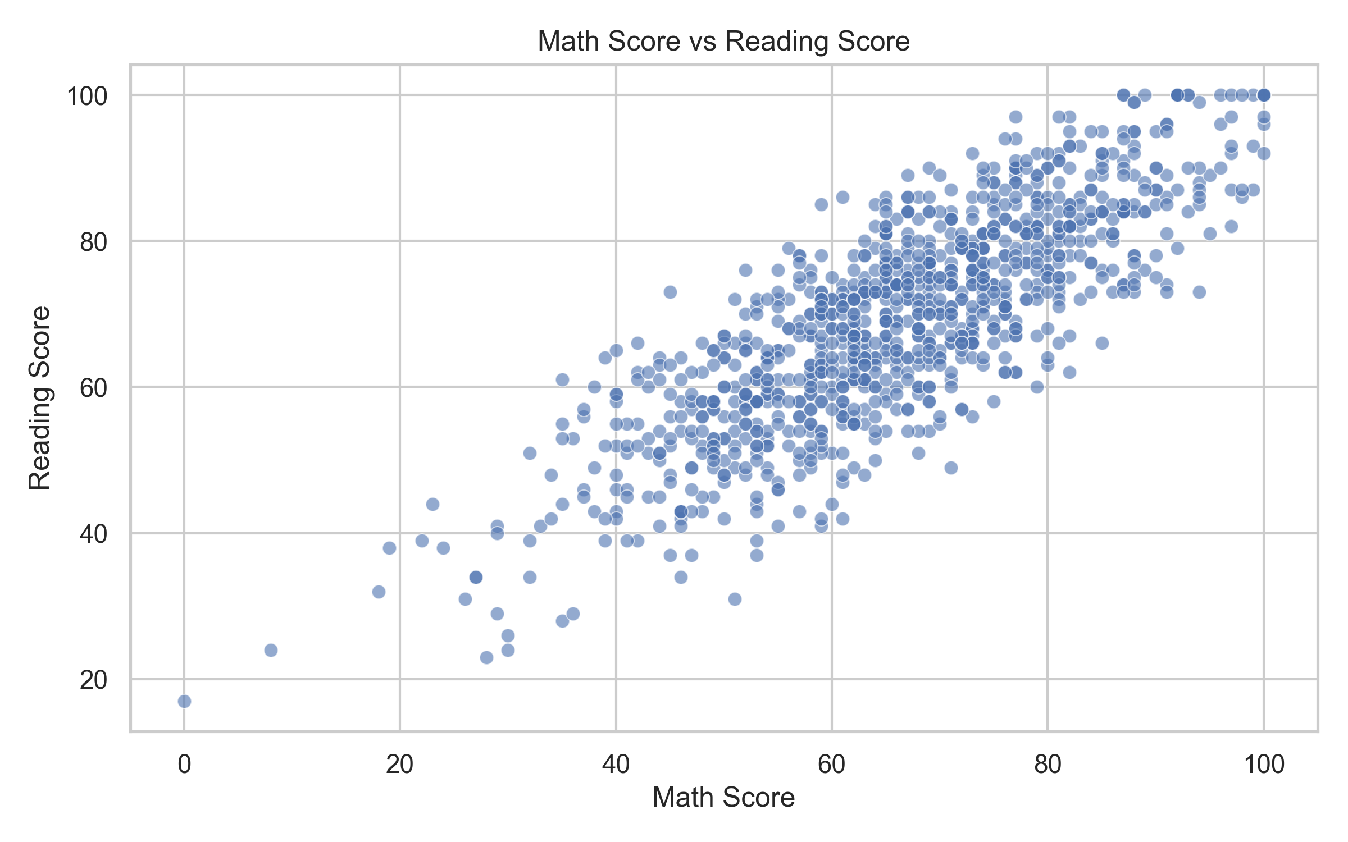
Figure 3. Relationship between mathematics and reading scores.
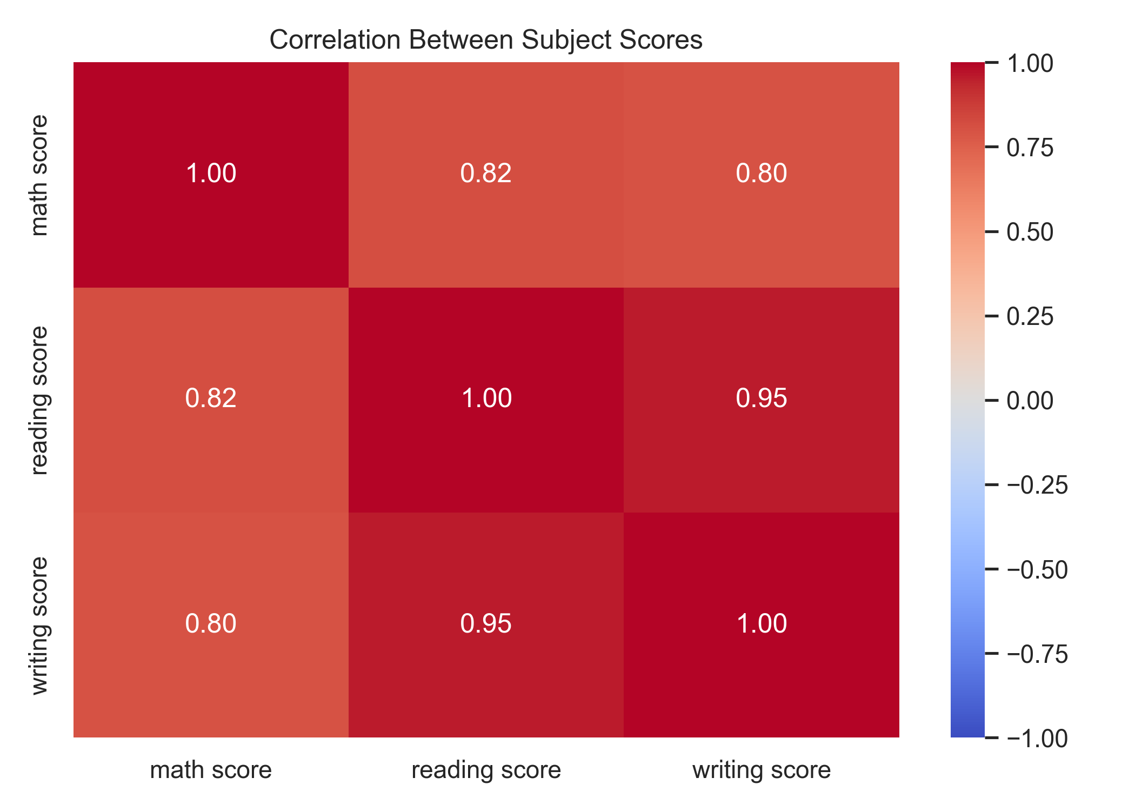
Figure 4. Correlation heatmap for the three subject scores.
Summary statistic | Math | Reading | Writing
Mean | 66.09 | 69.17 | 68.05
Median | 66.00 | 70.00 | 69.00
Minimum | 0 | 17 | 10
Maximum | 100 | 100 | 100

Interpretation: reading has the highest mean and median among the three subjects. The score ranges show that performance varies substantially across students. The scatter and correlation visualizations help assess how performance in one subject moves with another.

5. Week 4 – Statistical Analysis and Hypothesis Testing
Inferential analysis used a 5% significance level (α = 0.05). Welch’s independent t-test compared mathematics scores for students who completed test preparation and those who did not. One-way ANOVA compared mathematics means across parental-education categories. Pearson correlation measured the linear association between reading and writing scores.
Test | Statistic | P-value | Effect measure | Conclusion at 5%
Welch independent t-test | t = 5.787 | 1.04 × 10⁻⁸ | Cohen’s d = 0.376 | Significant difference
One-way ANOVA | F = 6.522 | 5.59 × 10⁻⁶ | Eta² = 0.0318 | At least one group mean differs
Pearson correlation | r = 0.9546 | Reported as 0.000 | Pearson r = 0.9546 | Very strong positive association

Welch t-test: the mean mathematics score was 69.70 for students who completed test preparation and 64.08 for those who did not. The estimated difference was about 5.62 points; the 95% confidence interval in the supplied results was approximately 3.71 to 7.52 points. This supports a statistically significant difference between the two groups.
One-way ANOVA: the p-value indicates that not all parental-education group means are equal. The supplied Tukey post-hoc table identifies selected pairwise differences; these results should be interpreted as associations, not causal effects.
Pearson correlation: reading and writing scores showed a very strong positive linear association (r ≈ 0.955). A p-value displayed as zero in the CSV reflects numerical rounding/underflow; it should be interpreted as an extremely small p-value, not literally zero.
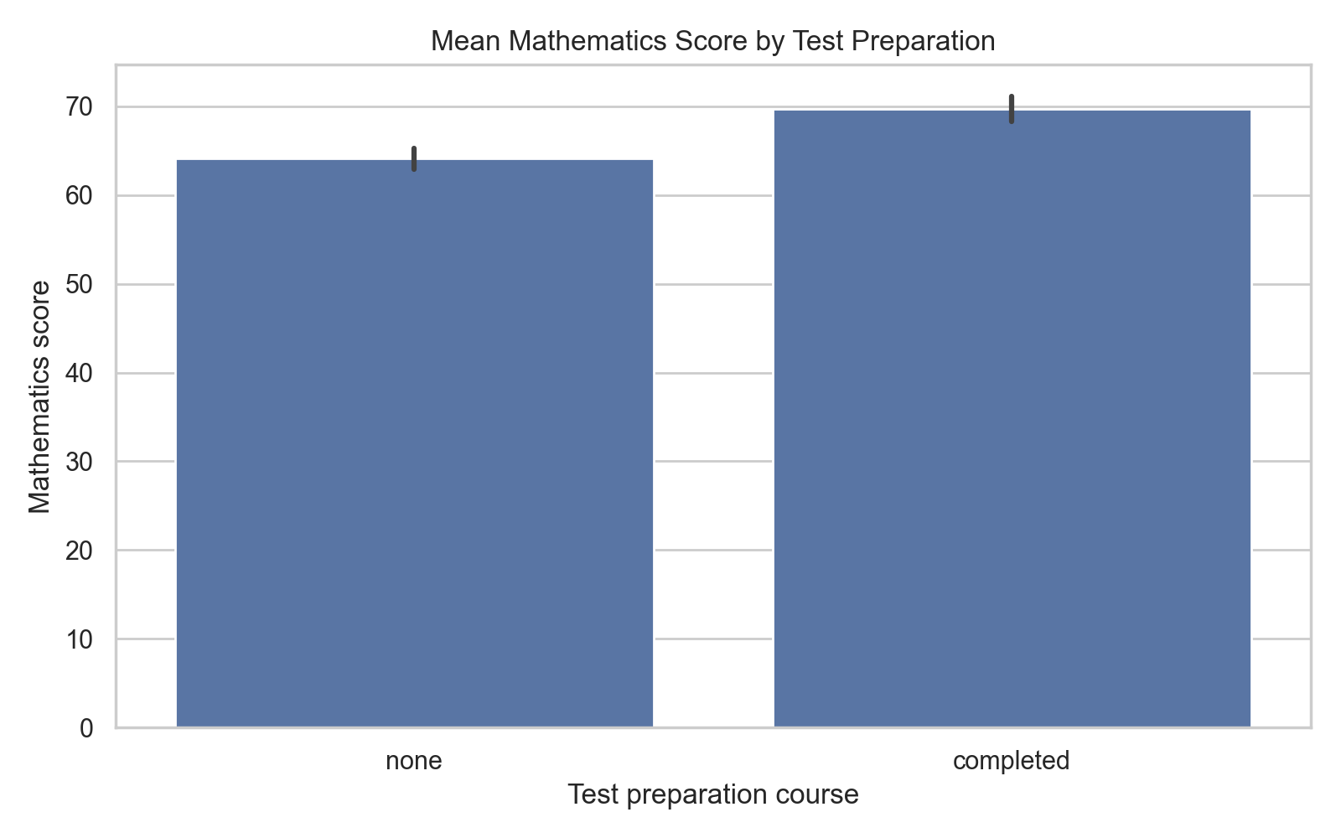
Figure 5. Mathematics scores by test-preparation status.
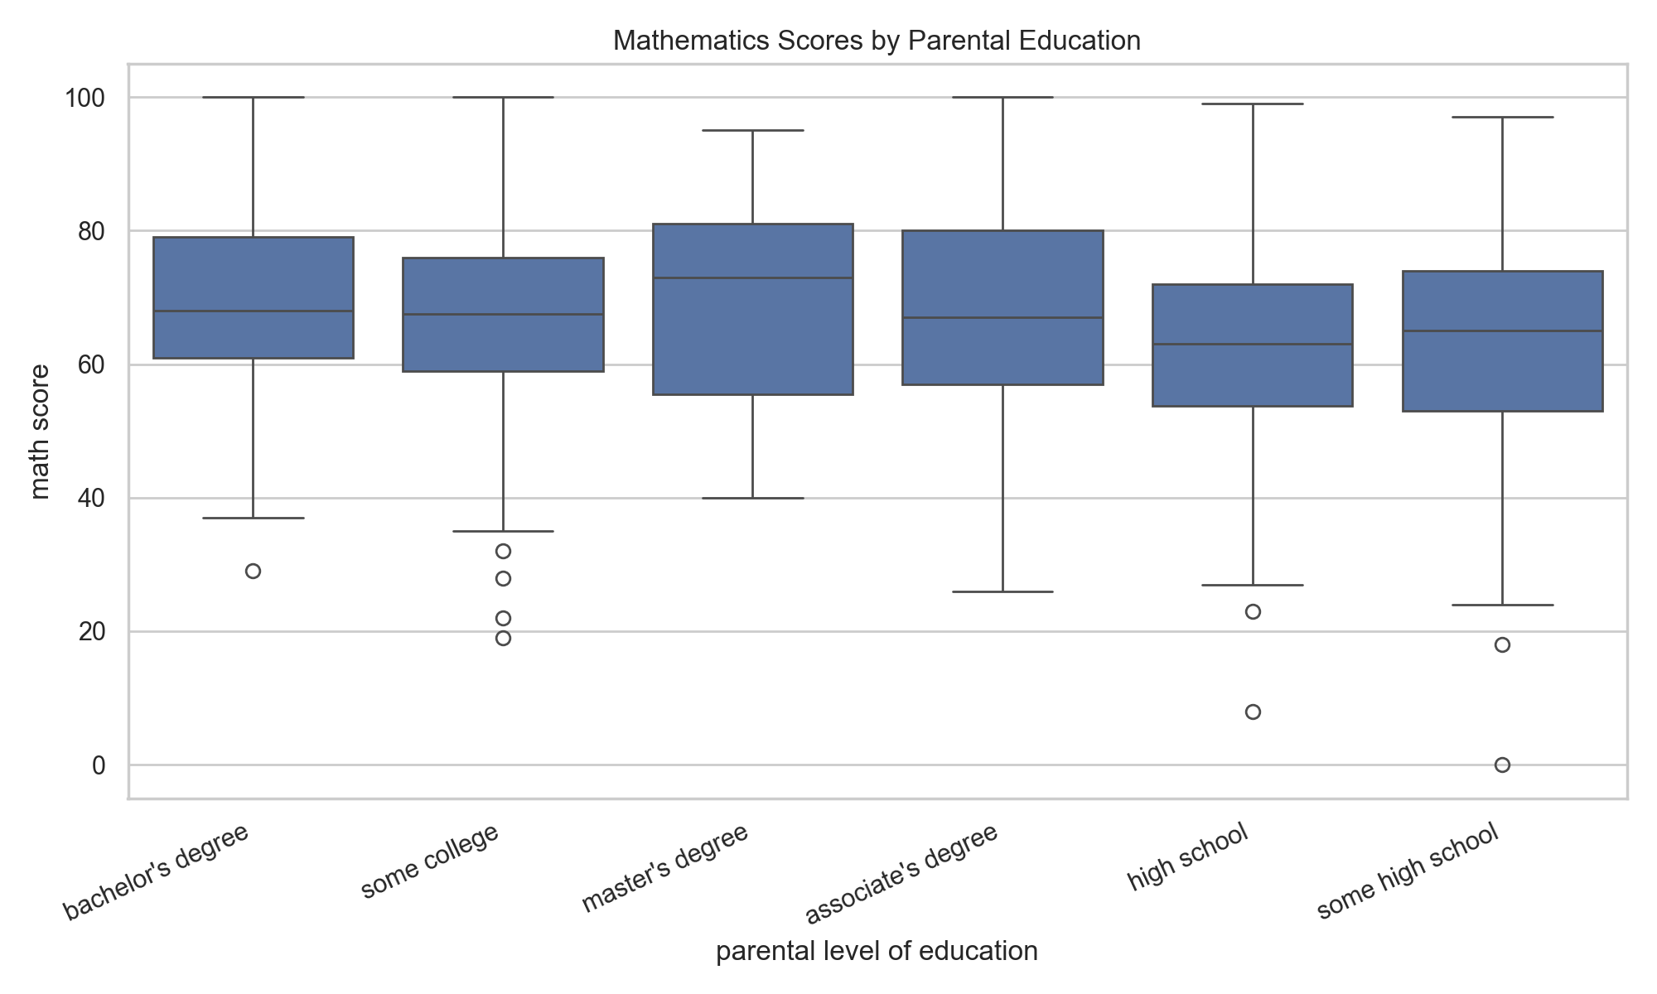
Figure 6. Mathematics score distribution across parental-education groups.
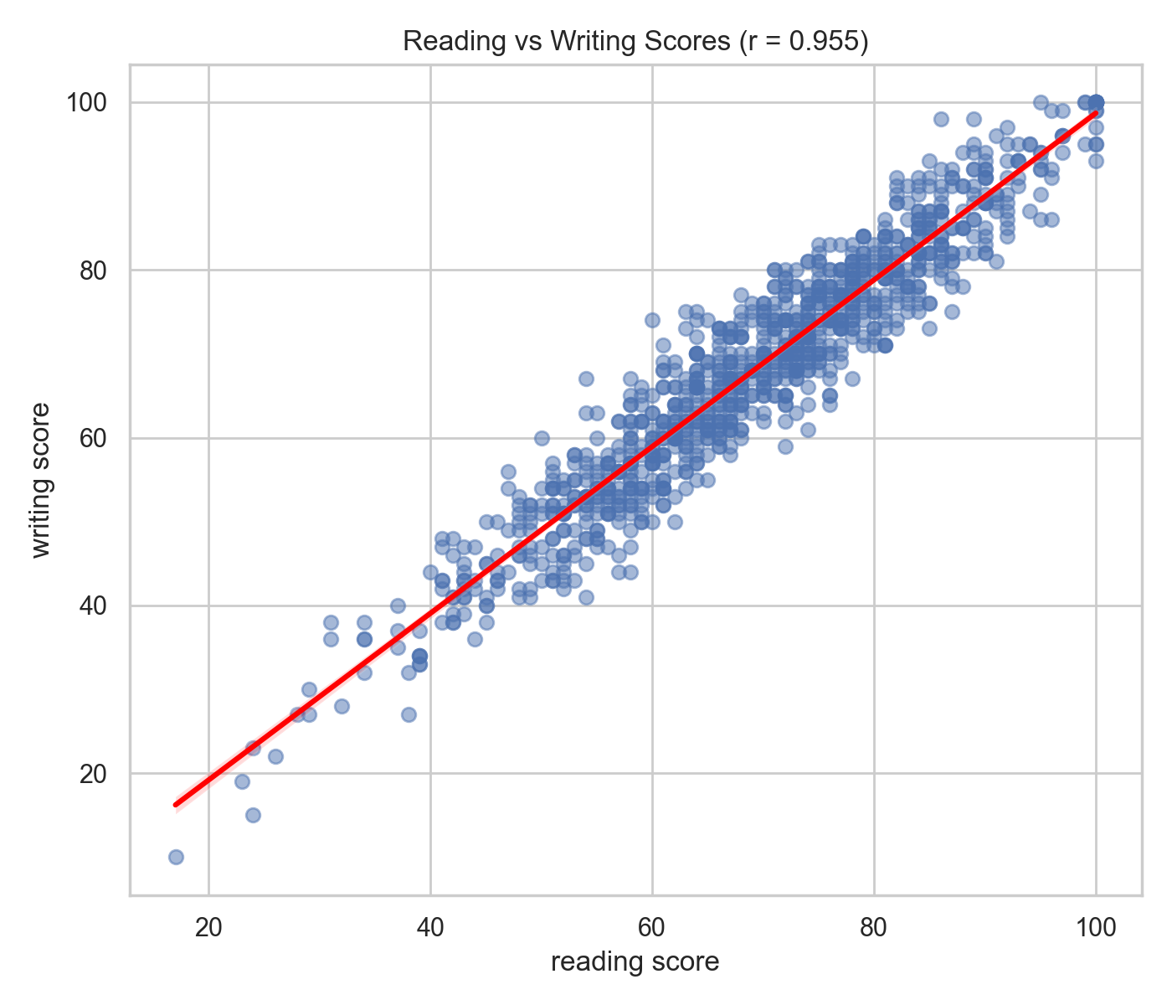
Figure 7. Reading and writing score relationship.

6. Week 5 – Machine Learning and Model Evaluation
The target variable was math score. The remaining seven original variables were used as predictors. The data was split into training and test subsets using an 80:20 split with random_state=42. Categorical predictors were transformed using OneHotEncoder(handle_unknown='ignore') inside a ColumnTransformer. The preprocessing transformer was fitted on training data and applied to test data.
Two regression algorithms were trained: Linear Regression and Random Forest Regression (100 estimators, random_state=42). Performance was measured with Mean Absolute Error (MAE), Mean Squared Error (MSE), Root Mean Squared Error (RMSE), and R-squared (R²).
Model | MAE ↓ | MSE ↓ | RMSE ↓ | R² ↑
Linear Regression | 4.2148 | 29.0952 | 5.3940 | 0.8804
Random Forest | 4.6655 | 36.3114 | 6.0259 | 0.8508

Linear Regression performed better on the recorded test split: it had lower MAE, MSE, and RMSE, and a higher R². Its R² of approximately 0.880 means the model explained about 88.0% of the variance in test-set mathematics scores for this split. The result is specific to this dataset and split and should not be treated as a guarantee of performance on new populations.
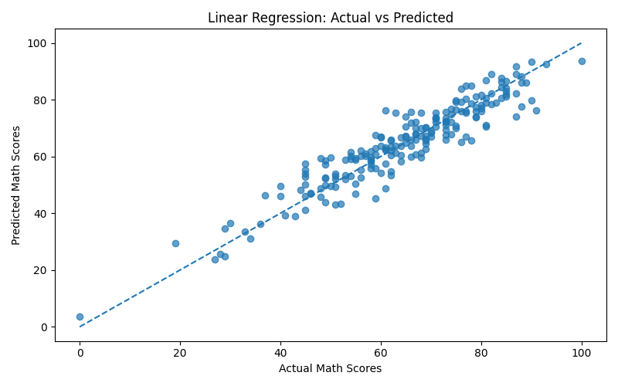
Figure 8. Linear Regression: actual versus predicted mathematics scores.
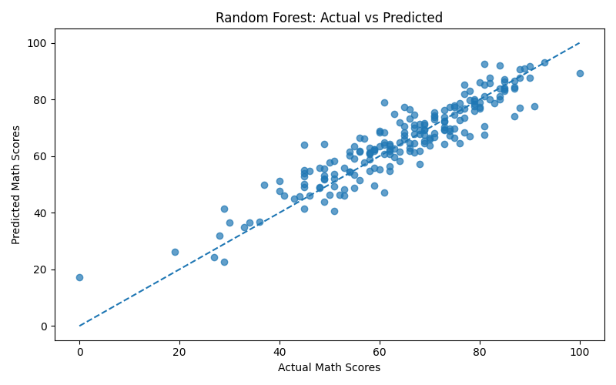
Figure 9. Random Forest: actual versus predicted mathematics scores.

7. Consolidated Key Findings
- The dataset contains 1,000 records and eight original variables, with no missing values or duplicate rows detected.
- Reading had the highest overall mean score (69.17), followed by writing (68.05) and mathematics (66.09).
- Students who completed test preparation had higher mean scores in mathematics, reading, and writing than students who did not.
- Standard-lunch students had higher average scores than free/reduced-lunch students in all three subjects in this dataset.
- Welch’s t-test found a statistically significant difference in mathematics scores by test-preparation status.
- ANOVA found evidence of differences in mathematics means across parental-education categories.
- Reading and writing scores had a very strong positive correlation (r ≈ 0.955).
- Linear Regression outperformed Random Forest on the recorded 80:20 test split for all four reported evaluation metrics.

8. Recommendations
- Use diagnostic assessment to identify students who may need additional support in mathematics, reading, or writing.
- Consider offering accessible test-preparation resources and monitor outcomes over time; the observed group difference alone does not prove the course caused the improvement.
- Use reading and writing performance together as a useful descriptive signal, while avoiding assumptions that one score causes the other.
- Investigate contextual factors such as access to learning resources and lunch category carefully and ethically; do not use these variables to stigmatize or limit students.
- Before deploying a predictive model, validate it on additional data, check subgroup performance, and assess fairness and potential bias.
- Explore cross-validation, hyperparameter tuning, feature importance, and additional algorithms in future work.

9. Limitations and Future Scope
- The dataset is observational; statistical relationships do not establish causal effects.
- The dataset contains limited contextual variables and may not represent all schools or student populations.
- The reported machine-learning metrics are based on one train-test split; repeated cross-validation would provide a more robust estimate.
- Future work can include model tuning, cross-validation, residual analysis, subgroup error analysis, and external validation on a separate dataset.
- Future analysis can explore whether additional contextual variables improve prediction while protecting student privacy and avoiding unfair use.

10. Tools, Libraries and Reproducibility
Tool / Library | Role in the project
Python | Programming language for the workflow
Pandas | Data loading, cleaning, grouping, and tabular outputs
NumPy | Numerical calculations
Matplotlib and Seaborn | Charts and visual exploration
SciPy / Statsmodels | Statistical tests and post-hoc analysis
Scikit-learn | Preprocessing, train-test split, regression models, evaluation
VS Code | Development environment

To reproduce the analysis, place the StudentsPerformance.csv dataset beside the relevant weekly Python script (or in the location expected by that script), install the required Python libraries, and run the scripts in order. The scripts and output files are maintained in their respective week folders.

11. Conclusion
This six-week internship project demonstrates a complete introductory data analytics pipeline, beginning with data exploration and preparation and progressing through visualization, statistical inference, and predictive modelling. The analysis identified meaningful patterns in student scores and showed that Linear Regression provided the strongest performance among the two tested models on the saved test split. The work strengthened practical skills in Python-based data handling, visualization, statistical reasoning, machine learning, and communicating results. The findings are useful for exploratory understanding, while any real educational decisions would require broader data, careful validation, and human judgement.

Appendix – Project Artifacts
- Week 1: data_analysis.py and README.md.
- Week 2: Week2_Data_Cleaning/cleaning.py and Week2_Preprocessing_Summary.csv.
- Week 3: visualization.py, create_report.py, chart outputs, score_summary.csv, and Week3_Data_Visualization_Report.docx.
- Week 4: statistical_analysis.py, statistical_results.csv, ANOVA/Tukey output, charts, and Week4_Statistical_Analysis_Report.docx.
- Week 5: machine_learning.py, model_comparison.csv, model_predictions.csv, and actual-versus-predicted plots.
GitHub repository: https://github.com/poonamfouzdar89-gif/Yuva-Intern-Week1-Data-Analysis
Note: The supplied ZIP archive did not contain a separate Week 5 Word report. This consolidated report documents Week 5 using the available script, CSV results, and plots.

