**Topics: Normal distribution, Functions of Random Variables**

1. The time required for servicing transmissions is normally distributed with *μ* = 45 minutes and *σ* = 8 minutes. The service manager plans to have work begin on the transmission of a customer’s car 10 minutes after the car is dropped off and the customer is told that the car will be ready within 1 hour from drop-off. What is the probability that the service manager cannot meet his commitment?
2. 0.3875
3. 0.2676
4. 0.5
5. 0.6987

**Answer: B**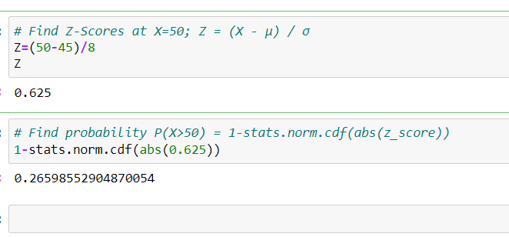

1. The current age (in years) of 400 clerical employees at an insurance claims processing center is normally distributed with mean *μ* = 38 and Standard deviation *σ* =6. For each statement below, please specify True/False. If false, briefly explain why.
2. More employees at the processing center are older than 44 than between 38 and 44.

**Answer: True**

1. A training program for employees under the age of 30 at the center would be expected to attract about 36 employees.

**Answer: True**

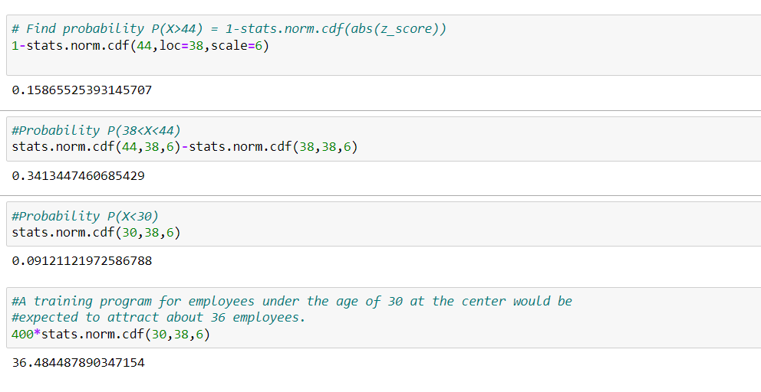

1. If *X1* ~ *N*(μ, σ2) and *X*2 ~ *N*(μ, σ2) are *iid* normal random variables, then what is the difference between 2 *X*1 and *X*1 + *X*2? Discuss both their distributions and parameters.

**Answer: The difference between https://tex.z-dn.net/?f=2%20X_1 and https://tex.z-dn.net/?f=X_1%20%2B%20X_2 is https://tex.z-dn.net/?f=N(%200%2C6%20%5Csigma%5E2).**

**According to the Central Limit Theorem, any large sum of independent, identically distributed(iid) random variables is approximately Normal.**

**The Normal distribution is defined by two parameters, the mean, https://tex.z-dn.net/?f=%5Cmu, and the variance, https://tex.z-dn.net/?f=%5Csigma%5E%7B2%7D and written as https://tex.z-dn.net/?f=X%20%5Csim%20N(%5Cmu%2C%20%5Csigma%5E2).**

**Given https://tex.z-dn.net/?f=X_1%20%5Csim%20N(%5Cmu%2C%20%5Csigma%5E2)~~%5Cmbox%7Band%7D~~%20X_2%20%5Csim%20N(%5Cmu%2C%20%5Csigma%5E2)  are two independent identically distributed random variables.**

**From the properties of normal random variables,**

**if https://tex.z-dn.net/?f=X%20%5Csim%20N(%5Cmu_1%2C%20%5Csigma_1%5E2) and https://tex.z-dn.net/?f=Y%20%5Csim%20N(%5Cmu_2%2C%20%5Csigma_2%5E2) are two independent identically distributed random variables then**

**the sum of normal random variables is given by**

**https://tex.z-dn.net/?f=X%20%2B%20Y%20%5Csim%20N(%5Cmu_1%20%2B%20%5Cmu_2%2C%20%5Csigma_1%5E2%20%2B%20%5Csigma_2%5E2%20),**

**and the difference of normal random variables is given by**

**https://tex.z-dn.net/?f=X%20-%20Y%20%5Csim%20N(%5Cmu_1%20-%20%5Cmu_2%2C%20%5Csigma_1%5E2%20%2B%20%5Csigma_2%5E2%20)**

**When  https://tex.z-dn.net/?f=Z%20%3D%20aX, the product of X is given by**

**https://tex.z-dn.net/?f=Z%20%5Csim%20N(a%5Cmu_1%20%2C%20a%5E2%5Csigma_1%5E2%20)**

**When  https://tex.z-dn.net/?f=Z%20%3D%20aX%20%2B%20bY, the linear combination of X and Y is given by**

**https://tex.z-dn.net/?f=Z%20%5Csim%20N(a%5Cmu_1%20%2B%20b%5Cmu_2%2C%20a%5E2%5Csigma_1%5E2%20%2B%20b%5E2%5Csigma_2%5E2%20)**

**Given to find, https://tex.z-dn.net/?f=2X_1**

**Thus, following the property of multiplication, we get**

**https://tex.z-dn.net/?f=2X_1%20%5Csim%20N(2%5Cmu%2C%202%5E2%5Csigma%5E2)%5Cimplies2X_1%20%5Csim%20N(2%5Cmu%2C%204%5Csigma%5E2)**

**and following the property of addition,**

**https://tex.z-dn.net/?f=X_1%2BX_2%5Csim%20N(%5Cmu%20%2B%20%5Cmu%2C%20%5Csigma%5E2%20%2B%20%5Csigma%5E2%20)%20%5Csim%20N(2%5Cmu%2C%202%5Csigma%5E2%20)**

**And the difference between the two is given by**

**https://tex.z-dn.net/?f=2X_1-(X_1%2BX_2)%20%5Csim%20N(2%5Cmu%20-%202%5Cmu%2C%202%5Csigma_1%5E2%20%2B%204%5Csigma_2%5E2%20)%5Csim%20N(%200%2C6%20%5Csigma%5E2)**

**The mean of https://tex.z-dn.net/?f=2X_1 and https://tex.z-dn.net/?f=X_1%2BX_2 is same but the var(https://tex.z-dn.net/?f=%5Csigma%5E2) of  https://tex.z-dn.net/?f=2X_1 is 2 times more than the variance of https://tex.z-dn.net/?f=X_1%2BX_2.**

**The difference between the two says that the two given variables are identically and independently distributed.**

1. Let X ~ N(100, 202). Find two values, *a* and *b*, symmetric about the mean, such that the probability of the random variable taking a value between them is 0.99.
2. 90.5, 105.9
3. 80.2, 119.8
4. 22, 78
5. 48.5, 151.5
6. 90.1, 109.9

**Answer: D**

1. Consider a company that has two different divisions. The annual profits from the two divisions are independent and have distributions Profit1 ~ N(5, 32) and Profit2 ~ N(7, 42) respectively. Both the profits are in $ Million. Answer the following questions about the total profit of the company in Rupees. Assume that $1 = Rs. 45
2. Specify a Rupee range (centered on the mean) such that it contains 95% probability for the annual profit of the company.

**Answer: Mean Profit of a company in rupee is 12*45= 540 million**

|  |  |
| --- | --- |
| **Division 1** | **Division 2** |
| **N(5,9)** | **N(7,16)** |
|  |  |

**µ=mean 1+mean 2**

**= 5+7**

**= 12**

**Variance of company distribution = σ^2 = 9+16=25 ^2 =225**

**Standard Deviation of company = sqrt 25=5**

**Confidence Level = 0.95**

**Confidence Interval = x̄ ± zα/2(σ/√n)**

**=540= +/-1.96(225)**

**=99981 millions**

1. Specify the 5th percentile of profit (in Rupees) for the company

**Answer:** Specify the 5th percentile of profit (in Rupees) for the company

          To calculate 5th percentile from Z table Zα/2= 0.05 = -1.645

                         5th percentile   = µ - Zα/2= 0.05(σ)

                                                    = 540 – 1.645(225)

                                                    = 169.87 Million

1. Which of the two divisions has a larger probability of making a loss in a given year?

**Answer:** 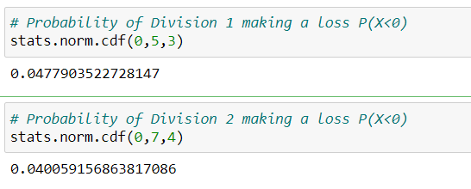

**Division 1 is having a larger probability of making a loss in a given year**