Opportunity Intelligence Agent
PRD • SerpApi India Hackathon 2026 • Multi-Agent Product Specification
Product thesis: turn opportunity discovery into a closed-loop workflow that can discover, investigate, verify, personalize, prepare, execute approved actions, and monitor opportunities over time.

1. Problem
- Opportunities are fragmented across jobs, university/lab, company, research and other web sources.
- Users must manually verify eligibility, compare requirements with their profile, identify skill gaps, research organizations/people, prepare applications and remember follow-ups.
- Opportunity information changes after discovery; a saved link can become stale.
- Search engines provide information, but the user still has to coordinate the workflow.

2. Proposed Solution
A stateful multi-agent system where each agent owns one part of the opportunity lifecycle. SerpApi provides structured live search data; an orchestrator decides which agent runs next and maintains the opportunity state.
Core loop: Discover → Investigate → Verify → Match → Prepare → User Approval → Act → Monitor → Re-investigate when needed.

3. Primary Users
User | Examples | Value
Students | Internships, research, scholarships, hackathons | Relevant opportunities + preparation
Job seekers | Jobs + networking | Fit analysis + application workflow
Researchers | Labs, positions, collaborators | Research alignment + outreach

4. Product Guardrail
The system is autonomous for research and drafting, but external/irreversible actions remain human-approved. It must never invent qualifications or submit false information.

Generated Full Multi-Agent Architecture
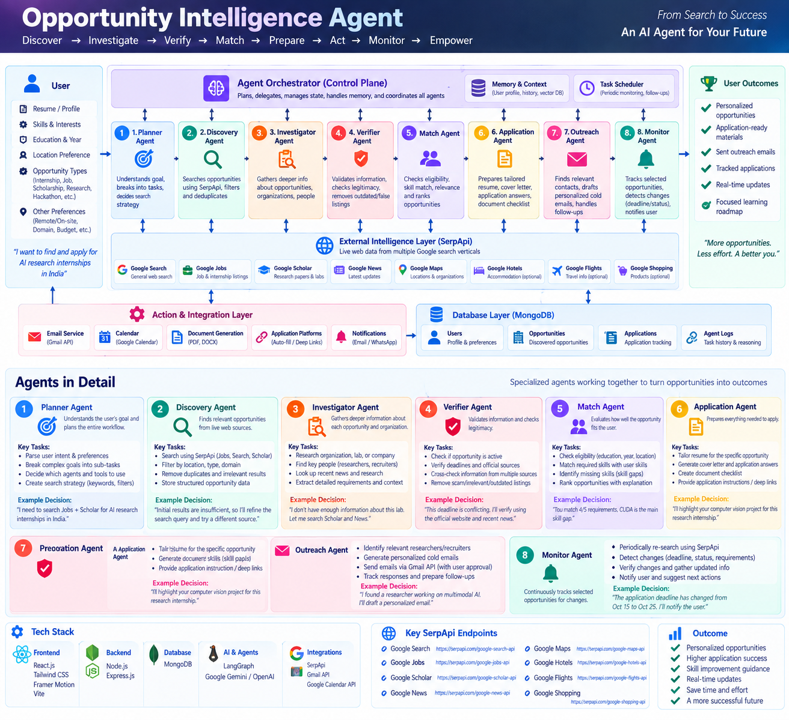
Figure: Complete Opportunity Intelligence architecture — all agents, SerpApi intelligence sources, memory, scheduler, integrations, and outcomes.

Complete Multi-Agent Architecture
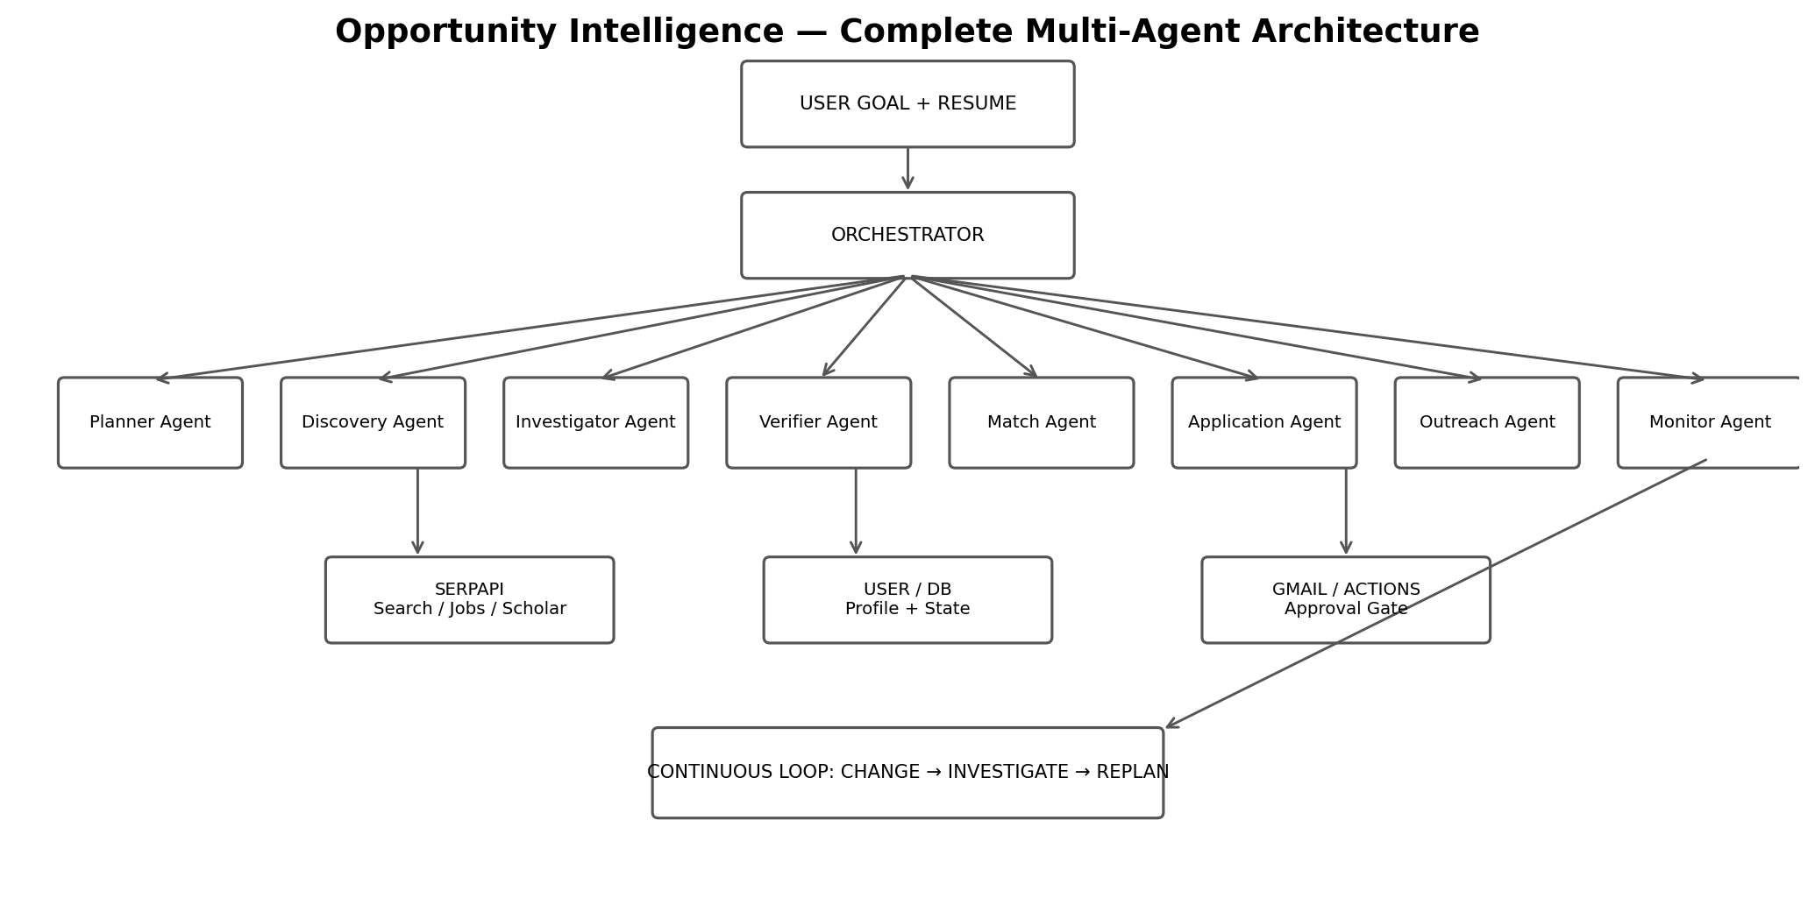
Figure 1. The generated architecture is embedded directly in this PRD. The Orchestrator coordinates specialized agents; SerpApi is the live web intelligence layer; profile/database state provides memory; an approval gate controls external actions.

5. All Agents — Responsibilities
Agent | What it does | Agentic decision
1. Planner | Parses user goal, constraints and desired opportunity type; creates research plan. | What must be searched and which constraints matter?
2. Discovery | Searches and normalizes candidate opportunities; deduplicates and filters. | Should I refine the query or search another vertical?
3. Investigator | Deep-researches promising opportunities, organizations, labs and relevant people. | What information is missing before this can be evaluated?
4. Verifier | Cross-checks critical facts such as deadline, eligibility and status across evidence. | Is the important claim sufficiently supported or should I verify again?
5. Match | Compares explicit requirements with profile, preferences and experience; identifies gaps. | How does this opportunity fit this specific user?
6. Application | Creates tailored resume suggestions, cover letter, answers and document checklist. | What application material should be prepared for this opportunity?
7. Outreach | Finds relevant public professional contacts and drafts targeted outreach using evidence. | Who is relevant to contact and why is the outreach personalized?
8. Monitor | Re-checks watched opportunities, compares current vs baseline state and triggers re-investigation. | Did something meaningful change and does it affect the user?

6. Orchestrator
The Orchestrator is not a separate research agent; it is the control plane. It stores task state, routes work between agents, prevents duplicate work, invokes tools, and pauses at human-approval checkpoints.

Functional Requirements & Agentic Behavior
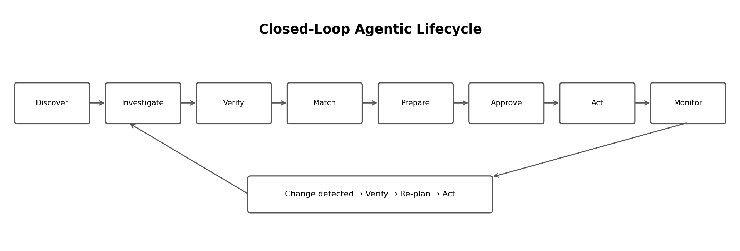
Figure 2. Closed-loop lifecycle. Monitoring can feed a changed opportunity back into verification and planning rather than producing a blind notification.

7. End-to-End Flow
- User provides a goal plus resume/profile and preferences.
- Planner creates search constraints and delegates discovery.
- Discovery uses SerpApi to find opportunities and removes duplicates/noisy results.
- Investigator performs second-hop research only when more evidence is needed.
- Verifier cross-checks critical fields and marks uncertainty when evidence conflicts.
- Match Agent produces transparent dimensions: eligibility, skill match, preference fit and research alignment.
- Application Agent prepares opportunity-specific materials; Outreach Agent prepares targeted networking email.
- User reviews and approves any external action; only then does the execution layer send/submit.
- Monitor Agent watches selected opportunities and, on change, triggers verification → re-planning → updated action.

8. Key Agentic Actions
Capability | Autonomy | Example
Adaptive search | Autonomous | Weak results → generate a narrower query.
Second-hop research | Autonomous | Missing lab context → search organization/researcher sources.
Evidence verification | Autonomous | Deadline conflict → search again before reporting it.
Skill-gap analysis | Autonomous | Requirement CUDA + profile lacks CUDA → flag gap.
Application drafting | Autonomous draft | Tailor cover letter and resume emphasis.
Outreach drafting | Autonomous draft | Generate a targeted email from public professional context.
Send / submit | Human approval | Show final action payload, then execute.
Monitoring | Autonomous | Detect deadline/status/requirement change.

9. Evidence & Trust
- Every material claim should retain its source URL/search evidence.
- Explicit listing requirements must be separated from AI inference.
- Conflicting evidence should create an uncertainty state, not a fabricated answer.
- Keep an activity timeline: search → evidence → reasoning output → draft → approval → action.

Technical Architecture, Stack & APIs

10. Recommended Stack
Layer | Technology | Role
Web UI | React + Vite + Tailwind CSS | Dashboard, agent timeline, opportunity detail
API | Node.js + Express | Auth, REST endpoints, business logic
Agent runtime | Python + LangGraph | Stateful orchestration and agent workflows
LLM | Gemini API or equivalent | Planning, extraction, matching, drafting
Database | MongoDB Atlas | Profiles, opportunities, evidence, applications, monitoring state
Search | SerpApi | Live structured search/retrieval
Email | Gmail API | User-authorized draft/send
Scheduler | Cron / managed scheduler | Periodic monitoring
Deploy | Vercel + Render/Cloud Run | Frontend + backend/agents

11. SerpApi Mapping
SerpApi engine | Product role
Google Search | General opportunity, organization and official-page discovery
Google Jobs | Jobs/internships discovery
Google Scholar | Researcher, publication and research-area investigation
Google News | Recent organization/opportunity updates
Google Maps | Location and organization context
Google Flights / Hotels | Optional travel planning for relevant opportunities

12. Official API / Documentation Links
SerpApi — Documentation
SerpApi — Pricing / Free plan
Google Search API
Google Jobs API
Google Scholar API
Google News results
Google Maps API
Google Flights API
Google Hotels API
SerpApi Markdown output
LangGraph
Gemini API
Gmail API
MongoDB
Quota note: the hackathon brief states that a free SerpApi account provides 250 search credits each month for building/testing. Design the MVP around caching, deduplication and selective second-hop searches so the agent does not waste calls.

MVP, Data Model & Hackathon Demo

13. MVP Scope
- Resume/profile ingestion with opportunity preferences.
- Agentic SerpApi discovery for jobs/research opportunities.
- Investigator + Verifier loop for evidence and current status.
- Transparent Match view with eligibility, matched skills, gaps and citations.
- Application Agent: tailored resume suggestions, cover letter and checklist.
- Outreach Agent: relevant-contact discovery + personalized email draft.
- Approval Gate: user confirms external communication/submission.
- Monitor Agent: watchlist + change detection + re-verification.

14. Suggested Data Model
Collection | Important fields
users | profile, education, skills, preferences, documents, consent
opportunities | title, organization, URL, deadline, requirements, evidence, baseline
matches | eligibility, skill matches, gaps, rationale, uncertainty
applications | status, documents, approvals, actions, timestamps
contacts | public professional identity, relevance evidence, outreach state
monitoring | baseline snapshot, last check, changes, alert state

15. Demo Narrative
User: “Find AI research internships in India that match my profile and help me apply.”
Show: Planner → SerpApi discovery → Investigator finds missing lab/research context → Verifier confirms deadline → Match identifies a skill gap → Application and Outreach agents prepare materials → user approves → Monitor later detects a changed deadline and re-verifies it.

16. Success Metrics
Metric | MVP target
Search relevance | At least 5 useful results from one user goal
Evidence coverage | Major claims have supporting source evidence
Agentic loop | At least one adaptive/second-hop search is demonstrated
Action readiness | One complete application package is generated
Monitoring | One controlled change is detected and re-verified
Human control | No external action without explicit approval

17. Core Pitch
“We don't just find opportunities. Our multi-agent system investigates them, verifies them, matches them to you, prepares you to apply, helps you reach the right people, and keeps watching until the opportunity changes or you act.”
Implementation principle: build fewer agents deeply. The eight-agent architecture is modular, but the hackathon MVP should prioritize Discovery + Investigator + Verifier + Match + Action + Monitor, with Planner and Orchestrator coordinating the loop.

Agent Reference — What Each Agent Actually Does
Agent | Role | Agentic Decision | Example
Planner Agent | Understands the user's goal, constraints and preferences, then converts one broad request into a concrete research plan. | Decides what needs to be searched, which constraints matter, and which agents/tools should run first. | Example: “Find AI research internships in India” → plans Jobs + Scholar + Search research.
Discovery Agent | Finds candidate opportunities using live SerpApi results, normalizes them and removes duplicates/noise. | Decides when results are weak and a query should be refined or another search vertical should be used. | Example: searches internship listings, company pages and research positions.
Investigator Agent | Performs deeper second-hop research on promising opportunities, organizations, labs, recruiters or researchers. | Decides what missing context must be collected before an opportunity can be evaluated. | Example: after finding a lab internship, researches the lab's research areas and recent work.
Verifier Agent | Cross-checks important facts such as deadline, eligibility, active status and requirements. | Decides whether evidence is strong enough or whether another search is required. | Example: deadline differs across sources → re-checks the official source before reporting it.
Match Agent | Compares opportunity requirements with the user's education, skills, experience and stated preferences. | Decides which requirements match, which gaps exist and which uncertainties should be surfaced. | Example: opportunity requires CUDA; profile lacks CUDA → identifies it as a skill gap.
Application Agent | Prepares opportunity-specific application material: resume emphasis, cover letter, answers and checklist. | Decides which genuine parts of the user's profile should be highlighted for the specific opportunity. | Example: highlights the user's relevant computer-vision project for a research internship.
Outreach Agent | Finds relevant public professional contacts and drafts personalized outreach messages. | Decides who is relevant to contact and what evidence makes the message specific rather than generic. | Example: identifies a researcher working on multimodal AI and drafts a targeted email.
Monitor Agent | Periodically re-checks watched opportunities and compares the latest state with the saved baseline. | Decides whether a change is meaningful enough to trigger verification, replanning or a user alert. | Example: deadline changes → re-verifies the listing and updates the user.

How the Agents Work Together
- The Orchestrator is the control plane: it maintains state, delegates work, handles retries and moves the opportunity through the lifecycle.
- Agents do not all run blindly. The workflow is conditional: weak discovery can trigger query refinement; missing evidence triggers investigation; conflicting facts trigger verification; a meaningful change triggers re-planning.
- SerpApi is the live intelligence layer connecting the agents to Search, Jobs, Scholar, News, Maps and optional Flights/Hotels/Shopping sources.
- External actions are approval-gated. Drafting can be autonomous, but sending an email or submitting an application requires explicit user approval.

Cold Mailing & Outreach Automation
Cold mailing is a core agentic capability of the Outreach Agent. The agent does not simply generate a generic email: it identifies a relevant public professional contact, collects evidence about their role/research/work, and uses that context to prepare a personalized outreach message.

Cold-Mailing Agent Flow
- Opportunity Agent finds a relevant internship, job, research position or other opportunity.
- Investigator Agent identifies potentially relevant recruiters, professors, researchers, founders or team members using public web information.
- Outreach Agent verifies why the person is relevant to the opportunity and collects personalization context.
- Outreach Agent drafts a concise, personalized cold email using only truthful information from the user's profile and source-backed context.
- Human Approval Gate shows the recipient, subject, body and supporting context before anything is sent.
- After approval, the Gmail API can send the email through the user's authorized account.
- The system stores the outreach status and can prepare a follow-up when appropriate; follow-up sending remains approval-gated.

Example
User goal: “Find AI research internships and help me reach relevant researchers.”
- Discovery finds a research internship.
- Investigator finds the lab and relevant researcher.
- Outreach Agent finds a genuine connection between the researcher's work and the user's projects/skills.
- Agent prepares a personalized email rather than a mass template.
- User approves the final email.
- Gmail API sends it and the application/outreach timeline records the action.

Agentic Value
Step | Agent decision | Result
Find contact | Who is actually relevant to this opportunity? | Targeted contact
Research context | What makes this person relevant? | Personalization evidence
Personalize | What truthful user experience connects to their work? | Specific email
Approve | Is the user happy with the final message? | Human-controlled action
Send | Should the approved email be sent now? | Gmail action
Follow up | Has a response arrived / is follow-up appropriate? | Drafted follow-up

Important Guardrail
The system should not mass-email, spam contacts, fabricate relationships, or invent qualifications. Cold emails are targeted, evidence-informed and explicitly approved by the user before sending.

