1. **What is Kubernetes?**

* Kubernetes is a portable, extensible, open source platform for managing containerized workloads and services, that facilitates both declarative configuration and automation.
* It has a large, rapidly growing ecosystem. Kubernetes services, support, and tools are widely available.

1. **Why Kubernetes?**

* Kubernetes provides an easy way to scale your application, compared to virtual machines.
* It keeps code operational and speeds up the delivery process.
* Kubernetes API allows automating a lot of resource management and provisioning tasks.
* Building on top of Kubernetes may also prepare you for cloud migration in the future.

1. **What Kubernetes can do?**

* Containers are a good way to bundle and run your applications. In a production environment, you need to manage the containers that run the applications and ensure that there is no downtime. For example, if a container goes down, another container needs to start.

1. **What is the difference between Kubernetes and Docker Swarm?**

* Docker swarm is a default container orchestration tool that comes with Docker.
* Docker swarm can only orchestrate simle Docker containers
* Kubernetes on the other hand helps mange much more complex software application containers.
* Kubernetes offers support for large demand production environment.
* Docker swarm can’t do auto scalling
* Docker Swarm doesn’t have a GUI
* Docker can deploy rolling updates but can’t deploy automatic rollbacks
* Docker requires third-party tools like ELK stack for logging and monitoring while Kubernetes has integrated tools for the same
* Docker Swarm can share storage volumes with any container easily while Kubernetes can only share storage volumes with containers in the same pod.

1. **What is a Heapster?**

* In a Kubernetes cluster, application performance can be examined at many different levels: containers, [pods](https://kubernetes.io/docs/user-guide/pods), [services](https://kubernetes.io/docs/user-guide/services), and whole clusters.
* As part of Kubernetes we want to provide users with detailed resource usage information about their running applications at all these levels.
* This will give users deep insights into how their applications are performing and where possible application bottlenecks may be found.
* In comes [Heapster](https://github.com/kubernetes/heapster), a project meant to provide a base monitoring platform on Kubernetes.
* Heapster is a cluster-wide aggregator of monitoring and event data.
* It currently supports Kubernetes natively and works on all Kubernetes setups.
* Heapster runs as a pod in the cluster, similar to how any Kubernetes application would run.
* The Heapster pod discovers all nodes in the cluster and queries usage information from the nodes’ [Kubelets](https://github.com/kubernetes/kubernetes/blob/master/DESIGN.md" \l "kubelet), the on-machine Kubernetes agent. The Kubelet itself fetches the data from [cAdvisor](https://github.com/google/cadvisor).
* Heapster groups the information by pod along with the relevant labels. This data is then pushed to a configurable backend for storage and visualization.

1. **What is kubelet?**

* The Kublet is a service agent that controls and maintains a set of pods by watching pod specs through the Kubernetes API server.
* It preserves the pod lifecycle by ensuring that a given set of containers are all running as they should.
* The kublet runs on each node and enables the communication between master and slave nodes.
* **Refer the link:** https://kubernetes.io/docs/reference/command-line-tools-reference/kubelet/

1. **What is kubectl?**

* The Kubernetes command-line tool, [kubectl](https://kubernetes.io/docs/reference/kubectl/kubectl/), allows you to run commands against Kubernetes clusters.
* You can use kubectl to deploy applications, inspect and manage cluster resources, and view logs.

1. **What are the different services within Kubernetes?**

**Different types of Kubernetes services are**

**Cluster IP:**

* In ClusterIP, the services are not available for external access of the cluster and used for internal communications between different Pods or microservices in the cluster.

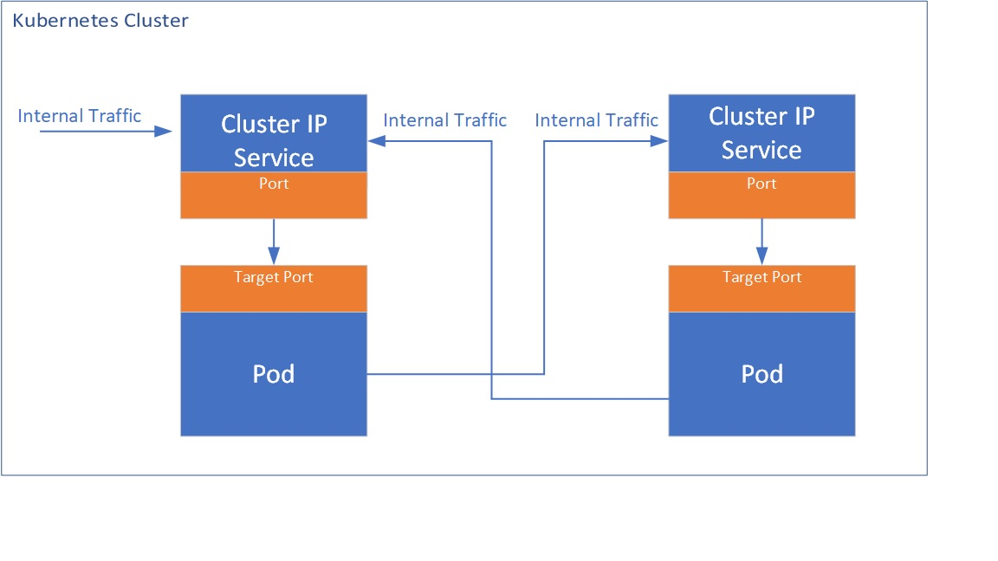

**Node Port:**

* This service exposes outside and allows the outside traffic to connect to Kubernetes Pods through the node port which is the port opened at Node end.
* The Pods can be accessed from external using <NodeIp>:<Nodeport>
* If there are multiple nodes, multiple IP addresses with the same port can be exposed.

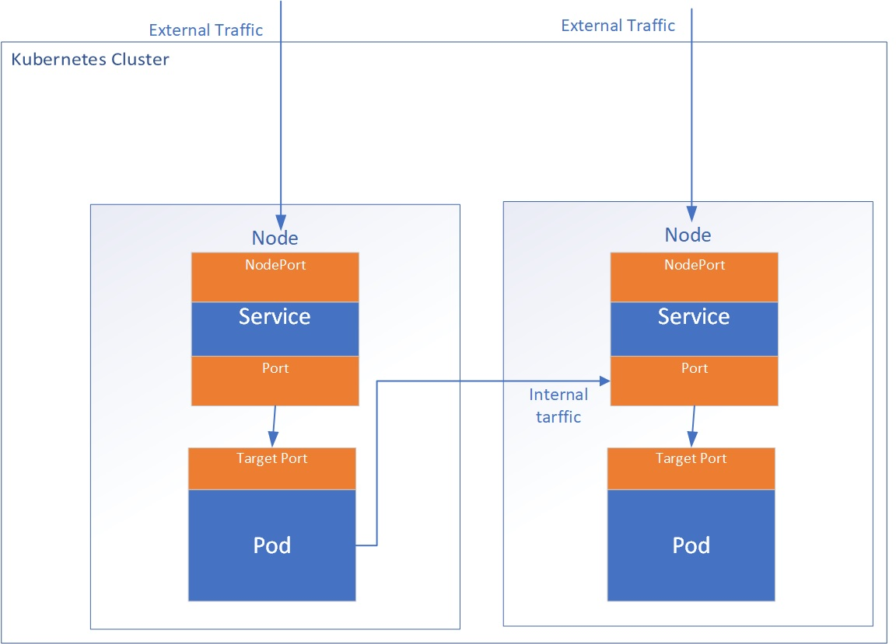

* Each node in your cluster has an open port called a NodePort. Even if your app runs on a different node, Kubernetes straightforwardly routes traffic from the NodePort to the service.
* Every Kubernetes cluster accepts NodePort, but you have to modify your firewalls if you’re using a cloud service provider like Google Cloud.

**Load Balancer:**

* This service will use or dynamically create an external load balancer like a cloud load balancer when running in the cloud.
* This uses Network load balancer (Layer 4 load balancer).  This generates additional costs for additional load balancer components.
* The advantage of this service is external load balancer features can be leveraged.

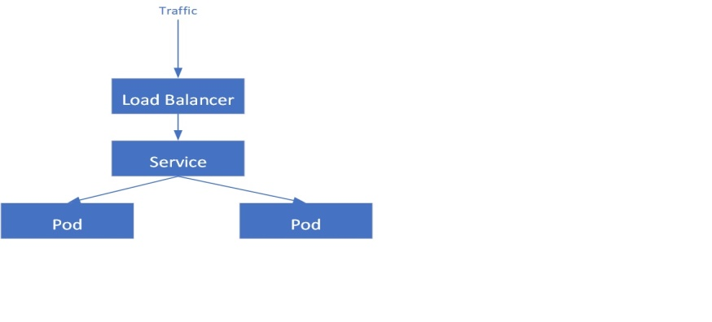

**Ingress:**

* This service allows the routing of HTTP(S) traffic according to defined rules like path-based routings.
* This can be associated with one or more service objects where these services are further associated with Pods. The ingress controller creates HTTP(S) load balancer Layer 7 load balancer which are configured automatically using the definition in the Ingress object.

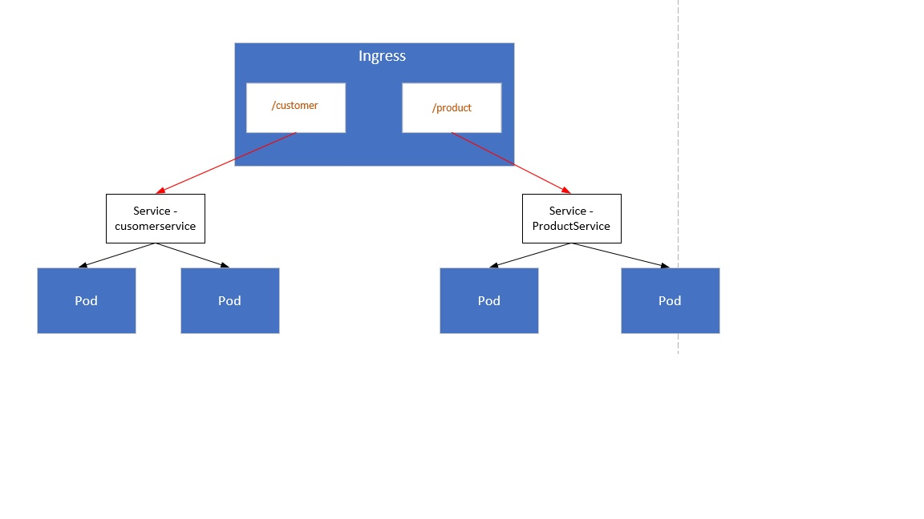

1. **How to set a static IP for Kubernetes load balancer?**

* Kubernetes Master assigns a new IP address.
* We can set a static IP for Kubernetes load balancer by changing the DNS records whenever Kubernetes Master assigns a new IP address.

1. **What is ETCD?**

* etcd is a consistent and highly-available key value store used as Kubernetes' backing store for all cluster data.
* If your Kubernetes cluster uses etcd as its backing store, make sure you have a [back up](https://kubernetes.io/docs/tasks/administer-cluster/configure-upgrade-etcd/" \l "backing-up-an-etcd-cluster) plan for those data.
* Kubernetes uses etcd as a distributed key value store for all of its data, including metadata and configuration data, and allows nodes in Kubernetes clusters to read and write data.
* ETCD represents the state of a cluster at a specific moment in time and is a center for state management and cluster coordination of a Kubernetes cluster.

1. **Can you use many claims out of a persistent volume?**

* The mapping between persistentVolume and persistentVolumeClaim is always one to one.
* Even when you delete the claim, PersistentVolume still remains as we set persistentVolumeReclaimPolicy is set to Retain and It will not be reused by any other claims.

1. **How do you deploy a feature with zero downtime in Kubernetes?**

* In Kubernetes you can define the update strategy in deployments, you should put Rolling Update as a strategy to ensure no down time.
* **Refer the link:** https://kubernetes.io/blog/2018/04/30/zero-downtime-deployment-kubernetes-jenkins/

1. **What is the difference between replication controllers and replica sets?**

* Replica Set and Replication Controller do almost the same thing. Both of them ensure that a specified number of pod replicas are running at any given time.
* The difference comes with the usage of selectors to replicate pods. Replica Set use Set-Based selectors while replication controllers use Equity-Based selectors.

1. **What is Kube-proxy?**

* kube-proxy is a network proxy that runs on each [node](https://kubernetes.io/docs/concepts/architecture/nodes/) in your cluster, implementing part of the Kubernetes [Service](https://kubernetes.io/docs/concepts/services-networking/service/) concept.
* [kube-proxy](https://kubernetes.io/docs/reference/command-line-tools-reference/kube-proxy/) maintains network rules on nodes. These network rules allow network communication to your Pods from network sessions inside or outside of your cluster.
* kube-proxy uses the operating system packet filtering layer if there is one and it's available. Otherwise, kube-proxy forwards the traffic itself.

1. **What is a Headless Service?**

* Headless service is similar to that of a ‘Normal’ service but does not have a Cluster IP.
* This service enables you to directly reach the pods without the need of accessing it through a proxy.

1. **Explain PVC?**

**PVC (Persistent Volume Claim):**

* It is storage requested by Kubernetes for pods. The user does not know the underlying provisioning.
* The claim should be created in the same namespace where the pod is created.
* **Refer the link:** https://kubernetes.io/docs/concepts/storage/persistent-volumes/

1. **Tell us about the different components of Kubernetes architecture**

* **Refer the Link:** https://kubernetes.io/docs/concepts/overview/components/

1. **If you have to pass sensitive information in you cluster how would you do it?**

* We can pass sensitive information in Kubernetes using secretes. Secrets can be created through yaml and text files.
* Majority of the organization use secret to pass sensitive information like username and password.
* **Refer the link:** https://kubernetes.io/docs/concepts/configuration/secret/

1. **What is sematext Docker agent?**

* Sematext Docker agent is a log collection agent with events and metrics.
* It runs as a small container in each Docker host.
* These agents gather metrics, events, and logs for all cluster nodes and contianers.
* **Refer Links:** https://github.com/sematext/sematext-agent-docker

1. **If you delete a pod(created as part of deployment) what happens to information inside of it?**

* Deployment will make sure that a new pod is created to maintain the number of replicas.
* Now talking about the information, it depends on the type of volume mount used, if you want information to be retained then you need to use persistent volume.

1. **Is there any pattern to pods being assigned to nodes? Can you make sure a Pod gets scheduled to a particular node?**

* Generally when you create a pod spawns automatically on any node(scheduled by Kubernetes internally to mange work-load and resources) but let’s say if you want to spawn a pod on a particular node that can also be done through taints.

1. **Let’s say a Kubernets job should finish in 20 seconds, however sometimes it takes 5 minutes, how I can make sure to stop the application if it exceeds more than 40 seconds.**

* When we create a job spec, we can give - -activeDeadlineSeconds flag to the command, this flag relates to the duration of the job, once the job reaches the threshold specified by the flag the job will be terminated.

1. **What is liveness and readiness probe?**

->Liveness Probe:-Kubernetes uses liveness probes to know when to restart a container.If a container is unresponsive -perhaps the application is deadlocked due to a multi-threading defect-restarting the container can make the application more available,despite the defect.

Readiness Probe:-Kubernetes uses readiness probes to decide when the container is available for accepting traffic. The readiness probe is used to control which pods are used as the backeds of the service.

**Q.Can we deploy a pod on particular node?**

**->Yes .**