Project - Legal Operations Assistant (Week-2)

1. Objective and Prompt
  - A simple guide to what it does and how it works
Think of the assistant as a guide to a small company-policy library. It finds useful information, writes an answer and checks the answer against its sources before showing it.

What problem does it solve?
Employees often need help finding the right legal procedure. This assistant provides a starting point for questions about contracts, confidentiality, employee information and vendors.
Example question | How the assistant helps
How do I request contract review? | Explains the documented steps and information to provide.
Can I share employee details with a vendor? | Explains the required Privacy review and approvals.
Is an NDA enough before sharing data? | Explains relevant confidentiality and Privacy conditions.
Approve sharing this spreadsheet now. | Directs the employee to Legal; it cannot grant approval.

Prompt : Act as an internal Legal Operations assistant. Answer using only the supplied evidence, preserve conditions and exceptions, and cite supporting passages. Explain gaps; direct requests requiring legal interpretation, approval or unsupported conclusions to Legal.
Note: The assistant cannot grant approval, verify actual signing authority, determine enforceability or make decisions reserved for Legal

2. Framework
Field | Current implementation
Use case | Employees receive cited Legal Operations guidance or a Contact Legal message through a Streamlit portal hosted on Replit, with claim validation before responses are displayed.
Corpus | Fictional English FAQs, policies and reviewed matters: 13 JSON/PDF content files and 49 passages. Local samples supply the source text; Pinecone stores searchable vectors and metadata.
Ingestion + cleaning | Read JSON and text-based PDFs; validate eligibility, dates, IDs and content. Trim whitespace and skip blank pages. Scanned PDFs and advanced document cleanup are not supported.
Ingestion + freshness | Administrator uploads a new versioned Pinecone snapshot after source changes. Startup verifies the existing snapshot and prepares a local manifest; it never uploads. No scheduled refresh or freshness SLA.
Chunking + embedding | Section/sentence-aware chunks: 220 tokens, up to 40-token overlap. Local MiniLM-L6-v2, producing 384-dimensional vectors.
Retrieve | Pinecone semantic + BM25 keyword search, up to 12 candidates each. RRF fusion and deduplication select the top four passages.

3. Architecture:
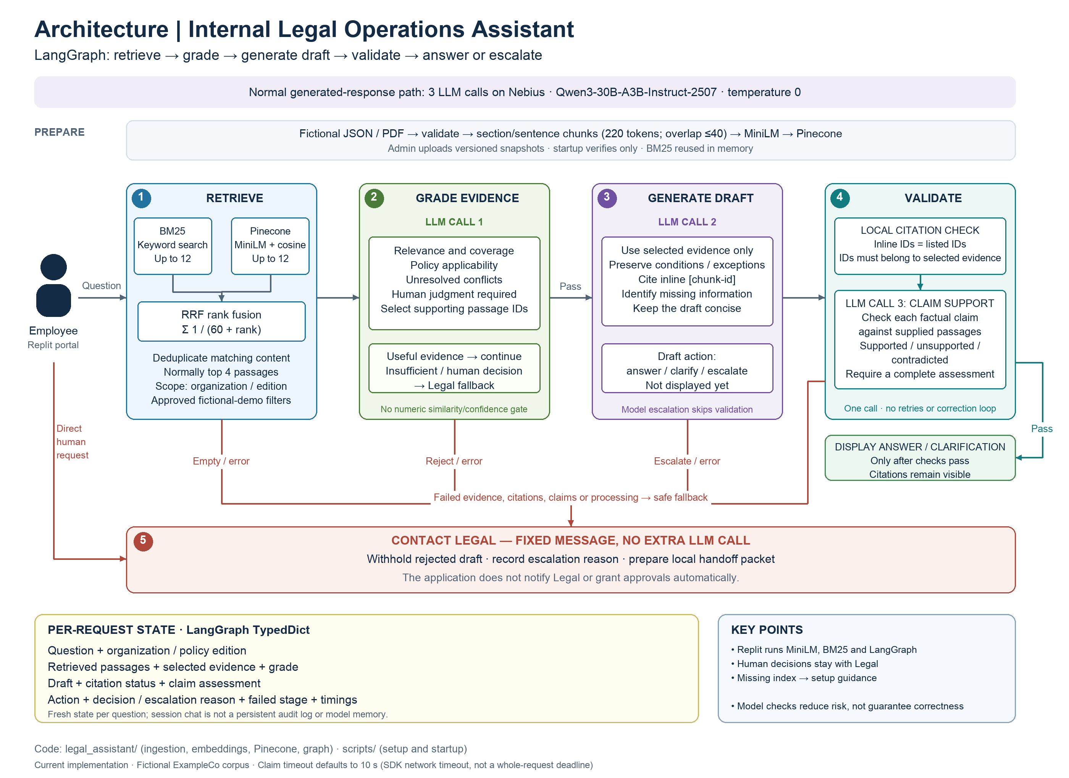

4. Tech Stack:
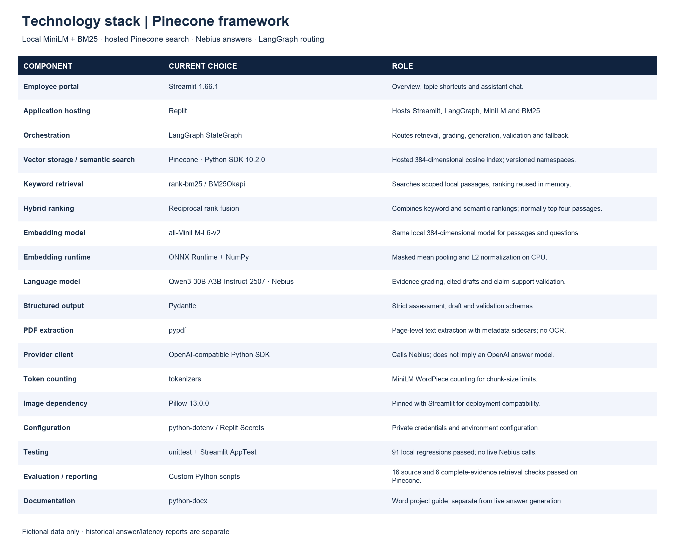

5. Knowledge Base:

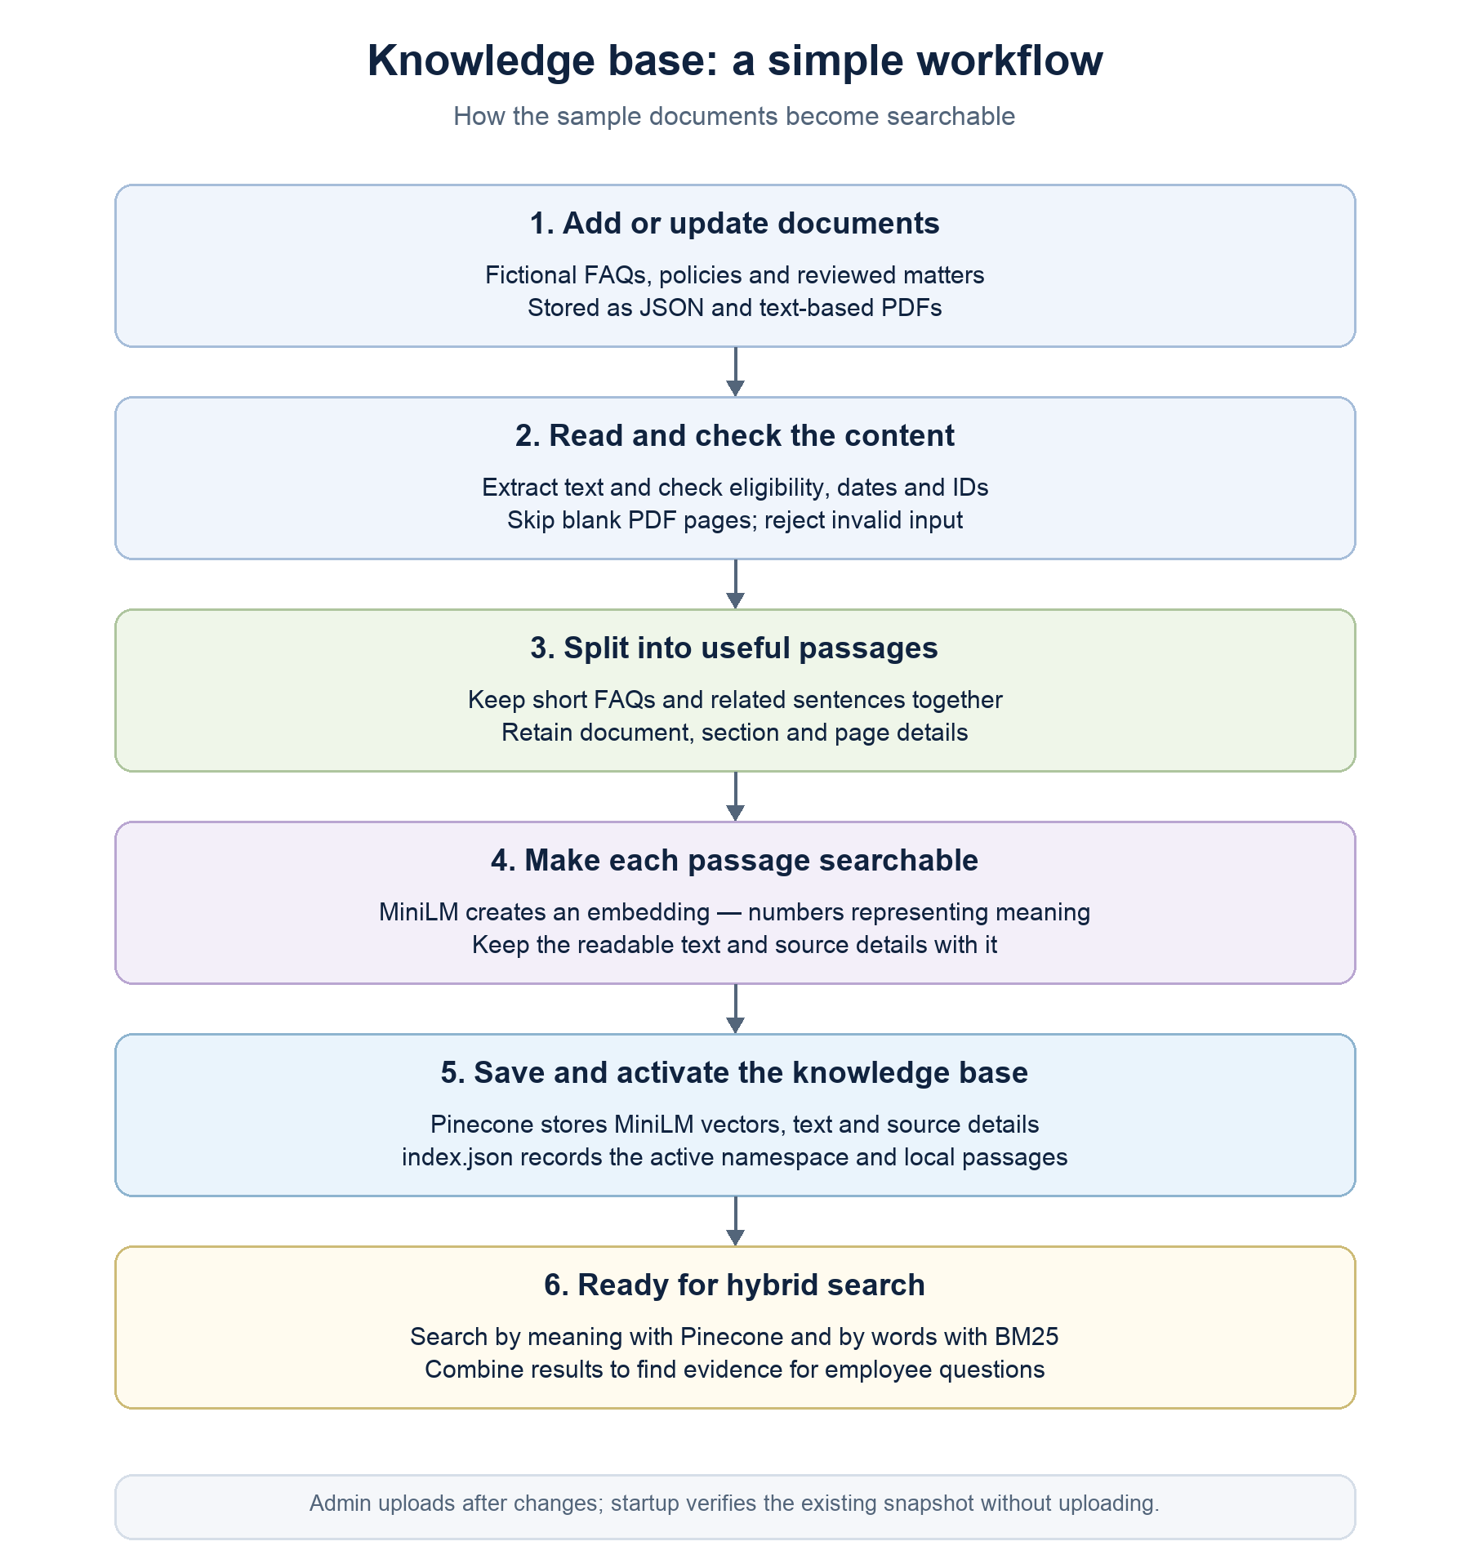

6. Trade-offs and production gaps
Decision | Benefit | Cost or limitation
RAG rather than model-only answers | Organization-specific context and traceable references. | Quality depends on source eligibility and retrieval.
Local MiniLM + Pinecone | Local embeddings avoid embedding-provider calls; Pinecone provides hosted vector storage. | Requires network access and Pinecone credentials; storage/query usage may incur charges. Not proven the optimal model/store for this corpus.
Hybrid BM25 + vectors | Combine exact terms and paraphrases. | More ranking settings; small candidate limit can miss broad context.
Section/sentence chunking | Reduce separation of rules and exceptions. | Heuristic extraction cannot fully recover complex PDF structure.
Evidence gate + live claim check | Separate evidence suitability from generated-claim support. | Three sequential LLM calls on a normal generated-answer path.
One bounded validation call | No repeated regeneration or repair loops. | Fixable drafts can fall back; failures withhold responses.
Single-request LangGraph | Testable state and explicit branch logic. | No persistent memory or human-review resume mechanism.
Simple portal and manual refresh | Easy employee demonstration and administration. | Not a deployed enterprise operating model.

7. Quick start
Use this guide on macOS/Linux from the project folder. You need Python, a terminal, internet access for initial library/model downloads, and a Nebius API key with an accessible model and account balance. The existing environment uses Python 3.14; dependencies must support your chosen Python version. The build uses a virtual environment, Streamlit 1.66.1 and Pillow 13.0.0. NumPy has separate pins for Python 3.11 and Python 3.12+. Replit installation and snapshot access were confirmed by the user; the application is hosted on Replit, as reported by the project owner. The published URL and deployment type have not been recorded, and independent hosted verification has not been performed.
The local .venv is already available in this workspace. On a new computer, create it first:
python -m scripts.build_environment
If .env already exists, edit it rather than replacing it. Otherwise, copy .env.example to .env and enter your own credentials. Never share the key or commit .env. Use these settings as a starting point; provider model availability can change:
LLM_PROVIDER=nebius
NEBIUS_API_KEY=<your private key>
LLM_BASE_URL=https://api.tokenfactory.nebius.com/v1
LLM_MODEL=Qwen/Qwen3-30B-A3B-Instruct-2507
EVIDENCE_MODEL=Qwen/Qwen3-30B-A3B-Instruct-2507
PINECONE_API_KEY=<your private key>
PINECONE_INDEX_NAME=legal-operations-minilm-vectors
PINECONE_INDEX_HOST=<copy from your Pinecone index>
PINECONE_NAMESPACE=legal-demo
The 49-passage snapshot is already uploaded. Verify it and start the portal; startup does not upload vectors:
.venv/bin/python -m scripts.prepare_app
.venv/bin/python -m scripts.start_app
Employees access the hosted portal through its published Replit URL (to be added). Replit Preview is for development checks; http://localhost:8501 applies only when running on your own computer. Replit runs Streamlit, LangGraph, MiniLM and BM25. Pinecone provides external vector storage/search; Nebius provides external grading, generation and claim-validation calls. Provider usage may incur charges.

8. Project structure
ProjectWeek2/
app.py # Portal entry point
legal_assistant/ # Core application
app_pages/ # Overview and chat
knowledge_base.py # Ingestion / Pinecone snapshots
chunking.py # Section/sentence passages
embeddings.py # Local MiniLM ONNX / tokenizer
vector_store.py # Pinecone connection / API adapter
retriever.py # BM25 + semantic search / fusion
bot.py # Model calls / validation helpers
workflow.py # LangGraph decisions
evaluation/ # Question sets, runners and reporting
scripts/ # Build, setup, startup and packaging
tests/ # Regression checks
data/ # Fictional FAQs, policies, matters
storage/ # Local manifest, model cache, reports
docs/ # Guide, diagrams and report summaries
.streamlit/ # Portal theme
.replit # Build/run commands and port 8501
requirements.txt # Pinned dependencies
.env / .env.example # Private settings / safe template
README.md / REPLIT_SETUP.md # Setup instructions
.venv/ / dist/ # Generated; excluded from Git
File or folder | Responsibility
app.py / legal_assistant/app_pages/ | Portal navigation, Overview and assistant chat.
legal_assistant/knowledge_base.py | Load eligible JSON/PDF sources, attach metadata and build the index.
legal_assistant/chunking.py | Keep short FAQs intact; split larger material by sections and sentences within the token budget.
legal_assistant/retriever.py | Combine BM25 keyword and Pinecone semantic results using reciprocal rank fusion.
legal_assistant/bot.py | Model requests, structured response schemas, prompts and validation helpers.
legal_assistant/workflow.py | LangGraph nodes, conditional routes, request state and timing.
data/ | Fictional source material; the bot does not search project documentation or test answers.
tests/ | Automated regression checks, separate from normal chat.
storage/ | Local active-snapshot manifest, MiniLM asset cache and saved reports. Active vectors are hosted in Pinecone.
evaluation/eval_set.py / evaluation/resolution_eval.py | Main question set and full-workflow evaluation/reporting.
evaluation/scenario_eval_set.json / evaluation/grouped_eval_report.py | Grouped answer, ambiguous and escalation scenarios; reports can reuse saved results.
docs/ / .streamlit/ | Project documentation and portal appearance settings.
.venv/ / requirements.txt | Installed project libraries and the dependency installation list.
.env / .env.example | Private local settings and a shareable configuration template.
legal_assistant/embeddings.py | Load verified MiniLM ONNX assets, tokenize and create normalized 384-dimensional vectors using ONNX Runtime directly.
legal_assistant/vector_store.py | Validate Pinecone settings and adapt legacy vector/new document APIs. Reject hosted embedding schemas.
scripts/build_environment.py | Create/repair .venv, bootstrap pip, install pinned libraries and run pip check.
scripts/prepare_app.py / scripts/start_app.py | Verify an uploaded snapshot, recreate the local manifest and start Streamlit; no remote uploads.
scripts/create_pinecone_index.py | One-time compatible index creation; never part of normal startup.
scripts/package_replit.py / .replit | Prepare the upload ZIP and configure build/run commands and port mapping.
docs/reports/ | Recorded Pinecone framework checks and a guide distinguishing historical answer reports.
Replit hosting | Runs the portal, graph, local MiniLM inference and BM25. Employees use the published URL; Preview is a development view.
Replit Secrets / Configurations | Hosted API keys and environment settings. Local .env is for development and is not uploaded or committed.

9. One question’s journey
Example employee question: What should I do if a counterparty supplies its own NDA or changes the approved template?
Stage | What happens
1. Receive | The portal submits the question and selected organization/policy edition. Prior chat messages are not supplied as memory.
2. Retrieve | BM25 searches exact terms while Pinecone searches meaning. Up to 12 candidates per branch are fused and deduplicated; the default final selection is four passages.
3. Grade evidence | The model checks relevance, coverage, policy applicability, contradictions and whether human judgment is required. It selects usable passage IDs.
4. Generate draft | The model writes a concise answer using selected evidence, retaining conditions and adding passage citations.
5. Check citation IDs | Code checks that references identify permitted passages. A valid ID alone does not establish claim support.
6. Validate claims | One bounded model call assesses whether the draft’s factual claims are supported. Incomplete or unsupported assessments prevent release; there is no repair loop.
7. Display or fallback | Release the validated response, or show a Contact Legal fallback. A normal generated answer uses three sequential model calls.
Historical answer example from a saved evaluation (not a newly generated result):
If a counterparty supplies its own NDA or changes the approved template, submit the document and marked changes to Legal through the intake form. Flag any changes to confidentiality scope, permitted recipients, duration, liability, and governing law for review. Do not accept the changes or represent that Legal has approved them. Only an authorized signatory may execute the agreement [POL-NDA-011:0].
The citation [POL-NDA-011:0] identifies the supporting indexed passage. Citations make the answer traceable; model validation is still fallible. If support checks fail, the draft is withheld and the user receives a Legal-contact message instead.

10. Answer, clarify or contact Legal
Outcome | When and how it appears
Answer | Evidence supports documented guidance. A partial answer can explain supported steps and identify gaps; it must not invent missing policy.
Clarify | Essential context is missing and the model asks for it or provides conditional guidance. Clarification is currently response content, not a durable multi-turn workflow; users should restate the context in their next question.
Contact Legal | The request needs approval, legal judgment, signing authority, or evidence is absent, inapplicable or contradictory. Explicit human requests also take this path.
Technical fallback | Retrieval/model failures, invalid citations or failed claim checks also prevent release. Internal status distinguishes processing failures from insufficient evidence.
Escalation currently means displaying a Legal-contact message and preparing local handoff details. No ticket, email or notification is automatically sent. There is no employee authentication, reviewer resume or delivery confirmation.

11. Testing and measured results
Three checks answer different questions: unit/UI tests check code behavior; retrieval checks test source discovery; live evaluation measures the complete workflow and automated answer quality. Passing code tests does not prove legal correctness.
.venv/bin/python -m unittest discover -s tests -t . -v
.venv/bin/python -m evaluation.eval
.venv/bin/python -m evaluation.eval_chunking
Recorded verification: 91/91 local regression tests, 16/16 expected-source retrieval checks and 6/6 complete-evidence retrieval checks passed. A fresh 20-question full-workflow evaluation was completed on 29 October 2026 using Pinecone and Nebius. The live run includes evidence grading, generation, citation checking, claim validation and a separate automated answer-quality assessment.
The main evaluation contains 20 queries: 16 expected answers and four expected escalations. Records include expected/actual outcome, answer-guidance quality, escalation reason and workflow latency. The grouped dataset adds five ambiguous questions (25 scenarios total); its saved grouped report marks those five as not run. Authored expected answers are not measured bot outputs.

Latest full-workflow results: 29 October 2026, 16:23 PDT (23:23 UTC). Source: storage/evaluations/pinecone_full_workflow_20261029_232340/resolution_report.json. All 20 cases completed. The table below replaces the earlier figures; original historical reports are preserved separately.
Metric | Fresh run result | Meaning
Automated resolution | 15/20 (75.0%) | Answer released, all automated guidance criteria met and live claim validation passed.
Answerable resolution | 15/16 (93.75%) | Resolution among questions expected to be answerable.
Correct escalation | 4/4 (100.0%) | Expected escalation cases routed to Legal without a processing failure; this is not independent review of each reason.
Unnecessary escalation | 1/16 (6.25%) | Answerable cases escalated despite no processing failure.
Processing failures | 0 | Technical failures in the saved workflow run.
Median / P95 / maximum | 5.32 / 8.28 / 9.03 seconds | Local-machine workflow timings using remote Pinecone and Nebius. Excludes the separate quality-assessment call; not a Replit latency measurement.
Interpretation: 15 answerable cases met every automated guidance criterion; all four expected Legal escalations were handled, and one expected-answerable question also escalated. There were no workflow or quality-evaluator failures. Overall resolution is 75% because intentional human-escalation cases are included in the denominator.
Review case LEGAL-EVAL-15: the question combining NDA and Privacy requirements was escalated because the claim validator flagged human judgment as required, despite marking its assessed claims supported. This suggests a routing/assessment issue to review; it is not evidence of a confirmed unsupported answer. No automatic retry or code correction was performed during evaluation.

12. Pinecone indexing, startup and publishing
The existing index is legal-operations-minilm-vectors: dense vectors, 384 dimensions, cosine similarity, AWS us-east-1. MiniLM generates both document and question vectors locally. This is not Pinecone-hosted Llama inference.
An administrator runs .venv/bin/python -m legal_assistant.knowledge_base only when sources or the embedding implementation change. It uploads text, metadata and vectors to a content/model-versioned namespace, verifies visibility, then switches the local manifest. Earlier namespaces remain for rollback and may incur storage charges; they are not silently deleted.
Startup runs .venv/bin/python -m scripts.start_app. It verifies that the exact uploaded snapshot exists, rebuilds only the local manifest/BM25 corpus, and starts Streamlit on 0.0.0.0:8501. If the snapshot is missing, startup stops; it does not create an index or upload data.
Replit build command: python -m scripts.build_environment. Run command: .venv/bin/python -m scripts.start_app. Keep Pinecone and Nebius API keys in Replit Secrets, and set the index name/host/namespace plus Nebius endpoint/models for the published deployment. Use a backend deployment and confirm access, costs and Preview before Publish. Hosting is reported by the project owner. Record the published URL and actual deployment type below; this document does not claim an independent deployment test.

13. Current checks versus earlier reports
See docs/reports/Pinecone_Framework_Checks.html for the verification summary and links to the fresh full-workflow report. The HTML, CSV and JSON outputs are in storage/evaluations/pinecone_full_workflow_20261029_232340/. Earlier saved reports remain historical baselines and were not overwritten.
The refreshed storage/chunking_comparison.json contains Pinecone retrieval checks. Its earlier baseline used a different corpus; the comparison cannot isolate the effect of chunking or the vector-store configuration.
Answer quality, resolution and response latency were assessed in the fresh live development run described in Section 11. The rubric and claim assessments are automated, not independent Legal review or user-confirmed resolution. The run was executed locally against remote services, not from the Replit-hosted application.

