AIMLZG546
Software Engineering for Machine Learning
Assignment I
Group 54 | Credit Default Risk Review Prototype
Assignment report and implementation evidence

Group Details
Group No: 54. Member contributions total 100%.
Sl. No | BITS ID | Name | Contribution (Qualitative) | Percentage (out of 100)
1 | 2025AE05017 | POONAM TANNA | Contributed across most project areas, collaborating on problem formulation, GR4ML views, system architecture, pattern implementation, Streamlit UI, and report generation. | 40
2 | 2025AE05791 | Mohammed Asif S | Requirements formulation: domain and problem statement, users and stakeholders, GR4ML measurable goals and indicators table, functional and non-functional requirements with acceptance criteria, and justification of the top three quality requirements. | 20
3 | 2025AF05145 | NAVEEN.K.B | GR4ML modelling: Business View, Analytics Design View and Data Preparation View (tables and diagrams), cross-view traceability, softgoal contribution links and decomposition correctness. | 20
4 | 2025AF05136 | SIMRAN SURI | Evaluation and reporting: model evaluation experiments (threshold sweep, fairness audit by subgroup), application testing and screenshots with captions, notebook execution and saved outputs, report compilation, formatting and consistency review between docx and notebook. | 20

1. Problem Formulation
Domain: financial risk management for existing credit-card accounts. Using account repayment status, credit limit, billed amounts and payment amounts, the prototype estimates the likelihood of payment default next month and flags an account for credit-risk analyst review. It uses the UCI Default of Credit Card Clients dataset: 30,000 historical Taiwan accounts and a binary next-month default outcome.
The analyst retains all account-level decision authority. This educational prototype must not be used for credit approval, pricing, collections, adverse action, or other customer-level decisions. The bundled CSV has no source ID in model inputs; sex, education, marital status, and age are excluded from model inputs. UI controls are illustrative median-based profiles, not customer data.
Users and stakeholders: the credit-risk analyst reviews flags and retains decision authority; the model owner validates and monitors; the data steward governs permitted use; customers are affected stakeholders; and the service operator is responsible for availability and security.
Dataset source: Yeh, I.-C. and Lien, C.-H. (2009), Expert Systems with Applications, 36(2), 2473-2480; UCI Machine Learning Repository, Default of Credit Card Clients (https://archive.ics.uci.edu/dataset/350/default+of+credit+card+clients).

2. Requirements and Measurable Goals

GR4ML Measurable Goals & Indicators Table
Goal ID | GR4ML Goal Type | Goal Statement | Indicator (KPI) | Target Threshold | Prototype Holdout Result (t=0.50)
G-B1 | Strategic Goal | Support timely review of accounts with elevated default risk. | Default recall on the positive class | >=70% on independent later-period validation | Logistic regression 62.85%; Random forest 59.61%.
DG-1 | Decision Goal | Decide account review priority for analyst follow-up. | Default recall and specificity | >=70% for each on independent validation | Recall 62.85%/59.61%; specificity 68.69%/82.09% (LR/RF).
QG-1 | Question Goal | What is the account's next-month default probability? | Probability output in [0, 1] and correct threshold flag | Valid probability and correct threshold behavior for every request | Probability and threshold boundary are covered by the automated test suite; no calibration claim.
IND-1 | Indicator | Measure default detection effectiveness. | Recall = TP / (TP + FN) | >=70% on independent later-period validation | Logistic regression 62.85%; Random forest 59.61%.
IND-2 | Indicator | Measure correct non-default identification. | Specificity = TN / (TN + FP) | >=70% on independent later-period validation | Logistic regression 68.69%; Random forest 82.09%.
Q-B2 | Softgoal | Ensure no material demographic disparity in recall. | Maximum recall gap by sex or age band | <=5 percentage points before pilot | Logistic regression: 12.33pp (does not meet <=5pp); Random forest: 11.53pp (does not meet <=5pp). Coursework audit only; not a governed audit.

Functional and Nonfunctional Requirements
ID | Specification | Acceptance / verification
FR-1 | Load bundled UCI data, remove ID and excluded demographics, map default to class 1. | Schema, exclusion, and target checks.
FR-2 | Use stratified 80/20 train/test split, random_state=42. | Repeated split and class proportions are reproducible.
FR-3 | Select logistic regression or random forest. | Both strategies fit and return valid probabilities.
FR-4 | Display recall, specificity, precision, accuracy; adjust threshold. | UI metrics match service; threshold-boundary check.
FR-5 | Return default probability and flag at/above threshold for analyst review. | Positive-class and decision-boundary tests.
NFR-1 Effectiveness | Independent later-period data must show recall >=70% and specificity >=70% before a pilot. | Temporal/external validation; block release if unmet.
NFR-2 Fairness | Relevant-group recall gap <=5 percentage points before a pilot. | Lawfully governed subgroup audit; demographics audit-only.
NFR-3 Privacy | No identifier/input/score retention or external transmission in prototype. | Code, log, and storage inspection.
NFR-4 Performance | Scoring p95 <2 s at 10 req/s after model load; availability >=99% monthly in production. | Reference load test and SLO report.
These are proposed acceptance targets, not achieved claims. The threshold sweep results show that neither strategy meets both targets between 0.30 and 0.60 on this fixed holdout.

3. GR4ML Views
Notation: G = goal, Q = quality/softgoal, A = actor, T = task, R = resource, BR = business/data rule. AND-decomposition requires all child goals; OR-decomposition denotes alternatives; dependencies state who relies on whom.

3.1 Business View
Element | GR4ML description
A-1 / A-2 / A-3 | Actors: credit-risk analyst / ML service / data steward.
G-B1 | Strategic Goal: support timely review of elevated-risk accounts; supports G-B2.
G-B2 | Decision Goal: prioritize accounts for analyst review; AND-decomposes to G-B2a and G-B2b.
G-B2a / G-B2b | Valid feature input / risk estimate and review flag.
IND-1 / IND-2 | Indicators: Default Recall >=70%; Specificity >=70%; both linked to Q-B1 and G-A1.
Q-B1 / Q-B2 | Softgoals: Decision Effectiveness; Demographic Fairness <=5pp recall gap.
T-B1 | Task: Analyst Account Review using approved conventional evidence.
BR-B1 | No automated credit approval, pricing, collections, adverse action, or customer decision.
BR-B2 | Exclude direct identifiers and demographics from model inputs; govern audit use.
Flow / dependencies | G-B1 supports G-B2; G-B2 AND-decomposes to G-B2a/G-B2b. IND-1/IND-2 measure Q-B1 and trace to G-A1; G-B2b supports T-B1.
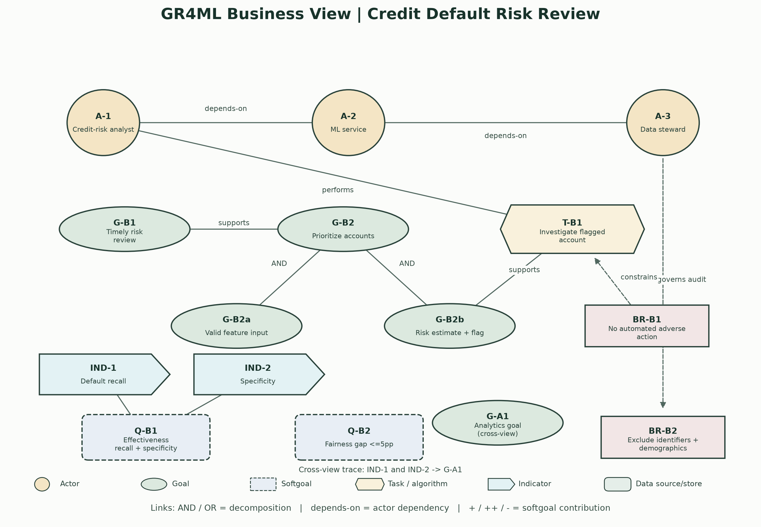

3.2 Analytics Design View
Element | GR4ML description
G-A1 | Analytics Goal: estimate next-month P(default) and support review.
T-A1 | Analytics Task: Supervised Binary Classification.
ALG-1 / ALG-2 | Algorithms: Logistic Regression OR Random Forest.
T-A2 | Evaluate holdout confusion matrix and metrics at threshold 0.50.
IND-A1 | Indicator: Holdout Confusion Matrix & Metrics.
Q-A1 / Q-A2 / Q-A3 | Softgoals: Recall/Specificity Balance, Model Interpretability, Reproducibility.
BR-A1 | Default is class 1; select predict_proba column by class label.
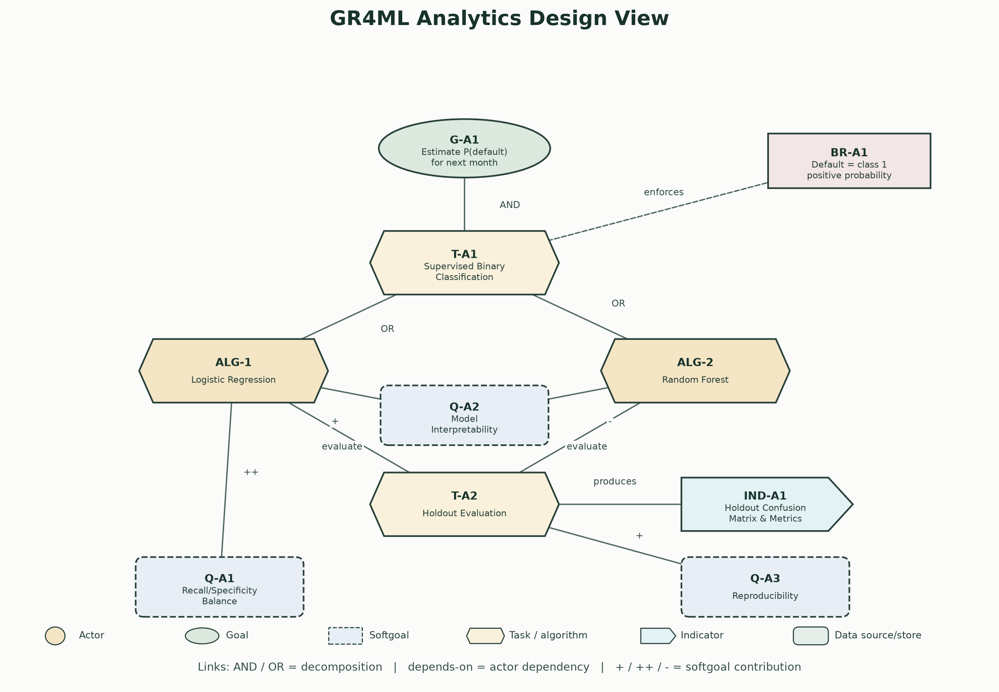

3.3 Data Preparation View
Element | GR4ML description
DS-1 | Data Source/Store: Raw UCI Credit CSV [30,000 x 24].
T-D1 | Data Preparation Task: Load & Target Mapping.
T-D2 | Data Preparation Task: Remove ID & Protected Attributes.
T-D3 | Data Preparation Task: Stratified Split & Train-Only Scaling.
DS-2 | Data Source/Store: Clean Stratified Train/Test Split [19 features].
Q-D1 / Q-D2 | Softgoals: Schema Completeness and Zero Test Leakage.
BR-D1 / BR-D2 | Map default=1; preserve schema; exclude ID/demographics; fit transforms on train only.
Traceability | G-B1 supports G-B2 -> (AND) G-B2a/G-B2b -> T-B1; IND-1/IND-2 -> G-A1 -> T-A1 -> (OR) ALG-1/ALG-2 -> T-A2 -> IND-A1; DS-1 -> T-D1 -> T-D2 -> T-D3 -> DS-2 -> T-A1.
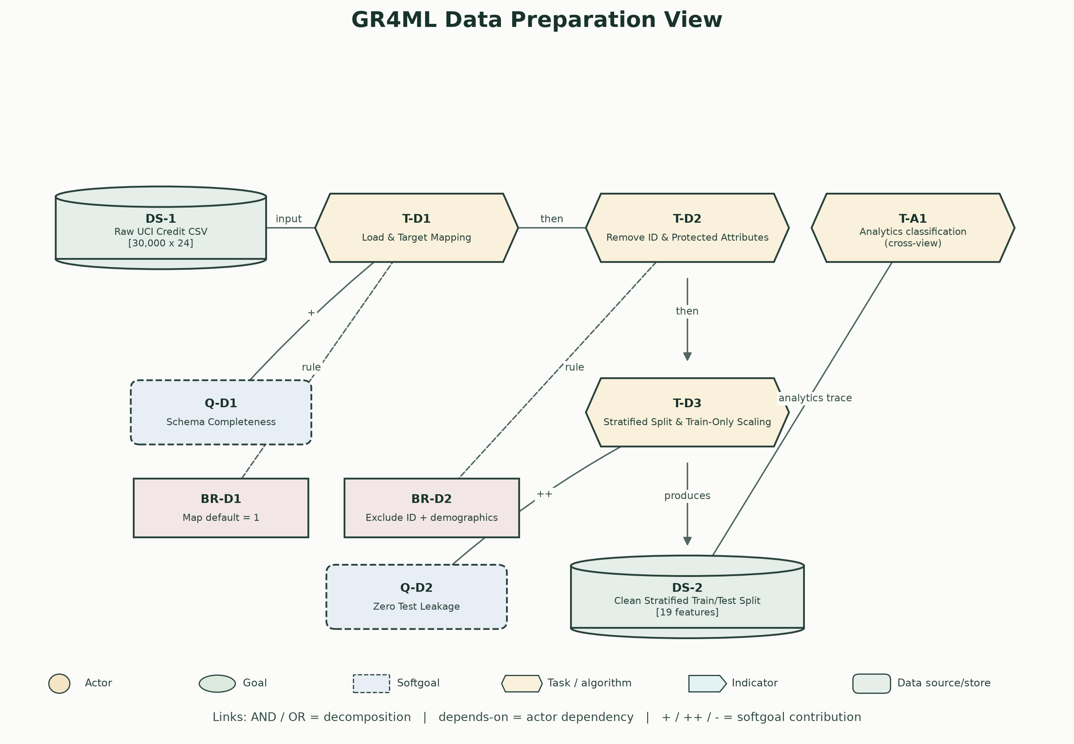

4. Top Three Quality Requirements
1. Effectiveness and decision safety: false negatives hide repayment risk; false positives consume analyst capacity and can burden customers. Measure both recall and specificity; require each >=70% on independent later-period data. The 0.30-0.60 coursework threshold sweep found no pair meeting both metrics on this fixed holdout. No release or automated-action claim is made.
2. Fairness: historic outcomes may reflect structural and policy bias. Excluding demographic fields does not remove proxy effects. Require a lawful subgroup audit and <=5 percentage-point relevant-group recall gap before any pilot; block if evidence is inadequate.
3. Privacy and security: financial account data is sensitive. The local prototype retains no customer input and makes no external transmission. Real deployment requires access control, encryption, audit, retention limits, threat modeling, and regulatory review.

5. System Architecture
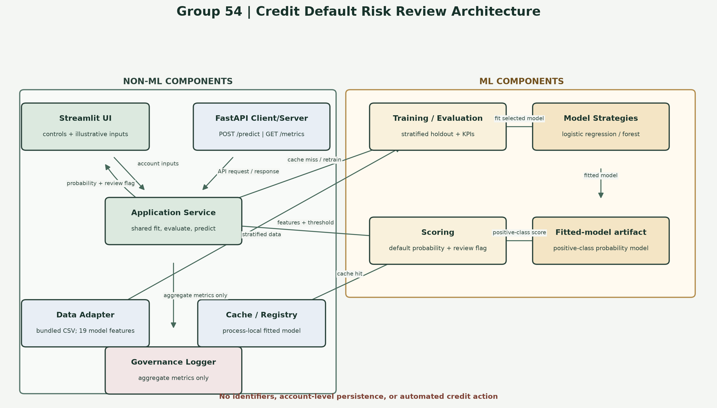
Non-ML components: Streamlit UI, FastAPI server, application service, cache/registry, data adapter, and governance logger. ML components: training/evaluation, model strategies, fitted artifact, and scoring. Streamlit remains a direct service client; FastAPI is an optional second client/server path. Inputs and predictions are not persisted; no automated credit action occurs.

6. Architectural Patterns and Implementation

Pattern 1: Layered Architecture
Implemented as app.py presentation -> credit_risk/service.py application workflow -> credit_risk/strategies.py model abstraction and credit_risk/data.py dataset access. The service separates fit_model from evaluate_model; Streamlit cache_resource retains the fitted model across threshold and input changes. Evaluation logs aggregate metrics only.
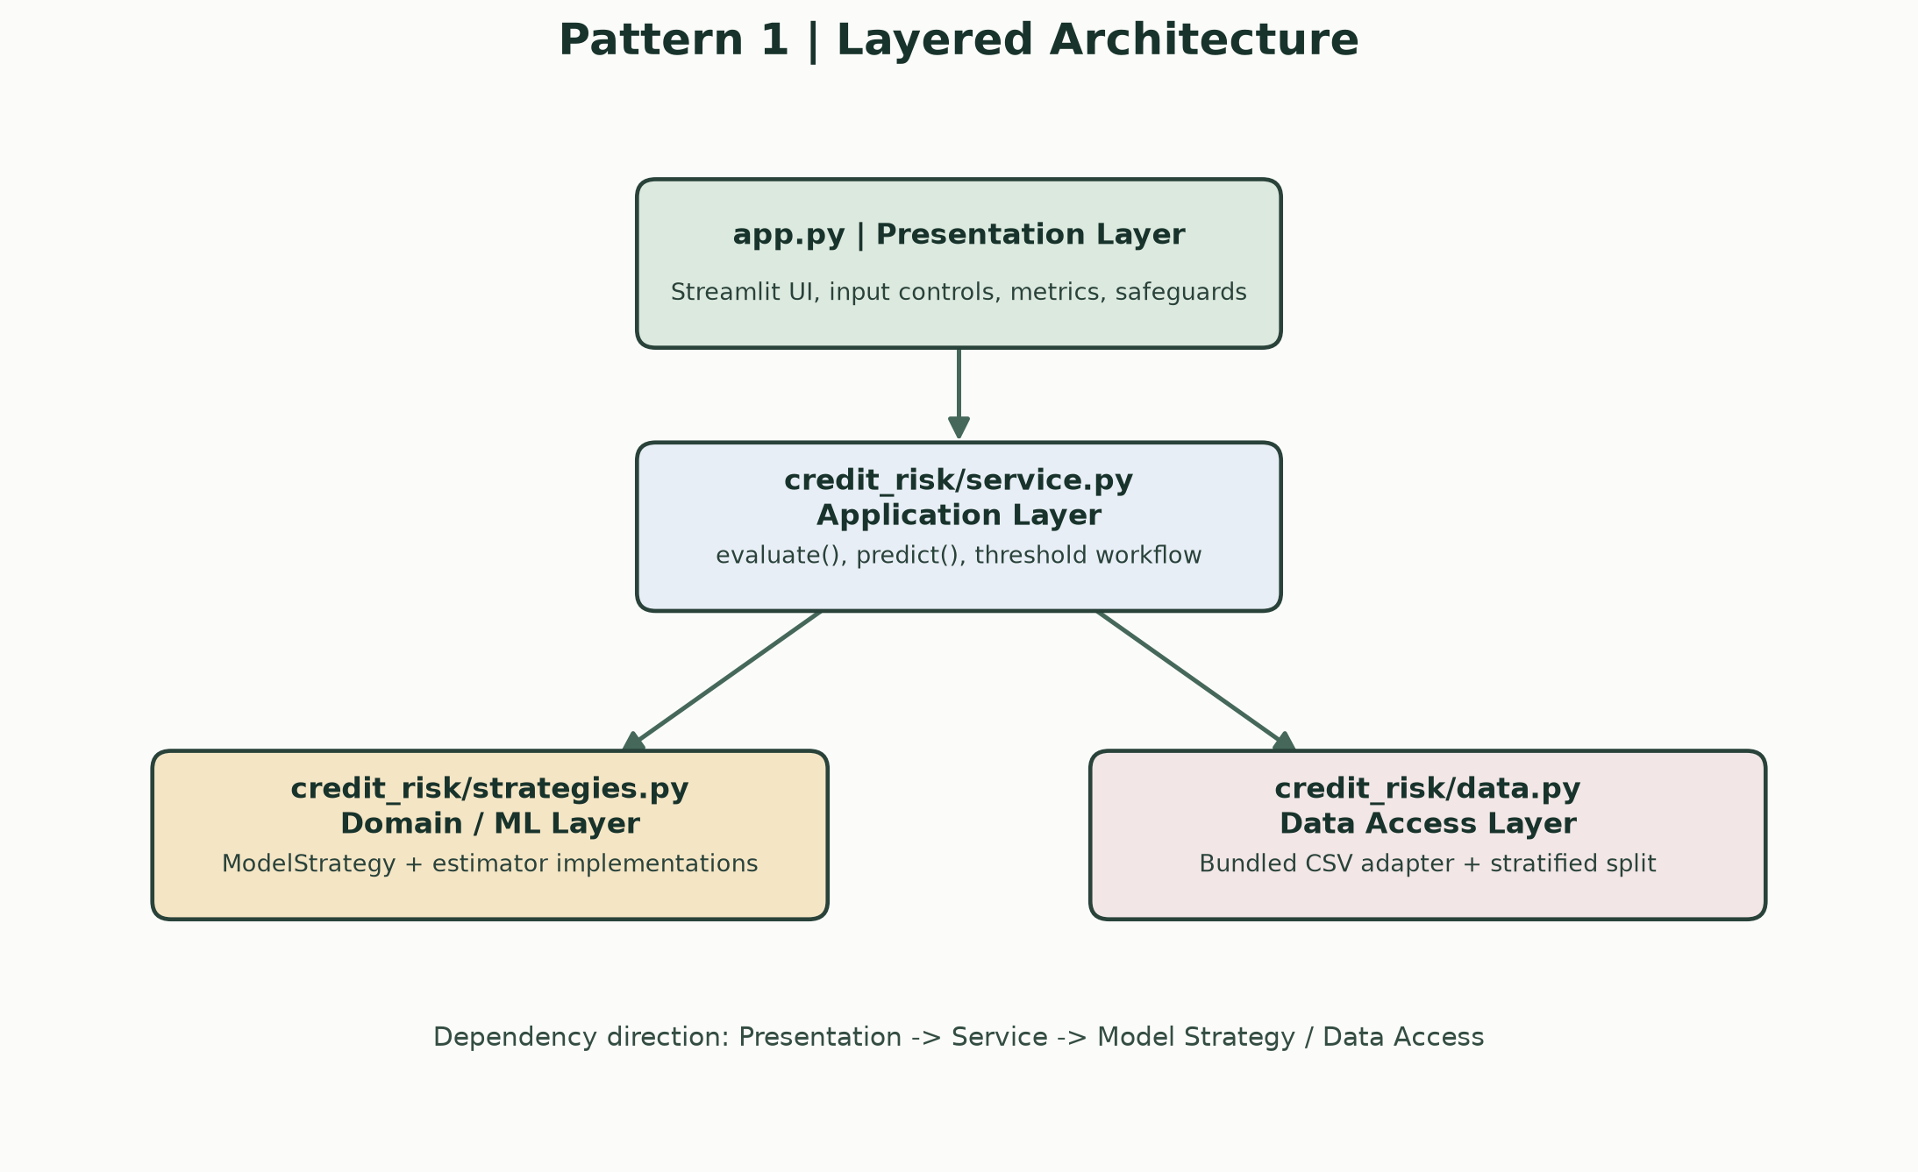

Pattern 2: Model-as-a-Service (Client-Server)
api.py exposes POST /predict and GET /metrics through FastAPI and reuses credit_risk.service. The API is an optional second client; the Streamlit app continues calling the shared service directly, so both clients use the same model and evaluation behavior.
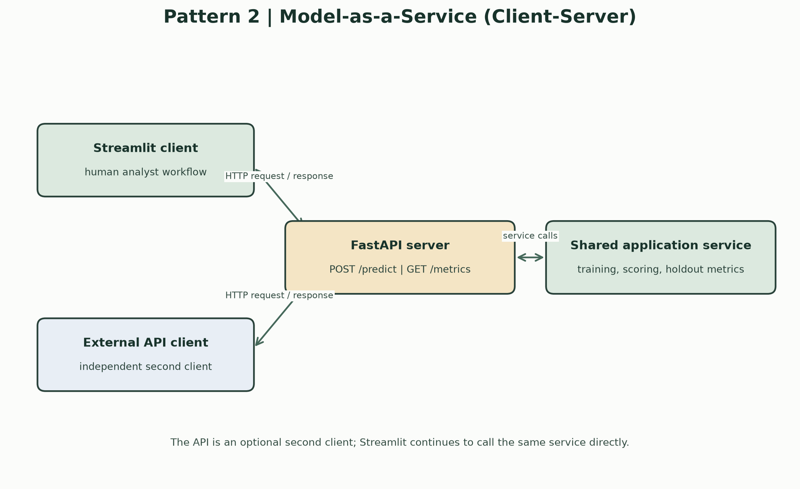

Supporting Design Pattern: Strategy
Within the model layer, ModelStrategy is implemented by LogisticRegressionStrategy and RandomForestStrategy, registered in STRATEGIES and selected by get_strategy. This is a GoF design pattern, not an architectural pattern.
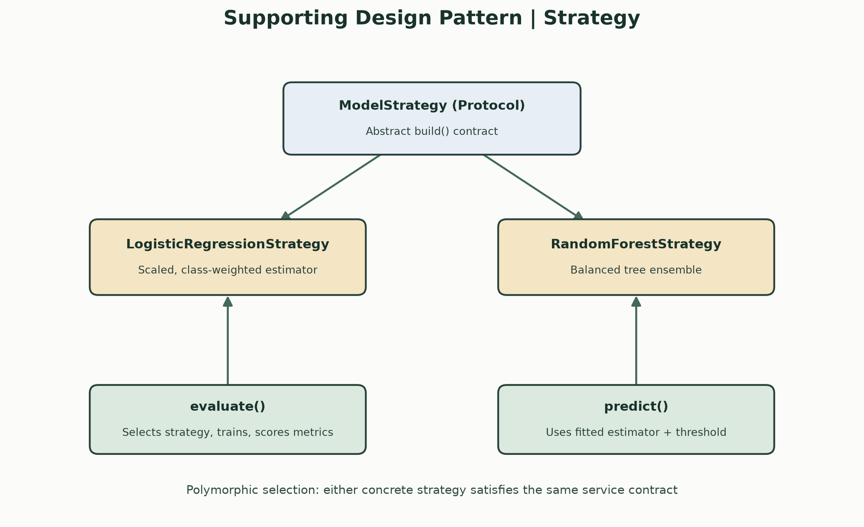
Pattern Name | Context / Problem | Solution / Structure | Components Mapped in Code | Advantages | Trade-offs
Layered Architecture | UI, ML workflow, and data access would otherwise be coupled. | Presentation calls service; service coordinates model and data layers. | app.py -> credit_risk/service.py -> strategies.py and data.py. | Clear responsibilities; focused tests; independent UI/model changes. | Added indirection; cache is process-local and must be invalidated after model/data changes.
Model-as-a-Service (Client-Server) | Provide a reusable prediction service to multiple clients without coupling clients to model internals. | FastAPI exposes POST /predict and GET /metrics; endpoints delegate to the shared credit_risk service. | api.py; FastAPI; credit_risk/service.py; Streamlit remains a direct second service client. | Client/server boundary; shared inference behavior; independently testable HTTP contract. | Adds deployment, API validation, and service-availability responsibilities.
Supporting design pattern: Strategy (GoF) | Compare or replace estimators without duplicating evaluation/inference logic. | Common build() contract with interchangeable model implementations. | ModelStrategy; LogisticRegressionStrategy; RandomForestStrategy; get_strategy(); evaluate_model(); predict(). | Add models without rewriting use cases; consistent comparison workflow. | Not itself an architectural pattern; implementations must honor feature/probability contracts.

7. Implementation Results
The fixed stratified holdout contains 6,000 records. The automated suite reports 7 tests passed. The tables below are computed at report-generation time from the same bundled CSV, split, fitted strategies, and threshold sweep used by the notebook code.
Verification result: 7 tests passed.
Strategy | Default recall | Specificity | Precision | Accuracy
Logistic regression | 62.85% | 68.69% | 36.31% | 67.40%
Random forest | 59.61% | 82.09% | 48.59% | 77.12%
Results are at threshold 0.50 on this fixed 6,000-row historical holdout. They do not establish future performance, calibration, fairness, or suitability for customer decisions.

Threshold sweep (fixed holdout)
Strategy | Threshold | Recall | Specificity | Precision
Logistic regression | 0.30 | 89.98% | 21.27% | 24.50%
Logistic regression | 0.35 | 82.22% | 32.48% | 25.69%
Logistic regression | 0.40 | 77.09% | 40.85% | 27.01%
Logistic regression | 0.45 | 71.36% | 51.23% | 29.36%
Logistic regression | 0.50 | 62.85% | 68.69% | 36.31%
Logistic regression | 0.55 | 48.83% | 86.52% | 50.70%
Logistic regression | 0.60 | 42.58% | 90.82% | 56.84%
Random forest | 0.30 | 82.89% | 48.96% | 31.56%
Random forest | 0.35 | 75.73% | 61.52% | 35.85%
Random forest | 0.40 | 68.43% | 71.09% | 40.19%
Random forest | 0.45 | 63.23% | 77.85% | 44.77%
Random forest | 0.50 | 59.61% | 82.09% | 48.59%
Random forest | 0.55 | 55.99% | 85.73% | 52.70%
Random forest | 0.60 | 51.70% | 88.27% | 55.59%
Threshold range 0.30 to 0.60 in 0.05 steps: no tested strategy/threshold met both >=70% recall and >=70% specificity. This is not independent validation.

Audit-only subgroup recall
Strategy | Audit dimension | Group | Recall
Logistic regression | SEX | 1 | 65.24%
Logistic regression | SEX | 2 | 61.10%
Logistic regression | AGE band | <=29 | 68.85%
Logistic regression | AGE band | 30-39 | 60.71%
Logistic regression | AGE band | 40-49 | 58.01%
Logistic regression | AGE band | 50-59 | 63.39%
Logistic regression | AGE band | 60+ | 56.52%
Random forest | SEX | 1 | 59.54%
Random forest | SEX | 2 | 59.66%
Random forest | AGE band | <=29 | 63.70%
Random forest | AGE band | 30-39 | 57.84%
Random forest | AGE band | 40-49 | 57.37%
Random forest | AGE band | 50-59 | 58.93%
Random forest | AGE band | 60+ | 52.17%
Logistic regression: maximum recall gap 12.33 percentage points; does not meet the <=5pp target.
Random forest: maximum recall gap 11.53 percentage points; does not meet the <=5pp target.
Coursework audit only, not a legally governed or production fairness assessment. Original SEX and AGE columns were read separately for the held-out row indices and were never model inputs.

8. Application Screenshots
Logistic regression at threshold 0.50 with the four held-out evaluation metrics.
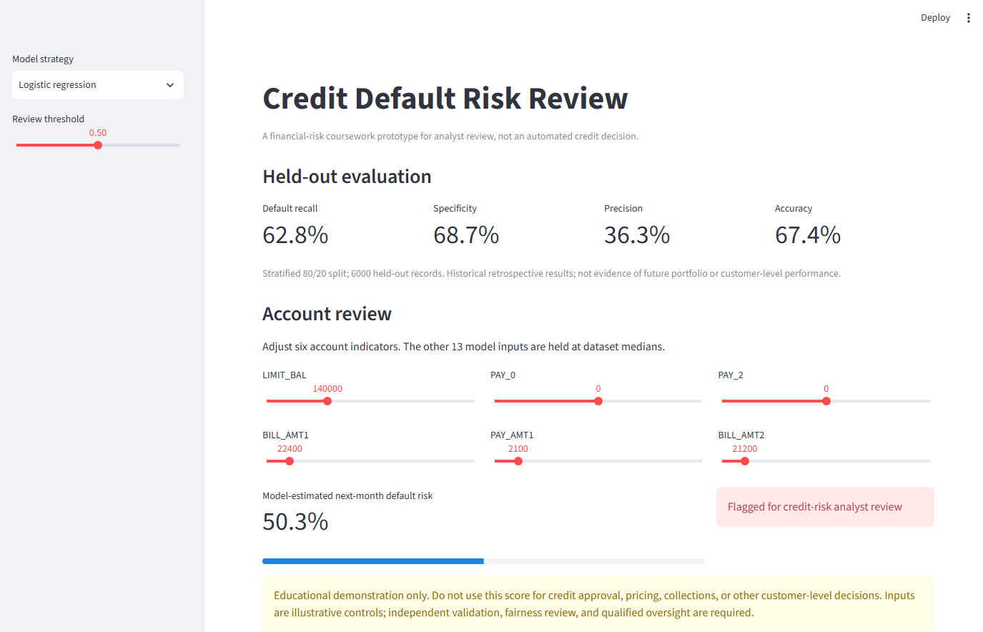
Random forest selected with the review threshold changed from its default.
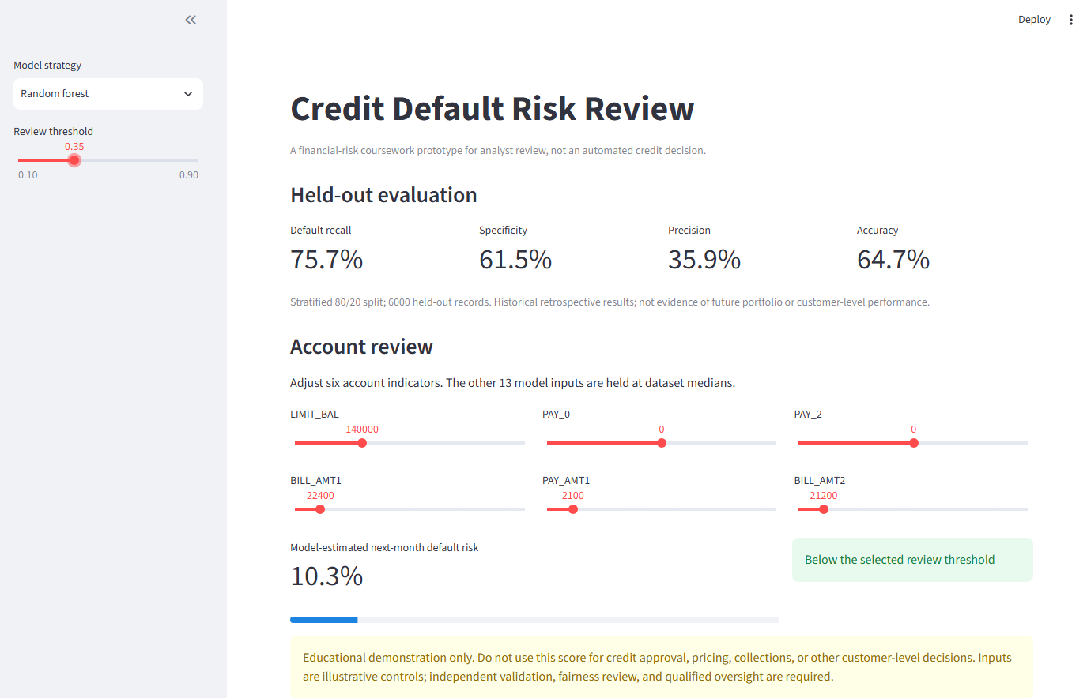
Illustrative account controls produce a flagged result for analyst review.
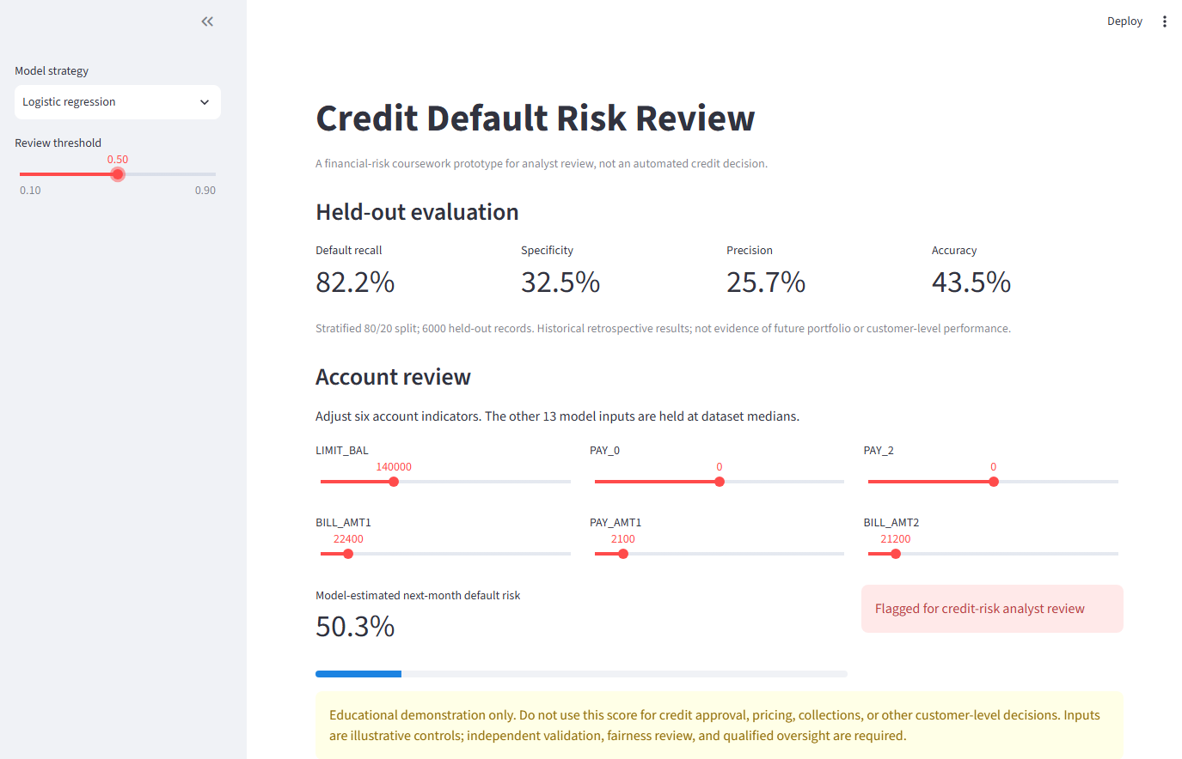
Illustrative account controls produce a result below the selected review threshold.
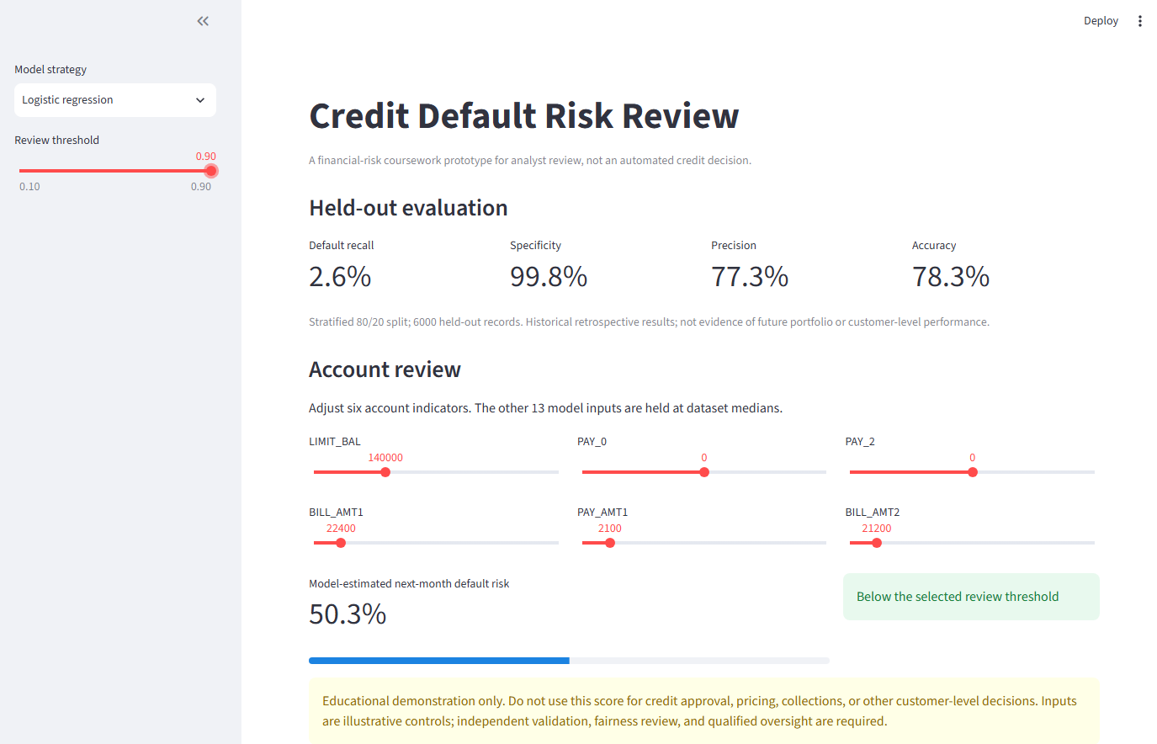

9. Run Instructions, Limitations and Conclusion
Install dependencies using `python -m pip install -r requirements.txt`; run with `streamlit run app.py`. The bundled CSV permits offline application use.
Optional API: `uvicorn api:app --reload`; test suite: `python -m pytest -q`.
Limitations: historical Taiwan accounts from 2005; one random split; imbalanced labels; no temporal/external validation, calibration, confidence intervals, governed subgroup audit, monitoring, authentication, persistence, load test, or production security review. Demographic exclusion and class weighting do not guarantee fairness. Never use these outputs for decisions about real customers.
The implementation demonstrates requirements traceability through all three GR4ML views, a layered architecture, and two implemented architectural patterns. Any real-world pilot would require independent evidence, legal/compliance review, fairness and security controls, and accountable human governance.

10. Appendix - Complete Source Code
The complete source files used by this implementation are reproduced here for review.

credit_risk/data.py
"""Credit-default dataset access and deterministic evaluation split."""
from pathlib import Path
import pandas as pd
from sklearn.model_selection import train_test_split
RANDOM_STATE = 42
DATA_PATH = Path(__file__).resolve().parents[1] / "submission_assets" / "credit_default.csv"
EXCLUDED_FEATURES = ["SEX", "EDUCATION", "MARRIAGE", "AGE"]
def load_data():
"""Return credit-account features and a target where 1 means default next month."""
dataset = pd.read_csv(DATA_PATH)
target = dataset.pop("default").astype(int).rename("default")
features = dataset.drop(columns=EXCLUDED_FEATURES)
return features, target
def split_data(test_size=0.2):
features, target = load_data()
return train_test_split(
features,
target,
test_size=test_size,
random_state=RANDOM_STATE,
stratify=target,
)

credit_risk/strategies.py
"""Interchangeable model strategies used by the application service."""
from typing import Protocol
from sklearn.ensemble import RandomForestClassifier
from sklearn.linear_model import LogisticRegression
from sklearn.pipeline import make_pipeline
from sklearn.preprocessing import StandardScaler
class ModelStrategy(Protocol):
name: str
def build(self):
"""Create an unfitted estimator."""
class LogisticRegressionStrategy:
name = "Logistic regression"
def build(self):
return make_pipeline(
StandardScaler(),
LogisticRegression(class_weight="balanced", max_iter=1500, random_state=42),
)
class RandomForestStrategy:
name = "Random forest"
def build(self):
return RandomForestClassifier(
n_estimators=160,
class_weight="balanced",
min_samples_leaf=10,
n_jobs=1,
random_state=42,
)
STRATEGIES = {
LogisticRegressionStrategy.name: LogisticRegressionStrategy,
RandomForestStrategy.name: RandomForestStrategy,
}
def get_strategy(name):
try:
return STRATEGIES[name]()
except KeyError as error:
raise ValueError(f"Unknown model strategy: {name}") from error

credit_risk/service.py
"""Application-level training, evaluation, and inference operations."""
import logging
from sklearn.metrics import accuracy_score, confusion_matrix, precision_score, recall_score
from .data import split_data
from .strategies import LogisticRegressionStrategy
DEFAULT_THRESHOLD = 0.5
LOGGER = logging.getLogger(__name__)
def default_probability(model, features):
default_index = list(model.classes_).index(1)
return model.predict_proba(features)[:, default_index]
def fit_model(strategy=None):
strategy = strategy or LogisticRegressionStrategy()
x_train, _, y_train, _ = split_data()
model = strategy.build()
model.fit(x_train, y_train)
return model
def evaluate_model(model, threshold=DEFAULT_THRESHOLD, split=None):
_, x_test, _, y_test = split if split is not None else split_data()
probabilities = default_probability(model, x_test)
predictions = (probabilities >= threshold).astype(int)
true_negative, false_positive, false_negative, true_positive = confusion_matrix(
y_test, predictions, labels=[0, 1]
).ravel()
metrics = {
"accuracy": accuracy_score(y_test, predictions),
"recall": recall_score(y_test, predictions, zero_division=0),
"specificity": true_negative / (true_negative + false_positive),
"precision": precision_score(y_test, predictions, zero_division=0),
"true_negative": int(true_negative),
"false_positive": int(false_positive),
"false_negative": int(false_negative),
"true_positive": int(true_positive),
"test_size": len(y_test),
}
LOGGER.info(
"Model evaluation: estimator=%s threshold=%.2f metrics=%s",
type(model).__name__, threshold, metrics,
)
return metrics
def evaluate(strategy=None, threshold=DEFAULT_THRESHOLD):
model = fit_model(strategy)
metrics = evaluate_model(model, threshold)
return model, metrics
def predict(model, features, threshold=DEFAULT_THRESHOLD):
probability = float(default_probability(model, features)[0])
return {
"default_probability": probability,
"flag_for_review": probability >= threshold,
"threshold": threshold,
}

credit_risk/fairness.py
"""Coursework subgroup recall audit using demographics excluded from modeling."""
import pandas as pd
from sklearn.metrics import recall_score
from .data import DATA_PATH, split_data
from .service import default_probability
def audit_recall_by_group(model, threshold=0.5):
"""Return holdout recall by sex and age band; audit fields never enter the model."""
_, x_test, _, y_test = split_data()
audit = pd.read_csv(DATA_PATH, usecols=["SEX", "AGE"]).loc[x_test.index]
predictions = (default_probability(model, x_test) >= threshold).astype(int)
rows = pd.DataFrame({"target": y_test, "prediction": predictions}, index=x_test.index)
rows["SEX"] = audit["SEX"]
rows["AGE band"] = pd.cut(
audit["AGE"],
bins=[0, 29, 39, 49, 59, float("inf")],
labels=["<=29", "30-39", "40-49", "50-59", "60+"],
)
recall_by_group = {}
for column in ("SEX", "AGE band"):
group_scores = {}
for group, values in rows.groupby(column, observed=True):
group_scores[str(group)] = float(
recall_score(values["target"], values["prediction"], zero_division=0)
)
recall_by_group[column] = group_scores
gaps = [
max(scores.values()) - min(scores.values())
for scores in recall_by_group.values()
if scores
]
return {
"recall_by_group": recall_by_group,
"max_gap_pp": max(gaps, default=0.0) * 100,
"target_pp": 5.0,
"meets_target": max(gaps, default=0.0) * 100 <= 5.0,
}

app.py
"""Streamlit user interface for credit-default risk review."""
import streamlit as st
from credit_risk.data import load_data, split_data
from credit_risk.service import evaluate_model, fit_model as train_model, predict
from credit_risk.strategies import STRATEGIES, get_strategy
st.set_page_config(page_title="Credit Default Risk Review | Group 54", page_icon="$", layout="wide")
st.title("Credit Default Risk Review")
st.caption("A financial-risk coursework prototype for analyst review, not an automated credit decision.")
@st.cache_resource
def fit_model(model_name):
return train_model(get_strategy(model_name))
@st.cache_data
def load_app_data():
return load_data()
@st.cache_data
def load_evaluation_split():
return split_data()
features, _ = load_app_data()
evaluation_split = load_evaluation_split()
model_name = st.sidebar.selectbox("Model strategy", list(STRATEGIES))
threshold = st.sidebar.slider("Review threshold", 0.10, 0.90, 0.50, 0.01)
model = fit_model(model_name)
metrics = evaluate_model(model, threshold, evaluation_split)
st.subheader("Held-out evaluation")
metric_columns = st.columns(4)
for column, label, key in zip(
metric_columns,
["Default recall", "Specificity", "Precision", "Accuracy"],
["recall", "specificity", "precision", "accuracy"],
):
column.metric(label, f"{metrics[key]:.1%}")
st.caption(
f"Stratified 80/20 split; {metrics['test_size']} held-out records. "
"Historical retrospective results; not evidence of future portfolio or customer-level performance."
)
st.subheader("Account review")
st.write("Adjust six account indicators. The other 13 model inputs are held at dataset medians.")
selected_features = [
"LIMIT_BAL",
"PAY_0",
"PAY_2",
"BILL_AMT1",
"PAY_AMT1",
"BILL_AMT2",
]
case = features.median().to_frame().T.copy()
input_columns = st.columns(3)
for index, feature_name in enumerate(selected_features):
with input_columns[index % 3]:
low = float(features[feature_name].quantile(0.05))
high = float(features[feature_name].quantile(0.95))
default = float(features[feature_name].median())
if feature_name in {"PAY_0", "PAY_2"}:
low, high, default = int(low), int(high), int(round(default))
case.loc[0, feature_name] = st.slider(
feature_name, low, high, default, 1
)
else:
step = float(max(100, round((high - low) / 1000 / 100) * 100))
low = float(round(low / step) * step)
high = float(round(high / step) * step)
default = float(min(max(round(default / step) * step, low), high))
case.loc[0, feature_name] = st.slider(
feature_name, low, high, default, step, format="%.0f"
)
result = predict(model, case, threshold)
left, right = st.columns([2, 1])
with left:
st.metric("Model-estimated next-month default risk", f"{result['default_probability']:.1%}")
st.progress(result["default_probability"])
with right:
if result["flag_for_review"]:
st.error("Flagged for credit-risk analyst review")
else:
st.success("Below the selected review threshold")
st.warning(
"Educational demonstration only. Do not use this score for credit approval, pricing, "
"collections, or other customer-level decisions. Inputs are illustrative controls; "
"independent validation, fairness review, and qualified oversight are required."
)

api.py
"""FastAPI client/server interface for the shared credit-risk service."""
from functools import lru_cache
import pandas as pd
from fastapi import FastAPI, HTTPException, Query
from pydantic import BaseModel, Field
from credit_risk.data import load_data
from credit_risk.service import evaluate_model, fit_model
from credit_risk.strategies import STRATEGIES, get_strategy
app = FastAPI(
title="Group 54 Credit Default Risk API",
description="Educational prototype only; not for real credit decisions.",
)
class PredictionRequest(BaseModel):
strategy: str = "Logistic regression"
features: dict[str, float]
threshold: float = Field(default=0.5, ge=0.0, le=1.0)
@lru_cache(maxsize=None)
def get_fitted_model(strategy_name):
return fit_model(get_strategy(strategy_name))
def checked_model(strategy_name):
try:
return get_fitted_model(strategy_name)
except ValueError as error:
raise HTTPException(status_code=422, detail=str(error)) from error
@app.post("/predict")
def predict_endpoint(request: PredictionRequest):
model = checked_model(request.strategy)
columns = load_data()[0].columns
missing = set(columns) - set(request.features)
extra = set(request.features) - set(columns)
if missing or extra:
raise HTTPException(
status_code=422,
detail={"missing_features": sorted(missing), "unknown_features": sorted(extra)},
)
values = pd.DataFrame([[request.features[name] for name in columns]], columns=columns)
probability = float(model.predict_proba(values)[0][list(model.classes_).index(1)])
return {
"default_probability": probability,
"flag_for_review": probability >= request.threshold,
}
@app.get("/metrics")
def metrics_endpoint(
strategy: str = Query(default="Logistic regression"),
threshold: float = Query(default=0.5, ge=0.0, le=1.0),
):
model = checked_model(strategy)
return {"strategy": strategy, "threshold": threshold, **evaluate_model(model, threshold)}
@app.get("/health")
def health_endpoint():
return {"status": "ok", "strategies": list(STRATEGIES)}

tests/test_credit_risk.py
import numpy as np
import pandas as pd
import pytest
from fastapi.testclient import TestClient
from api import app
from credit_risk.data import DATA_PATH, EXCLUDED_FEATURES, load_data, split_data
from credit_risk.fairness import audit_recall_by_group
from credit_risk.service import fit_model, predict
from credit_risk.strategies import STRATEGIES, get_strategy
client = TestClient(app)
def test_dataset_schema_target_and_demographic_exclusions():
features, target = load_data()
raw = pd.read_csv(DATA_PATH)
assert len(features) == 30_000
assert features.shape[1] == 19
assert not set(EXCLUDED_FEATURES).intersection(features.columns)
assert not {"SEX", "EDUCATION", "MARRIAGE", "AGE"}.intersection(features.columns)
assert "default" not in features.columns
assert set(target.unique()) == {0, 1}
assert int(target.sum()) == 6_636
assert len(raw) == 30_000
def test_split_sizes_are_stratified_and_reproducible():
first = split_data()
second = split_data()
x_train, x_test, y_train, y_test = first
assert (len(x_train), len(x_test)) == (24_000, 6_000)
for actual, repeated in zip(first, second):
pd.testing.assert_frame_equal(actual, repeated) if isinstance(actual, pd.DataFrame) else pd.testing.assert_series_equal(actual, repeated)
full_default_rate = (int(y_train.sum()) + int(y_test.sum())) / 30_000
assert abs(y_train.mean() - full_default_rate) < 0.001
assert abs(y_test.mean() - full_default_rate) < 0.001
assert set(x_train.index).isdisjoint(x_test.index)
@pytest.mark.parametrize("strategy_name", list(STRATEGIES))
def test_strategy_probability_and_threshold_boundary(strategy_name):
features, _ = load_data()
model = fit_model(get_strategy(strategy_name))
example = features.iloc[[0]]
result = predict(model, example, threshold=0.5)
assert 0.0 <= result["default_probability"] <= 1.0
boundary = predict(model, example, threshold=result["default_probability"])
assert boundary["flag_for_review"] is True
below = predict(model, example, threshold=min(1.0, result["default_probability"] + 0.001))
assert below["flag_for_review"] is (result["default_probability"] >= below["threshold"])
def test_unknown_strategy_raises_value_error():
with pytest.raises(ValueError, match="Unknown model strategy"):
get_strategy("not-a-model")
def test_fairness_audit_uses_demographics_only_for_audit():
features, _ = load_data()
model = fit_model(get_strategy("Logistic regression"))
audit = audit_recall_by_group(model)
assert not set(audit["recall_by_group"]).intersection(features.columns)
assert set(audit["recall_by_group"]) == {"SEX", "AGE band"}
assert 0.0 <= audit["max_gap_pp"] <= 100.0
def test_api_health_metrics_and_prediction():
assert client.get("/health").status_code == 200
metrics = client.get("/metrics", params={"strategy": "Logistic regression", "threshold": 0.5})
assert metrics.status_code == 200
assert metrics.json()["test_size"] == 6_000
features, _ = load_data()
request = {
"strategy": "Logistic regression",
"features": features.median().to_dict(),
"threshold": 0.5,
}
prediction = client.post("/predict", json=request)
assert prediction.status_code == 200
body = prediction.json()
assert 0.0 <= body["default_probability"] <= 1.0
assert body["flag_for_review"] is (body["default_probability"] >= 0.5)
bad_strategy = client.get("/metrics", params={"strategy": "unknown"})
assert bad_strategy.status_code == 422

