Generating Documents (BASIC) USING markdown

*Overview*

*The Generating Documents (Basic) Using Markdown User Manual outlines the objectives, requirements, and needs to be addressed when training users on how to generate a PDF, HTML, or ODT document using markdown file. The plan presents the activities needed to support file development.*

# INTRODUCTION

Markdown is a fast and easy way to take notes, create content for a website, and produce print-ready documents. It’s a lightweight markup language with plain text formatting syntax. Markdown is designed to be converted to many different output formats such as PDF, Word, ODT, HTML, and many more. It is both portable and platform independent, more intuitive to read and write, and can be used for websites, documents, notes, books, etc., but is often used to format readme files and in online discussion forums.

## How Does Markdown Work?

Markdown text is written and stored in plaintext file with a markdown extension (e.g. .md). Using a separate markdown application capable of processing markdown (we will be using Pandoc), it takes the markdown formatted text and converts it to HTML. The HTML file can then be viewable in a web browser or then converted to another file format, like PDF.

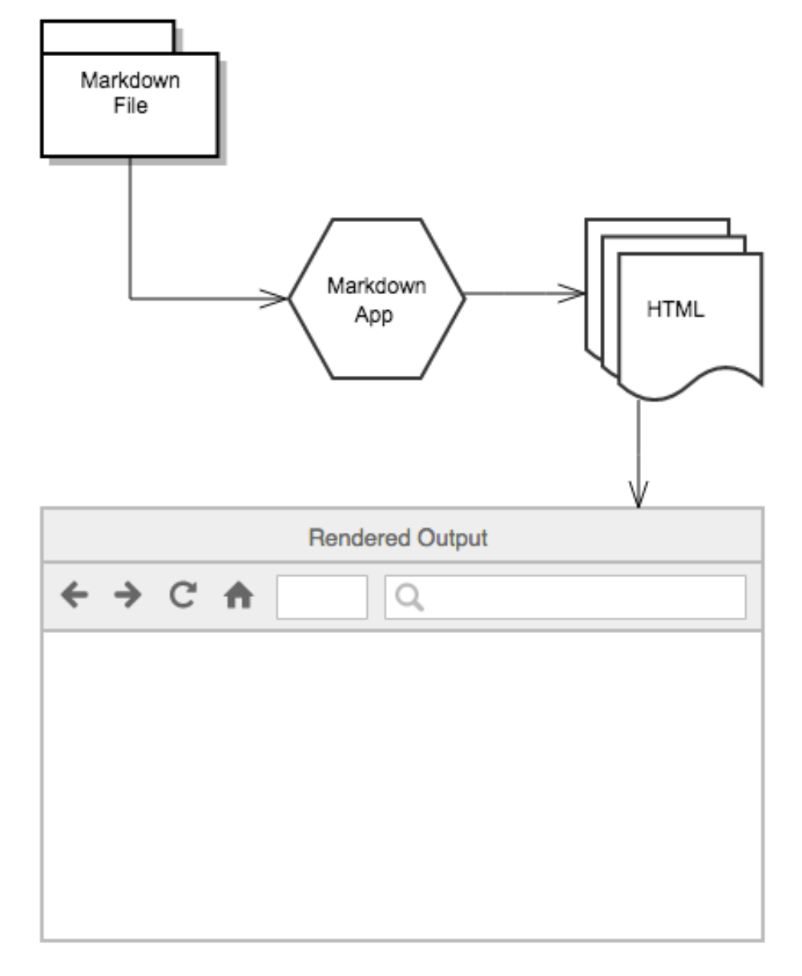

Figure 1.1: Markdown text file is converted and displayed in a web browser

# REQUIREMENTs

## Skills required

* Markdown
  + For a basic tutorial visit:
    - (<https://commonmark.org/help/tutorial/>)

Helpful Skills:

* LaTex code
* Common terminal commands
  + For more information visit:
    - (<https://www.dummies.com/computers/macs/mac-operating-systems/how-to-use-basic-unix-commands-to-work-in-terminal-on-your-mac/>)
* Pandoc’s Markdown
  + For more information visit:
    - (<https://pandoc.org/MANUAL.html#pandocs-markdown>)
* YAML (YAML Ain’t Markup Language)
  + For more information visit:
    - (<https://blog.stackpath.com/yaml/>)

## Software Requirements

For a fully functioning environment and step by step guide on installation instructions follow the instructions below:

NOTE: All the following steps must be installed on a Linux operating system.

1. Install Git

In your terminal, type (as root): apt update

then type: apt install git

NOTE: Upon opening your terminal, you may see <username@hostname: ~$>. You want your terminal to run as <root@hostname>. To do this, upon opening your terminal, type:

su –

Then enter your password. You should see something like this:

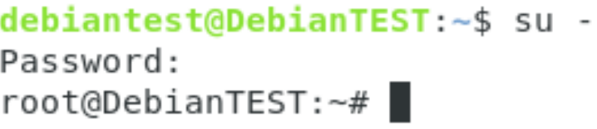

1. Install Make

In your terminal, type (as root): apt-get update

then type: apt-get install build-essential

1. Install LaTex

* Download [install-tl-unx.tar.gz](http://mirror.ctan.org/systems/texlive/tlnet/install-tl-unx.tar.gz) from <https://www.tug.org/texlive/acquire-netinstall.html>
* Extract the folder
* In the terminal, navigate to the location of the extracted folder
* In the terminal, type (as root): perl install-tl
* When prompted, enter command: I

1. Install Python 3

In your terminal type (as root): apt-get install python3-pip

1. Install Pandoc

* Download [pandoc-2.9.1.1-1-amd64.deb](https://github.com/jgm/pandoc/releases/download/2.9.1.1/pandoc-2.9.1.1-1-amd64.deb) from <https://github.com/jgm/pandoc/releases/tag/2.9.1.1>
* From your terminal navigate to location of the downloaded Pandoc folder (most likely the downloads folder) and type:

dpkg -i [pandoc-2.9.1.1-1-amd64.deb](https://github.com/jgm/pandoc/releases/download/2.9.1.1/pandoc-2.9.1.1-1-amd64.deb)

1. Install pandoc-include-code filter

* In your terminal (as normal user) type: cabal update
  + (cabal is a system for building and packaging Haskell libraries and programs. If cabal command not found then type (as root)):

apt-get install haskell-platformsu

* + Then, (as normal user) type: cabal update

NOTE: To run terminal as a normal user, type:

su - <username>

where “username” is your username. You should see something like this:

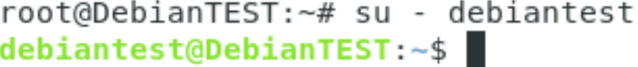

* Then type: cabal install pandoc-types
* Go to <https://github.com/owickstrom/pandoc-include-code> and download the repository by clicking “Download ZIP” and extract the folder
* In your terminal, navigate to the extracted folder
* In your terminal type: cabal configure
* Then type: cabal install

1. Install pandoc-numbering filter

* Type (as normal user): pip3 install pandoc-numbering

1. Install latexmk fully automated latex document generation)

* Go to <https://ctan.org/pkg/latexmk/>
* Click download link and download and extract the file.
* Open the extracted latexmk folder, locate the“latexmk.pl” file and move it to “~/.local/bin” and rename it to “latexmk”.
  + NOTE: You may need to expose hidden files while in “Home”. To do this press Ctrl + H.

1. Install pdf2svg

* In your terminal type (as root): apt-get install pdf2svg

1. Install librsvg2-bin

* In your terminal type (as root): apt-get install librsvg2-bin

1. Install texlive-xetex

* In your terminal type (as root): apt-get install texlive-xetex

1. Install linuxlibertine font and freefont

* In your terminal type (as root): apt-get install fonts-linuxlibertine
* Then type: apt-get install fonts-freefont-ttf

1. Clone this basic folder structure (as a normal user)

* Type: git clone <https://github.com/poonamveeral/CapstonProject>

1. Testing Pandoc

* In your terminal, navigate to Course/test
* In your terminal type: pandoc test_pandoc.md -o test_pandoc.html
* In the test folder, you should see a file called “test_pandoc.html”

1. Testing pandoc-numbering
   * In the same test folder, type:

pandoc test_pandoc-numbering.md --filter pandoc-numbering -o test_pandoc-numbering.html

* + If you’re receiving errors, in your terminal, type:

export PATH=$PATH:/home/<your username>/.local/bin

* In the test folder, you should see a file called “test_pandoc-numbering.html”

1. Test pandoc-citeproc

* In the same test folder, type:

pandoc --filter pandoc-citeproc test_pandoc-citeproc.md -o test_pandoc-citeproc.html

* In the test folder, you should see a file called “test_pandoc-citeproc.html”

1. Test pandoc-include-code

* In the same test folder, type:

pandoc --filter pandoc-include-code -o test_pandoc-include-code.pdf test_pandoc-include-code.md

* In the test folder, you should see a file called “test_pandoc-citeproc.html”

If you’re receiving “Could not find executable pandoc-include-code”

* Go to the root folder, and open the “.bashrc” file with a text editor
* Add this line to the bottom of the file and click “save” to save the file:

export PATH=$PATH:/home/<your username>/.cabal/bin

# creatING the document

Follow these steps to learn how to create a simple markdown document utilizing bibliographies, images/figures, and code blocks.

STEP 1:

To start off, you’re going to need a folder structure set up like this:

Figure 3.1: Folder Structure

If you completed number 13 from 2.2 Software Requirements skip step 2. If not, continue on.

STEP 2:

You want each folder to contain:

* Course: bib folder, code folder, fig folder, img folder, latex folder, style folder, and a Makefile file
* bib: .bib file (to store references)
* code: code files (e.g. .java, .xml, .sql)
* fig: latex figures
* img: img snapshots
* latex: latex style file (to store latex styles)
* style: .css file (to store css styles)
* test: .md files to test

An example of a basic template of a markdown file can be found at example.md in the generic repo from step 13 from above.

# Compiling and cONVERting the document

Follow these steps to learn how to compile and convert a markdown file to PDF, ODT, and HTML. Other possible conversion formats can be found here: <https://pandoc.org/>

* Open up a terminal, inside of it, change your directory to where your markdown file is located. In this example, navigate to your ‘Course’ folder. To do this, simply type:

cd Course

where “Course” is the name of your Course folder.

* Next, type:

make fig

“make fig” compiles all the latex code in order to produce the figures from the figures folder.

* Then:

make fig_svg

“make fig_svg” compiles all the latex code in order to produce the figures from the figures folder.

* To produce a PDF document common format is:

pandoc <filters> <inputfile.md> -o <outputfile.ext>

or

pandoc <filters> -o <outputfile.ext> <inputfile.md>

## PDF

For our example, in your terminal, while in the directory of where your markdown file is located, which should be your “Course” folder, type:

pandoc --toc --filter pandoc-numbering --filter pandoc-citeproc --filter pandoc-include-code --top-level-division=chapter -M date="$(LANG=en_us_88591 date '+%B  %e, %Y (%r)')" --pdf-engine=xelatex --pdf-engine-opt=-shell-escape -V links-as-notes --default-image-extension=pdf -o example.pdf example.md

To check if the results worked, from your desktop, navigate to your “Course” folder. You should see a new file called “example.pdf”.

## ODT

For our example, in your terminal, while in the directory of where your markdown file is located, which should be your “Course” folder, type:

pandoc  --toc --filter pandoc-numbering --filter pandoc-citeproc --filter pandoc-include-code --top-level-division=chapter -M date="$(LANG=en_us_88591 date '+%B  %e, %Y (%r)')" --default-image-extension=svg -o example.odt example.md

To check if the results worked, from your desktop, navigate to your “Course” folder. You should see a new file called “example.odt”.

## HTML

For our example, in your terminal, while in the directory of where your markdown file is located, which should be your “Course” folder, type:

pandoc --toc --filter pandoc-numbering --filter pandoc-citeproc --filter pandoc-include-code --top-level-division=chapter -M date="$(LANG=en_us_88591 date '+%B  %e, %Y (%r)')" --css=style/style.css --toc-depth=1 --self-contained --default-image-extension=svg -o example.html example.md

where “style.css” is the name of your css file.

To check if the results worked, from your desktop, navigate to your “Course” folder. You should see a new file called “example.html”.