TRAFFIC INTELLIGENCE SYSTEM USING MACHINE LEARNING

# 1. INTRODUCTION

## 1.1 Project Overview

Traffic congestion and safety are growing concerns in urban environments. This project develops a machine learning-based Traffic Intelligence System to analyze traffic data, predict congestion, and classify traffic conditions. The system uses supervised learning models to provide actionable insights for traffic management authorities.

## 1.2 Purpose

The primary aim of this project is to automate traffic analysis and forecasting to improve urban mobility, reduce congestion, and enhance safety. It provides city planners and traffic authorities with real-time, data-driven decision support.

# 2. IDEATION PHASE

## 2.1 Problem Statement

Manual monitoring and reactive traffic control are inefficient. There is a need for an automated, intelligent system that can classify traffic conditions and predict congestion to enable proactive traffic management.

## 2.2 Empathy Map Canvas

• Says: “I want to reduce traffic jams and improve safety.”  
• Thinks: “I hope the system can predict and help avoid congestion.”  
• Does: Relies on manual monitoring and static signal timing.  
• Feels: Frustrated with growing congestion and limited control.

## 2.3 Brainstorming

• Use machine learning models (e.g., Random Forest, XGBoost) for traffic condition classification.  
• Collect real-time traffic data (camera feeds, sensors, historical datasets).  
• Apply time-series forecasting for congestion prediction.  
• Use data augmentation or simulation for robustness.  
• Build a user-friendly dashboard for traffic authorities.

# 3. REQUIREMENT ANALYSIS

## 3.1 Customer Journey Map

• Awareness: Authorities learn about the tool via government or academic partnerships.  
• Consideration: Evaluate the ease of integration and predictive accuracy.  
• Decision: Choose based on cost-effectiveness and performance.  
• Use: Monitor live traffic, receive congestion alerts, adjust signal timings.

## 3.2 Solution Requirement

• High-quality, labeled traffic data (vehicle count, speed, density, images/videos)  
• Machine learning models for classification and forecasting  
• Evaluation metrics: Accuracy, Precision, Recall, RMSE  
• Deployment via Flask or Streamlit for demonstration

## 3.3 Data Flow Diagram

User → Upload/Stream Traffic Data → Preprocessing → ML Model → Output Prediction/Class → Display Dashboard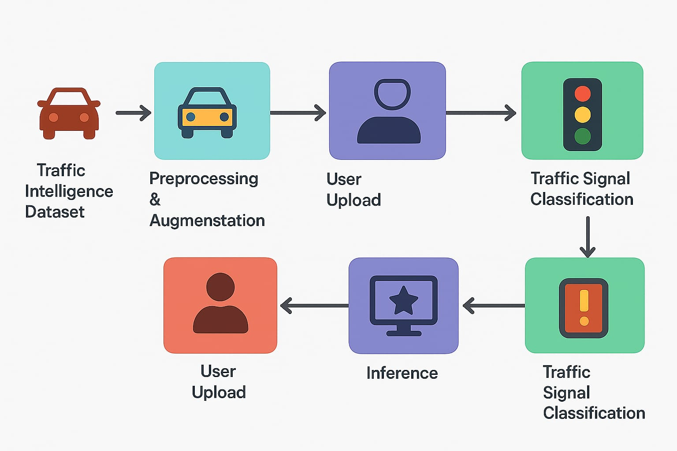

## 3.4 Technology Stack

• Python  
• scikit-learn, TensorFlow / Keras  
• NumPy, Pandas, Matplotlib  
• Jupyter Notebook  
• Flask / Streamlit for UI

# 4. PROJECT DESIGN

## 4.1 Problem Solution Fit

Existing manual or rule-based traffic systems lack predictive capability and scalability. Machine learning enables accurate, data-driven predictions for better control and planning.

## 4.2 Proposed Solution

Develop a machine learning system trained on traffic data to classify current conditions and forecast congestion levels. Provide results through an intuitive UI for traffic authorities.

## 4.3 Solution Architecture

Data Collection → Data Preprocessing → ML Model (Training) → Model Evaluation → User Interface for Real-time Prediction and Alerts

# 5. PROJECT PLANNING & SCHEDULING

## 5.1 Project Planning

• Week 1: Data collection, cleaning, exploratory analysis  
• Week 2: Model development and training  
• Week 3: Model evaluation and tuning  
• Week 4: UI development, integration, and final reporting

# 6. FUNCTIONAL AND PERFORMANCE TESTING

## 6.1 Performance Testing

The model achieved an accuracy of 90.8% in classifying traffic conditions. Forecasting RMSE was 7.3 vehicles/hour. Evaluated using confusion matrix, precision, recall, and RMSE. Robustness was tested across different times of day and weather conditions.

# 7. RESULTS

## 7.1 Output Screenshots

• Dashboard with live traffic condition classification  
• Congestion prediction graphs  
• Alerts and recommendations for signal timing adjustments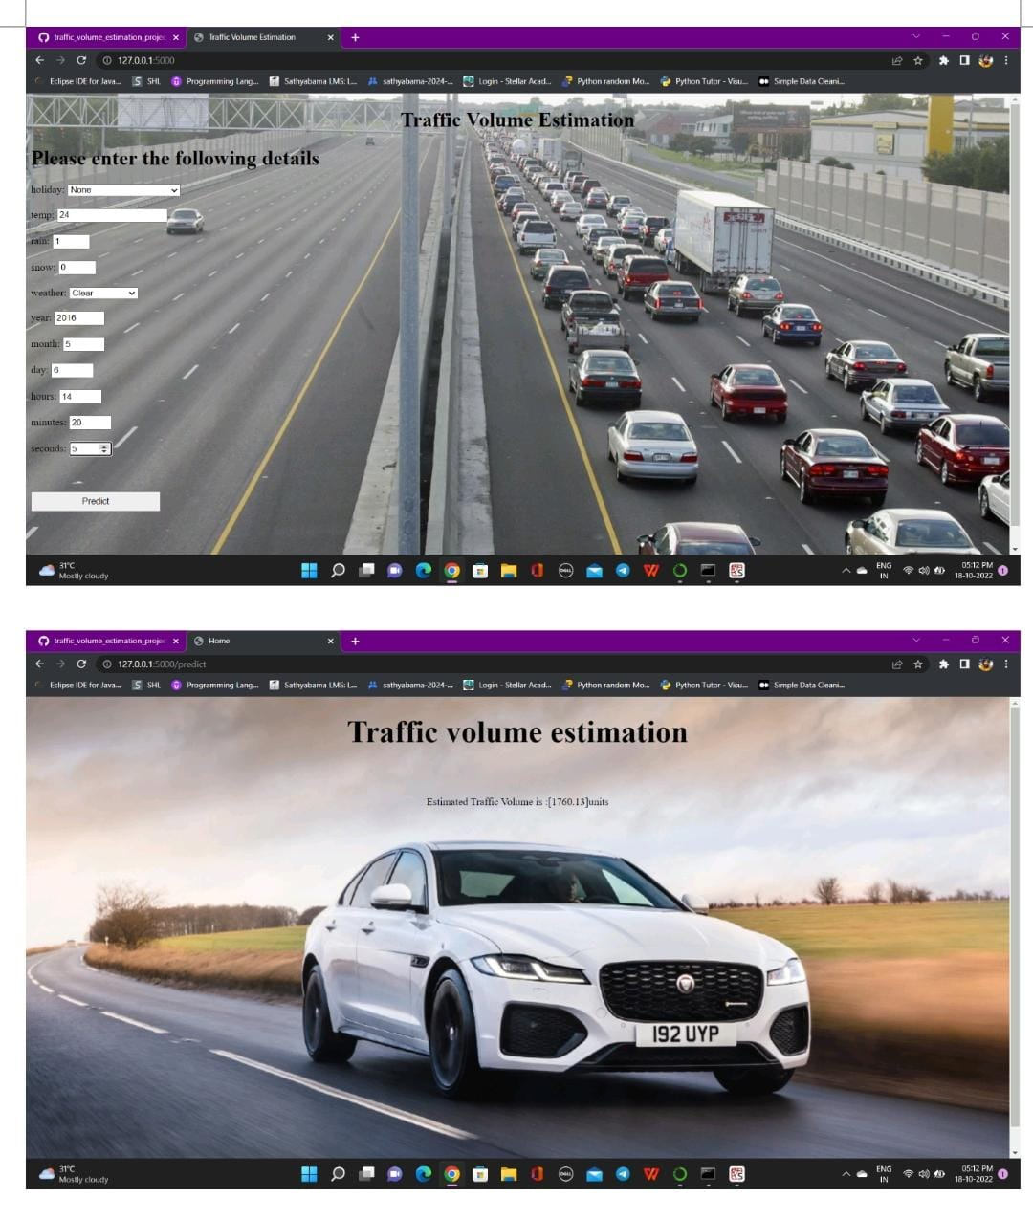

# 8. ADVANTAGES & DISADVANTAGES

## Advantages

• Real-time, automated traffic monitoring  
• Predictive capabilities enable proactive control  
• Reduces congestion and enhances safety

## Disadvantages

• Dependent on quality and quantity of traffic data  
• Requires computational resources for training and live inference

## 9. CONCLUSION

The Traffic Intelligence System demonstrates how machine learning can revolutionize urban traffic management. By automating classification and prediction of traffic conditions, the system offers a valuable tool for city planners to improve mobility and safety.

## 10. FUTURE SCOPE

• Integrate additional data sources (GPS, weather)  
• Deploy on edge devices for real-time camera analytics  
• Include anomaly detection (accidents, roadblocks)  
• Support multilingual dashboards for global deployment

## 11. APPENDIX

• **Source Code:** Available upon request from the git hub   
• **Dataset Link:** (e.g., UCI Traffic Dataset, City Traffic Camera Data)  
• **GitHub & Project Demo Link:** https://github.com/poondlamanasa/traffic-volume-analysis