DOCUMENTATION

**DETAILS NAME**: POONGUZHALI **REG NO**: 913120103025

**COLLEGE NAME**: VELAMMAL COLLEGE OF

ENGINEERING & TECHNOLOGY,MADURAI-625009

**PH NO**:8610693181

**NM ID**:0310738B99252F287AF44521CF7D564F

**SKILLS**:DIGITAL MARKETING

Blog Name: Arkhitecton category: 3D Designing

E-mail: [arkhitectonn@gmail.com](mailto:arkhitectonn@gmail.com) password:seven3d+

wordpress blog url: [http://arkhitectonn5.wordpress.com](http://arkhitectonn5.wordpress.com/)

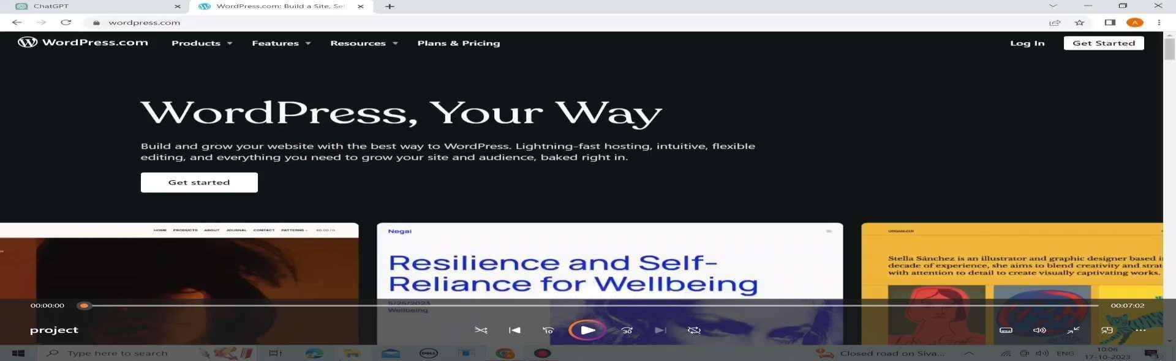step:1 open the wordpress.com

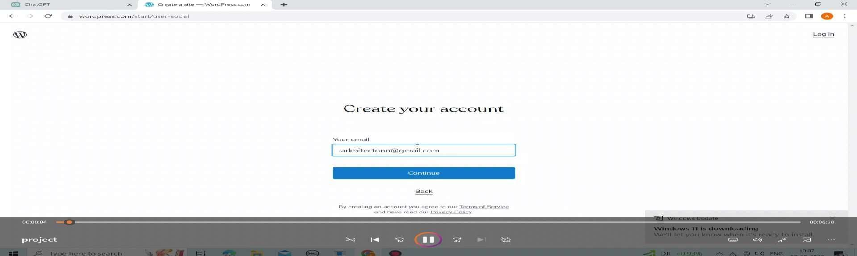step 2: login with your mail id

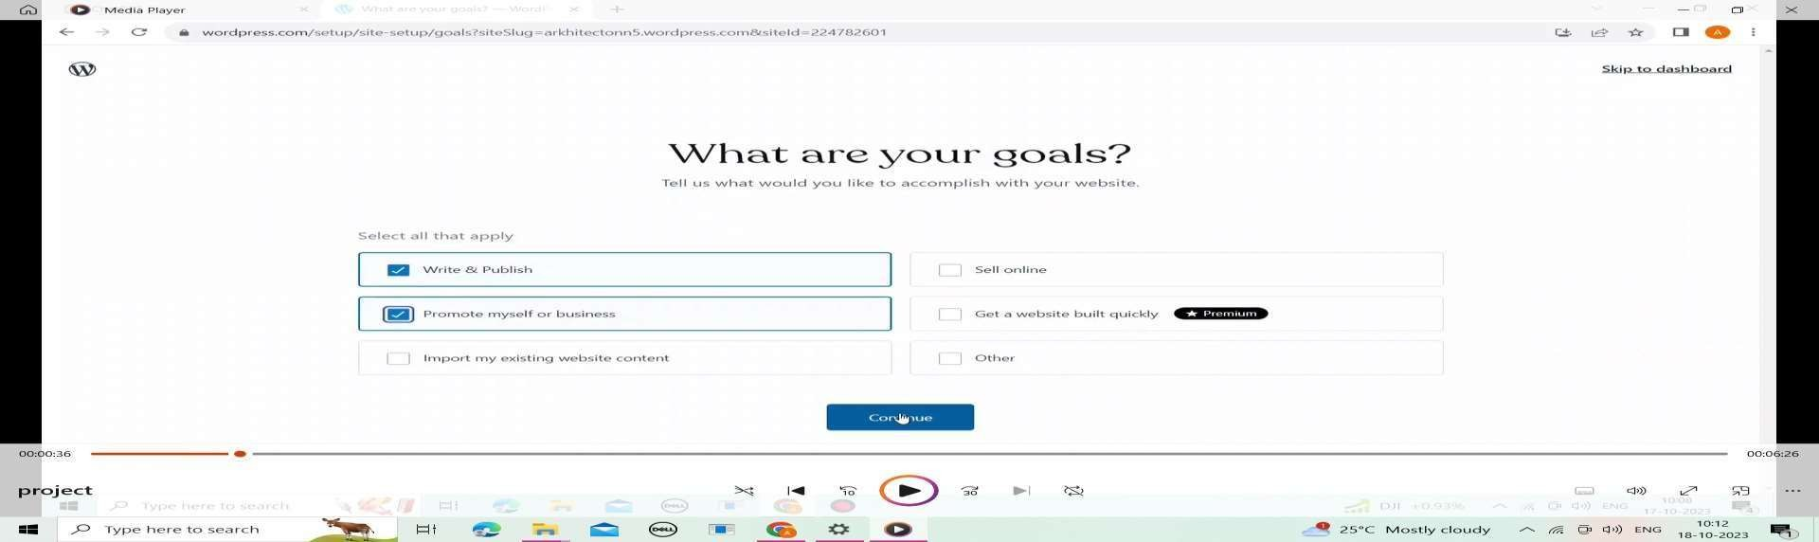step 3: choose your goals

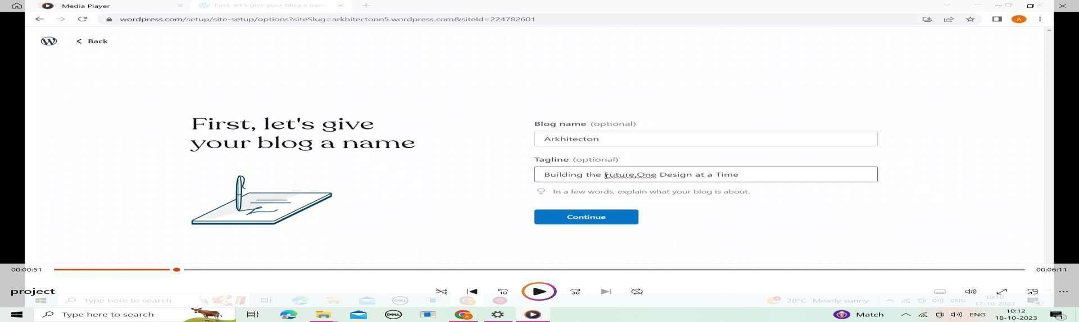step 4: choosing blog name

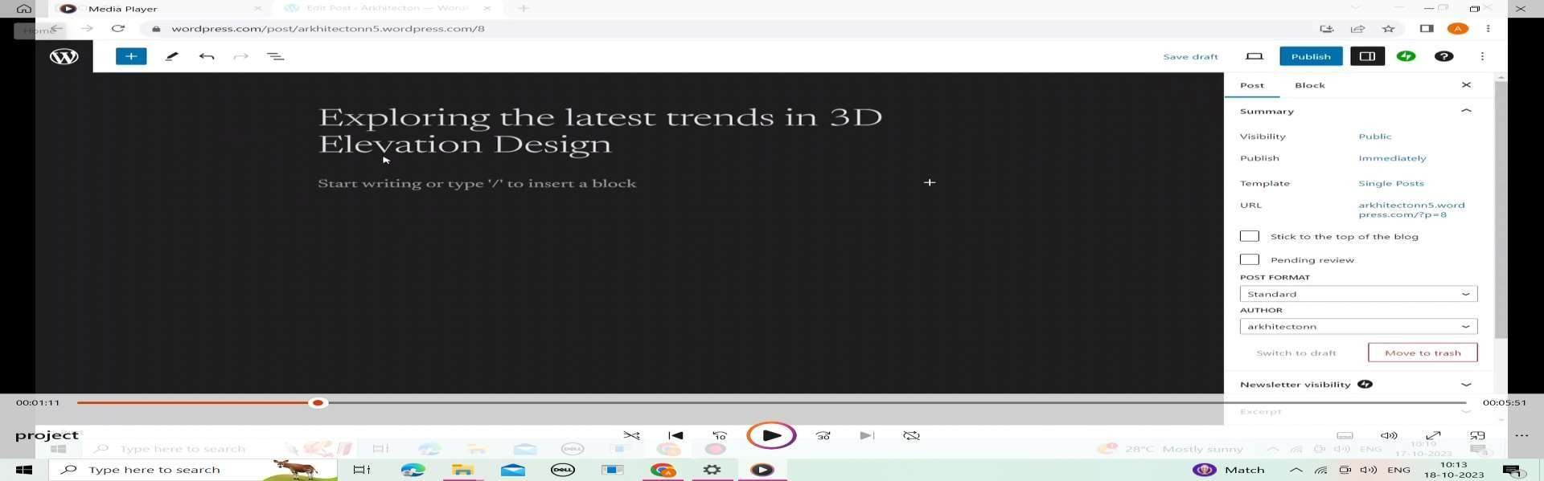step 5: import your ideas in word-press

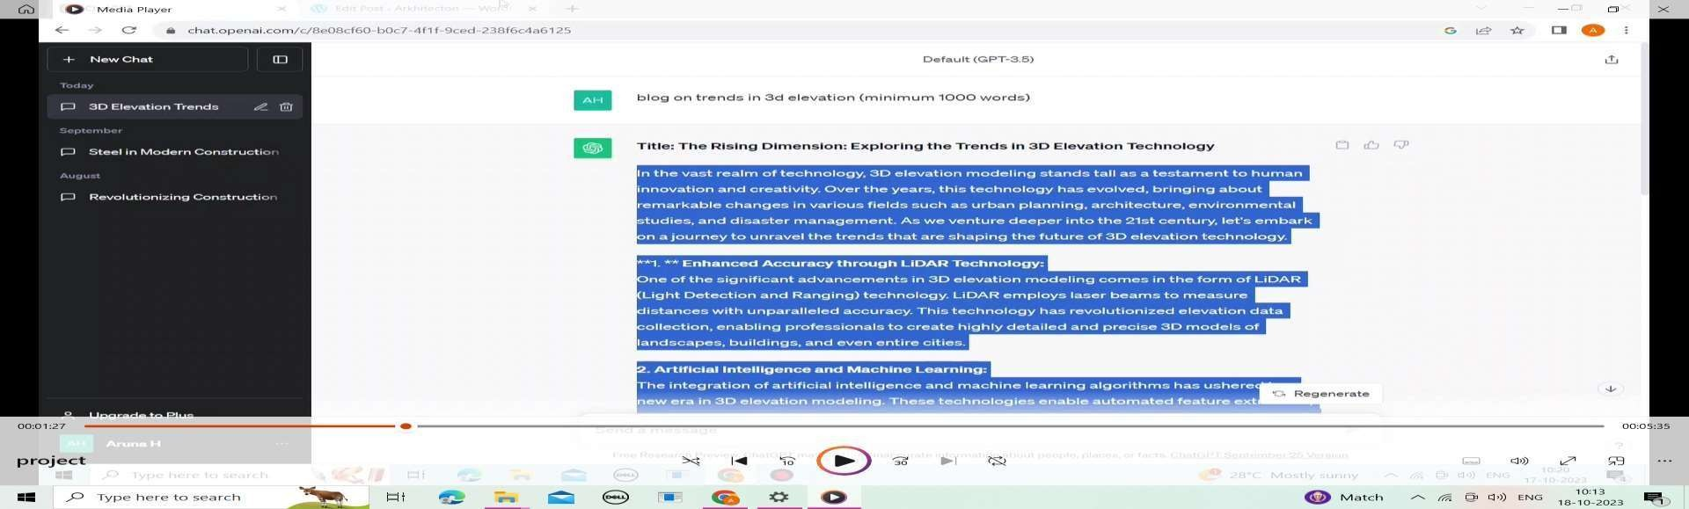step 6: searching for detailed explanation

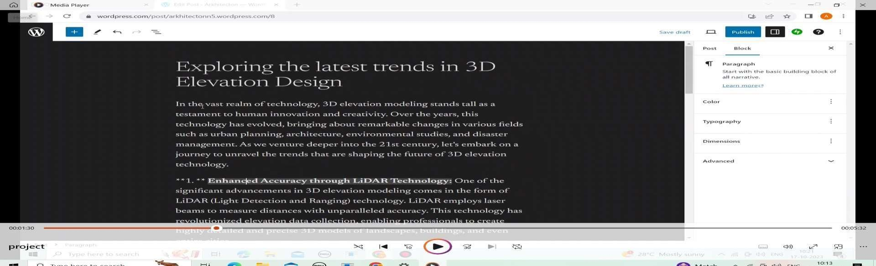step 7: Insert the information in the word-press

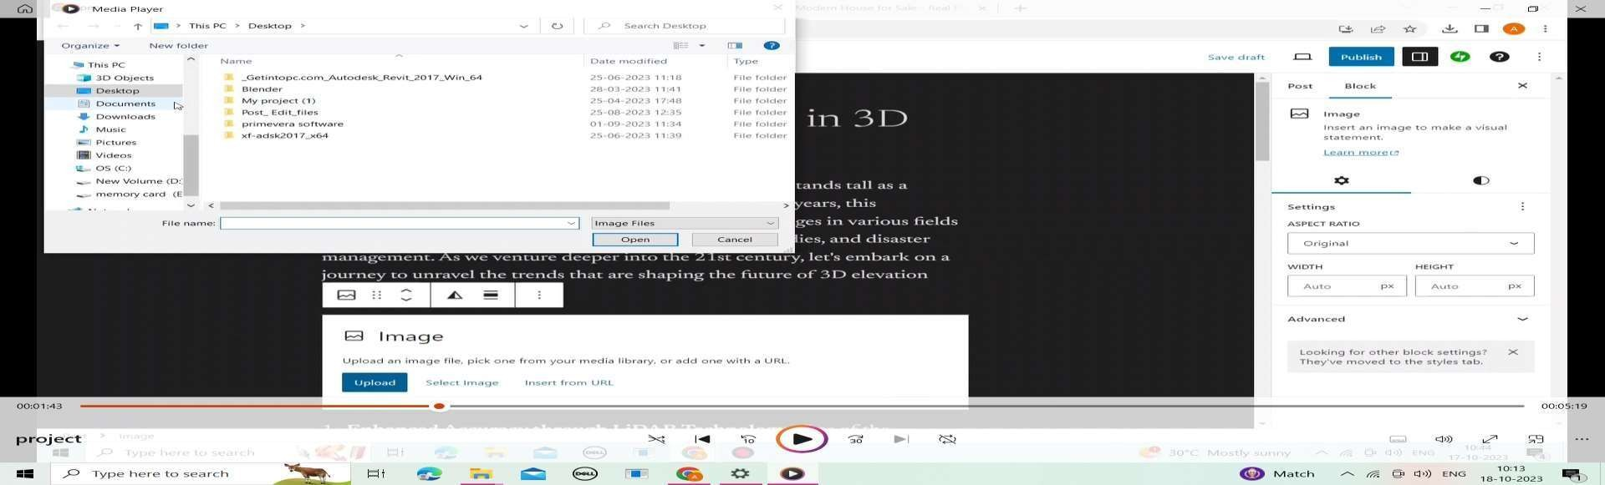step 8: Insert the created poster

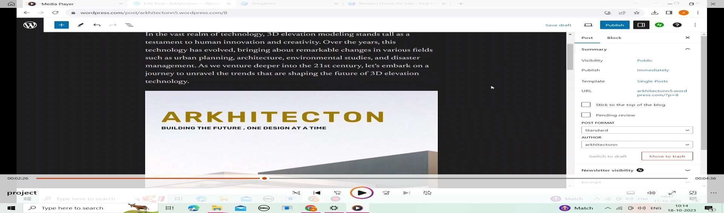step 9: poster implementation

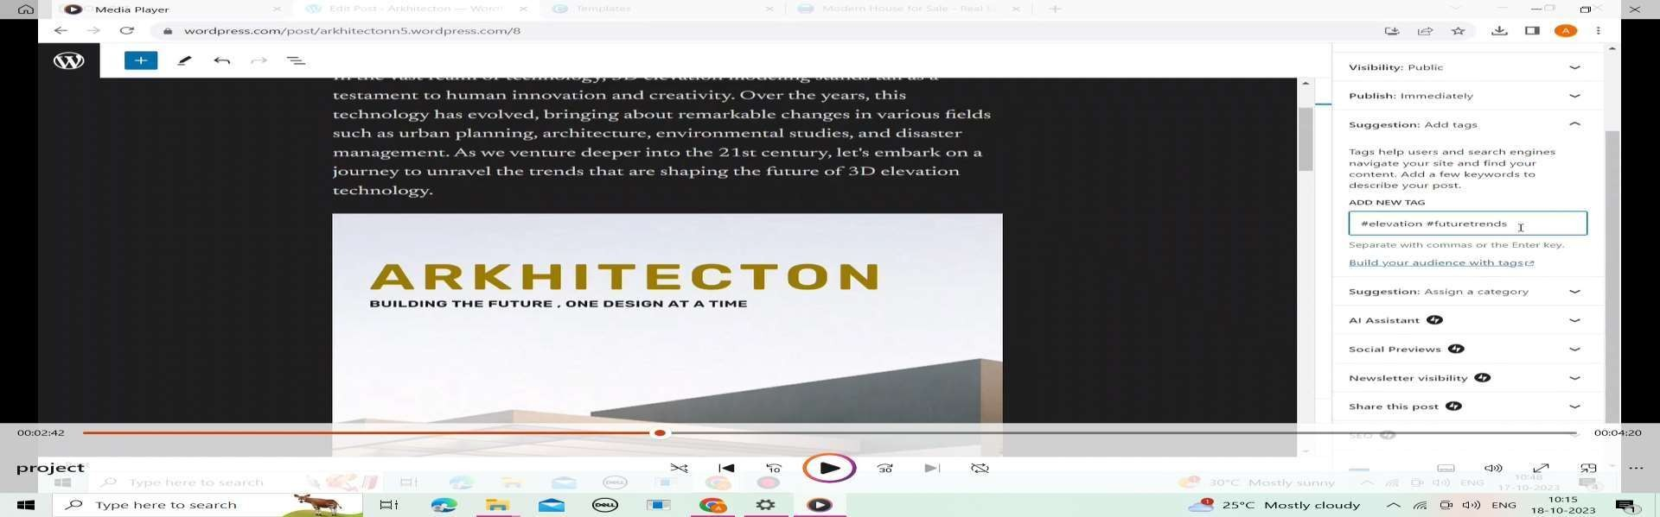step 10: creating tagline

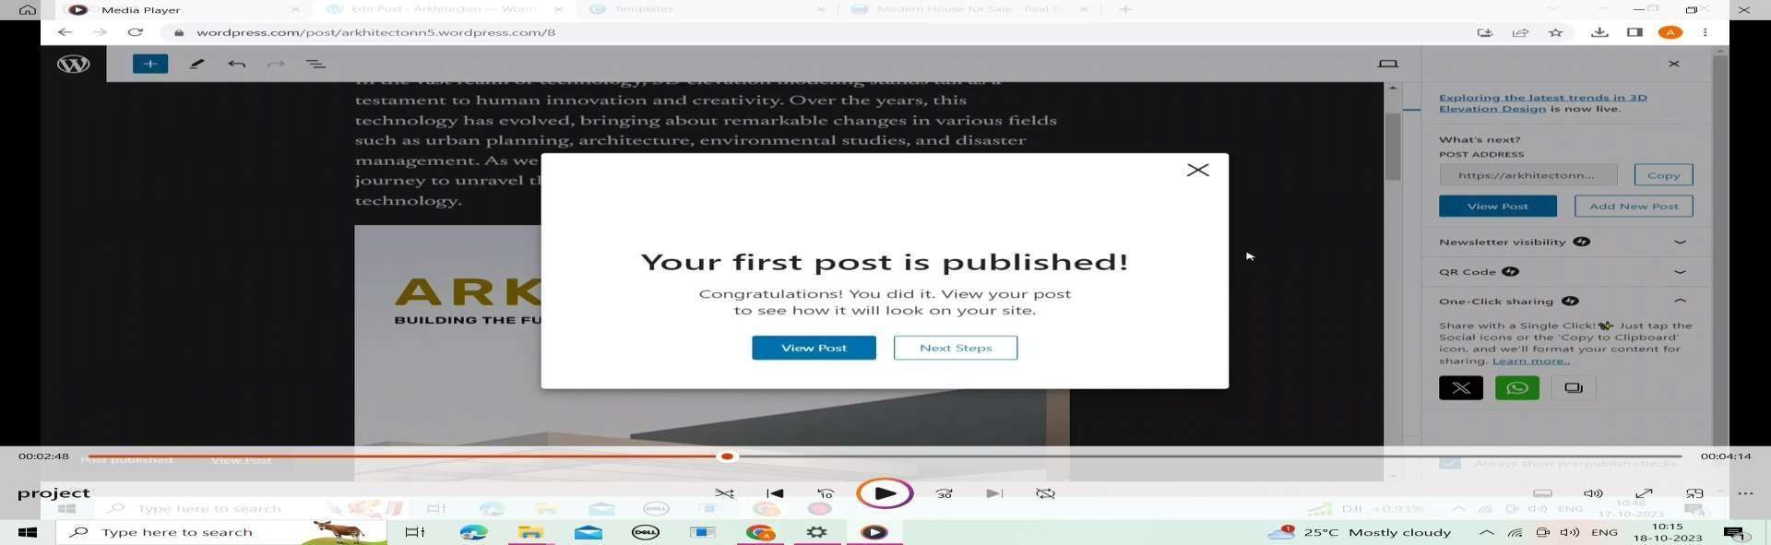step 11:publish your post

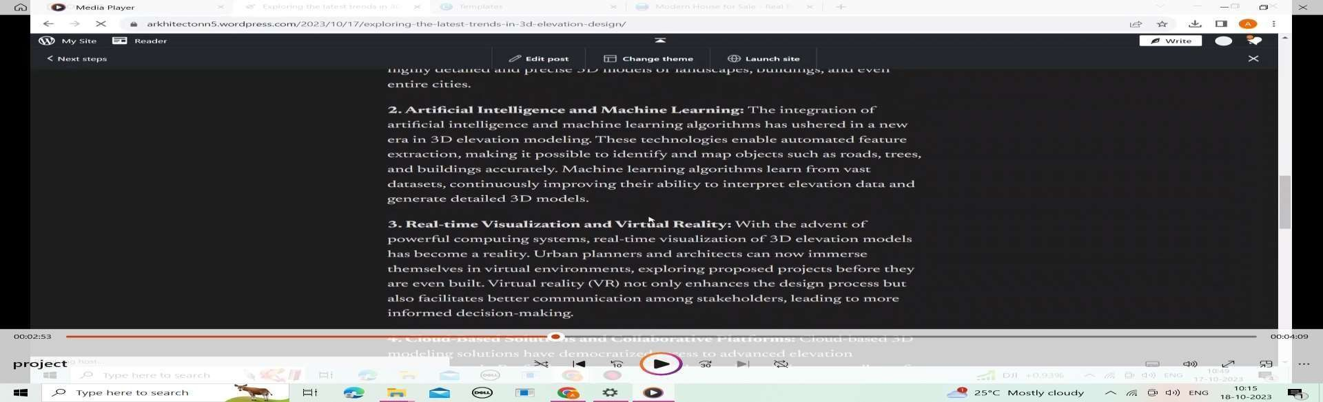step 12:review your post

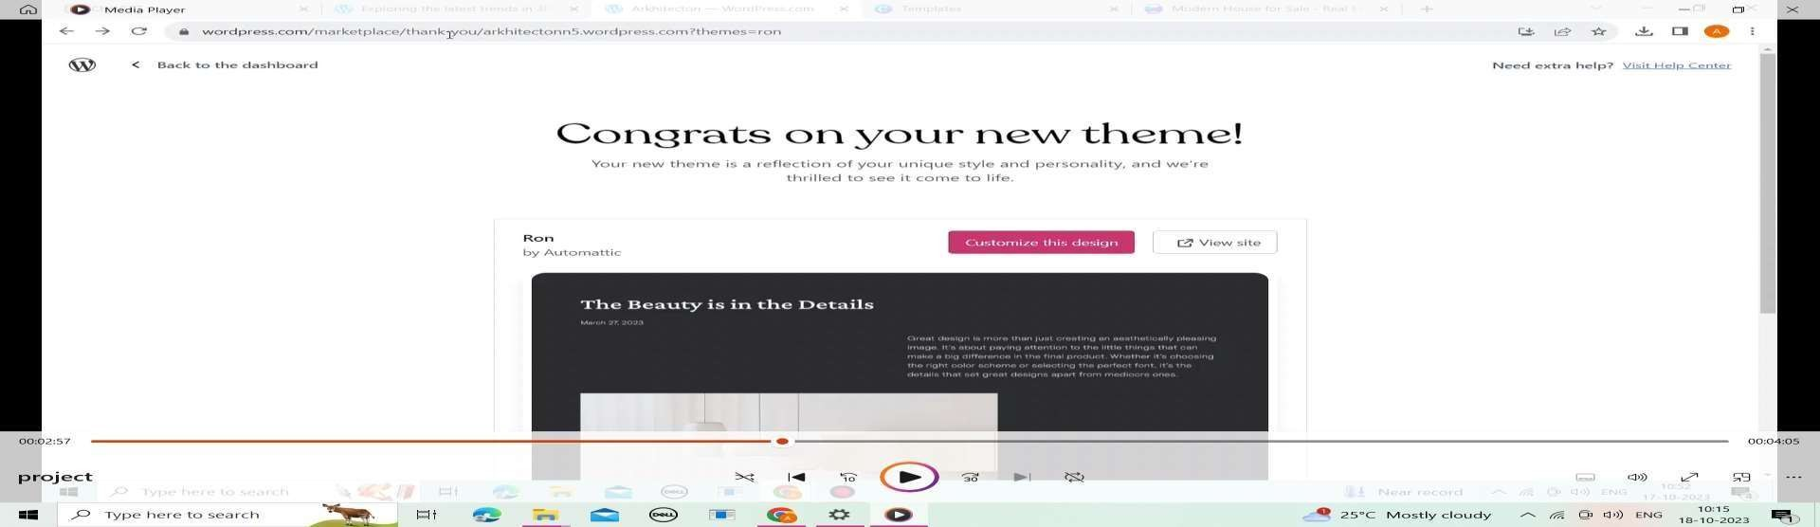step 13:setting up of theme

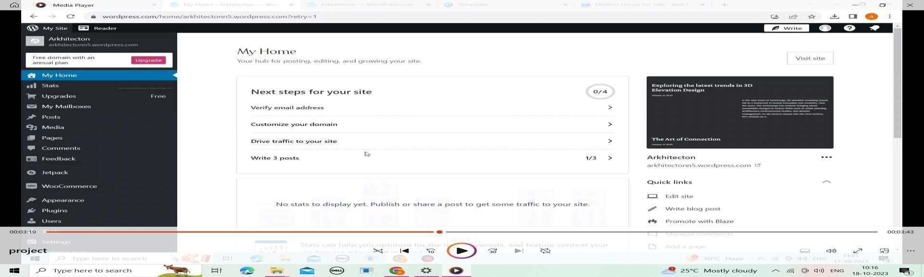step 14:view your home page

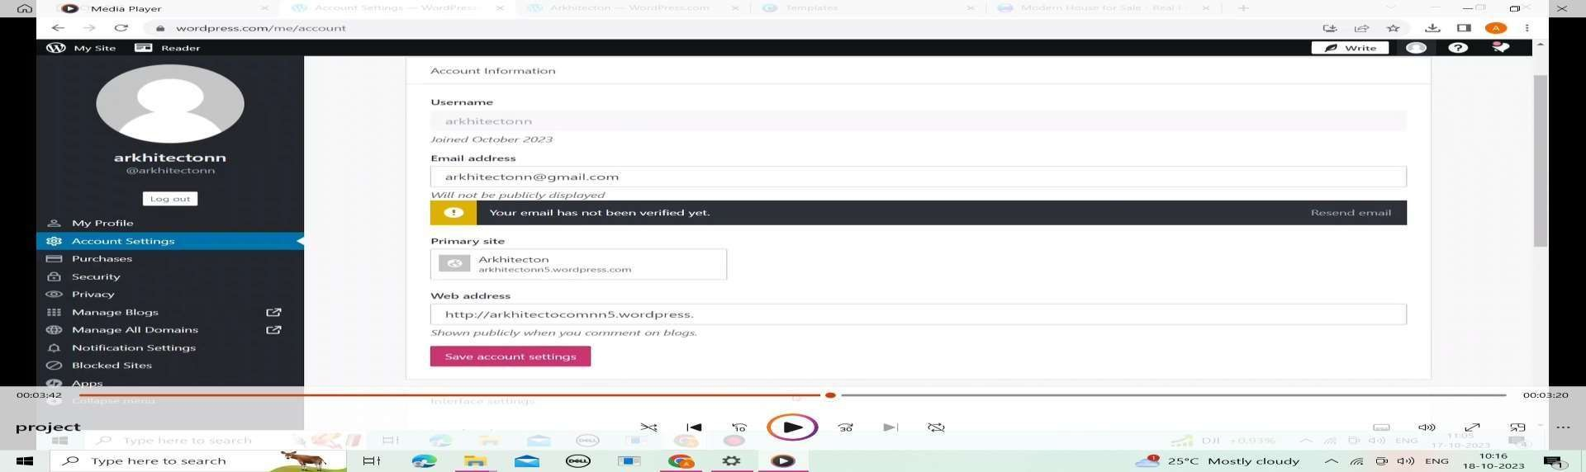step 15:verification of e-mail

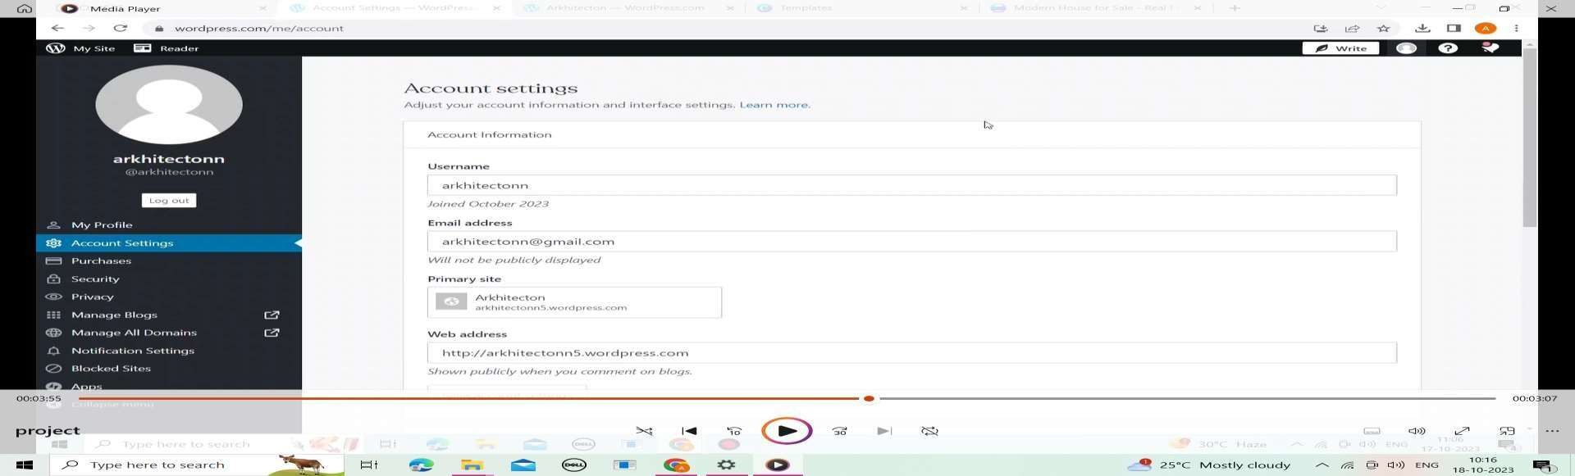step 16:account settings

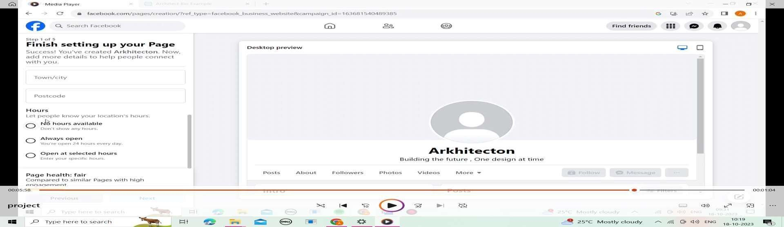

step 17:finish setting up your page

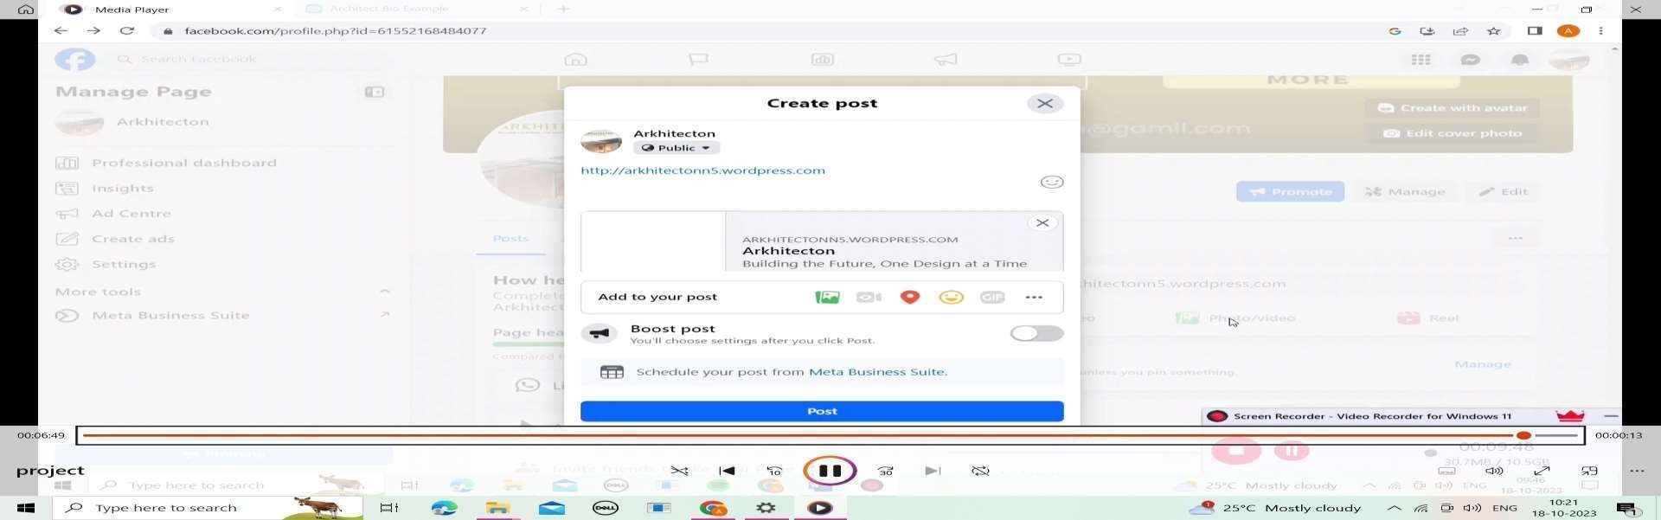step 18:post your article