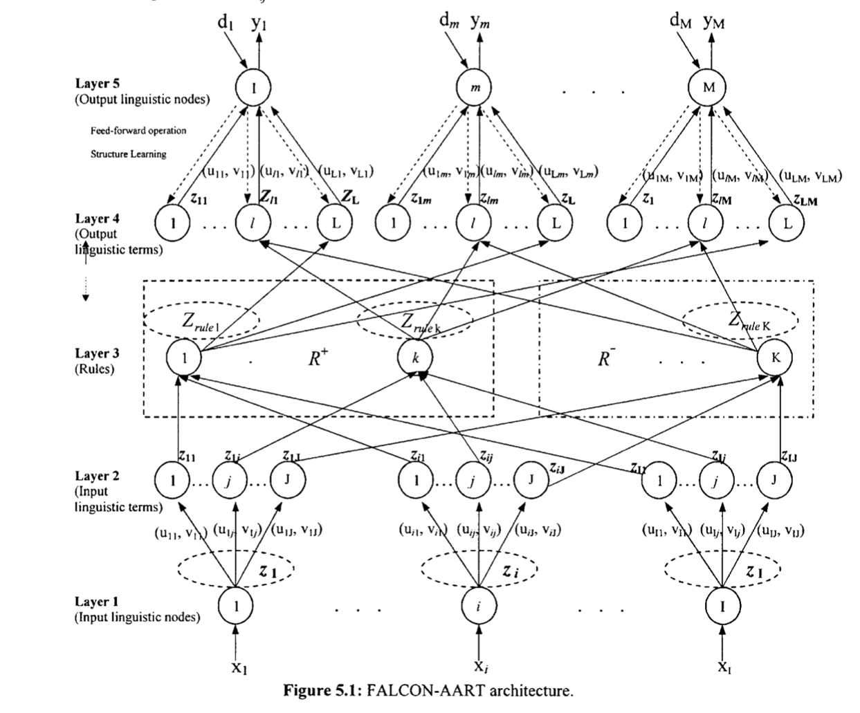

Fuzzy Adaptive Learning Control Network – Adaptive

Resonance Theory

Fuzzy Adaptive Learning Control Network – Adaptive

Resonance Theory

Fuzzy adaptive learning control network – adaptive renonsance theory

Seaborn density plot

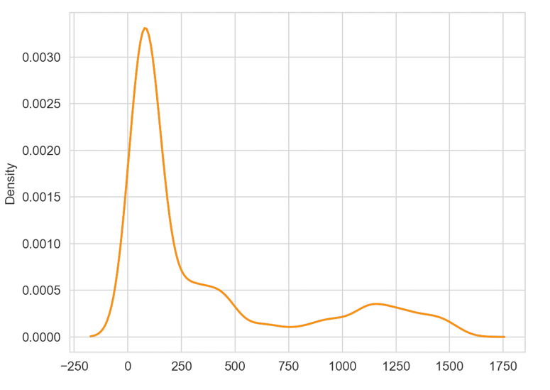  
<https://medium.com/@apbetahouse45/understanding-fuzzy-neural-network-with-code-and-graphs-263d1091d773>

s/y instead of s\*y for g, membership function

for learning rate removed the bottom left lambda initial to increase rate of adoption

Tan tuan zea tony not helpful

Completed most of the logic of structural learning

Change of dataset

What is momentum constant

CLS 🡪 Negative rule

ASK FOR DATASET – to learn about complimentary learning

Same old dataset issue

Learn adaptive resonance theory (ART)

Now I have too many all the fired node at level 4 with the same activation function

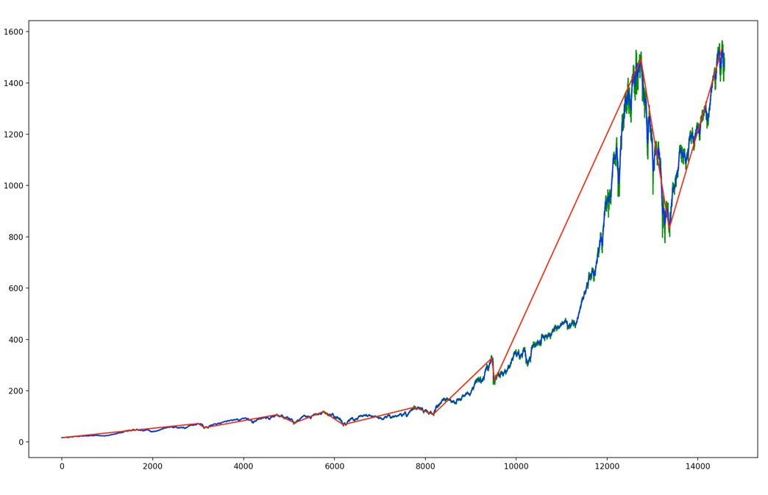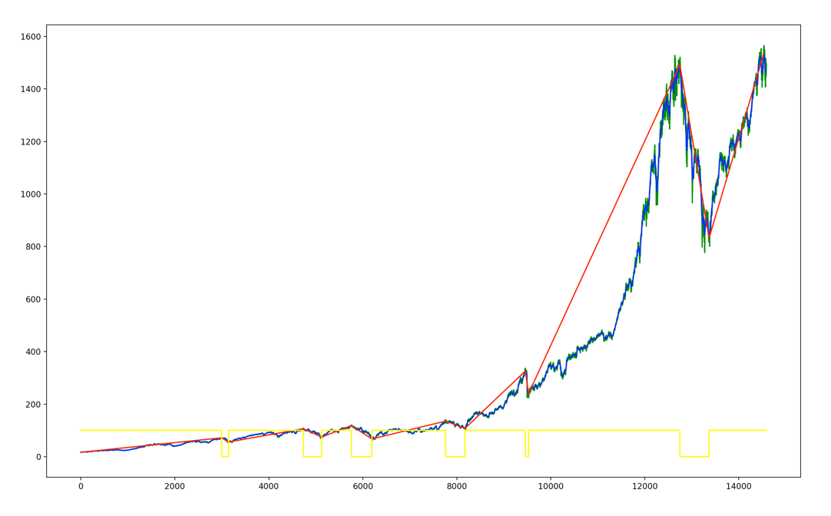

[15, 2997, 3140, 4734, 5122, 5758, 6192, 7761, 8174, 9459, 9527, 12746, 13369, 14536]

After 100 iterations

Bull/0/0/0/0/0/ 0.8902972520125806

Bull/0/0/0/1/0/ 0.10591323307542558

Bull/0/0/1/0/0/ 0.10591323307542558

Bull/0/1/0/2/0/ 0.10653005692252793

Bull/1/0/2/0/0/ 0.10653005692252793

Yea

fixed number of C for clustering/ Dynamic ?

clustering- the situation of every single trapezium sticking to each other?

\*\*Learning rate, b in clustering and o/ with lambda.   
  
fuzziness in g(s , y), y

\*\*Vigilance test purpose and meaning, p parameter how to set ?

Weights of each of the line initial value  
  
How is CLS made. Positive and negative rule- resonance theory  
  
Data input?

I am currently still at the structure learning stage.  
  
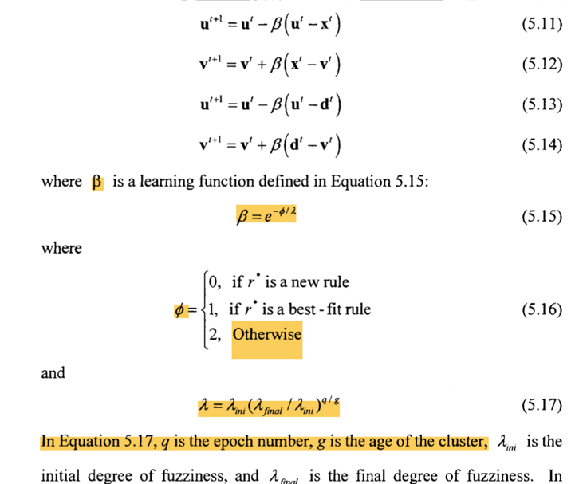

Firstly, the way the input/output cluster is updated using the following formula.   
For formula 5.16, what situation will be the ‘Otherwise’ because usually the rule is new rule or best-fit rule.   
For formulat 5.17, how is fuzziness calculated? How is fuzziness initiated at the start as well (when a new rule is formed)?  
