Game Design Document

Fill up the following document

1. Write the title of your project.

Car racing game

1. What is the goal of the game?

To reach the finish line without hitting the barriers

1. Write a brief story of your game.

It will be a 2 player game in which the players can bang into each other to throw them off the road to reach the finish line first.

1. Which are the playing characters of this game?

* Playing characters are the ones who respond to the user based on the input from the user.
* Cars, monkeys, dinos, wizards, etc., are the playing characters in the game.

|  |  |  |
| --- | --- | --- |
| Number | Character Name | What can this character do? |
| 1 | Racer 1 | Drive a car |
| 2 | Racer 2 | Drive a car |
| 3 |  |  |
| 4 |  |  |
| 5 |  |  |
| 6 |  |  |
| 7 |  |  |
| 8 |  |  |

1. Which are the Non-Playing Characters of this game?

* Non-Playing characters are the ones that don't have an action or behavior when the user interacts with the game.
* Hurdles, stones, bananas, coins, etc., are non-playing characters in the game.

|  |  |  |
| --- | --- | --- |
| Number | Character Name | What can this character do? |
| 1 | Side barriers | If a car hits them then its game over |
| 2 | Random cars | If a car hits them then its game over |
| 3 |  |  |
| 4 |  |  |
| 5 |  |  |
| 6 |  |  |
| 7 |  |  |
| 8 |  |  |

Draw your imagination of this game. What does this game look like?

* Draw the game either on your computer or on paper.
* Add images of the game scenes to show each of the playing and non-playing characters at least once.

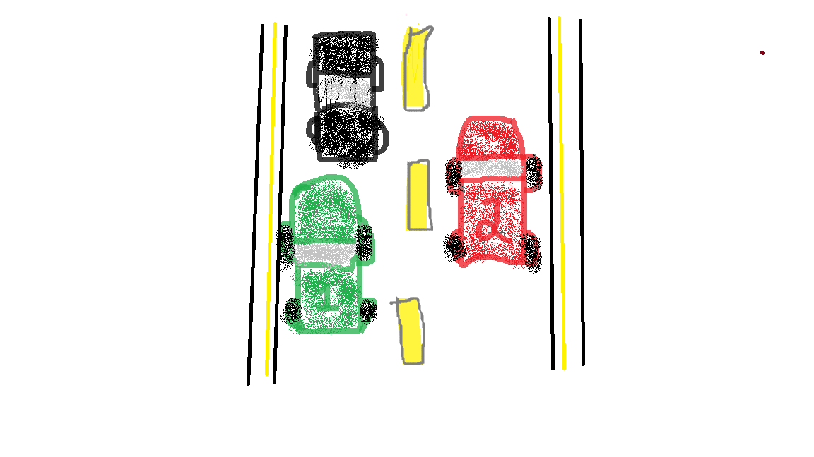

How do you plan to make your game engaging?

* I will add random cars as obstacles in between that the player has to avoid hitting.