- Aim:
To write a C++ program to read and display the elements of a one-dimensional array.
Algorithm:
Step 1: Start the program.
Step 2: Read the number of elements in the array. Step 3: Declare an array of the given size.
Step 4: Read the array elements.
Step 5: Display all the array elements. Step 6: Stop the program.
Program Code:
#include<iostream> using namespace std; int main(){
int n;
cout<<"Enter the no.of elements:"; cin>>n;
int arr[n];
cout<<"Enter the array elements:"; for(int i=0;i<n;i++){
cin>>arr[i];
}
cout<<"Array Elements:"; for(int i=0;i<n;i++){
cout<<arr[i]<<" ";
}
return 0;
}
Sample Output:
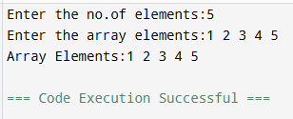

Result:

Thus, the C++ program to read and display the elements of an array was executed successfully.

- Aim:
To write a C++ program to search for an element in an array using linear search.
Algorithm:
Step 1: Start the program.
Step 2: Read the number of elements. Step 3: Read the array elements.
Step 4: Read the element to be searched.
Step 5: Compare the search element with each array element. Step 6: If the element is found, display its position.
Step 7: Otherwise, display "Element Not Found". Step 8: Stop the program.
Program Code:
#include<iostream> using namespace std; int main(){
int n,key,found=0;
cout<<"Enter the no.of elements:"; cin>>n;
int arr[n];
cout<<"Enter the array elements:"; for(int i=0;i<n;i++){
cin>>arr[i];
}
cout<<"Enter the array element to be searched:"; cin>>key;
for(int i=0;i<n;i++){ if(arr[i]=key){
cout<<"Element found a position:"; found=1;
break;
}
}
if(found=0){
cout<<"Element Not Found";
}
return 0;
}

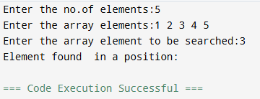

Result:

- Aim:

Thus, the C++ program to search for an element in an array using linear search was executed successfully.

To write a C++ program to display the elements of an array in reverse order.

Algorithm:
Step 1: Start the program.
Step 2: Read the number of elements. Step 3: Read the array elements.
Step 4: Traverse the array from the last element to the first element. Step 5: Display the elements in reverse order.
Step 6: Stop the program.
Program Code:
#include<iostream> using namespace std; int main(){
int n;
cout<<"Enter the no.of elements:"; cin>>n;
int arr[n];
cout<<"Enter the array elements:"; for(int i=0;i<n;i++){
cin>>arr[i];
}
cout<<"Array in the reverse order:"; for(int i=n-1;i>=0;i--){
cout<<arr[i];
}
return 0;
}

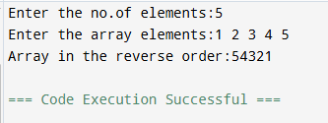

Result:

- Aim:

Thus, the C++ program to display the array elements in reverse order was executed successfully.

To write a C++ program to find the smallest and largest elements in an array.

Algorithm:
Step 1: Start the program.
Step 2: Read the number of elements. Step 3: Read the array elements.
Step 4: Assume the first element as the smallest and largest.
Step 5: Compare each remaining element with the smallest and largest values. Step 6: Update the smallest and largest values whenever required.
Step 7: Display the smallest and largest elements. Step 8: Stop the program.
Program Code:
#include<iostream> using namespace std; int main(){
int n;
cout<<"Enter the no.of elements:"; cin>>n;
int arr[n];
cout<<"Enter the array elements:"; for(int i=0;i<n;i++){
cin>>arr[i];
}
int smallest=arr[0]; int largest=arr[0]; for(int i=1;i<n;i++){
if(arr[i]<smallest){ smallest=arr[i];

if(arr[i]>largest){ largest=arr[i];
}
}
cout<<"Smallest Element:"<<smallest<<endl; cout<<"Largest Element:"<<largest<<endl; return 0;
}
Sample Output:
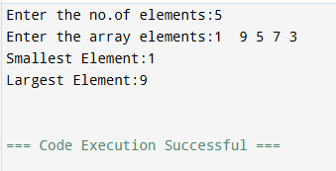
Result:
Thus, the C++ program to find the smallest and largest elements in an array was executed successfully.
- Aim:
To write a C++ program to merge two arrays into a single array.
Algorithm:
Step 1: Start the program.
Step 2: Read the size of the first array. Step 3: Read the size of the second array. Step 4: Read the elements of both arrays.
Step 5: Copy the elements of the first array into the merged array.
Step 6: Copy the elements of the second array after the first array elements. Step 7: Display the merged array.
Step 8: Stop the program.
Program Code:
#include<iostream> using namespace std; int main(){
int n1,n2;
cout<<"Enter the size of the first array:"; cin>>n1;

int arr1[n1];
cout<<"Enter the size of the second array:"; cin>>n2;
int arr2[n2];
cout<<"Enter the first array elements:"; for(int i=0;i<n1;i++){
cin>>arr1[i];
}
cout<<"Enter the second array elements:"; for(int i=0;i<n2;i++){
cin>>arr2[i];
}
int merge[n1+n2];
for(int i = 0; i < n1; i++) { merge[i] = arr1[i];
}
for(int i = 0; i < n2; i++) { merge[n1 + i] = arr2[i];
}
cout << "Merged array: "; for(int i = 0; i < n1 + n2; i++) {
cout << merge[i] << " ";
}
return 0;
}
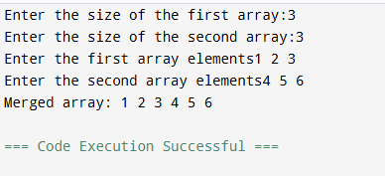
Sample Output:

Result:

Thus, the C++ program to merge two arrays into a single array was executed successfully.

- Aim:
To write a C++ program to find the sum of all elements in an array.
Algorithm:
Step 1: Start the program.
Step 2: Read the number of elements. Step 3: Read the array elements.
Step 4: Initialize the sum variable to zero. Step 5: Add each array element to the sum. Step 6: Display the sum of the array elements. Step 7: Stop the program.
Program Code:
#include<iostream> int main(){
int n,i,sum=0;
printf("Enter size of arra:"); scanf("%d",&n);
int a[n];
printf("Enter the array elements:"); for(int i=0;i<v;i++){
scanf("%d",&a[i]); sum+=a[i];
}
printf("Sum:%d",sum); return 0;
}
Sample Output:
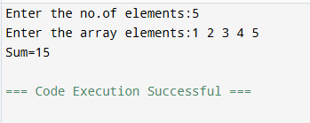

Result:

Thus, the C++ program to find the sum of all elements in an array was executed successfully.

- Aim:
To write a C++ program to read and display the elements of a two-dimensional array (matrix).
Algorithm:
Algorithm:
Step 1: Start the program.
Step 2: Read the number of rows and columns. Step 3: Declare a two-dimensional array.
Step 4: Read the matrix elements.
Step 5: Display the matrix elements row by row. Step 6: Stop the program.
Program Code:
#include <iostream> using namespace std; int main() {
int r, c;
cout << "Enter rows and columns: "; cin >> r >> c;
int arr[r][c];
cout << "Enter the elements:"; for (int i = 0; i < r; i++) {
for (int j = 0; j < c; j++) { cin >> arr[i][j];
}
}
cout << "2D Array:\n"; for (int i = 0; i < r; i++) {
for (int j = 0; j < c; j++) { cout << arr[i][j] << " ";
}
cout << endl;
}
return 0;
}

Sample Output:
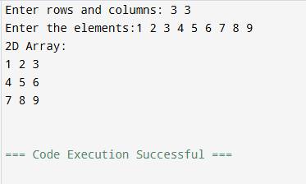

Result:

- Aim:

Thus, the C++ program to read and display the elements of a two-dimensional array was executed successfully.

To write a C++ program to find the transpose of a matrix.

Algorithm:
Step 1: Start the program.
Step 2: Read the number of rows and columns. Step 3: Read the matrix elements.
Step 4: Interchange the rows and columns while displaying the matrix. Step 5: Display the transpose of the matrix.
Step 6: Stop the program.
Program Code:
#include <iostream> using namespace std; int main() {
int r, c;
cout << "Enter rows and columns: "; cin >> r >> c;
int arr[r][c];
cout << "Enter the elements:"; for (int i = 0; i < r; i++) {
for (int j = 0; j < c; j++) { cin >> arr[i][j];
}
}
cout << "Transpose Matrix:\n"; for (int i = 0; i < c; i++) {

for (int j = 0; j < r; j++) { cout << arr[j][i] << " ";
}
cout << endl;
}
return 0;
}
Sample Output:
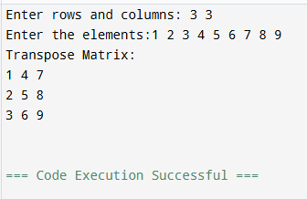

Result:
Thus, the C++ program to find the transpose of a matrix was executed successfully.
- Aim:
To write a C++ program to display the elements of a matrix in reverse order.
Algorithm:
Step 1: Start the program.
Step 2: Read the number of rows and columns. Step 3: Read the matrix elements.
Step 4: Traverse the matrix from the last row and last column towards the first row and first column.
Step 5: Display the matrix elements in reverse order. Step 6: Stop the program.
Program Code:
#include <iostream> using namespace std; int main() {
int r, c;
cout << "Enter rows and columns: "; cin >> r >> c;
int arr[r][c];
cout << "Enter the elements:"; for (int i = 0; i < r; i++) {

for (int j = 0; j < c; j++) { cin >> arr[i][j];
}
}
cout <<"Reversed Matrix:\n"; for (int i = r-1; i>=0; i--) {
for (int j =c-1; j >=0; j--) {
cout << arr[j][i] << " ";
}
cout << endl;
}
return 0;
}
Sample Output:
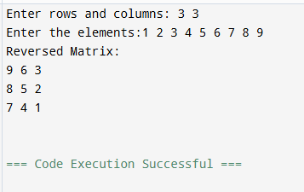

Result:

Thus, the C++ program to display the elements of a matrix in reverse order was executed successfully.

