Single Dimensional Array:
1.Aim:
To write a C++ program to find the smallest and largest elements in a single-dimensional
array.

Algorithm:
Step 1: Start.
Step 2: Read the number of elements n.
Step 3: Read the array elements.
Step 4: Initialize smallest and largest with the first element.
Step 5: Compare each element with smallest and largest.
Step 6: Update smallest if a smaller element is found.
Step 7: Update largest if a larger element is found. Step 8: Display the smallest and largest elements. Step 9: Stop.

Program Code:
#include<iostream> using namespace std; int main(){
int n;
cout<<"Enter the no.of elements:"; cin>>n;
int arr[n];
cout<<"Enter the array elements:"; for(int i=0;i<n;i++){
cin>>arr[i];
}
int smallest=arr[0]; int largest=arr[0]; for(int i=1;i<n;i++){
if(arr[i]<smallest){ smallest=arr[i];
}
if(arr[i]>largest){ largest=arr[i];
}
}
cout<<"Smallest Element:"<<smallest<<endl; cout<<"Largest Element:"<<largest<<endl; return 0;
}

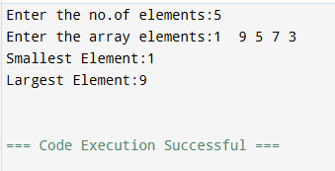
Output:

Result:
The C++ program to find the smallest and largest elements in a single-dimensional
array was successfully executed, and the desired output was obtained.
2.Aim:
To write a C++ program to merge two single-dimensional arrays into a single array.

Algorithm:
Step 1: Start.
Step 2: Read the sizes of the two arrays.
Step 3: Read the elements of the first array.
Step 4: Read the elements of the second array.
Step 5: Copy all elements of the first array into the merged array. Step 6: Copy all elements of the second array into the merged array. Step 7: Display the merged array.
Step 8: Stop.

Program Code:
#include<iostream> using namespace std; int main(){
int n1,n2;
cout<<"Enter the size of the first array:"; cin>>n1;
int arr1[n1];
cout<<"Enter the size of the second array:"; cin>>n2;
int arr2[n2];
cout<<"Enter the first array elements:"; for(int i=0;i<n1;i++){
cin>>arr1[i];
}
cout<<"Enter the second array elements:"; for(int i=0;i<n2;i++){
cin>>arr2[i];
}
int merge[n1+n2];
for(int i = 0; i < n1; i++) { merge[i] = arr1[i];
}
for(int i = 0; i < n2; i++) { merge[n1 + i] = arr2[i];
}
cout << "Merged array: "; for(int i = 0; i < n1 + n2; i++) {
cout << merge[i] << " ";

Output:
}
return 0;
}

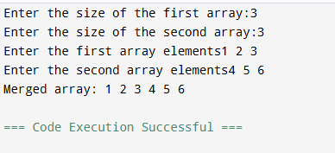

Result:
The C++ program to merge two single-dimensional arrays was successfully executed, and the merged array was displayed correctly.
3.Aim:
To write a C++ program to find the sum of all elements in a single-dimensional array.

Algorithm:
Step 1: Start.
Step 2: Read the number of elements n. Step 3: Read the array elements.
Step 4: Initialize sum = 0.
Step 5: Add each array element to sum. Step 6: Display the sum of all elements. Step 7: Stop.

Program Code:
#include<iostream> using namespace std; int main(){
int n,sum=0;
cout<<"Enter the no.of elements:"; cin>>n;
int arr[n];
cout<<"Enter the array elements:"; for(int i=0;i<n;i++){
cin>>arr[i];
}
for(int i=0;i<n;i++){ sum+=arr[i];
}
cout<<"Sum="<<sum; return 0;
}

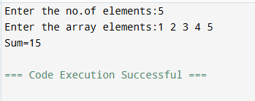

Result:
The C++ program to find the sum of all elements in a single-dimensional array was successfully executed, and the correct sum was displayed.

Multi Dimensional Array:
1.Aim:
To write a C++ program to read and display the elements of a 2D array.

Algorithm:
Step 1: Start.
Step 2: Read the number of rows and columns. Step 3: Read the elements of the 2D array.
Step 4: Display the elements row by row. Step 5: Stop.

Program code:
#include <iostream> using namespace std; int main() {
int r, c;
cout << "Enter rows and columns: "; cin >> r >> c;
int arr[r][c];
cout << "Enter the elements:"; for (int i = 0; i < r; i++) {
for (int j = 0; j < c; j++) { cin >> arr[i][j];
}
}
cout << "2D Array:\n"; for (int i = 0; i < r; i++) {
for (int j = 0; j < c; j++) { cout << arr[i][j] << " ";
}
}
return 0;
}

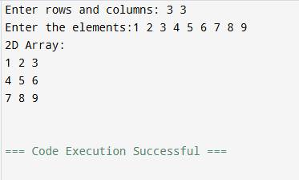

Result:

The C++ program to read and display the elements of a 2D array was successfully executed, and the desired output was obtained.

Aim:
To write a C++ program to find the transpose of a matrix using a 2d array.

Algorithm:
Step 1:Start.
Step 2:Read the number of rows and columns. Step 3: Read the matrix elements.
Step 4: Interchange rows and columns to form the transpose. Step 5: Display the transpose matrix.
Step 6: Stop.

Program Code:
#include <iostream> using namespace std; int main() {
int r, c;
cout << "Enter rows and columns: "; cin >> r >> c;
int arr[r][c];
cout << "Enter the elements:"; for (int i = 0; i < r; i++) {
for (int j = 0; j < c; j++) { cin >> arr[i][j];
}
}
cout << "Transpose Matrix:\n"; for (int i = 0; i < c; i++) {
for (int j = 0; j < r; j++) { cout << arr[j][i] << " ";
}
cout << endl;
}
return 0;
}

Output:
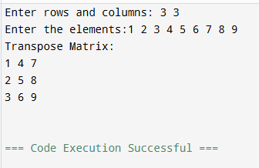

Result:
The C++ program to find the transpose of a matrix using a 2D array was successfully executed, and the transpose matrix was displayed correctly.

Aim:
To write a C++ program to reverse the elements of a 2D array.

Algorithm
Step 1: Start.
Step 2: Read the number of rows and columns. Step 3: Read the elements of the 2D array.
Step 4: Reverse the elements of the array. Step 5: Display the reversed 2D array.
Step 6: Stop.

Program Code:
#include <iostream> using namespace std; int main() {
int r, c;
cout << "Enter rows and columns: "; cin >> r >> c;
int arr[r][c];
cout << "Enter the elements:"; for (int i = 0; i < r; i++) {
for (int j = 0; j < c; j++) { cin >> arr[i][j];
}
}
cout <<"Reversed Matrix:\n"; for (int i = r-1; i>=0; i--) {
for (int j =c-1; j >=0; j--) {
cout << arr[j][i] << " ";
}
cout << endl;
}
return 0;
}

Output:


Result:
The C++ program to reverse the elements of a 2D array was successfully executed, and the reversed array was displayed correctly.

