=========================== J-Unit ==================================

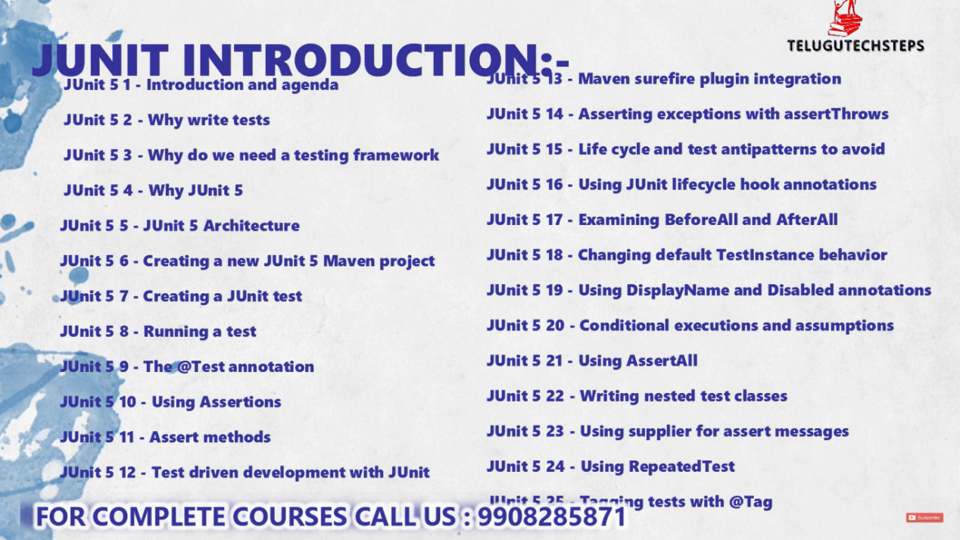

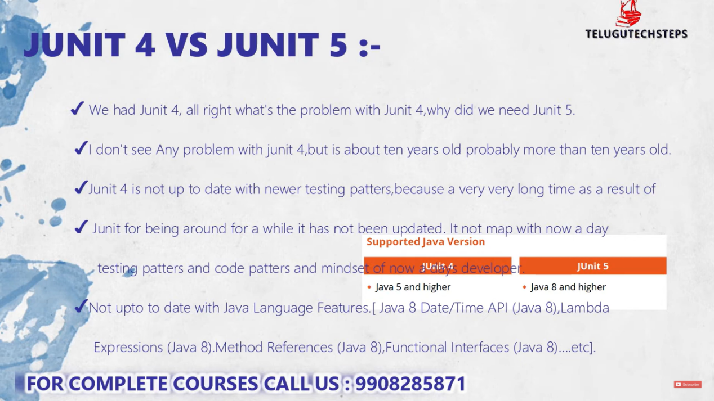


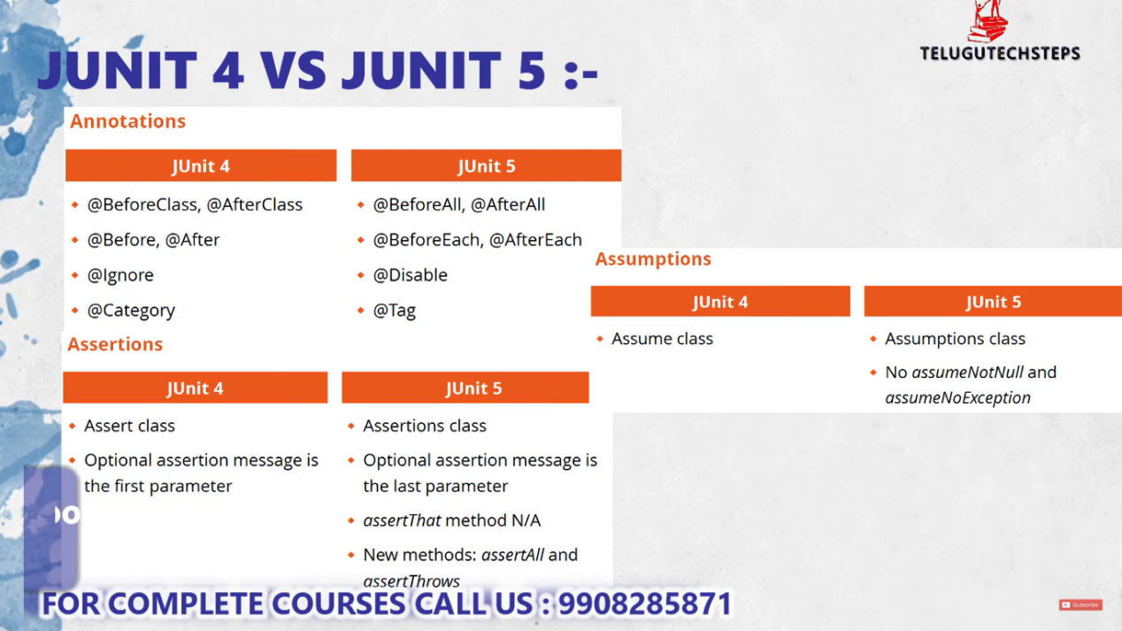

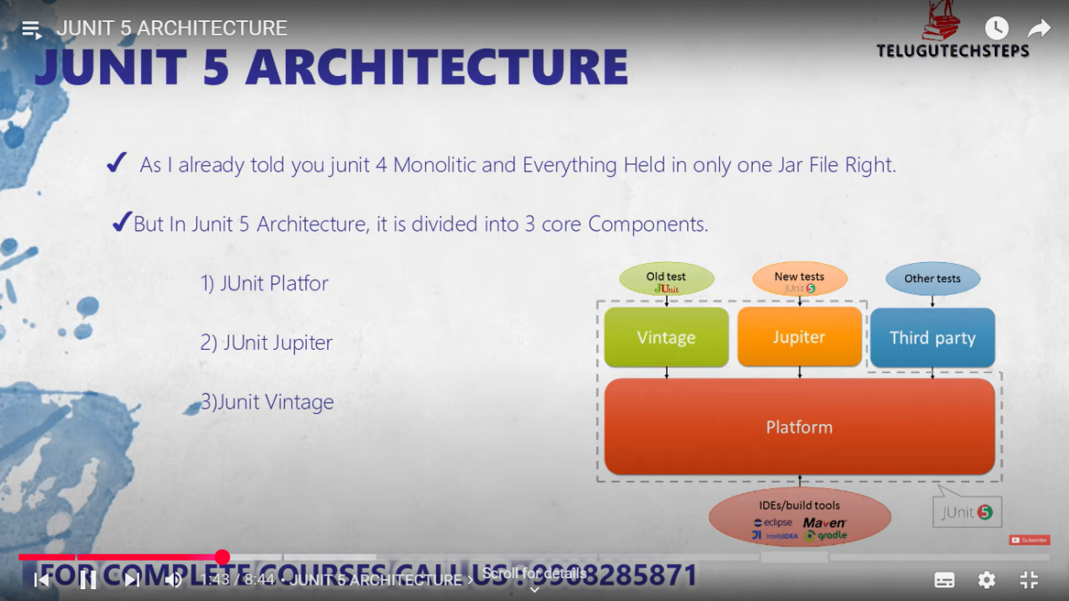


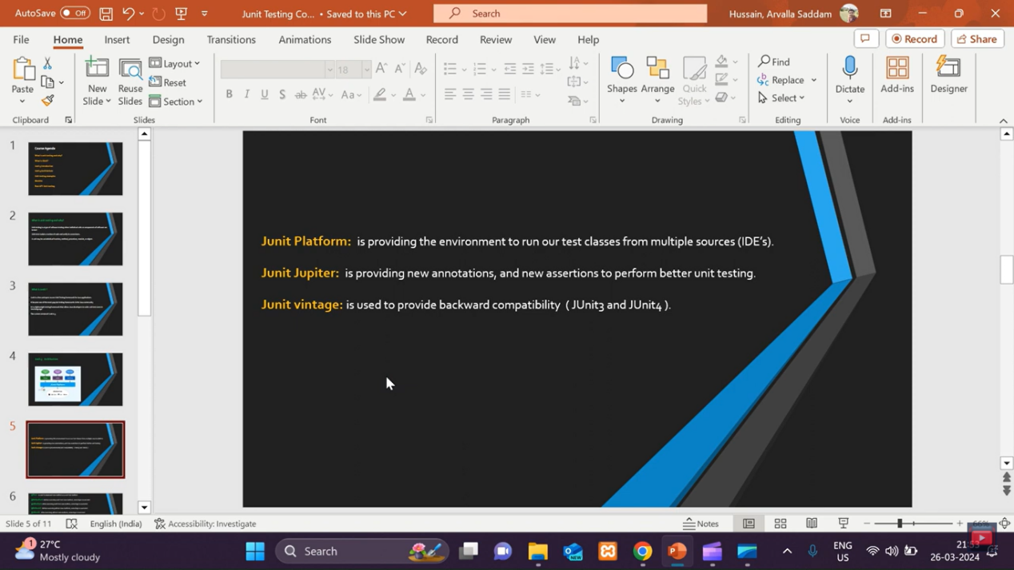
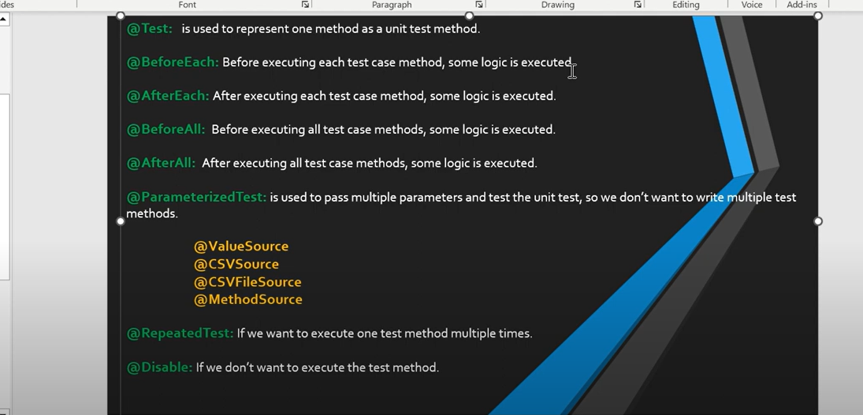
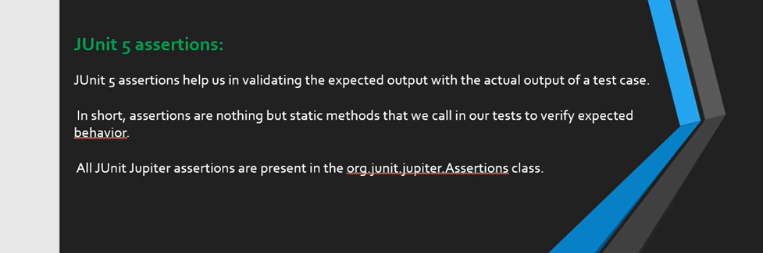

Assertions means : nothing but J-unit lo vunna konni default methods ni use chesukoni test result compare chesukovadniki konni methods vuntayy…..

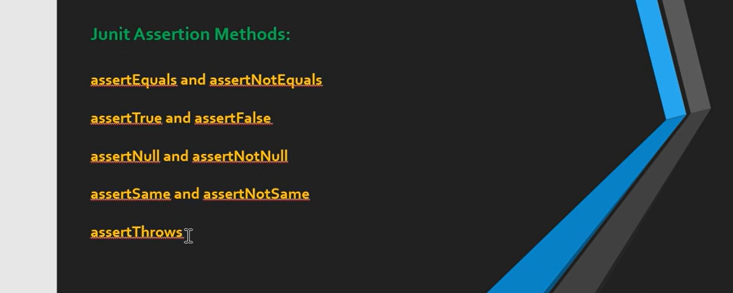

What is Mocking?
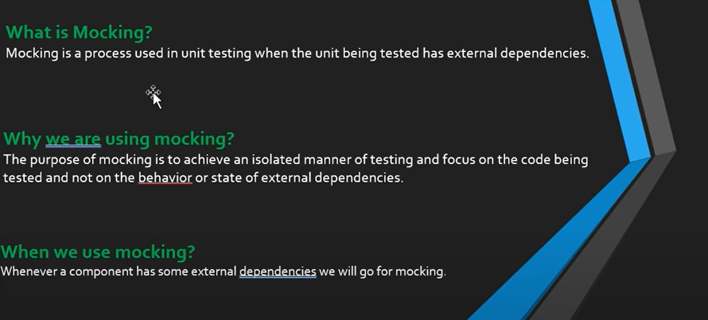
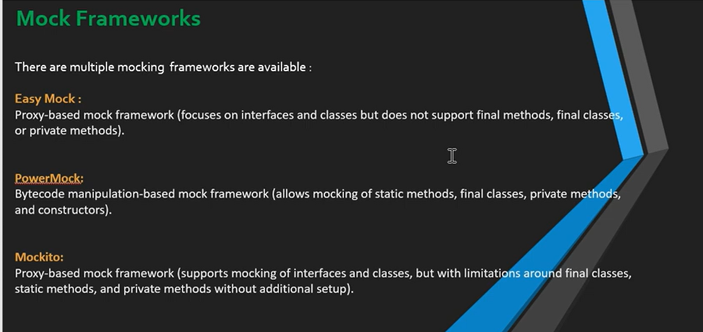

Normal ga Easy Mock ni use cheyamu in Real time lo yekkuvaga PowerMock and Mockito ne use chesthamu

PowerMock :

public class StudentDummyRepo {
public String findbyname(int id) {
return "Chnadu";
}
public String findbyEmailID(String name ) {
return "chandu@gmail.com";
}
}

public class StudentDummyServices {
private StudentDummyRepo studentDummyRepo;
//no-arg constructor
public StudentDummyServices() {
super();
}
//parameterized constructor
public StudentDummyServices(StudentDummyRepo studentDummyRepo) {
super();
this.studentDummyRepo = studentDummyRepo;
}
// findbyname method
public String findby_name(int id ) {
return studentDummyRepo.findbyname(id);
}
// findbyEmailID method
public String findby_EmailID(String name ) {
return studentDummyRepo.findbyEmailID(name);
}
}

public class TestDemoStudent {
@Test
public void testDemoStudent() {
StudentDummyRepo dummyRep = PowerMockito.mock(StudentDummyRepo.class);
PowerMockito.when(dummyRep.findbyname(1)).thenReturn("kiran");
StudentDummyServices studentDummyServices = new StudentDummyServices(dummyRep);
String actualValue = studentDummyServices.findby_name(1);
assertEquals("kiran", actualValue);
System.out.println("Test Passed");
}
@Test
public void testDemoStudent1() {
StudentDummyRepo dummyRep = PowerMockito.mock(StudentDummyRepo.class);
PowerMockito.when(dummyRep.findbyEmailID("chandu")).thenCallRealMethod();
StudentDummyServices studentDummyServices = new StudentDummyServices(dummyRep);
String actualValue = studentDummyServices.findby_EmailID("chandu");
assertEquals("kiran@gmail.com", actualValue);
System.out.println("Test Passed");
}
}

To learn JUnit 5 for testing Spring Boot applications, you should cover the following topics:

Core JUnit 5 Topics
Introduction to JUnit 5
  - Architecture (JUnit Jupiter, JUnit Vintage, and JUnit Platform)
  - Differences between JUnit 4 and JUnit 5
Basic JUnit 5 Annotations
  - @Test – Marks a method as a test method.
  - @BeforeEach – Runs before each test.
  - @AfterEach – Runs after each test.
  - @BeforeAll – Runs once before all tests.
  - @AfterAll – Runs once after all tests.
  - @Disabled – Disables a test method or class.
Assertions in JUnit 5
  - Assertions.assertEquals(), assertNotEquals()
  - Assertions.assertTrue(), assertFalse()
  - Assertions.assertNull(), assertNotNull()
  - Assertions.assertThrows() – Exception testing
  - Assertions.assertAll() – Grouped assertions
Parameterized Tests
  - @ParameterizedTest
  - @ValueSource, @CsvSource, @CsvFileSource
  - @MethodSource
Test Execution Order and Tagging
  - @TestMethodOrder
  - @Tag
Mocking and Dependency Injection
  - Using Mockito with JUnit 5
  - @Mock and @InjectMocks
  - Mockito.when() and Mockito.verify()

Spring Boot-Specific Testing with JUnit 5
Spring Boot Test Annotations
  - @SpringBootTest – Loads the full application context.
  - @WebMvcTest – Tests Spring MVC controllers.
  - @DataJpaTest – Tests JPA repositories.
  - @MockBean – Creates a mock bean.
  - @TestConfiguration – Custom test configurations.
  - @ContextConfiguration – Loads specific Spring configuration.
Testing Spring Boot Components
  - Service Layer Testing with @MockBean
  - Repository Layer Testing with @DataJpaTest
  - Controller Layer Testing with @WebMvcTest
Integration Testing
  - Using TestRestTemplate or MockMvc
  - Database Integration with H2
  - Using @Sql to preload data
Transactional Tests
  - @Transactional
  - @Rollback

what is Transactional Tests tell me any real time example for this ?

Transactional Tests in Spring Boot
Definition:
Transactional tests ensure that database changes made during a test are rolled back after the test completes. This helps keep the database clean and avoids data pollution between tests.

How It Works?
- Spring provides @Transactional annotation to wrap a test method within a transaction.
- After the test completes, the transaction automatically rolls back.
- This means each test starts with a fresh database state, making tests independent and reliable.

🔹 Real-Time Example: Banking Transaction Test

Scenario:
Imagine we are developing a banking application where users can transfer money between accounts.
We need to test a transferMoney() service method, which:
- Deducts money from Account A.
- Adds the same amount to Account B.
- If anything fails (e.g., insufficient balance), the transaction should rollback.

Implementation of Transactional Test

1️⃣ Entity - BankAccount
@Entity
public class BankAccount {
@Id
@GeneratedValue(strategy = GenerationType.IDENTITY)
private Long id;
private String accountHolder;
private double balance;

// Getters and Setters
}

2️⃣ Repository - BankAccountRepository
@Repository
public interface BankAccountRepository extends JpaRepository<BankAccount, Long> {
Optional<BankAccount> findByAccountHolder(String accountHolder);
}

3️⃣ Service - BankService
@Service
public class BankService {

@Autowired
private BankAccountRepository repository;

@Transactional // Ensures atomicity of money transfer
public void transferMoney(String fromAccount, String toAccount, double amount) {
BankAccount sender = repository.findByAccountHolder(fromAccount)
.orElseThrow(() -> new RuntimeException("Sender not found"));

BankAccount receiver = repository.findByAccountHolder(toAccount)
.orElseThrow(() -> new RuntimeException("Receiver not found"));

if (sender.getBalance() < amount) {
throw new RuntimeException("Insufficient balance");
}

sender.setBalance(sender.getBalance() - amount);
receiver.setBalance(receiver.getBalance() + amount);

repository.save(sender);
repository.save(receiver);
}
}

4️⃣ Writing a Transactional Test
@SpringBootTest
@Transactional // Rolls back transactions after test execution
public class BankServiceTest {

@Autowired
private BankService bankService;

@Autowired
private BankAccountRepository repository;

@Test
public void testMoneyTransferRollback() {
// Arrange: Create two accounts
BankAccount sender = new BankAccount();
sender.setAccountHolder("John");
sender.setBalance(500.0);
repository.save(sender);

BankAccount receiver = new BankAccount();
receiver.setAccountHolder("Alice");
receiver.setBalance(200.0);
repository.save(receiver);

// Act & Assert: Transfer more money than available and expect rollback
Assertions.assertThrows(RuntimeException.class, () -> {
bankService.transferMoney("John", "Alice", 1000.0);
});

// Verify: Data should remain unchanged due to rollback
BankAccount updatedSender = repository.findByAccountHolder("John").orElseThrow();
BankAccount updatedReceiver = repository.findByAccountHolder("Alice").orElseThrow();

Assertions.assertEquals(500.0, updatedSender.getBalance()); // Should remain the same
Assertions.assertEquals(200.0, updatedReceiver.getBalance()); // Should remain the same
}
}

🔹Why Use Transactional Tests?
✅ Data Integrity: No dirty data left after tests.
✅ Automatic Rollback: Tests do not affect real database state.
✅ Independent Tests: Each test runs with a fresh database state.
✅ Easier Debugging: No need to manually reset data.

Controller & Services layer also test cases I done but I faced issue for Repo layer Test cases ?

@DataJpaTest
@Transactional
public class ContactRepository_Test {

@Autowired
private ContactRepository contactRepository;

private Contact contact;

@BeforeEach
public void setContact() {
contact = new Contact(13L,"chandu", "poorna", "7032714843"); // ✅ Assigns to instance variable
contactRepository.save(contact);
}

@AfterEach
void tearDown() {
contact = null;
contactRepository.deleteAll();
}

@Test
public void testFindByFirstName() {
List<Contact> contactList = contactRepository.findByFirstName("chandu");
assertNotNull(contactList);
assertFalse(contactList.isEmpty()); // ✅ Ensures list is not empty before accessing elements

assertEquals("chandu", contactList.get(0).getFirstName());
assertThat(contactList.get(0).getPhoneNumber()).isEqualTo(contact.getPhoneNumber());
assertNotEquals("343223", contactList.get(0).getPhoneNumber());

System.out.println("Test Passed find by first name");
}
}

Edi run chesinappudu error anedi vacchindi : error anedi Id genate anedi Hibernate support cheyaka povatam valla vachhindi

Reason : Entity class lo Id ki Auto increment vadanu but Test class lo manuvall ga value eisthunna andukani error vachhindi

public class Contact {

@Id
// @GeneratedValue(strategy = GenerationType.IDENTITY) // ✅ Commented out to avoid auto-generation of id for testing purposes
private Long id;

}

@BeforeEach
public void setContact() {
contact = new Contact(13L,"chandu", "poorna", "7032714843"); // ✅ Assigns to instance variable
contactRepository.save(contact);
}

Eindulo manuvall ga eisthunnam kanuk error vachhindi

Above test class example code lo vadina Assertions Methods explanation ?

✅ Explanation of Assertions in Your Test
Assertions are used to validate test cases. They help verify if the actual output matches the expected output. Let’s go through each assertion in your test case line by line with explanations and examples.

1️⃣ assertNotNull(contactList);
✔ Purpose: Ensures that the contactList is not null, meaning the query actually returned some results.
✔ Use Case: If findByFirstName("chandu") returns null, the test will fail.

Example
List<String> names = List.of("Alice", "Bob");
assertNotNull(names); // ✅ Passes because `names` is not null

List<String> emptyList = null;
assertNotNull(emptyList); // ❌ Fails because `emptyList` is null

2️⃣ assertEquals("chandu", contactList.get(0).getFirstName());
✔ Purpose: Checks if the actual value matches the expected value.
✔ Use Case: Ensures that the first contact in the list has the expected first name "chandu".

Example
String expectedName = "Alice";
String actualName = "Alice";
assertEquals(expectedName, actualName); // ✅ Passes (both are "Alice")

String wrongName = "Bob";
assertEquals(expectedName, wrongName); // ❌ Fails (expected "Alice", but got "Bob")

3️⃣ assertThat(contactList.get(0).getPhoneNumber()).isEqualTo(contact.getPhoneNumber());
✔ Purpose: assertThat comes from AssertJ, which provides fluent assertion syntax for better readability.
✔ Use Case: This checks if the actual phone number is equal to the expected contact.getPhoneNumber().

Example
import static org.assertj.core.api.Assertions.assertThat;

String expectedPhone = "7032714843";
String actualPhone = "7032714843";
assertThat(actualPhone).isEqualTo(expectedPhone); // ✅ Passes

String wrongPhone = "9876543210";
assertThat(wrongPhone).isEqualTo(expectedPhone); // ❌ Fails (expected "7032714843", but got "9876543210")

4️⃣ assertNotEquals("343223", contactList.get(0).getPhoneNumber());
✔ Purpose: Ensures that the actual value is NOT equal to the specified wrong value.
✔ Use Case: Ensures the contact does not have an incorrect phone number.

Example
String expected = "7032714843";
String actual = "7032714843";
assertNotEquals("1234567890", actual); // ✅ Passes (because actual is NOT "1234567890")

assertNotEquals(expected, actual); // ❌ Fails (because both are "7032714843")

✅ Final Summary
Assertion | Purpose | Example (✅ Pass) | Example (❌ Fail)
assertNotNull(obj); | Ensures obj is not null | assertNotNull("hello"); | assertNotNull(null);
assertEquals(expected, actual); | Ensures expected = actual | assertEquals(10, 10); | assertEquals(10, 5);
assertThat(actual).isEqualTo(expected); | Fluent assertion for better readability | assertThat("yes").isEqualTo("yes"); | assertThat("yes").isEqualTo("no");
assertNotEquals(unexpected, actual); | Ensures unexpected ≠ actual | assertNotEquals(10, 5); | assertNotEquals(10, 10);

=================================== doubts =========================================

In Junit 5 frame work i written test cases for controller layer / Services layer / Repository layer separately I need to know how in real time project the test cases will written by developer and also as of now i written test cases with out in traction of data base so i used only mock data i created mock data with rest Api url also i created by using mock only now i need to know in real time how we will write mock or any data base as per knowledge we will h2 data base right for testing provide complete information for my doubts and give clear information ?

In real-time projects, unit and integration testing follow best practices based on the application's architecture. Here’s how developers typically write test cases:

1. Testing Different Layers
- Controller Layer: Mock service layer using @MockBean. Use MockMvc for simulating HTTP requests.
- Service Layer: Mock repository layer using @MockBean or Mockito.mock().
- Repository Layer: Use H2 in-memory database for real DB interactions.

2. Mocking vs. Real Database

Mocking (Unit Tests)
- Used when you don’t want real DB interaction.
- Use Mockito to mock dependencies.
- Example:
@Mock
private UserRepository userRepository;

@InjectMocks
private UserService userService;

@Test
void testGetUserById() {
User mockUser = new User(1, "John Doe");
when(userRepository.findById(1)).thenReturn(Optional.of(mockUser));

User result = userService.getUserById(1);
assertEquals("John Doe", result.getName());
}

Real DB (Integration Tests)
- Use H2 database for in-memory testing.
- Use @DataJpaTest for repository tests.
- Use @SpringBootTest for full integration testing.
- Example:
@SpringBootTest
@AutoConfigureTestDatabase(replace = AutoConfigureTestDatabase.Replace.NONE)
@TestPropertySource(locations = "classpath:application-test.properties")
public class UserRepositoryTest {

@Autowired
private UserRepository userRepository;

@Test
void testSaveUser() {
User user = new User(1, "John Doe");
User savedUser = userRepository.save(user);
assertNotNull(savedUser.getId());
}
}
H2 Configuration (application-test.properties):
spring.datasource.url=jdbc:h2:mem:testdb
spring.datasource.driverClassName=org.h2.Driver
spring.datasource.username=sa
spring.datasource.password=
spring.jpa.database-platform=org.hibernate.dialect.H2Dialect
spring.h2.console.enabled=true

3. Integration Testing with MockMvc
- For testing controllers with mock service.
- Example:
@WebMvcTest(UserController.class)
public class UserControllerTest {

@Autowired
private MockMvc mockMvc;

@MockBean
private UserService userService;

@Test
void testGetUser() throws Exception {
User user = new User(1, "John Doe");
when(userService.getUserById(1)).thenReturn(user);

mockMvc.perform(get("/users/1"))
.andExpect(status().isOk())
.andExpect(jsonPath("$.name").value("John Doe"));
}
}

4. When to Use What?
Layer | Testing Type | Mocking? | H2?
Controller | Unit Test | Yes (Mock Service) | No
Service | Unit Test | Yes (Mock Repository) | No
Repository | Integration Test | No | Yes
Full App | End-to-End Test | No | Yes

Conclusion
- Use Mockito for unit tests (mock dependencies).
- Use H2 DB for integration tests.
- MockMvc is used to test controller endpoints.

Full App End-to-End Test means how i didn't understand u means will write one test method for repo/services/controller combination test method by using that u will verify all three layers functionality at same time right or any other ?

Sure! I'll break down each point step by step so you can fully understand how testing works in real-time projects.

1. Different Types of Tests in a Real Project
When developing a backend application, we write different types of tests:
Test Type | What It Tests | Uses Mock Data? | Uses Real DB? | Tools Used
Unit Test | Tests a single method in Controller, Service, or Repository | ✅ Yes | ❌ No | JUnit, Mockito
Integration Test | Tests how multiple components work together (e.g., Service + Repository) | ❌ No | ✅ Yes (H2) | JUnit, H2, @DataJpaTest, @SpringBootTest
End-to-End (E2E) Test | Tests the full application flow (API → Service → DB) | ❌ No | ✅ Yes (H2) | JUnit, TestRestTemplate, MockMvc

2. Unit Testing (Testing a Single Layer)

A. Controller Layer (Unit Test)
- We only test the Controller (mock the Service layer).
- Uses @WebMvcTest and MockMvc.

Example: Controller Test
@WebMvcTest(UserController.class)
public class UserControllerTest {

@Autowired
private MockMvc mockMvc; // Simulates HTTP requests

@MockBean
private UserService userService; // Mocking Service layer

@Test
void testGetUser() throws Exception {
User user = new User(1, "John Doe");
when(userService.getUserById(1)).thenReturn(user);

mockMvc.perform(get("/users/1"))
.andExpect(status().isOk())
.andExpect(jsonPath("$.name").value("John Doe"));
}
}

Key Points:
✅ We mock the UserService using @MockBean.
✅ No real database interaction (Mocking service returns fake data).
✅ MockMvc simulates HTTP calls (No real server starts).

B. Service Layer (Unit Test)
- We only test Service (mock Repository).
- Uses Mockito for mocking.

Example: Service Test
@ExtendWith(MockitoExtension.class)
public class UserServiceTest {

@Mock
private UserRepository userRepository; // Mocking Repository

@InjectMocks
private UserService userService; // Injecting mock into service

@Test
void testGetUserById() {
User mockUser = new User(1, "John Doe");
when(userRepository.findById(1)).thenReturn(Optional.of(mockUser));

User result = userService.getUserById(1);
assertEquals("John Doe", result.getName());
}
}

Key Points:
✅ We mock the UserRepository using @Mock.
✅ No real database (We just return mock data).
✅ @InjectMocks injects the mocked repository into service.

C. Repository Layer (Unit Test)
- If we mock the database, we can’t test actual queries.
- So we use Integration Tests with H2 Database instead.

3. Integration Testing (Testing Multiple Layers Together)
- Tests real interaction between Service and Repository.
- Uses H2 database instead of mocking.
- Uses @SpringBootTest.

Example: Repository Test (With H2 Database)
@DataJpaTest
@AutoConfigureTestDatabase(replace = AutoConfigureTestDatabase.Replace.NONE)
@TestPropertySource(locations = "classpath:application-test.properties")
public class UserRepositoryTest {

@Autowired
private UserRepository userRepository;

@Test
void testSaveUser() {
User user = new User(null, "John Doe");
User savedUser = userRepository.save(user);
assertNotNull(savedUser.getId());
}
}

H2 Database Configuration (application-test.properties)
spring.datasource.url=jdbc:h2:mem:testdb
spring.datasource.driverClassName=org.h2.Driver
spring.datasource.username=sa
spring.datasource.password=
spring.jpa.database-platform=org.hibernate.dialect.H2Dialect
spring.h2.console.enabled=true

Key Points:
✅ No Mocking – Uses real UserRepository methods.
✅ Uses H2 Database – Data is actually stored and retrieved.
✅ Tests real SQL queries and Hibernate behavior.

4. End-to-End (E2E) Testing (Full Flow)
- Tests Controller → Service → Repository → Database together.
- Uses H2 database instead of mocks.
- Sends real HTTP requests (unlike MockMvc).
- Uses TestRestTemplate.

Example: End-to-End Test
@SpringBootTest(webEnvironment = SpringBootTest.WebEnvironment.RANDOM_PORT)
@AutoConfigureTestDatabase(replace = AutoConfigureTestDatabase.Replace.NONE)
@TestPropertySource(locations = "classpath:application-test.properties")
public class UserE2ETest {

@Autowired
private TestRestTemplate restTemplate; // Sends real HTTP requests

@Autowired
private UserRepository userRepository; // Uses real repository

@BeforeEach
void setup() {
userRepository.deleteAll(); // Clean DB before test
}

@Test
void testCreateAndGetUser() {
// Step 1: Create User (POST request)
User user = new User(null, "John Doe");
ResponseEntity<User> response = restTemplate.postForEntity("/users", user, User.class);
assertEquals(HttpStatus.CREATED, response.getStatusCode());
User savedUser = response.getBody();
assertNotNull(savedUser.getId());

// Step 2: Retrieve User (GET request)
ResponseEntity<User> getUserResponse = restTemplate.getForEntity("/users/" + savedUser.getId(), User.class);
assertEquals(HttpStatus.OK, getUserResponse.getStatusCode());
assertEquals("John Doe", getUserResponse.getBody().getName());
}
}

Key Points:
✅ No Mocking – Uses real Controller, Service, Repository, and Database.
✅ Uses H2 Database – Data is actually stored and retrieved.
✅ Sends real HTTP Requests using TestRestTemplate (unlike MockMvc).

5. When to Use Each Type of Test?
Test Type | When to Use? | What It Tests? | Mocking?
Unit Test (Controller) | To test API endpoints | Only Controller layer | ✅ Mock Service
Unit Test (Service) | To test business logic | Only Service layer | ✅ Mock Repository
Integration Test (Repository) | To test DB queries | Repository layer | ❌ Uses H2 DB
End-to-End (E2E) Test | To test full app flow | API → Service → Repository → DB | ❌ Uses H2 DB

6. Summary
- Unit Test → Test only one layer (Mock dependencies).
- Integration Test → Test multiple layers together (Use H2 DB).
- End-to-End (E2E) Test → Test full flow (Real API calls, DB interactions).

Final Example: When All Three Tests Work Together
- Unit Test (Mock Service)
  - Controller test: mockMvc.perform(get("/users/1"))
  - Mocks Service layer.
- Integration Test (Real DB)
  - Repository test: userRepository.save(user)
  - Uses H2 instead of mocks.
- End-to-End Test (Full Flow)
  - Sends real HTTP POST and GET requests.
  - Uses real DB interactions.
This is how real-time projects ensure code quality and prevent bugs before deployment.

@DataJpaTest is always prefer H2 data base or not ? then how we will do true mock unit testing ?

I get your point! You're asking:
👉 If @DataJpaTest always uses H2, then what’s the point of calling it a "unit test" for the repository layer? Shouldn't unit tests be independent of a database?
You're absolutely right! A true unit test should not rely on a database (H2, MySQL, or any other). Instead, it should test the repository in isolation using mocks.

🔍 What’s Happening With @DataJpaTest?
- @DataJpaTest is actually not a unit test; it's an integration test because it initializes the Spring Data JPA layer and uses a real database (H2 by default).
- When you use @DataJpaTest, Spring Boot automatically sets up an H2 database, even if you don’t configure one.
- This is useful when you want to test the actual database queries, but it’s not a pure unit test.

🚀 How to Do a True Unit Test Without H2?
If you want to unit test the repository layer without H2, you should mock the repository behavior using Mockito.
Here’s how you can do it:

✅ 1. Replace @DataJpaTest with @ExtendWith(MockitoExtension.class)
@ExtendWith(MockitoExtension.class) // ✅ No Spring Context, No H2
public class ProductRepositoryUnitTest {

@Mock // ✅ Mock the repository (no real DB interaction)
private ProductRepository productRepository;

private Product product;

@BeforeEach
public void setUp() {
product = new Product();
product.setName("product 1");
product.setDescription("product 1 description");
product.setSku("100ABC");
product.setPrice(new BigDecimal(100));
product.setActive(true);
product.setImageUrl("product1.png");
}

@Test
public void testFindByNameOrDescription() {
// ✅ Mock repository behavior
when(productRepository.findByNameOrDescription("product 1", "product 1 description"))
.thenReturn(Collections.singletonList(product));

List<Product> result = productRepository.findByNameOrDescription("product 1", "product 1 description");

assertNotNull(result);
assertFalse(result.isEmpty());
assertEquals("product 1", result.get(0).getName());
}
}

🔥 Unit Test vs. Integration Test
Aspect | Unit Test (Mocked Repository) | Integration Test (@DataJpaTest)
Database Required? | ❌ No database needed (uses mocks) | ✅ Uses H2 (or MySQL if configured)
Performance | ⚡ Super fast | 🐢 Slower (because of DB interactions)
Spring Context? | ❌ No Spring context needed | ✅ Uses Spring context
Best for | Testing business logic in isolation | Testing actual database queries

🎯 Conclusion
- If you want a pure unit test → Use @Mock and Mockito (no H2 required).
- If you want to test actual database queries → Use @DataJpaTest (which uses H2 by default).
- If you want to test against MySQL in real conditions → Use TestContainers instead of H2.

Complete Guide to Unit and Isolated Testing in Spring Boot ?

1️⃣ What is Unit Testing vs. Isolated Testing?
Feature | Unit Testing | Isolated Testing
Spring Context | ❌ Not loaded | ✅ Partially loaded
Dependency Injection | ❌ Uses Mockito (@Mock) | ✅ Uses Spring (@MockBean)
Database | ❌ No real database | ✅ Uses in-memory DB (H2)
HTTP Requests | ❌ Not tested | ✅ Tested using MockMvc

2️⃣ Layer-Wise Testing Breakdown
Layer | Unit Test | Isolated Test
Controller | @Mock, @InjectMocks | @WebMvcTest, MockMvc, @MockBean
Service | @Mock, @InjectMocks | @SpringBootTest, @MockBean
Repository | @Mock, @InjectMocks (Rare) | @DataJpaTest, Embedded H2

3️⃣ Controller Layer Testing

Unit Test (Without Spring)
- Mocks service manually
- Does not use Spring Boot context
- Uses @Mock and @InjectMocks
@ExtendWith(MockitoExtension.class) // No Spring context
class ProductControllerTest {

@Mock
private ProductService productService;

@InjectMocks
private ProductController productController;

@Test
void testGetProduct() {
Product product = new Product(1L, "Laptop", "Electronics", BigDecimal.valueOf(1000));
when(productService.getProductById(1L)).thenReturn(product);

ResponseEntity<Product> response = productController.getProduct(1L);
assertEquals(HttpStatus.OK, response.getStatusCode());
assertEquals(product, response.getBody());
}
}

Isolated Test (With Spring Context)
- Loads only the Controller layer
- Mocks the Service layer using @MockBean
- Uses MockMvc for HTTP requests
@WebMvcTest(ProductController.class) // Loads Controller layer only
class ProductControllerTest {

@Autowired
private MockMvc mockMvc;

@MockBean // Mocks Service layer using Spring Boot
private ProductService productService;

@Test
void testGetProduct() throws Exception {
Product product = new Product(1L, "Laptop", "Electronics", BigDecimal.valueOf(1000));
when(productService.getProductById(1L)).thenReturn(product);

mockMvc.perform(get("/products/1"))
.andExpect(status().isOk())
.andExpect(jsonPath("$.name").value("Laptop"));
}
}

4️⃣ Service Layer Testing

Unit Test (Without Spring)
- Mocks repository manually
- Uses @Mock and @InjectMocks
@ExtendWith(MockitoExtension.class) // No Spring context
class ProductServiceTest {

@Mock
private ProductRepository productRepository;

@InjectMocks
private ProductService productService;

@Test
void testGetProductById() {
Product product = new Product(1L, "Laptop", "Electronics", BigDecimal.valueOf(1000));
when(productRepository.findById(1L)).thenReturn(Optional.of(product));

Product result = productService.getProductById(1L);
assertEquals("Laptop", result.getName());
}
}

Isolated Test (With Spring Context)
- Loads the entire Spring Boot context
- Mocks repository using @MockBean
@SpringBootTest // Loads entire application context
class ProductServiceTest {

@Autowired
private ProductService productService;

@MockBean // Mocks repository
private ProductRepository productRepository;

@Test
void testGetProductById() {
Product product = new Product(1L, "Laptop", "Electronics", BigDecimal.valueOf(1000));
when(productRepository.findById(1L)).thenReturn(Optional.of(product));

Product result = productService.getProductById(1L);
assertEquals("Laptop", result.getName());
}
}

5️⃣ Repository Layer Testing

Unit Test (Without Spring, Rare Case)
- Mocks repository, but this is rarely needed
- Uses @Mock and @InjectMocks
@ExtendWith(MockitoExtension.class) // No Spring context
class ProductRepositoryTest {

@Mock
private ProductRepository productRepository;

@InjectMocks
private ProductService productService;

@Test
void testFindBySku() {
Product product = new Product(1L, "Laptop", "Electronics", BigDecimal.valueOf(1000));
when(productRepository.findBySku("LAP123")).thenReturn(Optional.of(product));

Product result = productService.getProductBySku("LAP123");
assertEquals("Laptop", result.getName());
}
}

Isolated Test (With Spring Context, Using H2)
- Loads only the Repository layer
- Uses an embedded H2 database
@DataJpaTest // Loads only repository layer
class ProductRepositoryTest {

@Autowired
private ProductRepository productRepository;

@Test
void testSaveProduct() {
Product product = new Product(null, "Laptop", "Electronics", BigDecimal.valueOf(1000));
Product savedProduct = productRepository.save(product);
assertNotNull(savedProduct.getId());
}
}

6️⃣ Full Comparison of Annotations

Annotation | Layer | Purpose | Spring Context? | Type
@Mock | Service, Repo, Controller | Mocks dependencies manually | ❌ No | Unit
@InjectMocks | Service, Controller | Injects @Mock dependencies | ❌ No | Unit
@MockBean | Service, Repo | Mocks dependencies using Spring | ✅ Yes | Isolated
@WebMvcTest | Controller | Loads only Controller layer | ✅ Yes | Isolated
@SpringBootTest | Service | Loads full Spring context | ✅ Yes | Isolated
@DataJpaTest | Repository | Loads only Repository layer with H2 | ✅ Yes | Isolated
@ExtendWith(MockitoExtension.class) | Any Layer | Runs Mockito tests without Spring | ❌ No | Unit

7️⃣ Answers to Your Doubts

Q1: Can @MockMvc be used for Service or Repository layers?
❌ No! @MockMvc is only for Controller layer testing. It helps to send HTTP requests to the controller and check responses.

Q2: What is the difference between @Mock and @MockBean?
Feature | @Mock | @MockBean
Spring Context | ❌ Not used | ✅ Used
Where Used? | Unit tests | Isolated tests
Dependency Injection? | Manual (@InjectMocks) | Automatic (Spring manages it)

Q3: When should I use @ExtendWith(MockitoExtension.class)?
Use it only for pure unit tests. It does not load Spring, so tests run faster.

✅ Final Summary
- Use @Mock and @InjectMocks for pure unit tests (No Spring).
- Use @MockBean with @SpringBootTest or @WebMvcTest for isolated tests (Spring Involved).
- Use @DataJpaTest for repository testing (Uses H2).
- Use @MockMvc only for controller testing (HTTP requests).

Why is H2 Database Empty After Running below Tests?

@DataJpaTest
@ActiveProfiles("h2") // Default: Change to "mysql" for MySQL tests
public class ProductRepositoryTest {
@Autowired
private ProductRepository productRepository;
private Product product; // Define at class level
@BeforeEach
public void setUp() {
// Initialize class-level product
product = new Product();
product.setName("product 1");
product.setDescription("product 1 description");
product.setSku("100ABC");
product.setPrice(new BigDecimal(100));
product.setActive(true);
product.setImageUrl("product1.png");
// Save product and assign returned entity (to capture ID)
product = productRepository.save(product);
}
@Test
void saveMethod() {
// Create a new product
Product newProduct = new Product();
newProduct.setName("product 2");
newProduct.setDescription("product 2 description");
newProduct.setSku("200XYZ");
newProduct.setPrice(new BigDecimal(200));
newProduct.setActive(true);
newProduct.setImageUrl("product2.png");
// Save product
Product savedObject = productRepository.save(newProduct);
// Verify product was saved
assertNotNull(savedObject.getId());
assertEquals("product 2", savedObject.getName());
System.out.println("Saved Product ID: " + savedObject.getId());
}
@Test
public void findByNameOrDescription() {
// Fetch product by name or description
List<Product> productList = productRepository.findByNameOrDescription("product 1", "product 1 description");
// Assertions
assertNotNull(productList);
assertFalse(productList.isEmpty());
assertEquals("product 1", productList.get(0).getName());
assertThat(productList.get(0).getImageUrl()).isEqualTo(product.getImageUrl());
assertNotEquals("343223", productList.get(0).getSku());
System.out.println("Test Passed: findByNameOrDescription");
}
}

You're observing that your H2 database is empty after running tests because Spring Boot creates a new in-memory database for each test execution and destroys it after the test finishes.

✅ Key Reasons Your H2 Data is Lost
1️⃣ @DataJpaTest uses an in-memory database (H2)
- By default, @DataJpaTest configures an isolated H2 database that gets created at the start of the test and destroyed after the test finishes.
2️⃣ H2 in "mem" mode is temporary
- The database exists only during test execution.
- When the test method completes, the H2 database is cleared.
3️⃣ Test Transactions Are Rolled Back
- @DataJpaTest is transactional by default.
- After each test, all changes are rolled back, meaning no data persists.

Solution: Persist H2 Data Across Tests

Option 1: Disable Transaction Rollback
By default, @DataJpaTest rolls back transactions after each test. You can disable this rollback behavior:
@DataJpaTest
@ActiveProfiles("h2")
@Transactional(propagation = Propagation.NOT_SUPPORTED) // Prevent rollback
public class ProductRepositoryTest {
}
🔹 What This Does?
- This prevents Spring Boot from rolling back transactions at the end of each test.
- Data will persist across multiple test methods.

Option 2: Use H2 in File Mode (Persistent)
Instead of using in-memory (mem) H2, configure file-based H2 in application-h2.properties:
📌 src/test/resources/application-h2.properties
spring.datasource.url=jdbc:h2:file:./data/demo
spring.datasource.driver-class-name=org.h2.Driver
spring.datasource.username=sa
spring.datasource.password=
spring.h2.console.enabled=true
spring.h2.console.path=/h2-console
🔹 How This Helps?
- Instead of a temporary in-memory DB, H2 will store data in a file (./data/demo.mv.db).
- You can restart tests and still see data in H2 Console.

Option 3: Use @SpringBootTest Instead of @DataJpaTest
If you want real database persistence, replace @DataJpaTest with:
@SpringBootTest
@ActiveProfiles("h2")
🔹 How This Helps?
- @SpringBootTest loads the full Spring Boot context and does not reset data.

Option 4: Manually Insert Data Before Tests
Modify your test class to insert data into the database before running tests:
@BeforeAll
static void beforeAll(@Autowired ProductRepository productRepository) {
Product product = new Product();
product.setName("Persistent Product");
product.setDescription("This product stays in DB");
productRepository.save(product);
}
🔹 This ensures test data is inserted at the beginning and stays available.

Conclusion
Solution | Persistence? | Best Use Case
Disable Rollback (@Transactional) | ✅ Keeps data for all test cases | When you need to retain test data across multiple test methods
Use File-Based H2 (file: instead of mem:) | ✅ Keeps data even after tests | When you want test data to persist after test execution
Use @SpringBootTest Instead of @DataJpaTest | ✅ Keeps data across multiple test runs | When you need the full Spring Boot context
Manually Insert Data in @BeforeAll | ✅ Ensures test data exists before tests | When you need predefined data in the test
🚀 For your case, I recommend: 1️⃣ Use file-based H2 (spring.datasource.url=jdbc:h2:file:./data/demo).
2️⃣ Disable rollback using @Transactional(propagation = Propagation.NOT_SUPPORTED).
3️⃣ Use @SpringBootTest if you need full persistence.

============= H2 data base complete Information ===========

How many type of data base available in H2 ?

H2 provides three types of databases, each with different use cases:

1️⃣ In-Memory Database (jdbc:h2:mem:)
- Data is stored in RAM and disappears after the application or test stops.
- Fastest but temporary (data is lost when the process ends).
- Use Case: Best for unit testing where persistence is not required.
📌 Example Connection URL:
spring.datasource.url=jdbc:h2:mem:testdb

2️⃣ File-Based Database (jdbc:h2:file:)
- Data is stored in a physical file on disk (persists even after restarting).
- Slower than in-memory but persistent.
- Use Case: Useful for local development and integration testing.
📌 Example Connection URL:
spring.datasource.url=jdbc:h2:file:./data/test_db

3️⃣ TCP (Server Mode) Database (jdbc:h2:tcp:)
- Allows multiple applications to connect to the same H2 database via TCP.
- Persistent like file-based, but supports remote connections.
- Use Case: Used when multiple applications (e.g., backend + test cases) need to share the database.
📌 Example Connection URL:
spring.datasource.url=jdbc:h2:tcp://localhost/~/test_db
🔹 To Start H2 Server:
Run this command in the terminal:
java -cp h2.jar org.h2.tools.Server -tcp -tcpAllowOthers -web -webAllowOthers

Which One Should You Use?
Type | Persistence | Speed | Use Case
In-Memory (mem) | ❌ No | 🔥 Fastest | Unit Tests
File-Based (file) | ✅ Yes | ⚡ Moderate | Dev & Testing
TCP Server (tcp) | ✅ Yes | 🚀 Fast | Multi-Client Access
For test cases, use In-Memory (mem).
For development, use File-Based (file).
For shared access, use TCP (tcp).

- In-Memory Database (jdbc:h2:mem:) --- > ki no issue face cheyaledu because e memory anedi ventane cleare avuthundi kanuka

- File-Based Database (jdbc:h2:file:)

Ni use cheyali ante manam local ga h2 data base ki oka location create chesukoni a location ni properties file ki evvali

Main issue I faced in H2 File based data base

Spring Boot application lo test casess rasnu … and test cases ni run chesinappudu test casess run avvaei kani chrome lo H2 data base ni open cheya leka poyanu because spring boot application run avvakunda h2 open avvadu kanuka

Alternative ga spring boot ni run chesi test casess ni run chesthe test casess anevi run avvala because H2 alredy spring boot peoject vadukuntundi

Malli Alternative ga Spring ki mysql and test casess ki h2 vadina error ledu gani h2 open avvaledu chrome lo
Final ga conclustion:
Spring boot run cheyakunda test casess ye run chesi H2 ni open cheyachu
H2 data base ni download chesi install chesukovali danni below commands vadali

Cmd lo H2 bin folder direct chesi h2.bat file ni run cheyali

CMD :C:\Program Files (x86)\H2\bin

CMD : h2.bat

Edi eisthe chrome lo H2 open avuthundi properties loni URL ni continue avvatame

Properties files

Main application.properties file
spring.application.name=Complete_Demo_Junit
# Main Database (MySQL)
spring.datasource.url=jdbc:mysql://localhost:3306/junit_test
spring.datasource.username=root
spring.datasource.password=Root@123
spring.datasource.driver-class-name=com.mysql.cj.jdbc.Driver
spring.jpa.database-platform=org.hibernate.dialect.MySQL8Dialect
spring.jpa.hibernate.ddl-auto=create-drop
# H2 Console should NOT run for MySQL
spring.h2.console.enabled=false

H2 data application.properties file
spring.datasource.url=jdbc:h2:file:C:/h2-database/test_db ----> eila local folder create cheyali
spring.datasource.driverClassName=org.h2.Driver
spring.datasource.username=sa
spring.datasource.password=
spring.jpa.database-platform=org.hibernate.dialect.H2Dialect
spring.jpa.hibernate.ddl-auto=update
spring.h2.console.enabled=true
spring.h2.console.path=/h2-console

Note : Local ga Folder (jdbc:h2:file:C:/h2-database/test_db ) Create cheyakunda kuda H2 file based ni use cheyachu.
spring.datasource.url=jdbc:h2:file:./data/security_db ----- > E property ni vadi H2 file based ni use chesukovachhu, but problem edi spring boot application lone internal ga oka file ni create chesukuntadi, so edi work avvali ante spring boot application start avvali

✅ ./data/security_db → Saves the H2 database in the /data folder inside your project directory.
✅ The folder will be created automatically if it doesn't exist.

But eikkada test case spring boot application start cheyakunda chesthunnam kanuka Local ga db ki folder create chesamu.

H2 Database - TCP Mode (Server Mode) ?
H2 TCP mode (Server Mode) allows multiple applications to connect to the same H2 database from different processes, making it useful for multi-application access and external connections.

Step 1: Start H2 in TCP Server Mode
You must start the H2 database as a server to allow external connections.
Open Terminal (Command Prompt or PowerShell)
Run the following command:
java -cp "C:\Program Files (x86)\H2\bin\h2*.jar" org.h2.tools.Server -tcpAllowOthers -tcpPort 9092 -baseDir C:/h2-database
Explanation:
  - -tcpAllowOthers → Allows remote connections.
  - -tcpPort 9092 → Runs H2 on port 9092.
  - -baseDir C:/h2-database → Specifies where to store the database files.
If successful, you’ll see:
TCP server running at tcp://localhost:9092 (only local connections)
Web console server running at http://localhost:8082

Step 2: Configure Spring Boot for H2 TCP Mode
Modify application.properties to connect via TCP:
# H2 TCP Server Configuration
spring.datasource.url=jdbc:h2:tcp://localhost:9092/~/test_db
spring.datasource.driverClassName=org.h2.Driver
spring.datasource.username=sa
spring.datasource.password=
spring.jpa.database-platform=org.hibernate.dialect.H2Dialect
spring.jpa.hibernate.ddl-auto=update

# Enable H2 Console
spring.h2.console.enabled=true
spring.h2.console.path=/h2-console
📌 Important:
- jdbc:h2:tcp://localhost:9092/~/test_db
  - Uses TCP mode (tcp://localhost:9092).
  - ~/test_db means H2 will store the database in your user home directory (e.g., C:/Users/YourName/test_db.mv.db).

Step 3: Open H2 Console & Connect
- Open http://localhost:8082 in your browser.
- Enter:
  - JDBC URL: jdbc:h2:tcp://localhost:9092/~/test_db
  - User: sa
  - Password: (leave blank)
- Click Connect to access the database.

Step 4: Run Spring Boot Application
- Start your Spring Boot application normally.
- It will connect to H2 via TCP mode.
- Multiple applications can connect to the same database.

Step 5: Run Test Cases Using In-Memory H2
For unit tests, use in-memory H2 instead:
📌 src/test/resources/application-test.properties
spring.datasource.url=jdbc:h2:mem:test_db
spring.datasource.driverClassName=org.h2.Driver
spring.datasource.username=sa
spring.datasource.password=
spring.jpa.database-platform=org.hibernate.dialect.H2Dialect
spring.jpa.hibernate.ddl-auto=create-drop

Summary
Mode | JDBC URL | Use Case
File | jdbc:h2:file:C:/h2-database/test_db | Persistent local database
In-Memory | jdbc:h2:mem:test_db | Temporary DB for tests
TCP | jdbc:h2:tcp://localhost:9092/~/test_db | Multi-application access

Spring.datasource.url=jdbc:h2:tcp://localhost:9092/~/test_db : this means we don’t want to create any local folder-for TCP right we can see the table information in direct browser?

Yes, you don’t need to manually create a local folder when using this URL:
spring.datasource.url=jdbc:h2:tcp://localhost:9092/~/test_db

How It Works:
- ~/test_db → H2 automatically stores the database in your user home directory.
  - Windows: C:/Users/YourUsername/test_db.mv.db
  - Linux/macOS: /home/YourUsername/test_db.mv.db
- You don’t need to create any folder manually. H2 will handle it.

How to Check Tables in the Browser
Start the H2 TCP Server
Open a terminal and run:
java -cp "C:\Program Files (x86)\H2\bin\h2*.jar" org.h2.tools.Server -tcpAllowOthers -tcpPort 9092
  - This starts the H2 database on port 9092.
Open the H2 Console in a Browser
  - Go to http://localhost:8082
  - Enter the details:
    - JDBC URL: jdbc:h2:tcp://localhost:9092/~/test_db
    - User: sa
    - Password: (leave blank)
  - Click Connect.
View Table Information
  - After connecting, you can see all tables, schemas, and data in the H2 console.

Alternative: Use a Custom Folder
If you want to store the database in a specific location, modify the JDBC URL like this:
spring.datasource.url=jdbc:h2:tcp://localhost:9092/C:/h2-database/test_db
This will save the database in C:/h2-database/test_db.mv.db instead of your user directory.
🚀 Final Answer:
✅ No need to create a folder manually when using ~/test_db.
✅ You can see tables directly in http://localhost:8082 after connecting.
✅ If you want a custom location, specify the full path.

