============================= OAuth2 ===============================
What Is OAuth2 and what is main purpose of OAuth2 ?
OAuth2 is mainly for authentication (logging in users securely). After successful authentication, we issue a JWT token that the user will use for subsequent API requests.
*OAuth2 handles user login (Google/GitHub/etc.).
* JWT is used for API authorization (so users don't need to log in repeatedly).
So, OAuth2 and JWT work together in most modern applications.
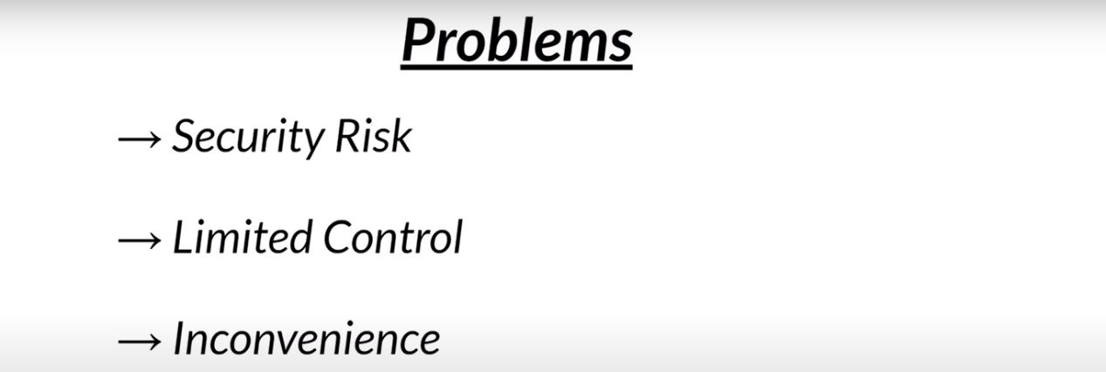
Before OAuth2 how things are working?
----> security risk : yedavina 3rd party application ni mana application lo use cheyali ante mana Credentials anevi share cheyali edi majore swcurity reason
-----> Limited Control : Oka sari credentials share chesaka a 3rd party applications ki All access anevi vellevi, LImited Acess ni control anedi vundedi kadu
-------> Inconvenience : manam yedavian multiple 3rd party applications lo login avvi vundi yedavina oka danni nuodi access thiseyali anna leda vati access anedi pokunda password mathrame change cheyali anukunte kudaradu password chestahe login avvina applications ki access anedi pothundi
E prbs anevi OAuth2 lekamundu face chesevallam

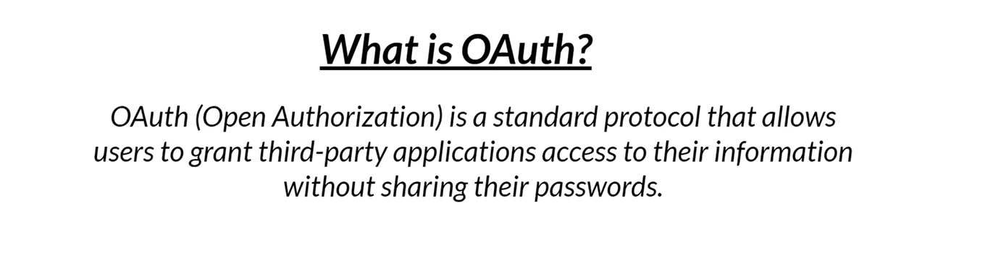
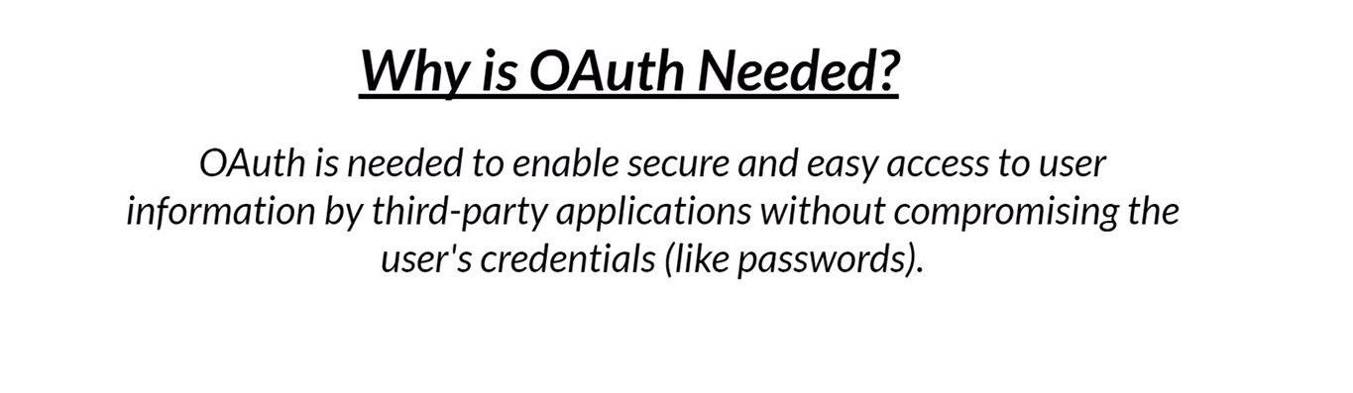
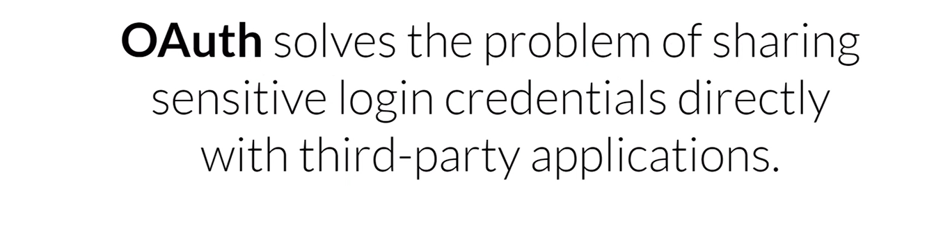
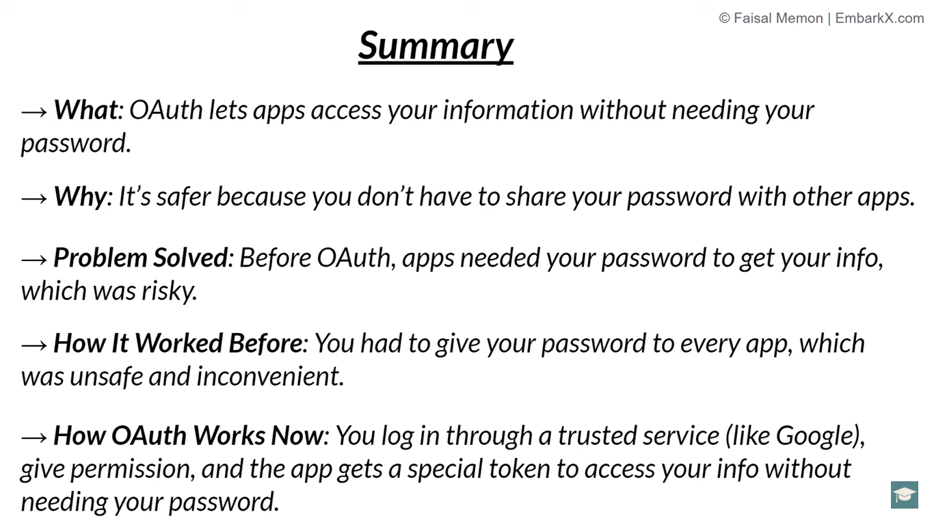
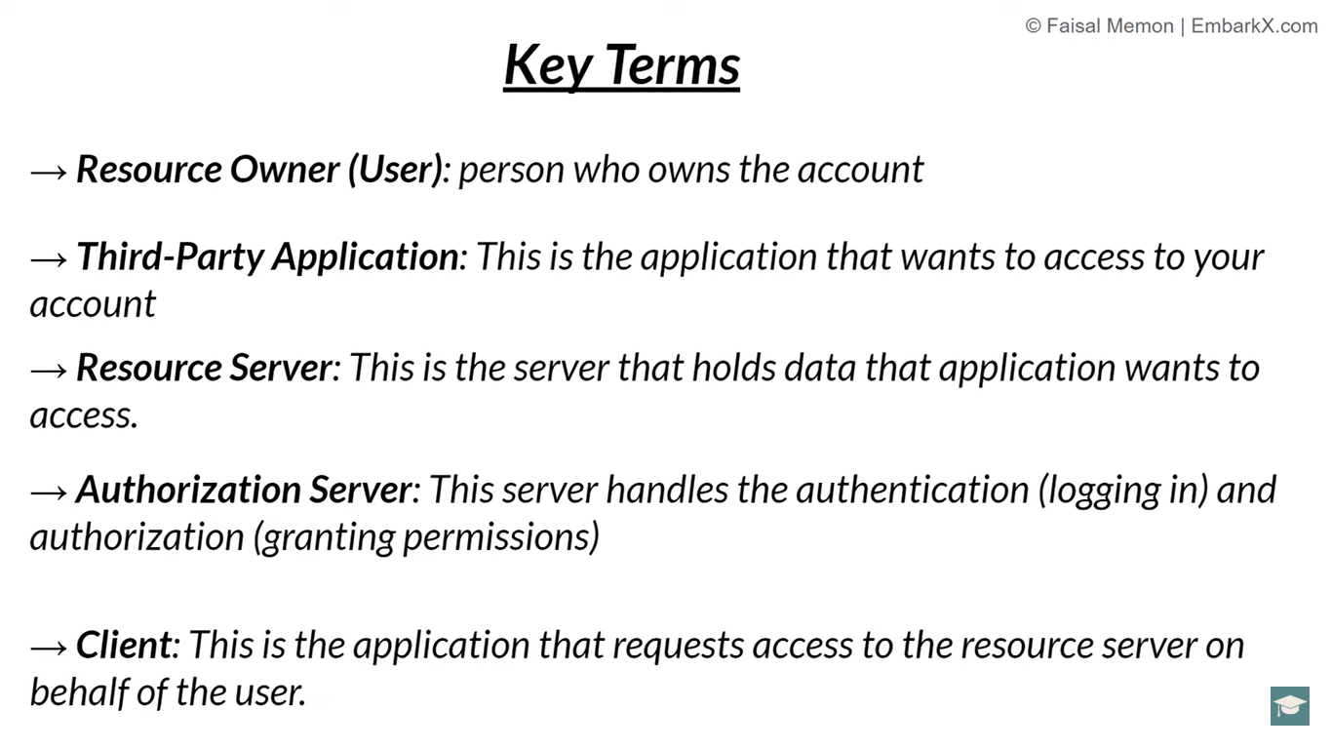
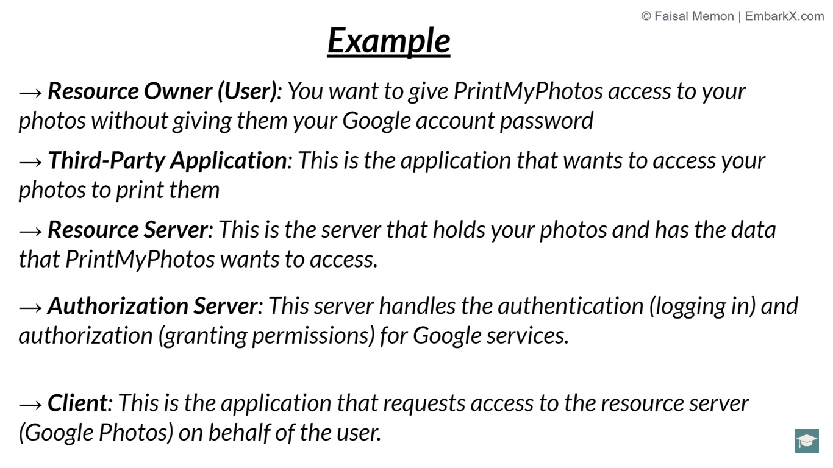

=============== doubts =============
How to create OAuth2 login setup ?
SecurityConfig class
@Configuration
@EnableWebSecurity
public class SecurityConfig {

public SecurityFilterChain securityFilterChain(HttpSecurity http) throws Exception {
http.authorizeHttpRequests(auth->auth.anyRequest().authenticated())
.oauth2Login(Customizer.withDefaults());
return http.build();
}
}
Controller Class
@RestController
//@RequestMapping("/Demo")
public class HelloController {
@GetMapping("/hello")
public String greet(){
return "Welcome to Telusko";
}
}
application.properties
spring.application.name=OAuth2_Spring_Demo
spring.datasource.url=jdbc:mysql://localhost:3306/spring_security
spring.datasource.username=root
spring.datasource.password=Root@123
spring.datasource.driver-class-name=com.mysql.cj.jdbc.Driver
spring.jpa.database-platform=org.hibernate.dialect.MySQLDialect
spring.jpa.hibernate.ddl-auto=update

#GitHub Oauth2 credentials
spring.security.oauth2.client.registration.github.client-id=Ov23liMjRvArJ6HH6AAU
spring.security.oauth2.client.registration.github.client-secret=ab7ea344068593aa6a6177f8b8bc5a9194ec3bda

Eppudu ante Na Git Hub Account nuodi Git client-id & .client-secret ni genarate chesanu but real time project lo yela create chesthamu?
Real-time lo OAuth2 Setup Ela Chestham?
Mee local lo GitHub lo register chesi client-id & client-secret ni use chesaru kada? Real-time lo same process untundi, but organization level lo chestham.

Step 1: Organization Level lo GitHub OAuth App Create Cheyyadam
Company/Organization ki GitHub Enterprise Account untundi. Ledu ante, regular GitHub account use chestharu.
GitHub Developer Settings ki vellali:
  - Open GitHub
  - Go to Settings (profile icon click cheyyi -> "Settings")
  - Left-side menu lo Developer settings click cheyyi
  - OAuth Apps click cheyyi
  - New OAuth App click cheyyi
Application details enter cheyyali
  - Application Name: Example – Company App
  - Homepage URL: https://yourcompany.com
  - Authorization callback URL: https://yourcompany.com/login/oauth2/code/github
(Spring Boot OAuth2 uses /login/oauth2/code/{provider} by default)
  - Register Application click cheyyali
GitHub miku Client ID & Client Secret istundi.
  - Client ID – Direct ga kanipistadi
  - Client Secret – Generate a new client secret click cheyyali, danini secure ga store cheyyali

Step 2: Ee Credentials ni Spring Boot lo Add Cheyyadam
Real-time projects lo secrets direct ga application.properties lo rayam. Instead, environment variables or secret vaults lo store chestham.

Option 1: application.properties (Development/Testing purpose)
spring.security.oauth2.client.registration.github.client-id=your-client-id
spring.security.oauth2.client.registration.github.client-secret=your-client-secret

Option 2: Environment Variables (Production best practice)
Terminal lo:
export GITHUB_CLIENT_ID=your-client-id
export GITHUB_CLIENT_SECRET=your-client-secret
Spring Boot lo:
spring.security.oauth2.client.registration.github.client-id=${GITHUB_CLIENT_ID}
spring.security.oauth2.client.registration.github.client-secret=${GITHUB_CLIENT_SECRET}

FAQs (Mee Doubts ki Samadhanam 😁)

❓ Real-time lo developers ki client-id & secret ela dorukuthai?
➡️ Usually, Admin (DevOps team) create chestharu. Developers ki direct ga properties lo access ivvakunda, Environment variables lo store chestharu.

❓ Company lo different environments ki (dev, test, prod) separate client-id & secret untaya?
➡️ Yes, different environments ki different OAuth apps create chestharu.
- Development OAuth App (Local testing)
- Staging OAuth App (Pre-production testing)
- Production OAuth App (Live users)

❓ Production lo client-secret security ela maintain chestham?
➡️ AWS Secrets Manager, Azure Key Vault, HashiCorp Vault laanti secret management tools use chestharu.
➡️ Direct ga .properties file lo petadam security risk.

❓ Only GitHub OAuth2 kakunda, Google, Facebook kuda ala integrate chesthaama?
➡️ Yes! Same process follow cheyyali:
- Google OAuth2 App – Google Cloud Console
- Facebook OAuth2 App – Meta Developer Console
- GitHub OAuth2 App – GitHub Developer Settings

Conclusion
✅ Mee local lo cheyyadam & real-time process almost same, but real-time lo Admin/DevOps teams maintain chestharu.
✅ Environment variables or secret vaults use cheyyali, direct .properties lo client secrets store cheyyakudadu.
✅ Different environments ki separate OAuth Apps create chestharu.
✅ Same process Google, Facebook ki apply avuthundi.

so realtime lo kuda eppudu nenu yela avithe na account tho create chesanoo...alane company account tho create chestahru right ?
Yes, exactly! 🎯
Real-time lo company GitHub/Google/Facebook account use chesi OAuth2 app create chestharu.
🔹 Nuvvu personal GitHub account tho create chesav kada?
➡️ Company lo admin (DevOps team) company account tho GitHub Developer Settings lo OAuth2 app create chestharu.
🔹 Client ID & Client Secret kuda alane generate chestharu
➡️ But production lo direct .properties lo petaru, instead, secret vaults (AWS Secrets Manager, Azure Key Vault) lo store chestharu.
🔹 Real-time lo different environments ki separate OAuth apps untai
➡️ Dev, Test, Production ki different Client ID & Secret untai.
So, overall process same, just company account lo create chestharu! 🚀

Project for OAuth2 with Git Login users need to save in DB
Yes, absolutely right! ✅

💡 This whole setup will handle both types of users in a single project:

🔐 1. Existing DB Users (Username + Password Login)
- These users already exist in your users and authorities tables.
- They can log in via username/password + JWT token generation.
- Their role-based access control works dynamically via the DB.

🌐 2. GitHub OAuth2 Login Users
- These users log in via GitHub using:
http://localhost:8080/oauth2/authorization/github
- On first login:
  - They get stored in users table with:
    - username = GitHub email or login
    - password = 'N/A' (or blank)
    - enabled = true
  - They are also inserted into authorities table with default GIT_USER role.
- A JWT token is generated for them and sent back.
- They can use that token in Postman or frontend to call secured endpoints.

✅ Summary:
User Type | Auth Method | DB Storage | JWT Role
Normal Users | Username/Password | Already in DB | From DB
GitHub Users | OAuth2 GitHub Login | Saved on 1st login | GIT_USER
So yes, your project will support hybrid login and role-based access — clean and real-world production ready.

Entire project Code
✅ Final Setup Goals:
- Existing DB users (from users & authorities) login via /JWT/signin and get JWT.
- GitHub users login via /oauth2/authorization/github, on first login their data is saved in users and authorities with default role GIT_USER, and JWT is generated.
- No extra tables or entities required.
- Inline JWT generation after GitHub login (No extra handler class).
- Dynamic role-based authorization from DB via JdbcUserDetailsManager.

🔐 1. SecurityConfig_mysql.java
@Configuration
@EnableWebSecurity
@EnableMethodSecurity
public class SecurityConfig_mysql {

@Autowired
private AuthEntryPointJwt_mysql unauthorizedHandler;

@Autowired
private JwtUtils_mysql jwtUtils;

@Autowired
private DataSource dataSource;

@Bean
public AuthTokenFilter_mysql authenticationJwtTokenFilter() {
return new AuthTokenFilter_mysql();
}

@Bean
public SecurityFilterChain filterChain(HttpSecurity http) throws Exception {
http.csrf(AbstractHttpConfigurer::disable)
.headers(headers -> headers.frameOptions().sameOrigin())
.sessionManagement(session -> session.sessionCreationPolicy(SessionCreationPolicy.STATELESS))
.exceptionHandling(exception -> exception.authenticationEntryPoint(unauthorizedHandler))
.authorizeHttpRequests(auth -> auth
.requestMatchers("/h2-console/**", "/JWT/signin", "/JWT/signup", "/public/**").permitAll()
.anyRequest().authenticated()
)
.oauth2Login(oauth -> oauth.successHandler((request, response, authentication) -> {
OAuth2AuthenticationToken oauthToken = (OAuth2AuthenticationToken) authentication;
OAuth2User oauthUser = oauthToken.getPrincipal();
String username = oauthUser.getAttribute("login");

// Save to DB if not exists
JdbcTemplate jdbcTemplate = new JdbcTemplate(dataSource);
Integer count = jdbcTemplate.queryForObject(
"SELECT COUNT(*) FROM users WHERE username = ?", Integer.class, username);
if (count != null && count == 0) {
jdbcTemplate.update("INSERT INTO users (username, password, enabled) VALUES (?, ?, true)", username, "N/A");
jdbcTemplate.update("INSERT INTO authorities (username, authority) VALUES (?, ?)", username, "GIT_USER");
}

// Generate JWT
String jwt = jwtUtils.generateTokenFromUsername(username);
response.setContentType("application/json");
response.getWriter().write("{\"token\": \"" + jwt + "\"}");
}));

http.addFilterBefore(authenticationJwtTokenFilter(), UsernamePasswordAuthenticationFilter.class);
return http.build();
}

@Bean
public UserDetailsService userDetailsService() {
return new JdbcUserDetailsManager(dataSource);
}

@Bean
public AuthenticationManager authenticationManager(AuthenticationConfiguration config) throws Exception {
return config.getAuthenticationManager();
}

@Bean
public PasswordEncoder passwordEncoder() {
return new BCryptPasswordEncoder();
}
}

🛡 2. AuthTokenFilter_mysql.java
@Component
public class AuthTokenFilter_mysql extends OncePerRequestFilter {

@Autowired
private JwtUtils_mysql jwtUtilsMysql;

@Autowired
private UserDetailsService userDetailsService;

private static final Logger logger = LoggerFactory.getLogger(AuthTokenFilter_mysql.class);

@Override
protected void doFilterInternal(HttpServletRequest request, HttpServletResponse response, FilterChain filterChain)
throws ServletException, IOException {
try {
String jwt = parseJwt(request);
if (jwt != null && jwtUtilsMysql.validateToken(jwt)) {
String username = jwtUtilsMysql.getUsernameFromToken(jwt);
UserDetails userDetails = userDetailsService.loadUserByUsername(username);
UsernamePasswordAuthenticationToken authentication = new UsernamePasswordAuthenticationToken(
userDetails, null, userDetails.getAuthorities());
authentication.setDetails(new WebAuthenticationDetailsSource().buildDetails(request));
SecurityContextHolder.getContext().setAuthentication(authentication);
}
} catch (Exception e) {
logger.error("Cannot set user authentication: {}", e);
}
filterChain.doFilter(request, response);
}

private String parseJwt(HttpServletRequest request) {
return jwtUtilsMysql.getJWTFromHeader(request);
}
}

🔐 3. JwtUtils_mysql.java
@Component
public class JwtUtils_mysql {

private static final Logger logger = LoggerFactory.getLogger(JwtUtils_mysql.class);

@Value("${spring.app.jwtsecret}")
private String jwtsecret;

@Value("${spring.app.jwtExpirationMs}")
private int jwtExpirationMs;

public String getJWTFromHeader(HttpServletRequest request) {
String bearerToken = request.getHeader("Authorization");
if (bearerToken != null && bearerToken.startsWith("Bearer ")) {
return bearerToken.substring(7);
}
return null;
}

public String generateTokenFromUsername(String username) {
return Jwts.builder()
.subject(username)
.issuedAt(new Date())
.expiration(new Date(System.currentTimeMillis() + jwtExpirationMs))
.signWith(key())
.compact();
}

public String getUsernameFromToken(String token) {
return Jwts.parser()
.verifyWith((SecretKey) key())
.build()
.parseSignedClaims(token)
.getBody()
.getSubject();
}

public boolean validateToken(String token) {
try {
Jwts.parser().verifyWith((SecretKey) key()).build().parseSignedClaims(token);
return true;
} catch (Exception e) {
logger.error("JWT validation error: {}", e.getMessage());
return false;
}
}

private Key key() {
byte[] keyBytes = Decoders.BASE64.decode(jwtsecret);
return Keys.hmacShaKeyFor(keyBytes);
}
}

🚫 4. AuthEntryPointJwt_mysql.java
@Component
public class AuthEntryPointJwt_mysql implements AuthenticationEntryPoint {

private static final Logger logger = LoggerFactory.getLogger(AuthEntryPointJwt_mysql.class);

@Override
public void commence(HttpServletRequest request, HttpServletResponse response, AuthenticationException authException)
throws IOException, ServletException {
logger.error("Unauthorized error: {}", authException.getMessage());

response.setContentType(MediaType.APPLICATION_JSON_VALUE);
response.setStatus(HttpServletResponse.SC_UNAUTHORIZED);
final Map<String, Object> body = new HashMap<>();
body.put("status", HttpServletResponse.SC_UNAUTHORIZED);
body.put("error", "Unauthorized");
body.put("message", authException.getMessage());
body.put("path", request.getServletPath());

final ObjectMapper mapper = new ObjectMapper();
mapper.writeValue(response.getOutputStream(), body);
}
}

Controller Class

@RestController
@RequestMapping("/JWT")
public class JWTController_mysql {

@Autowired
private JwtUtils_mysql jwtUtilsMysql;
@Autowired
private AuthenticationManager authenticationManager;

@Autowired
private PasswordEncoder passwordEncoder;

@Autowired
private DataSource dataSource;
@PostMapping("/signin")
public ResponseEntity<?> authenticateUser(@RequestBody LoginRequest_mysql loginRequestMysql) {
Authentication authentication;
try {
authentication = authenticationManager.authenticate(
new UsernamePasswordAuthenticationToken(loginRequestMysql.getUsername(), loginRequestMysql.getPassword()));
} catch (Exception e) {
return ResponseEntity
.badRequest()
.body("Invalid username or password");
}

SecurityContextHolder.getContext().setAuthentication(authentication);
UserDetails userDetails = (UserDetails) authentication.getPrincipal();
String jwt = jwtUtilsMysql.generateTokenFromUsername(String.valueOf(userDetails));
List<String> roles = userDetails.getAuthorities().stream()
.map(item -> item.getAuthority())
.collect(Collectors.toList());
LoginResponces_mysql loginResponcesMysql = new LoginResponces_mysql(jwt, userDetails.getUsername(), roles);
return ResponseEntity.ok(loginResponcesMysql);

}

@PostMapping("/signup")
public ResponseEntity<?> registerUser(@RequestBody LoginRequest_mysql loginRequestMysql) {
JdbcUserDetailsManager jdbcUserDetailsManager = new JdbcUserDetailsManager(dataSource);

// Create user with the provided username and password
String userRole = loginRequestMysql.getRole();

jdbcUserDetailsManager.createUser(org.springframework.security.core.userdetails.User.withUsername(loginRequestMysql.getUsername())
.password(passwordEncoder.encode(loginRequestMysql.getPassword()))
.roles(userRole) // Use user-provided role instead of hardcoding
.build());

return ResponseEntity.ok("User registered successfully!");
}

}

✅ Now you can test:
- Existing DB users: /JWT/signin (your normal login API)
- GitHub login: http://localhost:8080/oauth2/authorization/github — JWT will be shown in browser after first login and you can use it in Postman.

After running Above code for git users working fine but existing DB users JWT token genarated but while using that token and if hit URL in post man I am getting Error "message": "Full authentication is required to access this resource",?
Perfect! You’ve understood it almost 100% right — let’s now summarize everything clearly and provide you with:
✅ Full issue summary
✅ Root cause & explanation
✅ JWT decode examples for wrong token (object passed) and correct token (username passed)
✅ Final solution & takeaway

✅ ISSUE SUMMARY
You were generating JWT token in /signin endpoint using this line:
String jwt = jwtUtilsMysql.generateTokenFromUsername(String.valueOf(userDetails)); // ❌ WRONG
Instead of this:
String jwt = jwtUtilsMysql.generateTokenFromUsername(userDetails.getUsername()); // ✅ CORRECT
So even though the token was technically getting generated, it was generated with the wrong subject (username) in the JWT payload, resulting in authentication failure later (401 Unauthorized).

🔍 ROOT CAUSE
- generateTokenFromUsername(String username) expects a plain username like "john", "admin" etc.
- But String.valueOf(userDetails) gives you the entire object’s toString() value, like:
"org.springframework.security.core.userdetails.User@6d3f80ef"
So JWT was generated with this object string as subject (sub) instead of the real username.
Later, when request comes with that JWT:
String username = jwtUtilsMysql.getUsernameFromJwtToken(token);
UserDetails user = userDetailsService.loadUserByUsername(username);
This fails because that "org.springframework...User@xyz" is not a valid username in DB.

✳️ JWT Breakdown: Header, Payload, Signature
A JWT token has 3 parts:
[HEADER].[PAYLOAD].[SIGNATURE]
- Header (Base64-encoded JSON):
{
"alg": "HS256",
"typ": "JWT"
}
- Payload (Base64-encoded JSON):
Contains user info like username (sub), issued time, expiry etc.
{
"sub": "john123", // username
"iat": 1710922000, // issued at
"exp": 1710925600 // expiry
}
- Signature is generated using your secret key.

📌 Example 1: WRONG TOKEN (object passed)
String jwt = jwtUtilsMysql.generateTokenFromUsername(String.valueOf(userDetails));

➤ JWT Payload after decode:
{
"sub": "org.springframework.security.core.userdetails.User@6d3f80ef",
"iat": 1710922100,
"exp": 1710925700
}
- So getUsernameFromJwtToken(token) returns "org.springframework.security.core.userdetails.User@6d3f80ef" → Not found in DB → 401 Unauthorized

📌 Example 2: CORRECT TOKEN (username passed)
String jwt = jwtUtilsMysql.generateTokenFromUsername(userDetails.getUsername());

➤ JWT Payload after decode:
{
"sub": "john123",
"iat": 1710922200,
"exp": 1710925800
}
- Now getUsernameFromJwtToken(token) returns "john123" → Found in DB → Auth success ✅

💡 Solution Recap (Fix):
🔸 Always pass plain username to generateTokenFromUsername():
String jwt = jwtUtilsMysql.generateTokenFromUsername(userDetails.getUsername());
🔸 Avoid using String.valueOf(userDetails) or userDetails.toString() — it's not the actual username, just a string representation of the object.

🧠 Final Takeaway:
Parameter Passed | JWT Payload sub | Auth Works?
String.valueOf(userDetails) | "org.springframework.security.core.userdetails.User@xyz" | ❌ No
userDetails.getUsername() | "john123" | ✅ Yes

🔍 Optional Tip – Decode JWT tokens online:
Use https://jwt.io
Paste token → See payload → Quickly debug issues like this.
Conclustion : Manam “JwtUtils_mysql “ lo rasian “generateTokenFromUsername” method anedi token ni genarate chesthundi
Controller class lo (“/signin) end point lo generateTokenFromUsername method ki String.valueOf(userDetails) eila pass cheyattam valana token anedi Genarate avvindi but entire invalid username tho Token genarate avvindi ala kakunda object ni just userDetails ni pass chesina work avvedi.
Ala avvatam vala token ni validate chesetappudu Usename header anedi a Token lo ledu andukani Error vacchindi
JWT Token decode chesthe header lo username correct ga vasthe validation gariddi.
{
"sub": "kiran",
"iat": 1742413267,
"exp": 1742413367
}
Ala correct ga ravali ante “generateTokenFromUsername” method ki token genartion appudu only username ye pass cheyali

Conclusion of OAuth2 topic :
OAuth2 anedi users ki Hybrid mode lo login option evvatam( ex: Git,Google,Facebook…etc)
Diniki OAuth2 option evvali aukunna Apps lo Clien-id , Scerite - key ni register avvi mana application.poperties file lo evvali
Real time project lo Devoops team project related Account nuodi vatini eistharu avi manam use chesukovali
Best practies Oauth2 option dwara login avve users ki related configuration ni separate class lo rayatam and ala logina avina users detatils ni DB lo store chesi vallaki defaut ROLE evvatam best approch
Ala DB store cheyakunda and ROLE create cheyakunda kuda cheyachhu….
And einka chala validation cheyachhu… but as of now eve cover chesam

========== == Project === > I am generating JWT token for git login users and that token I am using to access for rest END points but facing issue “"message": "Full authentication is required to access this resource"

2 projects chesanu 1st = OAuth2_with_JWT - edi only JWT token ni genarate chesthundi but rest END points ni acess cheyaledu

Ans :
when i tested this code in chrome http://localhost:8080/oauth2/authorization/github gives a JWT but with that JWT token if i am trying to access in postman /demo - rest end point i am getting error like "message": "Full authentication is required to access this resource",
because i am using "JdbcUserDetailsManager" i am combining JWT + Spring Security built-in user management ,so i need to store git login username and details then it will work
Note : but without storing also it is possible daniki vere roots vunnay but project cheyaledu

✅ Yes — in your current design, every JWT token must correspond to a user that exists in your DB.
Why?
Because you are using:
JdbcUserDetailsManager
Spring Security does this flow on protected API call:
JWT arrives
Extract username from JWT
Load user from DB
Validate token and authorities
If user not found → ❌ 401 Unauthorized
So yes — in this setup, the JWT token is valid only if the user exists in your DB.

✅ Why is DB check needed?
You are combining JWT + Spring Security built-in user management.
This allows:
Benefit | Reason
Block users | You can disable a user in DB
Role management | DB stores roles/authorities
OAuth auto-register | GitHub users saved to DB

✅ But is DB check required for JWT in general?
No.
JWT can be completely stateless, meaning no DB lookup.
But that's only if:
You do not use JdbcUserDetailsManager
You store roles inside JWT itself
You trust JWT fully
Example: Microservice JWT architecture

✅ Two JWT patterns
Mode | DB Lookup? | When used
Stateful (your setup) | ✅ Yes | User DB, role checks, block users
Stateless JWT | ❌ No | Pure token auth, no DB, microservices

✅ Which one is better?
Feature | Your current design | Stateless JWT
Block users instantly | ✅ Yes | ❌ No (token still valid)
Change roles immediately | ✅ Yes | ❌ No
Scales microservices | ⚠️ OK | ✅ Best
Security | ✅ Strong | Depends on token safety
Your case (Spring Security + DB users + GitHub OAuth) → ✅ Correct approach

👍 Conclusion
✔ With your setup — JWT must match DB user
✔ GitHub login will auto-insert that user
✔ Protects endpoints and allows user control

❓ Want Option 2 (No DB lookup)?
If you'd like, tell me:
“I want JWT stateless mode (no DB lookup) for GitHub users”

1st project lo nenu STATELESS below vidam ga rasanu
// .sessionManagement(session -> session.sessionCreationPolicy(SessionCreationPolicy.STATELESS))
// ✅ Use session only if required (needed for GitHub OAuth)
.sessionManagement(session -> session.sessionCreationPolicy(SessionCreationPolicy.IF_REQUIRED))
But 2nd project lo STATELESS add chesi chesanu

2nd project = OAuth2_with_Git ---> JWT tho patu Rest END points ni kuda access cheyachhu.

Main points in 2nd project :
I used STATELESS and git dwara login avina users ki table lo insert chesi a users ki default ga oka role ni echhanu

How to test this project :?
Chrome browser : http://localhost:8080/oauth2/authorization/github --> it will give JWT like below
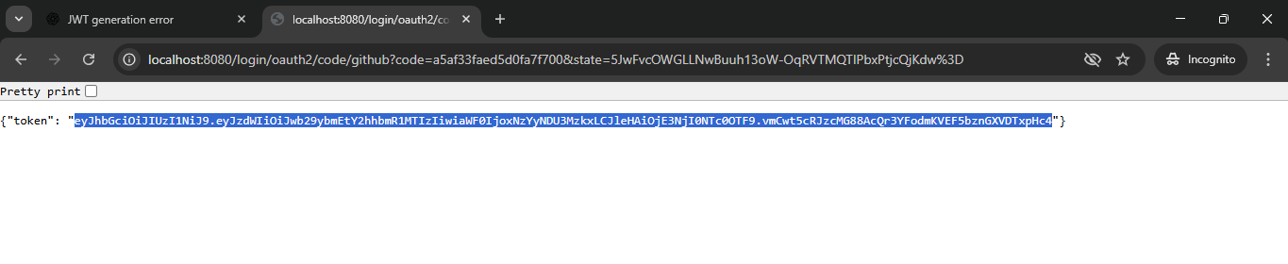

Post Man : http://localhost:8080/api/demo ---> hit required URL’s in post with JWT like below
