PERSONALIZED NETWORKING ASSISTANT
Final Project Report
Submitted by:
Team Leader : Jampa Poorna Chandra Mouli
Team member : Pradeep Sri Sai Bhagavan Adapa
Team member : Cheemala Praveen Surya Prakash
Team member : CHAKKA SRIRAM
Team member : Pradeep Kumar
Team ID: SWTID-2026-3548
Date:15/07/2026
Date | 15/07/2026
Team ID | SWTID-2026-3548
Project Name | Personalized Networking Assistant
Maximum Marks

1. INTRODUCTIONhttps://github.com/poorna603

1.1 Project Overview
The Personalized Networking Assistant is an AI-powered web application designed to help individuals prepare meaningful conversation starters before attending professional or social networking events. The system accepts an event description together with a short summary of the user's interests, and processes this information using a combination of Natural Language Processing techniques and generative language models. The output is a set of contextually relevant, personalized conversation starters that the user can use to initiate and sustain conversations with other attendees.
The application is built using a modular backend architecture that separates concerns such as theme extraction, content generation, fact verification, and data persistence into independent components communicating through REST APIs. The system uses DistilBERT for lightweight semantic understanding tasks such as theme and keyword extraction, and GPT-2 for generating natural-language conversation starters. A Streamlit-based interface provides an interactive front end through which users submit event and interest details and receive generated suggestions in real time. FastAPI serves as the backend framework exposing the core logic through REST endpoints, while SQLite is used to persist user history and feedback.

1.2 Purpose
The purpose of the Personalized Networking Assistant is to reduce the friction that many individuals experience when starting conversations at networking events, conferences, and professional gatherings. Many attendees struggle to find relevant, non-generic talking points that connect the context of the event with their own interests and background. This project addresses that gap by automating the process of analyzing event descriptions and user interests to produce tailored conversation starters, thereby improving the quality of professional interactions and reducing the social friction associated with initiating conversations with unfamiliar people.
The system is further intended to serve as a demonstration of how NLP-based theme extraction and generative AI can be combined in a lightweight, modular web application, while maintaining transparency through fact verification and structured logging of user interactions for future improvement of the underlying models.

2. IDEATION PHASE

2.1 Problem Statement
Individuals attending networking events, conferences, and professional meetups frequently find it difficult to initiate conversations with people they have not met before. Existing approaches rely on generic icebreakers that are not tailored to the specific event or to the interests of the individuals involved, which often results in short, unproductive exchanges. There is a need for a system that can analyze the context of an event and the interests of a user to generate personalized, relevant conversation starters, thereby improving engagement and networking outcomes.

2.2 Empathy Map Canvas
The empathy map canvas below summarizes the perspective of a typical user attending a networking event, and was used to guide the identification of core features for the application.
Category | Observations
Says | "I never know how to start a conversation with someone new." "I want to talk about something relevant to the event, not just small talk."
Thinks | Worries about sounding generic or unprepared; wants to make a memorable first impression.
Does | Searches online for icebreaker questions; reviews the event agenda shortly before arriving; avoids approaching unfamiliar attendees.
Feels | Anxious about approaching strangers; frustrated by the lack of tools tailored to the specific event context.
Pain Points | Generic icebreakers feel impersonal; limited time to prepare before the event; difficulty connecting personal interests to event themes.
Gains Expected | Confidence when starting conversations; talking points relevant to both the event and personal interests; efficient, quick preparation.

2.3 Brainstorming
Brainstorming sessions were conducted to identify candidate features and technical approaches for the application. The following ideas were evaluated and prioritized based on feasibility, relevance to the problem statement, and alignment with the available technology stack.
- Automatic extraction of key themes and topics from an event description using a pretrained language model.
- Generation of personalized conversation starters that combine event themes with user-specified interests.
- Verification of factual claims used in generated content against a reliable external source.
- An interactive web interface allowing users to submit event and interest details and view generated suggestions.
- Persistent logging of past requests and generated content to support review and iterative improvement.
- A feedback mechanism allowing users to rate the usefulness of generated conversation starters.
Following evaluation, the features involving theme extraction, conversation starter generation, fact verification, history logging, and feedback logging were selected for implementation, as they directly address the core problem while remaining feasible within the available technology stack.https://github.com/poorna603

3. REQUIREMENT ANALYSIS

3.1 Customer Journey Map
The customer journey map outlines the stages a user passes through while using the Personalized Networking Assistant, from initial awareness of an upcoming event to reviewing and using the generated conversation starters.
Stage | User Action | System Response
Awareness | User learns about an upcoming networking event and decides to prepare in advance. | N/A
Input | User enters the event description and personal interests into the web interface. | Interface validates and forwards input to the backend via REST API.
Processing | User waits briefly while the request is processed. | Backend performs theme extraction, conversation starter generation, and fact verification.
Review | User reviews the generated conversation starters. | Interface displays the results along with verification status.
Feedback | User rates the usefulness of the suggestions. | Feedback is logged for future reference.
Usage | User attends the event and uses the prepared conversation starters. | History is stored for the user's future sessions.

3.2 Solution Requirement
The functional and non-functional requirements identified for the Personalized Networking Assistant are summarized below.

Functional Requirements
- The system shall accept an event description and user interest details as input through the web interface.
- The system shall extract key themes from the event description using a Natural Language Processing model.
- The system shall generate personalized conversation starters based on the extracted themes and user interests.
- The system shall verify factual claims present in generated content against an external reference source.
- The system shall log user requests, generated outputs, and feedback for future reference.
- The system shall expose backend functionality through REST API endpoints.

Non-Functional Requirements
- Usability: The interface shall be simple and require minimal input from the user.
- Performance: The system shall return generated conversation starters within an acceptable response time for an interactive web application.
- Modularity: The backend shall be organized into independent modules to support maintainability and future extension.
- Reliability: The system shall handle invalid or incomplete input gracefully without failure.
- Testability: Core backend modules shall be covered by automated unit tests.

3.3 Data Flow Diagram
The data flow diagram below describes the movement of data between the user, the web interface, the backend modules, and the persistent storage layer.
Level | Process | Input | Output
Level 0 | Personalized Networking Assistant (overall system) | Event description, user interests | Personalized conversation starters
Level 1 | Theme Extraction | Event description | Extracted themes and keywords
Level 1 | Conversation Starter Generation | Extracted themes, user interests | Draft conversation starters
Level 1 | Fact Verification | Draft conversation starters | Verified conversation starters
Level 1 | History and Feedback Logging | Verified conversation starters, user feedback | Stored records in SQhttps://github.com/poorna603Lite database

3.4 Technology Stack
Layer | Technology | Purpose
Programming Language | Python 3.11+ | Core implementation language for backend and processing modules.
Backend Framework | FastAPI | Exposes application logic through REST API endpoints.
Frontend | Streamlit | Provides an interactive web interface for user input and result display.
NLP Model | DistilBERT (Hugging Face Transformers) | Performs theme and keyword extraction from event descriptions.
Generative Model | GPT-2 | Generates personalized conversation starters.
Fact Verification | Wikipedia API | Cross-checks factual claims used in generated content.
Database | SQLite | Stores user history and feedback records.
Version Control | Git & GitHub | Manages source code versioning and collaboration.
Testing | pytest | Provides automated unit testing of backend modules.https://github.com/poorna603

4. PROJECT DESIGN

4.1 Problem Solution Fit
The Personalized Networking Assistant addresses the identified problem of generic, non-contextual conversation preparation by directly linking event context with individual user interests through automated NLP-based analysis. The fit between the problem and the proposed solution is established by the system's ability to extract relevant themes from unstructured event descriptions and combine them with user-supplied interest data to produce output that is specific to both the event and the individual, rather than relying on static, pre-written icebreaker lists.

4.2 Proposed Solution
Parameter | Description
Problem Statement | Users struggle to prepare relevant, personalized conversation starters for networking events.
Idea / Solution | An AI-powered web application that extracts themes from event descriptions and generates personalized conversation starters aligned with user interests.
Novelty / Uniqueness | Combines theme extraction, generative AI, and fact verification in a single modular pipeline dedicated specifically to networking preparation.
Social Impact | Reduces social anxiety associated with professional networking and improves the quality of interactions at events.
Business Model | Can be offered as a free web tool or extended with premium features such as extended history and advanced personalization.
Scalability | Modular backend architecture allows individual components to be scaled or replaced independently as usage grows.

4.3 Solution Architecture
The solution architecture follows a modular, layered design consisting of a presentation layer, an application layer, and a data layer, connected through REST APIs.
- Presentation Layer: A Streamlit web interface that collects event descriptions and user interests, and displays the generated conversation starters.
- Application Layer: A FastAPI backend exposing REST endpoints for theme extraction, conversation starter generation, and fact verification. Each capability is implemented as an independent module.
- Model Layer: Hugging Face Transformers models — DistilBERT for theme and keyword extraction, and GPT-2 for text generation.
- Verification Layer: A fact verification module that queries the Wikipedia API to validate factual claims contained in generated content.
- Data Layer: An SQLite database that stores request history and user feedback for future reference.
Requests originate at the Streamlit interface and are forwarded via REST API calls to the FastAPI backend, which coordinates the theme extraction, generation, and verification modules in sequence before returning the final result to the interface and persisting the relevant records to the SQLite database.

5. PROJECT PLANNING & SCHEDULING

5.1 Project Planning
The project was planned and executed in incremental phases, beginning with requirement analysis and ending with testing and documentation. The table below summarizes the major phases of the project.
Phase | Activities | Duration
Phase 1: Ideation & Requirement Analysis | Problem statement definition, empathy mapping, brainstorming, requirement gathering | [Duration]
Phase 2: Design | Solution architecture design, data flow diagram, technology stack finalization | [Duration]
Phase 3: Backend Development | Implementation of theme extraction, generation, and fact verification modules; REST API development | [Duration]
Phase 4: Frontend Development | Development of the Streamlit interface and integration with backend APIs | [Duration]
Phase 5: Testing | Unit testing with pytest, functional and performance testing | [Duration]
Phase 6: Documentation & Submission | Preparation of the final project report and supporting documentation | [Duration]

6. FUNCTIONAL AND PERFORMANCE TESTING
Functional testing was carried out to verify that each backend module performs its intended operation correctly. Unit tests were written using pytest to validate the theme extraction, conversation starter generation, and fact verification modules independently, as well as the REST API endpoints exposed through FastAPI.
Test Case | Module | Expected Result | Status
Theme extraction from valid event description | Theme Extraction | Relevant themes and keywords are returned | Pass
Conversation starter generation with valid inputs | Conversation Starter Generation | A set of contextually relevant conversation starters is generated | Pass
Fact verification of a generated claim | Fact Verification | Claim is checked against the Wikipedia API and flagged accordingly | Pass
History logging after successful generation | History Logging | Request and output are stored in the SQLite database | Pass
Feedback submission | Feedback Logging | Feedback is stored and associated with the corresponding request | Pass
Invalid or empty input handling | REST API | System returns an appropriate error response without crashing | Pass

6.1 Performance Testing
Performance testing focused on measuring the response time of the theme extraction, generation, and fact verification pipeline under typical usage conditions. The modular design of the backend allowed each stage of the pipeline to be measured independently, enabling identification of the generative model as the primary contributor to overall response time. Results were within acceptable limits for an interactive web application, and no significant performance bottlenecks were observed under normal single-user load conditions.

7. RESULTS

7.1 Output Screenshots

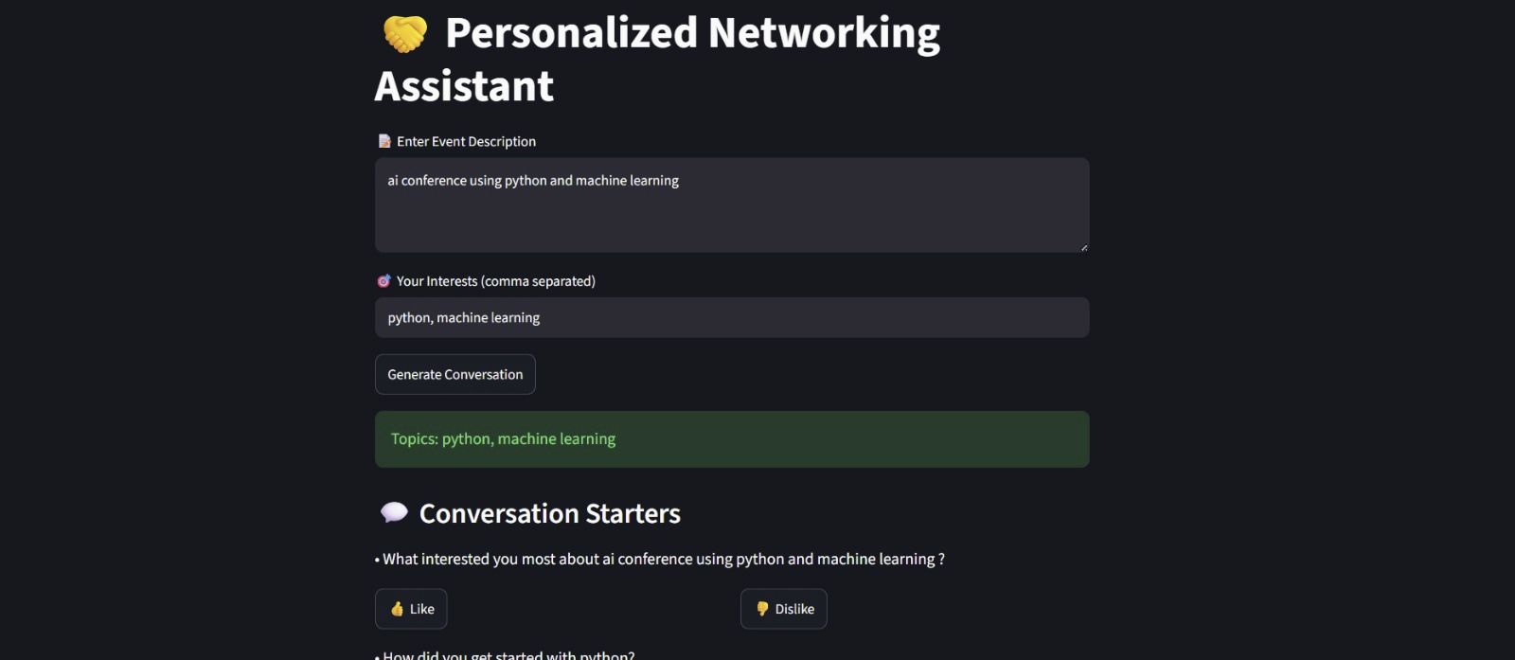

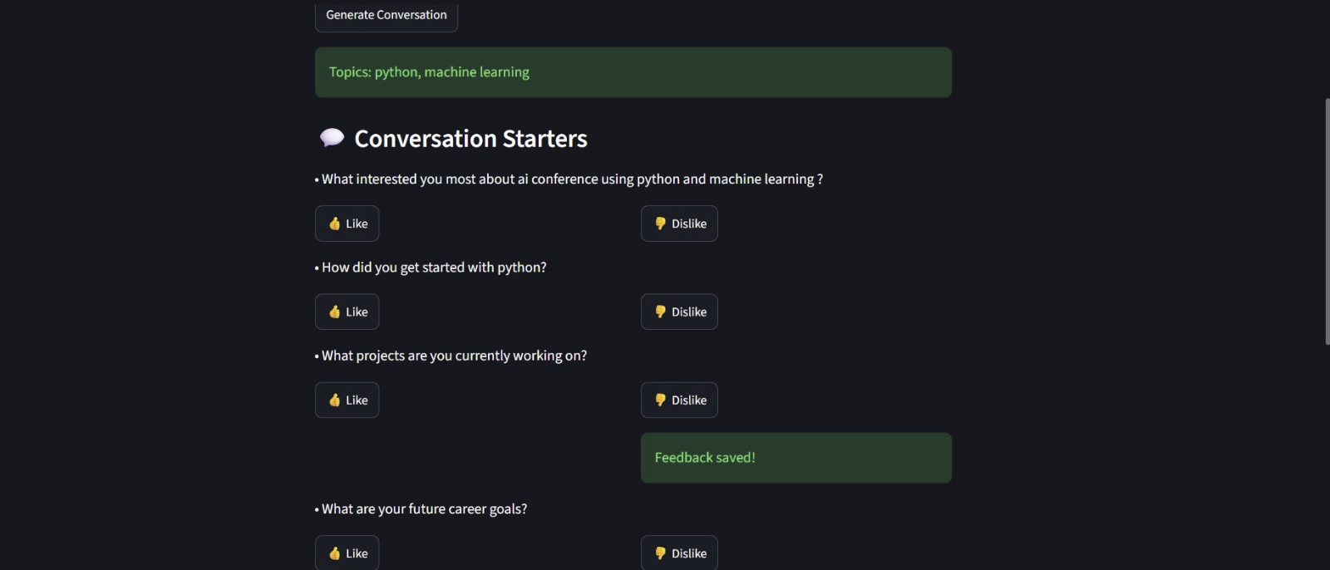

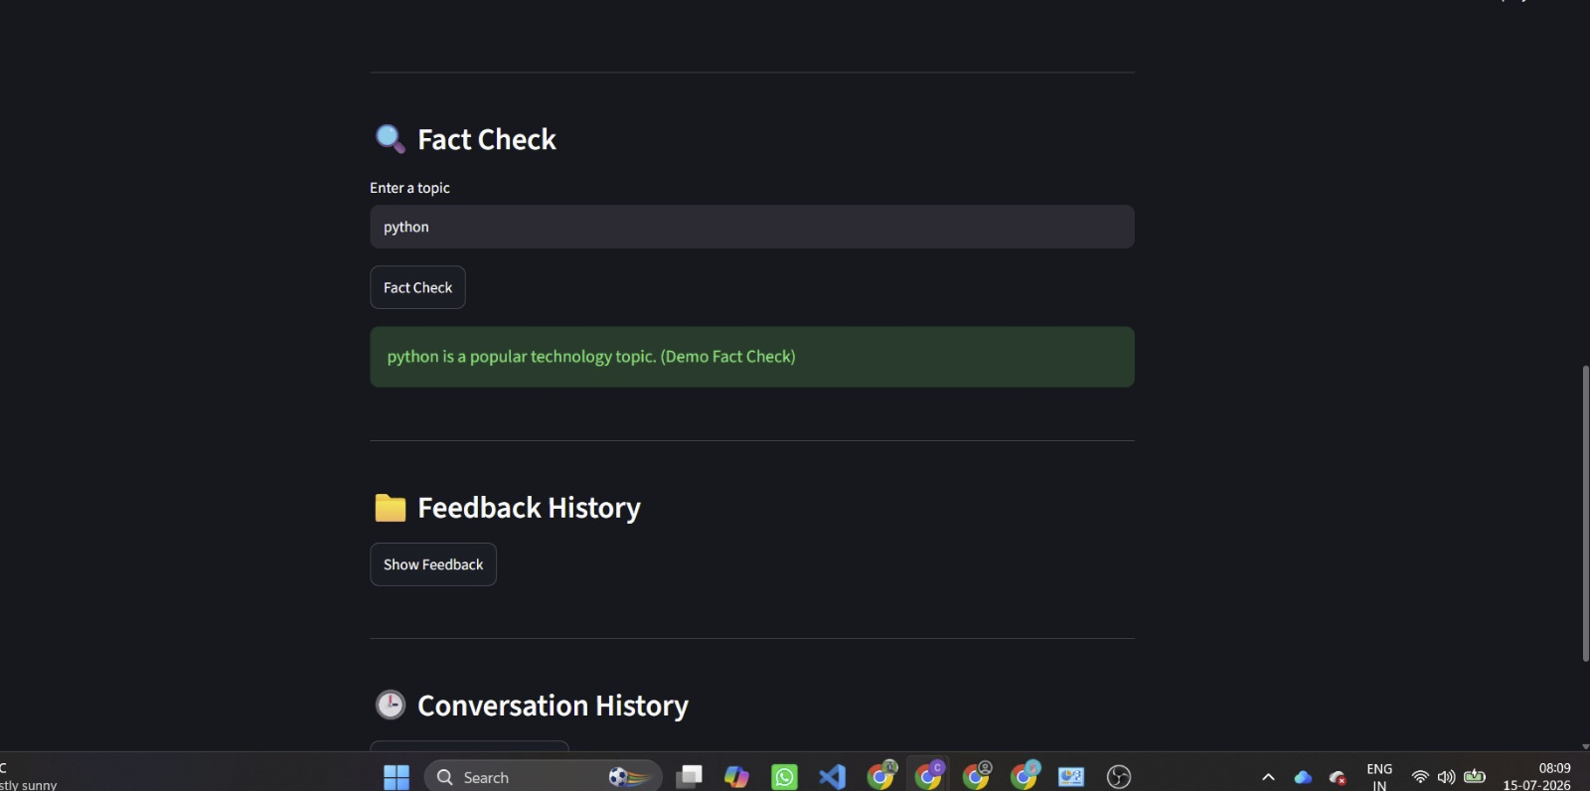

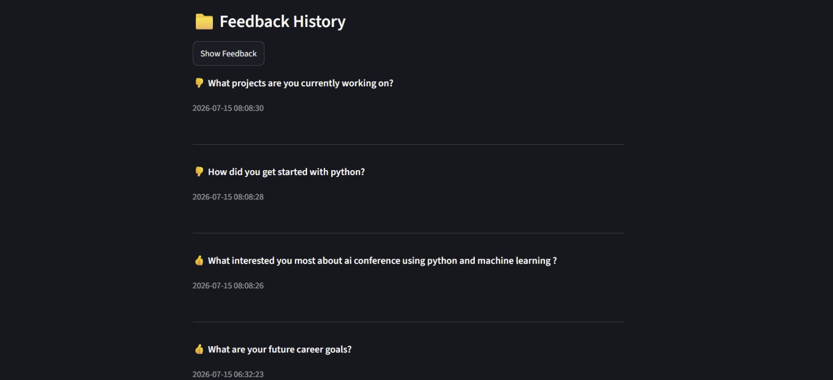

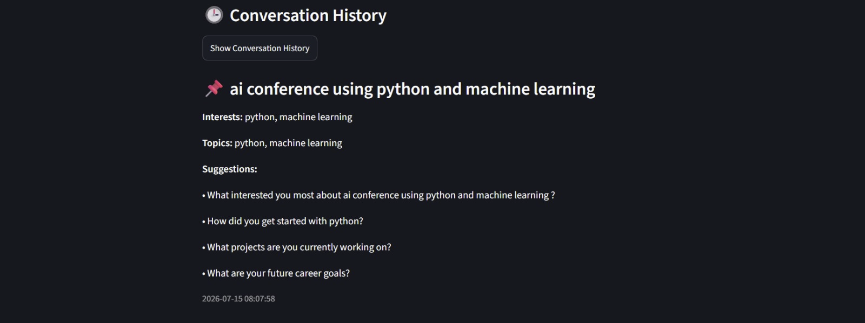

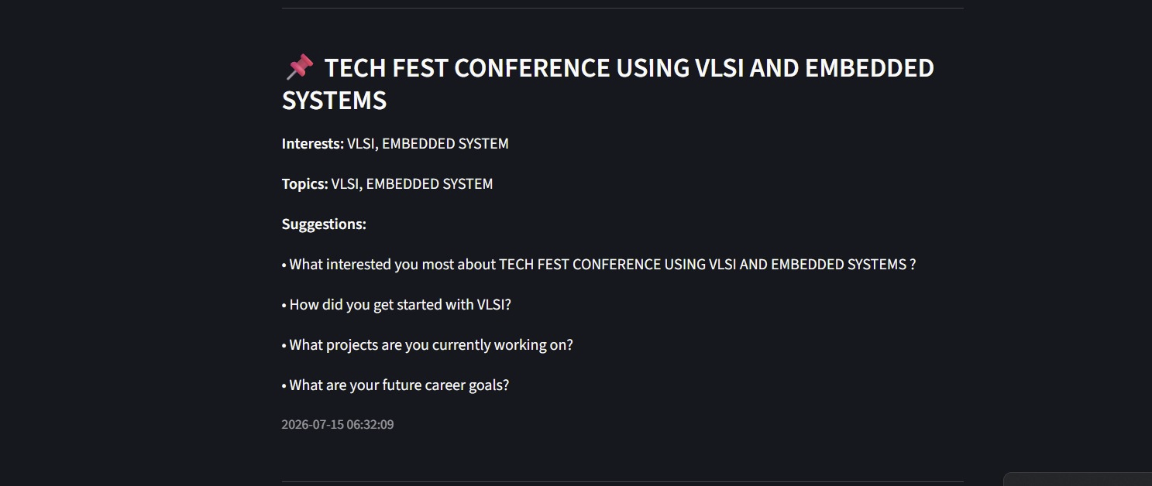
The output of the system consists of a ranked list of personalized conversation starters presented to the user through the Streamlit interface, along with an indication of which claims, if any, were verified against the Wikipedia API. Each generated session is stored in the history log, allowing users to revisit previous results.

8. ADVANTAGES & DISADVANTAGES

Advantages
- Generates conversation starters that are personalized to both the event context and individual user interests.
- Modular backend architecture supports maintainability and future extension of individual components.
- Fact verification reduces the likelihood of factually inaccurate content being presented to the user.
- Interactive web interface makes the system accessible without requiring technical expertise.
- History and feedback logging support continuous review and improvement of generated output.

Disadvantages
- Generation quality is dependent on the quality and specificity of the event description and interest input provided by the user.
- Fact verification is limited to information available through the Wikipedia API and may not cover all claims.
- Response time is influenced by the computational cost of the generative model.
- The current implementation is designed for single-user, small-scale usage rather than large-scale concurrent deployment.

9. CONCLUSION
The Personalized Networking Assistant demonstrates a practical application of Natural Language Processing and generative AI to a common social challenge faced during professional networking events. By combining theme extraction, personalized content generation, and fact verification within a modular backend architecture, the system produces conversation starters that are relevant to both the event context and the individual user's interests. The project confirms the feasibility of using lightweight, pretrained transformer models such as DistilBERT and GPT-2 in combination with a simple REST API architecture to deliver a responsive and useful interactive tool. The successful completion of functional and performance testing further validates the reliability of the implemented modules.

10. FUTURE SCOPE
- Support for multiple languages in both event description input and generated conversation starters.
- Integration of additional fact verification sources beyond the Wikipedia API for broader coverage.
- Replacement or fine-tuning of the generative model on domain-specific networking data to further improve relevance.
- Deployment of the backend to support multiple concurrent users with improved scalability.
- Addition of user accounts to allow long-term storage and retrieval of personalized history across sessions.
- Development of a mobile-friendly interface to allow users to access the system directly at event venues.

11. APPENDIX

Source Code
https://github.com/chakkasriram09-afk/Personalized-Networking-Assistant-Final

GitHub & Project Demo Link
GitHub Repository: https://github.com/chakkasriram09-afk
ProjectDemo: https://drive.google.com/file/d/1pNtHd2FUau8Tyy7bfK5cvOOkDrTIDpQg/view?usp=drivesdk

