Ideation Phase
Brainstorm & Idea Prioritization Template
Date | 15/07/2026
Team ID | SWTID-2026-3548
Project Name | Personalized Networking Assistant
Maximum Marks

Brainstorm & Idea Prioritization — Personalized Networking Assistant:
This record documents the ideation session held by the project team for the Personalized Networking Assistant, an AI-powered web application that generates personalized networking conversation starters from event descriptions and user interests. It follows a structured brainstorming and prioritization process: defining the problem, generating and grouping ideas, and prioritizing them by importance and feasibility.
The same three-step process used here can be reused for later ideation sessions on this project as new features or enhancements are considered.

Step-1: Team Gathering, Collaboration and Select the Problem Statement
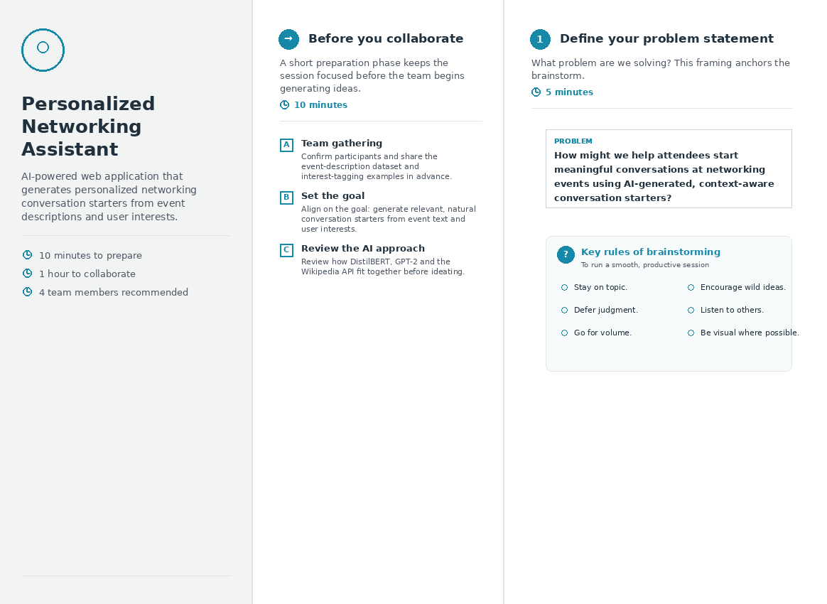
Step-2: Brainstorm, Idea Listing and Grouping
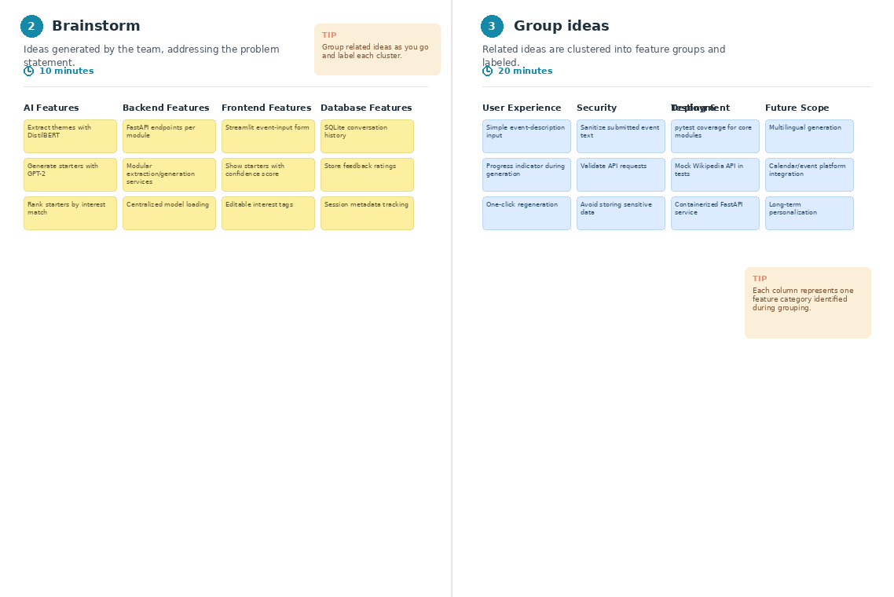
Step-3: Idea Prioritization
