Project Design Phase
Solution Architecture
Date | 15/07/2026
Team ID | SWTID-2026-3548
Project Name | Personalized Networking Assistant
Maximum Marks

Solution Architecture:
The solution architecture of the Personalized Networking Assistant defines how the user interface, backend services, AI processing modules, and data storage components work together to generate personalized, fact-verified networking conversation starters. It bridges the project's functional requirements with the technologies used to implement them, and its goals are to:
- Define the technical solution that fulfils the project's functional and non-functional requirements using the approved technology stack.
- Describe the structure, behavior, and interaction of the Streamlit frontend, FastAPI backend, AI processing layer, and SQLite database.
- Define the data flow from user input through theme extraction, fact verification, and conversation starter generation.
- Provide a specification against which the Personalized Networking Assistant is implemented and evaluated.
Architecture Diagram:
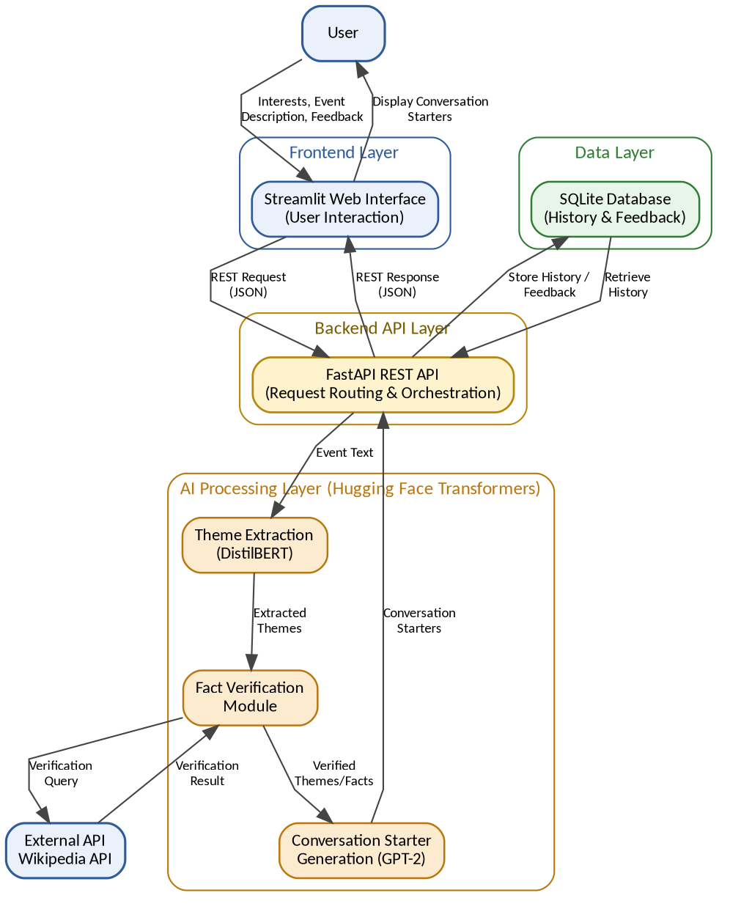
Figure 1: Solution Architecture and Data Flow of the Personalized Networking Assistant
Architecture Description:
The User Interface is implemented using Streamlit and allows the user to enter interests, event descriptions, and feedback, and to view generated conversation starters. All user requests are sent to the Backend API Layer, implemented with FastAPI, which orchestrates the processing workflow through REST endpoints.
Within the AI Processing Layer, the Theme Extraction module uses DistilBERT to identify key themes from the event description. Extracted themes are passed to the Fact Verification module, which queries the external Wikipedia API to confirm factual accuracy before the verified themes and facts are passed to the Conversation Generation module, which uses GPT-2 to produce personalized conversation starters.
The Data Layer, implemented using SQLite, stores conversation starter history and user feedback records. Generated conversation starters are returned through the FastAPI backend to the Streamlit interface, completing the user interaction flow.

