Project Design Phase-II
Technology Stack (Architecture & Stack)
Date | 15/07/2026
Team ID | SWTID-2026-3548
Project Name | Personalized Networking Assistant
Maximum Marks
Technical Architecture
The Personalized Networking Assistant follows a modular, layered architecture that separates the presentation layer, the backend processing layer, the artificial intelligence components, and the data storage layer. The application accepts an event description and a set of user interests through the web interface, processes this input through a series of natural language processing and generative AI modules, and returns a set of personalized, fact-checked conversation starters to the user. The architectural diagram below, along with Table 1 and Table 2, describes the components, their responsibilities, and the technologies used to implement each component.
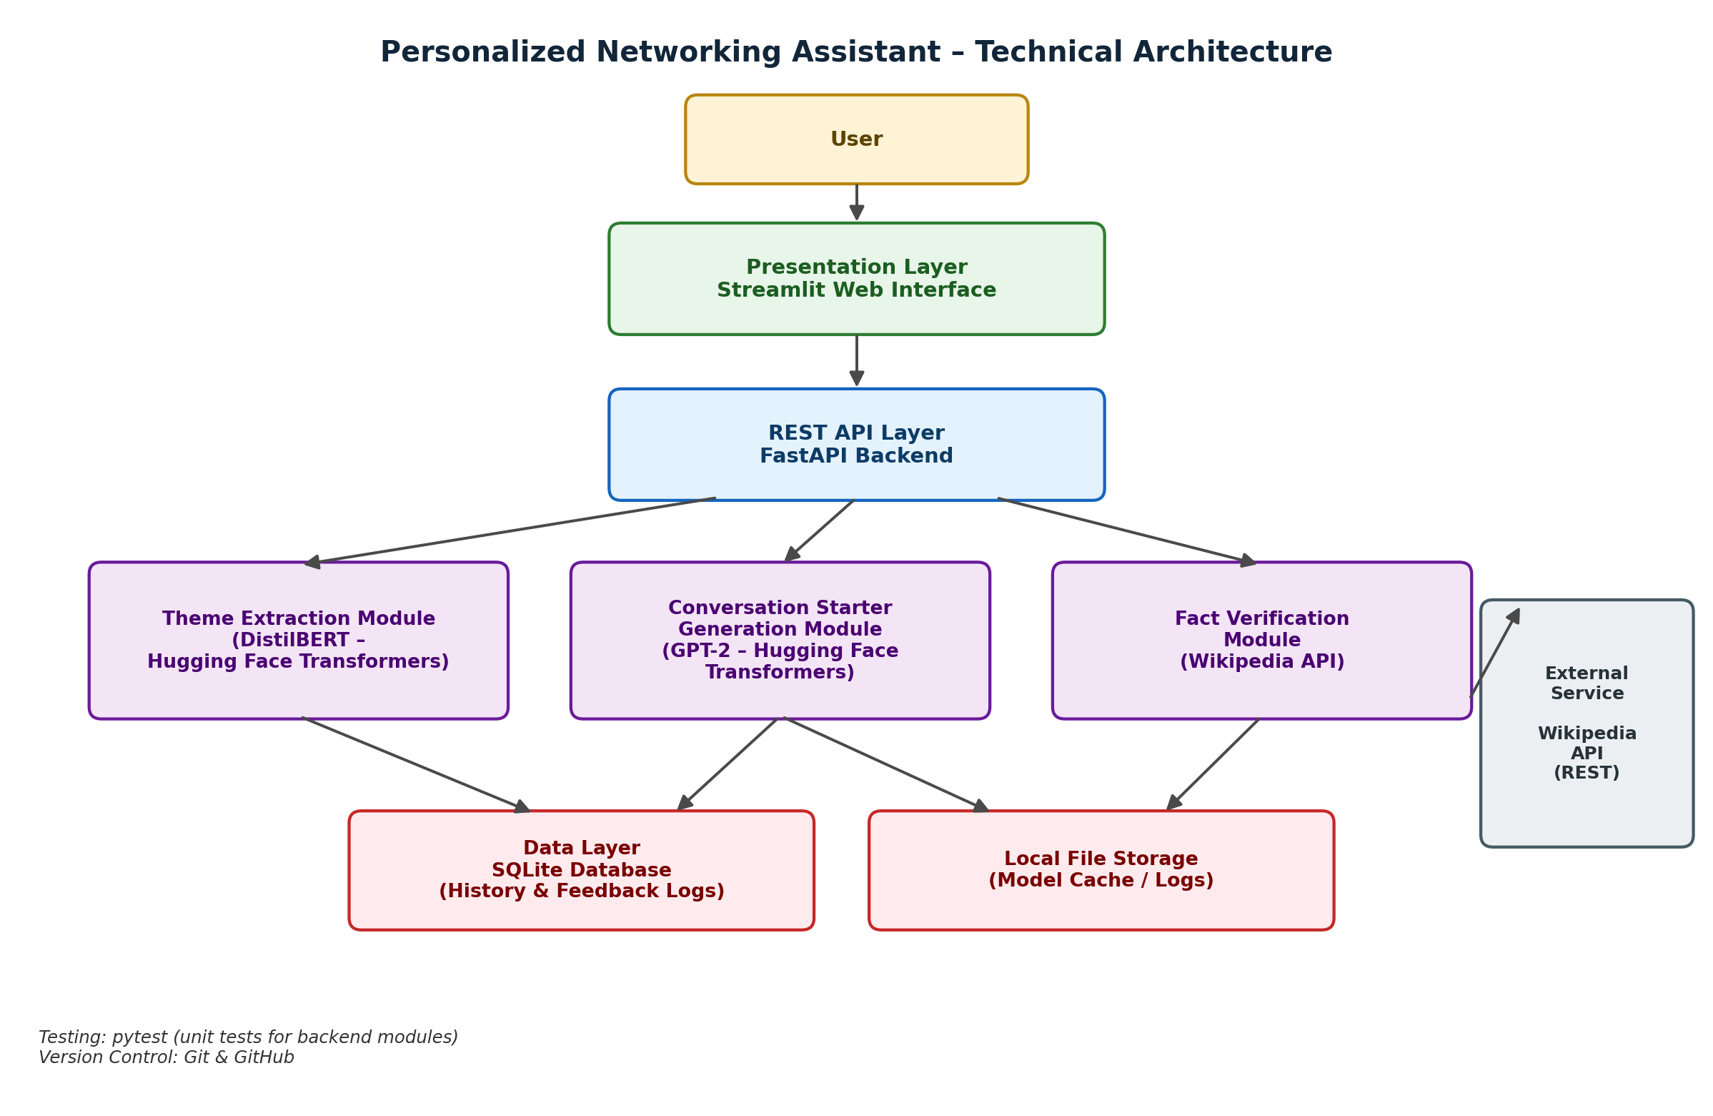
Figure 1: Technical Architecture of the Personalized Networking Assistant

Table 1: Components & Technologies
S.No | Component | Description | Technology
1. | User Interface | Interactive web interface where the user submits an event description and personal interests, and views generated conversation starters. | Streamlit
2. | Application Logic-1 (Theme Extraction) | Analyzes the event description to identify key themes and contextual topics used to guide conversation generation. | Python, Hugging Face Transformers (DistilBERT)
3. | Application Logic-2 (Conversation Starter Generation) | Generates personalized networking conversation starters using the extracted themes and the user's stated interests. | Python, Hugging Face Transformers (GPT-2)
4. | Application Logic-3 (Fact Verification) | Cross-checks factual references used in a generated conversation starter against an external knowledge source before it is returned to the user. | Python, Wikipedia API
5. | Backend / REST API Layer | Exposes the theme extraction, generation, and fact verification modules as REST endpoints and coordinates communication between the interface and the backend logic. | FastAPI, REST APIs
6. | Database | Stores conversation history logs and user feedback logs for later retrieval and review. | SQLite
7. | File Storage | Local storage of cached pre-trained model files and application log files. | Local Filesystem
8. | External API | Supplies factual reference content used by the Fact Verification module. | Wikipedia API
9. | Machine Learning / NLP Models | Pre-trained transformer models used for theme extraction and text generation respectively. | DistilBERT, GPT-2 (Hugging Face Transformers)
10. | Testing | Unit tests validate the correctness of individual backend modules, including theme extraction, generation, and fact verification. | pytest
11. | Infrastructure & Version Control | Application deployment and execution on a local server environment; source code versioning and collaboration. | Local Server (Uvicorn / Streamlit), Git & GitHub

Table 2: Application Characteristics
S.No | Characteristics | Description | Technology
1. | Open-Source Frameworks | The application is built entirely using open-source frameworks and libraries for the backend, frontend, and AI components. | FastAPI, Streamlit, Hugging Face Transformers, pytest
2. | Security Implementations | Request and response data exchanged between the interface and the backend is validated using typed data models before being processed by any module. | FastAPI request/response data validation
3. | Scalable Architecture | The backend is organized into independent modules for theme extraction, conversation generation, and fact verification, communicating through REST endpoints, which allows individual modules to be updated or scaled independently. | Modular REST API architecture (FastAPI)
4. | Availability | The REST API layer handles requests asynchronously, allowing the interface to remain responsive while backend modules process a request. | FastAPI asynchronous request handling
5. | Performance | A lightweight transformer model is used for theme extraction to reduce inference time, and loaded models are kept in memory for the duration of the application session to avoid repeated load overhead. | DistilBERT (lightweight transformer), in-memory model caching
6. | Maintainability | Unit tests cover the core backend modules, enabling changes to be verified quickly and reducing regression risk during development. | pytest, Git & GitHub
References
- FastAPI Documentation
- Streamlit Documentation
- Hugging Face Transformers Documentation
- SQLite Documentation
- Wikipedia API Documentation

