62318648859

6074310205697973

280

11/2024

9079

poorna99122poorna

Poorna@99122

50100388372653

4160211516822617

Cvc - 251

10/25

0598

Customer ID - 157129321

Net Banking- Amma@1357

Mobile app -  Amma@1357

Credit

4632020005741281

Cvv -675

04/25

9079

Forex -

4766433008652751

Poorna@1357

System pass -

Poorna@99122 - System

9912299122 - Bitlocker

Poorna@99122 - D Drive

DB  ID pass (Oracle) -

system

Manager

DB user

User : course

Pass : course

—--

Unmail pass reset question

1.Fav Movie - bahubali

Github

userId - poorna99122

Pass - Poorna@99122

Oracle 11g

UserId -

Pass - admin

My HP laptop -

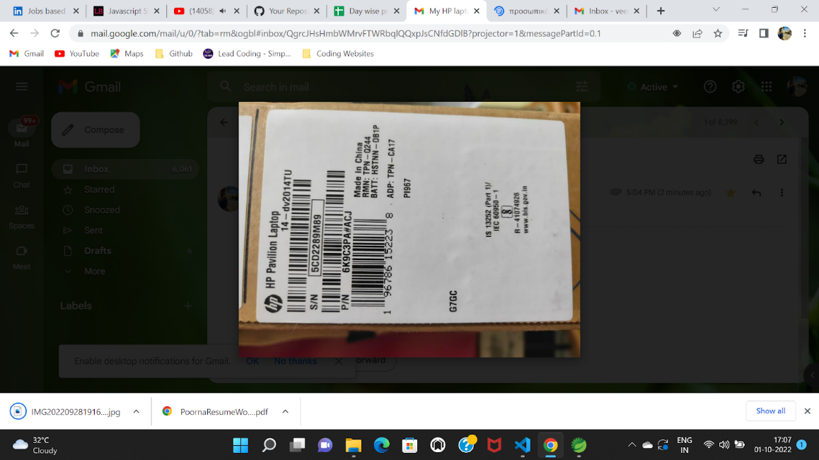

HP Upgrade for extended warranty

