A Multi-Task Deep Learning Framework for Plant Disease Classification and Weed Detection

Parvathy Vinod, V. V. N. S. Poorna Chandrika, M. Chandralekha, and Rahul Raj M
Department of Computer Science and Engineering,
Amrita School of Computing, Amrita Vishwa Vidyapeetham, Chennai, India vinodparvathy1144@gmail.com, chandrikavvns31@gmail.com, mchandralekha@ch.amrita.edu, mrahulraj@ch.amrita.edu

Abstract. The early identification of plant diseases and weeds is impor- tant to increase crop health, improve agricultural production, and reduce the overuse of pesticides. The traditional method of performing manual inspection on crops is difficult and labor-intensive and not practical for monitoring agriculture on a large scale. The development of automated analysis through advances in deep learning and computer vision technol- ogy allows for an effective alternative to traditional methods. This study proposes an integrated deep learning framework that provides multi-task capabilities for both plant disease classification and weed detection, al- lowing the simultaneous execution of both functions through the use of a single agricultural vision technology. The proposed method uses sepa- rate but compatible deep learning models for recognizing plant disease and localizing weeds, using a common inference pipeline.Classification of plant diseases is carried out using the PlantVillage dataset,while using weed detection is practiced using a publicly available annotated weed de- tection dataset sourced from Kaggle. Experimental outcomes show that the proposed multi-task learning framework is effective in delivering high accuracy for plant disease classification and accurate weed localization, thus supporting the potential for using the framework for scalable and practical applications within the field of precision agriculture.

Keywords: Weed detection· Plant disease classification · Router Based Multi-task learning· Deep learning· Computer vision· Precision agricul- ture

Introduction

Agriculture serves as the backbone of the world’s food supply and represents a tremendous opportunity for growth; however, it faces a number of challenges in- cluding those posed by herbicide-resistant (HR) weeds and plant diseases, which decrease crop quality, decrease yields, and lower profits. Plants are attacked by plant diseases, whereas HR weeds use the water, nutrients and sunlight nec- essary for crops to grow. Crop loss due to plant disease leads to significant

economic damage for farmers. For many years, farmers have primarily used vi- sual inspection for the identification of plant diseases and weeds. This practice is labor-intensive, time-intensive, and involves human error.
Computer vision and deep learning technologies have recently advanced to allow automated assessment of crops using image analysis methods. These new technologies can provide a more reliable and efficient means of assessing crop health than conventional methods. Convolutional neural networks (CNNs) have been used extensively in the classification of plant diseases, and models based on object detection have been developed for the identification of HR weeds. However, most current methods treat plant disease and HR weed identification as separate tasks that require independent models and inference pipelines. This results in increased computational resources, increased complexity of systems, and restrictions on the scalability of these systems for large-scale agricultural use.
In order to overcome these limitations, the authors of this study suggest a multi-task inference model to perform plant disease classification and weed de- tection at the same time within one single framework. By doing so, the new framework enables both functions to benefit from common features, however, they are tuned differently according to their needs which results in fewer re- peated calculations and enhanced overall model efficiency. The functionality of the framework was tested on publicly available benchmark datasets (PlantVil- lage dataset for plant disease classification and Kaggle Weed detection dataset for weed detection). The findings indicated that weed localization and plant disease classification were both accurately determined, and thus confirmed the framework’s potential to be a scalable and extensible solution for integrated applications in Agricultural Vision.

Literature Review
With the capacity of automatically learning discriminative visual features from plant imaging, deep learning has become the leading method for the analysis of plant diseases and weeds. Recent research has shown transfer learning to be a powerful technique for maximizing disease classification accuracy, especially when the number of labeled datasets is small. Hemalatha et al. [1] and Ali et al. [2] reported that the fine-tuned convolutional and transformer-based models always have better performance than the traditional machine learning methods. Moreover, review studies conducted by Sajitha et al. [3] and Isinkaye et al. [4] further validated the fact that deep learning is more effective than handcrafted feature-based techniques for diagnosing plant diseases.
Recent studies from 2024 to 2025 have emphasized robustness and repre- sentation learning for plant disease images in classification models. Ashurov et al. [5] improved disease recognition by considering delicate color and texture in- formation. Xu et al. [6] confirmed that attention-driven deep learning can boost disease image recognition accuracy for difficult visual conditions. Sekar et al. [7] proposed that attention-driven CNN networks facilitate disease image recogni-

tion for visually complex disease categories. The method substantially dimin- ished misclassifications in various lighting conditions and complex backgrounds. There has also been growing interest in the efficiency and deployability of the models. Nnamdi et al. suggested a light MobileNet architecture adequate for real-time deployment [8]. Duhan et al. developed an optimized deep architec- ture for fast inference [9]. Kheir et al. showed the applicability of deep-learning technology for plant disease diagnosis in web applications [10].
Studies on analysis of the weeds have also developed at a significant pace utilizing agricultural images at the ground level. Goyal et al. [11] worked on the detection of weeds in fully occluded crop fields using deep detectors. Deng et al. [12] proposed a semi-supervised learning approach for minimizing the an- notation burden regarding the classification of weeds. Pai et al. [13] used deep segmentation networks for effective separation of crops and weeds.
Recently, scalable learning and multi-task learning strategies for ag farm vi- sions have gained prominence in recent works. Fu et al. [14] presented a joint learning framework where different ag tasks can be learned collectively with com- mon features. Diallo et al. [15] presented the Enhanced-RICAP data augmenta- tion approach to improve generalization capacity over different crops. Bouacida et al. [16] investigated cross-crop deep learning methods to improve resilience over other plant species. The following contributions made significant progress towards agricultural vision research. Elfouly et al. [17] presented a multi-scale deep learning approach for better plant disease identification. Sonawane [18] worked on weed classification using deep learning techniques for real-life field images. Balafas et al. [19] presented efficient weed identification even for com- plex crop backgrounds. Zhao [20] presented a detailed survey of deep learning methods for plant leaf disease identification. Song et al. [21] presented an effec- tive vision transformer model for plant disease identification. Rahman et al. [22] designed a real-time plant disease monitoring system using deep learning con- cepts.
Finally, recent reviews and applied studies highlight the growing need for unified and efficient agricultural vision systems. Kebede et al. [23] optimized deep learning models for deployment on embedded platforms. Shoaib et al. [24] emphasized the importance of integrated disease and pest analysis using deep learning. Fu et al. [25] concluded that unified multi-task learning frameworks re- duce computational redundancy while maintaining high accuracy, making them well suited for next-generation intelligent agricultural applications.

Methodology

Plant Disease Classification
The classification of plant disease was carried out with the help of the PlantVil- lage dataset, which contains images of healthy and diseased plant leaves, with each class having a specific crop-disease combination. The dataset was divided into the training, validation, and test sets with a ratio of 80:10:10 for fair evalua- tion. All the images were resized to a size of 224 x 224 and then augmented with

the help of horizontal flip and rotation for better generalization. The validation and test sets were not augmented. The pre-trained MobileNetV3-Large model has been utilized for transfer learning, and the fully connected layer has been changed according to the number of disease classes. The model was trained for 30 epochs, and categorical cross-entropy loss, along with the Adam optimizer and a learning rate of 0.0005, a batch size of 32, was used to train the model. Checkpointing of the model was used to save the weights of the model corre- sponding to the lowest validation loss. To evaluate the performance of the model, accuracy, precision, recall, F1-score, and a confusion matrix were used. During the inference of the model, a softmax output layer was used to make predictions.

Weed Detection
The detection of weeds has been achieved by utilizing a Kaggle dataset for Weed Detection, which contains images of agricultural fields with bounding box anno- tations for various types of weeds. The bounding box annotation provides infor- mation about the location and class label for each image. The dataset has been divided into training, validation, and test sets for the correct evaluation of object detection models. All images have been resized to a resolution of 640×640 pixels, which is necessary for the YOLOv5 model. The annotation has also been trans- formed into YOLO format with normalized bounding box coordinates. Random rotation and brightness changes have been applied for data augmentation.
The YOLOv5s model was utilized for the purpose of detecting weeds. This model has a backbone based on CSP, a neck based on PANet, and a head for the purpose of detection. This model has been trained for 30 epochs with the help of a composite loss function that consists of bounding box regression, objectness, and classification losses. Mixed precision has been utilized for the purpose of training the model on the GPU.In the case of this model, bounding boxes are generated for the detected weeds.

Router-Based Multi-Task Framework
In the proposal, we have used modular router based framework rather than a multi-task shared backbone architecture. The models for disease classification and weed detection are trained as independent models and both models use a routing scheme for integration during inference. The modular router based de- sign allows for stable, task specific optimization and enables agricultural vision analysis through one common pipeline. The proposed agricultural vision frame- work performs plant disease classification and weed detection within a unified inference pipeline. The system processes input images through a two-step process which begins with image resizing to 224 × 224 and subsequent normalisation be- fore passing the image to a binary routing network built on EfficientNet-B0. The router classifies the image as either a plant leaf image or a weed scene and for- wards it to the appropriate task-specific model. The system uses an EfficientNet- B0 based plant disease classification model to process images which the system

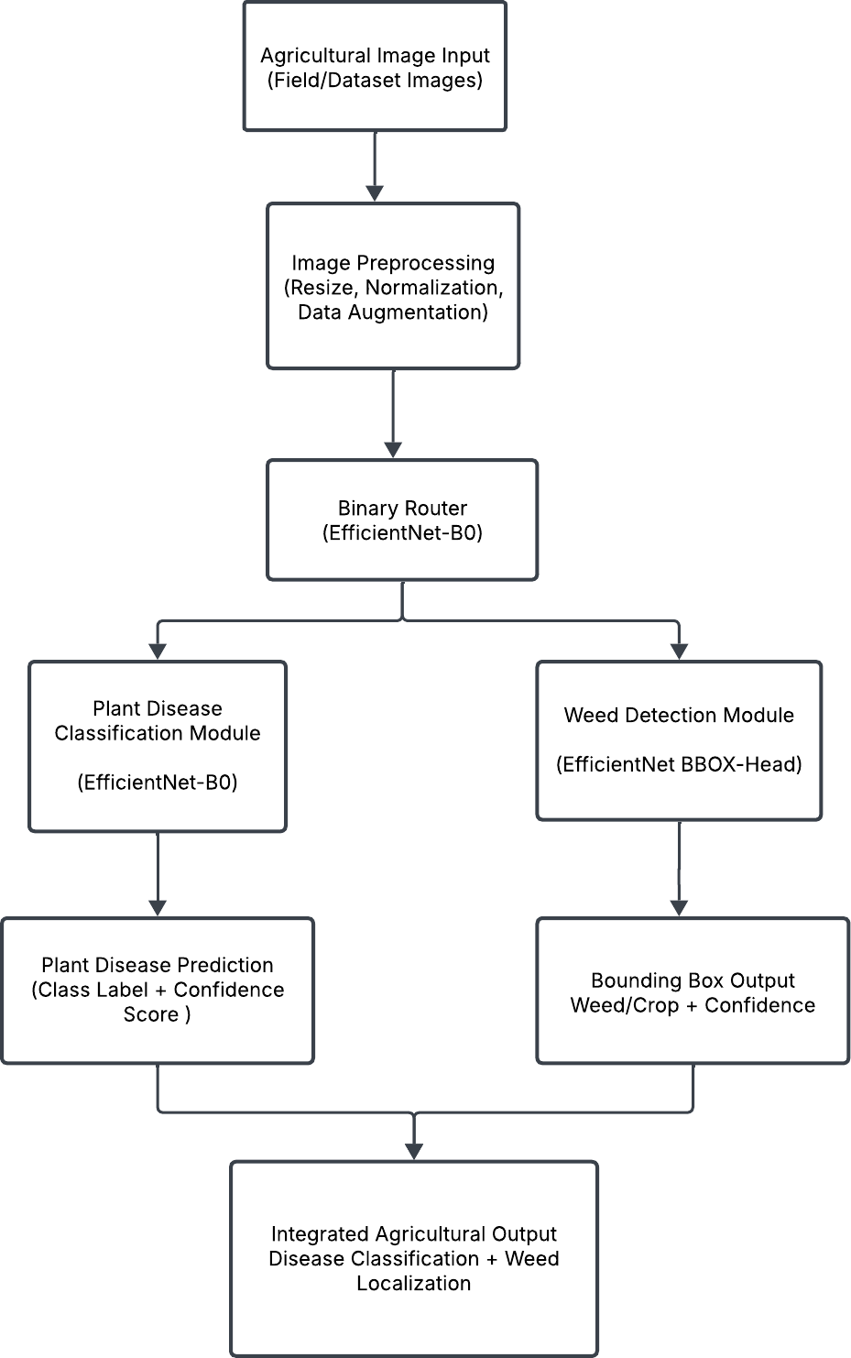

Fig. 1: System-level architecture of the proposed router-based multi-task agri- cultural framework.

identifies as plant leaf images. The classifier predicts one of 15 disease cate- gories using a softmax activation function. The system forwards images which the system identifies as weed content to a weed detection model which uses an EfficientNet-B0 backbone with a regression head to predict normalized bounding box coordinates (x, y, w, h). These coordinates are rescaled to the original image dimensions for visualization and localization of weed regions. The router, plant classifier, and weed detector were trained independently using their respective datasets. The router used binary cross-entropy loss for its optimization process while the plant classifier used sparse categorical cross-entropy loss and the weed detector employed mean squared error loss for bounding box regression. The training process maintains independent operation because it results in both con- sistent model development and protection against gradient conflicts which occur between classification tasks and regression tasks. The design based on routers allows for separate optimization processes while keeping a single system for infer- ence operations. The framework decreases task conflicts between different tasks while enabling expansion to new agricultural vision tasks and delivering a prac- tical system which can be used in actual operational environments.

Results and Discussion

Single-Task Baseline Evaluation

Plant Disease Classification The PlantVillage dataset served as the initial evaluation dataset to assess the plant disease classifier performance for estab- lishing a solid baseline dedicated to single-task evaluation. The model achieved an overall classification accuracy of 99% while maintaining high precision and recall and F1 scores across the majority of disease categories.(Table 1).
The qualitative results shown in Fig. 2c demonstrate accurate discrimination between healthy and diseased tomato leaves. The model successfully captures subtle visual variations between discoloration patterns and lesion shapes and texture differences. The plant pathology classification system faces difficulties because inter-class similarity makes it challenging to distinguish between visu- ally similar disease classes which affected the system’s performance for tomato diseases that are closely related.
The PlantVillage dataset consists of images taken in a controlled environment with clean backgrounds. Thus the problem of classifying those images by plant species was very easy and simple. In the future, data collected from live crops in fields would be used to evaluate how well the framework can predict and classify crop diseases and other pests in field-based datasets.

Weed Detection The weed detection module underwent testing through inde- pendent assessments which used marked field photographs. The model achieved weed area detection by utilizing bounding box predictions which operated suc- cessfully across different agricultural environments, as shown in Fig. 3.

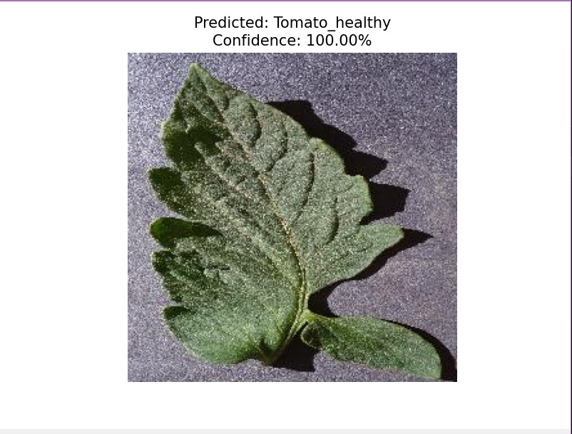
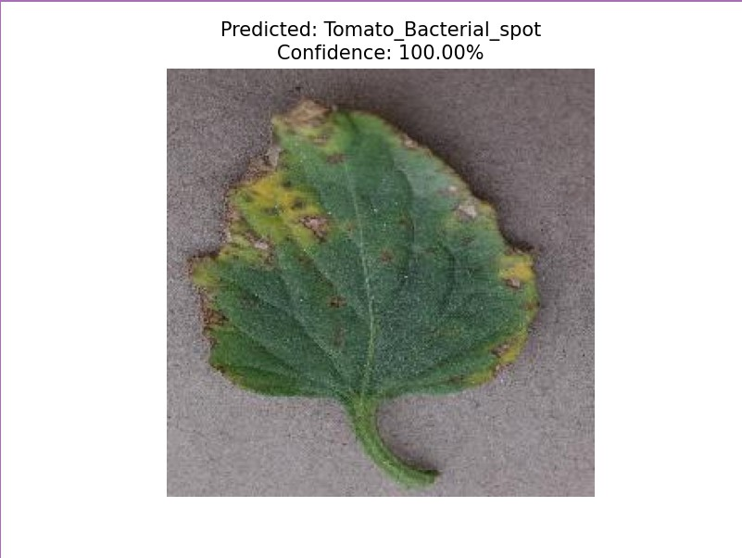
    - Healthy tomato leaf
    - Tomato leaf with bacterial spot
    - Qualitative outputs of the plant disease classification module.

Table 1: Classification report for plant disease classification on the PlantVillage test set
Class Precision Recall F1-score Support
Pepper bell Bacterial spot | 1.00 | 1.00 | 1.00 | 101
Pepper bell healthy | 1.00 | 1.00 | 1.00 | 149
Potato Early blight | 1.00 | 1.00 | 1.00 | 100
Potato Late blight | 1.00 | 1.00 | 1.00 | 109
Potato healthy | 1.00 | 1.00 | 1.00 | 16
Tomato Bacterial spot | 1.00 | 1.00 | 1.00 | 214
Tomato Early blight | 0.99 | 0.95 | 0.97 | 100
Tomato Late blight | 0.99 | 0.99 | 0.99 | 192
Tomato Leaf Mold | 1.00 | 1.00 | 1.00 | 96
Tomato Septoria leaf spot | 0.99 | 1.00 | 0.99 | 178
Tomato Spider mites | 0.99 | 0.99 | 0.99 | 169
Tomato Target Spot | 0.97 | 0.99 | 0.98 | 141
Tomato Yellow Leaf Curl Virus | 0.99 | 1.00 | 1.00 | 322
Tomato Mosaic Virus | 1.00 | 1.00 | 1.00 | 38
Tomato healthy | 1.00 | 1.00 | 1.00 | 150
Accuracy |  |  | 0.99 | 2076
Macro Avg | 1.00 | 0.99 | 0.99 | 2076
Weighted Avg 0.99 0.99 0.99 2076

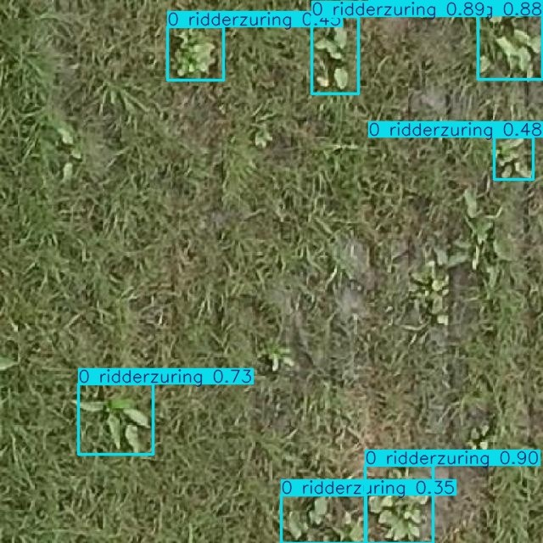
Fig. 3: Qualitative weed detection results with predicted bounding boxes.

The detector maintained its ability to function correctly despite changes in environmental conditions which included different soil textures and crop patterns and various light conditions. The system maintained precise spatial detection abilities when handling extremely small and partially hidden weed types despite showing lower confidence ratings. The finding demonstrates that the regression- based detection model achieved its goal by learning spatial features which help in real-world agricultural usage.Together, these baseline results confirm that both single-task models provide reliable performance prior to integration.

Router-Based Multi-Task Framework Evaluation

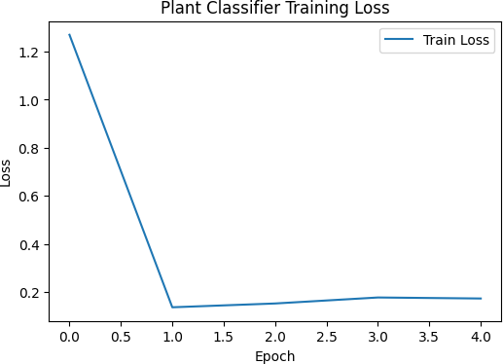

Fig. 4: Plant classifier training loss.

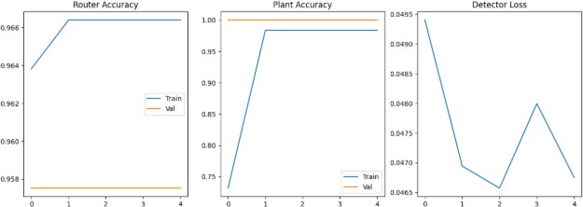

Fig. 5: Training curves showing router accuracy, plant accuracy, and detector loss.
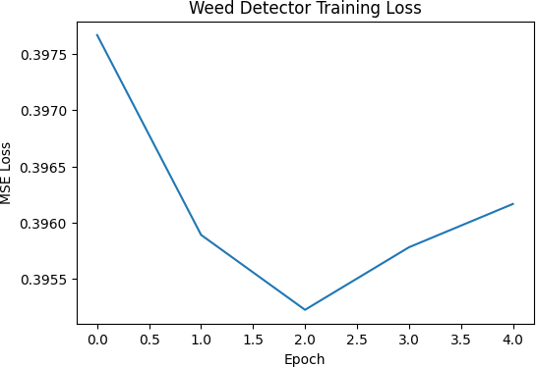

Fig. 6: Weed detector training loss.

Training Performance The training curves show that all components of the proposed framework achieve stable convergence. The plant classifier demon- strates effective transfer learning through its ability to achieve quick loss re- duction during the initial epochs of training. The router model maintains high accuracy in binary classification which enables it to accurately differentiate be- tween plant leaf images and weed scenes.
The weed detector shows continuous progress in bounding box localization through its steady reduction of regression loss which occurs at a slow and con- sistent pace. The training process maintained stability throughout because inde- pendent task optimization successfully prevented any training disruptions. Mod- ular training produces results which demonstrate that it maintains optimization efficiency while enabling models to reach their target performance through their dedicated objective functions.

Integrated Inference Results After validating the individual models, they were integrated into the router-based multi-task framework. The routing mecha- nism uses dynamic processes to send each input image to the correct task-specific module which operates within a single inference pipeline. The disease classifier and weed detector relied on two datasets that were collected independently and under different imaging conditions. The PlantVillage dataset was composed of close-up images of leaves while the weed dataset was made up of images taken

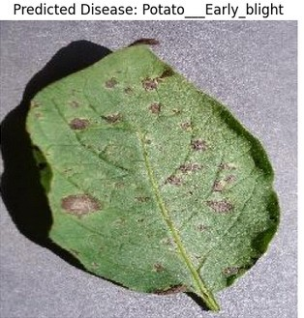
    - Plant classification output
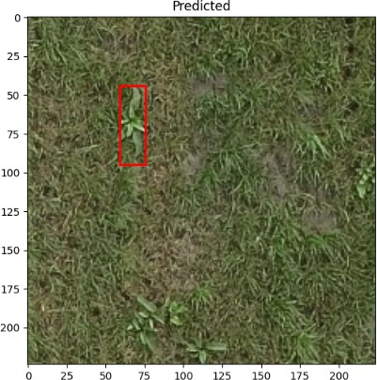

    - Weed detection output
    - Outputs of the proposed router-based multi-task framework.

from a distance in real agricultural fields. Future work will merge these two datasets and define a single set of disease and weed annotations to allow for a more complete evaluation of the models. The qualitative results presented in Fig. 7c demonstrate that the combined system performs accurate classifi- cation and detection tasks. The study found that all single-task performance metrics remained unchanged after the system integration. The study found that no reduction occurred in disease classification confidence or weed localization accuracy. The proposed framework decreases unnecessary computations which emerge from running two separate inference systems while it maintains its ability to optimize specific tasks. The system design allows all components to receive independent updates which do not disrupt the system’s overall performance.

The experimental results show that the router-based architecture successfully integrates plant disease classification with weed detection to create an expand- able agricultural vision system.

Conclusion

The research study introduced a deep learning system which uses routers as its framework to identify plant diseases and detect weeds through multiple con- current tasks. The proposed framework unifies agricultural vision tasks into one system which simultaneously operates both tasks through its flexible de- sign for system optimization. The plant disease classification module, trained on the PlantVillage dataset, achieved high accuracy across 15 disease categories, demonstrating strong discriminative capability for visually similar disease pat- terns. The weed detection module, trained using annotated field images, success- fully localized weed regions under varying background and lighting conditions.
The binary routing network creates two pathways which enable dynamic task assignment through image content analysis because it matches each input with its designated specialized model. The experiments demonstrate that unified model integration into one inference system maintains all task performance at their original levels. The system eliminates unnecessary processing tasks, which results in better deployment performance. The developed system proves its ca- pability to assess plant health while accurately tracking weeds throughout one expandable system. The system enables separate task improvement through its modular structure, which also provides complete agricultural monitoring to meet precision agriculture needs.

Future Scope
The router-based system currently provides effective results for plant disease identification and weed identification but needs further development for future enhancements. The proposed framework aims to evolve into a comprehensive end-to-end multi-task architecture that shares core representations while re- taining task-specific components where necessary. The system allows users to decrease computing needs while sharing resources from multiple tasks to work on both classification and detection. The researchers plan to study advanced multi-task optimization methods which use weighted loss balancing techniques together with uncertainty-based loss scaling approaches.6. Results suggest pos- itive use of this framework; however, there are limitations. For example, the PlantVillage dataset was created in controlled environments, which does not exactly replicate the conditions of the real world and the weed detector has po- tential challenges including weed size or not being able to see the weed due to something else blocking it. Future studies will continue to explore this area using shared multi-task frameworks and environmental datasets to improve reliability and features shared between tasks. Future research will expand its scope to

include extra agricultural vision tasks which require researchers to estimate dis- ease severity and detect pests and analyze nutrient deficiencies and predict crop growth stages. The system will enable users to track developments through time by using sequential field image data which will allow them to identify early-stage anomalies.
The framework needs testing on multiple authentic datasets which use dif- ferent environmental conditions that include various lighting situations and oc- clusion levels and different crop types. The use of domain adaptation techniques will improve system performance through better adaptation to different geo- graphical locations.The framework needs model compression and quantization and lightweight backbones to achieve optimal performance for edge deployment which will enable real-time monitoring through drones and mobile devices and embedded agricultural systems. The proposed system will become more suitable for large-scale precision farming environments because of these technological ad- vancements.

References

- Hemalatha, S., Karthikeyan, R., Srinivasan, P.: Multitask deep learning frame- work for plant disease classification and localization. Computers and Electronics in Agriculture 215, 108460 (2024)
- Ali, A., Ahmad, M., Hassan, S.: Optimized convolutional neural networks for plant disease classification under class imbalance. Expert Systems with Applications 236, 121312 (2024)
- Sajitha, P., Kumar, S.S., Suresh, R.: A comprehensive review on deep learning- based plant disease detection. Journal of Industrial Information Integration 36, 100531 (2024)
- Isinkaye, F.O., Fadipe, O.J., Adebayo, B.T.: Deep learning techniques for plant disease identification and treatment recommendation. Heliyon 10(2), e24961 (2024)
- Ashurov, A.Y., Kim, D.R., Lee, J.: Enhancing plant disease recognition through texture-aware deep feature extraction. Frontiers in Plant Science 16, 1293841 (2025)
- Xu, L., Zhang, Y., Wang, H.: Attention-guided deep learning model for accurate plant leaf disease classification. Frontiers in Plant Science 16, 1289273 (2025)
- Sekar, V., Anand, R., Balaji, K.: Attention-based convolutional neural networks for robust plant disease detection. Frontiers in Artificial Intelligence 8, 1350281 (2025)
- Nnamdi, U.V., Adebayo, M.O., Oladipo, T.: Lightweight MobileNet-based model for plant disease classification. Scientific Reports 15(1), 2841 (2025)
- Duhan, S., Malik, R., Verma, P.: An efficient deep learning model for real-time plant disease classification. Procedia Computer Science 232, 1187–1196 (2025)
- Kheir, A.M.S., El-Shafai, A., Tolba, M.F.: Web-based plant disease diagnosis using deep learning. Sustainable Computing: Informatics and Systems 41, 100912 (2025)
- Goyal, R., Jain, S., Singh, M.: Deep learning-based weed detection in highly oc- cluded crop environments. Crop Protection 176, 106451 (2025)
- Deng, B., Liu, J., Chen, Y.: Semi-supervised deep learning for weed classification in agricultural fields. Sensors 25(3), 1245 (2025)

- Pai, D.G., Rao, P.S., Nayak, R.: Deep learning-based crop and weed segmentation in complex field conditions. Scientific Reports 15(1), 7329 (2025)
- Fu, R., Li, X., Wang, Z.: Multi-task joint learning framework for plant disease analysis. Frontiers in Plant Science 16, 1301124 (2025)
- Diallo, M.B., Kouadio, K., Traore, A.: Enhanced-RICAP: A data augmentation strategy for plant image classification. Frontiers in Plant Science 16, 1287749 (2025)
- Bouacida, I., Amara, M., Boussaid, L.: Cross-crop deep learning for generalized plant disease detection. Computers and Electronics in Agriculture 218, 108604 (2025)
- Elfouly, M.K., ElSayed, A., Elsharkawy, H.: Multi-scale deep learning framework for plant disease detection. Journal of Big Data 12(1), 44 (2025)
- Sonawane, S.: Deep learning-based weed classification in field imagery. Indian Jour- nal of Weed Science 56(1), 23–30 (2024)
- Balafas, M., Tzotsos, E., Daras, P.: Weed recognition using deep learning under complex crop backgrounds. Frontiers in Plant Science 15, 1249213 (2024)
- Zhao, J.: A review of deep learning-based plant leaf disease identification. Frontiers in Plant Science 16, 1290045 (2025)
- Song, H., Chen, L., Liu, Y.: Efficient vision transformer for plant disease classifi- cation. Frontiers in Plant Science 16, 1305561 (2025)
- Rahman, M.K., Islam, A., Hossain, S.: Real-time plant disease monitoring system using deep learning. Computers and Electronics in Agriculture 217, 108540 (2025)
- Kebede, T., Bekele, A., Tadesse, Y.: Embedded deep learning models for smart agriculture applications. IEEE Access 13, 42310–42322 (2025)
- Shoaib, M., Riaz, F., Ullah, S.: Integrated deep learning framework for plant disease and pest analysis. Frontiers in Plant Science 16, 1298832 (2025)
- Fu, R., Zhou, Y., Sun, J.: Unified multi-task learning architectures for intelligent agricultural systems. IEEE Access 13, 59872–59884 (2025)

