Parkinson’s Disease Prediction using Machine Learning

In this project we are designing Advanced Convolution Neural Network based Machine Learning algorithm model to predict Parkinson disease from both Image and voice data. All existing ML algorithms such as SVM, Random Forest will not filter data multiple times so its prediction accuracy is less so we have used CNN algorithm which filter data multiple times using NEURON values so its prediction accuracy can be better.

To train CNN we have used WAVE and SINE images of normal and Parkinson disease patients and for voice we have used UCI Parkinson recorded voice and this dataset can be downloaded from below URL.

<https://archive.ics.uci.edu/ml/machine-learning-databases/00489/>

Below screen showing images used in this project to train CNN model

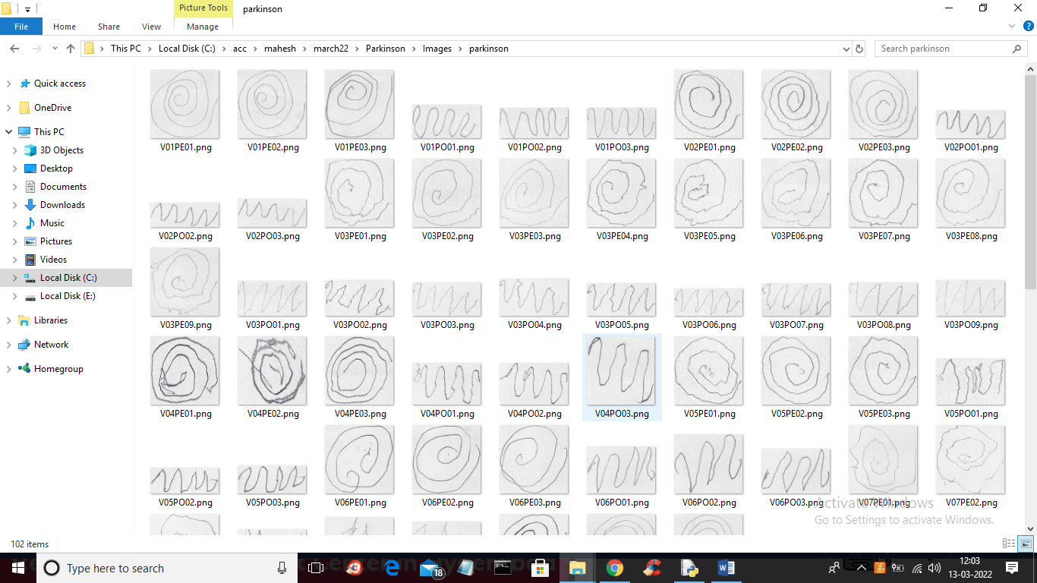

In above screen we have both wave and sine images and in below screen we can see voice data samples taken from different patients

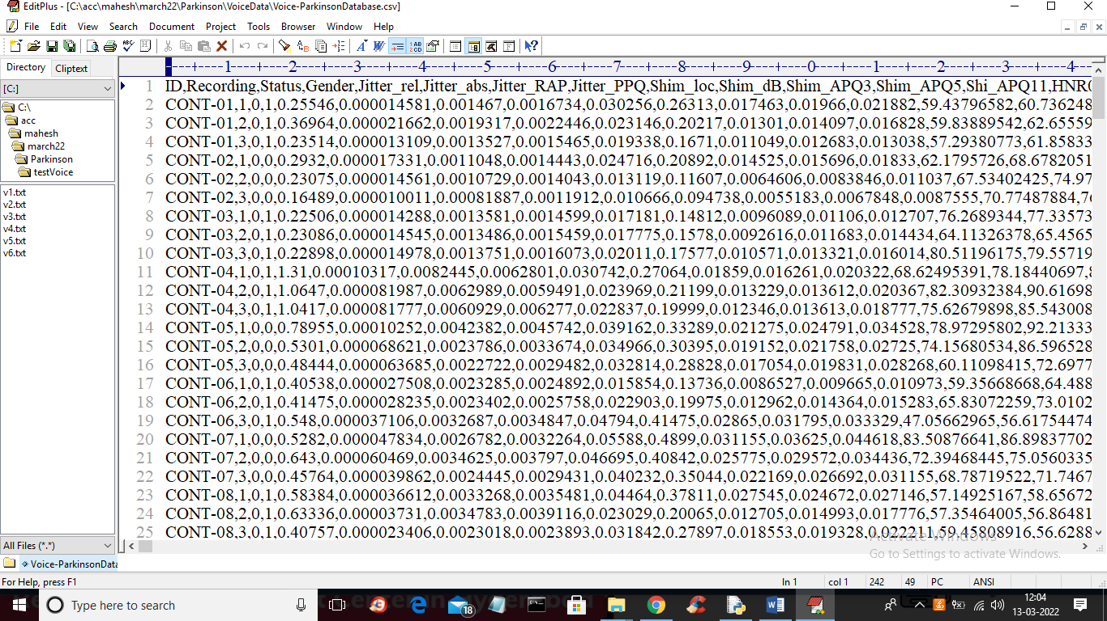

In above screen first row contains dataset column names and remaining are the dataset values. We trained CNN by using above datasets.

SCREEN SHOTS

To run project double click on ‘run.bat’ file to get below screen

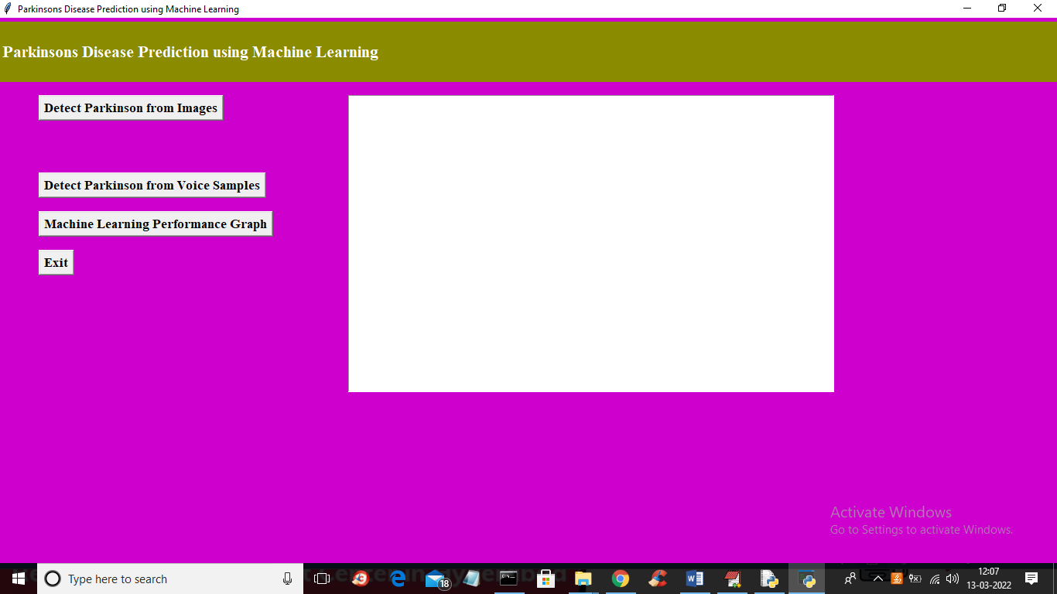

In above screen click on ‘Detect Parkinson from Images’ button to upload images and to get below screen

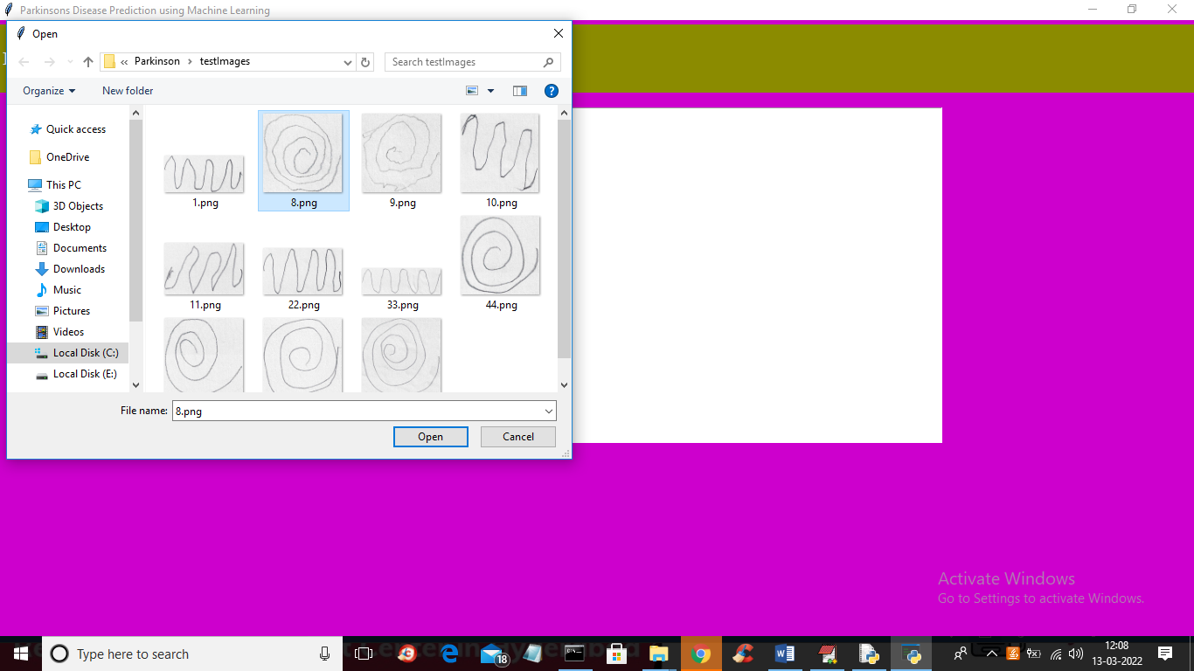

In above screen selecting and uploading ‘8.png’ file and then click on ‘Open’ button to get below output

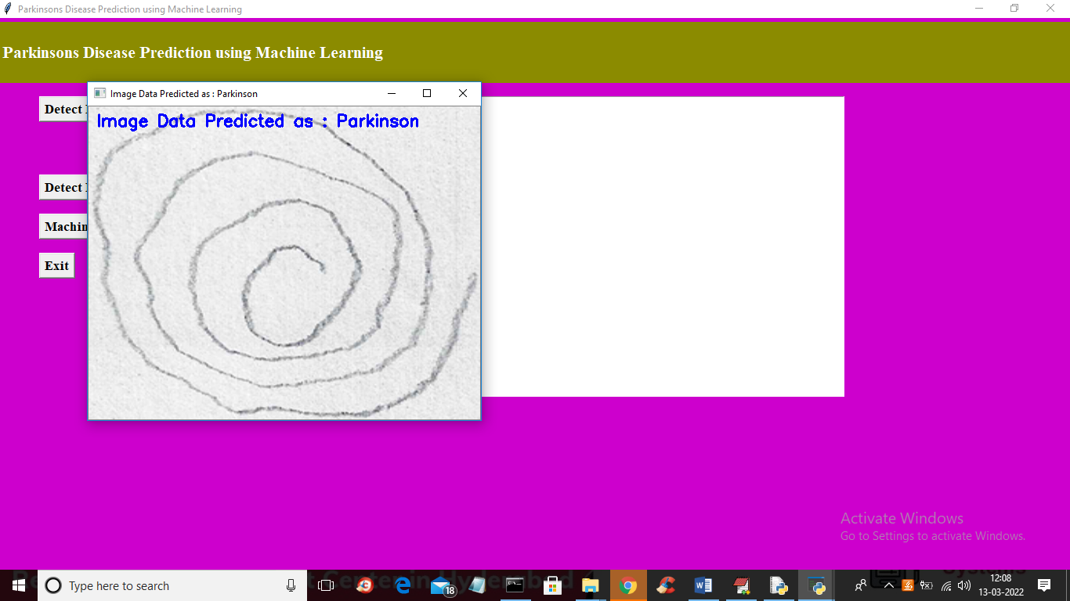

In above screen image is predicted as ‘Parkinson’ disease and now test other images

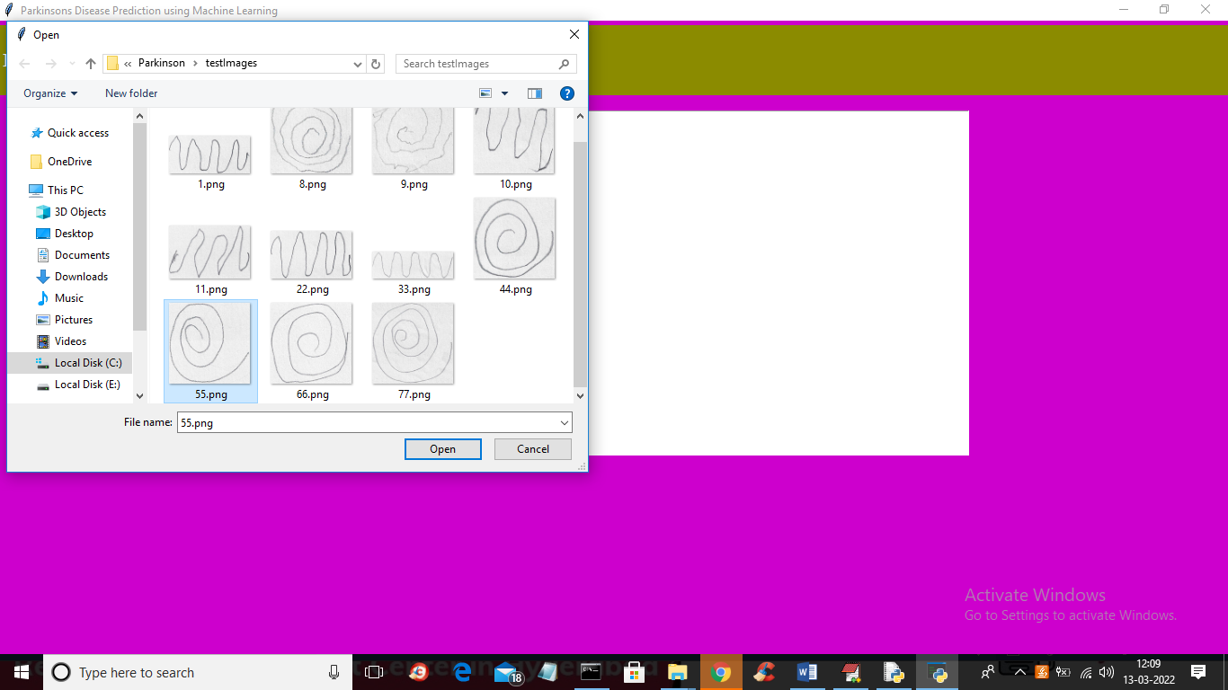

For above selected image will get below output

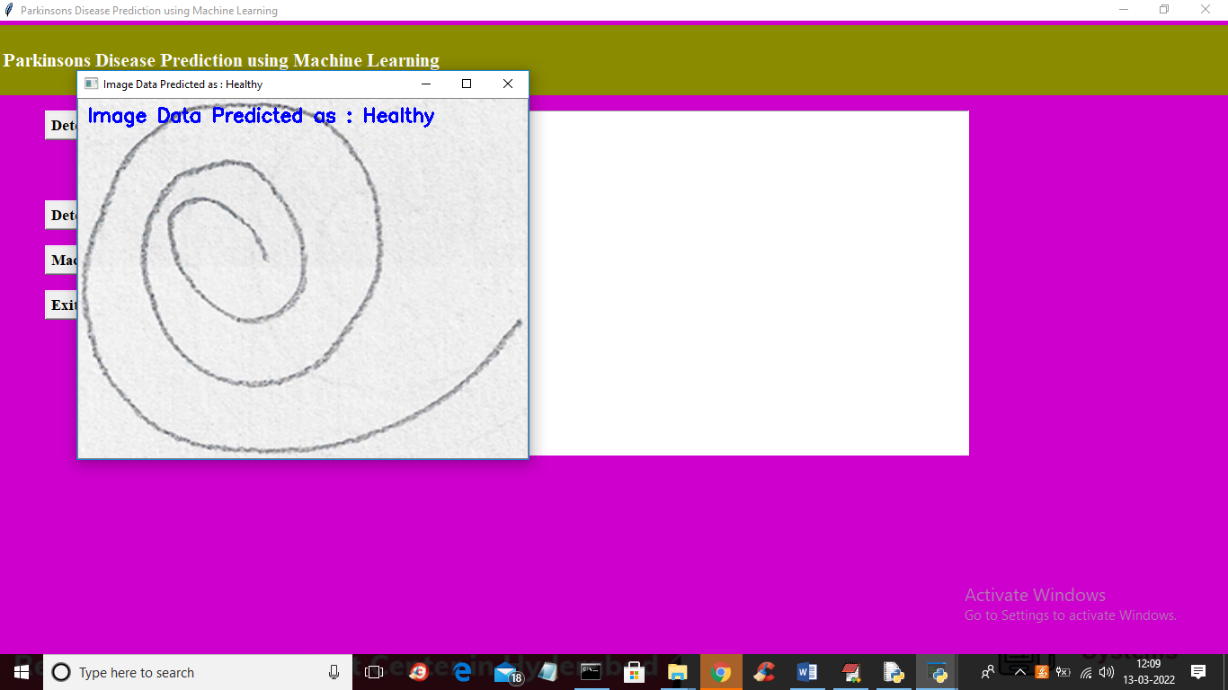

Above image is predicted as HEALTHY and similarly you can upload and test other image and now click on ‘Detect Parkinson from Voice Samples’ button to upload voice data and get below output

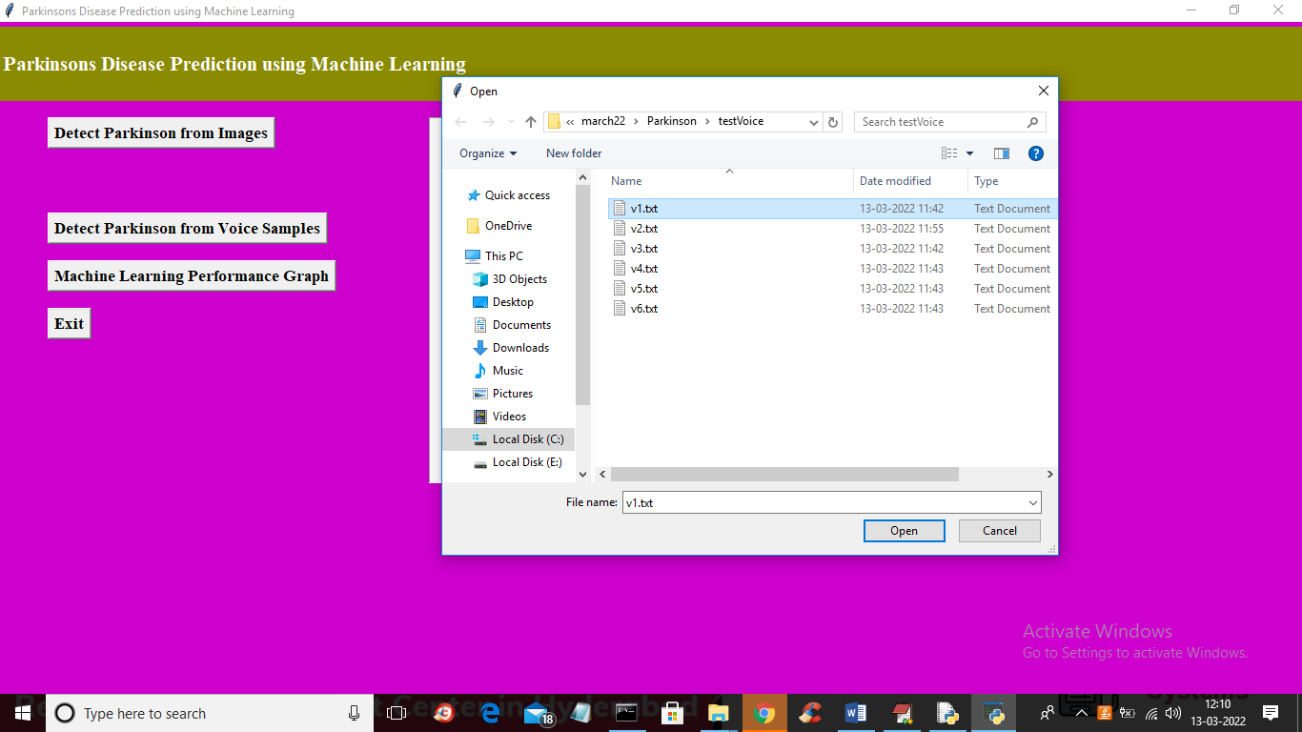

In above screen selecting and uploading ‘v1.txt’ voice data and then click on ‘Open’ button to get below output

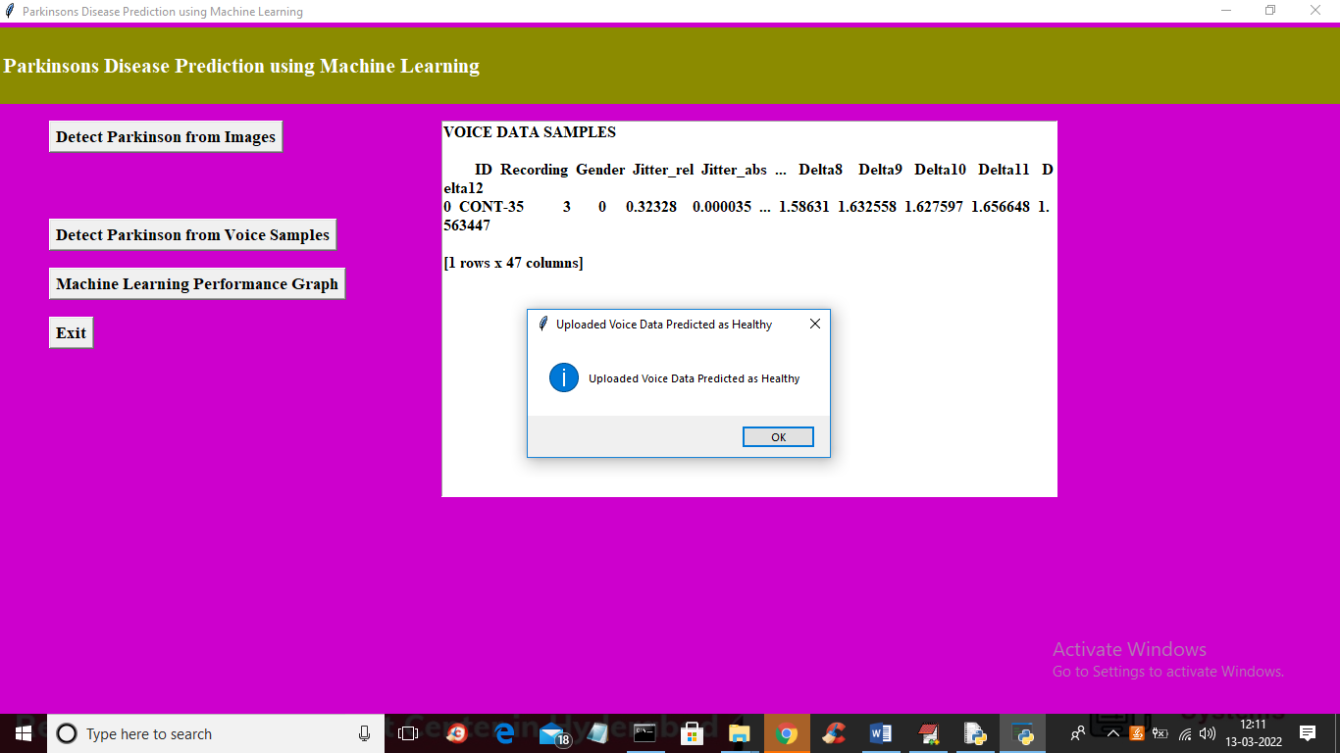

In above screen in text area we can see the voice recording data and in dialog box we can see voice data predicted as “HEALTHY” and now test other voice

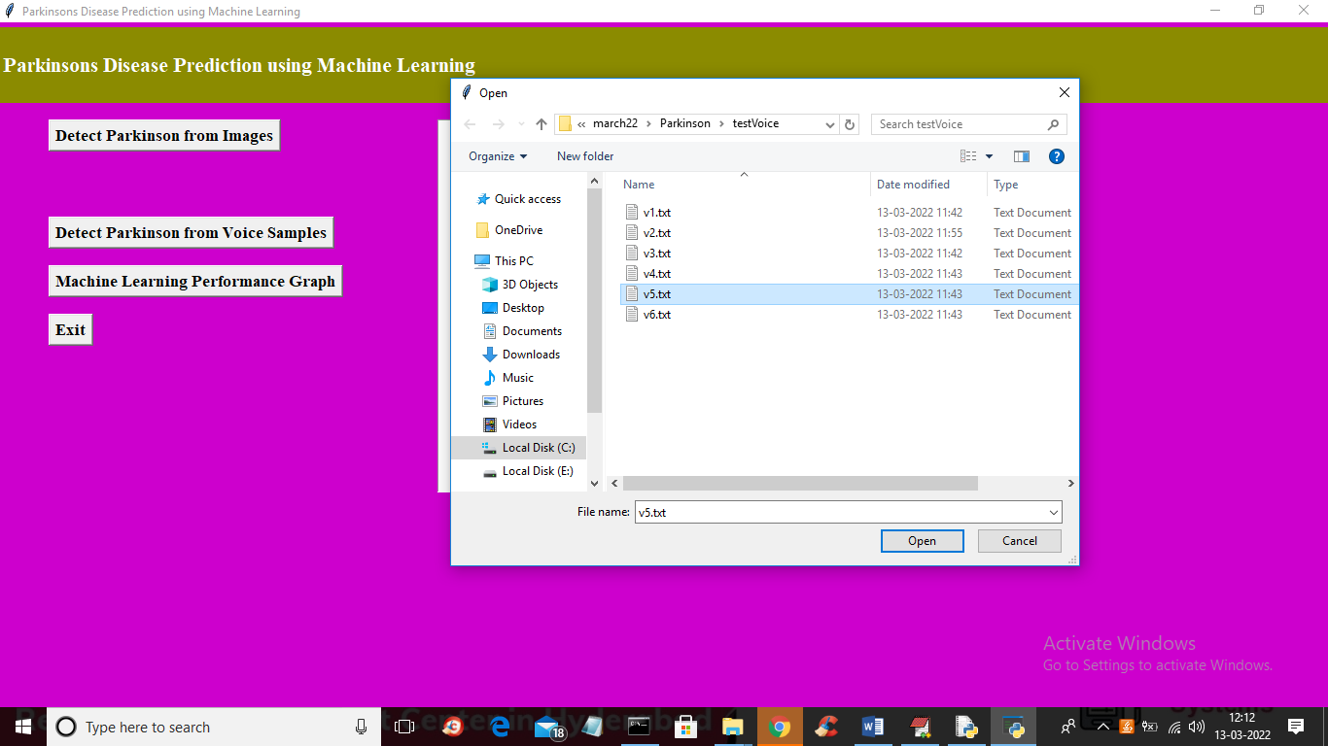

For above voice selection below is the output

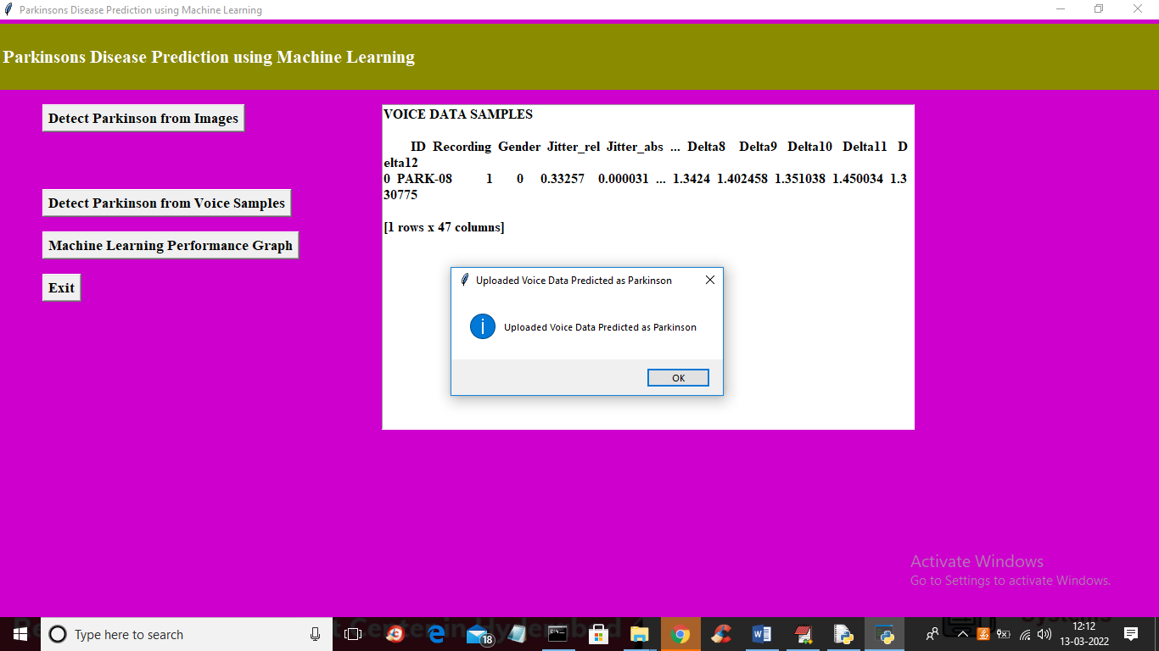

In above screen voice data predicted as ‘Parkinson’ disease and similarly you can upload and test other images. Now click on ‘Machine Learning Performance Graph’ button to get accuracy and loss graph of bot images and Voice CNN algorithm

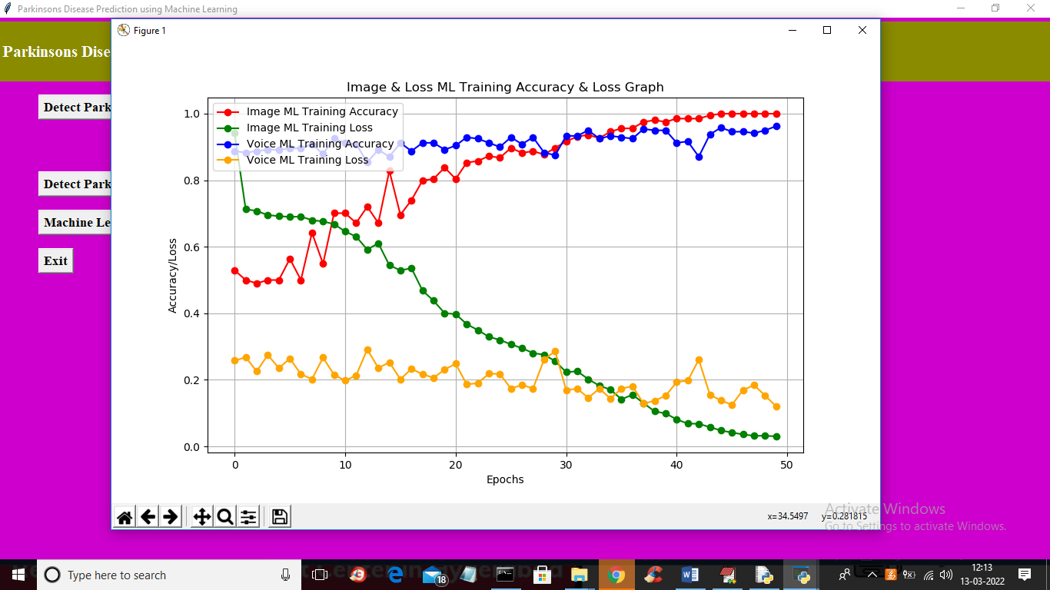

In above graph x-axis represents training epoch and y-axis represents accuracy and loss values and in above graph we can see with each increasing epoch accuracy got increase and loss got decrease and we can see at final epoch accuracy reached closer to 1 and loss reached closer to 0. In above graph blue line is for voice accuracy and red line is for image accuracy and green line for image loss and yellow line for voice loss