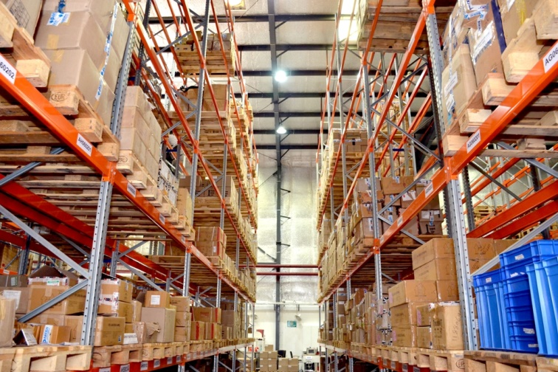
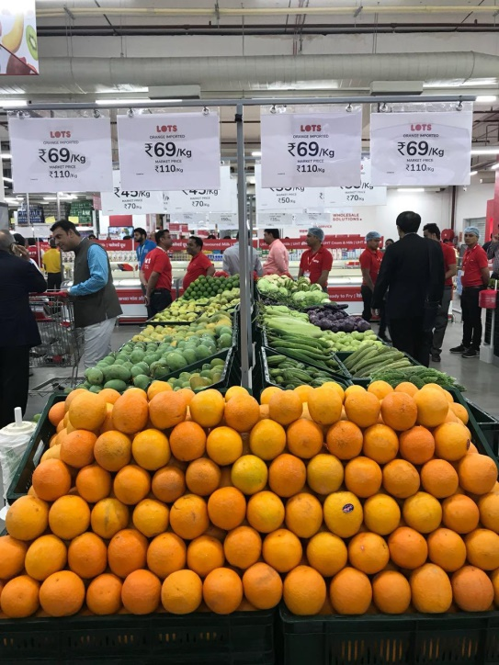
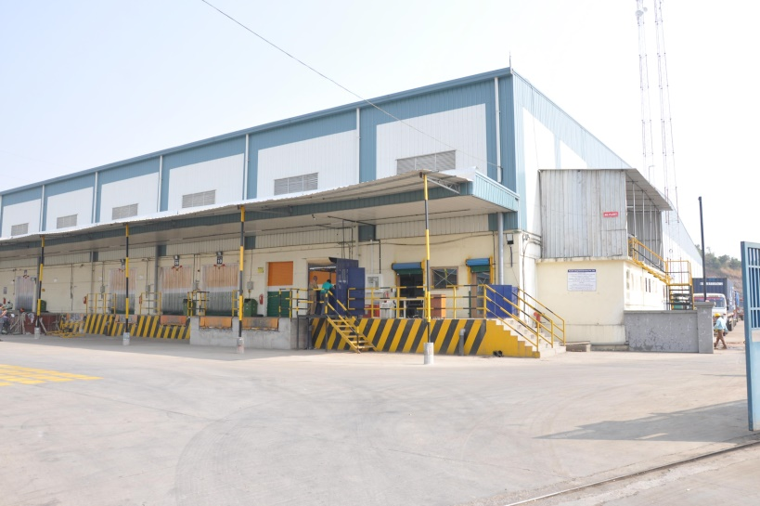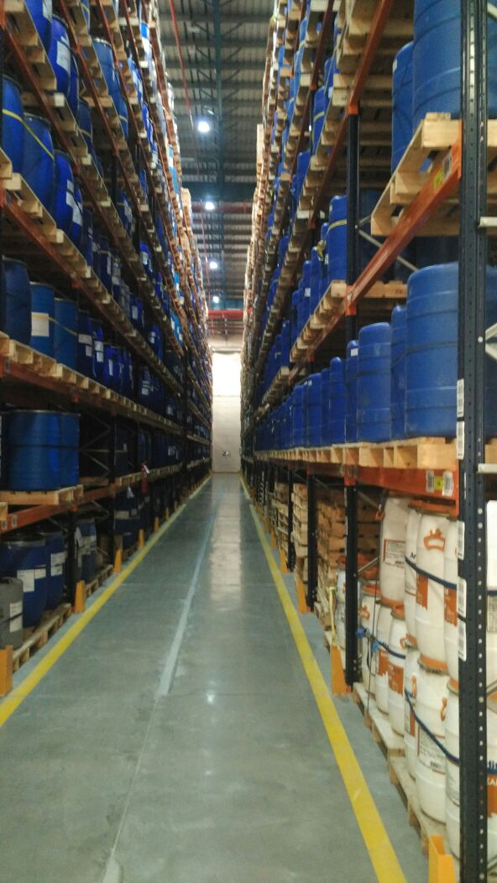

Certificate in
SUPPLY CHAIN MANAGEMENT
( 10 Modules Course)

Syllabus with Lesson Plan

ACADEMIC PARTNER
Escalating Abilities LLP (EAL)

Industry Led Program
This course will provide required skills and knowledge to educate individual and enhance performance in the area of SCM……
Design by Industry…Deliver by Industry…Evaluate by Industry…
COURSE MODULES
Module | Topic | Hrs | Certificate
Module 1 | INTRODUCTION TO TRADE AND THE SUPPLY CHAIN | 8 | Completion  of all the ten (10) modules, certificate will be awarded
Module 2 | MOVEMENT OF GOODS, PEOPLE, ANIMALS AND INFORMATION | 10
Module 3 | LOGISTICS, DISTRIBUTION AND THE SUPPLY CHAIN | 12
Module 4 | WAREHOUSING AND INVENTORY MANAGEMENT | 12
Module 5 | OPERATIONS MANAGEMENT | 10
Module 6 | PROCUREMENT, SOURCING AND CONTRACTING OF SERVICES | 14
Module 7 | BUSINESS MANAGEMENT IN SCM | 15
Module 8 | FINANCE IN SCM | 15
Module 9 | SUPPLY CHAIN SUSTAINABILITY | 8
Module 10 | RECENT AND EMERGING TRENDS IN SCM | 8

CERTIFICATE IN SUPPLY CHAIN MANAGEMENT
SYLLABUS WITH LESSON PLAN
MODULE 1 | INTRODUCTION TO TRADE AND THE SUPPLY CHAIN |  | 8 Hrs
This module sets the scene for the course by introducing global trade and the role logistics plays within this.

Learning outcomes: | - Evaluate the advantages and disadvantages of globalisation  - Identify and explain at least four different customs routines  - Research and highlight relevant issues in differing transport sectors
Indicative Structure: | - Evolution and development of trade  - Evolution of transport modes and the  opening-up of new markets and trades | 2 Hrs
Indicative Structure: | - Changes in manufacturing practices  - Deregulation  - Spread of globalisation  - Customs routines  - Free Trade Zones  - Trading Blocks and customs unions | 3 Hrs
Indicative Structure: | - Transport sectors (for example; retail,  oil & gas, project cargo, food, automotive,  pharma, humanitarian, people)  - Definitions and terminology | 3 Hrs
Name of the Faculty:
Pedagogy: Class discussion / Videos / Case study

MODULE 2 | MOVEMENT OF GOODS, PEOPLE, ANIMALS  AND INFORMATION | 10 Hrs
This module examines in depth the different modes of transport used in logistics and the role of intermodal transport.
Learning outcomes: | - Compare and contrast the advantages and disadvantages of three different modes of transport  - Justify the use of Intermodal transport  - Summarise the key information necessary for successful transportation
Indicative Structure: | • Comparison of freight and passenger transport  • Evaluation of road transport  • Evaluation of rail transport |  | 2 Hrs
Indicative Structure: | • Evaluation of sea transport  • Evaluation of air transport  • Intermodal transport |  | 2 Hrs
Indicative Structure: | • Equipment  • Infrastructure  • Other modes of transport |  | 3 Hrs
Indicative Structure: | • Animal transportation  • Transportation of people  • Information flows |  | 3 Hrs
Name of the Faculty:
Pedagogy: Class discussion / Videos / Case study

MODULE 3 | LOGISTICS, DISTRIBUTION AND  THE SUPPLY CHAIN |  | 12 Hrs
This module examines in depth the different modes of transport used in logistics and the role of intermodal transport.
Learning outcomes: | - The supply chain concept  - Supply chain strategy and planning  - The role of depots, warehouses and distribution centres  - Channels of distribution  - Modal selection  - Optimisation of transport modes  - Value-added services
Indicative Structure: | • The supply chain concept  • Supply chain strategy and planning | 3 hrs
Indicative Structure: | • The role of depots, warehouses and  distribution centres | 3 Hrs
Indicative Structure: | • Channels of distribution  • Modal selection | 3 Hrs
Indicative Structure: | • Optimisation of transport modes  • Value-added services | 3 Hrs
Name of the Faculty:
Pedagogy: Class discussion / Videos / Case study

MODULE 4 | WAREHOUSING AND INVENTORY  MANAGEMENT | 12 Hrs
The topics of warehouse management and inventory management are explored in detail in this module.
Learning outcomes: | - Create a suitable warehouse design for a given storage scenario  - Select suitable MHE based on product specifications  - Apply appropriate forecasting techniques to predict future demand
Indicative Structure: | - Storage methods  - Warehouse construction  - Warehouse design  - Inventory location  - Packaging |  | 2 Hrs
Indicative Structure: | - Mechanical Handling Equipment (MHE)  - Automation  - Technology |  | 3 Hrs
Indicative Structure: | - Warehouse routines and operations  - Reasons for holding inventory  - Inventory costs  - Lead times  - Inventory replenishment techniques |  | 3 Hrs
Indicative Structure: | - Re-order quantities  - Forecasting  - Collaborative planning and forecasting  - Demand management |  | 3 Hrs
Indicative Structure: | - Services vs goods  - Vendor Managed Inventory (VMI) |  | 1 Hr
Name of the Faculty:
Pedagogy: Class discussion / Videos / Case study

MODULE 5 | OPERATIONS MANAGEMENT | 10 Hrs
This module looks at the operations aspect of logistics, e.g., documentation, customer service and regulation.
Learning outcomes: | - Categorise the various operational processes involved in freight transportation  - Prepare for different pieces of documentation associated with international transportation  - Generate suitable KPIs for a given logistical scenario
Indicative Structure: | - Logistical operations and processes  - Who does what |  | 2 Hrs
Indicative Structure: | - Legislation and regulation  - Documentation  - Including animal and plant products,  licences, people  (i.e. passports and visas, etc.) |  | 3 Hrs
Indicative Structure: | - Packing  - Hazardous cargo  - Temperature control  - Out of Gauge (OOG) |  | 3 Hrs
Indicative Structure: | - Project cargo  - Customer service  - KPIs and SLAs |  | 2 Hrs
Name of the Faculty:
Pedagogy: Class discussion / Videos / Case study

MODULE 6 | PROCUREMENT, SOURCING AND  CONTRACTING OF SERVICES |  | 14Hrs
This module studies the issue of procurement and sourcing, including a look at tendering and ethical sourcing.
Learning outcomes: | - Apply appropriate techniques for the efficient sourcing of goods and services  - Relate the importance of ethical sourcing  - Prepare a suitable bid for a hypothetical Invitation to Tender
Indicative Structure: | - Sourcing Methods and techniques  - Selection process | 2 Hrs
Indicative Structure: | - Procurement practice | 4 Hrs
Indicative Structure: | - Payment terms  - Incoterms  - Ethical sourcing | 4Hrs
Indicative Structure: | - Tendering  - Service contracts  - The law | 4Hrs
Name of the Faculty:
Pedagogy: Class discussion / Videos / Case study

MODULE 7 | BUSINESS MANAGEMENT IN SCM | 15Hrs
The topic of business management in logistics is examined in this module, with an examination of marketing, people management and effective leadership.
Learning outcomes: | - Evaluate the advantages and disadvantages of various functional company structures  - Appraise outsourcing as a business strategy  - Prepare a business plan
Indicative Structure: | - Legal structures  (Insurance Laws / Labour Laws/ Documentation Laws  / The Motor Vehicles Act, 1988/ Contract Act/IT Act 2000) |  | 3 Hrs
Indicative Structure: | - Functional structures  - Leadership and management  - Outsourcing (3PL, 4 PL & 5 PL) |  | 4 Hrs
Indicative Structure: | - Marketing  - Services and goods  - People management  - HR  - Recruitment  - Team working |  | 4 Hr
Indicative Structure: | - GST online documentation  (Introduction to GST/Supply, Invoicing and  Input Credit/ Returns and Transition Provisions |  | 4 Hrs
Name of the Faculty:
Pedagogy: Class discussion / Videos / Case study

MODULE 8 | FINANCE IN SCM |  | 15Hrs
This module looks at finance in logistics, for example operating costs, P&L and budgets.
Learning outcomes: | - Analyse financial documents  - Classify supply chain costs  - Prepare a basic budget
Indicative Structure: | - Introduction to finance  - Operating costs  - Fixed  - Variable | 3Hrs
Indicative Structure: | - Costing techniques  - Selling prices | 3 Hrs  3 Hrs
Indicative Structure: | - P&L  - Balance sheet | 4Hrs
Indicative Structure: | - Budgets | 2 Hrs
Name of the Faculty:
Pedagogy: Class discussion / Case study / Demonstration

MODULE 9 | SUPPLY CHAIN SUSTAINABILITY | 8 Hrs
This module examines the important issue of supply chain risk, and how to manage it.
Learning outcomes: | - Judge supply chain risk  - Devise a supply chain risk management plan  - Predict environmental issues within a supply chain and recommend measures to reduce their impact
Indicative Structure: | - Supply chain risk  - Risk management |  | 2 Hrs
Indicative Structure: | - Environmental issues  - Modal comparison  - Waste and waste management |  | 3 Hrs
Indicative Structure: | - Reducing environmental impact  - Cooperation and collaboration |  | 3 Hrs
Name of the Faculty:
Pedagogy: Class discussion / Videos / Case study

MODULE 10 |  | RECENT AND EMERGING TRENDS IN SCM | 08Hrs
This final module examines the most pressing current and emerging trends in logistics and the impact they can have on business.
Learning outcomes: | - Hypothesize the effects of emerging technologies on existing supply chains  - Show how legislation can impact supply chains  - Estimate how changes to the external environment may affect supply chains
Indicative Structure: | - Autonomous vehicles  - 3D printing  - Drones |  |  | 2 Hrs
Indicative Structure: | - Online trading and exchanges  - Social media  - Future technology |  |  | 3 Hrs
Indicative Structure: | - Legislation  - Mergers and acquisitions – trends  - Changing demographics and economies |  |  | 3 Hrs
Name of the Faculty:
Pedagogy: Class discussion / Videos / Case study

CASE STUDY
Every module will be coupled with case study and will give the student guidance on creating an effective logistics plan for a company based in the different sectors, taking into account the topics learnt in the previous modules. Area of case study:
- Background to logistics and supply chain management
- Modelling techniques in logistics and supply chain management
- Review of logistics and supply chain performance indicators
- Analytical performance and benchmarking techniques
- Current issues in supply chain performance and optimisation

