MINI PROJECT REPORT
BharatDoc AI
Indian Document Understanding Tool
CS3235 Mini Project #3 (AI4Bharat and BharatGen)
Prototype v1.0
Submitted by
POORNA V M
B.Tech (Computer Science), School of Computer Science and Engineering
RV University, Bangalore
6 November 2026

1. Introduction
Government notices, circulars and application forms in India are issued in many languages and are often shared as PDFs or phone photos. A citizen who cannot read the language well, or who just wants the deadline and the contact number, has to read the whole page to find them.
BharatDoc AI is a lightweight web prototype that tackles this. The user uploads a PDF or an image of a document. The tool reads the text, pulls out the key details, writes a short summary and answers questions by pointing to the sentence in the document that supports the answer.

1.1 Objectives
- Accept PDFs and images (PNG, JPG) of Indian-language documents, with Kannada as the main target.
- Extract text, using embedded PDF text where possible and OCR otherwise.
- Detect dates, phone numbers, email addresses and reference numbers.
- Produce a short summary and answer simple questions with evidence from the document.
- Let the user download the extracted text and an analysis report.

1.2 Project Status
This is a working prototype. The upload interface, text extraction, OCR path, field extraction, summary, evidence-based Q&A and downloads are implemented. The two model integrations named in the brief, BharatGen Patram (document understanding) and AI4Bharat IndicTrans2 (translation), are not connected yet. Translation exists only as a placeholder that returns a clear "not connected" message. The report does not claim any Patram or IndicTrans2 results.

2. System Design and Flow
The system is a single Streamlit application with three small Python modules behind it. Every document follows the same path: extract text, then run three independent analysers on that text, then show the results in the interface.
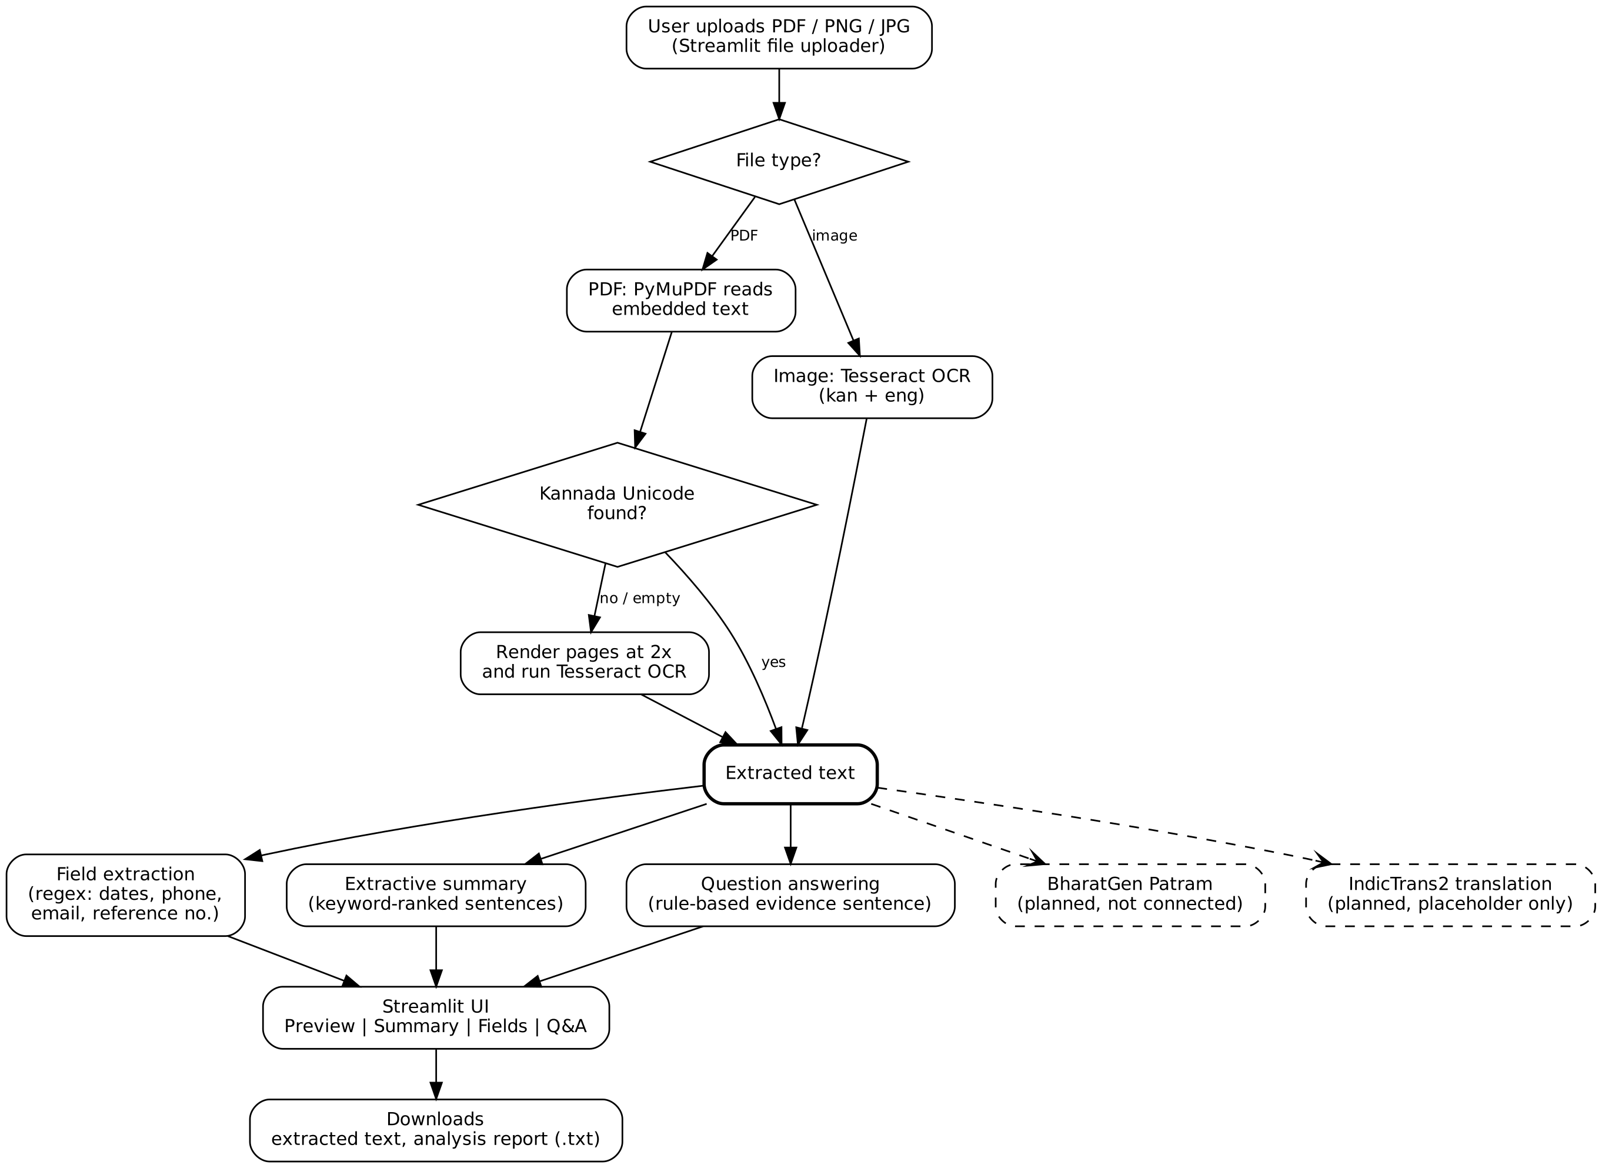
Figure 1: End-to-end pipeline. Dashed boxes are planned and not yet connected.

2.1 Technology Stack
Component | Tool | Role
Interface | Streamlit | Upload, preview, tabs, download buttons
PDF text | PyMuPDF | Reads embedded text from PDFs
OCR | Tesseract + pytesseract (kan+eng) | Scanned PDFs and images
Image handling | Pillow | Opens images and rendered PDF pages
Fields, summary, Q&A | Python (re) | Pattern and keyword based baselines
Document model | BharatGen Patram | Planned, not connected
Translation | AI4Bharat IndicTrans2 | Planned, placeholder only

2.2 Project Structure
File | Purpose
app.py | Streamlit interface, layout, styling, session history, report download
app/document_processor.py | Text extraction from PDFs and images, OCR fallback
app/analysis.py | Field extraction, summary, question answering
app/translation.py | IndicTrans2 placeholder
tests/test_cases.csv | 40 planned test scenarios
sample_docs/sample_notice.txt | Short English sample notice

3. Implementation

3.1 Text Extraction
For a PDF, PyMuPDF first reads the embedded text. If that text contains Kannada Unicode characters it is used directly. If the text is empty, or has no Kannada, each page is rendered at 2x resolution and passed through Tesseract with Kannada and English language data. This protects against PDFs whose embedded Kannada text is corrupted. Images go straight to Tesseract. The method used is shown under the upload box so the user knows how the text was obtained.

3.2 Field Extraction
Regular expressions find four kinds of values: dates in numeric form (for example 20/11/2026) or written form (20 November 2026), ten-digit Indian mobile numbers with an optional +91, email addresses, and reference numbers such as DPS/2026/1042. Duplicates are removed while keeping the order of appearance.

3.3 Summary
The summary is extractive. The text is split into sentences, each sentence is scored by how many deadline-related keywords it contains (English and Kannada), and the top three are shown in their original order. Nothing is rewritten, so no new facts can be introduced.

3.4 Question Answering
Answers come from an ordered set of rules. The question is matched against keyword groups (consent, reference number, date, deadline, contact, transport, safety, permission, topic, required documents). The matching rule searches the document and returns the exact sentence or value, which is also shown as evidence. If no rule fits, a keyword-overlap fallback picks the best sentence. If nothing is found the tool says so instead of guessing.

3.5 Interface
The page has a sidebar (language selector and recent history), an upload box, a document preview on the left, and three tabs on the right: Summary, Extracted Fields and Q&A. Two buttons let the user download the extracted text and a plain-text analysis report.

4. User Interface Walkthrough
The screenshots below were captured from the running application using the sample government notice in the project folder (an English text PDF, Reference No. DPS/2026/1042).

4.1 Home Screen
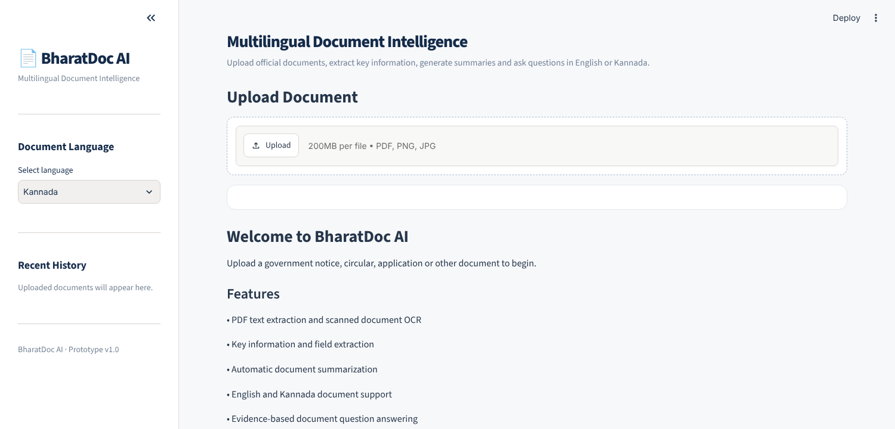
Figure 2: Home screen before any document is uploaded

4.2 Document Preview and Summary
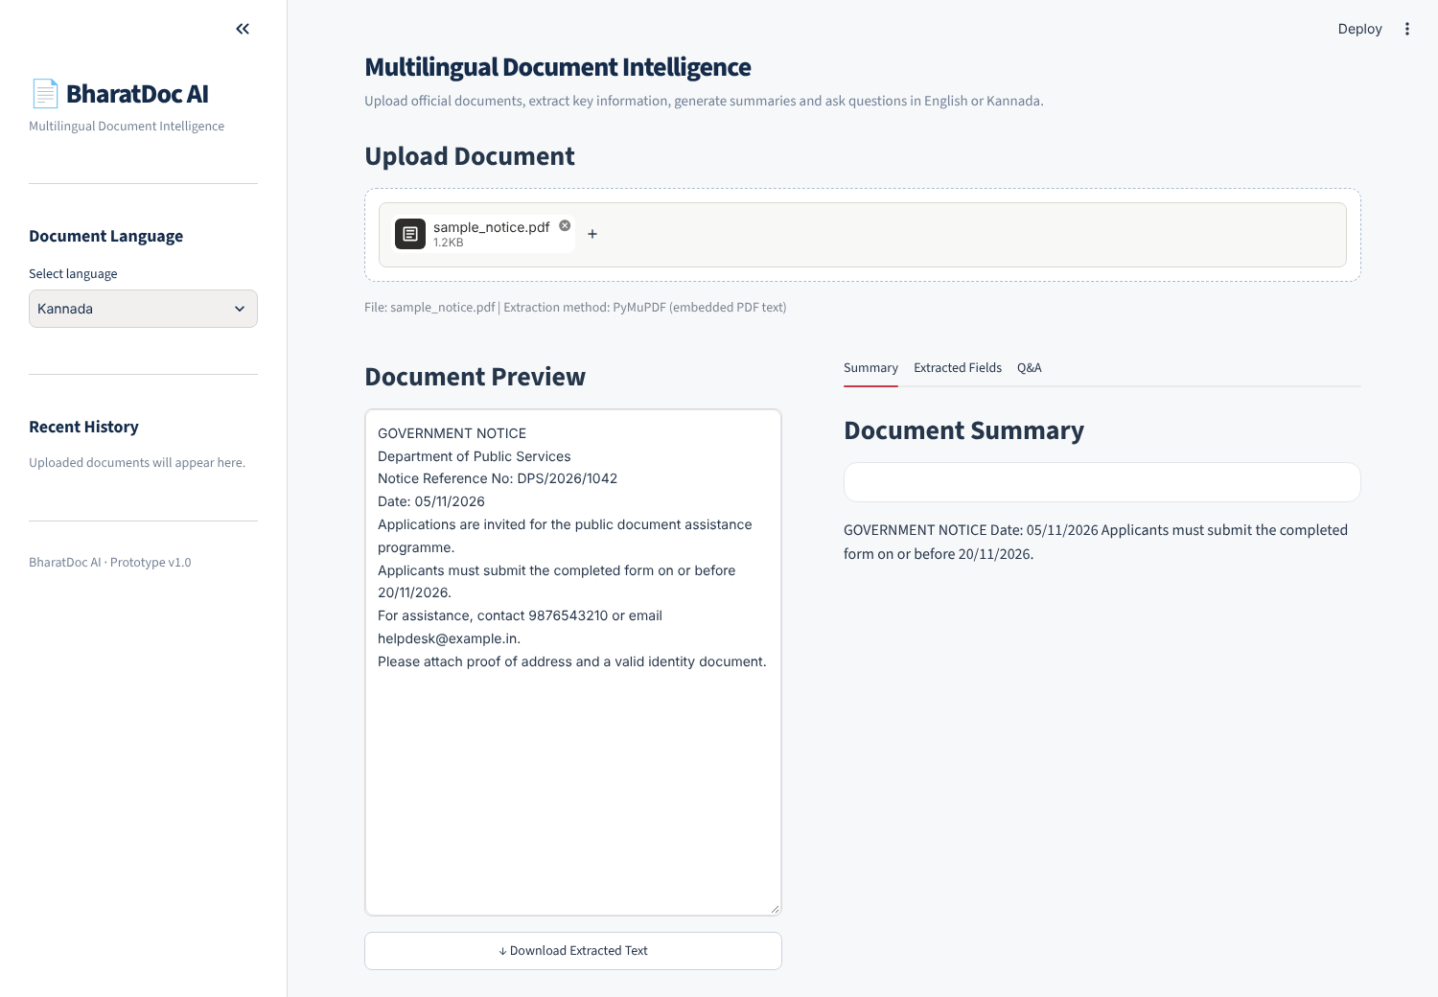
Figure 3: Extracted text on the left and the generated summary on the right

4.3 Extracted Fields
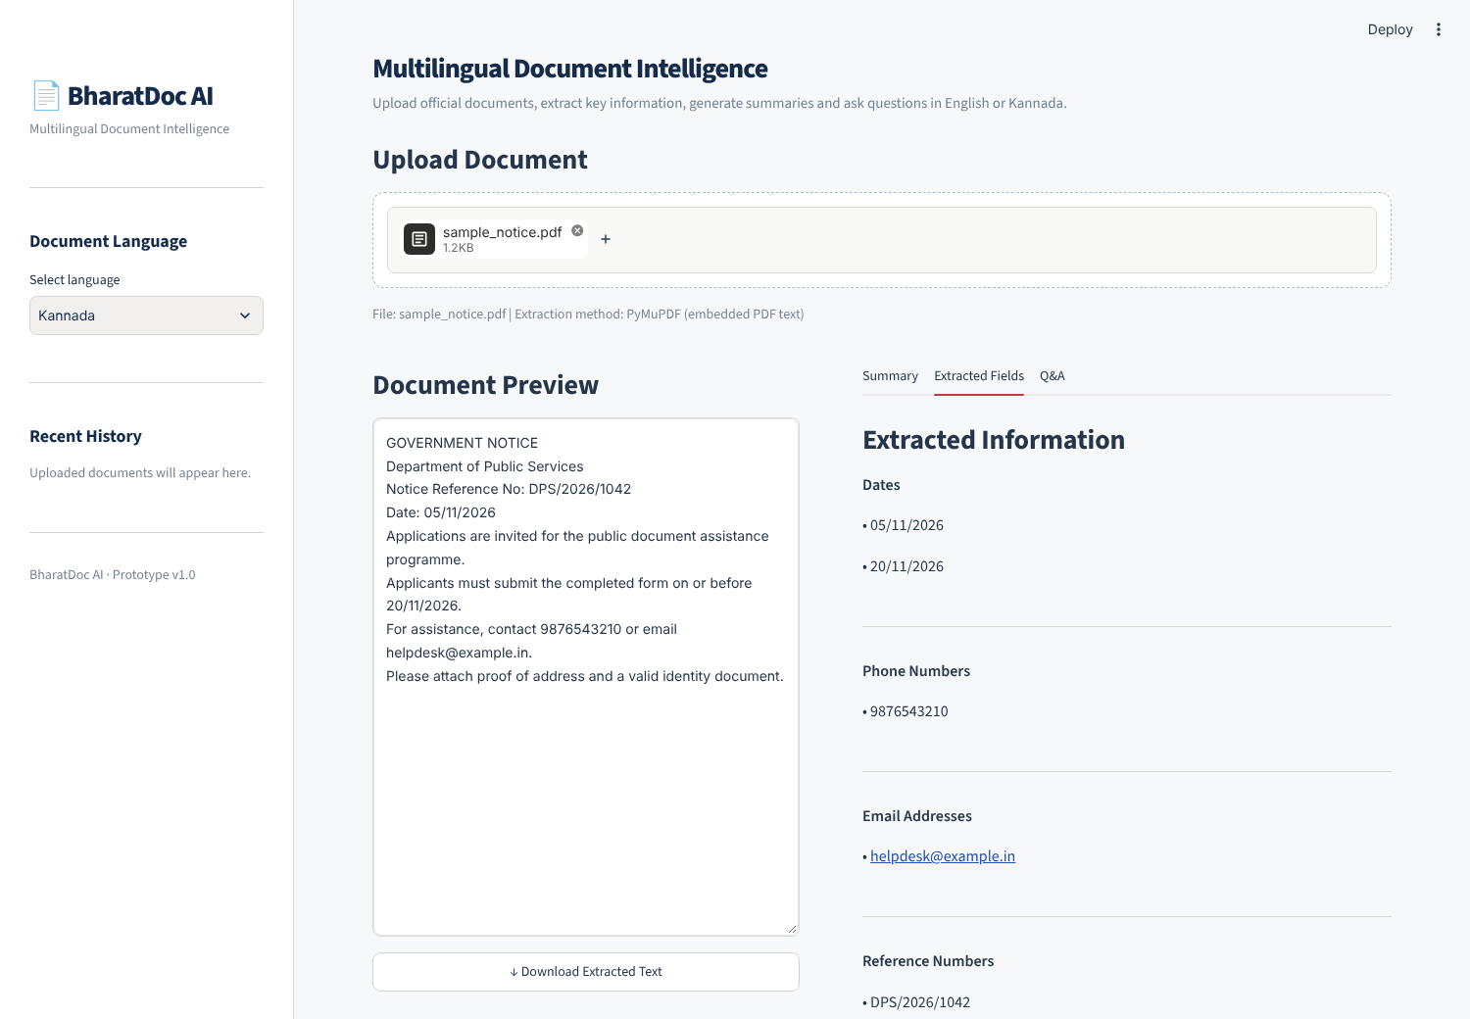
Figure 4: Dates, phone number, email and reference number detected from the notice

4.4 Question Answering
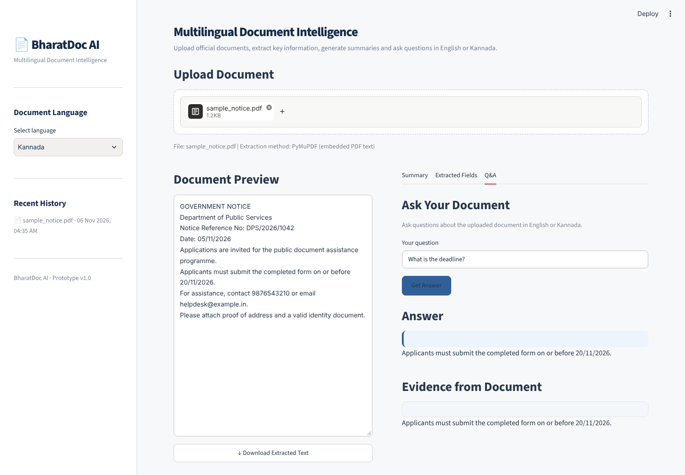
Figure 5: Question "What is the deadline?" returns the correct submission sentence

5. Testing and Results

5.1 Run on the Sample Notice
The sample notice was processed end to end and the outputs were compared with the source text.
Check | Tool output | Verdict
Dates | 05/11/2026, 20/11/2026 | Correct, both dates found
Phone number | 9876543210 | Correct
Email | helpdesk@example.in | Correct
Reference number | DPS/2026/1042 | Correct
Summary | Title line, issue date line and the submission sentence | Contains the deadline; first two lines add little value
Q: deadline? | Applicants must submit the completed form on or before 20/11/2026. | Correct
Q: contact number? | 9876543210 | Correct
Q: reference number? | DPS/2026/1042 | Correct
Q: last date for submission? | 05/11/2026 | Wrong, this is the issue date; expected 20/11/2026
Q: which documents are required? | Applications are invited for the public document assistance programme. | Wrong sentence; expected the line about proof of address and ID
Q: what is this notice about? | Document topic could not be extracted. | Fails on English; the rule only looks for a Kannada subject label

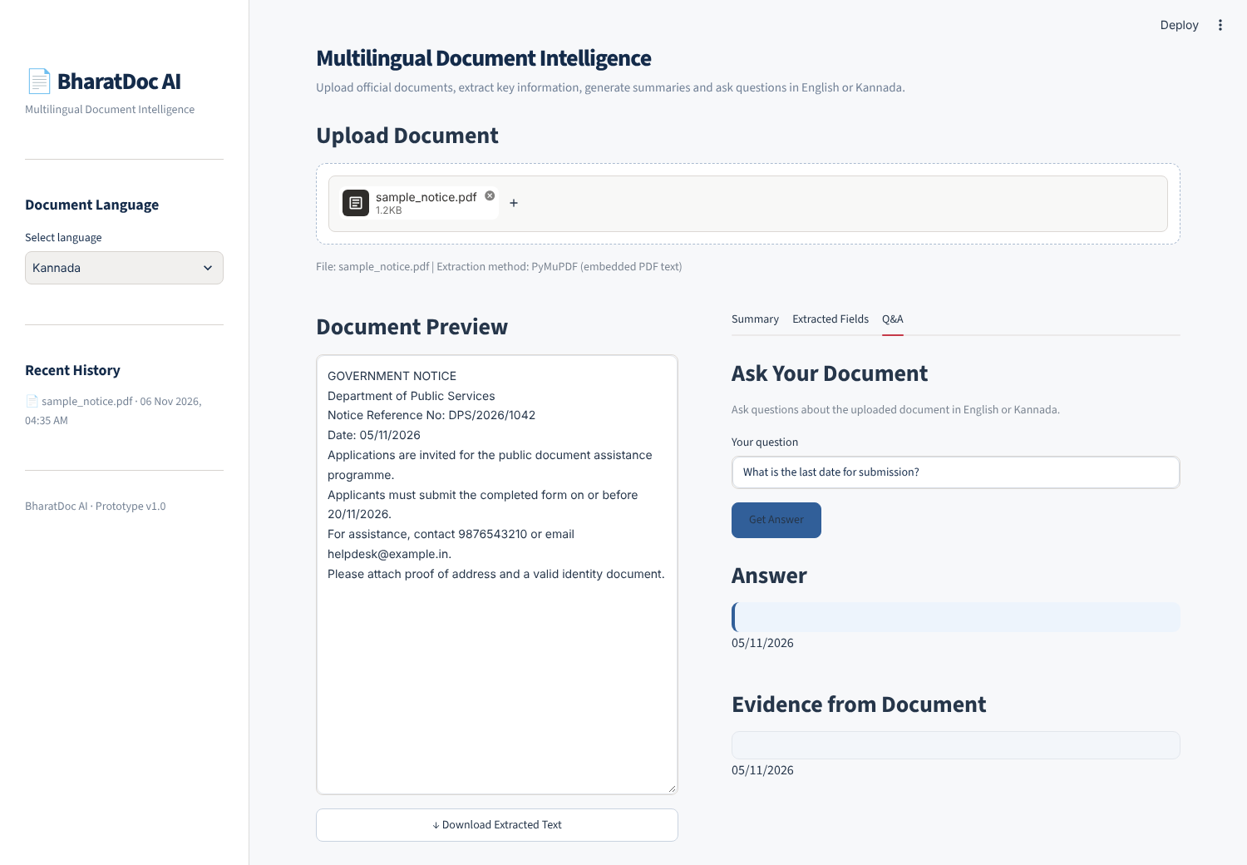
Figure 6: Wrong answer for "What is the last date for submission?" (shows the issue date)

5.2 Issues Found
- Date rule fires before the deadline rule. The word "date" inside "last date" matches the generic date rule first, so deadline questions return the first date in the document. Moving the deadline rule above the date rule fixes this.
- Substring matching is too loose. "document" in the question matches "document assistance programme" in the notice. Matching on whole phrases, or preferring sentences that contain "attach" or "proof", would help.
- Topic rule is Kannada only. English notices have no subject label of the kind it searches for.
- Many rules are tuned to one Kannada circular. Keywords such as educational tour, transport and parental consent come from a single document, so they will not generalise.
- Answer boxes render empty. The coloured answer and evidence panels appear as empty bars with the text below them (visible in Figure 6), because the HTML wrapper does not enclose the Streamlit text.
- Tesseract path is hard-coded for Windows. The path C:\Program Files\Tesseract-OCR\tesseract.exe makes OCR fail on Linux, macOS and Colab until it is made configurable.
- English PDFs always go through OCR. Embedded text is only trusted when Kannada characters are present, so clean English PDFs take the slower OCR route.
- Language selector has no effect. The sidebar choice is not passed to extraction or analysis.
All eight issues were found by testing the code as submitted. No source files were changed for this report. The screenshots were taken in a Linux sandbox without Kannada OCR data, so the extraction step was run on the English text PDF's embedded text.

5.3 Planned Test Set
tests/test_cases.csv holds 40 scenarios: 8 languages (Kannada, Hindi, Tamil, Telugu, Malayalam, Bengali, Marathi, Gujarati) with 5 cases each, 5 document types (government notice, application form, scholarship notice, municipal notice, admission notice), and 10 document conditions such as low-resolution scan, rotated page, multi-column layout, stamp over text, faint photocopy, handwritten margin note and mixed English and regional language. Each case checks OCR text, fields, summary and one question.
None of the 40 cases has been run yet; all are marked NOT TESTED. No accuracy figures are reported here, since none have been measured. The only measured results are the sample-notice checks in section 5.1.

6. Limitations
- OCR quality depends on scan quality. Blur, skew, stamps, handwriting and multi-column layouts can all produce wrong text.
- Regex extraction finds patterns, not meaning. It will miss names and addresses and can pick up irrelevant numbers.
- Numeric dates such as 05/11/2026 are ambiguous between day-first and month-first formats.
- Rule-based Q&A can return a related but incorrect sentence, as shown in section 5.1.
- Translation is not available. Translating legal or administrative text can also change its meaning, so critical content must always be checked against the original.
- Extracted values should always be verified against the original document.

7. Future Work
- Fix the issues in section 5.2, starting with the rule order and the Tesseract path.
- Run the 40 planned test cases and record correct and incorrect outputs per language and condition.
- Connect IndicTrans2 in app/translation.py to translate extracted text to English.
- Connect BharatGen Patram for layout-aware understanding. It needs a GPU with roughly 24 GB of memory, so it would run on a hosted GPU rather than locally.
- Replace keyword Q&A with retrieval over the document text, using Patram or a multilingual model.
- Add Hindi, Tamil and the other target languages to the language selector and OCR configuration.

8. Conclusion
BharatDoc AI shows the full user journey for document understanding: upload, extract, summarise, find key fields and ask questions with visible evidence. The baseline methods are honest about what they are, and the tool says when it cannot find an answer. On the sample notice all four fields were extracted correctly and most questions were answered correctly, while testing also exposed specific rule-order and matching errors that are quick to fix. The next steps are fixing those, running the full test set, and connecting Patram and IndicTrans2.

9. How to Run
Use Python 3.10 or 3.11. Install Tesseract with Kannada language data for OCR, then:
pip install -r requirements.txt
streamlit run app.py
The app opens at http://localhost:8501.

