**Run C# sample scripts Project**

1. **Before opening Visual Studio make sure installed Dot-net Core development platform.**
2. **Recommended Visual studio is VS2019.**
3. **Open Visual studio -> click on Create a new proje4.** 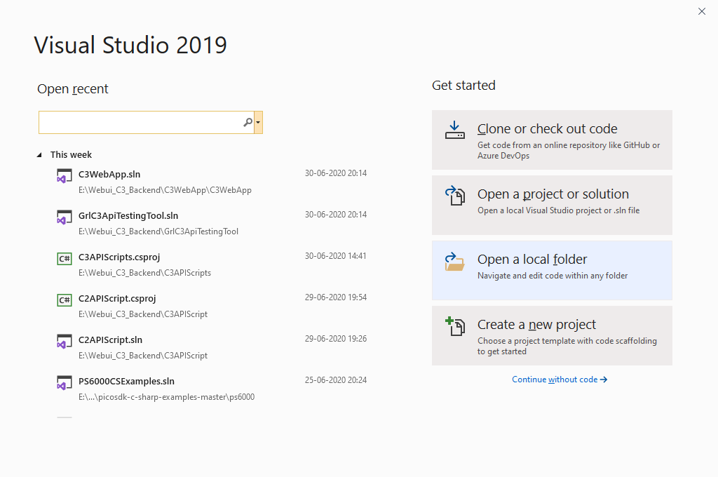
4. **Select Console App (.Net Core) project, will be available only after installing .net Core development in VS and click Next**
5. **Give appropriate project name, location and click next.**
6. **Right click on dependencies and click add button.**
7. **Select “GrlQiC3ApiLib.dll”, “Newtonsoft.Json.Bson.dll”, “Newtonsoft.Json.dll” and “System.Net.Http.Formatting.dll” from “C:\GRL\GRL-WP-TPR-C3\APILibrary” location.**
8. **Added C# scripts classes from “C:\GRL\ GRL-WP-TPR-C3\APILibrary\** **C3APIScripts”**
9. **In program.cs file create and object of appropriate scripts to run, update Run method as below.**

