Application Deployment
(Deploy the given React application to a production ready state)

Application:
Clone the below mentioned repository and deploy the application (Run application in port 3000).
Repo URL : https://github.com/Vennilavanguvi/Brain-Tasks-App.git

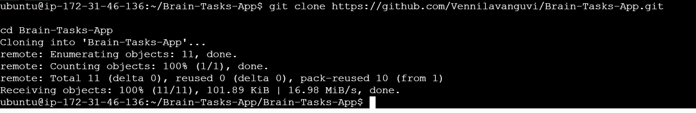

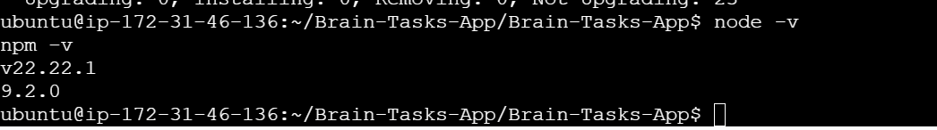

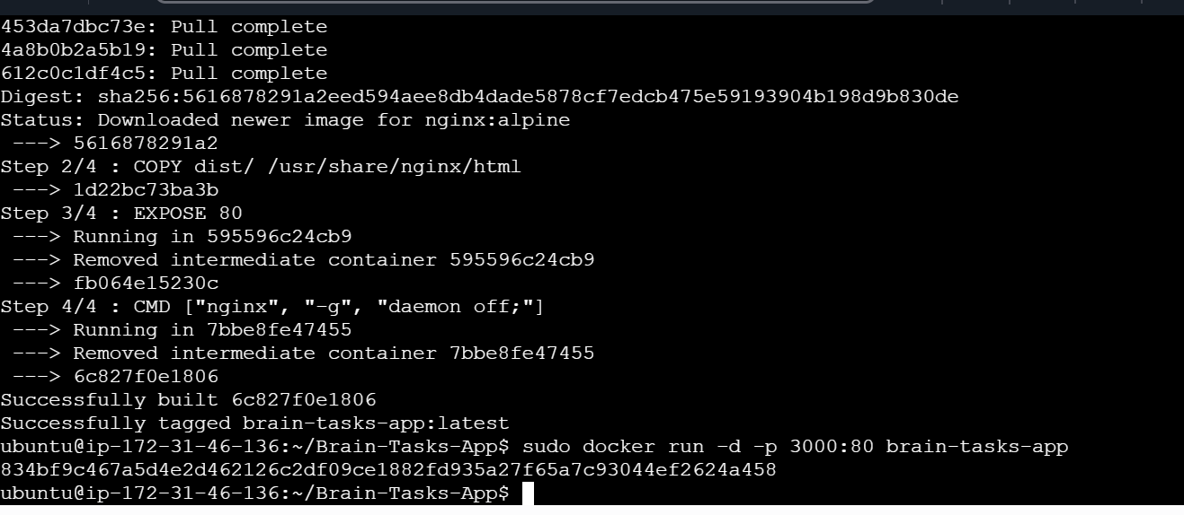

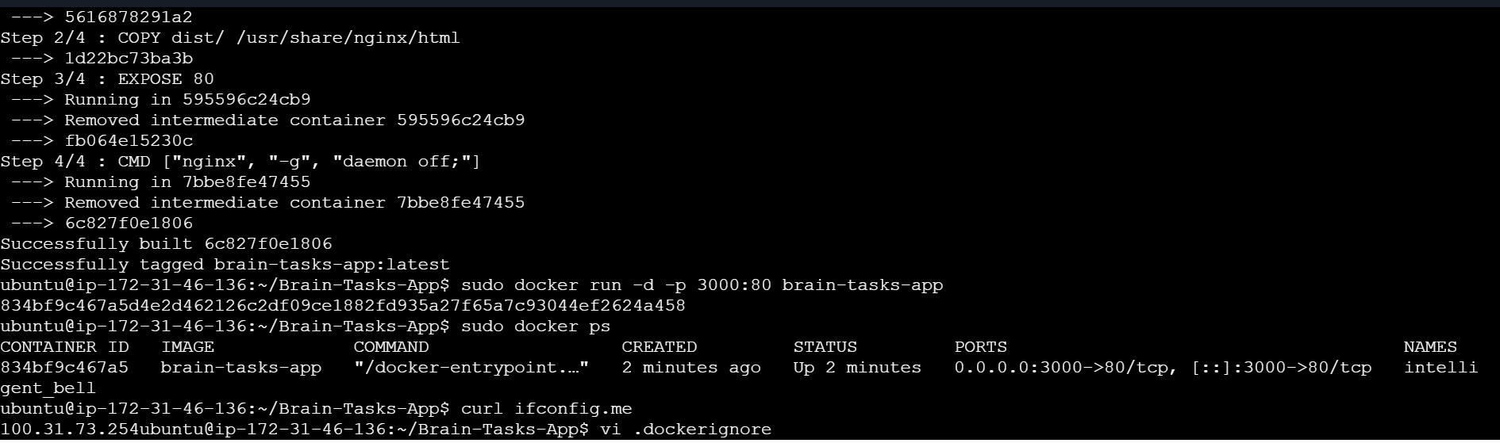

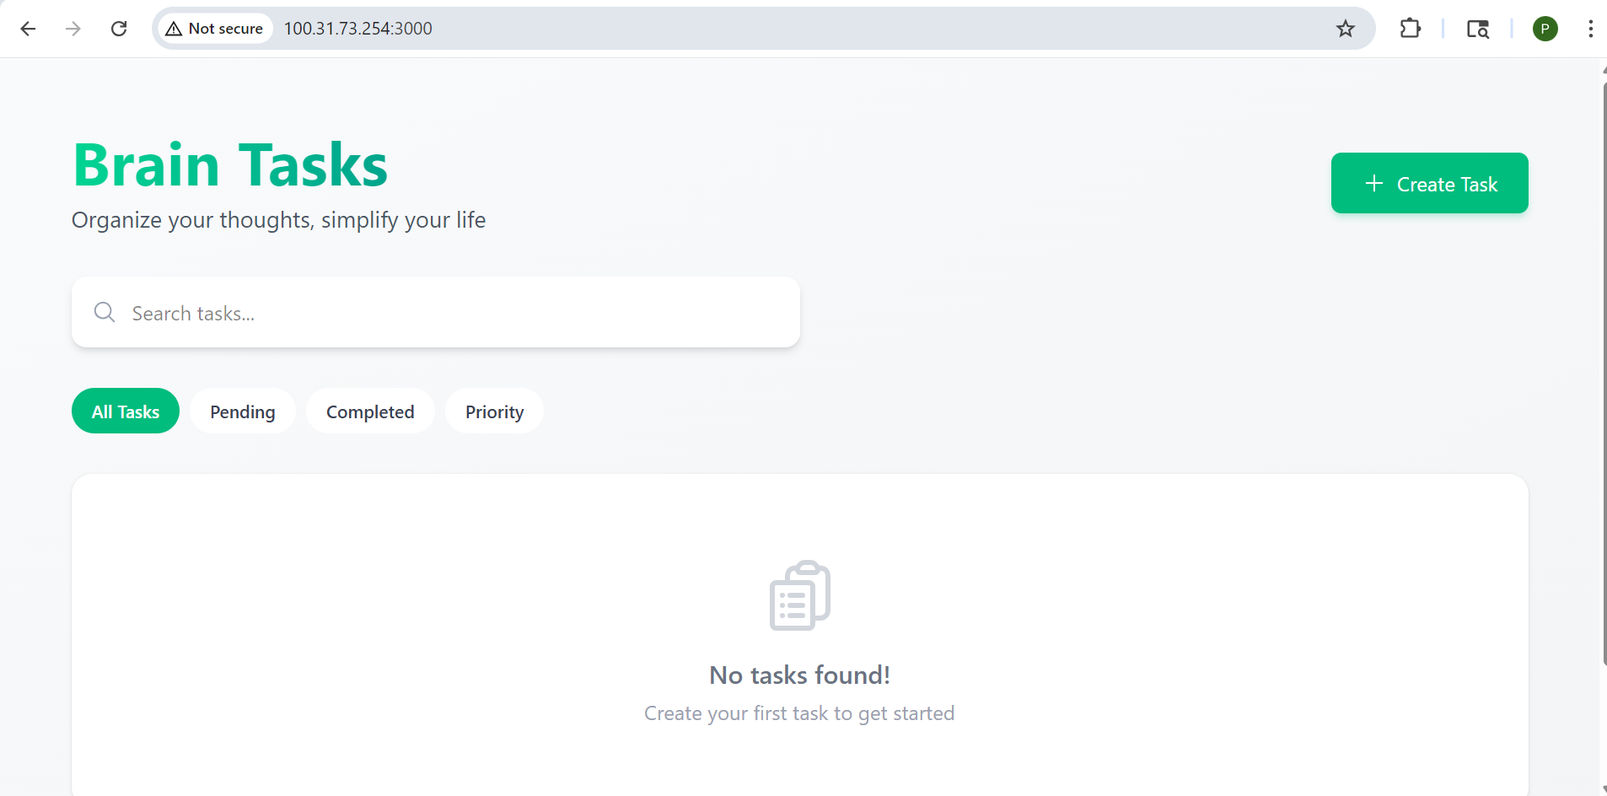
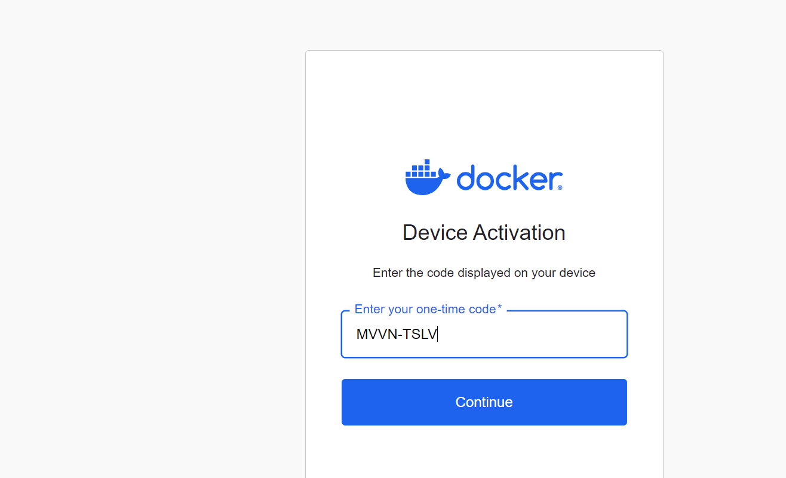
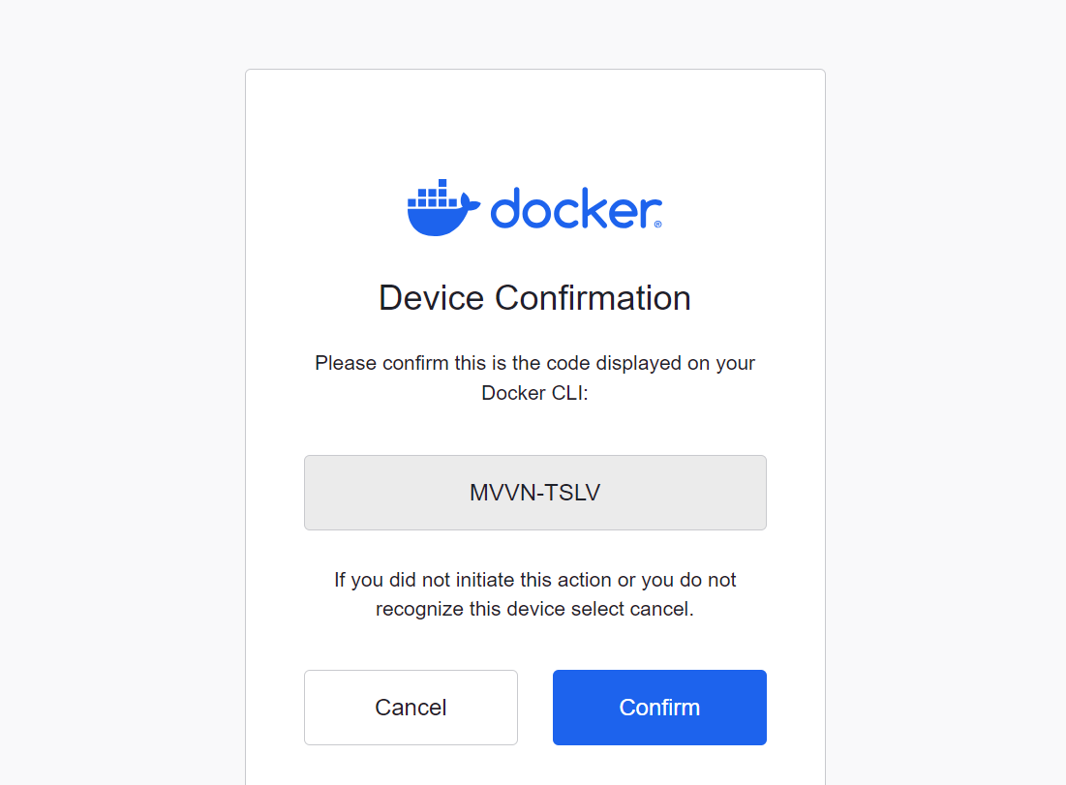
Create an AWS ECR or Dockerhub repository for storing docker images.
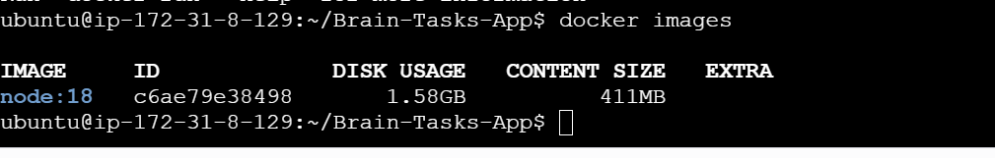
Setup Kubernetes in AWS EKS and Confirm EKS cluster is running.
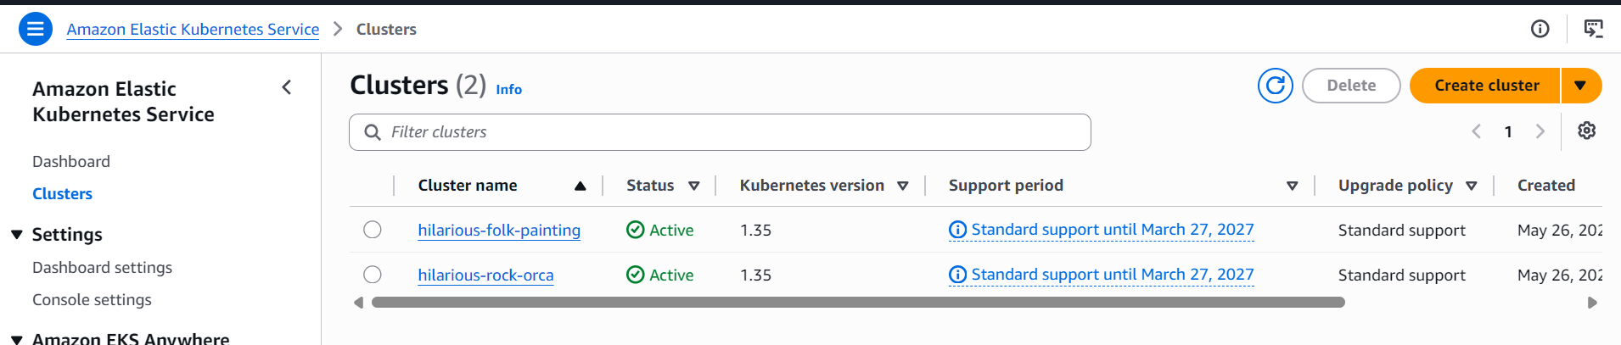

- Write deployment and service YAML files.
- Deploy using kubectl via CodeBuild or Codepipeline.
Create a CodeBuild project:
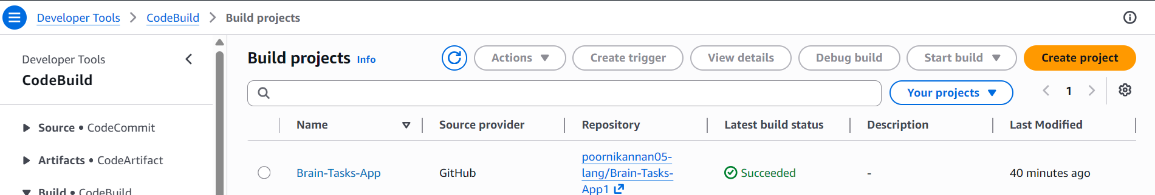

- Create a CodeBuild project:
- Source: Connect to your repository
- Environment: Use managed image (Amazon Linux, Ubuntu)
- Write and define commands in buildspec.yml.

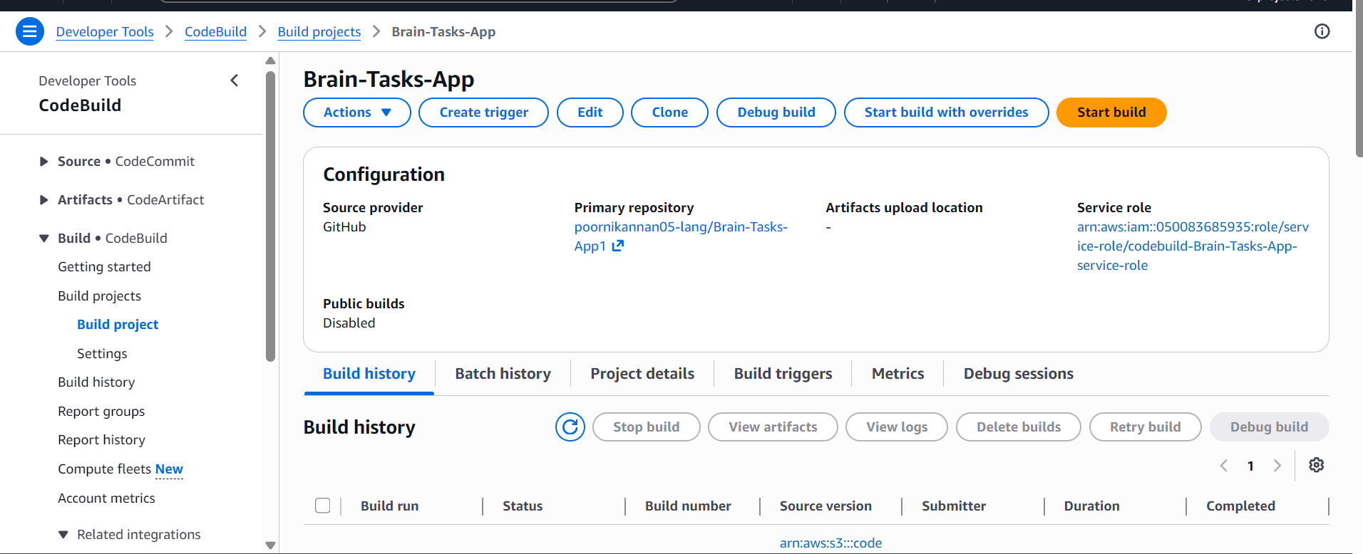

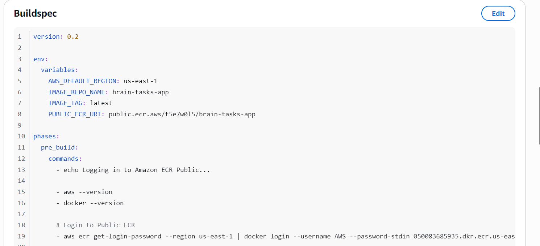

- Source: GitHub
- Build: AWS CodeBuild project
- Deploy: Deploy to EKS via Codepipeline EKS deploy stage..
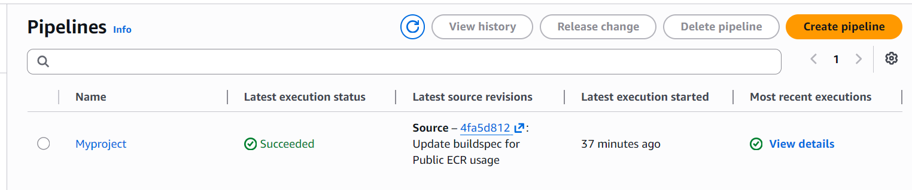

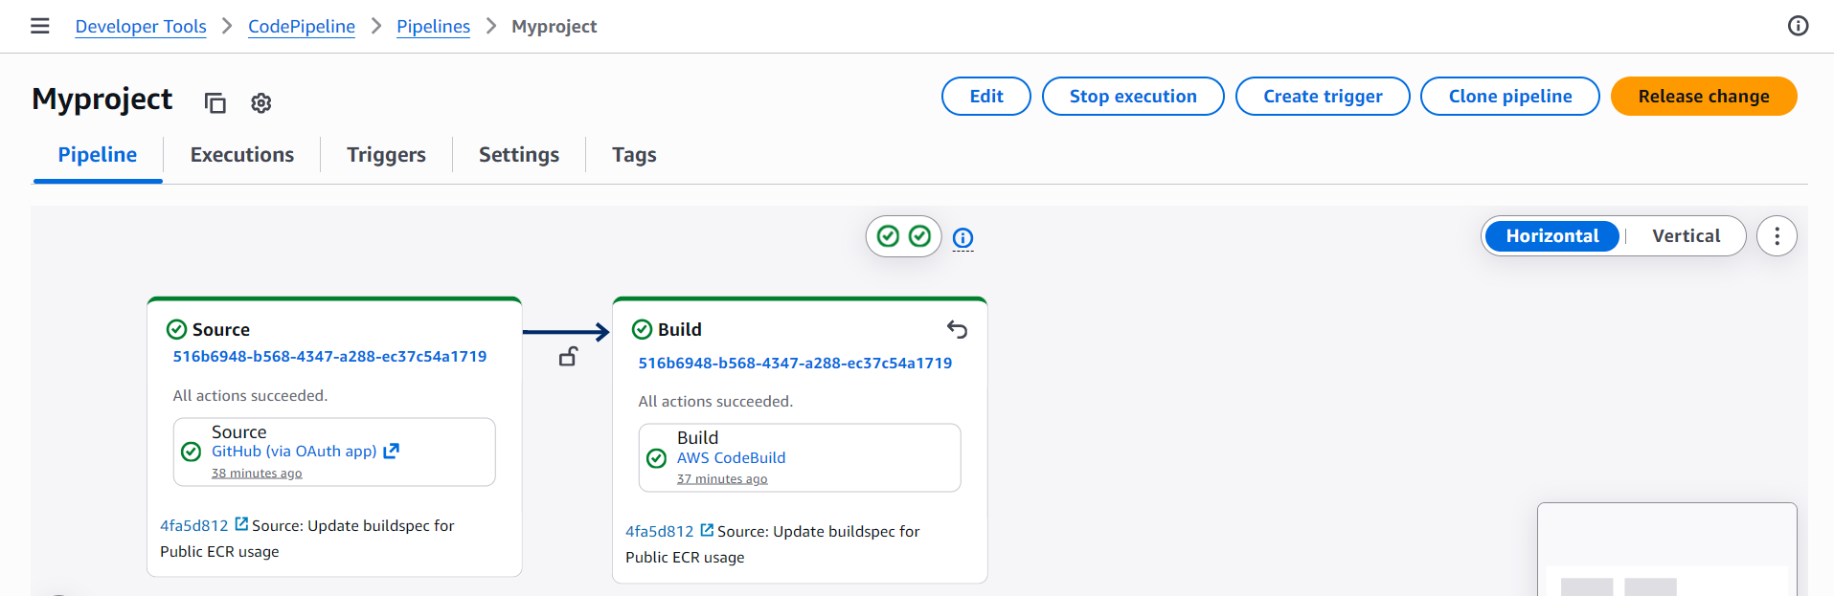

Monitoring:
- Use CloudWatch Logs to track build, deploy, and application logs.

