Docker:
- Dockerize the application by creating Dockerfile
- Build an application and check output using docker image.

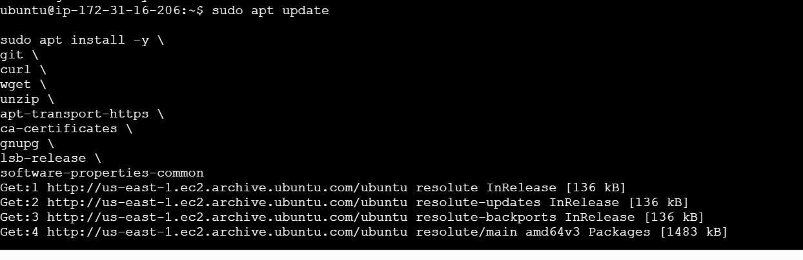

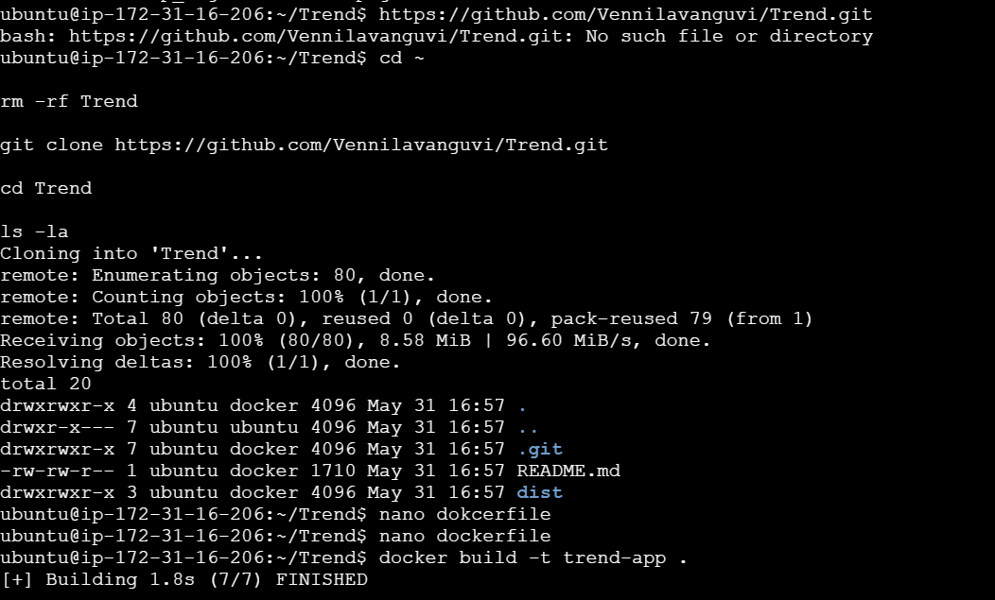
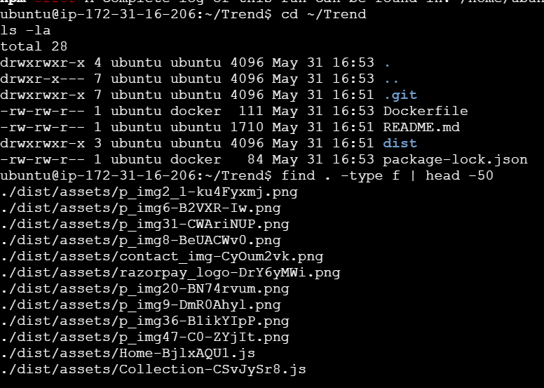

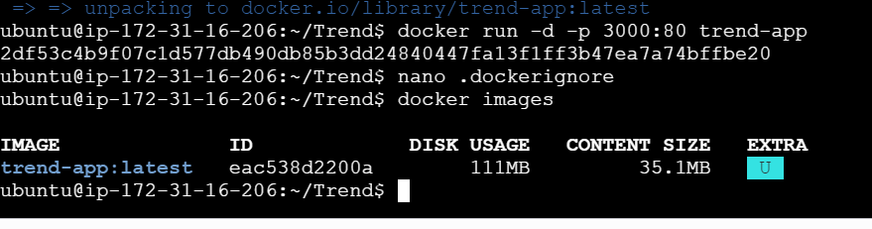

DockerHub:
- Create a DockerHub repository.

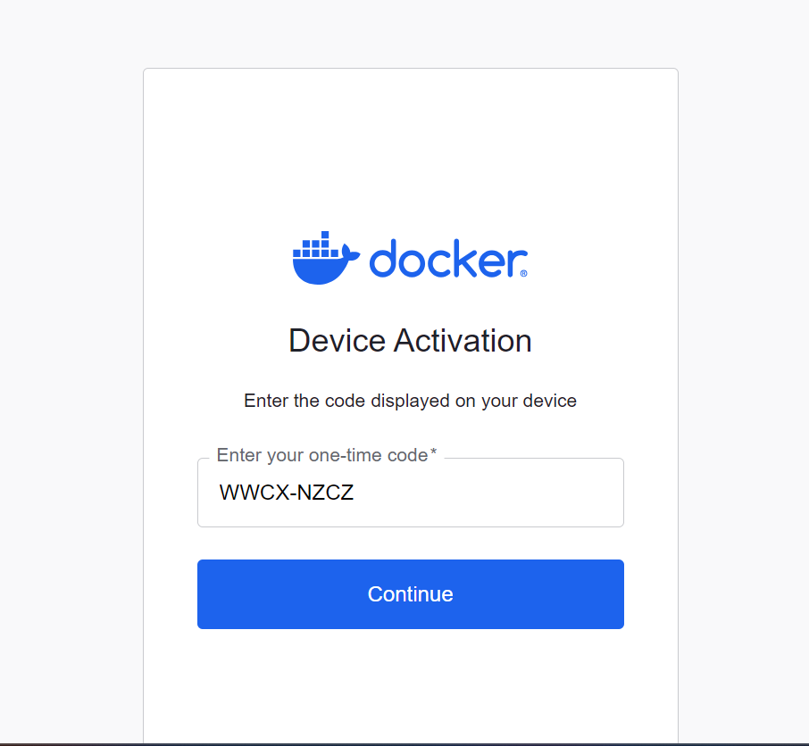

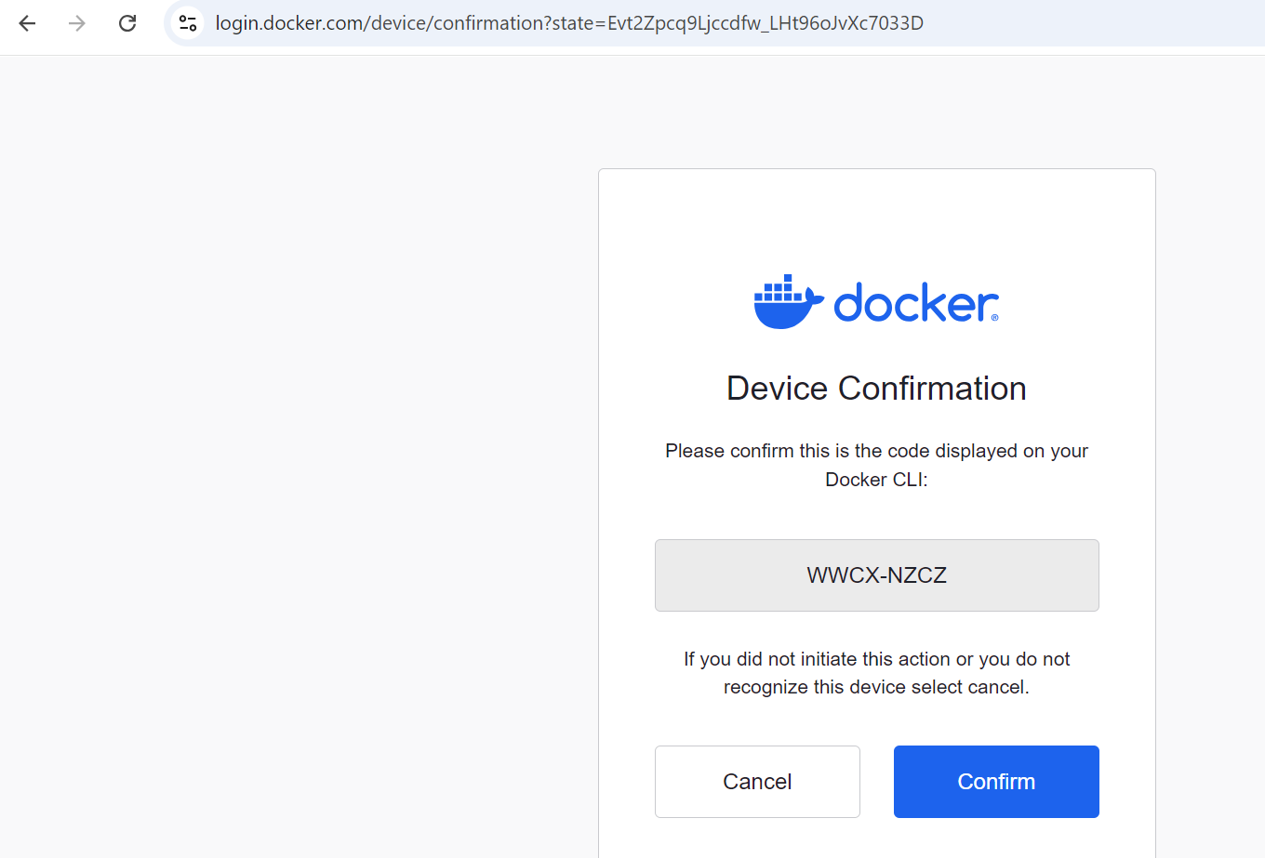
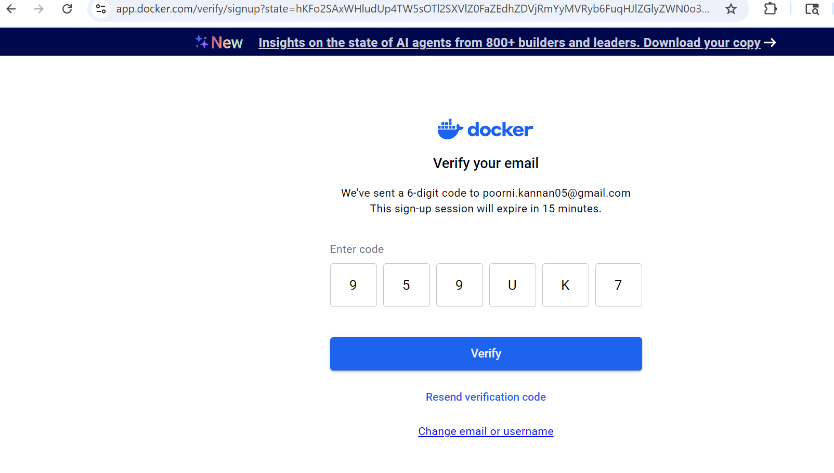
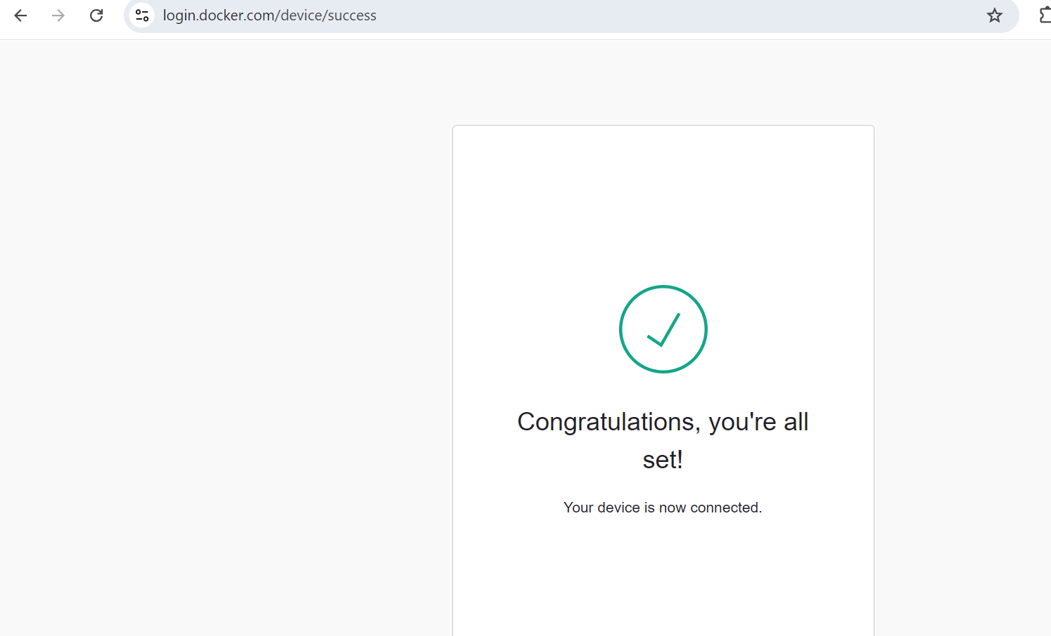

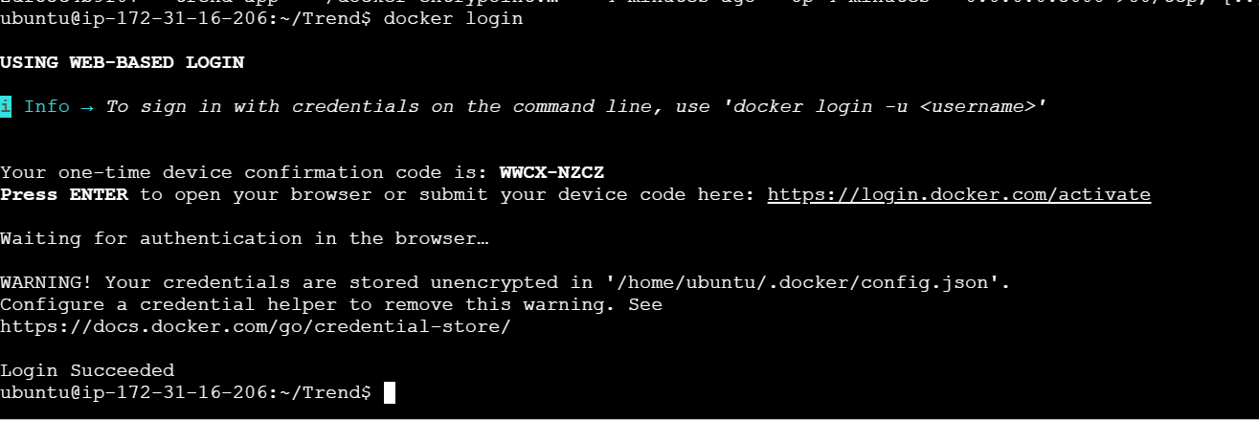
Terraform:
- Define infrastructure in main.tf to create VPC, IAM, EC2 with Jenkins, etc.
- Use terraform command to provision infrastructure.

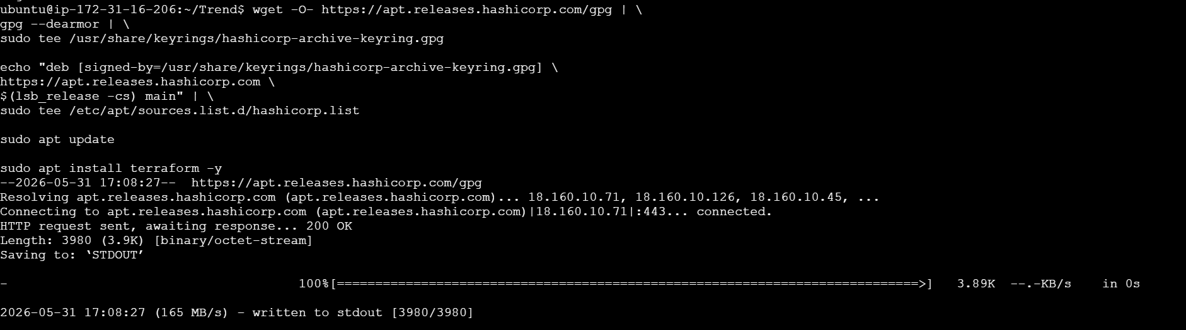
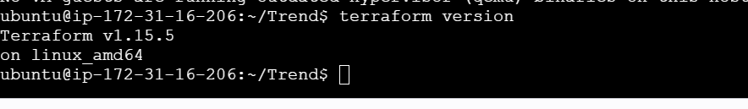
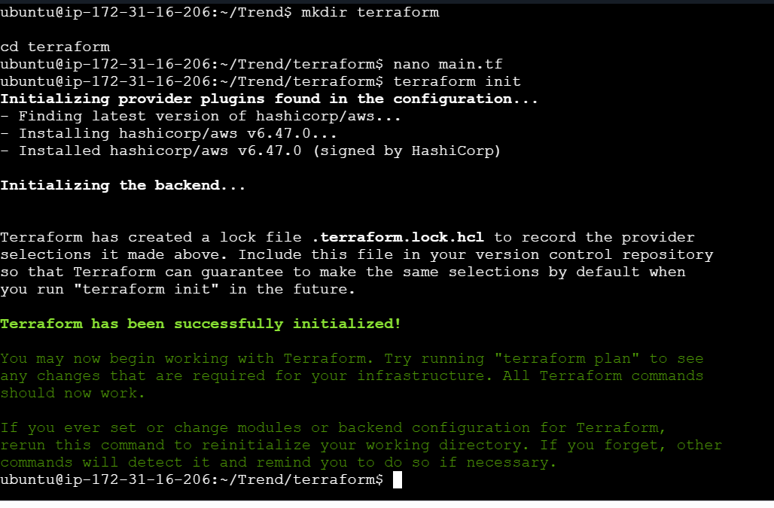
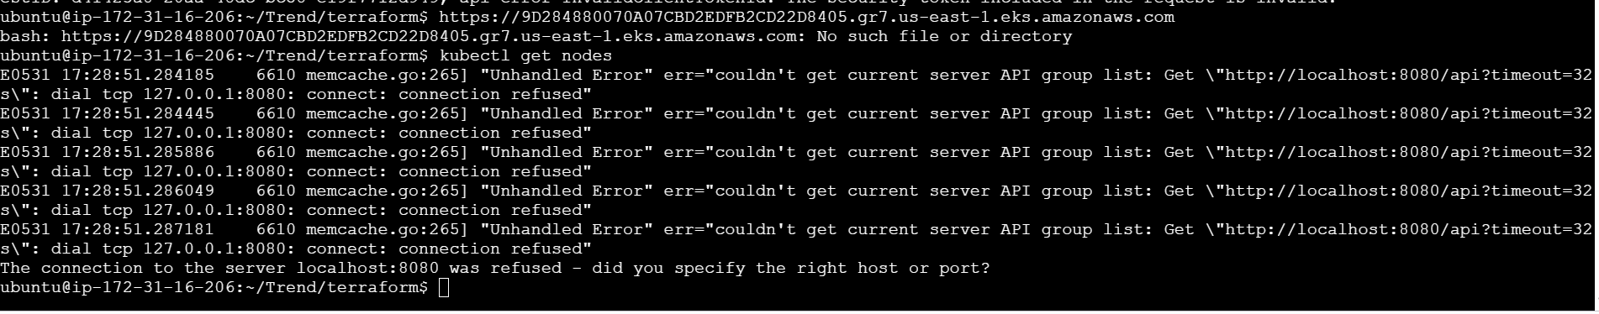
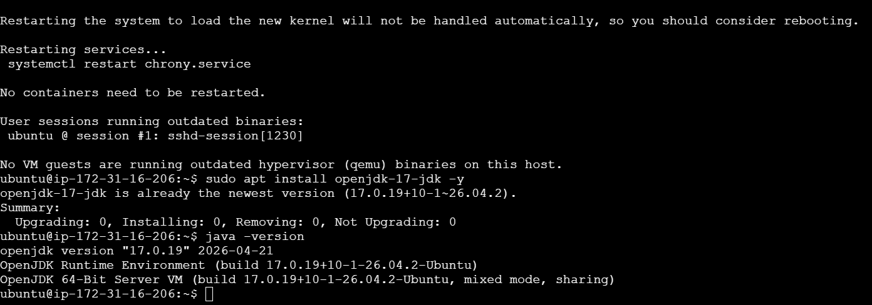
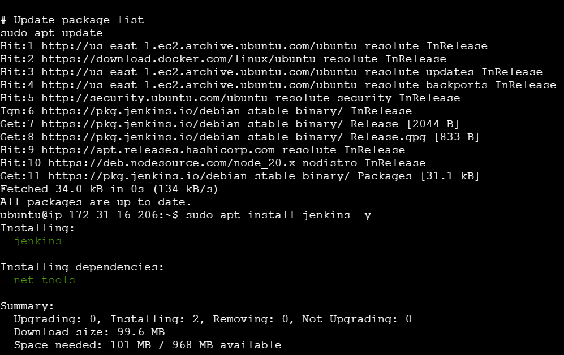
Kubernetes:
- Setup Kubernetes in AWS EKS and Confirm EKS cluster is running.
- Write deployment and service YAML files.
- Deploy using kubectl via Jenkins.
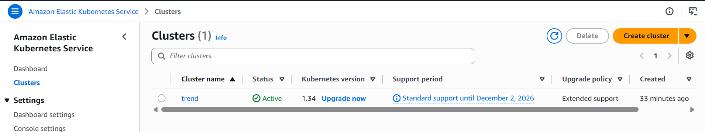
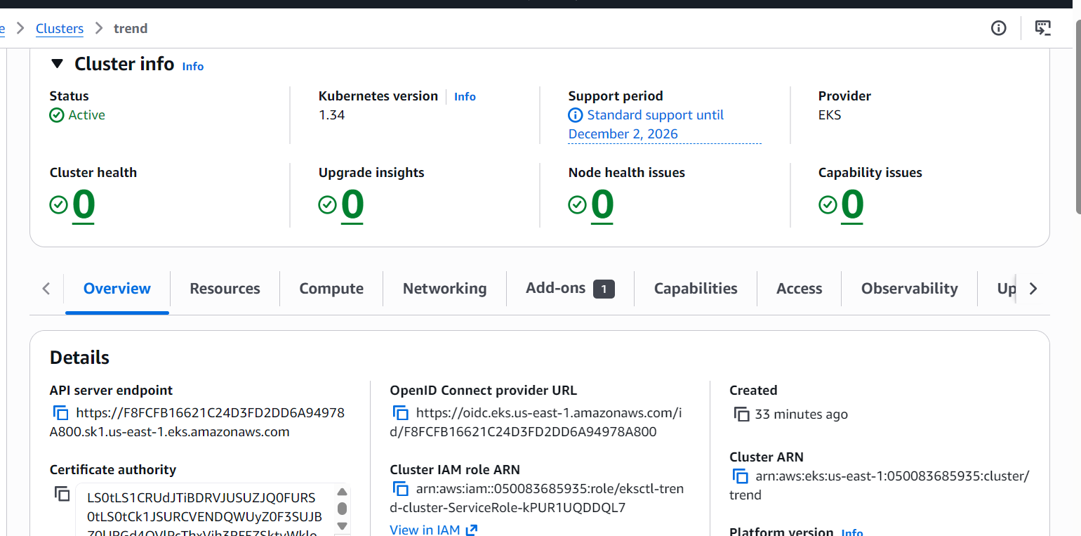

Version Control:
- Push the codebase to a Git provider (GitHub).
- Add gitignore and dockerignore files and use CLI commands to push code.

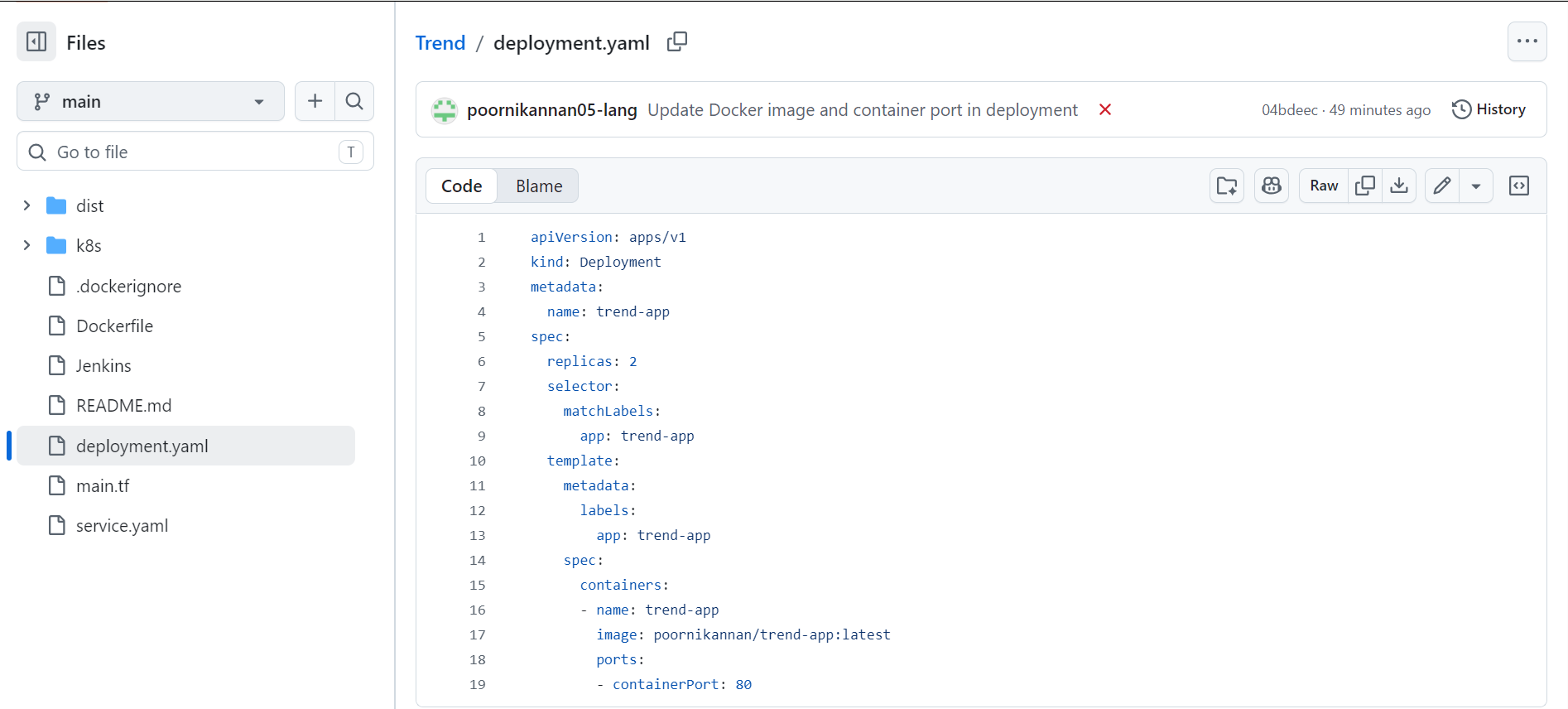

Jenkins:
- Install Jenkins and necessary plugins (Docker, Git, Kubernetes, Pipeline) for build, push &deploy applications.
- Setup Github and jenkins integration using github webhook build trigger for auto build for every commit.
- Create a declarative pipeline script and pipeline project to build, push & deploy using CI-CD.

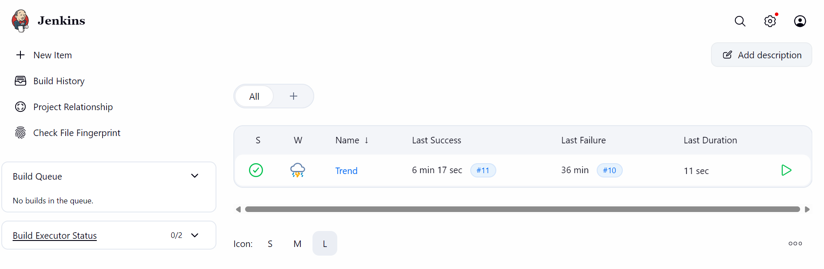
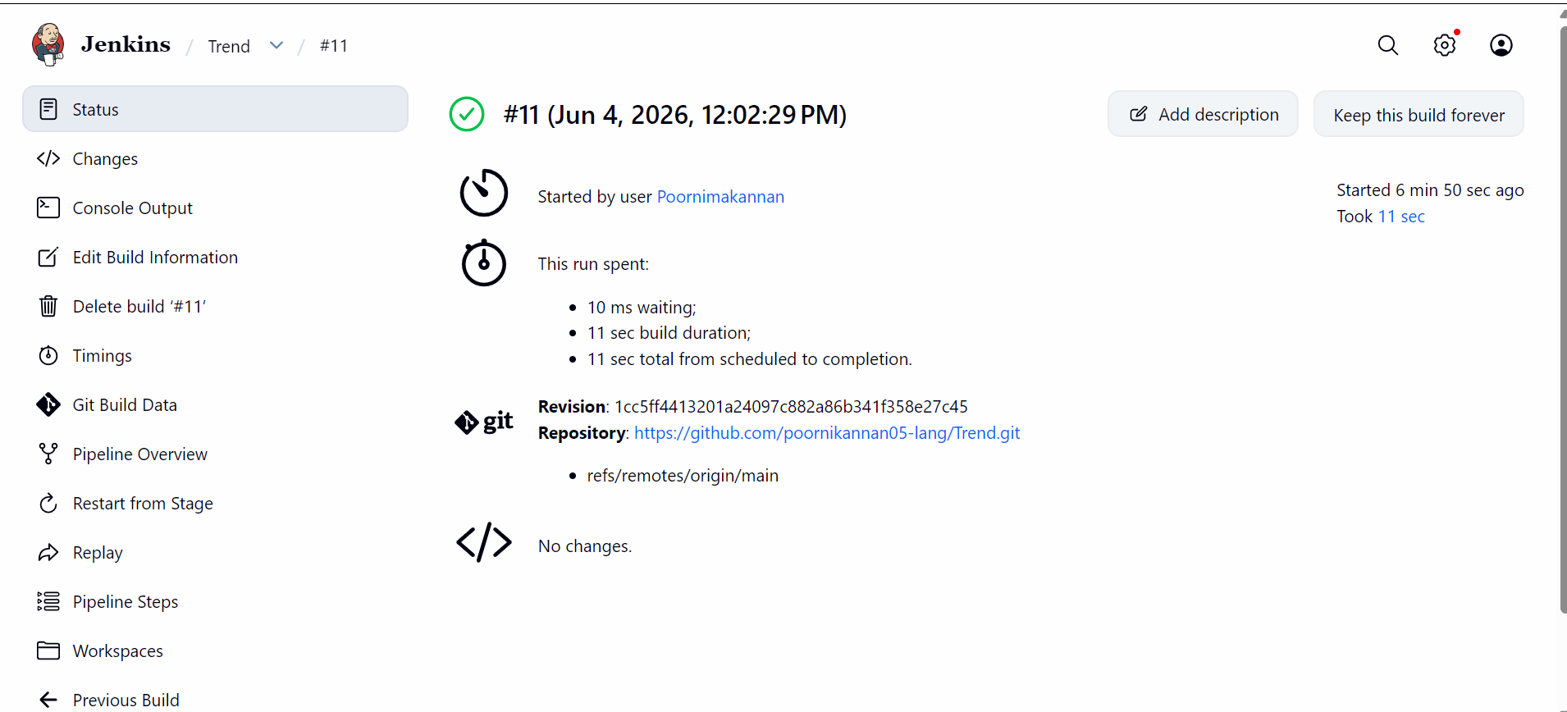


Monitoring:
- Setup a monitoring system to check the health of the cluster or application (opensource) is highly appreciable.

