CLEARVIEW: INTERACTIVE AIR QUALITY INSIGHTS

Google Colab:
https://colab.research.google.com/drive/1kfqIkTHOqHaKEzAGifEXBzQib92FOVpo?usp=sharing

Problem Statement
The growing complexity and fragmentation of air quality data create significant challenges in analyzing and making decisions based on this data. Environmental analysts, policymakers, and the public often face difficulties in interpreting raw air quality data and tracking trends due to inconsistent data sources and the lack of powerful visualization tools. The "Air Quality Index Visualization" project aims to solve this problem by creating an interactive Power BI dashboard that uses advanced data processing techniques like ETL (Extract, Transform, Load), data cleansing, and geospatial analysis. This dashboard will allow users to track AQI trends over time, monitor real-time changes, and compare air quality across different regions. By offering clear and actionable insights, the tool will support better decision-making and contribute to improving environmental sustainability.

Modules To Be Implemented
- Data Collection and Preprocessing
- Data Structuring and Transformation
- Power BI Dashboard Development
- Streamlit Integration
Module Implementation And High-Level Requirements:

- Data Collection and Preprocessing

Step 1: Search for Datasets
- Go to Kaggle (https://www.kaggle.com/) and search for air quality datasets (e.g., AQI, PM2.5, CO, SO2).
- Check government databases or environmental monitoring stations for open datasets (e.g., EPA, EEA, CPCB).

Step 2: Download Data
- Download relevant datasets that include air quality parameters and environmental factors

Step 3: Ensure Data Coverage
- Verify datasets include data from multiple regions and time periods (daily, monthly, yearly).

Step 4: Collect Corresponding Data (City, Date, etc.)
- Ensure Data Completeness: For each record, ensure the city, date, and other relevant details (like meteorological parameters) are present.

- Cross-check Data: Verify that each record has corresponding air quality and meteorological data for accurate analysis.
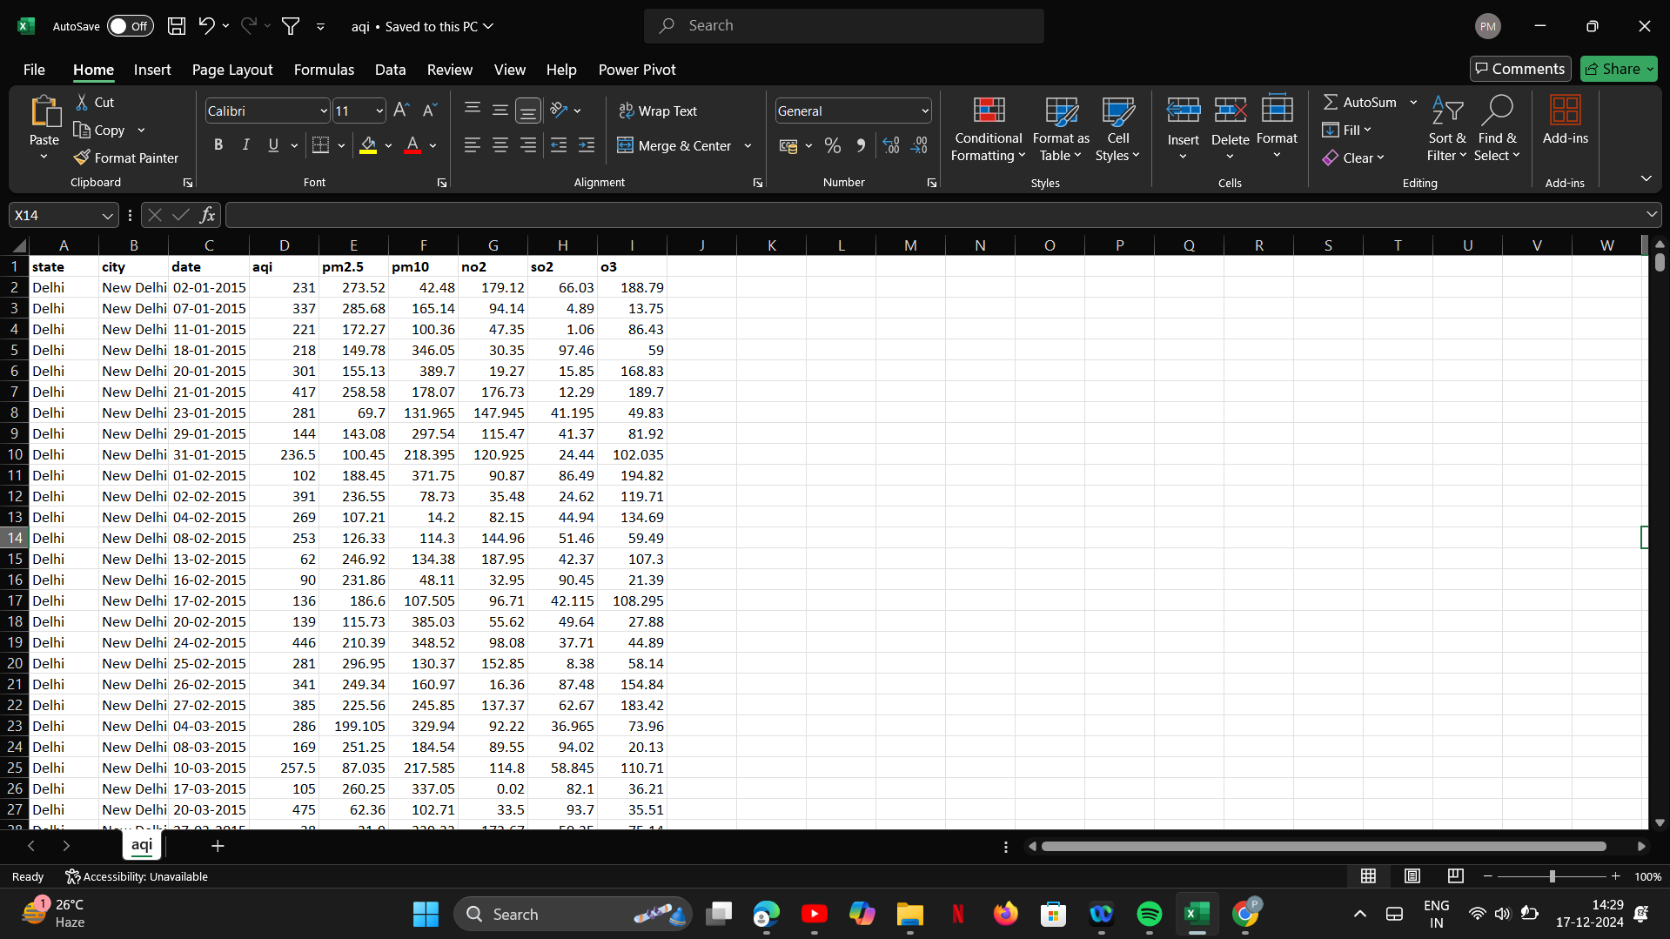
Figure 1: Clearview Interactive Air Quality Insights

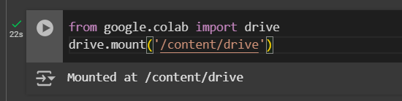
Step 5: This code mounts Google Drive to Colab, enabling access to Drive files as local files.
Figure 2: Mount Google Drive

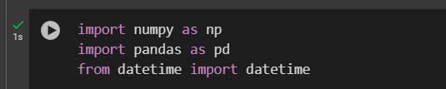
Step 6: numpy(as np) is used for numerical operations like handling NaN values and calculations. pandas(as pd) is used for reading, manipulating, and processing the CSV data.datetime is imported for potential date-related operations, though not used directly in this script.
Figure 3: Import Necessary Libraries

Step 7: Reads the dataset aqi.csv into a DataFrame (df) using pandas.
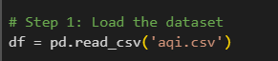
Figure 4: Load the Dataset

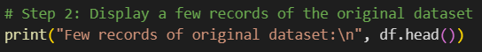
Step 8: Prints the first five rows of the dataset to preview its structure and contents using df.head().
Figure 5: Display a Few Records

Step 9: df.isnull() checks for missing data, and sum() counts the missing values in each column.
Figure 6: Check for Missing Values

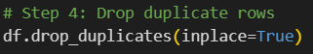
Step 10: df.drop_duplicates(inplace=True) removes duplicate rows directly in the DataFrame.
Figure 7: Drop Duplicate Rows

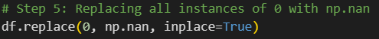
Step 11: All zeros in the dataset are replaced with NaN (Not a Number). This is useful if zeros are invalid values that need to be treated as missing data.
Figure 8: Replace All Zeros with NaN

Step 12: df.select_dtypes(include=[np.number]) selects only numerical columns.
.median() calculates the median of each numerical column.
.round(2) rounds the medians to two decimal places.
df.fillna() fills the missing values with the corresponding column's median.
Figure 9: Fill Missing Values with Median

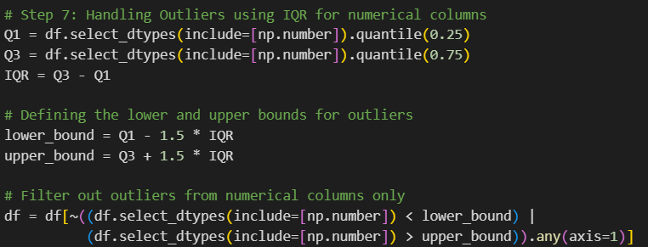
Step 13: quantile(0.25) and quantile(0.75) calculate the 25th and 75th percentiles for numerical columns. The IQR is the difference between Q3 and Q1. The lower and upper bounds are 1.5 times the IQR below Q1 and above Q3, marking outlier limits.The filter removes rows where any numerical value is outside the outlier bounds.
Figure 10: Handling Outliers Using IQR

Step 14: Filters rows where aqi is greater than zero, as negative values are unrealistic.
Converts the pm2.5 column to numeric, setting invalid values as NaN using errors='coerce'.
Figure 11: Handle Data Inconsistencies

Step 15: Defines parse_date() to convert date strings in two formats; returns NaT if both fail. Uses apply() to apply parse_date() to each entry in the Date column for handling format inconsistencies.
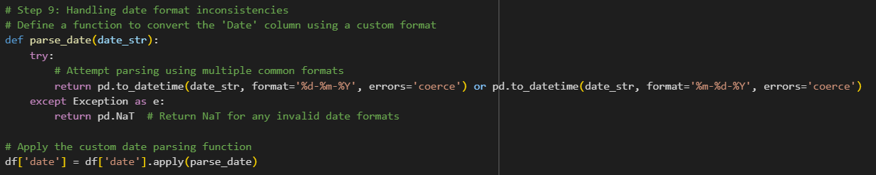
Figure 12: Handling Date Format Inconsistencies

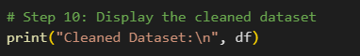
Step 16: Prints the cleaned DataFrame to verify the transformations.
Figure 13: Display the cleaned dataset
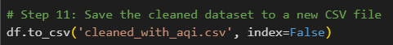
Step 17: Saves the cleaned DataFrame to a new CSV file (cleaned_with_aqi.csv) without the index column.
Figure 14: Save the cleaned dataset

- Data Structuring, Transformation and PowerBI dashboard development:
- Data Structuring
  - Clean data (remove duplicates, handle missing values).
  - Organize into tables (fact and dimension) using a star schema.

- Data Transformation
  - Normalize AQI values and standardize data formats.
  - Aggregate data (e.g., average AQI by state, month).
  - Create new features (e.g., AQI categories, pollutant proportions).

- Data Splitting and Categorization
  - Segment data by regions, AQI levels, and time (Year → Quarter → Month).
  - Prepare data for trend and regional comparisons.

- Dashboard Layout Design
  - Plan sections: Overview, Regional Comparisons, Time Trends.
  - Use a clean and structured grid layout with intuitive color themes.

- Visualizations
  - Line/area charts: AQI trends over time.
  - Bar/stacked bar charts: Regional comparisons.
  - Pie/donut charts: Pollutant proportions.
  - Maps: AQI distribution by state/city.
  - Funnel/waterfall charts: AQI changes.

- Interactivity
  - Add filters and slicers for state, city, year, and pollutant.
  - Enable drillthrough for detailed insights.
  - Ensure cross-highlighting between visuals.
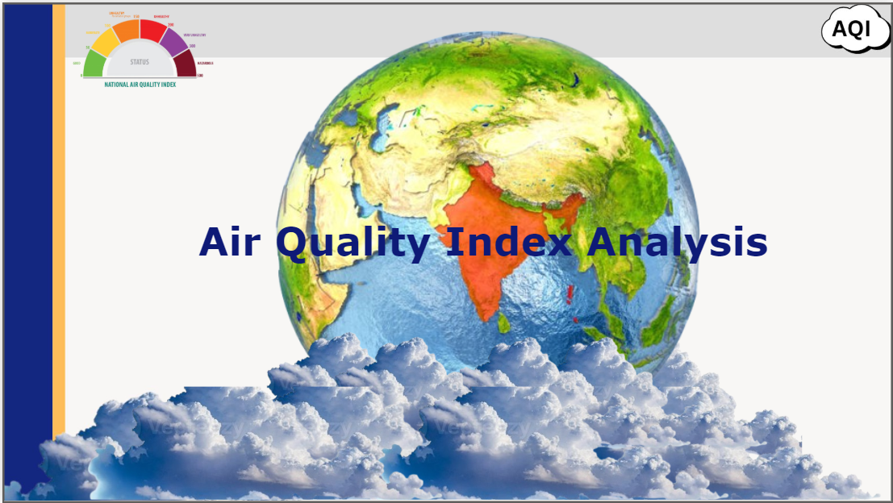
Figure 15: Dashboard of Air Quality Index
ClearView: Interactive Air Quality Insights is an advanced dashboard that offers detailed analysis of air quality across states, cities, and time periods. It provides key metrics such as AQI, PM2.5, PM10, NO2, SO2, and O3, helping users understand pollutant concentrations and their health impacts. The AQI combines these pollutants into a single index, where higher values indicate worse air quality. PM2.5 and PM10 are particulate matter, while NO2, SO2, and O3 are gaseous pollutants contributing to respiratory issues and smog. Users can filter data by State, City, and Date, allowing for localized, real-time monitoring of air quality trends. ClearView is a valuable tool for tracking pollution levels and assessing their impact on health, research, and policymaking.

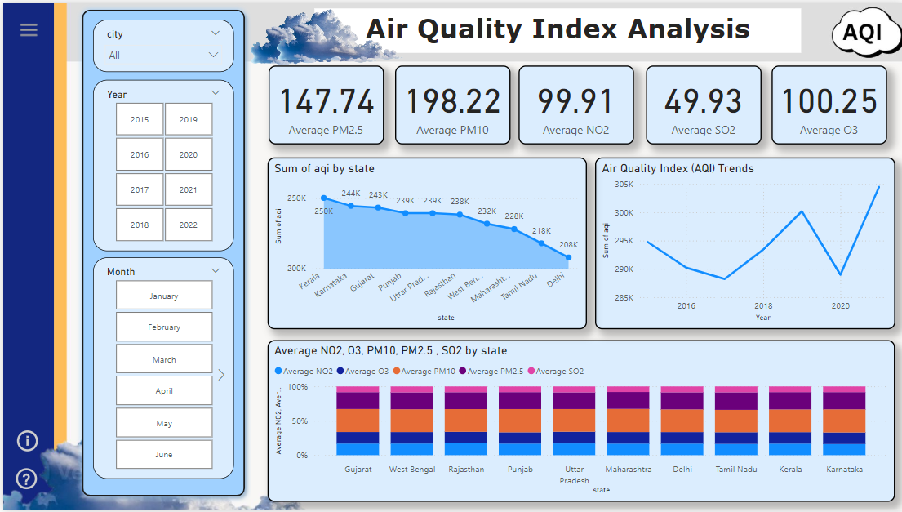
Figure 16: Air Quality Dashboard Overview: Slicers and Key Visualizations
The dashboard starts with slicers on the left sidebar to filter the data by city, year, and month, allowing users to narrow down their focus to specific locations and time periods. The City Slicer provides a dropdown to select a city, the Year Slicer uses checkboxes to choose the desired year, and the Month Slicer lets users filter data by specific months, such as March.
The top row displays key performance metrics using cards, showing the average AQI values for major pollutants like PM2.5, PM10, NO2, SO2, and O3. These metrics provide a quick overview of air quality for the selected filters.
Below the cards, an area chart represents the total AQI by state, visually displaying contributions from each state, helping users understand how regional factors impact the overall air quality. The line chart tracks AQI trends over time, revealing peaks and dips, while the stacked column chart breaks down the distribution of different pollutants (e.g., NO2, PM10) across states, showing which pollutants dominate in different regions.

Figure 17: Advanced Air Quality Insights: Visualizing Pollutant Distribution and Trends
The dashboard expands to include more interactive features. The State Slicer allows users to filter AQI data by state, offering a more localized view of the air quality. Similarly, the City Slicer filters data by city, and the Treemap provides a visual distribution of pollutant gases (e.g., PM2.5, NO2) by their relative contribution to the AQI. This helps users understand which pollutants contribute most to the air quality issues in different areas.
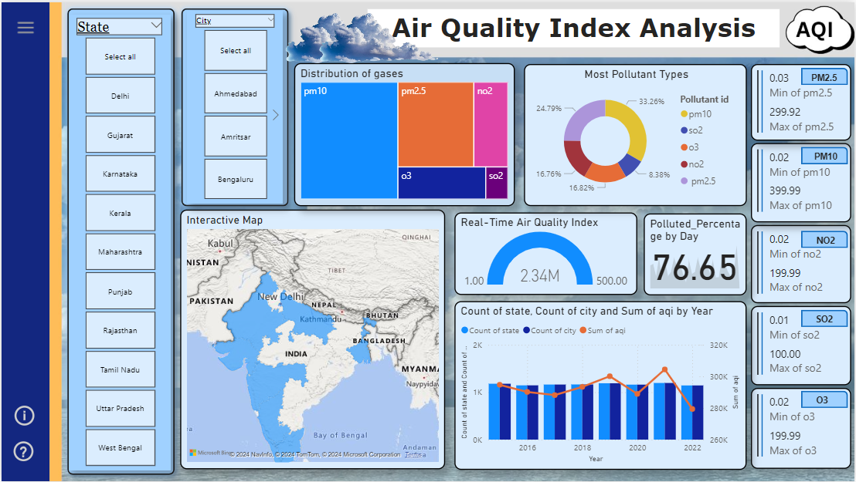
A Donut Chart offers a percentage breakdown of each pollutant's contribution to the AQI, giving users a clear view of the major pollutants in the air. The Interactive Map displays AQI data geographically, highlighting areas with high and low pollution levels across states and cities, allowing users to see where the worst air quality is located.
The Gauge Chart offers a snapshot of the current AQI value, showing real-time air quality in a visually engaging format. The Polluted Percentage Card shows the percentage of days with polluted air within the selected timeframe, helping users understand the frequency of pollution. The Column & Line Chart combines year-wise data on the number of polluted cities and the sum of AQI per state, making it easy to compare trends over multiple years. Lastly, the Pollutant Cards provide key statistics (minimum, maximum, and average values) for each pollutant, offering granular insights into the data.

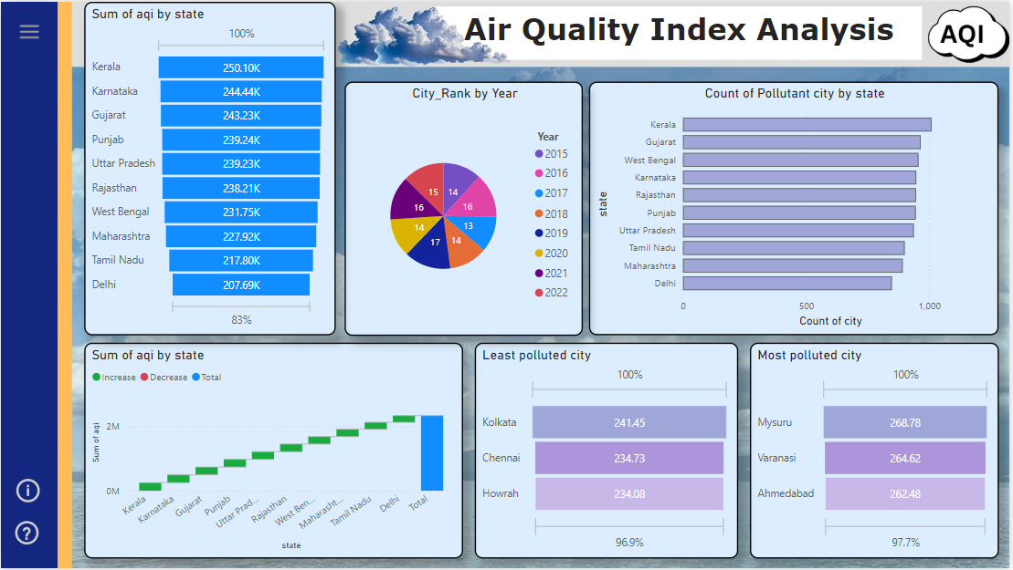
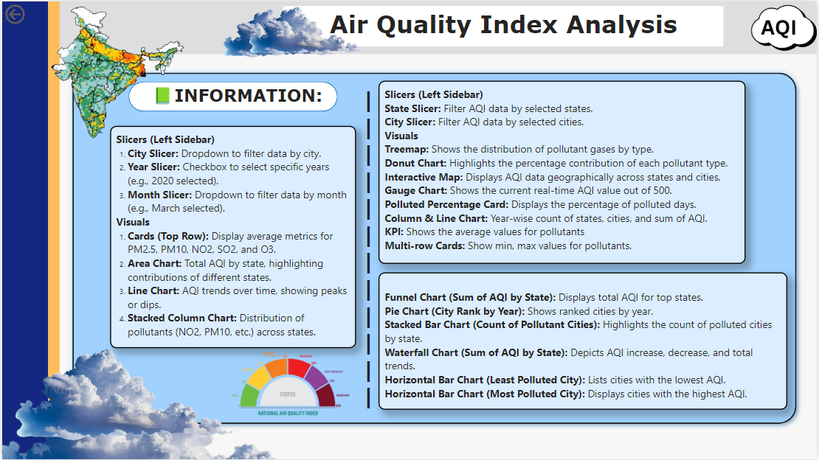
Figure 18: Interactive AQI Analysis Dashboard about Information
Figure 19: Interactive AQI Analysis Dashboard: Visualization of Pollutant Distribution and Trends
This section introduces even more detailed visualizations. The Funnel Chart shows the sum of AQI by state, helping visualize how AQI is distributed across different regions, with larger contributions at the top and smaller ones toward the bottom. This helps identify the states with the highest AQI levels.
The Pie Chart ranks cities by AQI for each year, allowing users to see which cities have the worst air quality over time, while the Stacked Bar Chart shows the count of polluted

cities by state, making it easy to compare how many cities in each state are experiencing significant pollution.
The Waterfall Chart highlights AQI changes over time, illustrating increases, decreases, and overall trends, helping users understand shifts in air quality. The Horizontal Bar Chart labeled Least Polluted City lists cities with the lowest AQI values, offering a positive view of air quality. Conversely, the Horizontal Bar Chart labeled Most Polluted City displays cities with the highest AQI values, revealing the most polluted areas.

- Exploring and Streamlit Integration

- Streamlit Overview: Streamlit is a free Python library that helps developers create interactive web applications for data science and machine learning projects. It is easy to use and enables the quick development of apps without requiring extensive coding skills. Key features of Streamlit include real-time interaction, support for advanced visualizations, and rapid app creation. It is ideal for building dashboards, reports, and dynamic visualizations. Streamlit apps can also be easily shared online using platforms like Streamlit Sharing, Heroku, or AWS.

- Streamlit and Power BI Integration: In this project, Streamlit will be used to build a web application that integrates a Power BI dashboard. The dashboard will be embedded within the app using an iframe, allowing seamless display of charts and visualizations. The main objective is to ensure the app is interactive and user-friendly, enabling users to explore data, filter information, and gain valuable insights from the Power BI dashboard effortlessly. This integration combines the strengths of Streamlit and Power BI, providing a smooth and engaging experience for users
1. Login/Signup Flow
- Signup Page: Users can register by entering their details (name, email, and password).
- Login Page: Existing users can log in with their credentials.
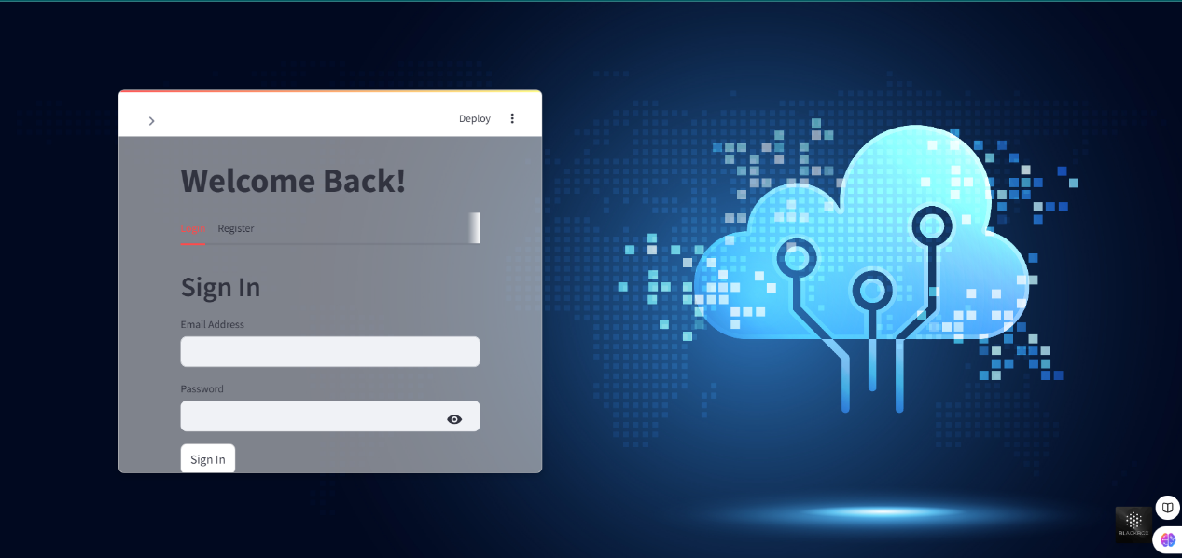
- Post-login: Upon successful login, users are redirected to the Home Page.
Figure 20: Login page
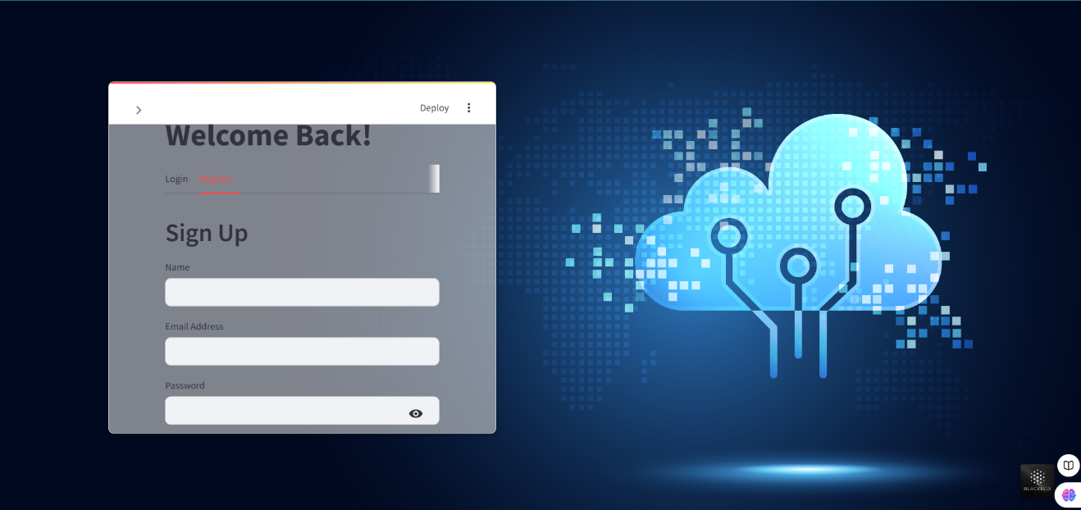
Figure 20: Signup page

2. Navigation and Home Page
- Home Page: The central hub with a navigation menu that includes:
  - Login/Signup: Visible when the user is logged out, allowing them to access login or signup.
  - Home: Takes the user back to the main overview or landing page.
  - Dashboard: Directs users to data analysis tools for working with uploaded data.
  - Conclusion: A page summarizing the insights and findings from the analysis.
  - Contact/Feedback: A form for users to leave feedback or ask questions.

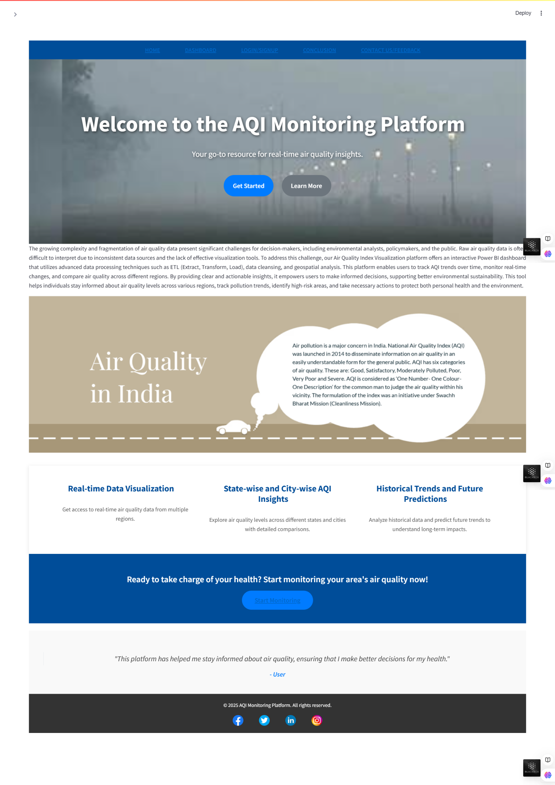
Figure 21: Main page
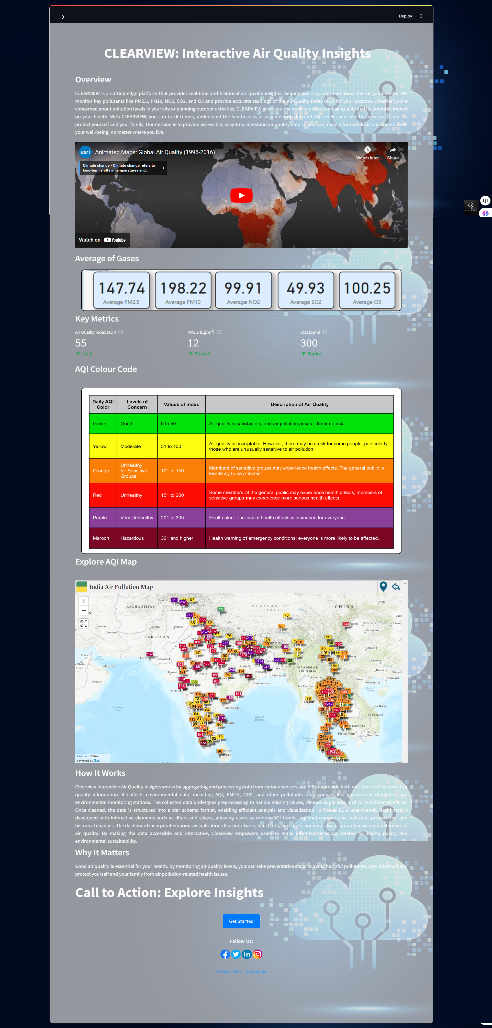
Figure 22: Home page
3. Dashboard Functionality
- Sidebar with “Upload File” Option: Users can upload datasets, for example, air quality data in CSV format.
- Data Display: The uploaded data is shown in a table format for users to review.
- Data Cleaning Tools: Includes options for handling missing data, filtering rows, or correcting errors in the data.
- Graph and Chart Generation: Users can create interactive graphs (e.g., bar charts, line charts, pie charts) to visualize trends in the data.
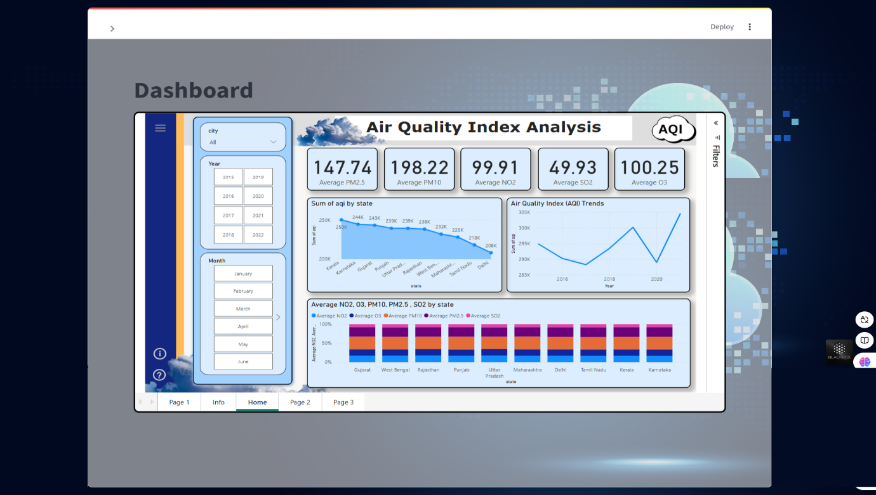
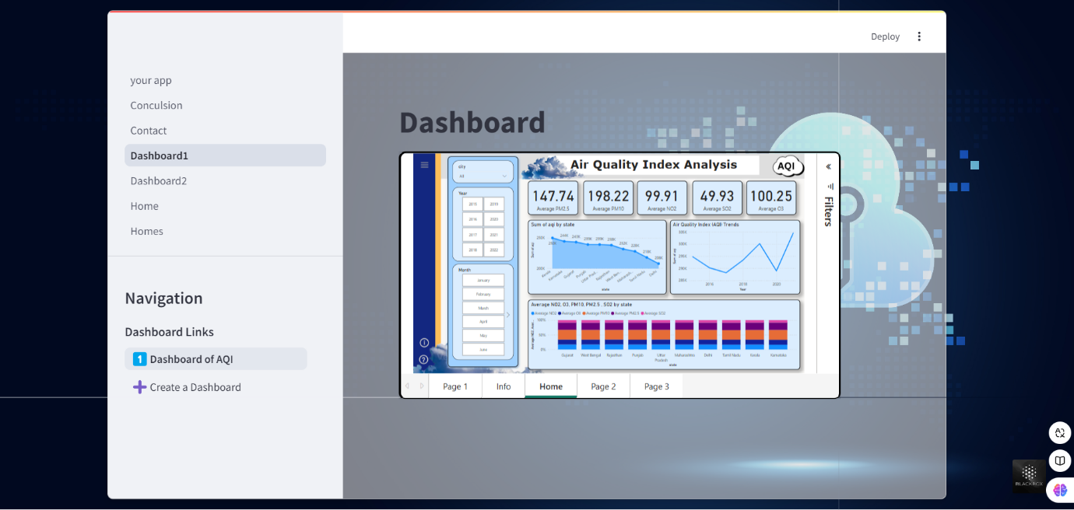
- Create Dashboard Button: Opens an interface where users can create customized dashboards for specific analyses.
Figure 23: Dashboard
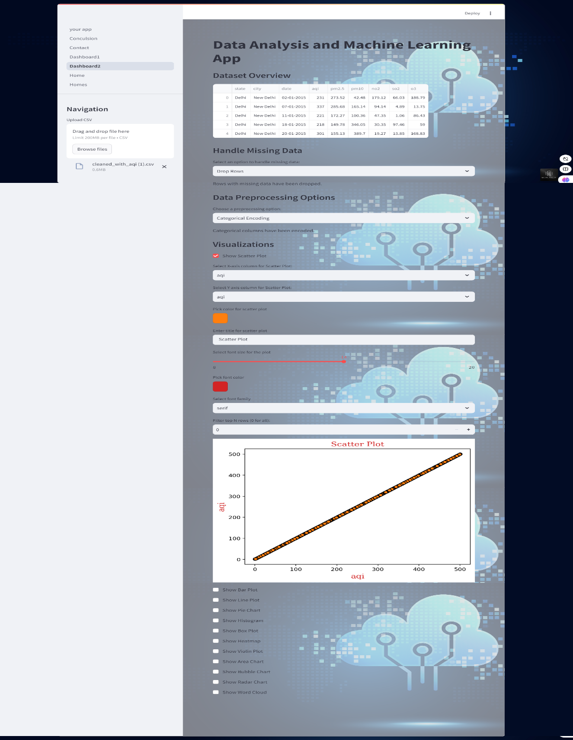
Figure 24: Create Dashboard
4. Conclusion Page
- A well-organized summary of the data findings:
  - Key Findings: Presents air quality metrics like PM2.5, PM10, and AQI trends.
  - Regional Comparison: Highlights differences in pollution levels across various regions.
  - Health and Environmental Implications: Discusses how pollution affects human health and ecosystems.
  - Trend Analysis: Analyzes yearly and seasonal trends, and identifies the causes such as industrial activities or climate change.
  - Recommendations: Provides actionable suggestions like stricter pollution control norms and increased public awareness.
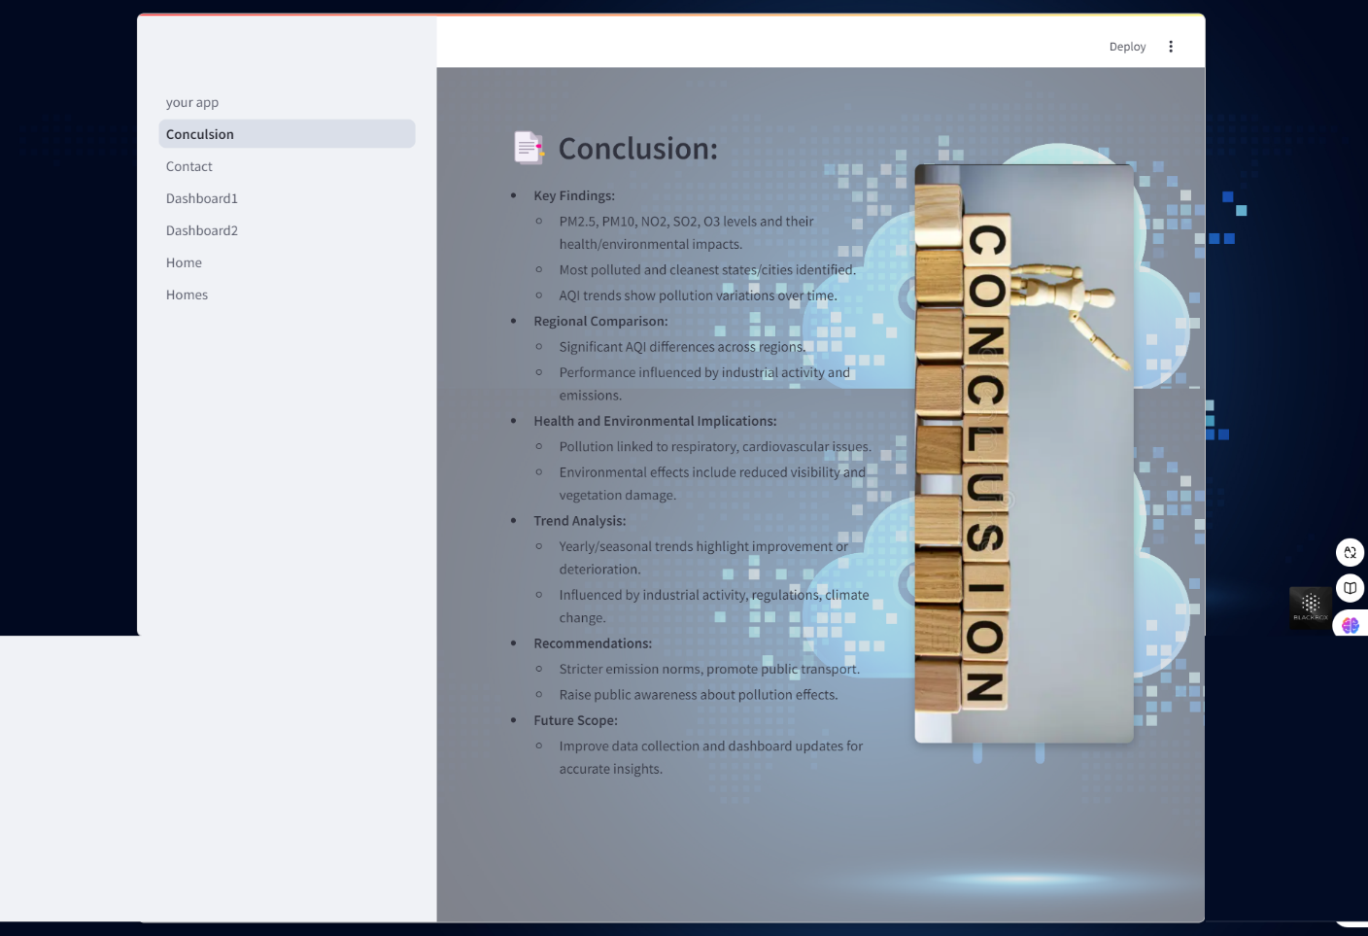
  - Future Scope: Discusses ways to improve data collection methods and dashboard features for better analysis.
Figure 25: Conclusion
5. Contact/Feedback Page
- Sidebar Dropdown Menu:
  - Feedback Form: Collects user opinions and suggestions for the platform.
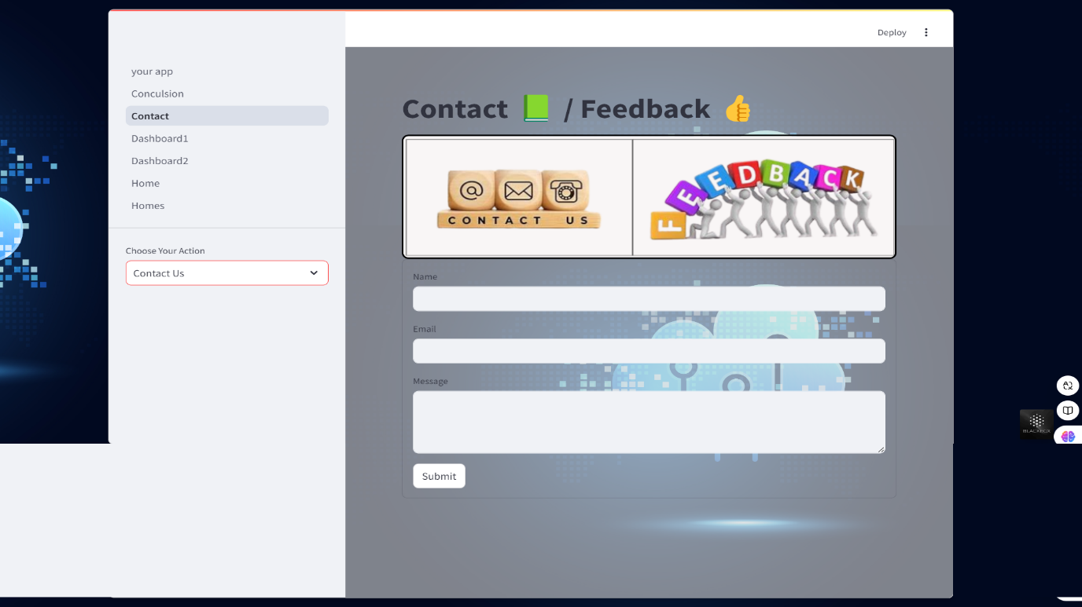
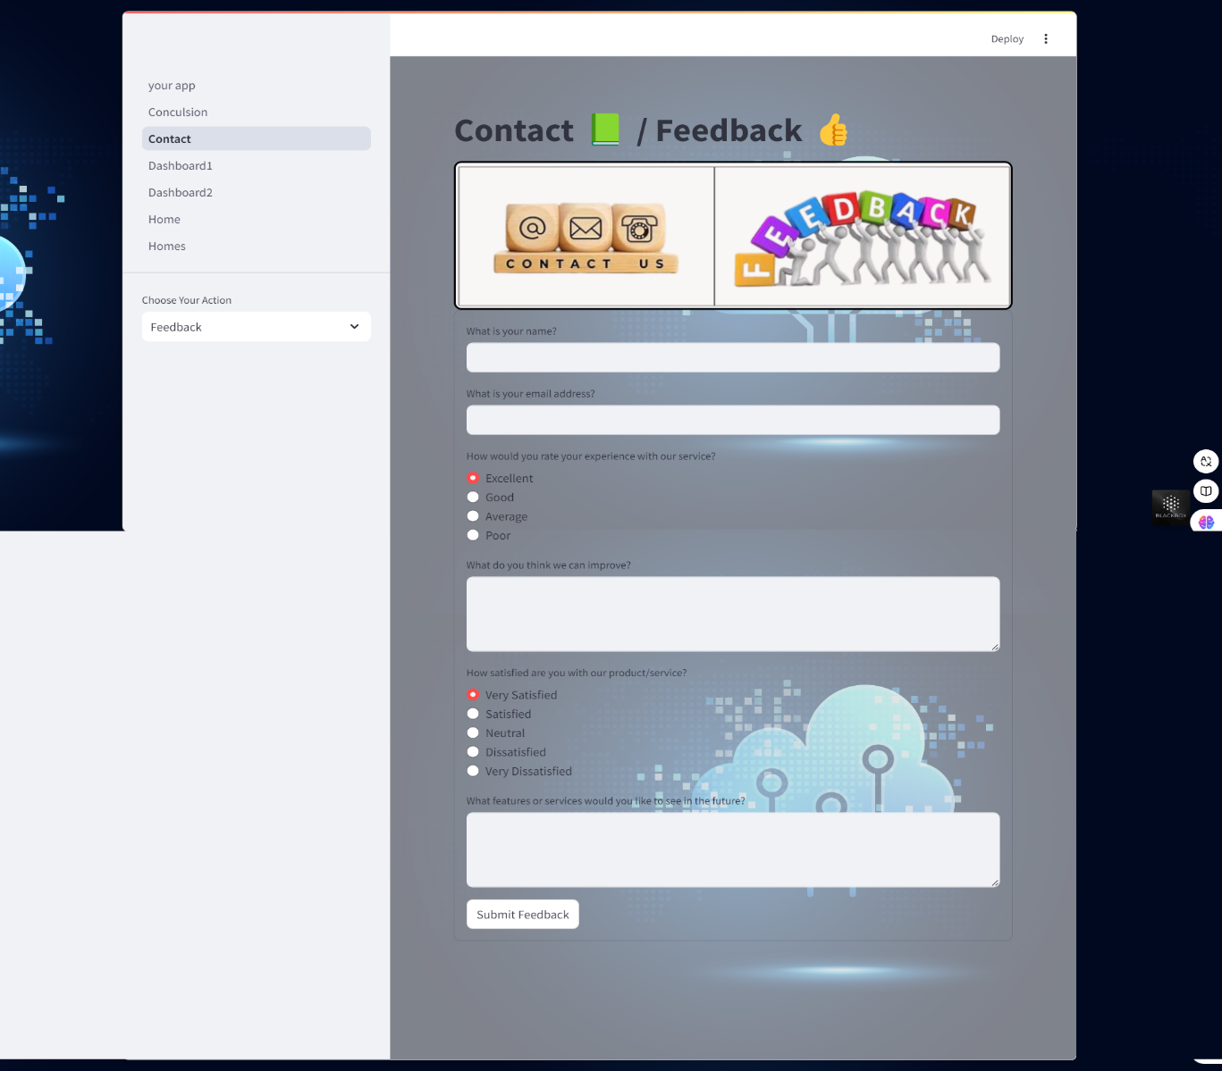
  - Contact Us Form: A way for users to submit queries or request assistance.
Figure 26: Feedback Form and Contact us Form

