EKS Cluster:

Postgresql-EKS:

3. Postgresl Service installation:

Kubectl get svc output:

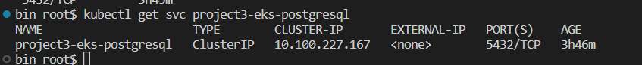

Kubectl get pods output

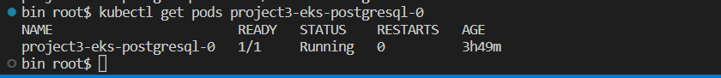

Screenshots:

1. AWS CodeBuild Pipeline

1. AWS ECR

1. Kubectl get svc

1. Kubectl get pods

1. Kubectl get svc project3-eks-postgresql

1. Kubectl describe deployment postgresql

1. AWS Cloud Watch:

CPU Utilization:

