PM2.5 Air Pollution Prediction Using Machine Learning and Deep Learning
A Comparative Study on Real-World Beijing Air Quality Data
Student: POORNIMA V Batch: DSBO2 Category: Deep Learning (Time Series Regression)
The sections follow the project notebook (sections 0 to 14).

PHASE 1 - Data Selection, EDA, Data Cleaning, Data Preprocessing

0. Project Setup (Google Colab + Google Drive)
- The project runs in Google Colab, and Google Drive stores the data, saved files and the app.
- A fixed seed (42) makes the results repeatable.

1. Problem Definition

1.1 Business / Real-World Problem Statement
- PM2.5 is very fine dust and smoke (particles smaller than 2.5 micrometres). It goes deep into the lungs and can cause breathing and heart problems.
- Stations show the level now, but people, schools and city authorities need the level in advance, so they can act.
- This project uses 5 years of hourly pollution and weather readings from Beijing to predict PM2.5.

1.2 Project Objectives
- Understand the real-world problem of air pollution.
- Analyze and preprocess a real hourly time-series dataset with missing values.
- Build machine learning models (baseline, Random Forest) and deep learning models (LSTM, GRU).
- Compare experiments using MAE, RMSE and R2.
- Deploy the final solution as an API.

1.3 Target Users / Stakeholders
- General public and people with asthma or heart conditions, schools and hospitals, city authorities and environmental agencies.
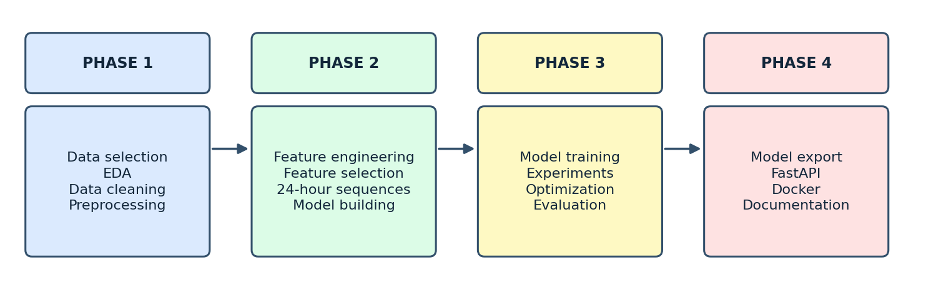
Figure 1: Project workflow (four phases).

2. Dataset Selection & Understanding

2.1 Dataset Source
- UCI Machine Learning Repository, Beijing PM2.5 Data (Liang et al., 2015, Proceedings of the Royal Society A).

2.2 Dataset Description
- 43,824 records (one row per hour), 13 columns, from 1 January 2010 to 31 December 2014.
- Regression problem: the target is a number, so there are no classes.
- PM2.5 is measured at the US Embassy in Beijing. Weather data is from Beijing Capital International Airport.
- Known issue: the pm2.5 column has missing values.

2.3 Dataset Overview
- 8 integer columns, 4 float columns and 1 text column.
- Only pm2.5 has missing values: 2,067 (about 4.7%).
- pm2.5 is right-skewed (mean 98.6, median 72, maximum 994).

2.4 Feature / Data Description
Feature | Description
No | Row number (not used)
year, month, day, hour | Date and time of the reading
pm2.5 | PM2.5 in ug/m3 (target)
DEWP | Dew point (degrees C)
TEMP | Temperature (degrees C)
PRES | Air pressure (hPa)
cbwd | Combined wind direction (text)
Iws | Cumulated wind speed (m/s)
Is | Cumulated hours of snow
Ir | Cumulated hours of rain

2.5 Target Variable / Class
- pm2.5: concentration of fine particles in ug/m3. A higher value means more polluted air.

3. Exploratory Data Analysis (EDA)

3.4 Missing Value Analysis
- 2,067 missing PM2.5 values (4.7%) in 214 gaps. About 91% of the gaps are 24 hours or shorter, and most are in 2010 to 2012.
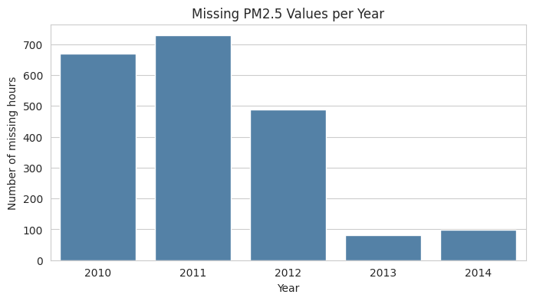
Figure 2: Missing PM2.5 hours per year.

3.5 Class Distribution (Target Distribution)
- PM2.5 is right-skewed with many high spikes. About 4.2% of values are above 300.
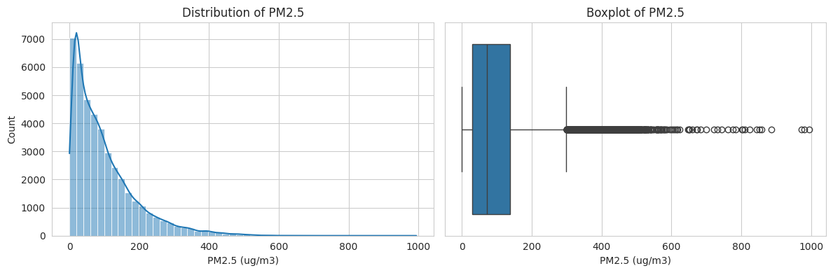
Figure 3: Distribution and boxplot of PM2.5.

3.6 Correlation / Relationship Analysis
- Weather columns alone have weak correlation with PM2.5. The strongest are wind speed (-0.25) and dew point (0.17).
- The previous hour is very strongly related to the current hour (0.97). The link falls to about 0.4 after 24 hours.
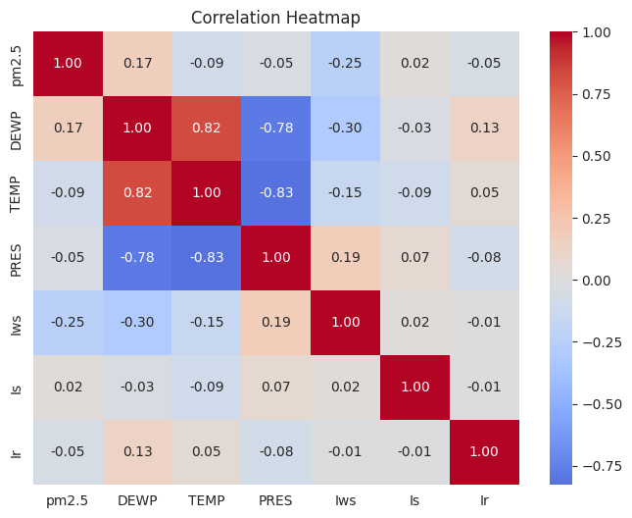  Figure 4: Correlation heatmap. | 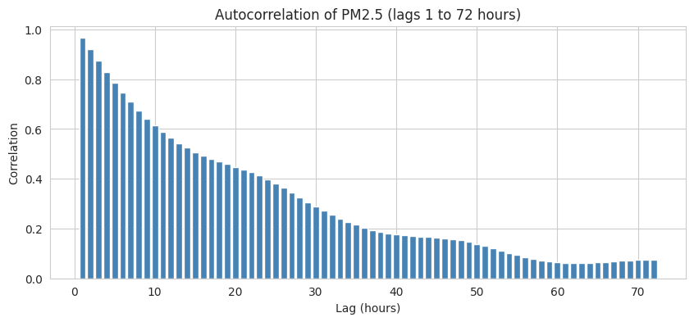  Figure 5: Autocorrelation of PM2.5 (lags 1 to 72 hours).

3.7 Visualizations (findings)
- Pollution is highest in February, October and January, and around midnight.
- NW wind gives the cleanest air (median 31). SE and cv winds give the dirtiest (median 91 and 98).
- High wind speed means low PM2.5. The highest PM2.5 occurs in cold weather.
- There is no clear long-term trend over the years.
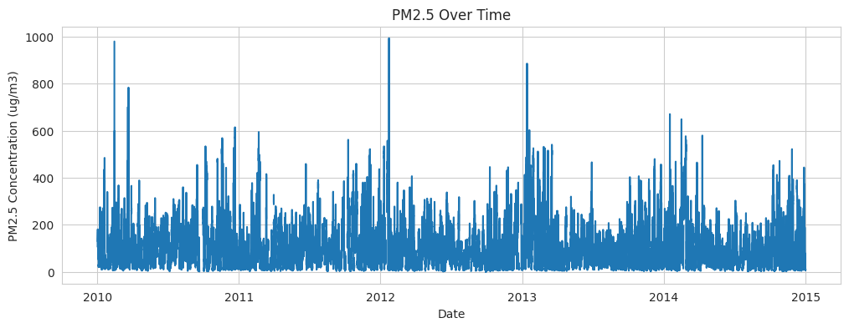  Figure 6: PM2.5 over time. | 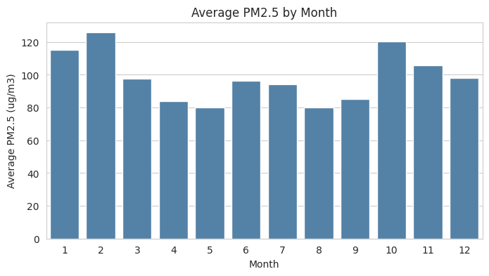  Figure 7: Average PM2.5 by month.

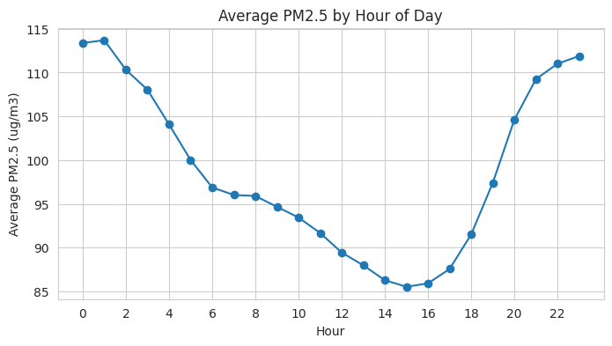  Figure 8: Average PM2.5 by hour of day. | 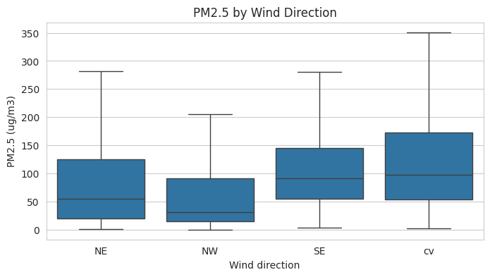  Figure 9: PM2.5 by wind direction.

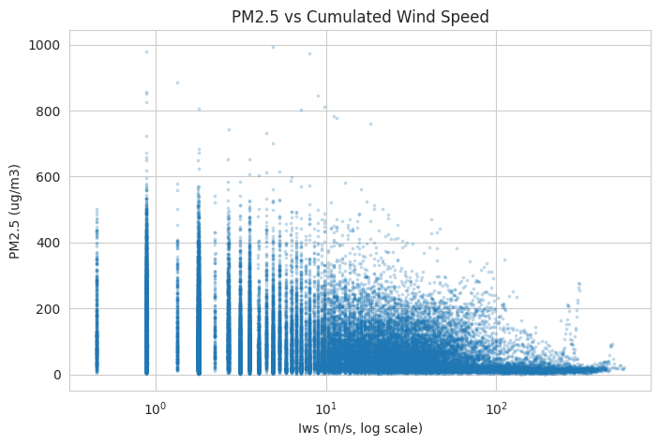  Figure 10: PM2.5 against cumulated wind speed. | 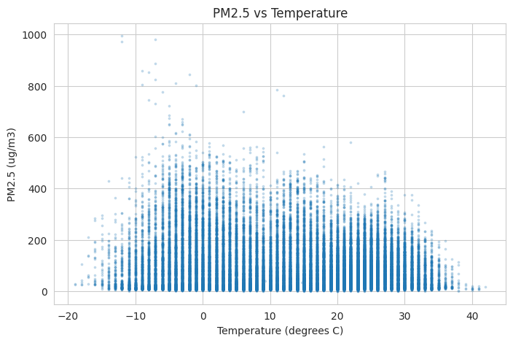  Figure 11: PM2.5 against temperature.

3.8 Key EDA Insights
- The last hours are the best clue for the next hour, so lag features are important.
- Short gaps can be filled, but long gaps should not be invented.
- High PM2.5 values are real pollution episodes, so outliers are kept.

4. Data Cleaning & Preprocessing

4.1 Missing Value Treatment
- Gaps of 24 hours or less were filled by linear interpolation (702 values).
- Longer gaps stay empty (1,365 values) and are not invented. The link between hours falls to about 0.4 after 24 hours, so a longer straight line would be unreliable.
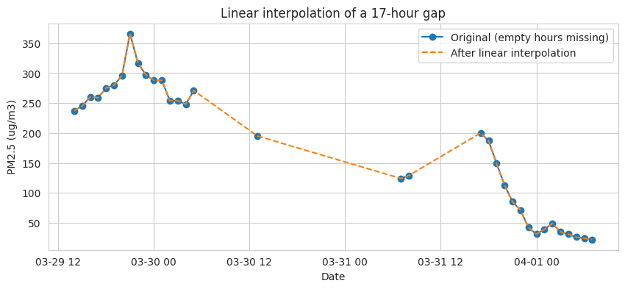
Figure 12: Example of linear interpolation of a 17-hour gap.

4.2 Duplicate Handling
- No duplicate rows, and every row is exactly one hour after the previous one.

4.3 Outlier Treatment
- The IQR rule found outliers (PM2.5 1,796 or 4.1%; wind speed 11.6%).
- Decision: all are kept, because the high PM2.5 values are real pollution episodes, not errors.

4.4 Encoding
- Wind direction (the only text column) was one-hot encoded into 4 columns: NE, NW, SE and cv.

4.5 Scaling / Normalization
- MinMaxScaler (0 to 1), fitted on the training years (2010 to 2012) only, so no future information leaks in.
- The target has its own scaler, to convert predictions back to ug/m3.

4.6 Project-Specific Preprocessing
- Columns that are not needed (No, day and the original pm2.5) were dropped. Rows stay in time order.

4.7 Train / Validation / Test Split
- Split by whole years, in time order, without shuffling: training 2010 to 2012, validation 2013, test 2014.

PHASE 2 - Feature Extraction, Representation, Model Building

5. Feature Engineering / Representation

5.1 Feature Engineering
- Time features: sine and cosine of hour and month.
- Lag features: PM2.5 from 1, 2, 3, 6, 12 and 24 hours ago.
- Previous-hour weather: only information known before the predicted hour is used.
- Rows with an empty target or lag (1,838) were removed. Final sizes: training 24,466, validation 8,760, test 8,760.

5.2 Feature Extraction / Representation
- SelectKBest scored the 20 candidate features and kept the best 18. TEMP_prev and Is_prev were removed.
- The Random Forest uses these 18 features in training, validation and test.
- LSTM and GRU: each sample is the last 24 hours with 15 values per hour, and the answer is the PM2.5 of the next hour.

6. Model Building

6.1 Baseline Model
- The next hour equals the last hour.

6.2 Model 1: Random Forest
- 100 trees, maximum depth 12, minimum 5 samples per leaf, 18 features.

6.3 Model 2: LSTM and 6.4 Model 3: GRU
- 64 units, dropout 0.2, Adam optimizer (learning rate 0.001), up to 20 epochs, batch size 128, early stopping (patience 4), seed 42.

6.5 Model Architecture
- Random Forest input: 18 features of one hour. LSTM and GRU input: 24 hours x 15 values. All output the PM2.5 of the next hour.
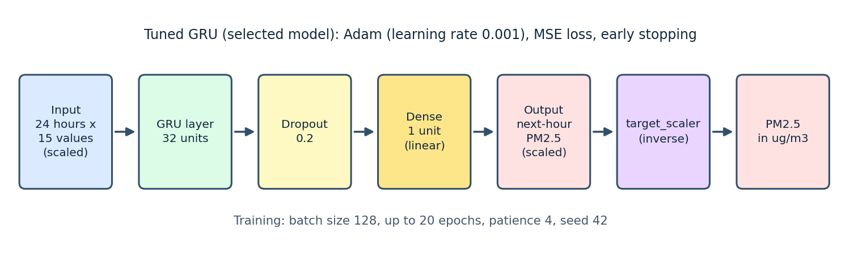
Figure 13: Architecture of the selected Tuned GRU model.

PHASE 3 - Model Training, Experimentation, Optimization, Evaluation

7. Model Training

7.1 Model Training
- The LSTM stopped after 14 epochs and the GRU after 18 epochs (early stopping).

7.2 Training / Validation MAE and 7.3 Training / Validation Loss
- Training and validation curves fall fast in the first 2 to 3 epochs, then flatten and stay close. There is no overfitting.

8. Model Experimentation & Optimization

8.1 Experiment 1 - Baseline
- The four basic models on validation 2013 give very close results (RMSE 24.58 to 25.23).

8.2 Experiment 2 - Model Improvement
- The Random Forest and the GRU predict the change from the last hour.
- Results improved: GRU RMSE 24.58 to 24.17; Random Forest RMSE 25.23 to 24.86.

8.3 Experiment 3 - Hyperparameter / Fine-Tuning
- The GRU was trained with other settings. The best is 32 units (validation RMSE 23.49). Others: learning rate 0.0005 (23.84), dropout 0.3 (23.98), 128 units (24.37).
- The best setting is kept as the Tuned GRU (32 units, dropout 0.2, learning rate 0.001).

8.4 Optimization Techniques
- Dropout and early stopping control overfitting.
- Predicting the change and tuning the GRU lowered the validation error.

9. Model Evaluation

9.1 Evaluation Metrics
- MAE, RMSE and R2. Lower MAE and RMSE are better; a higher R2 is better.

9.2 Model Comparison
All models were compared on the validation year 2013. The test year was not used to compare or choose models.
Model | MAE | RMSE | R2
Tuned GRU | 13.39 | 23.49 | 0.942
GRU (change) | 13.83 | 24.17 | 0.939
GRU | 15.23 | 24.58 | 0.937
Baseline | 13.08 | 24.69 | 0.936
LSTM | 15.35 | 24.84 | 0.936
RF (change) | 12.78 | 24.86 | 0.936
Random Forest | 12.97 | 25.23 | 0.934

- The baseline is strong. Only the GRU models improve its RMSE. The Tuned GRU gives the largest gain (24.69 to 23.49, 4.9%).

9.3 Best Model Selection
- Selected model: Tuned GRU. It is best in RMSE and R2, but only 4th in MAE (13.39, against 12.78 for RF (change)).
- Why RMSE and R2 decide: RMSE punishes big errors more, and big misses at high pollution matter most. The MAE gap is small (0.61 ug/m3, about 5%).
- Data used: training 2010 to 2012 (24,466 rows), validation 2013 (8,760), test 2014 (8,760).
- Final result on the test year 2014 (selected model only): MAE 12.25, RMSE 21.17, R2 0.949.
- Interpolation check: 863 of 8,760 validation rows (9.9%) and 810 test rows (9.2%) use interpolated data. On observed-only rows RF (change) is slightly better than the Tuned GRU (RMSE 23.01 against 23.25), but the Tuned GRU stays selected, because the rule was fixed before the check. Its test RMSE on observed-only rows is 21.55 against 21.17.

9.4 Error Analysis
- The biggest mistakes are sudden jumps and drops. Example: on 9 April 2014 the real value was 580 and the model predicted 88.
- The average error is 11.36 on normal hours and 28.05 above 300 ug/m3, about 2.5 times larger.
- Limitation: such hours are rare (469 of 8,760 test hours, 5.4%), and the model uses only the past 24 hours and weather. Sudden spikes are not predicted well, so use it with care for severe pollution alerts.

9.5 Overfitting / Underfitting
- The LSTM, GRU, GRU (change) and Tuned GRU show no overfitting (Tuned GRU: train RMSE 23.22, validation 23.49, test 21.17).
- The Random Forest overfits mildly (train 18.19, validation 25.23), and RF (change) a little more (19.25, 24.86).

PHASE 4 - Deployment & Documentation

10. Model Export
- The Tuned GRU is saved as model.keras and the target scaler as target_scaler.pkl, in the app folder.

11. API Deployment

11.1 Technology Used
- FastAPI, served with Uvicorn.

11.2 API Endpoint
- GET / (home), GET /health, and POST /predict.
- Input of /predict: 24 hours x 15 scaled values, in the same column order as training.
- Output: {"predicted_pm25": <number>, "unit": "ug/m3"}. There is no confidence value, because this is a regression model.
- A wrong input shape returns status 400 with a clear message.

11.3 API Implementation
- app.py loads the model and the scaler, checks the input shape, predicts, and converts the answer back to ug/m3.
- Test result: status 200, and the API value equals the model value for the same sample (58.14).
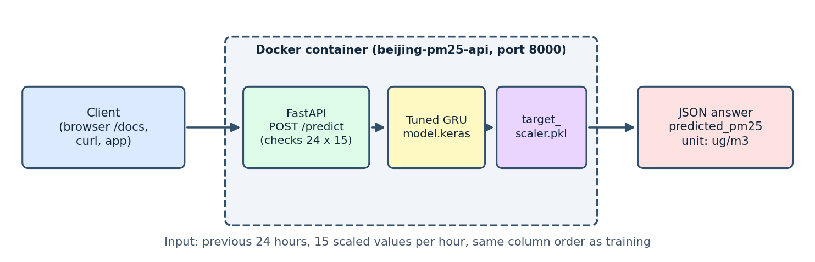
Figure 14: client, FastAPI and Docker container.
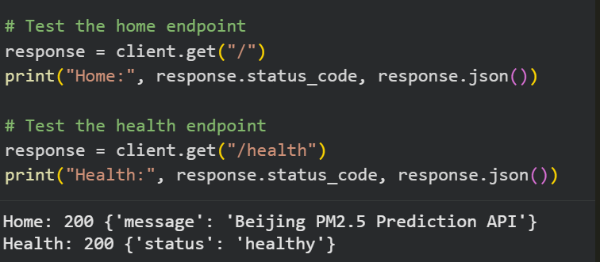
Figure 15: Home and health endpoint test.

12. Docker Containerization

12.1 Dockerfile
- The Dockerfile and requirements.txt package the API and the model, with the same library versions as the notebook.

12.2 Docker Build
- docker build -t beijing-pm25-api .
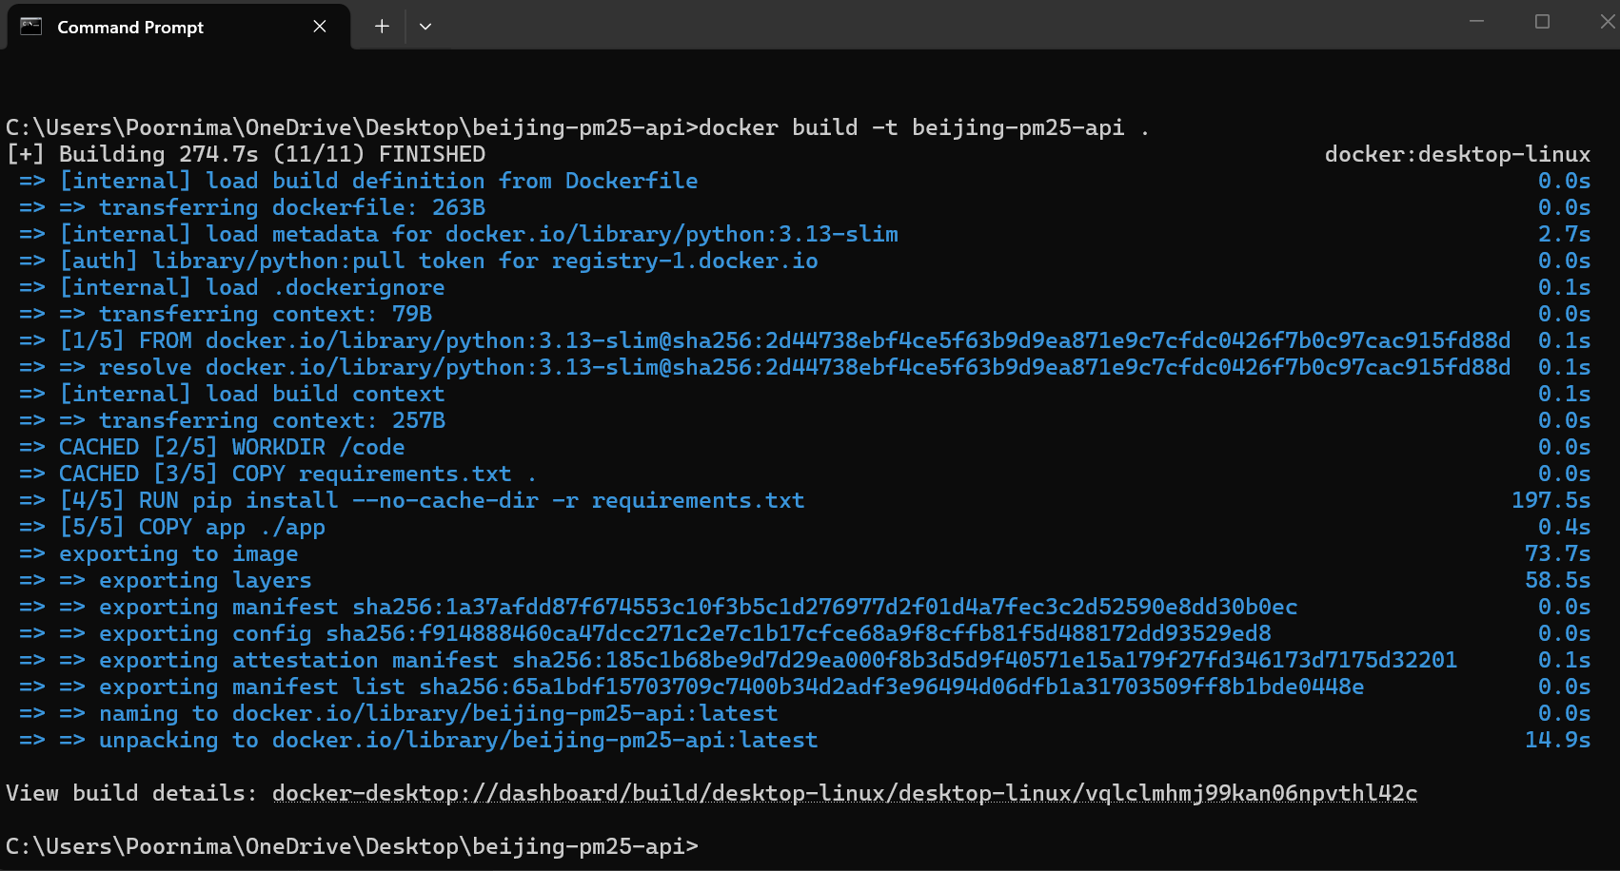
Figure 16: Docker build success.

12.3 Docker Run
- docker run -p 8000:8000 beijing-pm25-api, then open http://localhost:8000/docs
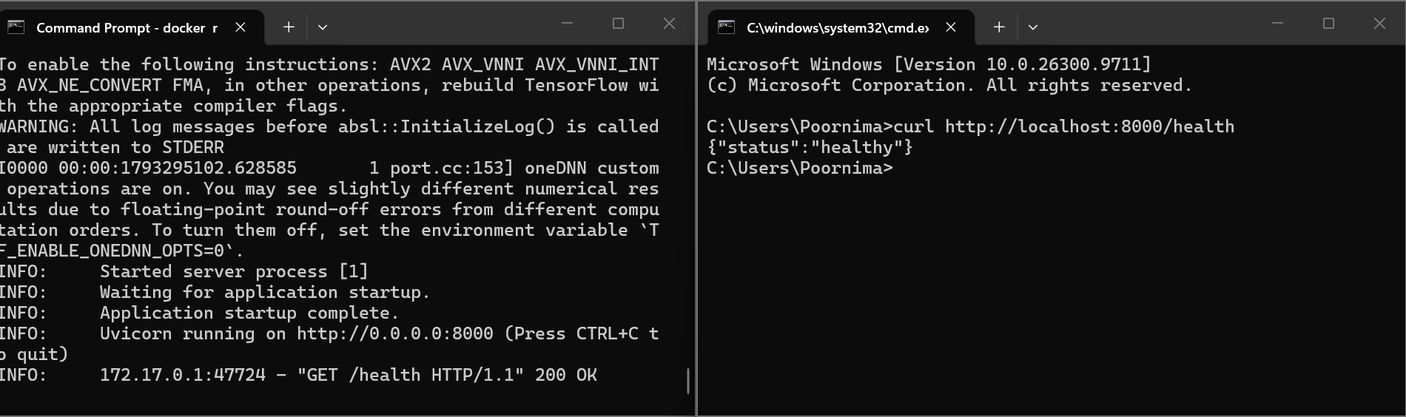
Figure 17: Docker run success and health check.
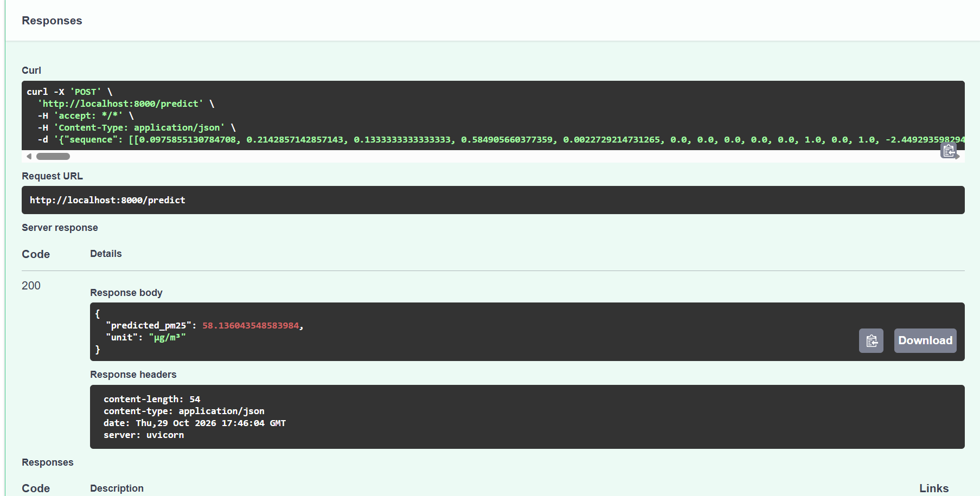
Figure 18: API response (status 200).

13. Documentation

13.1 README.md
- The README has the project overview, dataset, model details, installation, API usage, Docker instructions, results, limitations and future improvements.
- Training and prediction use the same scaling, lag features and column order.

14. Conclusion

14.1 Final Findings
- Problem solved: the next-hour PM2.5 in Beijing is predicted from the previous 24 hours.
- Best model: Tuned GRU, with test 2014 results MAE 12.25, RMSE 21.17 and R2 0.949.
- The baseline is strong because the last hour explains most of the next hour. The Tuned GRU still lowers the validation RMSE by 4.9%.
- Errors are larger at high pollution, and sudden spikes are not predicted well.

14.2 Business Impact
- City authorities and schools can plan for the next hour, for example outdoor activities and warnings.
- People with breathing problems can get an early notice.
- The API and Docker image let a dashboard or a mobile app use the model easily.
- It should not be the only source for severe pollution alerts.

14.3 Future Improvements
- More data: more years, more stations, more weather and event data.
- Better models: models built to handle sudden spikes, and ensembles.
- Cloud deployment: host the Docker container on a cloud service.
- Real-time implementation: feed live readings and build the 24-hour window automatically.
- MLOps and model monitoring: track the errors over time and retrain when the scores drop.

References
- Dataset: UCI Machine Learning Repository, Beijing PM2.5 Data. https://archive.ics.uci.edu/dataset/381/beijing+pm2+5+data
- Liang, X., Zou, T., Guo, B., Li, S., Zhang, H., Zhang, S., Huang, H. and Chen, S. X. (2015). Assessing Beijing's PM2.5 pollution: severity, weather impact, APEC and winter heating. Proceedings of the Royal Society A, 471(2182), 20150257.
- Hochreiter, S. and Schmidhuber, J. (1997). Long short-term memory. Neural Computation, 9(8), 1735-1780.
- Cho, K., van Merrienboer, B., Gulcehre, C., Bahdanau, D., Bougares, F., Schwenk, H. and Bengio, Y. (2014). Learning phrase representations using RNN encoder-decoder for statistical machine translation. EMNLP 2014.
- Breiman, L. (2001). Random forests. Machine Learning, 45(1), 5-32.
- Pedregosa, F. et al. (2011). Scikit-learn: Machine learning in Python. Journal of Machine Learning Research, 12, 2825-2830.
- Abadi, M. et al. (2016). TensorFlow: A system for large-scale machine learning. 12th USENIX Symposium on Operating Systems Design and Implementation (OSDI 16).
- FastAPI documentation. https://fastapi.tiangolo.com
- Docker documentation. https://docs.docker.com

