GitHub Hands-On:

Website: <https://github.com>

Experiment: 01 Create a GitHub account, then create a new repository with a README file. Upload a basic file named hello.txt, edit the file through GitHub’s web interface, commit the changes, and view the commit history. Share the link to your repository after completion.

Step 1: Create a GitHub Account

Go to <https://github.com>

Click “Sign Up”

Enter: Email address

Username

Password

Verify your email and log in

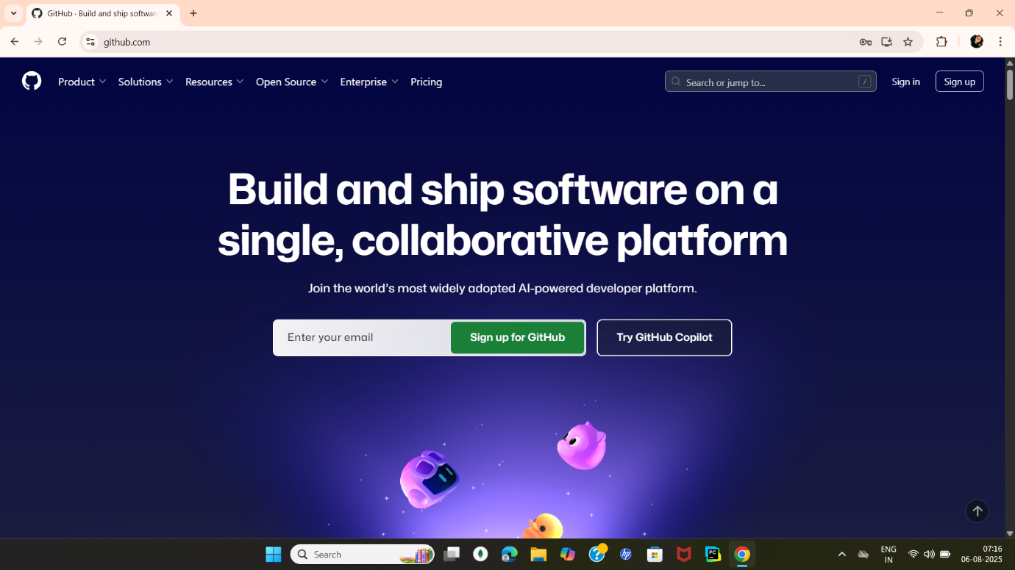

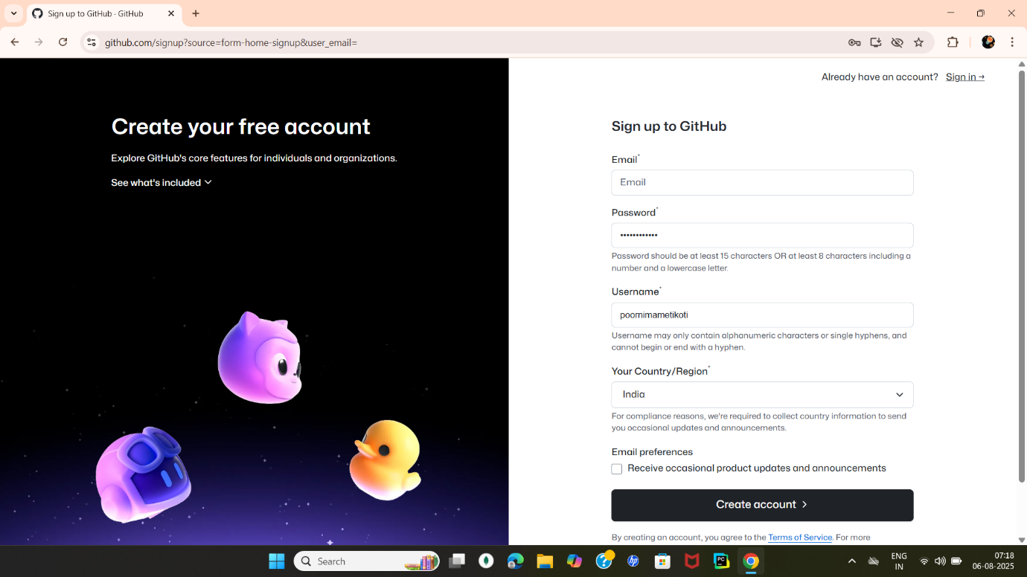

Step 2: Create a New Repository

After logging in, click the + icon →

New Repository Fill the form:

Repository name: my-first-repository

Description: Learning GitHub with DevOps

Check: “Initialize this repository with a README”

Click “Create Repository”

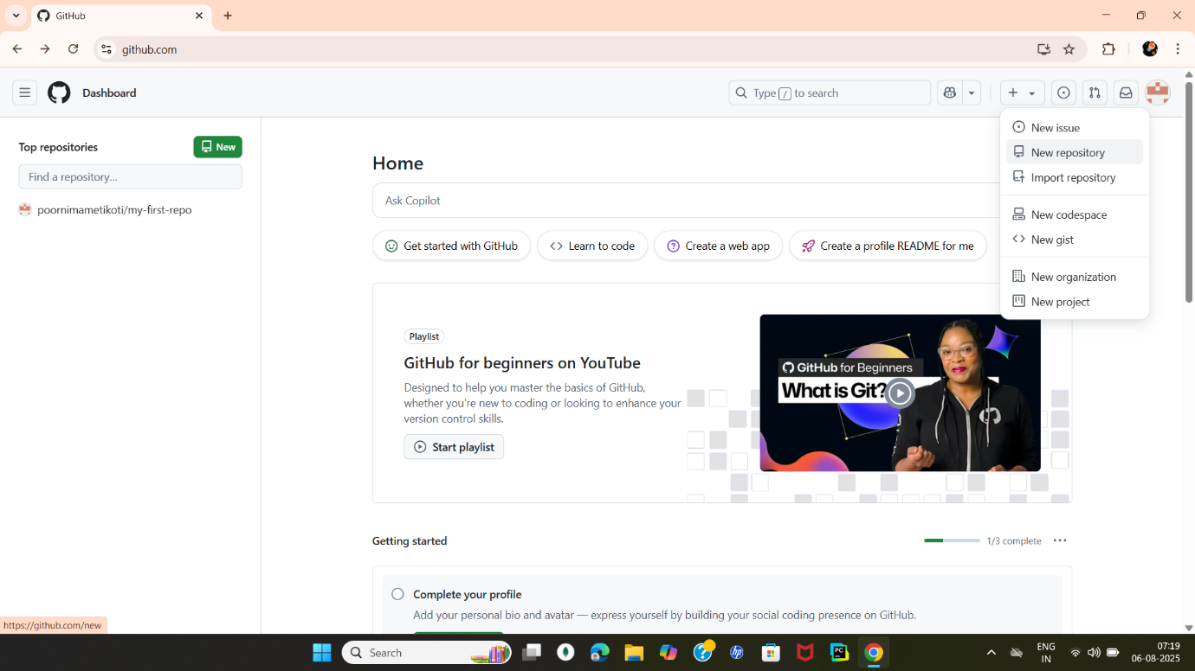

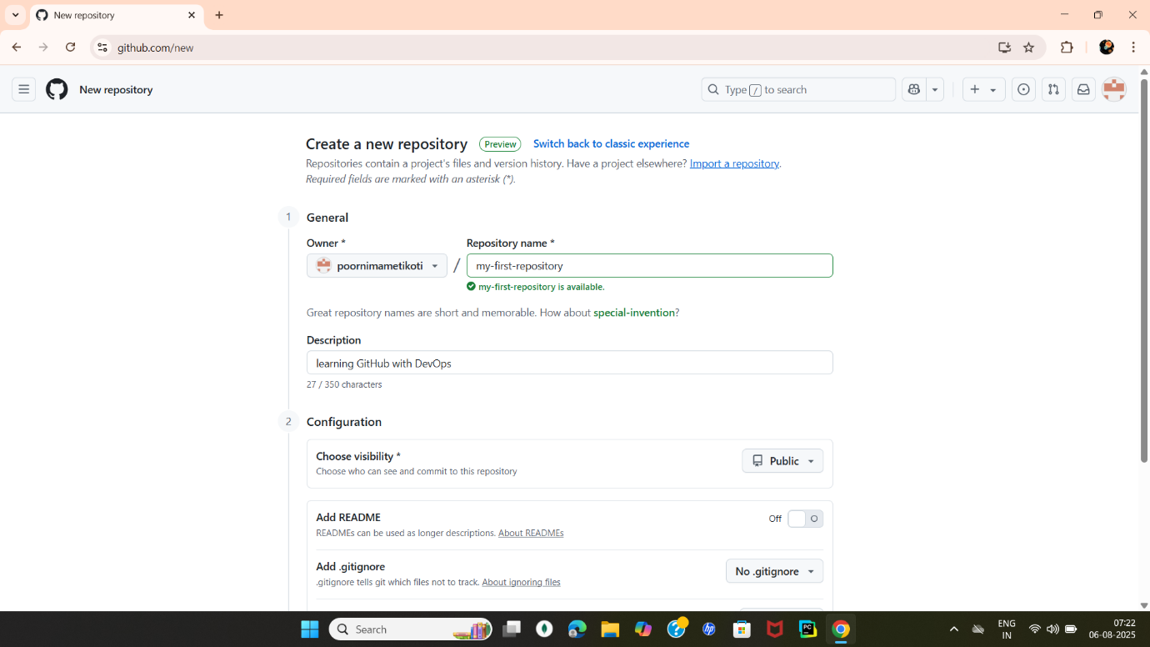

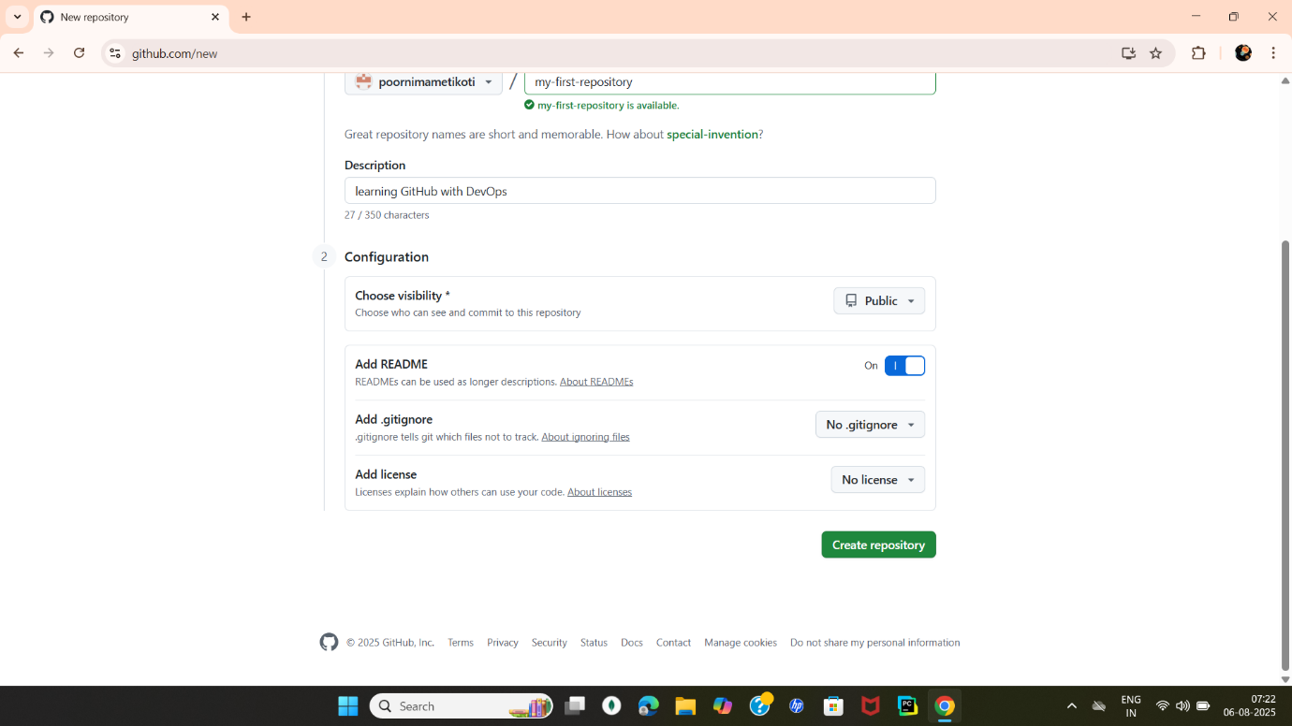

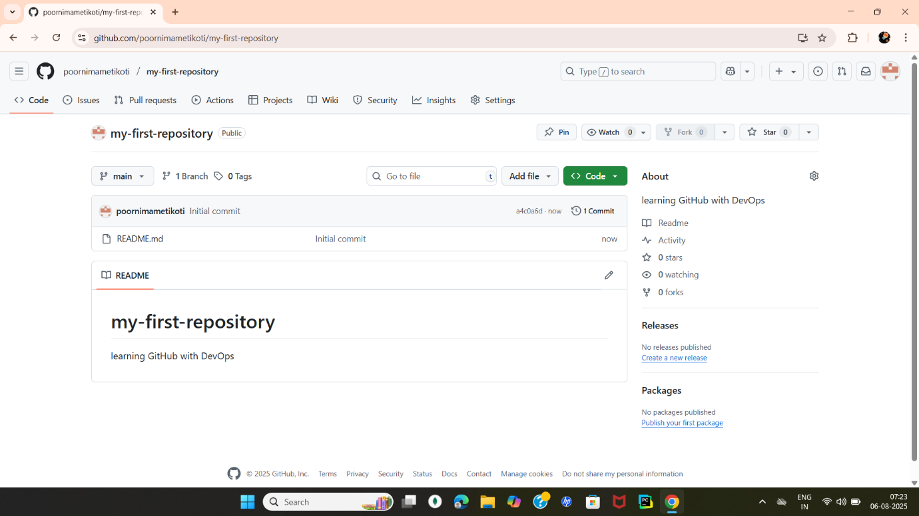

Step 3: Upload a File (hello.txt)

Inside your new repo, click “Add file” → “Upload files”

Drag & drop or select a file named hello.txt

You can create it using Notepad or just type “Hello GitHub” inside

Scroll down → Add a commit message: added hello.txt

Click “Commit changes”

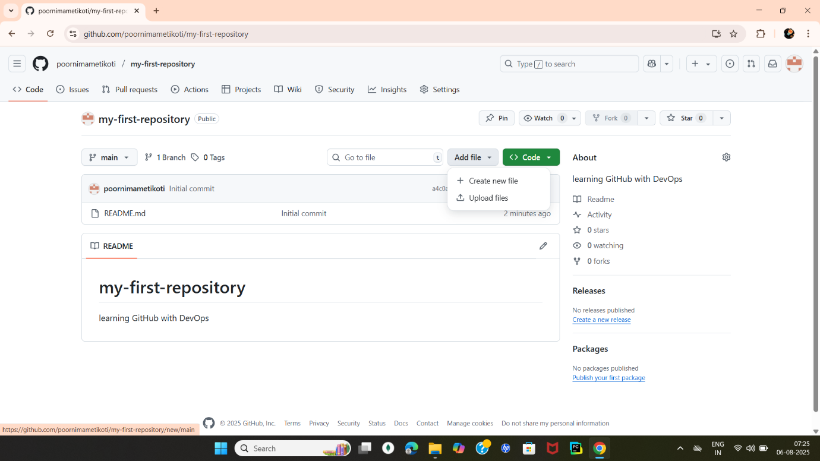

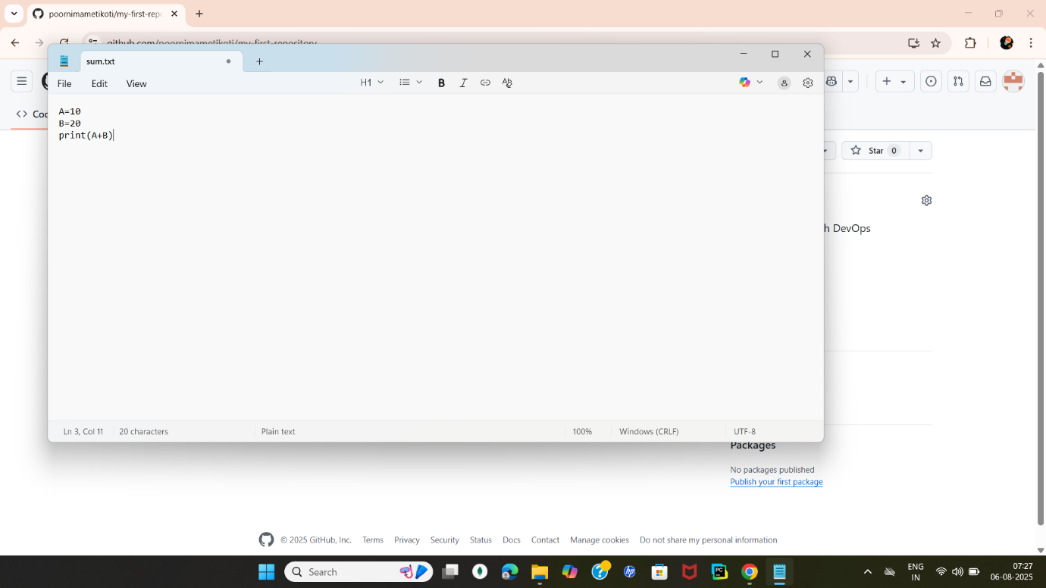

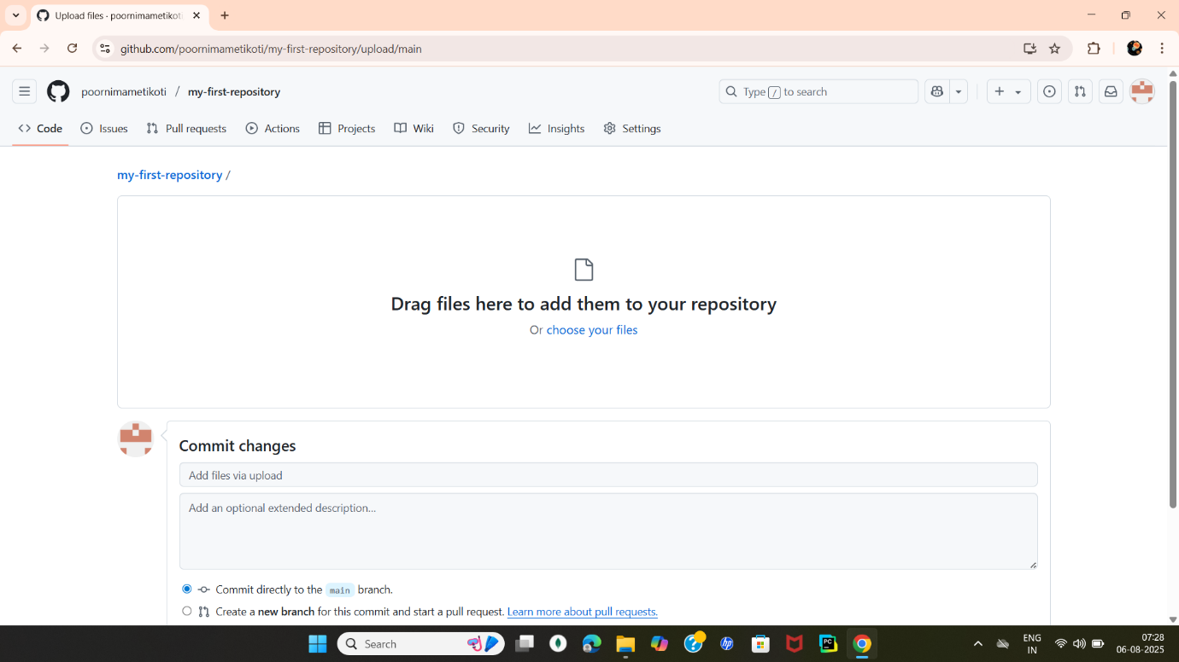

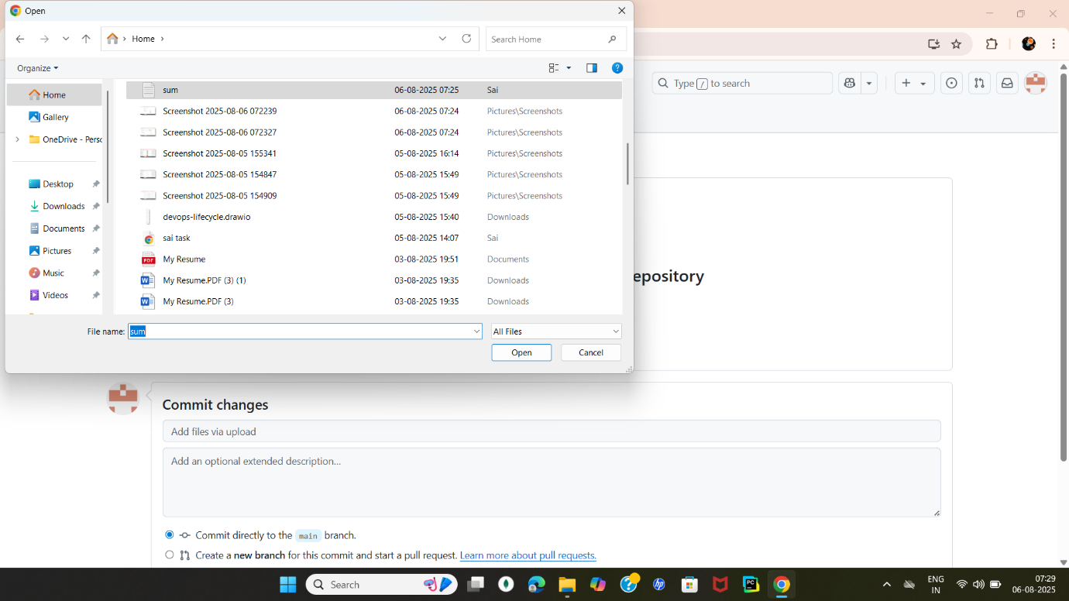

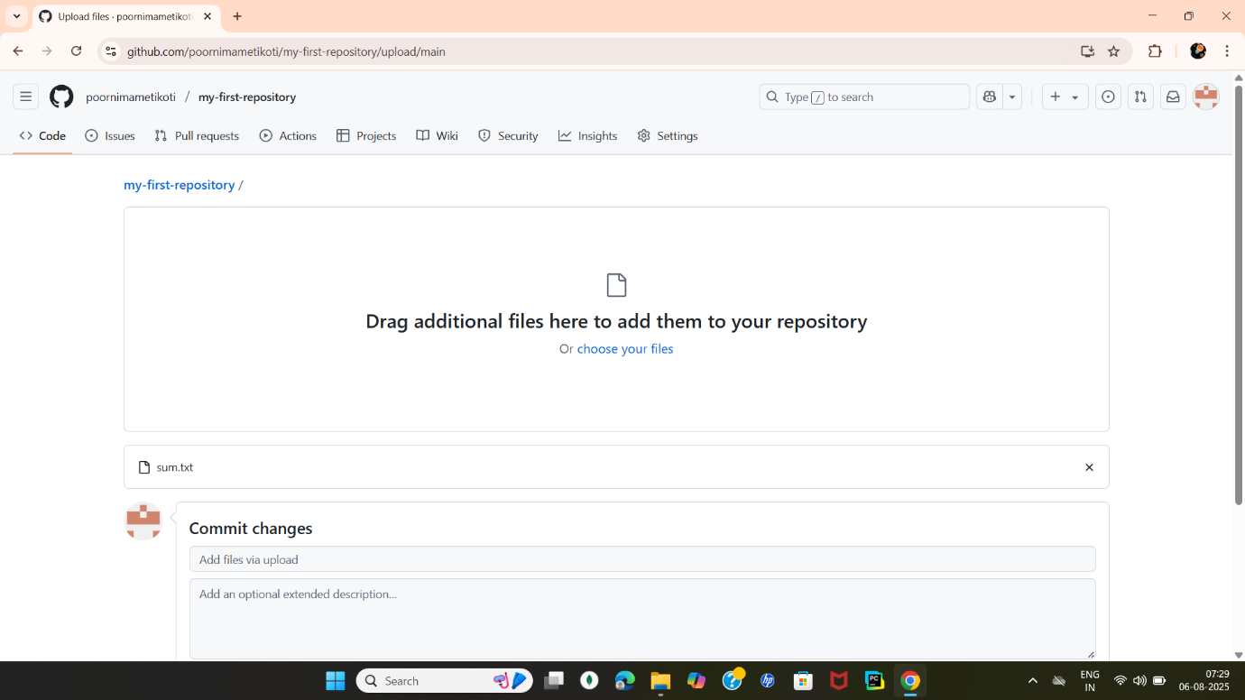

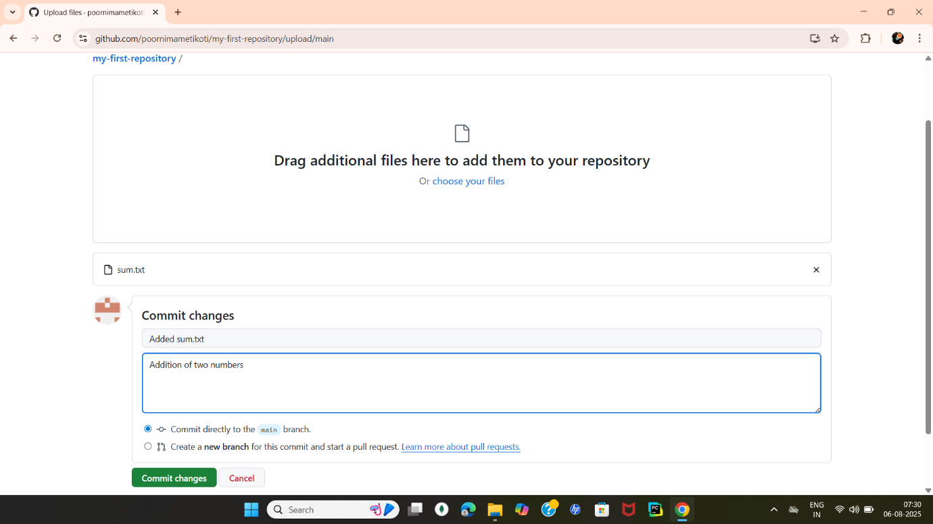

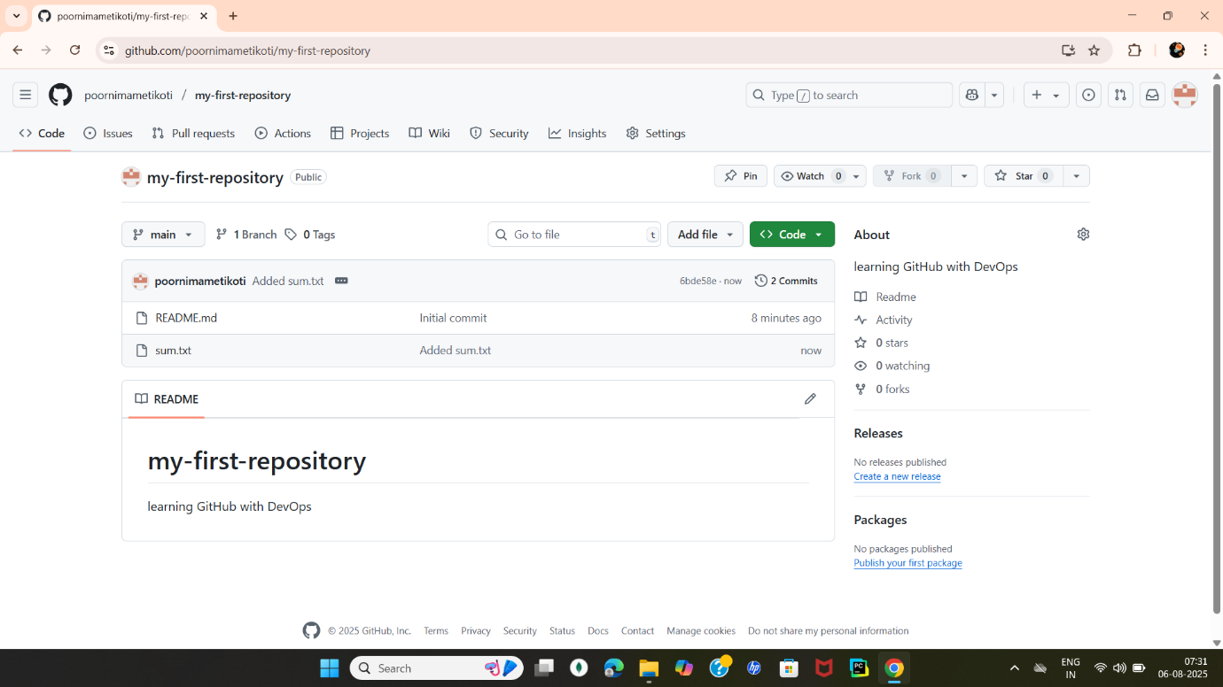

Step 4: Edit the File Online

Click on hello.txt from the repo file list

Click the pencil icon (Edit this file)

Change the content, e.g., add your name or a second line

Scroll down, add a commit message: updated hello.txt

Click Commit changes

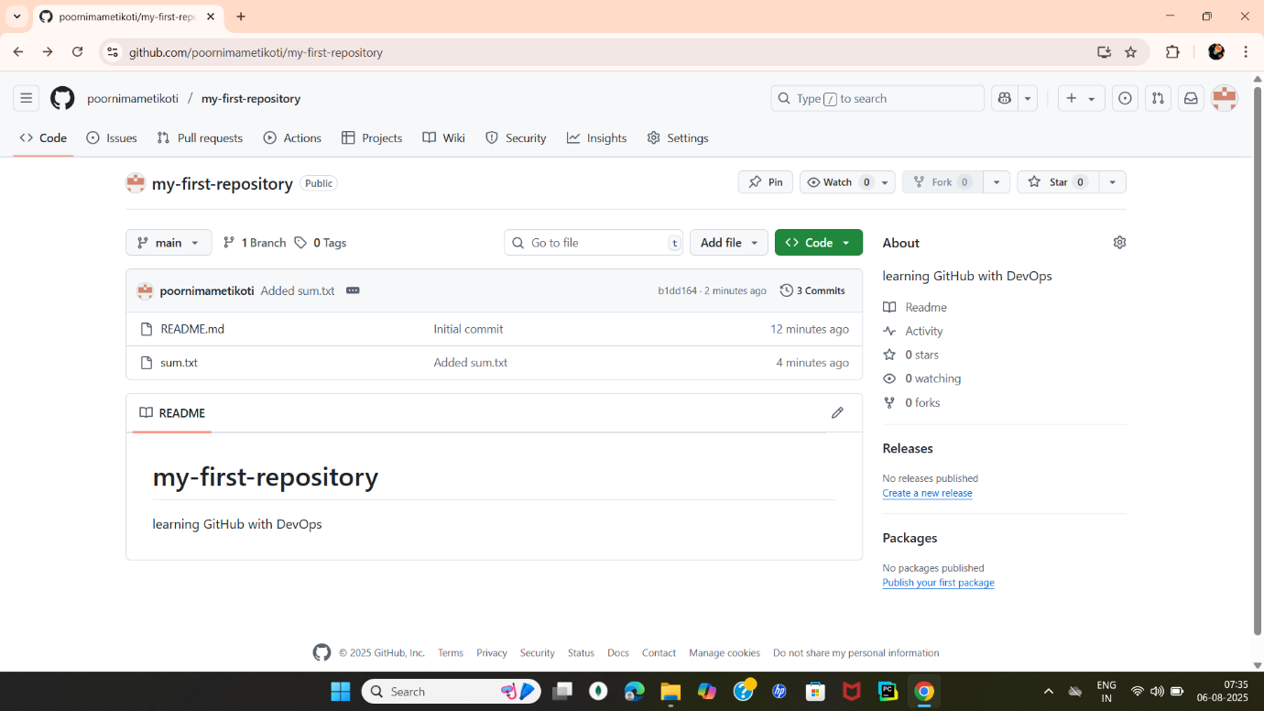

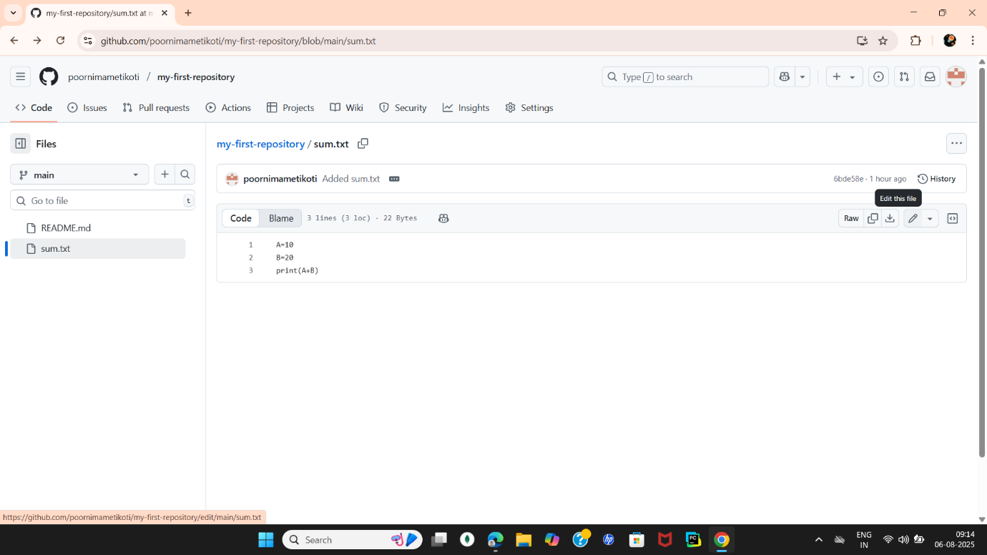

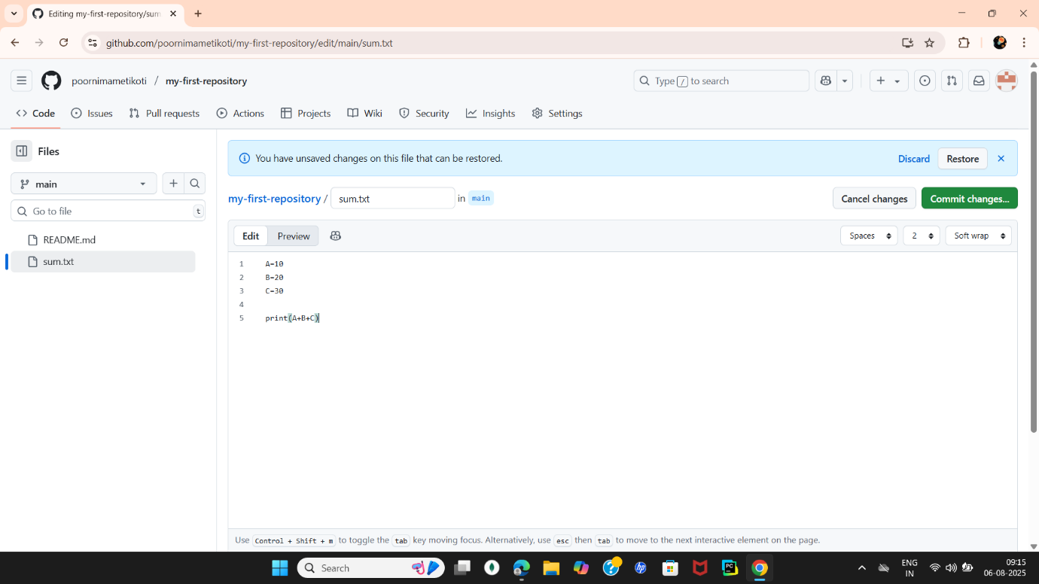

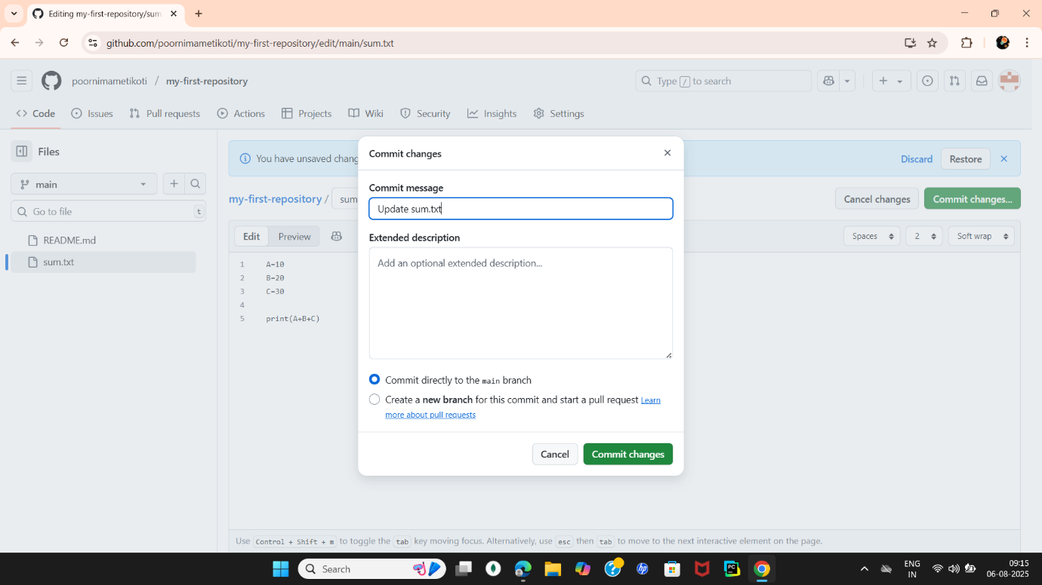

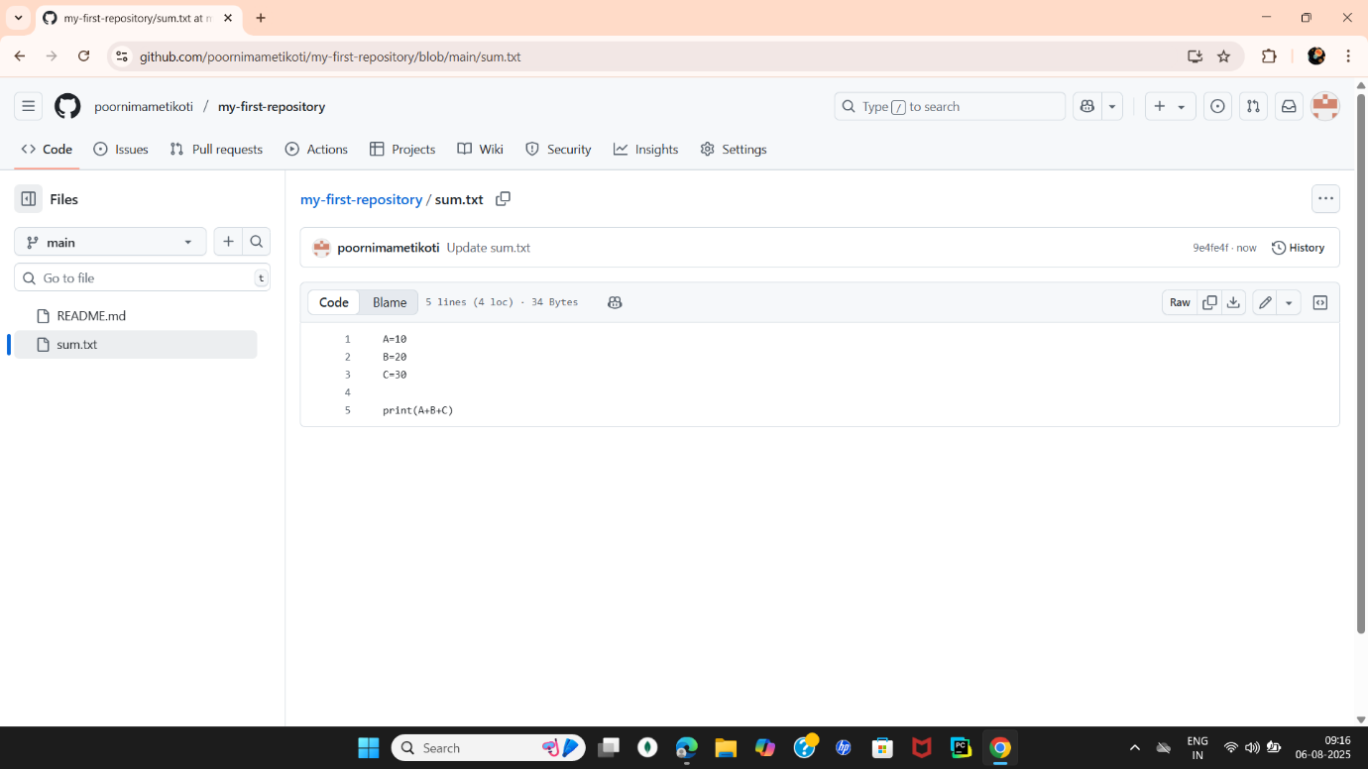

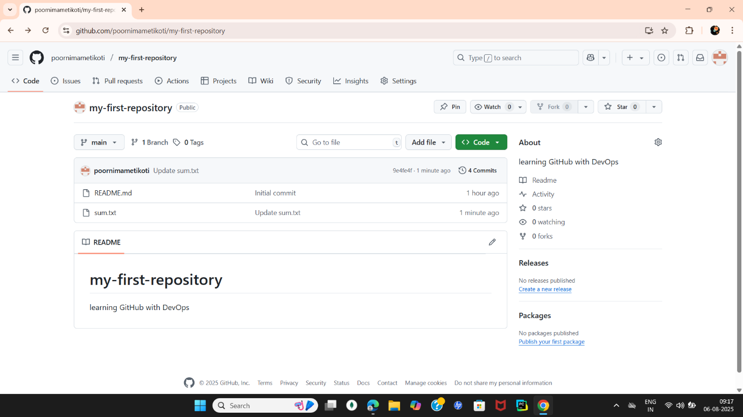

Step 5: View Version History

At the top of your repo, click the “Commits” tab

You will see all your commit messages and time of changes

Click on a commit to view the file version at that point

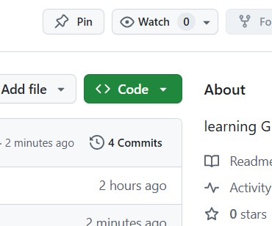

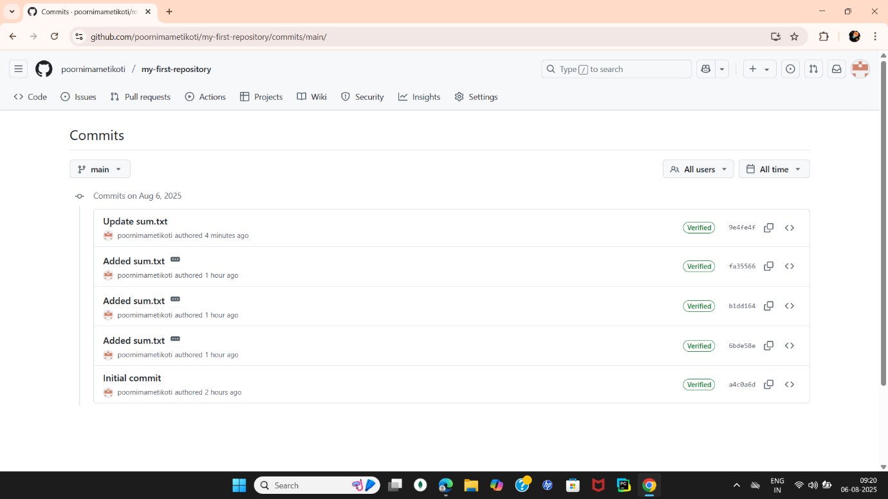

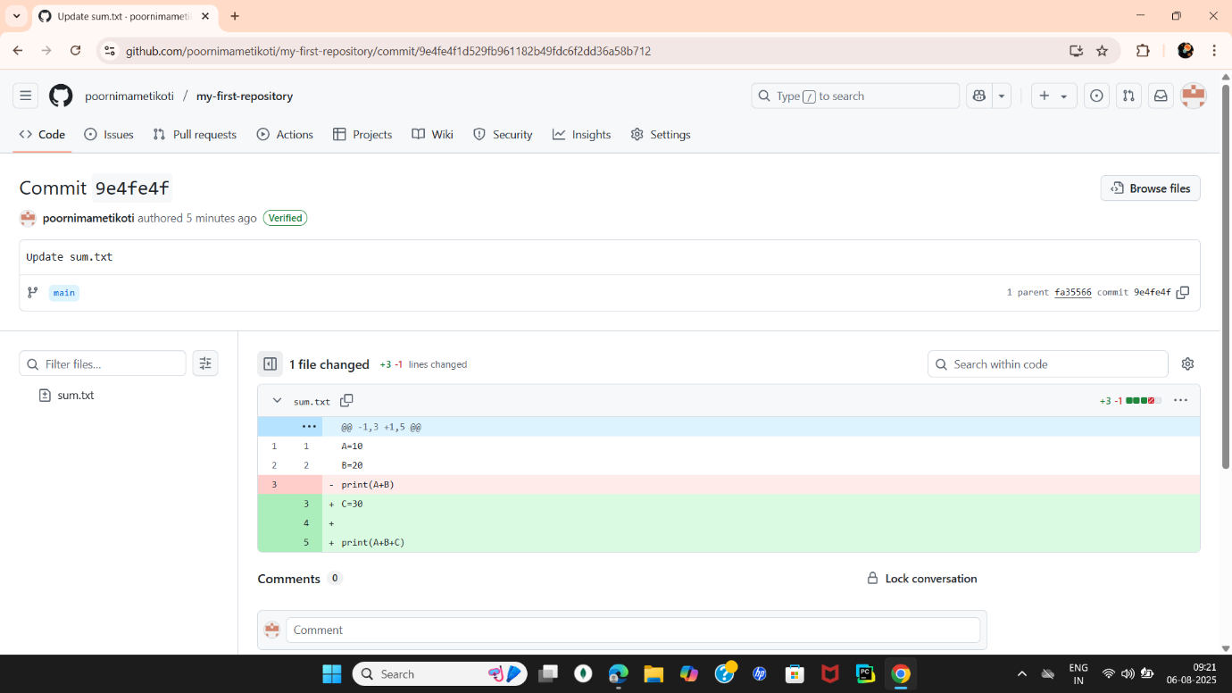

Final Submission:

Copy your repo link

(example: <https://github.com/yourname/my-first-repo>)

Example: <https://github.com/poornimametikoti/my-first-repository>

Paste it into your classroom form / send it to trainer

EXPERIMENT-02