- At the firebase console, click on Authentication.
- Click on setup sign in method
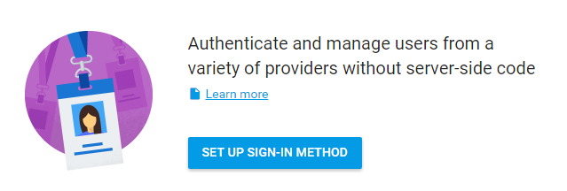

- Click on E-mail Password
  - Slide the Enable slider to the right.
  - Click on Save
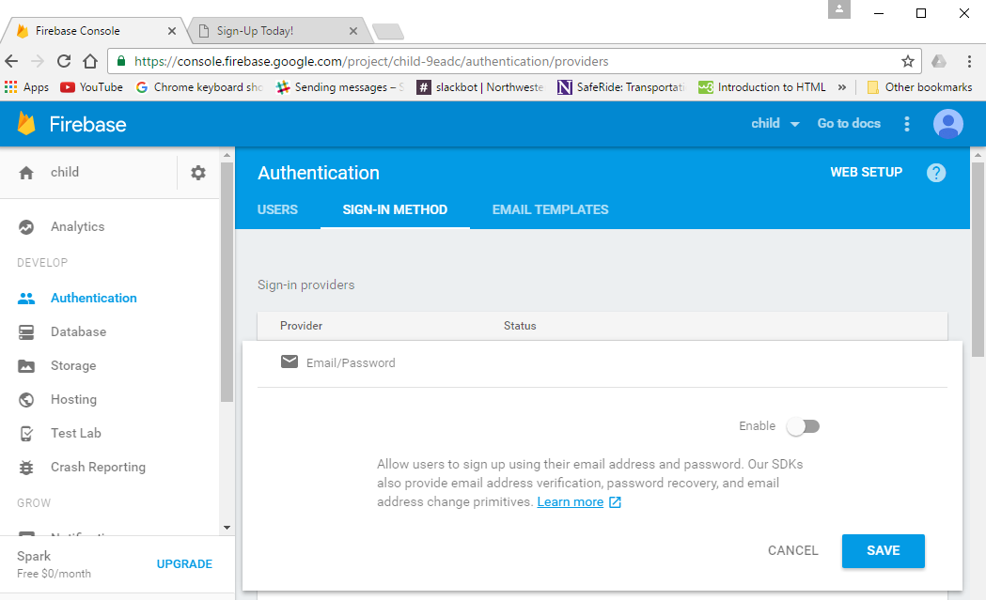
4.) Make sure Email Password is enabled.
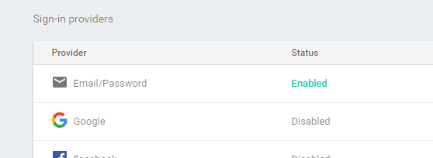
5.) Click on Rules
6.) Make the rules “auth != null” as you see below.

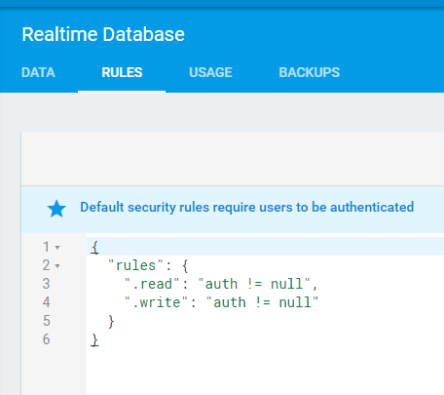
7.) After adding a user click on Authentication. The webpage and the firebase console can both add new users.
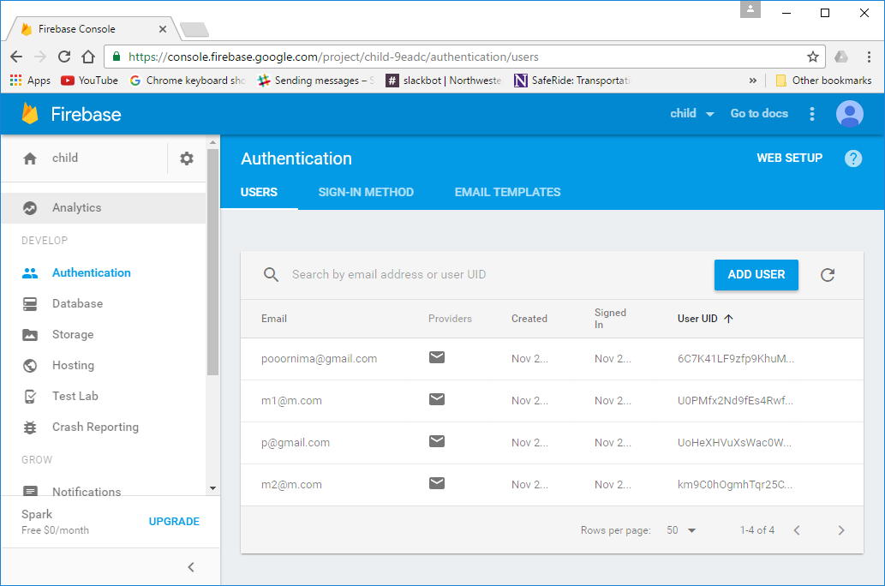

8.) Click on database after using the Web page to add recipes.
