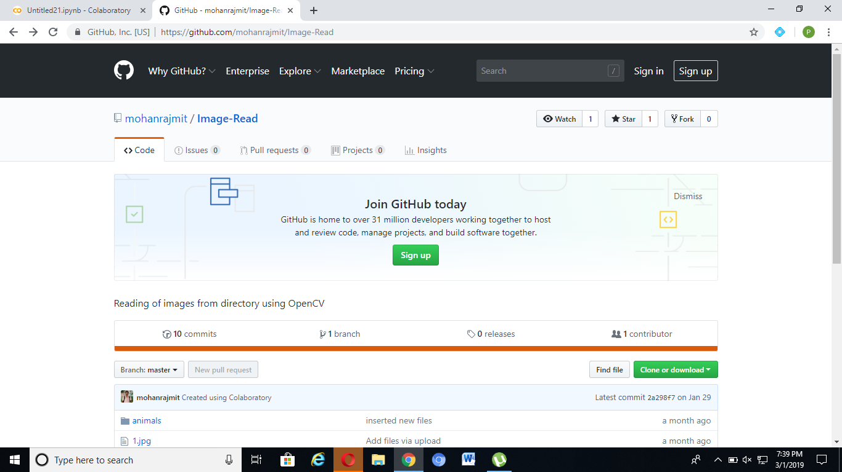

Select imageread.ipynb.click on it and open in colab

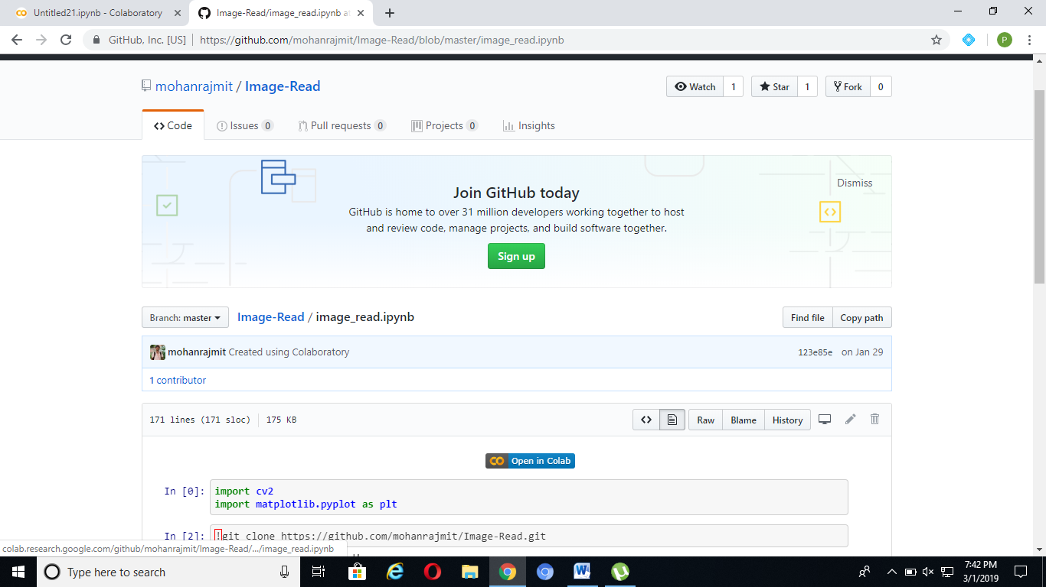

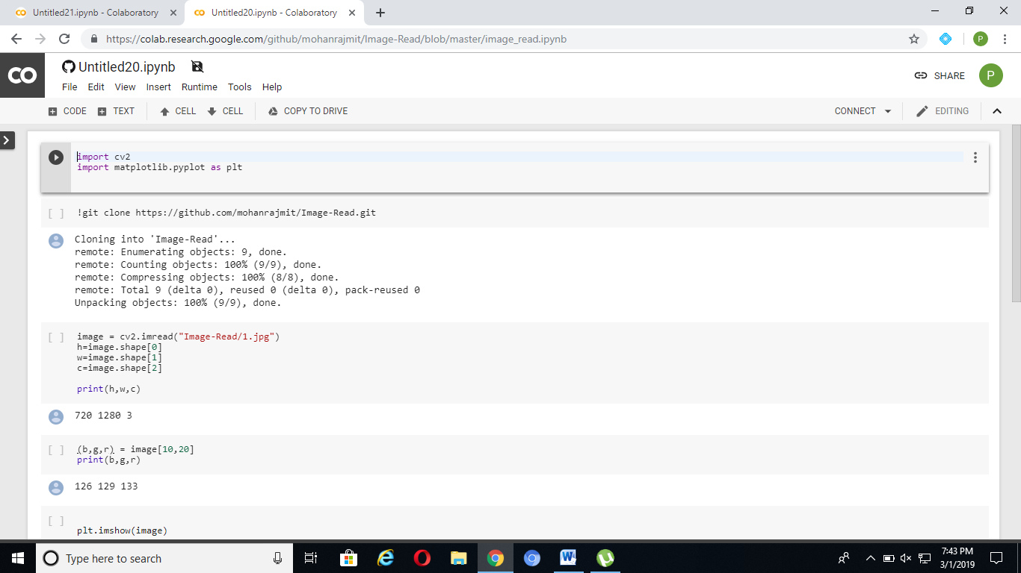

Now run one by one.

Imread.ipynb

IMPORT LIBRARIES



CLONING mohanraj repository



READING IMAGE USING image-read

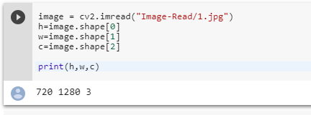

READING rgb AS REVERSE bgr

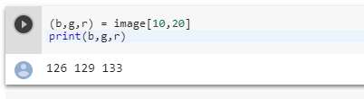

PLOT IMAGE

